Connecticut State Department of Education
Bureau of Child Nutrition Programs

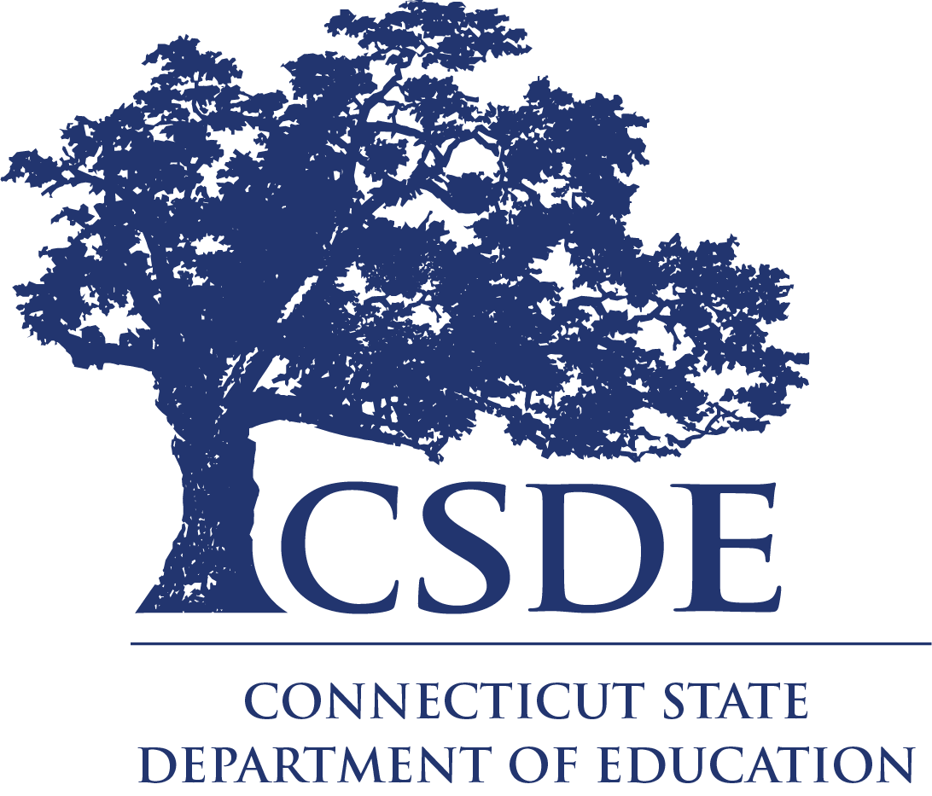

Charlene M. Russell-Tucker
Commissioner of Education

Request for Information

Chefs to Schools
RFI 003

The Connecticut State Department of Education is committed to a policy of equal opportunity/affirmative action for all qualified persons. The Connecticut Department of Education does not discriminate in any employment practice, education program, or educational activity on the basis of race; color; religious creed; age; sex; pregnancy; sexual orientation; workplace hazards to reproductive systems, gender identity or expression; marital status; national origin; ancestry; retaliation for previously opposed discrimination or coercion, intellectual disability; genetic information; learning disability; physical disability (including, but not limited to, blindness); mental disability (past/present history thereof); military or veteran status; status as a victim of domestic violence; or criminal record in state employment, unless there is a bona fide occupational qualification excluding persons in any of the aforementioned protected classes. Inquiries regarding the Connecticut State Department of Education’s nondiscrimination policies should be directed to: Attorney Louis Todisco, Connecticut State Department of Education, by mail 450 Columbus Boulevard, Hartford, CT 06103-1841; or by telephone 860-713-6594; or by email louis.todisco@ct.gov.

The Connecticut State Department of Education is an Affirmative Action/Equal Opportunity Employer.

Contents
Part I. Legal Authority: 4
Part II. Request for Information 4
Background: 4
Scope: 4
Responses to the RFI: 4
Part III. Informational Documentation Requirements 5
Submission Information: 5
Additional Information: 5
Contact Information: 5
Schedule: 5
Part IV. Freedom of Information: 6
Part V. Definitions 6

Part I. Legal Authority:

Section 6 of Public Act No. 23-167 (“An Act Concerning Transparency in Education”), directs the Connecticut State Department of Education (CSDE) to administer a wholesome school meals pilot program (hereinafter referred to as “Chefs to Schools”) that awards grants to alliance districts, as defined in Connecticut General Statutes (C.G.S.) Section 10-262u of the general statutes, for the purpose of embedding professional chefs in such alliance districts to assist school meal programs.

Part II. Request for Information

Background:
The CSDE requests information from interested providers for placing a professional chef in an alliance district to assist school meal programs in building the capacity of food service staff, improving school meal quality, increasing diner satisfaction, streamlining operations, and establishing a financially viable school meal program. This RFI is not an offer, and no contract will be awarded as a result.

Scope:
The purpose of this RFI project is to identify organizations that specialize in the placement of chefs that could partner with the CSDE for the purpose of embedding professional chefs in five (5) alliance districts for three (3) schoolyears (2024, 2025 and 2026). The professional chefs would be able to assist school meals programs in building the capacity of food service staff, improving school meal quality, increasing diner satisfaction, streamlining operations, and establishing a financially viable school meal program.

Responses to the RFI:
Responses may include, but are not limited to, explanations of the following range of resources.
- An organization that can embed a professional chef in an alliance district for the purposes of:
  - assisting school meal programs in building the capacity of food service staff;
  - improving the quality of school meals;
  - increasing diner satisfaction;
  - streamlining operations; and,
  - establishing a financially viable school meal program.

Part III. Informational Documentation Requirements

Submission Information:
- By December 22, 2023, 4:00 p.m., submit a complete response as specified in the Scope section and Responses to the RFI section of this document via email to Sean.Fogarty@ct.gov. Only written RFI responses submitted via email will be accepted.
- Label the submission using the following information.
  - Request for Information: Chefs to Schools
  - RFI Number 003
  - Include the following title in the subject line of the submission email: Chefs to Schools RFI
  - No late submissions will be accepted.

Additional Information:
Information gathered because of this RFI may be included in guidance documents developed by the CSDE for distribution to local and regional boards of education and alliance districts.

Contact Information:
Questions concerning this Request for Information (RFI) may be directed to the CSDE Bureau of Child Nutrition Programs, Grants & Contracts Specialist, Sean Fogarty (Sean.Fogarty@ct.gov or 860-807-2055).

Schedule:
Task | Organization/Agent | Required Action | Date
Issue RFI | CSDE | Post the RFI on the DAS State Contracting Portal and the CSDE Website. | November 27, 2023
Receive Questions from Prospective RFI Respondents | Prospective RFI Respondents | Review the RFI and submit any questions via email to Sean.Fogarty@ct.gov | November 27, 2023 - December 8, 2023
Amend the RFI and Answer Submitted Questions | CSDE | Publish amendments to the RFI and written responses to submitted questions on the DAS State Contracting Portal and the CSDE Website. | December 8, 2023
Submit Information | RFI Respondents | Submit information to the CSDE by email to Sean.Fogarty@ct.gov | December 22, 2023

Part IV. Freedom of Information:

This RFI is being issued solely for informational planning purposes and does not constitute a solicitation. Pursuant to C.G.S. Section 1-210 et seq. (the FOIA), all responses to this RFI are considered public records and every person shall have the right to (1) inspect such records promptly during regular office or business hours, (2) copy such records in accordance with C.G.S. Section 1-212(g), or (3) receive a copy of such records in accordance with C.G.S. Section 1-212.

Part V. Definitions

Alliance Districts - Are school districts with the thirty-three lowest Accountability Index measures, as calculated by the Connecticut State Department of Education or those previously designated as Alliance Districts by the Commissioner of Education for the fiscal years ending 2022-2023, inclusive. Alliance Districts may be found at: https://portal.ct.gov/SDE/Alliance-Districts/Alliance-and-Opportunity-Districts Related Resources - List of Alliance Districts.

Chefs to Schools – The CSDE assigned name for the “wholesome school meals pilot program” legislation.

Request for Information - A document that an organization uses to request and obtain information about a product or service from suppliers. In this structured manner, an organization can learn about the possible solutions for the scope of work as indicated in the request for information.

RFI Respondent - A supplier (e.g., publisher, organization) that provides a written response to a request for information, providing details about the possible solutions for the scope of work as indicated in the request.

