
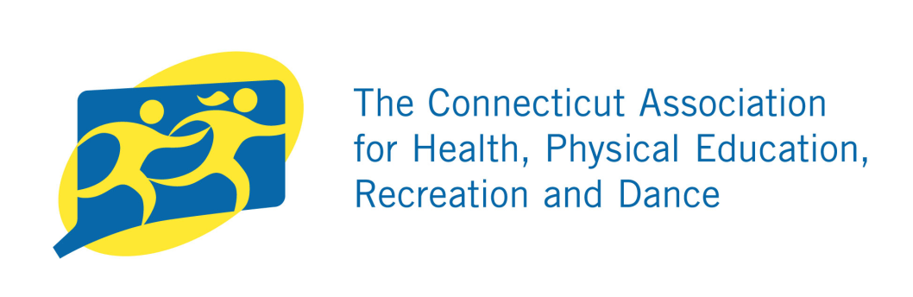
School Representative
Certificate of Achievement
IN
PHYSICAL FITNESS
Presented to:

For Outstanding Performance In The
2018-2019 Connecticut State Physical Fitness Assessment
A Test in Strength, Endurance, and Flexibility

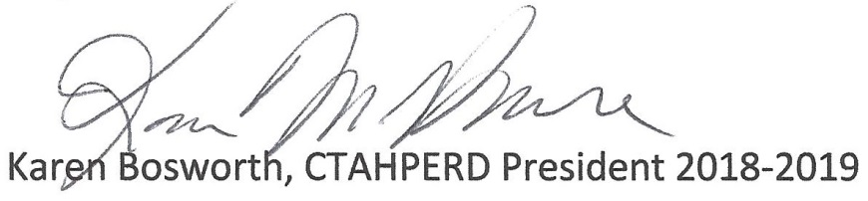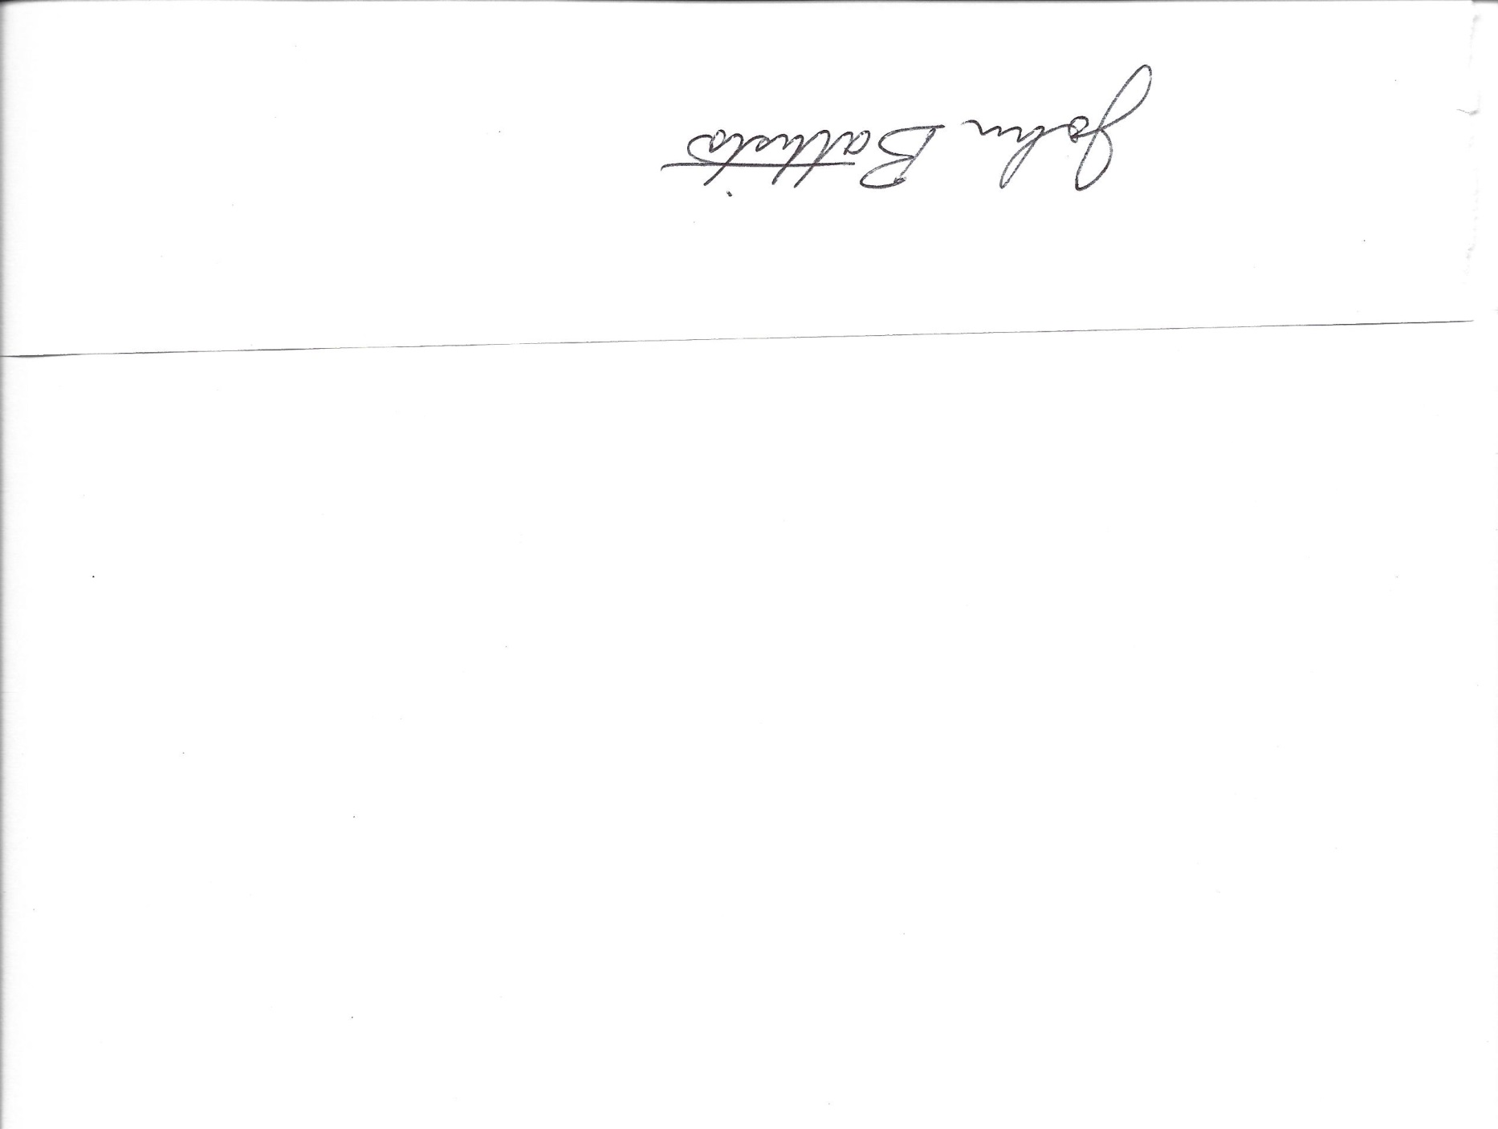Our Congratulations On This Accomplishment

