Reason FAPE at three not on timeConnecticut State Department of Education
Performance Office
SEDAC User Guide
Handbook-Reference Guide

Version 11.0
10/1/2021

Table of Contents
Objective 3
Documentation Change Log 4
Contact Information 12
Handbook / Reference Guide 13
District Contact List 13
SEDAC Overview 13
IEP Students 13
Services Plan Students 13
Measurements 14
October 1 Child Count 15
Active Roster 15
Student Exits 17
Federal Child Count Timely and Accurate (SPP Indicator 20) 17
District Certification 19
Managing Student Data 19
Preparing your Data for SEDAC October Collection 19
Online Entry 26
Upload Requirements 26
SEDAC Record Layout 28
SEDAC Screen Samples 31
SEDAC and PSIS Data Fields 34
District Reports 68
IEP Students and Services Plan Students 70
Child Count Verification Reports 70
Mandatory Off-cycle Reports 75
Data Cleaning Reports 80
Potential Noncompliance 80
Case Management 85
Managing Student Data 92
Noncompliance Summary Report 95
Statewide Reports 98
CSDE's Statement of Nondiscrimination 99

Objective
The purpose of the SEDAC User Guide is to provide Districts with procedures and guidance for submitting data regarding the use of this data collection.

The SEDAC User Guide is organized into four separate documents:
Handbook or reference guide on purpose of this collection and definition of data collected

Step by step procedures for use of the system
Frequently Asked Questions (FAQs)

Appendix of terminology and references

Documentation Standards
Standards used in this documentation include the following:

- FIELDS displayed on a screen are referenced using ALL CAPS
- Field values are highlighted in bold
- Screens are referenced using italics
- Buttons or menu selections are in bold

Look for text in red where new information has been added or existing information has been changed.

 Represents important information or cautionary instructions related to data reporting.
Represents helpful tips and references to other sections of documentation for related topics.
Represents reminders of information previously stated related to the current topic.

Documentation Change Log

Version | Section / Page | Date | Description
1.0 |  | 8/12/2011 | Published
2.0 | FAPE AT THREE OTHER / DATE p.64 | 10/11/11 | Clarified the PPT Meeting Date entered needs to be prior to the student’s third birthday.
2.0 | Parent/Guardian Address 1 p. 51 | 10/11/11 | Added reference to SPP/APR 8 Parent Survey and SPP/APR 14 Exit Survey
2.0 | Secondary Transition PPT Date p. 48 | 10/12/11 | Clarified the Secondary Transition PPT Date cannot be on or before October 1
2.0 | Upload Requirements p. 21 | 11/15/11 | For IEP Students, removed LAST NAME having to match.  Replaced “SASID provided is not valid.” with “The student could not be found.”
2.0 | AGE 3-5 PLACEMENT/SETTING Decision Rules p. 67-70 | 11/25/11 | Removed decision rules and replaced with the updated rules.
2.0 | Age of Children with Disabilities by Educational Environment (3-5) p. 67 & p. 82 | 11/25/11 | Added chart, how values are assigned for each student.
2.0 | 5-Admin Override Pending p.16 | 11/25/11 | Added 5-Admin Override Pending.
2.0 | Most Recent Evaluation p. 42 | 2/7/12 | Added citation warning, Cannot be after 3 years from the last reevaluation date, citation is issued during SEDAC October Collection.
2.0 | Most Recent Evaluation p. 42 | 2/16/12 | Added Note: A reevaluation cannot be held more than 3 years, to the day, from the last reevaluation date. There will be no justifications allowed for the reevaluation not being held within the 3 year timeline.
2.0 | Implementation Date p. 44 | 2/27/12 | Added: We recognize there will be some cases where an Annual Review is held the last week of September and the START DATE will be after October 1, please report the accurate information based on where the student is on October 1, as there are no edit checks associated with implementation date that would result in an error message.
2.0 | Primary Reason For Educational Location p. 71 | 3/28/12 | Added edit check for PRIMARY REASON FOR EDUCATIONAL LOCATION is 19 - District Transition / Vocational Program or Age Appropriate Community Based Program, 17-Vo-Ag School (Parental Choice), and 03-VoTech / CTHSS
2.0 | Early Intervention Participant (EIP) p. 23 | 3/28/12 | Moving this data field to Evaluation Timelines  This field must be blank in Record Layout.
2.0 | Expected Graduation Year p.74 | 4/5/12 | Clarified rules around displaying previous value.
2.0 | Whom should you report in SEDAC p. 15 | 4/10/12 | Added Parent Initiated Placements (No IEP)
2.0 | Active Roster p. 9 | 4/18/12 | Clarified status and General Education Students
2.0 | Timely/Accurate p. 11 | 4/24/12 | Updated
2.0 | District Reports, Managing Student Data Reports p. 96 | 4/30/12 | Added Disclaimer
2.0 | Due Process Hearing Requests - Resolution Meetings Data Collection p. 107 | 4/30/12 | Clarified wording
2.0 | SEDAC Record Layout p. 23 | 4/30/12 | Added hyperlink to fields in Record Layout. Ctrl + Click will link to that data field in the SEDAC and PSIS Data Fields section
2.0 | Nondiscrimination Statement p. 111 | 4/30/12 | Updated with 9-30-2011 version
2.0 | District Contact List p. 7 | 8/1/12 | Added District Contact List
2.0 | Birth to Three Notification Reports p. 106 | 8/10/12 | Updated with 2011 IDEA Part C Regulations 303.209  Updated data is updated nightly
2.0 | ED166 Primary Disability p.93 | 9/4/12 | Added NOTE about where a student may have been recently identified as a student with disabilities.
2.0 | Reporting District in PSIS p. 13 | 9/4/12 | Added Students placed in “other non-public” facilities
2.0 | Evaluation Timeline Eligible Records p. 95, p.76, p. 17 | 10/18/12 | Added new data cleaning report.
2.0 | Upload Requirements p. 21 | 10/25/12 | Combined Batch File Entry and Batch File and Online Entry sections with the Upload Requirements Section
2.0 | Managing Student Data p. 12 | 10/25/12 | Renamed Reporting Student Data to Managing Student Data and moved Preparing your Data for SEDAC October Collection and Nightly Update of PSIS Changes sections.
2.0 |  | 10/26/12 | Published
 | Age 3-5 Placement / Settings (Not limited to IEP) p. 67 | 11/23/12 | AGE 3-5 PLACEMENT/SETTING is 05-Home or 06-Service Provider Location (Itinerant Services) removed edit check SPECIAL EDUCATION HOURS must equal TOTAL SCHOOL HOURS.
 | Total School, Special Education and Non-Disabled Peer Hours Fields p. 54, 55 | 1/14/13 | - If AGE 3-5 PLACEMENT/SETTING is:  - 05-Home  - 06-Service Provider Location (Itinerant Services)  - SPECIAL EDUCATION HOURS PER WEEK must equal TOTAL SCHOOL HOURS PER WEEK and  - NON-DISABLED PEER HOURS PER WEEK must equal 0
 | Race / Ethnicity, p. 34, 35 |  | Added Values
 | IEP Implementation Date, p. 24, 45 |  | Changed field name to IEP Start Date (pg. 11)
 | Birth to Three Notification Reports, p. 109 |  | Districts should review reports weekly for additions/deletions.
 | Accurate due date, p. 11 |  | Accurate due date is typically near December 20
 | AGE, p. 31 |  | age as-of October 1 of NEXT collection year
 | AGE 3-5 PLACEMENT/SETTING, p. 67 |  | If AGE 3-5 PLACEMENT/SETTING is 04-Early Childhood Special Education Program in Residential Facility, WHERE DOES THE STUDENT LIVE must equal 09-Private Residential Treatment Center or 19-Private Residential Educational School.
 | WHERE DOES THE STUDENT LIVE, p.74 |  | If WHERE DOES THE STUDENT LIVE = 06-Permanent Family Residence, then error cannot be 06-Permanent Family Residence.
 | Child Count Verification Reports, p. 76, 83, 84 |  | Added two new reports:  - Indicator 13 IEP Goals and Transition Services Summary Report (16-21)  - Indicator 13 IEP Goals and Transition Services (16-21) – Students
 | Data Cleaning, p.18, 77, 86, 98 |  | Added new report:  - Students with less than 25 Total School Hrs/Wk (KF-12)(Requirement to meet 900 Total School Hrs/Yr)
3.0 |  | 11/1/13 | Published
 | Expected Grad Year p. 25 | 1/7/14 | Field Eliminated beginning with the 10/1/14 collection. Column AA will be blank and ignored upon upload.
 | Expected Grad Year | 1/7/14 | Removed all references to Expected Grad Year
 | Extracurricular Activities, p.58 | 2/1/14 | Updated definition
 | Nondiscrimination Statement p. 111 | 3/19/14 | Updated with March 2014 version
4.0 |  | 11/3/14 | Published
 | Primary Disability | January, 2015 | Added per state legislation  - 8A-Specific Learning Disabilities/Dyslexia
 | Home Facility Code | January, 2015 | Field Eliminated beginning with the 10/1/15 collection. Column G will be blank and ignored upon upload.
 | Primary Reason for Educational Location | January, 2015 | Field Eliminated beginning with the 10/1/15 collection. Column X will be blank and ignored upon upload.
 | Who Established Non-Education Boundary | January, 2015 | Field Eliminated beginning with the 10/1/15 collection. Column Y will be blank and ignored upon upload.
 | Where Does The Student Live | January, 2015 | Condensed from 16 to 4 options  Values  - 00-None of these locations  - 02-Temporary Housing Situation: Foster Home, Group Home, Safe Home, Supported Housing; and Temporary Shelters (Housing that is subsidized by DCF, DDS, DMHAS or other state agency)  - 03-Hospital  - 09-Private Residential Facility
 | Attends Home School | January, 2015 | Calculation Eliminated beginning with the 10/1/15 collection.
 | Status Codes | March, 2015 | Starting SEDAC Active Roster 2015, clear ALL SEDAC Values (ALL records status code 3) to help ensure every data field is uploaded/reported accurately for the next October 1 collection.
 | Student Missing Nexus Information | April, 2015 | Added new data cleaning report.
 | Related Services 11 – Transportation | May, 2015 | Updated Source
 | FAPE at Three | 11/13/15 | will compare against MOST RECENT EVALUATION DATE
5.0 |  | 11/13/15 | Published
6.0 | Accurate, p. 14 |  | IMPORTANT: Once a SEDAC file is frozen Districts cannot make changes to the file. Students cannot be added or removed and data fields cannot be changed. IT IS CRITICAL that districts review all reports to ensure data are reported accurately. For example, if Race/Ethnicity, Primary Disability, TWNDP or Facility Code 1 are reported inaccurately, the PSIS Coordinator (or SEDAC Data Manager) must update/fix PSIS (or SEDAC) before the Freeze Date, otherwise these errors will impact the analysis of Disproportionality by Disability and FAPE Environments and could potentially impact the use of federal IDEA funds through redirection of the District’s IDEA Grant.
 | Screen Samples, p. 29 |  | Updated
 | Non-disabled Peer (Hours / Week), p. 52 |  | Added Note: For additional information refer to the Determination of Time with Non-Disabled Peers for Students with Disabilities memorandum (9/9/15)
 | RELATED SERVICES FIELDS (1 – 11), p. 27 | 3/18/2016 | Fields Eliminated beginning with the 10/1/16 collection.
 | October 1 Child Count, p. 11 |  | Clarification and Examples for when Annual Review is held the last week of September, or later, because the previous Annual Review has expired. In these cases, the IEP START DATE may be after October 1 and all SEDAC data reported should be from this IEP or Services Plan.
 | Most Recent Evaluation Date, p. 42 |  | Added language - if after October 1 of this collection year because the previous Most Recent Evaluation Date was out of compliance and the district was correcting noncompliance, citation is issued during SEDAC October Collection
 | Annual Review Date, p. 43 |  | Added language - if after October 1 of this collection year because the previous Annual Review Date was out of compliance and the district was correcting noncompliance, citation is issued during SEDAC October Collection
 | IEP Start Date, p. 44 |  | Clarification - We recognize there will be some cases where an Annual Review is held the last week of September or later, to correct noncompliance with the Annual Review and the IEP START DATE will be after October 1. Therefore, the IEP START DATE after October 1 is allowed and will not result in an error.
 | Special Program Status, p. 40 |  | Additions
6.0 |  | 11/1/16 | Published
7.0 | Fax Number | Jan 2017 | Updated
 | District Certification, p. 16 | Jan 2017 | Updated
 | Preparing your Data for SEDAC October collection, Step 4 – Certification, p. 21 | Jan 2017 | Updated
 | Indicator 15 p. 11 & 100 | 4/20/17 | Removed Indicator 15 - Data / General supervision State Requirements from State Requirements & Noncompliance Summary Report
 | AGE 3-5 PLACEMENT/SETTING Decision Rules p. 63 | 3/24/17 | Updated
 | Race / Ethnicity, p. 37 & 71 | 5/31/17 | For Federal reporting requirements aggregate data will be reported using one of the seven aggregate reporting categories. These reporting categories are:  - Hispanic/Latino of any race,  - For individuals who are Non-Hispanic/Latino  - American Indian or Alaska Native  - Asian  - Black or African American  - Native Hawaiian or Other Pacific Islander  - White  - Two or more races
 | October 1 Child Count, p. 12 | 7/19/17 | Clarification and added another Example for when Annual Review is held the last week of September.
 | District Reports, p. 69 |  | Added Records did NOT Upload report, moved Due Process Hearing Requests –Resolution Meetings and Birth to Three Notifications
 | Mandatory Off-cycle Reports, p. 77 |  | Moved Due Process Hearing Requests –Resolution Meetings and Birth to Three Notifications sections here
 | Nondiscrimination Statement, p. 104 | 11/8/17 | Updated with 2-1-2017 version
 | Contact Information, p. 9 | 11/8/17 | Updated
7.0 |  | 11/9/17 | Published
8.0 | Records that did NOT Upload | Dec 2017 | Added new data cleaning report
 | Evaluation Timelne Eligible Records Report | Dec 2017 | Moved data cleaning report to Evaluation Timelines
 | Extracurricular Activities | May 2018 | Field Eliminated beginning with the 10/1/18 collection. Column T will be blank and ignored upon upload
 | Case Manager | May 2018 | Field Eliminated beginning with the 10/1/18 collection. Column AB will be blank and ignored upon upload.
 | Primary Disability | May 2018 | If 15-Developmental Delay if AGE 6 or older, citation is issued during SEDAC October Collection  Added district must immediately hold PPT meeting to correct noncompliance (for more information refer to the Step by Step Procedures document)
 | Most Recent Evaluation Date | May 2018 | Removed Cannot be after October 1  Added district must immediately hold PPT meeting to correct noncompliance (for more information refer to the Step by Step Procedures document)  Updated Cannot be If after 3 years from the last reevaluation date, citation is issued during SEDAC October Collection
 | Annual Review/PPT To Develop The First IEP and | May 2018 | Removed Cannot be after October 1  Added district must immediately hold PPT meeting to correct noncompliance (for more information refer to the Step by Step Procedures document)  Added If after October 1 of this collection year because the previous Annual Review was out of compliance and the district was correcting noncompliance, citation is issued during SEDAC October Collection
 | Secondary Transition In Place | May 2018 | If N-No, citation is issued during SEDAC October  Added district must immediately hold PPT meeting to correct noncompliance (for more information refer to the Step by Step Procedures document)
 | Student Invited to Attend the PPT | May 2018 | If N-No, citation is issued during SEDAC October  Added district must immediately hold PPT meeting to correct noncompliance (for more information refer to the Step by Step Procedures document)
 | Was an Outside Agency Invited to The PPT? | May 2018 | If 04-No, no outside agency was invited, citation is issued during SEDAC October Collection  Added district must immediately hold PPT meeting to correct noncompliance (for more information refer to the Step by Step Procedures document)
 | Birth to Three Notification Reports | May 2018 | Updated titles & explanations of reports.
 | CT Technical High School System (CTHSS) | May 2018 | Replaced with Connecticut Technical Education and Career System (CTECS)
 | SEDAC Screen Samples | July 2018 | Updated
 | Statewide Reports |  | Added These reports are for internal use only, NOT to be released publicly. Do not print these secure unsuppressed reports and present to your boards of education. If you need data to report to your board or any other public entity, please use the suppressed data available publicly through the EdSight Portal.
8.0 |  | 9/14/2018 | Published
 | Child Count Verification Reports | 2/4/2019 | Replaced Federal Child Count Extract Sign-off with Federal Child Count Certification
 | IEP Start Date (pg. 11) | 3/28/2019 | Revised edit check Must be at least one day on or after the ANNUAL REVIEW/PPT TO DEVELOP THE FIRST IEP
 | Facility Code 1 | 4/15/19 | Documenting Rule in PSIS - beginning with the 2017-18 school year, a check was implemented to ensure only grade 12 students are reported in Transition Programs in Facility Code 1 in PSIS.
 | Suppressed Prevalence Rate for Public Reporting | 4/24/2019 | Removed. Added NOTE:  Note: Prevalence Rates back to 2008 - suppressed data is available publicly through the EdSight portal (http://edsight.ct.gov) (Students>Students with Disabilities).
 | Students with less than .10 special education hours/week | Oct 2019 | Added new data cleaning report
 | Secondary Transition Report: Primary Disability is Autism (13 yr olds) | Oct 2019 | Added new managing student date report
 | Nightly Update of PSIS Changes |  | Disabled 1/8/2013. Removed all references.
 | Exit Report – SEDAC Oct compared to subsequent PSIS Collections |  | Disabled 11/5/2018. Removed all references.
 | Evaluation Timeline Eligible Records |  | Moved to 18-19 Evaluation Timelines Data Collection. Removed all references.
9.0 |  | 10/1/2019 | Published
 | Reporting District in PSIS |  | Enhanced
 | Facility Code 1 | 3/2/2020 | For Services Plan Students report the private school the student attends, regardless of where they receive special education services.
 | Reason FAPE at three not on time |  | Added Reason 8 – Early Intervention Service (EIS) over Age 3 provided during Covid School Closures **Only for 10/1/2020 Reporting: During the Covid-19 School Closure, the PPT convened to review the referral (PPT 1) and the team designed a comprehensive evaluation plan to determine Part B eligibility. However, due to public health mandates the evaluation was delayed. Early Intervention Services (EIS) over age 3 were offered to this student. Evaluation was completed and IEP services were implemented on or before 9/30/2020.
10.0 |  | 10/1/2020 | Published
 | Reason FAPE at three not on time |  | Removed Reason 8 – Early Intervention Service (EIS) over Age 3 provided during Covid School Closures **Only for 10/1/2020 Reporting
 | Child Count Verification Reports |  | - Educational Placement of Students with Disabilities (K-12) **Update to ages 6-21 and 5 yr. olds Not in PK or P3 (5 y.old and in KF, FH, KE, or 1 or 2)  - Educational Placement of Students with Disabilities (K-12) - Students **Update to ages 6-21 and 5 yr. olds Not in PK or P3 (5 y.old and in KF, FH, KE, or 1 or 2)  - Preschool Student Data **Update to ages 3 & 4 and 5 yr. olds in PK or P3  - Age of Children with Disabilities By Educational Environment (3-5) **Update to ages 3 & 4 and 5 yr. olds in PK or P3  - Indicator 13 IEP Goals and Transition Services Summary Report (16-21) **Update 14-21 [this year will only list the 14/15 year old kids with AR's on or after 7/1 where district acknowledged citation]  - Indicator 13 IEP Goals and Transition Services (16-21) - Students *if 100% compliance with report 14 no students will be listed in this report **Update 14-21 [this year will only list the 14/15 year old kids with AR's on or after 7/1 where district acknowledged citation]
 | Mandatory Off-cycle Reports |  | Removed All Disabilities - Aggregate by District
 | SEDAC and PSIS Data Fields |  | Updated – New Legislation 7/1/2021  All Transition Fields (Secondary Transition In Place, Student Invited to Attend the PPT, Student attended the PPT, Was an Outside Agency Invited to The PPT?, Academic Program)
 | Managing Student Data |  | Upated – New Legislation 7/1/2021  - Secondary Transition Report (13, 14 and 15 yr olds)  Removed  - Secondary Transition Report: Primary Disability is Autism (13 Yr Olds)
11.0 |  | 10/1/2021 | Published

Contact Information
SEDAC
Contact | Name | Email | Phone
Bureau of Special Education Consultant | Your District Liaison |  | 860-713-6910
SDE Data Manager | Laura Guerrera | Laura.Guerrera@ct.gov | 860-713-6898
Analyst | Diane Murphy | Diane.Murphy@ct.gov | 860-713-6891

Resolution Meetings
Contact | Name | Email | Phone
Bureau of Special Education Consultant | Mary Jean Schierberl | Maryjean.Schierberl@ct.gov | 860-713-6943
SDE Data Manager | Laura Guerrera | Laura.Guerrera@ct.gov | 860-713-6898
Analyst | Diane Murphy | Diane.Murphy@ct.gov | 860-713-6891

Discipline / Suspension and Expulsion
Contact | Name | Email | Phone
Bureau of Special Education Consultant | Mary Jean Schierberl | Maryjean.Schierberl@ct.gov | 860-713-6943
SDE Data Manager/Analyst | Keryn Felder | Keryn.Felder@ct.gov | 860-713-6833
SEDAC – ED166 Primary Disability Report Manager | Laura Guerrera | Laura.Guerrera@ct.gov | 860-713-6898
Caution: The Family Educational Rights & Privacy Act (FERPA; 20 U.S.C. § 1232g; 34 CFR Part 99) prohibits disclosure of personally identifiable information from students' education records.
DO NOT EMAIL Student Names. You may email student SASIDs.

Handbook / Reference Guide

District Contact List
It is the districts’ responsibility to keep SEDAC contact and director information accurate. It is imperative the district’s contact information is kept up-to-date in SEDAC. In addition to SEDAC using the contact information for all SEDAC correspondence, the director’s contact information is used by the Bureau of Special Education for correspondence.

SEDAC Overview
The Special Education Data Application and Collection (SEDAC) system is used to collect data regarding the provision of special education and related services by districts. The data collected is required to provide measurement of each district’s and the state’s compliance with the Individuals with Disabilities Education Improvement Act of 2004 (IDEA).

There are two essential requirements for a student to be included in SEDAC:
- Every student must be registered as a student in Connecticut using the Public School Information System (PSIS).
- Every student must have an active Individualized Education Program (IEP) or Services Plan as of October 1.

For federal reporting purposes, all district special education data reflect information as of October 1. Each year data are collected for students with disabilities in Connecticut, ages 3 to 21. Other reporting may also be produced from active data collected throughout the year as required by the State. Data are collected for state and departmental reporting purposes.

IEP Students
Public School Districts are required to report students with disabilities receiving special education and related services for students they are fiscally responsible for, regardless of whether or not that agency is receiving funds under Part B of IDEA. _{Section 300.2(b) of IDEA}

Services Plan Students
Public School Districts are required to report students with disabilities receiving special education and related services that have been Parentally Placed in Private Schools. These are students who have been enrolled by their parents or guardians in parochial or other private schools and whose basic education is paid through private resources and who receive special education and related services at public expense from a local educational agency or intermediate educational unit under a Services Plan. Sections 300. 2(c), 300.132(b), 300.137(c) and 300.138(b) of IDEA

Measurements

Federal Requirements

The Individuals with Disabilities Education Improvement Act of 2004 (IDEA) is a law ensuring services to children with disabilities throughout the nation. IDEA governs how states and public agencies provide early intervention, special education and related services to students with disabilities.

Each state is measured on its compliance with IDEA. One method of measurement is based on the data reported by each district.
Section 616 of IDEA - Determinations
- In accordance with Section 616 of the statute, the Secretary will make determinations upon a State
  - Meets Requirements
  - Needs Assistance
  - Needs Intervention
  - Needs Substantial Intervention
- Section 616 also says the State must enforce determinations upon LEAs.
- Full statute is accessible at http://idea.ed.gov/explore/view/p/%2Croot%2Cstatute%2C
- Reporting requirements are defined at https://www.ideadata.org

State Requirements
- Besides the State Annual Performance Report (APR) to OSEP in February, the state must publicly disseminate data for every district on indicators 1 and 20:
  - District Annual Performance Report
  - http://www.sde.ct.gov/sde/cwp/view.asp?a=2626&q=322094
- Compare each district’s data against State targets
- Results are input into the APR and a Longitudinal Data System (LDS)
- The data collected also supports the SEDAC Grants process, which is documented separately.

State Performance Plan Indicators affected by SEDAC data reporting:
- 1 - Graduation
- 2 - Dropouts
- 4 - Suspension/Expulsion
- 5 - Removal from Regular Class
- 6 - Preschool Settings
- 7 - Preschool Social, Knowledge and Behavior Skills
- 8 - Parent Involvement
- 9 - Districts with Disproportionate Representation in Special Education and Related Services
- 10 - Districts with Disproportionate Representation in Specific disability Categories
- 12 - Individualized Education Programs Implemented at Age 3
- 13 - Individualized Education Program Goals and Transition services
- 14 - Post-Graduation
- 20 - Timely and Accurate Reporting

Reference: Review the SEDAC and PSIS Data Fields section of this document to learn which SPP Indicators are affected by data reported in each field.
There are two identified sources of reporting within SEDAC, the October 1 Child Count and the Active Roster.

October 1 Child Count
SEDAC October Collection consists of:
- IEP students - An active registration, an active IEP, and special education=”Yes” as well as a NEXUS DISTRICT assigned in PSIS October Collection
- Services Plan students - An inactive registration in PSIS Registration with an assigned Nexus District and an active Services Plan
- Data is representative of a student’s status as of October 1.

During entry to the SEDAC October Collection PSIS student data is accessed from the following sources:
- For IEP Students
  - PSIS October Collection
- For Services Plan Students
  - PSIS Registration.

Important: We recognize there will be some cases where an Annual Review is held the last week of September, or later, because the previous Annual Review has expired. In these cases, the IEP START DATE may be after October 1 and all SEDAC data reported should be from this IEP or Services Plan.

Examples are based on the SEDAC October 1, 2016 Collection
o Example #1) Annual Review is held 9/20/2016 with a start date after 10/1/2016.
The previous Annual was held 10/5/2015 and was still in effect on 10/1/2016.
Report the 10/5/2015 Annual Review Date and all services from this IEP.

o Example #2) Annual Review is held 9/20/2016 with a start date after 10/1/2016.
The previous Annual was held 9/5/2015 and in effect on 9/15/2016.
Report the 9/20/2016 Annual Review Date because the 2015 IEP was expired and the Annual Review was out of compliance.

o Example #3) Annual Review is held 9/20/2016 with a start date of 9/30/2016.
This IEP is in effect on 10/1/2016.
Report the 9/20/2016 Annual Review Date and all services from this IEP.

During the time period of October to December, SEDAC data represent student status as of October 1. These data are reported using batch upload or online (hand-entry). The SEDAC October Collection is designated for use to fulfill federal, state and departmental reporting requirements.

Active Roster
SEDAC Active Roster originates from the most recent archived copy of SEDAC October Collection compared with data as reported in PSIS Registration, and consists of students with:
- IEP students - An active IEP, an assigned NEXUS DISTRICT, and has a blank NEXUS DISTRICT EXIT DATE;
- Services Plan students - An inactive registration in PSIS Registration with an assigned Nexus District and a Services Plan established in SEDAC.

SEDAC Active Roster is open during the time period of February to September. Districts may use SEDAC throughout this time period to maintain current records. Both upload and online entry are allowed. SEDAC Active Roster is also used for mandatory off-cycle reporting and compliance monitoring.

During this time period, all students start as a status of 3-Enter Data (IEP students not reported by your district the previous October) or 4-Corrections Needed (IEP students your district reported in the previous Oct 1 collection). If a District is mandated to report specific data, it is necessary to update each of these student records and verify they have a status of 1-Ready to Certify.

Remember: If the student is a general education student (Special Education = “N”) your district may be reported as Nexus District, due to rules associated with State Agency Placement Grants. In this case the student will appear in your active roster. Since this is a general education student, the student will remain a status code 3 in SEDAC Active Roster

The following picture represents the annual cycle for SEDAC data. Information flows from year to year, starting with the SEDAC data that is reported for the Federal Child Count as of October 1. This base file is compared with the PSIS current registration data to select students with disabilities for reporting in SEDAC. Once the data are completed by each district and certified, these data are then used for federal reporting requirements. Once reporting is complete, these data are then used as a base for collection during the following school year’s Active Roster. The SEDAC Active Roster is later compared with the new PSIS October Collection for use as a base of collection for SEDAC’s next October 1 Data Collection. This cycle repeats each year.

Student Exits
When a student with disabilities exits the district for any reason or returns to general education, they must be exited. Services Plan and IEP students are exited in two different methods.

Services Plan Exits reported in SEDAC
Exit data must be reported in SEDAC for Services Plan students reported in the previous October 1 child count for which a Services Plan is no longer being provided.
- The date the student no longer receives services.
- Typically, when a Services Plan student exits due to completion of IEP goals you would report:
  - 04-Transfer to a private, non-religiously-affiliated school in the same LEA, or
  - 07-Transfer to a private, religiously-affiliated school in the same LEA

IEP Exits reported in PSIS
IEP students who exit from your district must be unregistered in PSIS Registration (i.e. moved, graduated, reached maximum age for services, discontinued schooling, etc.).

When a student with disabilities returns to general education, report the NEXUS DISTRICT EXIT DATE in PSIS Registration from the DATE OF EXIT FROM SPECIAL EDUCATION on page 3 of the IEP (ED620) in the Exit Information section of the form.

Federal Child Count Timely and Accurate (SPP Indicator 20)
The Department will take into account whether or not district data are submitted in a timely and accurate manner in District-level Annual Performance Report (APR) Determinations. Please work with both special education and general education staff to ensure data submitted to the Department are timely and accurate. _{(20 U.S.C. 1416(a)(3)(B))}

The Department has defined Timely and Accurate and how compliance will be determined under SPP Indicator 20. Timely and Accurate is defined as a holistic system analysis, thereby ensuring the indicator is not about minor edits/errors…but instead is about systemic failure to report and/or follow reporting directions/guidelines.

Timely
1) Submission of file by due date (no extensions); 2) passed general edit checks and provided complete data.
We will use the following to examine component two of Timely: a) district did not report placeholder data; b) there are no missing data (i.e., failure to report an entire field or school, etc.)
and c) the data pass all reasonability tests (comparisons to state data and last year’s data…no unexplained significant changes in counts or percent’s of students within various data points).
  - Reports are available to support your efforts to track students. SEDAC will provide a Year-To-Year Change Report that will contain a comparison of students reported the previous school year
  - Every student record at a status code of 1 (no errors in record) Data Cleaning Reports resolved to zero

Accurate
District corrects data errors within the edit checking timeframe established for each data collection.
Any data errors not corrected by the established “freeze date” of the file for federal reporting will be considered not accurate. Any student records missing exit data will be considered not accurate.
Accuracy includes the return of any required attestations to the data submitted (i.e., federal signoff submitted).
  - Review of Child Count Verification Reports
Important: Once a SEDAC file is frozen Districts cannot make changes to the file. Students cannot be added or removed and data fields cannot be changed. IT IS CRITICAL that districts review all reports to ensure data are reported accurately. For example, if Race/Ethnicity, Primary Disability, TWNDP or Facility Code 1 are reported inaccurately, the PSIS Coordinator (or SEDAC Data Manager) must update/fix PSIS (or SEDAC) before the Freeze Date, otherwise these errors will impact the analysis of Disproportionality by Disability and FAPE Environments and could potentially impact the use of federal IDEA funds through redirection of the District’s IDEA Grant.
  - Federal Child Count Certification submitted. *Districts will receive an email when available, aligns with the Freeze date.

District Due Dates
SEDAC
- Timely due date is typically near December 5.
- Accurate due date is typically near December 20.
- Freeze date is typically near January 31.
SEDAC Exits
- Timely due date is typically near September 15.
- Accurate due date is typically near September 30.
Each collection year, the exact calendar due dates are published in the LEA Level Determinations - Timely and Accurate Data Collection calendar.

District Certification
The responsibility of districts during this time period is to verify each student identified in the SEDAC October collection has a SEDAC STATUS of 1 - Ready to Certify. To achieve this, all mandatory fields must be completed and all data cleaning reports must be reviewed and cases resolved. Additionally, all Child Count Verification Reports must be reviewed for accuracy.

Students with any other status are incomplete and will not be counted for the district’s federal count.

The CSDE requires that all final data submissions be certified by certified administrators only. Should any questions come up from the media, the legislature or the public, we will refer those questions to the Directors of Special Education. A Certification Confirmation report is displayed; print this report for your records.
Important: If students are changed in PSIS after the SEDAC collection freeze date, indicating the student should have been reported in SEDAC but were not or were reported in SEDAC and should not have been; the district may be cited based on incomplete or misreported data. _{20 U.S.C 1416(a)(3)(B)}
Review and complete the checklist in the Preparing your Data for SEDAC October Collection section in this document to help prevent the above scenario.

Managing Student Data

Preparing your Data for SEDAC October Collection
To prepare for use of SEDAC, understanding the difference between the Reporting and Nexus District in PSIS and how it affects your nexus students is important. First, obtain a roster of all your active IEP students wherever they are educated. Services Plan Students should also be on this roster.

Reporting District in PSIS
The reporting district is the district in which the student is currently registered.
For IEP students, their REPORTING DISTRICT is:
- Public Schools, including students attending:
  - Public schools/programs within your district;
  - OPEN Choice students attending schools within your district;
  - Approved Private Special Education Programs (APSEPs);
  - Residential facilities;
  - Out-of-state schools;
  - Students placed in “other non-public” facilities
  - Students placed in municipal detention centers;
  - Students placed in Transition/Vocational Service Provider (TVSP) Programs.
- Quasi-Public - Endowed and Incorporated Academies
- Charter Schools
- Regional Education Service Center (RESC)
- Connecticut Technical Education and Career System (CTECS)
- Department of Corrections (USD1)
- Department of Children and Families (USD2)
- Department of Mental Health and Addiction Services (DMHAS).

For Parentally Placed Private School Children being serviced via a Services Plan, their REPORTING DISTRICT is the district in which the not-for-profit facility is located.

Nexus District in PSIS
The Nexus District is the district that has the legal responsibility to identify, educate, and pay for a special education student under the Individuals with Disabilities Education Act (IDEA). Generally, nexus means the town where the student’s parent(s) reside (and pay taxes).
Exceptions
- Districts considered to be the NEXUS DISTRICT for students attending their schools:
  - Connecticut Technical Education and Career System (CTECS)
  - Department of Corrections (USD1)
  - Department of Children and Families (USD2)
  - Department of Mental Health and Addiction Services (DMHAS)
  - OPEN Choice (Receiving District).
For OPEN Choice students, the receiving district is the REPORTING and NEXUS DISTRICT. These are also the only students attending a RESC-operated facility that are not reported in PSIS by the RESC.
Reference: There are specific details regarding reporting an OPEN Choice student in the Appendix document.

Step 1 - Preparation - Know your students
You need to know your nexus students, where they attend school, which district will be their Reporting District and keep track of them in preparation for the PSIS October Collection.
- Spring/Summer Review of existing student data in SEDAC Active Roster
Use SEDAC Data Cleaning Reports to review and confirm the data is accurate.
Potential Noncompliance Reports with a Report Goal of 0:
- Misreported Student(s) Reported in SEDAC Certified Oct 1 Child Count
- Student(s) Missing from SEDAC Certified Oct 1 Child Count
Case Management Report with a Report Goal of 0:
- Student Missing Nexus Information
Managing Student Data Reports used to help districts complete their data in a timely and accurate manner (do not go to “0”)
- Grade Twelve Report
- Developmental Delay Report (5 Yr Olds)
- Secondary Transition Report (15 Yr Olds)
- Secondary Transition Report: Primary Disability is Autism (13 Yr Olds)
- Fall Preparation
You can begin by getting a roster of active nexus cases and where they attend school.
Have your PSIS data manager print the following PSIS Summary Reports (available at time of PSIS pre-certification) to be sure all of your students with disabilities are listed, therefore will be reported in SEDAC:
- Students with Disabilities Reported by Your District with your District Listed as Nexus
For your Nexus in and out of district students:
- PSIS October Collection has your district as the NEXUS DISTRICT
- PSIS October Collection has a SPECIAL EDUCATION indicator of Y-Yes.
- Students with Disabilities Reported by Other School Districts with your District Listed as Nexus
For your Nexus students attending public school in another district:
- PSIS October Collection has your district as the NEXUS DISTRICT
- PSIS October Collection has a SPECIAL EDUCATION indicator of Y-Yes.
Note: Go to https://www.csde.state.ct.us/districts/psis/districtcontact.asp for the most current list of PSIS district contacts.
- Whom should you report in SEDAC?
Students reported as special education must turn 3 years old within 45 days of October 1st. Students who turn 3 after November 14th of the current reporting year cannot be reported with a SPECIAL EDUCATION indicator of Y-Yes in PSIS (and subsequently in SEDAC), and will be rejected from entry.
- Report all IEP students with disabilities, where your district is NEXUS DISTRICT, attending:
      - Public schools in your district
      - OPEN Choice school in your district
      - Approved Private Special Education Programs (APSEP)
      - Residential facilities
      - Out of state facilities
      - Municipal Detention Centers
      - Transition/Vocational Service Provider (TVSP) Programs
      - Charter Schools
      - Magnet Schools
      - Regional Education Service Center (RESC)
      - Quasi-Publics - Endowed and Incorporated Academies
      - Another district’s public school
- Report all Services Plan students with disabilities, where your district is NEXUS DISTRICT, attending:
      - Not-for-profit facility located within your district’s geographical boundaries where you are implementing a Services Plan
- If your district is one of the following, report each student that attends school in your facilities, no matter their residence:
    - Connecticut Technical Education and Career System (CTECS)
    - Department of Corrections (USD1)
    - Department of Children and Families (USD2)
    - Department of Mental Health and Addiction Services (DMHAS)
Reminder: If one of your students with disabilities now attends or has transferred to a facility under (CTECS), UDS1, USD2 or DMHAS, then your district’s PSIS Data Manager should unregister the student, so that the new district can then register the student in PSIS. The new district will be the reporting and nexus district for this student.
Reminder: If one of your students with disabilities now attends one of the following public schools, then your district’s PSIS Data Manager should unregister the student, while you continue to be the NEXUS DISTRICT for this student, the new district is now the new PSIS REPORTING DISTRICT:
      - Quasi-Publics - Endowed and Incorporated Academies
      - Charter Schools
      - Regional Education Service Centers (RESC)
Caution: For Parent Initiated Placements where the parent rejected the District’s IEP, unilaterally placed the student in a private facility and the district has not accepted programmatic responsibility for the child’s education through the development and implementation of an IEP refer to the Parent Initiated Placements (No IEP) guidance located in the Appendix of Terminology and References document.
Step 2 - Updating SEDAC Data to Status 1-Ready to Certify
Next, once you have obtained a list of all of your students with disabilities, access SEDAC and verify or report data for each of the students. Once you have reported all of the required data for each of your students, use the following checklists to verify the collection.
- Make sure all of your students are reported
- If you Upload, review the Error Messages Report for “The student could not be found.” This means the SASID# is not displayed in SEDAC.
- Review Evaluation Timelines students that were determined eligible from the prior year that should now be reported in SEDAC.
- Review all students that have entered or exited your district and their special education status to make sure they are reported properly in PSIS and SEDAC.
- Verify each student that left your district or that no longer receives special education or related services has been exited properly in PSIS (IEP) or SEDAC (Services Plans).
- Verify PSIS data reported for SEDAC students
- SASID | - Nexus District | - Facility Code 1
- Last Name | - Nexus Entry Date | - Facility Code 2
- First Name | - Nexus Exit Date | - Special Program Status
- Date Of Birth | - Reporting District
- Grade | - Exit Type
- Race / Ethnicity | - Exit Date
- Identify, schedule and convene all appropriate PPT meetings.
- Reevaluations every three years
- Annual Reviews
- Establishing Secondary Transition Goals and Objective prior to age 16 **Update 14-21 [this year will only list the 14/15 year old kids with AR's on or after 7/1 where district acknowledged citation]
- Developmental Delay re-determination prior to age 6.

SEDAC STATUS CODES
Students with a status code of 3 or 4 are incomplete and are not counted for the district’s federal count.
- 1-Ready to Certify
Your Federal Child Count is complete when all students have a status code of 1.
- 3-Enter Data
Indicates that the student was reported in PSIS in October with SPECIAL EDUCATION indicator of Yes with your district listed as NEXUS. If this is not true, you need to determine who reported the student and have that district’s PSIS person fix the October PSIS submission.
- 4-Corrections Needed
Data is saved but there is an actual error that you need to review and fix. Some errors indicate noncompliant data reporting. In this case, the system will display a citation message for your records. Read and acknowledge these citations and follow any corrective action as instructed. Some of these errors also require administrator approval prior to completion.
- 5-Admin Override Pending
Data is saved but the district acknowledged a citation of noncompliance and an admin override is pending
Step 3 - Resolve noncompliant cases

- Verify the SEDAC data reported is complete and accurate.
- Make sure each student record is at a STATUS of 1-Ready to Certify.
- For those that are out of compliance, follow through on Administrative Overrides and any corrective action required.
- Review each of the reports provided in the SEDAC Management | Reporting | Data Cleaning | Case Management group.
Reports with a Report Goal of 0 should have no students displayed:
      - View Orphan Records
      - Total School Hours Over 40 Hours
      - Student Missing Nexus Information
      - Students with less than 25 Total School Hrs/Wk (KF-12)
      - Records that did NOT Upload
      - Students with less than .10 special education hours/week
Reports in Evaluation Timelines:
      - Evaluation Timeline Eligible Records
      - Eligible Student List - verify all students found eligible in Evaluation Timeline’s last collection and are still residing in CT, have an IEP implemented and are reported in SEDAC
- Review each of the reports provided in the SEDAC Management | Reporting | Child Count Verification Reports group with your Director to identify any potential data misreported.
- Review the View / Download Oct 1 IEP [Services Plan] Students (used for searching & analysis) reports to double check and analyze the data you have reported. Try using your spreadsheet’s sort and filter features to assist in identifying any anomalies or data that may look inappropriate.

Step 4 - Certification

Refer to the District Certification Section.
Suggested View / Download Oct 1 IEP [Services Plan] Students (used for searching & analysis) reports and save to your computer as your district’s Oct 1, YYYY snapshot for your district’s future use.
Suggested Synchronize your local IEP system with any data changed in SEDAC, using the Download Oct 1 IEP and Services plan Students (used for keeping data up-to-date for later upload) report

Step 5 - Preparing for next year

- Periodically review the SEDAC Data Cleaning Reports and confirm the data are accurate
Potential Noncompliance Reports with a Report Goal of 0:
- Misreported Student(s) Reported in SEDAC Certified Oct 1 Child Count
- Student(s) Missing from SEDAC Certified Oct 1 Child Count
Managing Student Data Reports used to help districts complete their data in a timely and accurate manner (do not go to “0”)
- Grade Twelve Report
- Developmental Delay Report (5 Yr Olds)
- Secondary Transition Report (15 Yr Olds)
- Secondary Transition Report: Primary Disability is Autism (13 Yr Olds)

Online Entry
For districts that use SEDAC as the only tool for tracking and reporting special education data, this information is entered and stored in the SEDAC October Collection, which is accessible through a secure website. Online entry is also available for the SEDAC Active Roster.

If entering data online, students reported in the PSIS October Collection with a SPECIAL EDUCATION indicator of Y-Yes are accessible in SEDAC. New Services Plan students are to be entered separately by each district. Students reported in prior years continue to be reported in SEDAC until an Exit is submitted for a student, whether in PSIS for IEP students or SEDAC for Services Plan students.

Upload Requirements
If districts choose they may upload data directly into SEDAC. Upload of data is accessible during specified periods during the year identified by the collections open and close dates.
Data may be collected using a third-party vendor, database or spreadsheet entry and then uploaded to SEDAC:
  - Using a State-defined CSV file format
  - Using upload tools accessible from SEDAC’s secure website.
In addition, because some districts may not have the ability to store all of the fields in a local vendor provided system, there is a provision to permit data to be uploaded into the data entry system and then completed online.
SEDAC requires two separate uploads, one for IEP students and another for Services Plan students.

Error Messages Report
Error messages for each of the student entries are displayed on the screen after the upload is processed. Save the Error Messages Report to your computer. The upload process will not give you a report of students that would require an admin override, as it would be hard to determine if the record just has errors in certain fields or an override should be performed.
Reference: See the How to Upload your Students to SEDAC section of the SEDAC Step by Step Procedures document for details.
Important: Save error messages report to your computer.

Common Upload Errors
“The student was not found” usually means that you uploaded students that do not match the SASID, last name, date of birth (dob) and facility code 1 in PSIS Collection or Registration. This must be corrected in the PSIS Collection during the October Collection period or in the Registration Module (Services Plan students, non-collection grant students, Active Roster IEP students). This message may also occur when the leading zero is dropped in the dob.
CSV Information
- We only accept files in CSV (Comma Separated Values) format. We do not allow .txt, .xls or .xml files at this time.
- You must format all fields as TEXT to ensure that any leading zeros (0) are not removed from the field. If you click in the upper left corner of the spreadsheet where row 1 meets column A, the whole spreadsheet should highlight. (You can also hit Ctrl-A on the keyboard to select all fields). Select Format > Cells at the top of the screen, go to the Number tab, and select “Text” under Category. Click OK.
- There must be the exact number of columns for each row, 42 for Student files and 19 for Grant files. If you don't have data for a certain field, just leave it blank and when you create the csv file it will create a column for that blank row delimited properly by a comma (,).
- The file being uploaded contains column headers. If you open the file you are trying to upload does it contain column headers (Names of the Column fields) in the first row? If it does, delete the row, save your file to apply the change, and try to upload the file again.
- The file includes records with too few or too many columns. If you open the file you are trying to upload in Excel, then check that
  - If End Of Record Marker (column AU in Student batches, column S in Grant batches) is empty, add the letter "X" in this column for each record (do not include the quote marks). The "X" will trick Excel into thinking information is in this column so that when Excel converts your file to CSV format the proper number of commas are generated.
  - Do any of your students have suffixes (Jr, III, etc) or nicknames separated by commas in the name field? Are commas included in the Parent Address Field? These extra commas can throw off your file and cause the upload to be unsuccessful. Please remove the commas and try uploading the file again.

SEDAC Record Layout
Data Types:
Char - Character, Alphanumeric
Num - Numeric
Date - MM/DD/YYYY date where MM = Month, DD = Day, YYYY = Year

Requirements:
Mandatory - If this field is not complete an error is generated. Fields are mandatory for the SEDAC October Collection.
Optional - Districts have the option to report this field or leave it blank.
Recommended - We recommend that this field be reported, but the district has the option to or leave it blank.
Conditional - This field may be required depending upon the response to a related field.
Disallowed - Districts may not report this field for this submission.

Origins of Data:
PSIS - Public School Information System; PSIS Oct Collection is used for SEDAC October 1 Child Count, PSIS Registration is used for SEDAC Active Roster.
RDC - Required Data Collection on the form ED620
LEA - Local Education Agency
IEP - IEP on the form ED620

 | Field Name | Excel Column | Data Type | Starting Position | Ending Position | Length | Origin | Requirements (M,O,R,C,D) | Valid Values / Default Value / Notes
 | SASID | A |  |  |  | 10 | PSIS | M | 10-digit number. SASID must be assigned to a student prior to this collection
 | LAST NAME | B |  |  |  | 35 | PSIS | M | Character field allowing a dash, period space and apostrophe. Must be the same as reported in PSIS
 | DATE OF BIRTH | C |  |  |  | 8 | PSIS | M | MMDDYYYY. Must be the same as Reported in PSIS
 | FACILITY CODE 1 | D |  |  |  | 7 | IEP, p. 1 and PSIS | M | Seven digit code of the school attended by the student. Must be the same as reported in PSIS
 | PRIMARY DISABILITY | E |  |  |  | 2 | IEP, p. 1 | M | See SEDAC Table in Field Descriptions and Codes
 | MOST RECENT EVALUATION DATE | F |  |  |  | 8 | IEP, p. 1 | M | MMDDYYYY
 | BLANK FIELD | G |  |  |  |  |  | D | This field must be blank
 | PARENT/GUARDIAN ADDRESS 1 | H |  |  |  | 35 | IEP, p. 1 | M | Cannot be blank
 | PARENT/GUARDIAN ADDRESS 2 | I |  |  |  | 35 | IEP, p. 1 | O
 | PARENT/GUARDIAN CITY | J |  |  |  | 20 | IEP, p. 1 | M | Cannot be blank
 | PARENT/GUARDIAN STATE | K |  |  |  | 2 | IEP, p. 1 | M | Cannot be blank
 | PARENT/GUARDIAN ZIP CODE | L |  |  |  | 5 | IEP, p. 1 | M | Cannot be blank
 | ANNUAL REVIEW/PPT TO DEVELOP THE FIRST IEP | M |  |  |  | 8 | IEP, p. 1 | M | MMDDYYYY
 | IEP START DATE  (PG. 11) | N |  |  |  | 8 | IEP, p. 11 | M | MMDDYYYY
 | BLANK FIELD | O |  |  |  |  |  |  | This field must be blank
 | SECONDARY TRANSITION IN PLACE | P |  |  |  | 1 | IEP, p. 6/7 | C | Y/N
 | TOTAL SCHOOL HOURS PER WEEK | Q |  |  |  | 5 | IEP, p. 11 | M | Valid range: 00.01 - 99.99
 | SPECIAL EDUCATION HOURS PER WEEK | R |  |  |  | 5 | IEP, p. 11 | M | Valid range: 00.01 - 99.99
 | NON-DISABLED PEER HOURS PER WEEK | S |  |  |  | 5 | IEP, p. 11 | M | Valid range 00.00 - 99.99
 | BLANK FIELD | T |  |  |  | 1 | IEP, p. 11 | M | This field must be blank
 | EXTENDED SCHOOL YEAR SERVICES REQUIRED? | U |  |  |  | 1 | IEP, p. 11 | M | Cannot be blank. Y/N
 | BLANK FIELD | V |  |  |  |  |  | D | This field must be blank
 | AGE 3-5 PLACEMENT/SETTING (not limited to the IEP): | W |  |  |  | 2 | RDC, p. 12 | C
 | BLANK FIELD | X |  |  |  |  |  | D | This field must be blank
 | BLANK FIELD | Y |  |  |  |  |  | D | This field must be blank
 | WHERE DOES THE STUDENT LIVE? | Z |  |  |  | 2 | RDC, p. 12 | M
 | BLANK FIELD | AA |  |  |  |  |  | D | This field must be blank
 | BLANK FIELD | AB |  |  |  | 30 | LEA | O | This field must be blank
 | BLANK FIELD | AC |  |  |  |  |  | D | This field must be blank
 | BLANK FIELD | AD |  |  |  |  |  | D | This field must be blank
 | BLANK FIELD | AE |  |  |  |  |  | D | This field must be blank
 | BLANK FIELD | AF |  |  |  |  |  | D | This field must be blank
 | BLANK FIELD | AG |  |  |  |  |  | D | This field must be blank
 | BLANK FIELD | AH |  |  |  |  |  | D | This field must be blank
 | BLANK FIELD | AI |  |  |  |  |  | D | This field must be blank
 | BLANK FIELD | AJ |  |  |  |  |  | D | This field must be blank
 | BLANK FIELD | AK |  |  |  |  |  | D | This field must be blank
 | BLANK FIELD | AL |  |  |  |  |  | D | This field must be blank
 | BLANK FIELD | AM |  |  |  |  |  | D | This field must be blank
 | GRADE | AN |  |  |  | 2 | IEP, p. 1 | C
 | ENGLISH LANGUAGE LEARNER (ELL) | AO |  |  |  | 1 | IEP, p. 1 | C | Y/N
 | STUDENT INVITED TO ATTEND THE PPT | AP |  |  |  | 1 | IEP, p. 6 | C | Y/N
 | STUDENT ATTENDED THE PPT | AQ |  |  |  | 1 | IEP, p. 6 | C | Y/N
 | OUTSIDE AGENCIES INVITED TO ATTEND THE PPT | AR |  |  |  | 2 | IEP, p. 6 | C
 | ACADEMIC PROGRAM | AS |  |  |  | 2 | IEP, p. 6 | C
 | EC PROGRAM HOURS (NOT PART OF THE IEP) | AT |  |  |  | 5 | RDC, p. 12 | C | Valid range 00.00 - 99.99
 | END OF RECORD MARKER | AU |  |  |  | 1 | X | M | The letter "X" must be included in this position to mark the end of each record

Remember: Upload must be a Comma Separated Value (CSV) file format. All fields are character (Excel format of Text) and are to retain leading zeroes, especially dates. Remember to close the file before attempting to upload.

Note: There are no naming conventions for the SEDAC CSV file upload, but it should be easily recognizable to the district. There should be no header rows in the CSV file when uploading.

Districts may use the IEP and Services Plan Student Template that can be found in SEDAC > Help/Information > Upload as a method for uploading information into SEDAC.

Important: There are certain fields that must be reported online and cannot be uploaded. These fields are identified in the Data Fields section of this document.

SEDAC Screen Samples

Student Details - Student Data
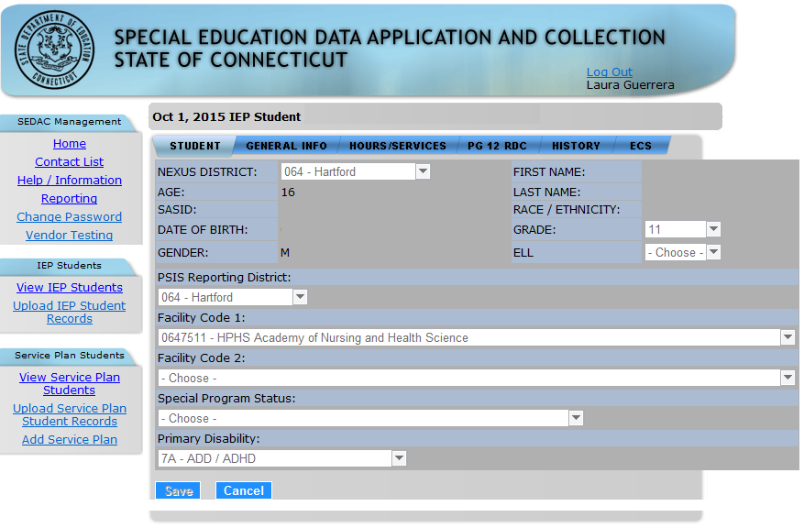

Student Details - Required Meeting Dates and other General Information
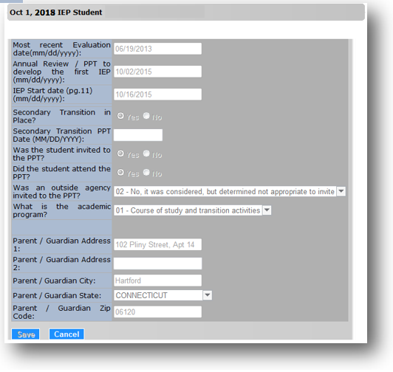

Student Details - School Hours and Services Provided
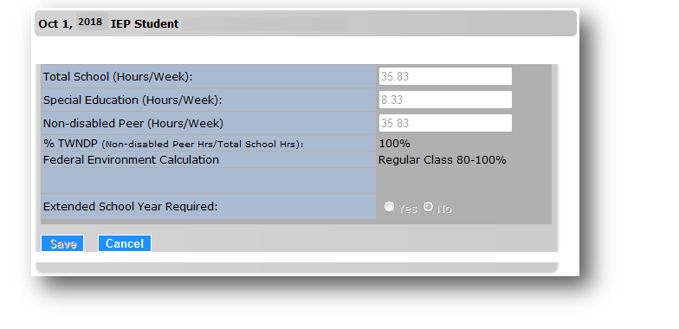

Student Details - Required Data Collection - Page 12 of the IEP / ED620 form
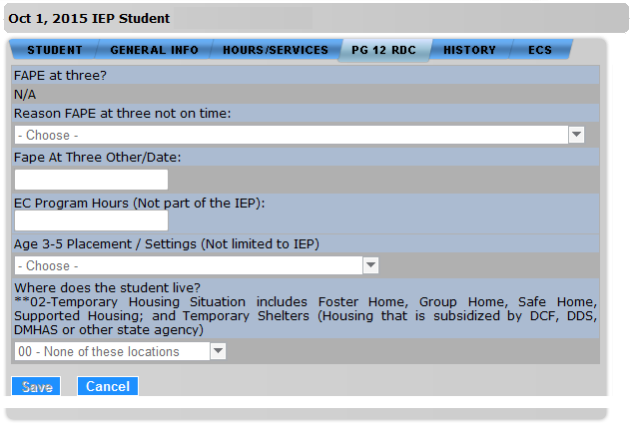

Student Details - SEDAC History Snapshots from Previous Collection Periods

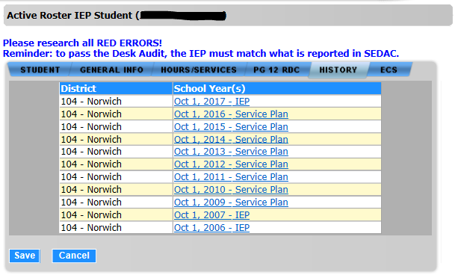

SEDAC and PSIS Data Fields
Following is a list of fields and guidance for reporting data for your students with disabilities.
Note: Fields are presented in the order as displayed on SEDAC screens.
Nexus District | The Nexus District is the district that has the legal responsibility to identify, educate and pay for a student with disabilities receiving special education or related services under IDEA. Generally, nexus means the town where the student’s parent(s) reside (and pay taxes).  Exceptions  Districts considered to be the NEXUS DISTRICT for students attending their schools:  - Connecticut Technical Education and Career System (CTECS)  - Department of Corrections (USD1)  - Department of Children and Families (USD2)  - Department of Mental Health and Addiction Services (DMHAS)  - OPEN Choice (Receiving District)  How does the NEXUS DISTRICT affect SEDAC?  - To be reported in the SEDAC Active Roster for your NEXUS DISTRICT, the IEP student must have a NEXUS DISTRICT ENTRY DATE and no NEXUS EXIT DATE for your district in PSIS Registration.  - To be reported in the SEDAC October 1 Child Count for your NEXUS DISTRICT, the IEP student must have a NEXUS DISTRICT for your district and SPECIAL EDUCATION indicator of Y-YES in the PSIS October Collection. This determines the list of students displayed for your district.  - For Services Plan student, prior to reporting in SEDAC the district where the private school is located must register and unregister the student in PSIS Registration so that their town is listed as Nexus District. Once the student is registered/unregistered the district may add the student to SEDAC.
Nexus District | Rules  - During SEDAC Active Roster, IEP students NEXUS DISTRICT (NEXUS DISTRICT EXIT DATE must be blank) is updated nightly from PSIS Registration  - During SEDAC October 1 Child Count, IEP students NEXUS DISTRICT is updated nightly from PSIS October Collection  - During SEDAC Active Roster upload, matching SASID and NEXUS DISTRICT are located in PSIS Registration  - During SEDAC October 1 Child Count upload, matching SASID and NEXUS DISTRICT are located in PSIS October Collection  - If no match found in PSIS, system will skip upload record and SEDAC record will not be created or updated  - If match found in PSIS, the system will compare LAST NAME, DATE OF BIRTH and FACILITY CODE 1  - If no match, the system will skip upload record and SEDAC record will not be created or updated  Values  - Nexus Districts include districts 001-219, 336, 337, 347 and 900  Source  - Always verify SEDAC displayed values coincide with PSIS and the data recorded on the ED620 form / IEP page 1  - IEP Students - Displayed from PSIS:  - PSIS Registration during SEDAC Active Roster  - PSIS October Collection during SEDAC October Collection  - Services Plan Students – Displayed from PSIS Registration
Age  Screen Label:  During SEDAC Active Roster  AGE: (age as-of October 1 of NEXT collection year)  During SEDAC October Collection  AGE: (as of October 1) | Calculated value of a student’s age. This age drives the need for specific fields to be reported or to be of a certain value.  - Sections 300.640, 300.641, 300.642(b), 300.644 and 300.645 of IDEA
Rules
- The DATE OF BIRTH is updated nightly which may affect the AGE calculation
- The AGE calculated during the SEDAC October Collection is as of October 1 of the current school year
  - for IEP Students, uses data from PSIS October Collection
  - for Services Plan Students, uses data from PSIS Registration
- The AGE calculated during SEDAC Active Roster is as of October 1 of NEXT collection year
  - During SEDAC Active Roster, uses data from PSIS Registration
- Edits and required entry of the following fields are based on the calculated AGE:
  - FACILITY CODE 1
  - PRIMARY DISABILITY
  - SECONDARY TRANSITION IN PLACE
  - WAS THE STUDENT INVITED TO THE PPT
  - DID THE STUDENT ATTEND THE PPT
  - WAS AN OUTSIDE AGENCY INVITED TO THE PPT
  - FAPE AT 3
  - AGE 3-5 PLACEMENT SETTING
  - EC PROGRAM HOURS (NOT PART OF THE IEP)
Values
- N/A
Source
- Calculated by SEDAC

SASID | The State Assigned Student Identifier (SASID) established in the PSIS Registration system for your student.  This is a unique 10-digit numeric code assigned to each student. Reporting in the field conforms to PSIS Registration rules. All students must have a SASID assigned to be reported in SEDAC (including Services Plan students).
SASID | Rules  - SASID must be assigned to a student before entry to SEDAC.  - During SEDAC Active Roster upload, matching SASID and NEXUS DISTRICT are located in PSIS Registration  - During SEDAC October 1 Child Count upload, matching SASID and NEXUS DISTRICT are located in PSIS October Collection  - If no match found in PSIS, system will skip upload record and SEDAC record will not be created or updated  - If match found in PSIS, the system will compare LAST NAME, DATE OF BIRTH and FACILITY CODE 1  - If no match, the system will skip upload record and SEDAC record will not be created or updated  Values  - N/A  Source  - Always verify SEDAC displayed values coincide with PSIS and the data recorded on the ED620 form / IEP page 1  - IEP Students - Displayed from PSIS:  - PSIS Registration during SEDAC Active Roster  - PSIS October Collection during SEDAC October Collection  - Services Plan Students – Displayed from PSIS Registration
Date Of Birth | Student’s date of birth.
Date Of Birth | Rules  - The DATE OF BIRTH is updated nightly from PSIS  - Upload files  - If SASID and NEXUS DISTRICT matched, then LAST NAME, DATE OF BIRTH and FACILITY CODE 1 must also match in PSIS.  - If no match is found, SEDAC will skip this record.  Values  - MMDDYYYY, where MM is Month, DD is Day, YYYY is Year  Source  - Always verify SEDAC displayed values coincide with PSIS and the data recorded on the ED620 form / IEP page 1  - IEP Students - Displayed from PSIS:  - PSIS Registration during SEDAC Active Roster  - PSIS Registration during SEDAC October Collection  - Services Plan Students – Displayed from PSIS Registration
Gender | Gender is captured from PSIS Registration for the use in Child Count Verification and Federal Reporting requirements.  - Section 300.646 of IDEA  - Sections 300.640, 300.641, 300.642(b), 300.644, 300.645 of IDEA
Gender | Rules  - N/A  Values  - N/A  Source  - Always verify SEDAC displayed values coincide with PSIS and the data recorded on the ED620 form / IEP page 1  - IEP Students - Displayed from PSIS:  - PSIS Registration during SEDAC Active Roster  - PSIS Registration during SEDAC October Collection  - Services Plan Students – Displayed from PSIS Registration
First Name | The student’s legal first name.
First Name | Rules  - N/A  Values  - N/A  Source  - Always verify SEDAC displayed values coincide with PSIS and the data recorded on the ED620 form / IEP page 1  - IEP Students - Displayed from PSIS:  - PSIS Registration during SEDAC Active Roster  - PSIS October Collection during SEDAC October Collection  - Services Plan Students - Displayed from PSIS Registration
Last Name | The student’s legal last name.
Last Name | Rules  - The LAST NAME is updated nightly from PSIS  - Dash, period, space and apostrophe are allowed  - When adding a Services Plan student, the LAST NAME entered must match the NAME for this SASID in PSIS Registration and this student must be in your ASSIGNED NEXUS DISTRICT.  - During upload, used for identification and verification only  - Once SASID and NEXUS DISTRICT are matched, the LAST NAME is used for verification that the correct student is located.  - If no match, the system will skip upload record and SEDAC record will not be created or updated  - During SEDAC Active Roster, IEP students DISTRICT EXIT DATE must be blank in PSIS Registration  Values  - N/A  Source  - Always verify SEDAC displayed values coincide with PSIS and the data recorded on the ED620 form / IEP page 1  - For new IEP Students - Displayed from PSIS:  - PSIS Registration during SEDAC Active Roster  - PSIS October Collection during SEDAC October  - For new Services Plan Students - Displayed from PSIS Registration
Race / Ethnicity | The PSIS designation of the student’s race and ethnicity.  - Section 300.646 of IDEA  - Sections 300.640, 300.641, 300.642(b), 300.644, 300.645 of IDEA  For Federal reporting requirements aggregate data will be reported using one of the seven aggregate reporting categories. These reporting categories are:  - Hispanic/Latino of any race,  - For individuals who are Non-Hispanic/Latino  - American Indian or Alaska Native  - Asian  - Black or African American  - Native Hawaiian or Other Pacific Islander  - White  - Two or more races
Race / Ethnicity | Rules  - PSIS ENTRY DATE must be after July 1, 2010  Values  - 01-American Indian/Alaskan Native  - 02-Asian  - 03-Black/African American  - 04-White (non-Hispanic)  - 05-Hispanic/Latino of any race  - 06-Native Hawaiian/Other Pacific Islander  - 07-Two or more races  Source  - IEP Students - Displayed from PSIS  - PSIS Registration during SEDAC Active Roster  - PSIS Registration during SEDAC October Collection  - Services Plan Students - Displayed from PSIS Registration
Grade | Report the grade in which the student is enrolled.  When in doubt, check the student’s services plan. After checking the services plan, if you are still unable to make a determination, report the age-appropriate grade for the student. Age-appropriate grade is defined by the “1/1 rule.” That is: if the student is age six by January 1, report him/her in grade 01; if the student is age nine by January 1, report him/her in grade 04; if the student is age thirteen by January 1, report him/her in grade 08; etc.
Grade | Rules  - The GRADE is updated nightly from PSIS for IEP students  - Available for selection in SEDAC for Services Plan students only  - If AGE 3-5 PLACEMENT/SETTING is 06-Service Provider Location (Itinerant Services), GRADE must be PK or P3  Values  - 01 includes transitional first graders  - 01 through 12  - KE-Kindergarten, Extended Day - Programs greater than 2 ½ hours and less than a full day.  - KF-Kindergarten, Full Day - Programs comparable in length to general elementary education duration.  - KH-Kindergarten, Half Day - Programs of approximately 2 ½ hours duration per day.  - P3-Prekindergarten students who are three years of age and who will most likely remain in Pre-K next year. SDE treats these students the same as PK. This status is optional.  - PK-Prekindergarten. If not P3, this is the default for Pre-K.  Source  - Always verify SEDAC displayed values coincide with PSIS and the data recorded on the ED620 form / IEP page 1  - IEP Students - Displayed from PSIS  - PSIS Registration during SEDAC Active Roster  - PSIS October Collection during SEDAC October Collection  - For Services Plan Students Only - Entered in SEDAC
English Language Learner (ELL) | An ELL student has a dominant language other than English and the LEA has determined that the student is not proficient in English on the basis of language proficiency testing, interviews and a review of the child’s school records.  - Sections 300.640, 300.641, 300.642(b), 300.644, 300.645 of IDEA
English Language Learner (ELL) | Rules  - Available for selection in SEDAC for Services Plan students only  - ELL is updated nightly from PSIS for IEP students  Values  - Y-Yes  - N-No  Source  - Always verify SEDAC displayed values coincide with PSIS and the data recorded on the ED620 form / IEP page 1 and 10  - IEP Students - Displayed from PSIS  - PSIS Registration during SEDAC Active Roster  - PSIS October Collection during SEDAC October Collection  - Services Plan Students Only - Entered in SEDAC
PSIS Reporting District | The reporting district is the district in which the student is currently registered.  Including:  - Public Schools  - Public schools within your district  - OPEN Choice students attending schools within your district  - Approved Private Special Education Programs (APSEPs)  - Residential facilities  - Out-of-state schools  - Students placed in municipal detention centers;  - Students placed in Transition/Vocational Service Provider (TVSP) Programs  - Quasi-Public - Endowed and Incorporated Academies  - Charter Schools  - Regional Education Service Center (RESC)  - Connecticut Technical Education and Career System (CTECS)  - Department of Corrections (USD1)  - Department of Children and Families (USD2)  - Department of Mental Health and Addiction Services (DMHAS)  For example, a student may live in Town A and attend school in Town B. Town A’s district is the NEXUS DISTRICT, while Town B is the REPORTING DISTRICT.  For Parentally Placed Private School Children being serviced via a Services Plan, their REPORTING DISTRICT is the district in which the not-for-profit facility is located.
PSIS Reporting District | Rules  - For display purposes only  - The REPORTING DISTRICT is updated nightly from PSIS  Values  - N/A  Source  - Always verify SEDAC displayed values coincide with PSIS and the data recorded on the ED620 form / IEP page 1  - IEP Students - Displayed from PSIS  - PSIS Registration during SEDAC Active Roster  - PSIS October Collection during SEDAC October Collection  - Services Plan Students - Displayed from PSIS Registration
Facility Code 1 | Seven digit code of the school attended by the student.  This field consists of three separate fields in PSIS.  - District Code - first three digits  - School Code - second two digits  - Institution Code - last two digits
Facility Code 1 | Rules  - The FACILITY CODE 1 is updated nightly from PSIS  - Upload files use your SEDAC user’s assigned district, which must match the student’s current PSIS NEXUS DISTRICT.  - If SASID and NEXUS DISTRICT matched, then LAST NAME, DATE OF BIRTH and FACILITY CODE 1 must also match in PSIS.  - If no match is found, SEDAC will skip this record.  - Online entry allowed for Services Plans  - For Services Plan Students report the private school the student attends, regardless of where they receive special education services.  - K-12 Districts without a high school and student’s GRADE is higher than 8, specify a designated high school (as reported in Education Directory).  - When a preschool age student is receiving itinerant services in the home use the school they would otherwise attend once entering Kindergarten for FACILITY CODE 1  - Rule in PSIS - beginning with the 2017-18 school year, a check was implemented to ensure only grade 12 students are reported in Transition Programs in Facility Code 1.  Values  - Connecticut Public School Codes - PSIS Data Table A at  http://www.csde.state.ct.us/public/psis/downloads.asp  Source  - Always verify SEDAC displayed values coincide with PSIS and the data recorded on the ED620 form / IEP page 1  - IEP Students - Displayed from PSIS:  - PSIS Registration during SEDAC Active Roster  - PSIS October Collection during SEDAC October Collection  - Services Plan Students - Entered in SEDAC
Facility Code 2 | Other facility attended by student.
Facility Code 2 | Rules  - For display purposes only  Values  - Connecticut Public School Codes - PSIS Data Table A at  http://www.csde.state.ct.us/public/psis/downloads.asp  Source  - Verify SEDAC displayed values from PSIS coincide with the data recorded on the ED620 form / IEP page 1  - IEP Students - Displayed from PSIS  - PSIS Registration during SEDAC Active Roster  - PSIS October Collection during SEDAC October Collection  - Services Plan Students - Entered in SEDAC
Special Program Status | This field further explains student status that is associated with Facility Code 1 but cannot be determined based solely on Facility Code 1. In the majority of cases, Special Program Status Code identifies a student with a specific program, which allows the CSDE to determine a student’s grant impact (e.g., Vocational Agriculture, Magnet, and OPEN Choice). Other status options reportable via Special Program Status Code include truancy, dual enrollment status and detention center placement.
Special Program Status | Rules  - IEP Only  - The SPECIAL PROGRAM STATUS is updated nightly from PSIS October Collection  - Since PSIS Registration does not contain this field, it is available for selection when the system is in SEDAC Active Roster  - Any updates to this field, made in SEDAC are overwritten by values from PSIS October Collection when it becomes available  - If this field is not specified during SEDAC Active Roster, then dependent edits cannot be processed and may produce inappropriate results  - During SEDAC October Collection  - For IEP students, the default display of this field is from PSIS October Collection and cannot be changed  Values  See Appendix for descriptions of each of the following:  - 00-N/A  - 01-Vo-Ag  - 02-OPEN Choice  - 03-Magnet  - 04-Interdistrict Coop  - 05-Designated High School  - 06-Vo-Ag @ Designated High School  - 07-Bristol Technical Education Center  - 08-Homebound  - 09-Detention Center  - 10-2 Facilities with IEP  - 11-Vo-Ag with IEP (2 Facilities)  - 12-OPEN Choice with IEP at Private Facility  - 13-Magnet with IEP (2 Facilities)  - 14-Interdistrict Coop with IEP (2 Facilities)  - 15-Designated High School with IEP (2 Facilities)  - 16-Vo-Ag at Designated High School with IEP (2 Facilities)  - 17-Bristol Technical Education Center with IEP (2 Facilities)  - 18-Homebound with IEP (2 Facilities)  - 20-To be used for truant students where three conditions are met  - 21-Reserved for future use  - 22-OPEN Choice with IEP at other Public School District (including RESC)  - 23-Detention Center and State-approved full-time Magnet School Program  - 32-Detention Center and OPEN Choice  Source  - IEP Students  - Pull-down enabled during SEDAC Active Roster  - Displayed from PSIS October Collection during SEDAC October Collection  - Services Plan Students – Not required
Primary Disability | The disability which is most indicative of the student’s primary disability. Use one of the disabilities eligible for special education services under IDEA or Connecticut statutes.  - SPP Indicators 4B, 9, 10  - Section 300.8 of IDEA  - Sections 300.640, 300.641, 300.642(b), 300.644, 300.645 of IDEA  - For suspension and expulsion data - 20 U.S.C. 1416(a)(3)(A); 1412(a)(22)  - Connecticut General Statute, Section 10-76 (a)(5)(c)
Primary Disability | Rules  - IEP or Services Plan  - PRIMARY DISABILITY cannot be 15-Developmental Delay if AGE 6 or older  - If 15-Developmental Delay if AGE 6 or older, citation is issued during SEDAC October Collection  - district must immediately hold PPT meeting to correct noncompliance (for more information refer to the Step by Step Procedures document)  - Administrative overrides allowed during SEDAC October Collection  Values  - 01-Intellectually Disabled  - 02-Hearing Impairments  - 03-Speech / Language Impairments  - 04-Visual Impairments  - 05-Emotional Disturbances  - 06-Orthopedic Impairment  - 07-Other Health Impairments  - 7A-ADD / ADHD  - 08-Learning Disabilities  - 8A-Specific Learning Disabilities/Dyslexia  - 09-Deaf-Blindness  - 10-Multiple disabilities  - 11-Autism  - 12-TBI  - 15-Developmental Delay (3-5)  Source  - ED620 form / IEP Page 1
Most Recent Evaluation Date | This date represents one of the following:  - When the student was first evaluated to determine eligibility for special education and related services by your PPT  - The most recent evaluation to determine if the student remains eligible for special education and related services. This date does not refer to the date that a student is tested but rather, to the date that a PPT reviewed evaluation results and made a decision regarding eligibility for special education services.  - The documented date the parent and district agreed to waive the reevaluation.  Note: A reevaluation cannot be held more than 3 years, to the day, from the last reevaluation date. There will be no justifications allowed for the reevaluation not being held within the 3 year timeline.  - Section 300.303 of IDEA  - Section 300.324 (b)(1)(i) of IDEA  - Initial Evaluations - Section 614(a)(1)(A) of IDEA  - Reevaluations - Section 614(a)(2)(B) of IDEA
Most Recent Evaluation Date | Rules  - IEP or Services Plan  - Administrative overrides allowed during SEDAC October Collection  - Cannot be earlier than 36 months before October 1  - If more than 36 months before October 1 of this collection year, citation is issued during SEDAC October Collection  - district must immediately hold PPT meeting to correct noncompliance (for more information refer to the Step by Step Procedures document)  - If after 3 years from the last reevaluation date, citation is issued during SEDAC October Collection  - Cannot be a future date  - If MOST RECENT EVALUATION DATE is before or on the DATE OF BIRTH plus 3 years, FAPE AT THREE? is calculated and set to a value of Met.  - If MOST RECENT EVALUATION DATE is after the DATE OF BIRTH plus 3 years, FAPE AT THREE? is calculated and set to a value of Not Met and a REASON FAPE AT THREE NOT ON TIME is required.  Values  - Date (MMDDYYYY)  Source  - ED620 form / IEP Page 1 when REASON FOR MEETING is  - Determine Continuing Eligibility
Annual Review/PPT To Develop The First IEP | This date represents one of the following:  - When the student was first evaluated to determine eligibility for special education and related services by your PPT  - The date of the annual review of an IEP that reviews the educational progress and special education placement of a student.  - Section 300.324 (b)(1)(i) of IDEA  - Development of IEP; Agreement - Section 614(d)(3)(D) of IDEA  - Review and revision of IEP - Section 614(d)(4)(i) of IDEA  - Multi-year IEP demonstration - Section 614(d)(5) of IDEA
Annual Review/PPT To Develop The First IEP | Rules  - IEP or Services Plan  - Administrative Overrides allowed during SEDAC October Collection  - Cannot be 365 days before October 1  - If more than 365 days before October 1 of this collection year, citation is issued during SEDAC October Collection  - district must immediately hold PPT meeting to correct noncompliance (for more information refer to the Step by Step Procedures document)  - If after October 1 of this collection year because the previous Annual Review was out of compliance and the district was correcting noncompliance, citation is issued during SEDAC October Collection  - Cannot be a future date  - Must be before IEP START DATE (PG. 11)  Values  - Date (MMDDYYYY)  Source  - ED620 form / IEP Page 1 when REASON FOR MEETING is  - Determine Eligibility  - Conduct Annual Review
IEP Start Date  (PG. 11) | Specific special education and related services may begin at different times; the IEP START DATE is for the service with the most recent start date prior to October 1 when the most current IEP is implemented for data being collected as of October 1. We recognize there will be some cases where an Annual Review is held the last week of September, or later, to correct noncompliance with the Annual Review and the IEP START DATE will be after October 1. Therefore, the IEP START DATE after October 1 is allowed and will not result in an error.  The IEP START DATE entered in SEDAC is the most recent START DATE for the services found on page 11 of the IEP under the Start Date column.  Typically, the start date on page 11 of the IEP is a minimum of 5 to 10 school days from the date of the development of the IEP due to prior written notice procedures which allow a district 5 days to mail an IEP to a parent and a parent 5 days to consider IEP prior to implementation. However, you could note in your minutes that the changes will be implemented immediately and parents are aware of their right to 5 days of prior written notice.  - Section 300.323(c)(2) of IDEA
IEP Start Date  (PG. 11) | Rules  - IEP or Services Plan  - Must be on or after the ANNUAL REVIEW/PPT TO DEVELOP THE FIRST IEP  Values  - Date (MMDDYYYY)  Source  - START DATE of most recent service from ED620 form / IEP Page 11
Examples:
The scenarios provided here are guidance for entry of an appropriate date and how the date relates to the Start Date on page 11 of the IEP.

Scenario 1 - Student’s initial identification:
Student’s initial identification (eligibility determination) is made at a PPT meeting on March 3; the student is found to be eligible for special education and related services. An IEP is developed at the March 3rd meeting. The start date on page 11 of the IEP is 5 school days from the date of the development of the IEP.
• Most Recent Evaluation Date - 03/03
• Annual Review/PPT to develop the first IEP - 03/03
• IEP Start Date (pg. 11) - approximately 03/08

Scenario 2 - Annual Review - full calendar year:
Student has an Annual Review on March 3. This Annual Review IEP is developed to cover 1 full calendar year. Implementation of the IEP is March 8. This date is the start date on page 11 of the IEP.
• Annual Review/PPT to develop the first IEP - 03/03
• IEP Start Date (pg. 11) - approximately 03/08

Scenario 3 - Annual Review - spans 2 different school years; goals and service delivery are different:
Student has an Annual Review on March 3 that spans 2 different school years and two different grade levels, where the goals and service delivery are different. Since we are collecting the data as of October 1:

On Page 11 services are listed as follows:
Service | Frequency | Start Date | End Date
Resource | 2.0 hours | 3/8 | 6/13 (last day of current SY)
Resource | 3.0 hours | 8/27 (1st day of the next SY)

• Annual Review/PPT to develop the first IEP - 03/03
• IEP Start Date (pg. 11) - 08/27

Scenario 4 - Review / Revise IEP (Program Review):
Student has an Annual Review on March 3 with a start date of March 8. School starts and we need to revise the IEP so we hold a program review on September 15. New implementation date becomes September 20; this is the start date on page 11.

On Page 11 services are listed as follows:
Service | Frequency | Start Date
Resource | 2.0 hours | 9/20

• Annual Review/PPT to develop the first IEP - 03/03
• IEP Start Date (pg. 11) - 09/20

Scenario 5 - Student moves to our district from another Connecticut district:
Student moves to our district from another Connecticut district with an active IEP and the annual review was conducted on March 3 (by other district) with a start date of March 8 on page 11. When the student enrolls in our district with an active IEP we grant services immediately based on the other district’s IEP. On September 15 we hold a program review to develop an IEP with a start date of September 20.

• Annual Review/PPT to develop the first IEP - 03/03
• IEP Start Date (pg. 11) - 09/20

Scenario 6 - Student moves to our district from out of state:
When a student moves to our district with an out of state active IEP we grant services immediately based on the out of state IEP and hold a PPT ASAP. On first day of school student begins receiving special education services based on out of state IEP. District holds program review to develop this student’s IEP on 9/15 with a start date of 9/20.

• Annual Review/PPT to develop the first IEP – use the other state’s Annual Review date
• IEP Start Date (pg. 11) - 09/20

When a student enters from out of state you must determine eligibility within a reasonable amount of time within entrance to the state. From the time they enter and the time you conduct eligibility you must make a good faith effort to implement the IEP from the other state.

Secondary Transition In Place | This includes Post-School Outcome Goal Statements (PSOGS) and Secondary Transition Measurable Annual Goals and Objectives being in place. Transition planning and related goals and objectives are an integral part of the IEP that was in effect when the student turned 16 14, or earlier if determined appropriate by the PPT, and annually thereafter. This response is multifaceted and should be answered using information found on pages 6 and 7 of the IEP. Students who are parentally placed in private schools and who have services plans are not required to have transition goals and services.  Section 300.320(b) of IDEA  Beginning not later than the first IEP to be in effect when the child turns 16 14, or younger if determined appropriate by the IEP Team, and updated annually thereafter, the IEP must include:  - Appropriate measurable postsecondary goals based upon age-appropriate transition assessments related to training, education, employment and, where appropriate, independent living skills;  - The transition services (including courses of study) needed to assist the child in reaching those goals; and  - Beginning not later than one year before the child reaches the age of majority under State law, a statement that the child has been informed of the child’s rights under Part B, if any, that will transfer to the child on reaching the age of majority under §300.520 [see 20 U.S.C. 1415(m)].  - SPP Indicator 13  - Compliance is determined by the answers to SECONDARY TRANSITION IN PLACE, STUDENT INVITED TO PPT and OUTSIDE AGENCY INVITED TO PPT questions. All three must be Y-Yes to be in compliance.  - Section 300.320(b)(c) of IDEA  - Section 300.305(e)(3) of IDEA  In order to answer Yes to this question, all of these steps must be complete:  - IEP page 7 - There must be a minimum of two Page 7 forms. One page 7 will contain a Measurable Annual Goal for Postsecondary Education / Training, and the other page 7 will contain a Measurable Annual Goal for Employment. Check the appropriate boxes at the top of each page indicating which goal the page addresses.  - IEP page 6, item 3 - Age Appropriate Transition Assessment(s) Performed must be filled out.  - IEP page 6, item 6 - Course of Study OR Student Has Completed Academic Requirements must be selected.  Note: If course of study is selected, additional information must be documented on the IEP form.  - IEP page 6, item 5a - Post-School Outcome Goal Statement - Postsecondary Education or Training must be filled out and the check-box for annual goals and related objectives is selected.  - IEP page 6, item 5b - Post-School Outcome Goal Statement - Employment must be filled out and the check-box for annual goals and related objectives is selected.
Secondary Transition In Place | Rules  - IEP Only  - During SEDAC October Collection, required when student is AGE 16 or older or 14 or 15 and the Annual Review (PPT Date) is on or after 7/1/2021 as of October 1  - During SEDAC Active Roster February 2022, required when student is AGE 16 14 or older as of IEP START DATE (PG. 11)  - Optional if AGE of 14 or 15  - Not allowed if younger than AGE of 14  - Administrative Overrides allowed during SEDAC October Collection  - If N-No, citation is issued during SEDAC October Collection  - district must immediately hold PPT meeting to correct noncompliance (for more information refer to the Step by Step Procedures document)  Values  - Y-Yes, in place  - N-No, not in place - requires an Administrative Override  Source  - ED620 form / IEP Pages 6 and 7
Secondary Transition PPT Date | If SECONDARY TRANSITION IN PLACE was N-No, the district is out of compliance and this date must be reported. This is the date the goals were put in place, if they were after the student’s 16th 14th birthday.  - SPP Indicator 13  - Section 300.320(b)(c) of IDEA  - Section 300.305(e)(3) of IDEA
Secondary Transition PPT Date | Rules  - IEP Only  - Hand Entry Only. Must be entered online (field not available in upload)  - Required for entry when student AGE 16 or older or 14 or 15 and the Annual Review (PPT Date) is on or after 7/1/2021 on October 1 of current school year and SECONDARY TRANSITION IN PLACE is N  - Cannot be on or before October 1  - If on or before October 1 of this collection year, select SECONDARY TRANSITION IN PLACE is Yes  - If after October 1 of this collection year, citation is issued during SEDAC October Collection  - Cannot be a future date  Values  - Annual goal created at PPT after age 16 14  Source  - ED620 form / IEP Page 1 when REASON FOR MEETING is  - Transition Planning  - ED620 form / IEP Pages 6 and 7
Student Invited to Attend the PPT | Indicates whether the student was invited to the most recent team meeting.  - SPP Indicator 13  - Compliance is determined by the answers to SECONDARY TRANSITION IN PLACE, STUDENT INVITED TO PPT and OUTSIDE AGENCY INVITED TO PPT questions. All three must be Y-Yes to be in compliance.  - IDEA Section 300.321 (a)(7);(b)
Student Invited to Attend the PPT | Rules  - IEP Only  - Required if Student is AGE 16 or older or 14 or 15 and the Annual Review (PPT Date) is on or after 7/1/2021.  - Optional if AGE is14 or 15  - Not allowed if AGE younger than 14  - If N-No, citation is issued during SEDAC October Collection  - district must immediately hold PPT meeting to correct noncompliance (for more information refer to the Step by Step Procedures document)  Values  - Y-Yes  - N-No  Source  - ED620 form / IEP Page 6
Student Attended the PPT | Indicates whether the student attended the most recent team meeting.
Student Attended the PPT | Rules  - IEP Only  - Required if Student is AGE 16 or older or 14 or 15 and the Annual Review (PPT Date) is on or after 7/1/2021.  - Optional if AGE is14 or 15  - Not allowed if AGE younger than 14  Values  - Y-Yes  - N-No  Source  - ED620 form / IEP Page 6
Outside Agencies Invited to Attend The PPT  Screen Label:  Was an Outside Agency Invited to The PPT? | Indicates whether any outside agencies were invited to attend the most recent team meeting.  - SPP Indicator 13  - Compliance is determined by the answers to SECONDARY TRANSITION IN PLACE, STUDENT INVITED TO PPT and OUTSIDE AGENCY INVITED TO PPT questions. All three must be Y-Yes to be in compliance.  - IDEA Section 300.321(a)(4);(6)
Rules
- IEP Only
- Required if Student is AGE 16 or older or 14 or 15 and the Annual Review (PPT Date) is on or after 7/1/2021.
- Optional if AGE is14 or 15
- Not allowed if AGE younger than 14
- If 04-No, no outside agency was invited, citation is issued during SEDAC October Collection
  - district must immediately hold PPT meeting to correct noncompliance (for more information refer to the Step by Step Procedures document)
Values
- 01-Yes, written consent to invite was obtained
- 02-No, it was considered, but determined not appropriate to invite an outside agency
- 03-No, written consent not provided
- 04-No, no outside agency was invited

Source
- ED620 form / IEP Page 6

Academic Program | Type of program currently in effect for this student, for post-secondary goals and services.  - Sections 300.321(a)(4) and (6) of IDEA
Academic Program | Rules  - IEP Only  - Required if Student is AGE 16 or older or 14 or 15 and the Annual Review (PPT Date) is on or after 7/1/2021.  - Optional if AGE is14 or 15  - Not allowed if AGE younger than 14  Values  - 01-Course of study and transition activities  - 02-Transition goals and services only  Source  - ED620 form / IEP Page 6
Parent/Guardian Address 1 | The address of custodial parent(s).  If the student is in an out-of-home placement, enter the address of the parent/guardian whose address generates your district’s jurisdiction (nexus) on this PARENT/GUARDIAN ADDRESS.  DCF communicates a student’s no-nexus status to the districts, using a DCF 603.  Note: No-nexus means that there is no relationship between a particular student and any Connecticut town. The term no-nexus is not defined in either statute or regulation, but rather has been interpreted by policy of the state.  - SPP/APR 8 Parent Survey  - SPP/APR 14 Exit Survey
Parent/Guardian Address 1 | Rules  - Out-of-home placement,  - Enter the address of the parent/guardian whose address generates your district’s jurisdiction (nexus)  A student is determined to have no nexus if any of these conditions are applicable.  - Parental rights have been terminated  - Enter the DCF Social Worker’s address  - The parent(s) or guardian(s) is deceased  - Enter the DCF Social Worker’s address  - The whereabouts of the parent(s) or guardian(s) are unknown  - Enter the DCF Social Worker’s address  - The parent(s) or guardian(s) does not reside in Connecticut  - Enter the out of state address  - The parent(s) or guardian(s) resides as a patient in a treatment facility and does not maintain a Connecticut residence  - Enter the treatment facility address  - The parent(s) or guardian(s) resides as an inmate in a correction facility and does not maintain a Connecticut residence  - Enter the Correction facility address.  Values  - N/A  Source  - ED620 form / IEP Page 1
Parent/Guardian Address 2 | The address of custodial parent(s).
Parent/Guardian Address 2 | Rules  - N/A  Values  - N/A  Source  - ED620 form / IEP Page 1
Parent/Guardian City | The town or city of custodial parent(s).
Parent/Guardian City | Rules  - N/A  Values  - N/A  Source  - ED620 form / IEP Page 1
Parent/Guardian State | The state of custodial parent(s).
Parent/Guardian State | Rules  - N/A  Values  - N/A  Source  - ED620 form / IEP Page 1
Parent/Guardian Zip Code | The zip code of custodial parent(s).
Parent/Guardian Zip Code | Rules  - N/A  Values  - N/A  Source  - ED620 form / IEP Page 1
Total School (Hours / Week) | The number of hours per week the student is required to be in attendance. Total School Hours/Week includes homeroom, hallway passing time, lunch and recess, etc. If a student’s IEP includes a requirement for an extended day program, the time spent in that program should be included in Total School Hours/Week. If a student’s IEP provides for a shortened school day, then the Total School Hours should accurately reflect the shortened day. Report hours in effect as of October 1.  - SPP Indicator 5  - Section 300.114(a) of IDEA
Total School (Hours / Week) | Rules  - IEP or Services Plan  - Cannot be less than SPECIAL EDUCATION HOURS PER WEEK or NON-DISABLED PEER HOURS PER WEEK  - If AGE 3-5 PLACEMENT/SETTING is:  - 05-Home  - 06-Service Provider Location (Itinerant Services)  - NON-DISABLED PEER HOURS PER WEEK must equal 0  Values  - Valid range: 00.01 - 99.99  Source  - ED620 form / IEP page 11
  Time Converted to Decimals
  5 minutes or 1/12 hour | 0.08
  10 minutes or 1/6 hour | 0.17
  15 minutes or 1/4 hour | 0.25
  20 minutes or 1/3 hour | 0.33
  25 minutes or 5/12 hour | 0.42
  30 minutes or 1/2 hour | 0.50
  35 minutes or 7/12 hour | 0.58
  40 minutes or 2/3 hour | 0.67
  45 minutes or 3/4 hour | 0.75
  50 minutes or 5/6 hour | 0.83
  55 minutes or 11/12 hour | 0.92
  60 minutes or 1 hour | 1.00

Special Education (Hours / Week) | The number of special education hours per week does not include related services hours. Report hours in effect as of October 1.  - Section 300.114(a) of IDEA
Special Education (Hours / Week) | Rules  - IEP or Services Plan  - Cannot be greater than TOTAL SCHOOL HOURS PER WEEK  - If AGE 3-5 PLACEMENT/SETTING is:  - 05-Home  - 06-Service Provider Location (Itinerant Services)  - NON-DISABLED PEER HOURS PER WEEK must equal 0  Values  - Valid range: 00.01 - 99.99  Source  - ED620 form / IEP page 11
Non-disabled Peer (Hours / Week) | The number of hours the student spends with non-disabled students. If special education and related services are provided to the child in the general education classroom, this time should be reflected in this field. Report hours in effect as of October 1.  - SPP Indicator 5  - Section 300.114(a) of IDEA  Note: For additional information refer to the Determination of Time with Non-Disabled Peers for Students with Disabilities memorandum (9/9/15)
Non-disabled Peer (Hours / Week) | Rules  - IEP or Services Plan  - Cannot be greater than TOTAL SCHOOL HOURS PER WEEK  - If AGE 3-5 PLACEMENT/SETTING is:  - 05-Home  - 06-Service Provider Location (Itinerant Services)  - NON-DISABLED PEER HOURS PER WEEK must equal 0  Values  - Valid range: 00.00 - 99.99  Source  - ED620 form / IEP page 11

% TWNDP  Screen Label:  % TWNDP (Non-disabled Peer Hrs/ Total School Hrs) | Time with non-disabled peers (TWNDP) is a percentage calculated value based on the school hours reported.  % TWNDP equals the NON-DISABLED PEER HOURS divided by the TOTAL SCHOOL HOURS multiplied by 100.  - SPP Indicator 5  - Section 300.114(a) of IDEA
Rules
- NON-DISABLED PEER HOURS divided by TOTAL SCHOOL HOURS
- Display only
Values
- Calculated to .000001, but is displayed as rounded to two decimal places
Source
- Calculated by SEDAC
This result is used in categorization of students in the following reports:
- Summary Statistics
- Year to Year Change Report
- Three TWNDP Categories: Students with Disabilities (K-12) Report
- Ten TWNDP Categories: Students with Disabilities (K-12) Report
- Educational Placement of Students with Disabilities (K-12) Report
- Educational Placement of Students with Disabilities (K-12) – Students Report
- Gender of Children with Disabilities by Education Environment (K-12) Report
- Gender of Children with Disabilities by Education Environment (K-12) - Students Report
- Pre-school Student Data Report
- Age of Children with Disabilities by Educational Environment (3-5) Report
- Federal Child Count Certification
- Intellectually Disabled – Aggregate by District Report
- Intellectually Disabled – Student Level by District Report
- All Disabilities – Aggregate by District Report

Federal Environment Calculation | Federally-defined categories for grouping students representing their Educational Environment  For federally-defined TWNDP percentages, students are categorized into the following groups:  - 1-79.000001-100% TWNDP  - 2-40.000001-79% TWNDP  - 3-0-40% TWNDP  - 4-Separate School  - 5-Residential Facility  - 6-Hospital or Homebound  - 7-Correctional Facility  - 8-Parentally Placed in Private School (Services Plan)  - SPP Indicator 5  - Section 300.600(d)(1) of IDEA
Federal Environment Calculation | Rules  - Calculated at time of display when specific data is changed, stored in SEDAC for report production and archival  - Uses %TWNDP calculation as a base for further categorization  - Display only  Values  - N/A  Source  - Calculated by SEDAC
This result is used in categorization of students in the following reports:
- Year to Year Change Report
- Gender of Children with Disabilities by Education Environment (K-12)-Students Report
- Gender of Children with Disabilities by Education Environment (K-12)-Report
- Pre-school Student Data Report
- Intellectually Disabled-Aggregate by District Report
- Intellectually Disabled-Student Level by District Report
- All Disabilities-Aggregate by District Report

Extended School Year Services Required | This field is used to indicate if an extended school year is required for this student.
Extended School Year Services Required | Rules  - IEP or Services Plan  - Required  - Cannot be blank  Values  - Y-Yes  - N-No  Source  - ED620 form / IEP page 11
FAPE at three | Indicates whether each eligible student with disabilities has received a Free Appropriate Public Education (FAPE) by their third birthday. This field is determined when a student is AGE 2 or 3 by comparing MOST RECENT EVALUATION DATE to the DATE OF BIRTH and verifying the meeting date is on or before their third birthday.  Remember: The student’s IEP must be developed and ready to implement on (not after) the child’s third birthday.  Whether this requirement is Met or Not Met is displayed in SEDAC. If it is Not Met, then a reason is required. Selecting a reason does not change the calculated value of FAPE AT THREE; the status remains Not Met.  - SPP Indicator 12  - Section 300.101(b) of IDEA
FAPE at three | Rules  - If the AGE of a student is 2 or 3, the meeting date for the MOST RECENT EVALUATION DATE must be before the student’s 3rd birthday; otherwise FAPE AT THREE is considered not met and the reason this occurred must be reported.  - The STATUS is 4-Correction Needed  - If MOST RECENT EVALUATION DATE is before or on the student’s 3rd birthday, FAPE AT THREE is Met.  - Display Only  Values  - Met  - Not Met  Source  - Calculated by SEDAC  - Record also on ED620 form / IEP page 12  Note: If there are any discrepancies between your recorded answer on this form and the SEDAC calculated value, contact the CSDE SEDAC Data Manager.
Reason FAPE at three not on time | The reason the MOST RECENT EVALUATION DATE meeting was not held by the child’s third birthday. If this was not done, FAPE was not met, and a reason must be documented and reported.  - SPP Indicator 12
Reason FAPE at three not on time | Rules  - IEP or Services Plan  - Hand Entry Only. Must be entered online (field not available in upload)  - Required if FAPE AT THREE is Not Met and the AGE of student is 2 or 3  - FAPE is in noncompliance if Not Met and a REASON of 3-Other is selected  - If 3-Other, citation is issued during SEDAC October Collection  Values  - 1-Late Referral (less than 90 days before 3rd birthday; OR referred after 3rd birthday)  - 2-Parental Choice (requested delay in implementation of IEP)  - 3-Other (when selected the SEDAC user must provide a response in the text box)  - 4-FAPE met via earlier PPT (when selected the SEDAC user must provide the date of initial PPT)  - 5-Child initially found not eligible by age 3 (re-referred to district at a later date)  - 6-Moved into district late  - 7-PPT rescheduled due to weather/emergency (record this under “Other” on page 12)  Source  - ED620 form / IEP page 12

FAPE Reason - Other  Screen Label:  FAPE at three Other / Date | Additional information to support the reason FAPE was not met.  - SPP Indicator 12
Rules
- IEP or Services Plan
- Hand Entry Only. Must be entered online (field not available in upload)
- Enter reason FAPE was not met, if REASON FAPE NOT ON TIME is 3-Other, citation is issued during SEDAC October Collection
- Enter PPT Meeting Date, prior to the student’s third birthday, if REASON FAPE NOT ON TIME is 4-FAPE met via earlier PPT
Values
- N/A
Source
- ED620 form / IEP page 12

EC Program Hours (Not part of the IEP) | The number of hours per week the child participates in an early childhood program which is not provided as a part of the IEP.  - Section 300.114(a) of IDEA
EC Program Hours (Not part of the IEP) | Rules  - IEP or Services Plan  - Required when student AGE 5 or younger or GRADE is PK.  - Otherwise optional  Values  - Valid range: 00.00 - 99.99  Source  - ED620 form / IEP page 12
Age 3-5 Placement/Setting (Not limited to the IEP) | This field indicates if a child attends any early childhood preschool or kindergarten even if the district does not fund the attendance at an early childhood program.  When recording the Placement/Setting (e.g., educational environment) for children 3-, 4- or 5 years of age, the child's planning and placement team (PPT) must select one of six (6) choices that describe a child's educational placement/setting. This information will be collected by the child’s school district to prepare and submit the district's October 1st data to the State Department of Education through SEDAC. The six early childhood placement/setting categories are not intended to solely reflect the educational environment in which children, ages 3 through 5, receive their special education and related services but rather the extent to which children with disabilities participate in educational programs with their peers without disabilities outside of public school. For children with disabilities who do not attend educational programs with peers without disabilities, the placement/setting will reflect only the setting in which children receive their special education and related services.  Note: The order of the categories for children with disabilities ages 3 through 5 do not reflect a continuum from least to most restrictive.  - SPP Indicator 6  - Section 300.116 of IDEA  - Section 300.117 of IDEA  - Section 300.118 of IDEA
Rules
- IEP or Services Plan
- Required when student AGE 5 or younger or GRADE is PK.
- If AGE 3-5 PLACEMENT SETTING is 06-Service Provider Location (Itinerant Services), GRADE must be P3 or PK
- If AGE 3-5 PLACEMENT/SETTING is:
  - 05-Home or 06-Service Provider Location (Itinerant Services)
    - NON-DISABLED PEER HOURS must be zero, and
    - EC PROGRAM HOURS (NOT PART OF THE IEP) must be zero
- AGE 3-5 PLACEMENT/SETTING cannot be 01-Early Childhood Preschool or Kindergarten if the combination of NON-DISABLED PEER (HOURS / WEEK) and EC PROGRAM HOURS (NOT PART OF THE IEP) is 00.00
- If AGE 3-5 PLACEMENT/SETTING is 04-Early Childhood Special Education Program in Residential Facility, WHERE DOES THE STUDENT LIVE must equal 09-Private Residential Facility or 03-Hospital.
Values
- 00-All students AGE 6 or older and not GRADE not PK
- 01-Regular E.C. Preschool or Kindergarten Program
  - includes 50% or more children without disabilities
- 02-E.C. Special Education Program in Separate Class
  - includes less than 50% children without disabilities
- 03-E.C. Special Education Program in Separate School
  - includes less than 50% children without disabilities in a separate school
- 04-E.C. Special Education Program in Residential Facility
  - includes less than 50% children without disabilities in a residential facility
- 05-Home
  - Special education and related services are delivered in the home AND the child is not participating in any program with children without disabilities
- 06-Service Provider Location (Itinerant Services)
  - All special education and related services are delivered at a prescribed location AND the child is not participating in any program with children without disabilities
Source
- ED620 form / IEP page 12
This field is used to present student data on this report:
- Year to Year Change Report

This field and the %TWNDP value are used to present student data on this report:
- Age of Children with Disabilities by Educational Environment (3-5) Report

AGE 3-5 PLACEMENT/SETTING Decision Rules | Before starting, it is helpful to know the definitions of each placement/setting and what factors are to be used in selecting the correct placement/setting code for an individual child. Please note that the order of the placement/setting categories for children with disabilities ages 3 through 5 reflect a Decision Tree and not necessarily a continuum from least to most restrictive.  The Placement/Settings categories for children, ages 3 through 5, are:  The following Decision Rules are a Decision Tree used to select the most appropriate placement/setting for children, ages 3 through 5.  - Start by considering Decision Rule #1 – Does the child spend any time in a program or service where 50% or more of the population consists of students without disabilities? To answer this question districts must consider whether a child participates in an early childhood program outside of their IEP as well as the design of the child’s IEP services.  - If the response is yes, select Early Childhood Preschool or Kindergarten Program;  - If the response is no, consider Decision Rule #2 - Does the child spend any time in a program or service where less than 50% of the population consists of students without disabilities?;  - If the response is yes, select Early Childhood Special Education in a Separate Class;  - If the response is no, consider the next Decision Rule – and so forth until the appropriate placement/setting for a child, ages 3 through 5, has been identified.  Decision Rule #1:  If a child attends any early childhood program that meets the definition that 50% or more of the children in that program are children without disabilities, (including but not limited to the child’s IEP), the school district would select an Early Childhood Preschool or Kindergarten Program.  Early Childhood Preschool or Kindergarten Program - This setting applies when a child is participating in any early childhood program and/or the IEP describes a program/classroom where at least 50 percent or more of the classroom composition consists of children without disabilities. This category includes a child's participation in any early childhood program and is not limited to the program/classroom in which a child receives their special education and related services. Early childhood programs can include but are not limited to the following:  - Head Start Classroom;  - School Readiness Classroom;  - Integrated Classroom (e.g., reverse mainstreaming);  - Charter or Magnet School Classroom;  - Private Preschool Program/Classroom;  - General Education Preschool Classroom offered to 3- and/or 4-year-old children by the Public School; and  - Group/Center-based Child-Care  - Kindergarten Classroom;  - 1st grade Classroom;  Select the placement/setting code, Early Childhood Preschool or Kindergarten Program, even if the child receives their special education and related services in another type of setting. The key to ensuring valid and accurate data is represented by answering yes to whether the child participates in any program with children without disabilities. The determination of whether a child participates in an Early Childhood Preschool or Kindergarten Program is not based upon whether the school district provides and/or purchases an early childhood placement/setting as a part of a child's IEP. Programs or services that provide custodial care, such as home day care, should not be included in the determination. Informal settings such as library groups, Y programs, school-based playgroups or other are not included.  In selecting an Early Childhood Preschool and/or Kindergarten Program, there are two additional pieces of information that must be considered. Each piece of information is related to the amount of time that a child participates in a program where 50% or more of the composition is comprised of children without disabilities. This information will be found in two (2) places on the student’s IEP. Information about whether or not a child participates in an early childhood program OUTSIDE of the public school can be found on page 2 of the IEP which identifies the hours per week that a child participates in an early childhood program. The other place where information can be found is on page 11 of the IEP which identifies the child’s participation with non-disabled peers during a school week. If either page 2 or page 11 of the IEP indicate that a child participates in a program where 50% or more of the class composition consists of typical peers, the placement/setting will be an Early Childhood Preschool and/or Kindergarten Program.  Decision Rule #2:  If the response to Decision Rule #1 is not applicable because the child does not attend an early childhood program or service which includes a population where 50% or more of the class composition consists of children without disabilities, the school district would consider the next setting, which is Early Special Education Program in a Separate Class.  Early Childhood Special Education Program in a Separate Class –This setting applies when a child is not participating in any early childhood program and the IEP describes a program/classroom where the class composition represents that less than 50% of the children are children without disabilities. This placement/setting category includes an integrated classroom where the ratios of children with without disabilities are less than children with disabilities. Included in this placement/setting are classrooms with a less than 50/50 ration that are special education classrooms in public school buildings, trailers or portables inside or outside of public school facilities.  Decision Rule #3  If the responses to Decision Rules #1 and #2 are not applicable, then the school district must determine whether the child attends an Early Childhood Special Education Program in a Separate School.  Early Childhood Special Education Program in a Separate School – This setting applies when a child is not participating in any early childhood program and the IEP describes a classroom composition represents in which less than 50% of the children are children without disabilities and such program/classroom is a Separate School. This placement/setting category includes, for example, facilities such as RESC programs, State-Approved Private Special Education Facilities such as the Foundation School, etc.  Decision Rule #4  If the responses to Decision Rules #1, #2 and #3 are not applicable, then the school district must determine whether the child attends an Early Childhood Special Education Program in a Residential Facility.  Early Childhood Special Education Program in a Residential Facility– This setting applies when a child is not participating in any early childhood program and the IEP describes a program/classroom where the classroom composition represents that less than 50% of the children are children without disabilities and such program/classroom is a Residential Facility. This placement/setting category includes, for example, the American School for the Deaf, Perkins School for the Blind, etc.  Decision Rule #5  If the responses to Decision Rules #1, #2, #3 and #4 are not applicable, the school district must determine whether the child receives their special education and related services at Home.  Home –This setting applies when a child is not participating in any early childhood program and the IEP describes that special education and related services are provided at home, report the child’s setting as Home.  Decision Rule #6  If the responses to Decision Rules #1, #2, #3, #4 and #5 are not applicable, the school district must determine whether the child receives their special education and related services in a Service Provider Location (Itinerant Services).  Service Provider Location (Itinerant Services) - This setting applies when a child is not participating in any early childhood program and the IEP describes that special education and related services are provided in a Service Provider Location. The child’s services may be provided individually or in a small group of children with disabilities. Services can be provided in a school, hospital, or other settings.
  Placement/Setting | Definition
  - Early Childhood Preschool or Kindergarten Program | A program that includes a population of 50% or more of children without disabilities
  - Early Childhood Special Education Program in a Separate Class | A program that includes a population of less than 50% of children without disabilities
  - Early Childhood Special Education Program in a Separate School | A program that includes a population of less than 50% of children without disabilities in a separate school
  - Early Childhood Special Education Program in a Residential Facility | A program that includes a population of less than 50% of children without disabilities in a residential facility
  - Home | Special education and related services are delivered in the home AND the child is not participating in any program with children without disabilities
  - Service Provider Location [Itinerant Services] | All special education and related services are delivered at a prescribed location AND the child is not participating in any program with children without disabilities
Where Does The Student Live | Does the student live at any of the following locations?
Where Does The Student Live | Rules  - IEP or Services Plan  - If WHERE DOES THE STUDENT LIVE = 09-Private Residential Facility. DM Organization Type=Nonpublic Elementary and Secondary Schools (21)  - If SPECIAL PROGRAM STATUS CODE is 08-Homebound, WHERE DOES THE STUDENT LIVE? must be 00-Default or 02-Temporary Housing Situation: Foster Home, Group Home, Safe Home, Supported Housing; and Temporary Shelters (Housing that is subsidized by DCF, DDS, DMHAS or other state agency)  Values  - 00-None of these locations  - 02-Temporary Housing Situation: Foster Home, Group Home, Safe Home, Supported Housing; and Temporary Shelters (Housing that is subsidized by DCF, DDS, DMHAS or other state agency)  - 03-Hospital  - 09-Private Residential Facility  Source  - ED620 form / IEP page 12

District Reports
The data collected within this application is analyzed and displayed for each district in a variety of vantage points.
The reports available in SEDAC aid the district in management of their data collection process, identifying students that need further information and follow-up, and identifying non-compliance issues.

District Reports
IEP Students
View / Download IEP Students (used for searching & analysis)
Services Plan Students
View / Download Services Plan Students (used for searching & analysis)
Child Count Verification Reports
Summary Statistics
Year to Year Change Report
Count and Percent of Students (K-12) by Racial/Ethnic Group within Disability Subgroups
Three TWNDP Categories: Students w/ Disabilities (K-12)
Ten TWNDP Categories: Students w/ Disabilities (K-12)
Educational Placement of Students with Disabilities (K-12) **Update to ages 6-21 and 5 yr. olds Not in PK or P3 (5 y.old and in KF, FH, KE, or 1 or 2)
Educational Placement of Students with Disabilities (K-12) - Students **Update to ages 6-21 and 5 yr. olds Not in PK or P3 (5 y.old and in KF, FH, KE, or 1 or 2)
Gender of Children with Disabilities by Education Environment (K-12)
Gender of Children with Disabilities by Education Environment (K-12) - Students
Preschool Student Data **Update to ages 3 & 4 and 5 yr. olds in PK or P3
Age of Children with Disabilities By Educational Environment (3-5) **Update to ages 3 & 4 and 5 yr. olds in PK or P3
Indicator 13 IEP Goals and Transition Services Summary Report (16-21) **Update 14-21 [this year will only list the 14/15 year old kids with AR's on or after 7/1 where district acknowledged citation]
Indicator 13 IEP Goals and Transition Services (16-21) – Students **Update 14-21 [this year will only list the 14/15 year old kids with AR's on or after 7/1 where district acknowledged citation]
Federal Child Count Certification
Mandatory Off-cycle Reports
All Disabilities - Aggregate by District
Summary of Performance (SOP/ED635) - Contact Information Collection
Due Process Hearing Requests - Resolution Meetings
Birth to Three Notification

Data Cleaning
Potential Noncompliance
Misreported Student(s) in SEDAC Certified Oct 1 Child Count
Student(s) Missing from SEDAC Certified Oct 1 Child Count
Case Management
View Orphan Records
Total School Hours Over 40 Hours
ED166 Primary Disability Update
Student Missing Nexus Information
Students with less than 25 Total School Hrs/Wk (KF-12)
Records that did NOT Upload
Students with less than .10 special education hours/week
Managing Student Data
Grade Twelve Report
Developmental Delay (5 yr olds)
Secondary Transition (15 yr olds)
Secondary Transition Report: Primary Disability is Autism (13 Yr Olds)
Annual Reviews DUE (based on previous SEDAC Oct.)
Reevaluations DUE: (based on previous SEDAC Oct.)
Reevaluations & Annual Reviews DUE: (based on previous SEDAC Oct.)
Noncompliance Summary Report
Summary of Noncompliance in SEDAC Data Reporting
Statewide Reports
Prevalence Rate : October 1, YYYY
Prevalence Rate within Special Education : October 1, YYYY
Significant Disproportionality Summary Report
Note: All reports include the Services Plan and IEP students within the selected or assigned NEXUS DISTRICT.
Reference: Sample Child Count Verification reports may be found in the Appendix.

IEP Students and Services Plan Students
These reports are designed for research and analysis purposes. Districts may download files of SEDAC data for all students with disabilities.
The reports in this group represent:
- SEDAC students, including IEP or SP (depending on report selected), all GRADES, all AGES, with a SEDAC STATUS of 1-Ready to Certify, 3-Enter Data or 4-Needs Correction.
Source of data:
- SEDAC Archive Data (if prior year selected)
- SEDAC October Collection (if current year selected)
- SEDAC Active Roster (if Active Roster selected)
- PSIS Registration (during SEDAC Active Roster)
- PSIS October Collection (during SEDAC October Collection).

Report Format: MS Excel file (*.xls)

View / Download IEP [Services Plan] Students (used for searching & analysis)
The Searching & Analysis format provides all collected and calculated fields for use in research and analysis of a student’s status.

Child Count Verification Reports
Reports in this section are designed for superintendent and director of special education review purposes and official submission. These reports allow districts to verify that students are accurately categorized for federal reporting prior to submission of the official child count file to the federal government.
Multiple reports covering all major data elements have been designed in district level aggregate form. Additionally two reports provide student level data that mirror the aggregate report basis.
The reports in this group represent:
- SEDAC students, including IEP and SP, all GRADES and AGES (except where otherwise stated), with a SEDAC STATUS of 1-Ready to Certify or 4-Needs Correction.
- Does not include STATUS 3-Enter Data.
Source of data:
- SEDAC Archive Data (if prior year selected)
- SEDAC October Collection (if current year selected)
- SEDAC Active Roster (if Active Roster selected)
- PSIS Registration (during SEDAC Active Roster)
- PSIS October Collection (during SEDAC October Collection).

Summary Statistics
The purpose of this report is to capture the total number of students with disabilities and to present in various data groupings for verification of submitted data.
The number of students is presented in 7 groups and categorized by:
- Students by Age
  - Total number of students of all ages reported in SEDAC for this district
  - Number of students, ages 3 to 5 or 6 to 21
  - Includes all ages, where students below the age of 3 are grouped with age 3 counts and students above the age of 21 are grouped with age 21 counts
  - Does not include STATUS 3-Enter Data.
- Students by Grade
  - GRADE of PK or P3
  - GRADE of K-12
  - Includes all ages
- Students by Race / Ethnicity
For Federal reporting requirements aggregate data will be reported using one of the seven aggregate reporting categories. These reporting categories are:
- Hispanic/Latino of any race,
- For individuals who are Non-Hispanic/Latino
  - American Indian or Alaska Native
  - Asian
  - Black or African American
  - Native Hawaiian or Other Pacific Islander
  - White
  - Two or more races
  - Includes all ages
- Special Education Type
  - IEP or Services Plan
  - Includes all ages
- Gender
  - Includes all ages
- Disability Type
  - Intellectually Disabled
  - Hearing Impairment
  - Speech / Lang. Impairment
  - Visual Impairment
  - Emotional Disturbance
  - Orthopedic Impairment
  - Other Health Impairment
    - Includes PRIMARY DISABILITY of 07-Other Health Impairments and 7A-ADD / ADHD
  - Learning Disabilities
    - Includes PRIMARY DISABILITY of 8A-Specific Learning Disabilities/Dyslexia
  - Deaf-Blindness
  - Multiple Disabilities
  - Autism
  - Traumatic Brain Injury (TBI)
  - Developmental Delay
  - ADD/ADHD
    - Also included in Other Health Impairment
  - Includes all ages
- TWNDP Groups.
  - TWNDP is the result of NON-DISABLED PEER HOURS divided by TOTAL SCHOOL HOURS, and then grouped into one of the following:
    - 80-100%
    - 40-79%
    - 0-39%
  - Includes only GRADES K-12

Report Format: Adobe PDF file (*.pdf)

Year to Year Change Report
The purpose of this report is to show by District, the change in number of students on an annual basis. This change is demonstrated with percent of total students with disabilities in eight (8) categories:
- Gender or Race / Ethnicity (Table 1)
- Disability Type (Table 2)
- Location of Student (Table 3)
- IEP or Services Plan (Table 9)
Reference: The rules to categorize students for this table are described in the Calculations Used in SEDAC Reports section of this Handbook, and Federal Educational Environment (K-12) table documented in the Appendix.
- Time Spent with Non-Disabled Peers (Table 5)
Reference: The rules to categorize students for this table are described in the Calculations Used in SEDAC Reports section of this Handbook, and Public School Setting (K-12) table documented in the Appendix.

- Percent of Time Spent with Non-Disabled Peers (Table 6)
- Preschool with Disabilities (Table 8)
Reference: The rules to categorize students for this table are described in the Calculations Used in SEDAC Reports section of this Handbook, and Early Childhood Setting table documented in the Appendix.

Report Format: Adobe PDF file (*.pdf)

Count and Percent of Students (K-12) by Racial/Ethnic Group within Disability Subgroups
The purpose of this report is to show the number of and percentage of students with disabilities by race or ethnic heritage, broken down by disability type. The percentage represents the total students with disabilities within the district.
This report represents:
- SEDAC students in GRADES K-12

Report Format: Adobe PDF file (*.pdf)

Three TWNDP Categories: Students w/ Disabilities (K-12)
The purpose of this report is to show the number of students with disabilities, within each disability type, by the percentage of time they spend with non-disabled peers. This report uses the three federally-defined TWNDP categories.
- 79.1-100% TWNDP
- 40.1-79% TWNDP
- 0-40% TWNDP

This report represents:
- SEDAC students in GRADES K-12

Report Format: Adobe PDF file (*.pdf)

Ten TWNDP Categories: Students w/ Disabilities (K-12)
The purpose of this report is to show the number of students with disabilities, within each disability type, by the percentage of time they spend with non-disabled peers. This report uses 10 TWNDP categories.
- 0 - 10%
- 10.1 - 20%
- 20.1 - 30%
- 30.1 - 40%
- 40.1 - 50%
- 50.1 - 60%
- 60.1 - 70%
- 70.1 - 80%
- 80.1 - 90%
- 90.1 - 100%

This report represents:
- SEDAC students in GRADES K-12

Report Format: Adobe PDF file (*.pdf)

Educational Placement of Students with Disabilities (K-12) **Update to ages 6-21 and 5 yr. olds Not in PK or P3 (5 y.old and in KF, FH, KE, or 1 or 2)
The purpose of this report is to show the number of and percentage of students with disabilities, based on the percentage of time spent with non-disabled peers (EDUCATIONAL PLACEMENT (FAPE_4) formula) and if they attend school within their NEXUS DISTRICT or outside of the district.
This report represents:
- SEDAC students in GRADES K-12 as noted above

Report Format: Adobe PDF file (*.pdf)

Educational Placement of Students with Disabilities (K-12) – Students **Update to ages 6-21 and 5 yr. olds Not in PK or P3 (5 y.old and in KF, FH, KE, or 1 or 2)
The purpose of this report is to list students with disabilities along with their educational placement category based on the EDUCATIONAL PLACEMENT (FAPE_4) formula.
This report represents:
- SEDAC students in GRADES K-12 as noted above

Report Format: MS Excel file (*.xls)

Gender of Children with Disabilities by Education Environment (K-12)
The purpose of the report is to show the number of students by gender with the categories of educational environment based on the EDUCATIONAL ENVIRONMENT (FAPE_ENV) formula.

The reports in this group represent:
- SEDAC students in GRADES K-12

Report Format: Adobe PDF file (*.pdf)

Gender of Children with Disabilities by Education Environment (K-12) - Students
The purpose of this report is to list students with disabilities along with their educational environment category based on the EDUCATIONAL ENVIRONMENT (FAPE_ENV) formula.
This report represents:
- SEDAC students in GRADES K-12

Report Format: MS Excel file (*.xls)

Preschool Student Data **Update to ages 3 & 4 and 5 yr. olds in PK or P3
This report represents:
- SEDAC students AGE 2-7 as noted above
- SEDAC students GRADE of PK or P3

Report Format: Adobe PDF file (*.pdf)

Age of Children with Disabilities by Educational Environment (3-5) **Update to ages 3 & 4 and 5 yr. olds in PK or P3
The reports in this group represent:
- SEDAC students of AGE 2-5 as noted above
The following values are assigned for each student:
Early Childhood Setting (3-5 or FAPE3_5)
 | Educational Environment (Age 3-5) | Criteria
1 | EC Hours >= 10: Majority of Special Ed delivered in Regular EC Program | AGE 3-5 PLACEMENT SETTING is 01-Early Childhood Preschool or Kindergarten and (ECHours + Total School Hours >= 10) and %TWNDP >= 50
2 | EC Hours >= 10: Majority of Special Ed delivered outside of Regular EC Program | AGE 3-5 PLACEMENT SETTING is 01-Early Childhood Preschool or Kindergarten and (ECHours + Total School Hours >= 10) and %TWNDP < 50
3 | EC Hours < 10: Majority of Special Ed delivered in Regular EC Program | AGE 3-5 PLACEMENT SETTING is 01-Early Childhood Preschool or Kindergarten and (ECHours + Total School Hours < 10) and %TWNDP >= 50
4 | EC Hours < 10: Majority of Special Ed delivered outside of Regular EC Program | AGE 3-5 PLACEMENT SETTING is 01-Early Childhood Preschool or Kindergarten and (ECHours + Total School Hours < 10) and %TWNDP < 50
5 | Special Education Program: Separate Class | AGE 3-5 PLACEMENT SETTING is 02-Early Childhood Special Education Program in Separate Class
6 | Special Education Program: Separate School | AGE 3-5 PLACEMENT SETTING is 03-Early Childhood Special Education Program in Separate School
7 | Special Education Program: Residential Facility | AGE 3-5 PLACEMENT SETTING is 04-Early Childhood Special Education Program in Residential Facility
8 | Home | AGE 3-5 PLACEMENT SETTING is 05-Home
9 | Service Provider Location | AGE 3-5 PLACEMENT SETTING is 06-Service Provider Location (Itinerant Services)

Report Format: Adobe PDF file (*.pdf)

Indicator 13 IEP Goals and Transition Services Summary Report (16-21) **Update 14-21
The purpose of this report is to show the percentage of students with disabilities where Secondary Transition is not in compliance.

This report represents:
- SEDAC students AGE 16-21

Report Format: Adobe PDF file (*.pdf)

Indicator 13 IEP Goals and Transition Services (16-21) - Students *if 100% compliance with report 14 no students will be listed in this report **Update 14-21
The purpose of this report is to list students with disabilities and show where Secondary Transition is not in compliance.

This report represents:
- SEDAC students AGE 16-21 as noted above

Report Format: MS Excel file (*.xls)

Federal Child Count Certification
The reports in this group represent:
- SEDAC students, including IEP and SP, all GRADES and AGES (except where otherwise stated)

Report Format: Adobe PDF file (*.pdf)

Mandatory Off-cycle Reports

Due Process Hearing Requests - Resolution Meetings Data Collection
Beginning with the 2011-12 school year, Resolution Meetings has a new data collection which displays existing hearing request cases, and collects data regarding the results of each resolution meeting, in a way that captures whether the resolution meeting was either held or waived within the required timeframe. It is a requirement by Section 300.510(a)(1) of IDEA to offer a resolution meeting for each hearing within 15 calendar days of the date the hearing request was received.

Data Collection
Each district is presented with a list of individual students which have had a hearing request initiated by a parent, student or parent surrogate, and currently reported in the State Department of Education managed Due Process system between July 1 and June 30.
SEDAC determines the date the meeting is due by and if the results met the required 15 calendar day timeline. The DATE HEARING REQUEST RECEIVED is day 0 of the timeline. The Resolution meeting is considered timely when the resolution meeting was held or waived by the 15th calendar day after the date the hearing request was received by the LEA (as reported in the Due Process system).
Each district will no longer need to track aggregate numbers for expedited and non-expedited meetings. The original hearing requests reported in the State Department of Education managed Due Process system along with the district level SEDAC Due Process Hearing Requests data collection results, will produce the aggregate numbers for use in federal, state and departmental reporting requirements.

Time Periods and Deadlines
- Anticipated opening of collection is typically July 1 of the current school year.
- Anticipated closure of collection is typically August 9 of the next school year.

District Certification
There is no automated certification process. It is the responsibility of district to complete the Due Process Hearing Requests data collection for each student where a hearing request exists in the State Department of Education managed Due Process system.
Due Process Hearing Requests - Resolution Meetings

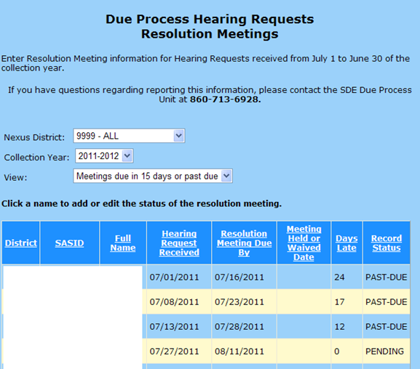

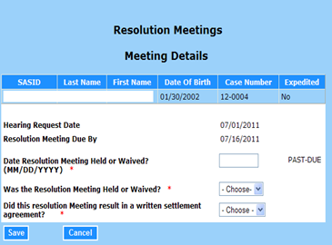

Data Fields
District | The District of the student as recorded in the Due Process system.
Collection Year | The Resolution Meeting collection year, based on the Hearing Request Date between July 1 and June 30.
Due Process Case Number | Case Number of student as reported in Due Process system.
SASID | SASID of student as reported in Due Process system.
Name | Student’s first and last name as reported in the Due Process system.
Hearing Request Received | The date the hearing request was received by SDE or the district, as reported in the Due Process system.
Resolution Meeting Due By | The last date before the resolution meeting is considered late.
Resolution Meeting Due By | Rules  - 15 calendar days after the HEARING REQUEST RECEIVED date, where this date is considered day zero.  Values  - N/A
Was the Resolution Meeting Held or Waived? | Indicates if the meeting was held or waived. If a waiver is not received, the meeting must be held.
Was the Resolution Meeting Held or Waived? | Rules  - Required if DATE RESOLUTION MEETING HELD OR WAIVED entered  Values  - Held  - Waived
Date Resolution Meeting Held or Waived | The date of the meeting or the date the waiver was signed and received by the district.
Date Resolution Meeting Held or Waived | Rules  - Required if RESOLUTION MEETING HELD OR WAIVED entered  - Cannot be future date  - Cannot be before July 1 of the current collection year  - Cannot be before the Hearing Request Date  Values  - MMDDYYYY
Days Late | DAYS LATE is the number of days past the RESOLUTION MEETING DUE BY date.
Days Late | Rules  - If RESOLUTION MEETING DUE BY is prior to today, the DAYS LATE is displayed  Values  - N/A
On-time / Late | Indicates whether the resolution meeting was held or waived within the 15 day calendar day requirement.
On-time / Late | Rules  - Calculated at save based on the DATE RESOLUTION MEETING HELD OR WAIVED  - If DATE RESOLUTION MEETING HELD OR WAIVED is past the RESOLUTION MEETING DUE BY date, then display Late, if not display On-time.  - If no DATE RESOLUTION MEETING HELD OR WAIVED has been entered and calculated RESOLUTION MEETING DUE BY has not passed, show “Pending”.  - If no DATE RESOLUTION MEETING HELD OR WAIVED has been entered and calculated RESOLUTION MEETING DUE BY has passed, show “Past Due”.  Values  - Pending  - Past Due  - On-time  - Late
Did this resolution meeting result in a written settlement agreement? | Indicates whether a written agreement resulted from the resolution meeting.
Rules
- Required if RESOLUTION MEETING HELD OR WAIVED is Held
Values
- No
- Yes

Birth to Three Notification Reports
Use this report to meet your responsibility for Child Find under IDEA and to ensure a smooth transition for those children who may be eligible for special education under Part B of IDEA.
In accordance with the Connecticut General Statutes, Section 17a-248d(e) and IDEA Part C (34 CFR Part 303), it is the responsibility of the Part C lead agency to notify local school districts and the SEA of all children enrolled in Birth to Three who reside in their town or who may become their educational responsibility.
This report is provided by the Office of Early Childhood (OEC), and notifies school districts about all children enrolled in Birth to Three who either reside in their district or who have nexus with their district (as determined by the Department of Children and Families).

Refer to the Step by Step Procedures document for detailed information.

Data Cleaning Reports

Potential Noncompliance
Data in this group allow districts to track the movement of students with disabilities in order to ensure up-to-date reporting.

Potential Noncompliance
- Misreported Student(s) Reported in SEDAC Certified Oct 1 Child Count
- Student(s) Missing from SEDAC Certified Oct 1 Child Count

Case Management
- View Orphan Records
- Total School Hours over 40 Hours
- ED166 Primary Disability Update
- Student Missing Nexus Information
- Students with less than 25 Total School Hrs/Wk (KF-12)
- Records that did NOT Upload
- Students with less than .10 special education hours/week

Managing Student Data
- Grade Twelve Report
- Developmental Delay Report (5 yr olds)
- Secondary Transition Report (13, 14 and 15 yr olds)
- Annual Reviews DUE: (based on previous SEDAC Oct.)
- Reevaluations DUE: (based on previous SEDAC Oct.)
- Reevaluations & Annual Reviews DUE: (based on previous SEDAC Oct.)

Noncompliance Summary Report
- Summary of Noncompliance in SEDAC Data Reporting

Misreported Student(s) in SEDAC Certified Oct 1 Child Count
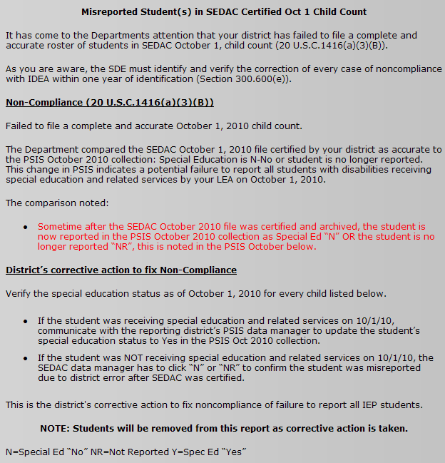
Total number of students: 5
Report Goal: 0
SASID | Name | Facility Code 1 | SEDAC Oct YYYY | PSIS Oct YYYY
1234567890 | Last Name, First Name | 0185311 | Y | N
1234567890 | Last Name, First Name | 0185311 | Y | NR
1234567890 | Last Name, First Name | 0185311 | Y | N
1234567890 | Last Name, First Name | 0185311 | Y | NR
1234567890 | Last Name, First Name | 0185311 | Y | N

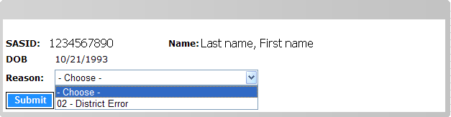

  - If 02-district error, display the citation and require acknowledgement before OK selected.
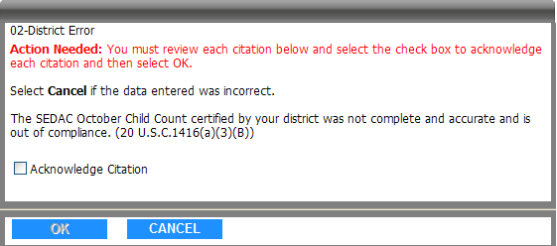

Students Missing from Certified Oct 1 Child Count
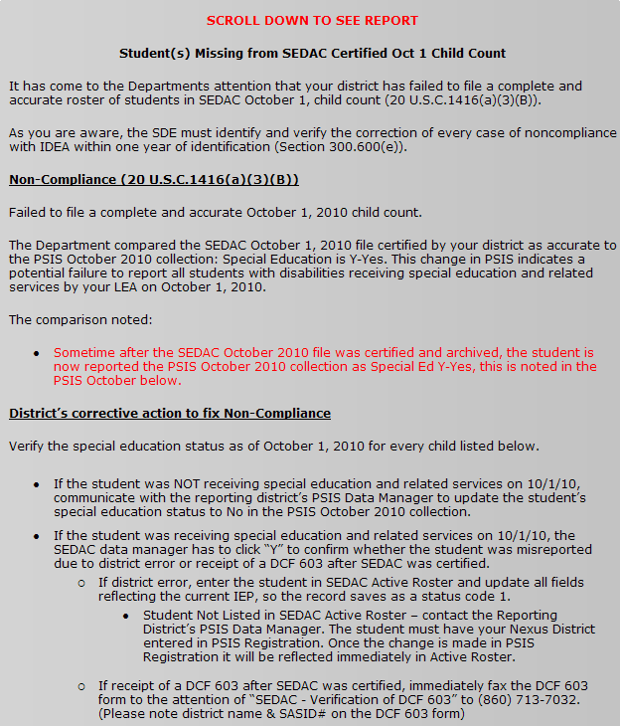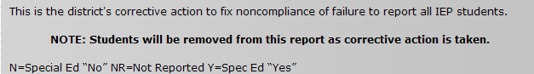

Total number of students: 5
Report Goal: 0
SASID | Name | Facility Code 1 | SEDAC Oct 2009 | PSIS Oct 2009
1234567890 | Last, First | 0185311 | N | Y
1234567890 | Last, First | 0185311 | N | Y
1234567890 | Last, First | 0185311 | N | Y
1234567890 | Last, First | 0185311 | N | Y
1234567890 | Last, First | 0185311 | N | Y

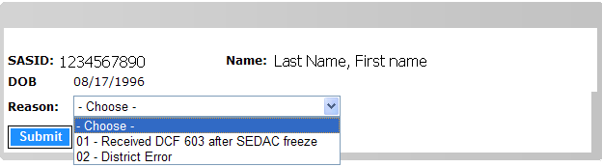

- 01 - Received DCF 603 after SEDAC freeze
- 02 - District error
- If “Close” is selected return to data cleaning report.

  - If 01-dcf 603, display the fax message.
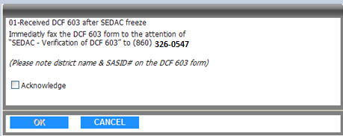

  - If 02-district error, display the citation and require acknowledgement before OK selected.

Case Management

View Orphan Records
This report allows districts to track IEP students whose status in PSIS, as a student with disabilities, changes during the collection period. This report is only available during the SEDAC October Collection period. It helps manage data changes prior to the certification and final reporting for the year’s data. Districts review the individual students listed and designate the reason why they are appearing on this report.

An ORPHAN RECORD is created for a student when a student is initially reported in PSIS October Collection with SPECIAL EDUCATION of Y-Yes and then the student is removed from the collection or SPECIAL EDUCATION is changed to N-No. This causes the student to no longer show on your SEDAC list of students. Districts must resolve all orphans in order to certify their reported data.

To resolve these cases, select a REASON and then select Update.
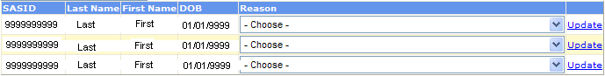
Data Fields
The following is a list of fields and guidance for closing the cases on this report.

View Orphan Record Report Data Fields
Reason | The reason this student record is on this report.
Reason | Rules  - Required  Values  - Student was not our Nexus on 10/1  - Student was not special education on 10/1  - Student was special education on 10/1 and should be in our SEDAC list
Update | Select Update after a reason is selected.
Update | Rules  - When REASON 1-Student was not our Nexus on 10/1 or 2-Student was not special education on 10/1 is selected, the orphan record is deleted and the student’s name is removed from the Orphan Records list.  - When REASON 3-Student was special education on 10/1 and should be in our SEDAC list is selected, the student remains in the Orphan Records list.  - Contact the appropriate PSIS Data Manager to correct the PSIS October Collection immediately. Once the PSIS October Collection reflects SPECIAL EDUCATION of Y-Yes and your District as Nexus District, the student will show in your SEDAC list and will come off your orphan list. Until the change is made, the student remains visible to the district in this Orphan Records list.

Total School Hours Over 40 Hours
The purpose of this report is for district and administrative use in managing the accuracy of reported data as it relates to the school hours reported, while reducing the time spent in analyzing that data. Districts must resolve all cases in order to certify their reported data.

Specific data targeted with these reports include:
- Students with Total School Hours per Week of more than 40 hours - students with reported school hours greater than 40 hours must be reviewed and confirmed. It is rare that a student spends more than 40 hours a week at school.

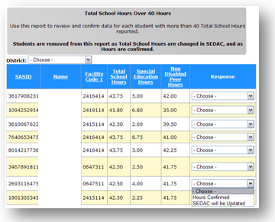

The following is a list of fields and guidance for reporting data.

Total School Hours over 40 Hours Report
Data Fields
Response | Select your response with a confirmation for the hours reported, or indicate that the hours will be corrected in SEDAC.
Response | Rules  - Required  Values  - Hours Confirmed - If hours are corrected, confirm to remove student from report.  - SEDAC will be Updated - If hours were reported incorrectly, SEDAC must be corrected. When SEDAC data is changed the student record is then removed from this report.

ED166 Primary Disability Update

Use this report to report the primary disability needed for the ED166 - Disciplinary Offense Online Application to report discipline incidents for students with disabilities. Student records with the NEXUS DISTRICT as of the INCIDENT DATE matching the SEDAC user’s assigned district are displayed when this report is selected.
Federal discipline reporting requires a breakout of incident data for students with disabilities (SWD) by their primary disability. In order to eliminate duplicate reporting, primary disability data for SWD will be obtained from SEDAC using a combination of data from PSIS Registration, ED166 Discipline, SEDAC October 1 Child Count and SEDAC Active Roster .
For students not included in the SEDAC October 1 Collection, a report is necessary to collect the primary disability data.
Students without disabilities may also be included in this student report due to the rules for reporting general education state agency placement grants. A district will be able to designate these students with a primary disability code indicating “general education”.
- The ED166 Primary Disability Collection report in SEDAC displays students that have a Disciplinary Incident, are reported with a NEXUS DISTRICT in PSIS Registration and were not reported in the previous SEDAC October 1 collection. The district’s SEDAC Data Manager selects the PRIMARY DISABILITY on this report, which is stored in SEDAC and removed from this list.
Note: Where a student may have been recently identified as a student with disabilities, the district is required to report the disability. We will attribute the Disciplinary Incidents that occurred before eligibility to the student as “general education” and after eligibility as the disability reported by the district.
These discipline data are used to fulfill reporting requirements for the IDEA Part B Federal Disciplinary Offense Report (Table 5) and the Part B State Annual Performance Report (APR) Indicator 4 - Rates of Suspension and Expulsion:
A. Percent of districts that have a significant discrepancy in the rate of suspensions and expulsions of greater than 10 days in a school year for children with IEPs; and
B. Percent of districts that have: (a) a significant discrepancy, by race or ethnicity, in the rate of suspensions and expulsions of greater than 10 days in a school year for children with IEPs; and (b) policies, procedures or practices that contribute to the significant discrepancy and do not comply with requirements relating to the development and implementation of IEPs, the use of positive behavioral interventions and supports, and procedural safeguards. ((20 U.S.C. 1416(a)(3)(A); 1412(a)(22)))
The following is a list of fields and guidance for reporting data.

ED166 Primary Disability Collection Report Data Fields
Primary Disability | The primary disability of a student with disabilities not yet reported in a SEDAC collection, which has had disciplinary incident(s) reported in ED166 for the current collection year.
Primary Disability | Rules  - Required  Values  - 01 - Intellectually Disabled  - 02 - Hearing Impairments  - 03 - Speech / Language Impairments  - 04 - Visual Impairments  - 05 - Emotional Disturbances  - 06 - Orthopedic Impairment  - 07 - Other Health Impairments  - 7A - ADD / ADHD  - 08 - Learning Disabilities  - 8A-Specific Learning Disabilities/Dyslexia  - 09 - Deaf-Blindness  - 10 - Multiple disabilities  - 11 - Autism  - 12 - TBI  - 15 - Developmental Delay (3-5)  - RE/18 - General Education

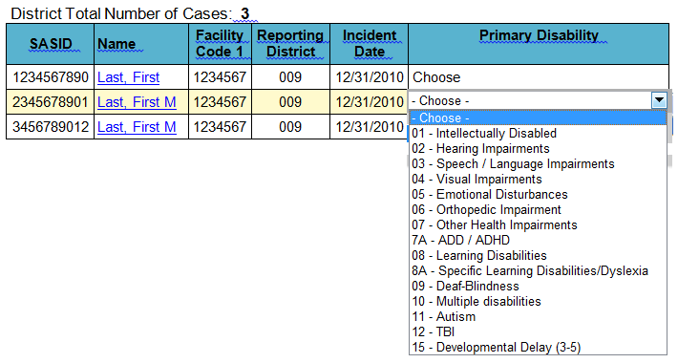

Student Missing Nexus Information
Over the years we’ve had many conversations about students who move into your district and you don’t know the previous district was implementing an IEP for weeks, months, or even over a year. Once your district discovers the student was previously receiving special education, Nexus District and Special Education Status are updated accordingly in PSIS. In many cases, this results in a citation of noncompliance because your district did not report the student in the SEDAC 10/1 child count collection. This report supports districts in:
- Knowing a student’s previous special education status (In accordance with Connecticut General Statutes (C.G.S.) Section 10-220h. Transfer of student records.)
- Timely reporting of ALL students with disabilities in SEDAC
- Reducing the number of citations districts receive for not reporting a student, after SEDAC is archived

This report identifies students with disabilities reported in the past two SEDAC 10/1 Archives where Nexus is not being reported in PSIS. These students with disabilities may have:
- Moved into your district
- Left your district and returned to your district
- Started attending a new school/program outside of your district, where your district is still Nexus

Please resolve all cases no later than 10 days from date displayed in the ACTIVE PSIS REGISTRATION LAST UPDATED column.
The following is a list of fields and guidance for closing the cases on this report.

Reason | The reason this student record is on this report.
Reason | Rules  - Required  Values  - 01-Student should be in SEDAC, working with PSIS to correct  - 02-Student returned to general education, working with PSIS to correct  - 03-Student returned to general education & withdrew from the district the same day, PSIS is accurate
Update | Select Update after a reason is selected.
Rules
- When REASON 01-Student should be in SEDAC, working with PSIS to correct the student will remain on this report until PSIS is updated.
◦NOTE: if the student entered your district after 10/1, the student will not appear on your SEDAC 10/1 child count. The student will appear on your SEDAC Active Roster list.
- When REASON 02-Student returned to general education, working with PSIS to correct the student will remain on this report until PSIS is updated.

- When REASON 03-Student returned to general education & withdrew from the district the same day, PSIS is accurate and click Update, the student will remain on this report until CSDE Verifies PSIS Registration.

Students with less than 25 Total School Hrs/Wk (KF-12)
This report allows districts to track students in grade Kindergarten Full Day through 12, where the requirement to meet 900 TOTAL SCHOOL HOURS has not been met (C.G.S. Sec. 10-15). This helps ensure accurate reporting of students with disabilities prior to the certification. Districts review the individual students listed and designate the reason they are appearing on this report. This report is only available during the SEDAC October Collection. Districts must resolve all cases in order to certify their reported data.
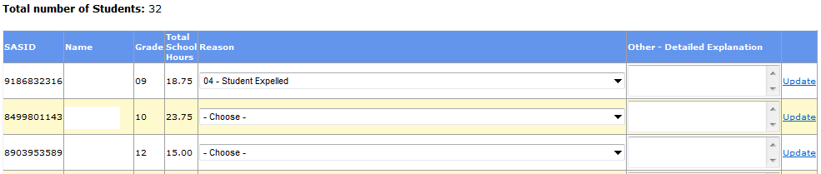
Data Fields
The following is a list of fields and guidance for closing the cases on this report.

Reason | The reason this student record is on this report.
Reason | Rules  - Required  Values  - 01-Homebound student missing special program status code (08 or 18); will update in PSIS October  - 02-Error in total school hours reported; will update in SEDAC  - 03-PPT decision to alter student's total school hours is documented in the IEP  - 04-Student Expelled  - 05-will contact SDE
Update | Select Update after a reason is selected.

Managing Student Data

Disclaimer
The “Managing Student Data Reports” display students reported in the previous SEDAC October 1 child count for whom an important compliance related date is approaching (i.e., children with developmental delays about to turn 6; youth about to turn 16 14 in need of transition goals; etc.) . These reports are intended to be an aid to support district efforts to increase compliance across several specific areas where ongoing state-wide concerns exist . It is important to remember that these reports are simply tools to help districts monitor compliance, and that the district is ultimately responsible to monitor compliance for all students with disabilities. It is also important to note that these reports will fail to alert you to students (1) whom were found eligible for special education after October 1, or (2) transferred in to your district with an existing IEP.

Grade Twelve Report
The purpose of this report is to display a district’s 12th graders reported as of last year. This report assists districts in correct reporting of graduation, related to Federal Exit Reports.

These students may have exited or may still be receiving educational services during the upcoming school year. The report is intended to ensure accurate reporting of students with disabilities who are graduating versus those who are continuing for additional education even though they may be participating in a graduation ceremony.
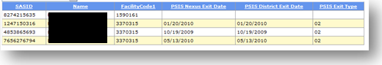
- Services Plan exits are collected in SEDAC.
- All IEP exits will be collected through PSIS.
- You can use the Grade 12 report to communicate with PSIS data managers regarding IEP students who graduated. You should see an EXIT TYPE of 15-Graduated with regular, advanced, International Baccalaureate, or other diploma type in the PSIS Exit Type column before the start of the next school year.
- You can also use the Grade 12 report to communicate with PSIS data managers regarding IEP students who are continuing for additional education even though they may have participated in a graduation ceremony (i.e. 5th and 6th year students, students staying until age 21). Give your PSIS data manager a list of these students who should not be exited as graduating at this time.
Reference: A list of the PSIS Exit Codes is located in the Appendix of Terminology and References document.

PSIS DISTRICT EXIT DATE and PSIS EXIT TYPE are displayed when:
- A student graduated
  - PSIS District Exit Date and PSIS Exit Type of 15-Graduated with regular, advanced, International Baccalaureate, or other diploma type.
- A student received a certificate of completion
  - PSIS District Exit Date and PSIS Exit Type of 16-Completed school with other credentials.
- A student reached maximum age
  - PSIS District Exit Date and PSIS Exit Type of 20-Reached maximum age for services.

No PSIS DISTRICT EXIT DATE or PSIS EXIT TYPE is displayed when:
A student who meets academic requirements and participates in the graduation ceremony but does NOT receive a regular high school diploma or certificate of completion (district holds diploma/certificate until official exit from district enrollment); such student maintains his/her eligibility for special education and related services until such student takes receipt of their regular high school diploma or certificate of completion or until the end of the school year in which the student turns twenty-one (21) years of age. Communicate with the PSIS data manager that the student is still eligible and will continue to be reported in PSIS, SEDAC and eligible for reporting in SEDAC-G.
Note: Students are not removed from this report.

Developmental Delay (5 yr olds)
The purpose of this report is to provide districts with a list of students to review and manage PRIMARY DISABILITY data where the student was AGE of 5 as of October 1 of the previous SEDAC October Child Count and a PRIMARY DISABILITY of 15-Developmental Delay.
As you are holding spring PPT meetings, ensure each of these students has the appropriate meetings and evaluations scheduled and a new disability category has been identified prior to certifying your SEDAC October 1 Child Count.
Specific data targeted with these reports include:
- Age 5 students with a Primary Disability of 15-Developmental Delay in the previous SEDAC October Child Count.

Students age 6 or older may not be classified with a Primary Disability of 15-Developmental Delay. These records must be changed prior to the October 1 Child Count of their 6th birthday.
Note: Students will not be removed from this report.
C.G.S. Sec. 10-76a-1(4)(B) “A child requiring special education” means any exceptional child who is age three, four or five and is experiencing developmental delay, as defined in section 10-76a (5) of the Connecticut General Statutes, that causes such child to require special education.
Statute
C.G.S. Sec. 10-76a(5)(C). Whenever used in sections 10-76a to 10-76i, inclusive:
(5) “A child requiring special education“ means any exceptional child who
(C) is age three to five, inclusive, and is experiencing developmental delay that causes such child to require special education.
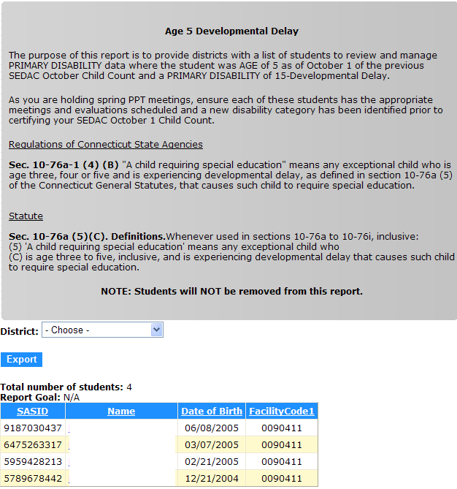

Secondary Transition (13, 14 and 15 yr olds)
The purpose of this report is for district use in managing the accuracy of their reported data, while reducing the time spent in analyzing that data.
Specific data targeted with these reports include:
- Age 13, 14 and 15 students in the previous SEDAC October Child Count.
Use the report as a tool to ensure that districts have addressed the three Secondary Transition components listed below in the IEP that will be in effect for any student when he/she turns 1614.

- In order to ensure compliance for the upcoming October 1 Child Count, districts should review the IEP of every student who will be 16 14 years old on October 1st.
  - Was the student invited? (IEP pg. 6, #2a)
  - Was the appropriateness of inviting outside agencies to the transition planning PPT considered and documented? (IEP pg. 6, #4a)
  - Were appropriate transition goals & objectives written for the student? (IEP pg. 6, #5 a-c and pg. 7)
    - Goals based on age-appropriate transition assessment? (IEP pg. 6, #3)
    - Post-School Outcome Goal Statement for Postsecondary Education/Training? (IEP pg. 6, #5a)
      - Annual goal for Postsecondary Education/Training? (IEP pg. 7, Postsecondary Education/Training checked at top of page)
    - Post-School Outcome Goal Statement for Employment? (IEP pg. 6, #5b)
      - Annual goal for Employment? (IEP pg. 7, Employment checked at top of page)
    - Course of study OR “Student has completed academic requirements” checked? (IEP pg. 6, #6)

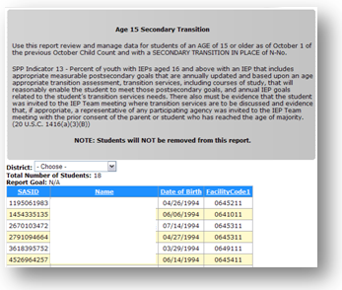

Noncompliance Summary Report

Summary of Noncompliance in SEDAC Data Reporting
The reporting of timely and accurate data is a required measure in the Connecticut State Performance Plan (SPP; Indicator 20) used to monitor compliance with the Individuals with Disabilities Education Improvement Act (IDEA) 2004 regarding submission of federal child count data (20 U.S.C. 1416(a)(3)(B)). Part of the state’s responsibility for ensuring the accuracy of the federally reported data includes identifying noncompliance reported by districts on students with disabilities and ensuring it the noncompliance is corrected as soon as possible, and in no case later than one year.
Use this report to view the number of noncompliant student records reported for a collection year. This report is available when SEDAC Oct 1 Child Count opens and is not final until subsequent Child Count.
This report may impact the results of Indicator 20 in the LEA APR published in March 2012 and the results of in Connecticut’s SPP/APR published in February 2013.

Summary of Noncompliance in SEDAC Data Reporting
Administrative Overrides | The record is added to the Citation Count when the Administrative Override is approved with a status of 5, 6, 7 or 8.  - Developmental Delay over Age 5  - Count of citations with AO Requests approved (AO status 5, 6, 7 or 8)  - Withdrawn (AO status 9) are subtracted from this count  - Annual Review Not Complete  - Count of citations with AO Requests approved (AO status 5, 6, 7 or 8)  - Withdrawn (AO status 9) are subtracted from this count  - Most Recent Evaluation Not Complete  - Count of citations with AO Requests approved (AO status 5, 6, 7 or 8)  - Withdrawn (AO status 9) are subtracted from this count  - Secondary Transition Not In Place at 16 **Update 14-21 [this year will only list the 14/15 year old kids with AR's on or after 7/1 where district acknowledged citation]  - Count of citations with AO Requests approved (AO status 5, 6, 7 or 8)  - Withdrawn (AO status 10) are subtracted from this count  - Total Citations
Child Count Errors | The record is added to the Citation Count when the district selects a REASON of 02-District Error on the corresponding report.  - Misreported Student(s) in Oct 1 Child Count  - Student(s) Missing from Certified O  - ct 1 Child Count  - Total district errors
Other Noncompliance | The record is added to the Citation Count when the citation is acknowledged.  - Secondary Transition - Student Invited to Attend - Student Invited to Attend of No  - Secondary Transition - Outside Agency Invited to Attend - Outside Agency Invited to Attend of 04- No, no outside agency was invited  - FAPE at Three Not on Time - Reason FAPE at 3 Not on Time is 3-Other  - Total district errors

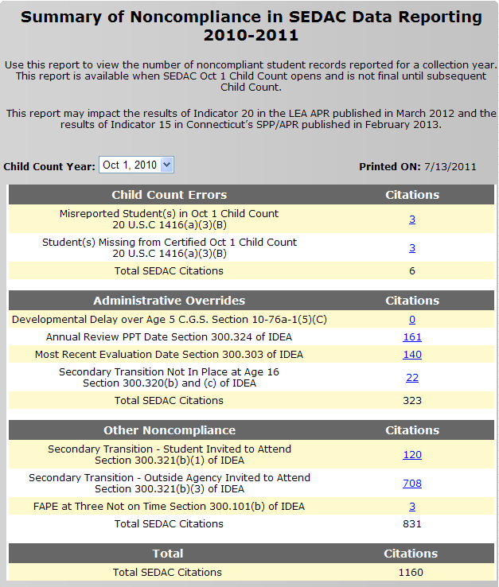

Count of Citations link to a list of SASIDs, Names, DOB, and AdminOverride Status for students that make up the count. Use the View IEP Students screen/list format. Essentially, filter the list of students shown on View IEP students, with the Administrative Override type selected. This screen will operate just as the View IEP Students screen does, allowing link to student details.

Link from Name to show student details in SEDAC screens.

Viewing your students
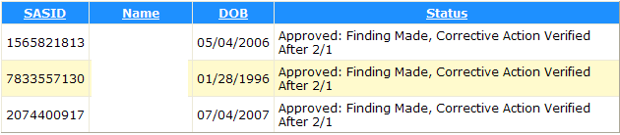

Statewide Reports
Reports in this section are posted for ease of access to the states most requested data by directors of special education.
The reports in this group represent:
- SEDAC students, including IEP and SP, GRADES K-12 (except where otherwise stated).

These reports are for internal use only, NOT to be released publicly. Do not print these secure unsuppressed reports and present to your boards of education. If you need data to report to your board or any other public entity, please use the suppressed data available publicly through the EdSight Portal.

Prevalence Rate: October 1, YYYY

Prevalence Rate within Special Education: October 1, YYYY

Significant Disproportionality Summary Report
Note: Prevalence Rates back to 2008 - suppressed data is available publicly through the EdSight portal (http://edsight.ct.gov) (Students>Students with Disabilities).

CSDE's Statement of Nondiscrimination

The Connecticut State Department of Education is committed to a policy of equal opportunity/affirmative action for all qualified persons. The Connecticut State Department of Education does not discriminate in any employment practice, education program, or educational activity on the basis of race, color, religious creed, sex, age, national origin, ancestry, marital status, sexual orientation, gender identity or expression, disability (including, but not limited to, intellectual disability, past or present history of mental disorder, physical disability or learning disability), genetic information, or any other basis prohibited by Connecticut state and/or federal nondiscrimination laws. The Connecticut State Department of Education does not unlawfully discriminate in employment and licensing against qualified persons with a prior criminal conviction. Inquiries regarding the Connecticut State Department of Education’s nondiscrimination policies should be directed to:

Levy Gillespie
Equal Employment Opportunity Director/American with Disabilities Act Coordinator
Connecticut State Department of Education
450 Columbus Boulevard, Suite 607
Hartford, CT 06103
860-807-2071
Levy.Gillespie@ct.gov

