Connecticut State Department of Education - Research and Data Collection

Evaluation Timelines
User Guide

Version 6.0.4

12/20/2021

Contents
Document Change Log 4
Objective 6
Contact List 7
Handbook / Reference Guide 8
Evaluation Timelines Overview 8
Child Find Requirement 8
SPP Indicator 11 - Timeline for Eligibility 8
Individualized Student Evaluation Timeline Collection 8
Determining Timely Evaluations 9
Collection Period 11
Timely and Accurate 11
SPP Indicator 11 Percentage Calculation 12
District Certification 12
Monitored Submissions for Noncompliant Districts 13
Managing Student Data 14
Who to Report 14
Upload Requirements 14
Evaluation Timelines Record Layout 15
Data Fields 16
District Reports Used to Manage Collection 27
Eligible Student Records with Nexus Missing 27
Private Pay Eligible Student Records 28
Birth to Three NOT Eligible – Follow-up Communication with Family Required (P.A. 21-46) 28
Reason for Delay Review 29
Student Data for Download 29
Download Student List for Analysis 29
Download Student Evaluation Data 29
Certification Confirmation Report 33
Procedures 34
How to Access the Evaluation Timelines System 34
How to Add an Individual Student Record 37
How to Add a Foster Care Student not in my District 44
How to Change an Individual Student Record 49
How to Upload a Group of Student Records 51
How to Certify Your District’s End of Year Data Submission 54
How to Complete a Monitored Submission 56
FAQs 58
General Questions 58
Which Collection Year 58
When to Report a Student in the Evaluation Timelines Data Collection 59
Which Date to Use 61
Private Pay or Public 62
Denial of Basic Rights 63
Closing or Holding Undetermined Evaluations 63
Exceptions and Special Cases 64
Timeline Calculation 64
Connecticut Birth to Three 65
Appendix 67
Terminology 67
References 68

Document Change Log
Version | Section / Page | Date | Description
4.0.00 | TOC | 6/18/2010 | Added Documentation Change Log / Published
4.0.01 | Procedures | 6/22/2010 | Updated screens and error messages
4.0.02 | FAQs | 6/30/2010 | Added new FAQs  Corrected typos
4.0.03 | Procedures | 6/30/2010 | Updated error messages in Procedures section  Added procedure How to Upload a Group of Student  Records  New Report to download student data for later upload
4.0.04 | Handbook pg. 7 | 7/8/2010 | Corrected order or Reason for Delay  Added notes to the Upload Requirements based on issues encountered by districts.
4.0.05 | Procedures | 7/8/2010 | Added steps to How to Upload a Group of Students
4.0.07 | Handbook pg. 9 | 7/13/2010 | Expanded description of Timely and Accurate
4.0.08 | FAQ pg. 48 | 7/18/2010 | Added clarification to existing FAQ
4.0.09 | FAQ pg. 48 | 7/22/2010 | Additional clarification to existing FAQ
4.0.10 | Managing Student Data pg. 15  Procedures pg. 37  Procedures pg. 47 | 8/10/2010 | New Note on entering incomplete student records  New Procedure - How to Add Foster Care not in my  District  How to Upload a Group of Student Records - Clarifications on upload requirements - New prerequisite and note on entering incomplete student records
4.1.00 | Handbook  pp.10-12  pg.13 pg.27-30  Procedures pp.42, 51 pp.54-59  FAQ  pp.61, 62 | 9/1/2010 | Added details and revisions to Accurate reporting,  District Certification and Monitored Submissions for Noncompliant Districts  New Note on entering incomplete student records  Added description of district reports  New notes procedures  Added procedures:  - How to Certify Your District’s Reported Data  - How to Complete Monitored Submission  New and updated FAQs
4.1.01 | Procedures  Pg.53 | 9/15/2010 | Add Upload screen with revised text
4.1.02 | Add a Individual  student  Pg.40  Change an Individual student  Pg.46 | 11/16/2010 | Added Reason for Delay edit check (06 - The Date of  Eligibility PPT in Reason for Delay 6 cannot be more then 3 years past the Date of birth)
4.1.03 | Added FAQ |  | When should you obtain a SASID?
4.1.04 | Added EIP  P 16, 23-4 | 4/5/12 | Added EIP to Record Layout, added description of field.
 | Nondiscrimination  Statement p. 78 | 4/30/12 | Updated with 9-30-2011 version
5.0.00 | Record layout | 10/10/12 | Added B (Private Pay Birth to Three) value
 | Body | 10/10/12 | Added detail throughout on Private Pay Birth to Three and EIP. Added Birth to Three popup window. Updated  screen captures covering EIP, Birth to Three. Corrected typos. Removed sections stating that all records must  be complete in an upload. Changes related to EIP / Private Pay Birth to Three are highlighted
6.0 | Navigation Pane | 10/14/20 | Added this formatting
 | Who to Report | 10/14/20 | Added
 | When should you obtain a SASID? | 10/14/20 | Updated to align with SEDAC FAQ
 | How does the timeline work for children in Birth-to-Three referrals | 10/14/20 | Updated
 | Updated guidance to reflect 45-School Day Timeline | 10/14/20 | Updated guidance with regard to using the State’s 45-school-day evaluation timeline, instead of the federal timeline.
 | Reason for Delay | 10/14/20 | Repurposed Reason for Delay #7 to collect if the state’s 45-school day timeline was met.
 | Published | 10/14/20
6.0.1 | Private Pay? | 09/03/2021 | SASID required for Private Pay=B (referred from the Birth-to-Three system)
 | How to Add an Individual Student Record | 09/03/2021 | Updated SASID required for Private Pay=B (Birth-to-Three)
 | District Reports Used to Manage Collection | 09/03/2021 | Updated
 | Private Pay Eligible Student Records Report | 09/03/2021 | Added
6.0.2 | Birth to Three NOT Eligible – Follow-up Communication with Family Required (P.A. 21-46) Report | 10/01/2021 | Added
6.0.3 | When should you obtain a SASID? | 11/01/2021 | Updated
6.0.4 | When should you obtain a SASID? | 12/20/2021 | Updated

Objective
The purpose of this document is to provide districts with procedures and guidance for submitting data and to address questions regarding the use of this data collection.

The document is organized into four sections:

 Handbook or reference guide on the purpose of this collection and definition of data collected

 Step by step procedures for use of the system  Frequently Asked Questions (FAQs)  Appendix of terminology and references
Documentation Standards
Standards used in this document include the following:
- FIELDS displayed on a screen are referenced using ALL CAPS
- Field values are highlighted in bold
- Screens are referenced using italics
- Buttons or menu selections are in bold
- When following procedures contained in this guide, always proceed to the next step if not directed
  - to go to another step

Look for where new information or FAQs have been added or existing FAQs changed.

Represents important information related to data reporting.

Represents helpful tips and references to other sections of documentation for related topics. Represents reminders of information previously stated related to the current topic.

Contact List

Contact | Name | E-mail | Phone
Bureau of Special Education Consultant | Viviana Toure | Viviana.Toure@ct.gov | 860-713-6924
SDE Data Manager | Ada Kovaci-Kume | Ada.Kovaci-Kume@ct.gov | 860-713-6855
Analyst | Diane Murphy | Diane.Murphy@ct.gov | 860-713-6891

The CSDE Data Acquisition Plan and Timely & Accurate Dates can be found at this site:

https://portal.ct.gov/SDE/Performance/Data-Collections-Guide

Handbook / Reference Guide

Evaluation Timelines Overview

Child Find Requirement

Each state is required by the Individuals with Disabilities Education Improvement Act (IDEA) to identify, locate, and evaluate all children in the state who are in need of special education and related services. To do so, states conduct what are known as Child Find activities.

(a) General. (1) The State must have in effect policies and procedures to ensure that
(i) All children with disabilities residing in the State, including children with disabilities who are homeless children or are wards of the State, and children with disabilities attending private schools, regardless of the severity of their disability, and who are in need of special education and related services, are identified, located, and evaluated; and
(ii) A practical method is developed and implemented to determine which children are currently receiving needed special education and related services.
Child Find requirements [20 U.S.C. 1412 (a) (3); 34 CFR §300.111]

SPP Indicator 11 - Timeline for Eligibility

Each state is required to report on the evaluation timeline compliance of the Child Find requirements, using the Indicator 11 section of the federally mandated State Performance Plan (SPP).

Pursuant to Regulations of Connecticut State Agencies §10-76d-13, once a district receives a written referral for special education evaluation, it has 45 school days to complete an initial evaluation, exclusive of the time required to obtain parental consent. The State timeline encompasses the entire eligibility determination process including reviewing the referral, obtaining written parental consent for evaluation, conducting a comprehensive evaluation, determining eligibility, obtaining written parental consent for the provision of special education services and implementing an IEP if the student is found eligible.

Individualized Student Evaluation Timeline Collection

The Evaluation Timeline system’s objective is to provide an automated method to collect individual student data for the calculation of SPP Indicator 11. The data collected includes students referred for evaluation, with written parental consent to evaluate, for determination of eligibility for special education and related services.

These data are used to monitor a district’s compliance to the state timeline rules for the initial evaluation process and to report on the results. The data collected provides the state with information to determine the percent of children evaluated and whose IEP was implemented within the state established timeline of 45 school days from the date of the receipt of referral. The state timeline of 45 school days is exclusive of

the time it takes to obtain the parental consent after being requested by the district; and is based on actual school days.

Only student referrals with a parental consent are to be included in these collections. The year of collection is determined by the DATE OF PARENTAL CONSENT TO EVALUATE; therefore, if parental consent is not received no data are collected within this system.

Once a student is found eligible, any further evaluations (i.e., reevaluations) are not collected in this system The CSDE expects that the district will conduct a full and individual evaluation that consists of procedures to determine if the child is a child with a disability under 34 C.F.R. § 300.301. Further, the evaluation must be “sufficiently comprehensive to identify all of the child’s special education and related services needs, whether or not commonly linked to the disability category in which the child has been classified.” 34 C.F.R. § 300.304(c)(6). The practice of determining a child “not eligible” and then immediately re-referring the child to conduct a second initial evaluation is not permitted.

When calculating the SPP Indicator 11, acceptable reasons for delay are considered on time. Acceptable reasons for delay are pre-defined situations that may be selected when a timeline exceeds the 45- school-day timeline.

Determining Timely Evaluations

REFERRAL | Timeline Starts | CONSENT  to Evaluate |   Reporting  to State Required | ELIGIBILITY | PPT Date | COMPLETE  Within 45 School Days | Implement IEP or Found Ineligible

1. Soon after a referral is received, a PPT meeting is scheduled to discuss the referral. Once the Consent to Evaluate is received, the referral record is required to be reported to the Evaluation Timelines Collection (ETC). Records regarding students referred for special education, for whom consent to evaluate is not received, are not reported to the ETC.

2. A student’s evaluation timeline begins upon receipt of the referral and continues until the IEP is implemented or the student is found ineligible.

3. Once eligibility has been determined and all data are properly reported; the user changes the ELIGIBILE field to Eligible or Not Eligible and reports the DATE OF ELIGIBILITY PPT.

a. The number of DAYS TO EVALUATE (a calculated field in ETC Days to Evaluate Report) is no longer valid. Please ignore this field as the system uses the old federal timeline for calculation and not the State 45-school day timeline.

4. The initial evaluation is considered on time, when the district calculated number of days to evaluate is less than or equal to 45 school days from referral to implementation.

a. All records are required to have a REASON FOR DELAY reported. Reasons for delay 01-07 and 09 are all considered ON-TIME Evaluations and the record status will be set to COMPLETE. Only [Reason 08 – Other] is considered not timely and record status will be set to Complete - Beyond Timeline.

- 01-Documented request by parent to reschedule or delay PPT meeting after agreeing to attend at a particular time and date.
- 02-Parent repeatedly fails or refuses to produce the child for evaluation
- 03-Student Hospitalized/Extended student absence with medical documentation that the student is not available for evaluation
- 04-Student placed in diagnostic placement for the purpose of determining eligibility
- 05-PPT Cancelled Due to Inclement Weather/Emergency closing
- 06-Child referred from the Birth to Three System, had a 90-day transition conference, and either had an IEP in place by their 3rd birthday or was found not eligible
- 07- Met state 45-school day implementation timeline
- 09-Documented agreement to extend the evaluation timeline for the purpose of determining a Specific Learning Disability (ED637 form)

When one of the above Reasons for Delay are reported for the record, the RECORD STATUS will be set to Complete. Please note – it is anticipated that the majority of records will use Reason for Delay 07 – Met the state 45-School Day Timeline.

b. The timeline is considered late, when the number of school days between referral and IEP Implementation exceeds 45-school days and REASON FOR DELAY is 08-Other.

As a result, the RECORD STATUS is set to Complete-Beyond Timeline.

A sample of Unacceptable Reasons for Delay
1. Parent did not return phone calls
2. Parent did not have transportation
3. Statewide assessments
4. Staff illness
5. Extensive observation needed
6. Need time to determine student’s dominant language
7. Not enough staff/staff schedules/increases in staff caseloads
8. Student not available due to school activities
9. Vision issues (student needs testing and/or reading glasses)
10. Parent schedule inflexible
11. Student refusal

Collection Period

There is one collection per school year. Two collections may be open concurrently to collect data for any delayed evaluations. Each collection’s purpose is to fulfill the Indicator 11 reporting requirements for a specific school year.
- Evaluation Timelines is accessible year round
- Evaluation Timelines is closed during federal reporting
- Student records are accepted for a specific school year, based on whether the DATE OF PARENTAL CONSENT TO EVALUATE falls between July 1 and June 30 of that school year
- Federal Reporting of Indicator 11 occurs on February 1.

Timely and Accurate
The Department will take into account whether or not district data are submitted in a timely and accurate manner in District-level Annual Performance Report (APR) Determinations. Please work with both special education and general education staff to ensure data submitted to the Department are timely and accurate. (20 U.S.C. 1416(a)(3)(B))

The Department has recently met to define Timely and Accurate and how we will determine compliance for the SPP. We have attempted to define Timely and Accurate as a holistic system analysis, thereby ensuring the monitoring of Timely and Accurate Reporting is not about minor edits/errors, but instead is about systemic failure to report and/or follow reporting directions/guidelines.

Timely
1) Submission of file by due dates (no extensions);
2) Passed general edit checks and provided complete data.
a) district did not report old/previous year/fake data;
b) there are no missing data (i.e., failure to report an entire field or school, etc.) and
c) the data pass all reasonability tests (comparisons to state data and last year’s data…no unexplained significant changes in counts or percent of students within various data points).

Placeholder Records
By the Timely Date, there should be an entry in ETC for any pending evaluation for which a consent to evaluate has been received. By necessity, these records will be categorized as incomplete until evaluations are completed when school resumes. This is typical for consents to evaluate that were received very close to the end of a school year. The incomplete record serves as a placeholder for the count of a district’s evaluations for a given school year.

Accurate
District corrects data errors within the edit checking timeframe established for each data collection.

Any data errors not corrected by the established “freeze date” of the file for federal reporting will be considered not accurate.

Certification is not required to meet the accurate reporting deadline for a school year.
• Timely due date is June 30.
• Accurate due date is typically November 15.

SPP Indicator 11 Percentage Calculation

 On-time
Evaluations
Parental Consents Received

Result x 100

Percent = [(On-time Evaluations) divided by (Parental Consents Received)] times 100

On-time evaluations include evaluations completed on time or complete with an acceptable reason for delay.

NOTE: Students that have moved out of your district prior to eligibility determination are not considered in this calculation. The district has indicated this by selecting an ELIGIBILITY status of Moved.

District Certification

Your district is required to sign-off on the content of your data, which in turn locks the data against any further changes. You may not add, change or delete any student records after certification.

To certify your district, which allows for the preparation of federal and state reporting, all student records must have a completed status, with all eligibilities reported (eligible, not eligible or moved).

The CSDE Evaluation Timelines Data Manager is able to decertify and unlock your district’s data after certification if changes are needed. Once changes are made, the collection will need to be re-certified by your district. Each time you certify, the Certification Confirmation report is presented with the results for your district.

Final end of year certification occurs after June 30 of the Collection Year. For a district to certify, all student records must be complete. Districts that have no reported data, must still certify. NOTE: The button to certify will become active on July 1.

During district certification, the system calculates the current percentage of on-time evaluations and displays the Certification Confirmation report; and if under 100%, a citation and corrective action message is available on this report for printing. It is recommended the district also print the SPP Indicator 11
Summary report for their records at this time.

IMPORTANT: It is your responsibility to make sure the documented citation and corrective actions, along with a copy of the SPP Indicator 11 Summary report, are saved or printed for your records.

Monitored Submissions for Noncompliant Districts
If the percentage calculated during final certification of the current Collection Year is below 100% your district will be required to participate in monitored submissions during the next Collection Year.

When Monitored Submissions are in effect for a district, the district must submit data for every two month period by administrator-defined due dates. When data entry is complete and the data verified, the Monitored Submissions are submitted using the Certify menu option, which locks the collection.
• Data are entered for monitored submissions in the same manner as normal reporting.
• Districts may report student records across monitored submission ranges with any date as long as it adheres to existing Parental Consent and Collection rules.

The student records considered in each monitored submission time period are determined by their
Parental Consent Dates. The collection year is defined by the Parental Consent Dates of July 1 to June
30. The monitored submission time periods are a two-month subset of each collection year.

Each submission has a due date for reporting student data:

Submission Type | Parental Consent Date Range | Due Date
Monitored Submission 1 | July 1 to August 31 | December 15
Monitored Submission 2 | September 1 to October 31 | January 15
Monitored Submission 3 | November 1 to December 31 | March 15
Monitored Submission 4 | January 1 to February 28 | May 15
End of Year Submission  (covers Monitored Submissions 5 & 6) | Includes data reported throughout whole Collection Year | August 15

The 5th and 6th submissions are collected together at the End-of-Year Submission due date.

Managing Student Data

Who to Report
Every student with a Referral to Determine Eligibility for Special Education and Related Services (ED621) where the Notice and Consent to Conduct an Initial Evaluation (ED625) was signed.
IMPORTANT: do not report:
- students with a referral to Gifted and Talented
- students referred, where the Consent to Conduct an Initial Evaluation (ED625) form was not signed
- re-evaluations
- 504 evaluations
- In most cases, students with lapsed IEPs would not be reported in the ETC upon re-enrollment in a public school. Please refer to the ETC Frequently Asked Questions (FAQ) section for further guidance.

Upload Requirements

Districts that choose not to use Evaluation Timelines as their data entry tool are allowed to upload data directly into Evaluation Timelines via CSV format.
• Upload files may include incomplete records. At a minimum, Date of Referral and Date of Parental Consent to Evaluate must be included in the student record.
• Data may be collected using a third-party vendor, database or spreadsheet entry and then uploaded to Evaluation Timelines
• Using a State-defined file format and file types
• Using upload tools provided within Evaluation Timelines.

Error messages for each of the student entries are provided after the upload is processed. Errors may be corrected and the file resubmitted. Each submission of an upload replaces the previously saved data.

The data uploaded must meet strict requirements for all mandatory fields. Batches are only accepted if each entry has all mandatory or conditionally mandatory fields completed in the proper format. If the data are not complete and does not comply with the documented rules for each field, the whole file is rejected.

Once data are uploaded, a system-generated REFERRAL ID is assigned to each entry. If any manual changes are made online or if your district wishes to upload changes to these data in the future, it is recommended that you download your data for use within your local system, to prevent duplicates or potential file rejects.

REMEMBER: Once an upload is completed successfully, immediately download your data with the Evaluation Timelines assigned REFERRAL ID.

Note that subsequent uploads replace duplicate records and append new records to a district’s submission in the ETC system.

Evaluation Timelines Record Layout

The following is a list of all the fields and guidance for completing each student record.

Data Types:
Char - Character, Alphanumeric
Num - Numeric
Date - MMDDYYYY date where MM = Month, DD = Day, YYYY = Year

REMEMBER: Always use a two digit month; for example, for June 1,
2020, enter 06012020. When using a spreadsheet program to create your file, change the format of the column of dates to text. This will ensure the field retains any leading zeroes when saved. There should not be any slashes (/) in the date.

IMPORTANT: When saving a spreadsheet to create a CSV file, make sure you close the file before attempting to upload the file. Otherwise, the file uploaded may not be saved in the proper format and will be rejected.

Requirements:
Mandatory - If this field is not complete, an error is generated.
Optional - Districts have the option to report this field or leave it blank.
Recommended - We recommend that this field be reported; districts have the option leave it blank.
Conditional - This field may be required depending upon the response to a related field.
Disallowed - Districts may not report this field for this submission. This field is for display purposes only.

Origins of Data:
PSIS - Public School Information System; the PSIS Registration module is referenced for student data.
LEA - Local Education Agency or District

 | Field Name | Excel  Column | Data  Type | Starting  Position | Ending  Position | Length | Origin | Requirements  (M,O,R,C,D) | Valid Values / Default  Value / Notes
1. | Evaluation Timelines District | A | Char | 1 | 3 | 3 | LEA | M | ### (include leading zeros if applicable)
2. | Private Pay? | B | Char | 4 | 4 | 1 | LEA | M | Y/N/B (Y- (Private |  | ,
 |  |  |  |  |  |  |  |  | Pay not Birth to Three |  | ,
 |  |  |  |  |  |  |  |  | N-No, B – Private Pay |  | ,
 |  |  |  |  |  |  |  |  | Birth to Three)
3. | State Assigned Student ID (SASID) | C | Char | 5 | 14 | 10 | PSIS | C | Numeric
4. | Referral ID | D | Char | 15 | 24 | 10 | Evaluation  Timelines | C | Numeric
5. | Formal Last  Name | E | Char | 25 | 59 | 35 | LEA/PSIS | C | Character allowing a dash, period, space  and apostrophe
6. | Formal First  Name | F | Char | 60 | 79 | 20 | LEA/PSIS | C
7. | Formal Middle  Name | G | Char | 80 | 99 | 20 | LEA/PSIS | O
8. | Date of Birth | H | Char | 100 | 107 | 8 | LEA/PSIS | M | MMDDYYYY
9. | Date of Referral | I | Char | 108 | 115 | 8 | ED621 | M | MMDDYYYY
10. | Date of  Parental Consent to Evaluate | J | Char | 116 | 123 | 8 | ED625 | M | MMDDYYYY
11. | Date of  Eligibility PPT | K | Char | 124 | 131 | 8 | IEP / ED620 | C | MMDDYYYY
12. | Eligibility | L | Char | 132 | 132 | 1 | IEP / ED620 | M | Y/N/M
13. | Reason for  Delay | M | Char | 133 | 134 | 2 | LEA | C | See Appendix for values
14. | Reason Details | N | Char | 135 | 334 | 200 | LEA | C | Character allowing a dash, period, space  and apostrophe
15. | Denial of Basic  Rights? | O | Char | 335 | 335 | 1 | LEA | C | Y/N
16. | Corrective  Action | P | Char | 336 | 535 | 200 | LEA | C | Character allowing a dash, period, space and apostrophe
17. | District Student  ID | Q | Char | 536 | 555 | 20 | LEA | R | Character and/or numbers
18. | Early Intervention Participant (EIP) | R | Char | 556 | 556 | 1 | ED621 | M | Y/N
19. | End of Record  Marker | S | Char | 557 | 557 | 1 | X | M | The letter X must be  included in this position to mark the end of each record

NOTE: The above layout describes the fixed length format. For districts providing a comma-delimited file, please follow the above layout for field sequence and maximum length. Also, please include a carriage return (cr) and line feed (lf) after each record regardless of format.

Data Fields

Description of the fields used in data reporting for Evaluation Timelines.

EVALUATION TIMELINES
DISTRICT
What is the district reporting the evaluation?

Since you are reporting this student’s record, your district is the
Evaluation Timelines reporting district.

Rules
❑ If Public, your assigned Evaluation Timelines DISTRICT must match one of the following, otherwise during file upload, the file is rejected:
o Student’s PSIS REGISTRATION REPORTING DISTRICT
o Student’s PSIS REGISTRATION RESIDENT TOWN
o Student’s PSIS REGISTRATION RESIDENT TOWN’s
corresponding Regional School District
Values
▪ Reporting Districts
Source
▪ LEA

Description of the fields used in data reporting for Evaluation Timelines.

PRIVATE PAY?

Screen Label:
AT THE TIME OF REFERRAL, WAS THE STUDENT REGISTERED IN A PUBLIC SCHOOL OR PRIVATE PAY?
Until a student is registered in PSIS, they are not considered a public school student. At the time of the referral PPT meeting, if the parental consent to evaluate (ED625) is signed/received prior to the student being registered in PSIS (DISTRICT ENTRY DATE), the child is reported as Private Pay regardless of whether a SASID has been obtained.

Rules
❑ Selection is required.
❑ If the student is a Public school student, a SASID must be assigned in PSIS REGISTRATION prior to entry into the Evaluation Timelines system.
❑ If Public, the following fields are required to identify the student
and establish the student record:
o SASID
o DATE OF BIRTH
o DATE OF PARENTAL CONSENT TO EVALUATE
❑ If Private Pay not Birth to Three or Private Pay Birth to
Three, the following fields are required:
o LAST NAME
o FIRST NAME
o DATE OF BIRTH
o DATE OF PARENTAL CONSENT TO EVALUATE
❑ If Private Pay=Y – Private Pay (not referred from the Birth-to-Three), the SASID is optional.
❑ If Private Pay=B – Private Pay (referred from the Birth-to-Three System), the SASID is required.
Values
▪ Y - Private Pay (not referred from Birth-to-Three)
▪ N - Public
▪ B - Private Pay (referred from the Birth-to-Three System)
Source
▪ LEA

STATE ASSIGNED STUDENT
ID (SASID)

Screen Label:
SASID
What is the State Assigned Student Identifier established for the student in the PSIS REGISTRATION system?

Rules
❑ If Public, this field is required.
o A SASID must be assigned in PSIS REGISTRATION if you intend to report the student in the Evaluation Timelines system.
o If match not found in PSIS REGISTRATION, during file upload, the record is rejected.
❑ If Private Pay (B - Birth-to-Three), this field is required.
If Private Pay (Y - Not Birth-to-Three), this field is optional.
o A SASID must be assigned in PSIS REGISTRATION if you intend to report it into the Evaluation Timelines system.
o If match not found in PSIS REGISTRATION, during file upload, the record is rejected.
Values
▪ N/A
Source
▪ From your PSIS Data Manager

Description of the fields used in data reporting for Evaluation Timelines.

REFERRAL ID This is a unique system-assigned identifier for this student’s evaluation referral. This is important if you are making changes using a local application and want to upload those changes.

Rules
❑ For districts submitting data using the upload function, this identifier is required for any changes to an existing student record.
❑ For districts submitting data using the upload features, if the REFERRAL ID is not present, the system attempts to create a new student record.
❑ Make sure you download an updated file with the REFERRAL ID after a successful upload, so that future updates are made to the proper record.
Values
▪ N/A
Source
▪ Assigned by the Evaluation Timelines system upon entry

FORMAL LAST NAME

Screen Label:
LAST NAME
What is the student’s formal last name?

Rules
❑ If Private Pay, this field is required.
Values
▪ N/A
Source
▪ From the ED620, ED621, or ED625 forms

FORMAL FIRST NAME

Screen Label:
FIRST NAME
What is the student’s formal first name?

Rules
❑ If Private Pay, this field is required.
Values
▪ N/A
Source
▪ From the ED620, ED621, or ED625 forms

FORMAL MIDDLE NAME

Screen Label:
MIDDLE NAME
What is the student’s formal middle name?

Rules
❑ Optional. Recommended for Private Pay, especially if a SASID
is not available.
Values
▪ N/A
Source
▪ From the ED620, ED621, or ED625 forms

Description of the fields used in data reporting for Evaluation Timelines.

DATE OF BIRTH What is the student’s birth date?

Rules
❑ Required.
❑ When SASID provided, the DATE OF BIRTH reported must
match the student’s DATE OF BIRTH in PSIS REGISTRATION.
o If not matched during file upload the file is rejected.
Values
▪ MMDDYYYY (required format for upload)
▪ MM/DD/YYYY (required for online data entry)
Source
▪ From the ED620, ED621, or ED625 forms

DATE OF REFERRAL What is the date of receipt of the signed parent note or Referral to Determine Eligibility for Special Education and Related Services (ED621) form?

This is the date the referral was received, not necessarily the Referral Date field from this same form. This date should be stamped on the document upon receipt.

Rules
❑ Required.
❑ Cannot be future date.
❑ Cannot be after the DATE OF PARENTAL CONSENT TO EVALUATE.
Values
▪ MMDDYYYY (required format for upload)
▪ MM/DD/YYYY (required for online data entry)
Source
▪ Received Date stamped on the ED621 form.

Description of the fields used in data reporting for Evaluation Timelines.

DATE OF PARENTAL
CONSENT TO EVALUATE
What is the date your district received the signed Notice and Consent to
Conduct an Initial Evaluation form (ED625)?

This may be the same as the PPT meeting date, if the parent signed the form at the meeting.

Rules
❑ Required.
❑ Cannot be future date.
❑ Must be after or equal to the DATE OF REFERRAL.
❑ If the student is Public
o Must be after the PSIS REGISTRATION DISTRICT ENTRY DATE
o Must be before the PSIS REGISTRATION DISTRICT EXIT DATE
❑ Cannot have two records for the same student with the same
DATE OF PARENTAL CONSENT TO EVALUATE.
Values
▪ MMDDYYYY (required format for upload)
▪ MM/DD/YYYY (required for online data entry)
Source
▪ From the ED625 form, date form stamped as received or
parent’s signature date

DATE OF ELIGIBILITY PPT What is the date of the PPT meeting where the evaluation was decided?

The date that a PPT reviewed evaluation results and made a decision regarding eligibility for special education and related services.

Rules
❑ Required if ELIGIBILITY is Y-Eligible or N-Not Eligible.
❑ Not allowed if ELIGIBILITY is M-Moved or not chosen.
❑ Cannot be future date.
❑ Must be after or equal to the DATE OF PARENTAL CONSENT TO EVALUATE
Values
▪ MMDDYYYY (required format for upload)
▪ MM/DD/YYYY (required for online data entry)
Source
▪ Meeting Date from the ED620 form where REASON FOR MEETING has Determine Evaluation selected.

Description of the fields used in data reporting for Evaluation Timelines.

ELIGIBILITY Upon evaluation, was the student found Eligible or Ineligible for special education or related services?

If the student has not yet been evaluated, do not select any value.

If the student moved out of your district or became unable to evaluate prior to completion of this student record, select Moved.

Rules
❑ Required.
❑ This field cannot be Y-Eligible or N-Not Eligible if the DATE OF ELIGIBILITY PPT is blank.
Values
▪ Y-Eligible
▪ N-Not Eligible
▪ M-Moved
Source
▪ From “Eligible as a Student in Need of Special Education” field on the IEP / ED620 form

REASON FOR DELAY What is the reason for the delay in completing the evaluation?

REASONS FOR DELAY of 01-07 and 09 are acceptable reasons for delay and this student record is considered on time.

If a REASON FOR DELAY of 08-Other is selected; the timeline is late.

NOTE: REASON FOR DELAY 07 has been changed to read: 07-Met state 45-school day implementation timeline. This Reason for Delay was repurposed to provide a place where districts indicate records that have met the state 45-school-day implementation timeline. All records for evaluations that were completed within the state 45-school day timeline must be indicated with this Reason for Delay = 07. This change was made to bridge the gap between the current Legacy application and its replacement.

Description of the fields used in data reporting for Evaluation Timelines.

Rules
❑ Required if IEP implementation is 45 school days after the DATE OF REFFERAL.
❑ If REASON FOR DELAY is 08-Other, then REASON DETAILS
and DENIAL OF BASIC RIGHTS are required.
Values
▪ 01-Documented request by parent to reschedule or delay PPT
meeting after agreeing to attend at a particular time and date
▪ 02-Parent repeatedly fails or refuses to produce the child for evaluation
▪ 03-Student Hospitalized/Extended absence with medical documentation that student not available for evaluation
▪ 04-Student placed in diagnostic placement for the purpose of
determining eligibility
▪ 05-PPT Cancelled Due to Inclement Weather/Emergency closing
▪ 06-Child referred from the Birth to Three System, had a 90-day transition conference, and either had an IEP in place by their 3rd birthday or was found not eligible
▪ 07-Met state 45-school day implementation timeline
▪ 08-Other.
▪ 09-Documented agreement to extend the evaluation timeline for the purpose of determining a Specific Learning Disability (ED637 form)

Source
▪ LEA

REASON DETAILS If you selected a REASON FOR DELAY of 08-Other, then an additional description is required.

This is your description of the reason for delay if you did not select one of the pre-defined values provided. If this is reported, the timeline is considered late and, therefore, non-compliant. You must have documentation supporting your selection of reasons 01-07 and 09; if not, your student record is not in compliance.

Rules
❑ Required if REASON FOR DELAY is 08-Other.
Values
▪ N/A
Source
▪ LEA

Description of the fields used in data reporting for Evaluation Timelines.

DENIAL OF BASIC RIGHTS? Was the student denied basic rights due to a delay in the evaluation process?

Denial of basic rights is considered when more than a minimal procedural violation has taken place denying a student’s right to a Free Appropriate Public Education (FAPE), as stated in the 34 C.F.R Section 300.101

Rules
❑ Required if REASON FOR DELAY is 08-Other.
❑ If DENIAL OF BASIC RIGHTS is Y-Yes, then CORRECTIVE ACTION is required.
Values
▪ Y-Yes
▪ N-No
Source
▪ LEA

CORRECTIVE ACTION If the student was denied basic rights, what is your district’s action plan
to correct or rectify the situation?

Rules
❑ Required if DENIAL OF BASIC RIGHTS is Y-Yes.
Values
▪ N/A
Source
▪ LEA

DISTRICT STUDENT ID What is the local student identifier, assigned by your district or the local
school’s system?

Rules
❑ This field is recommended and can be used to update your district or school’s system from the Evaluation Timelines system, along with the REFERRAL ID.
Values
▪ N/A
Source
▪ LEA

EARLY INTERVENTION
PARTICIPANT (EIP)
This indicates that prior to referral to special education, a team of general educators met to discuss, develop or try other ways to help the student. This Early Intervention Service (EIS) is sometimes referred to as a Child Study Team, Early Intervention Team, Student Assistance Team or a Response to Intervention (RTI) model. This “pre-referral” step is a requirement of IDEA
2004; the response should be Yes.
§ Section 300.226 of IDEA
§ Section 300.124 of IDEA

If a Pre-K student was enrolled in the Birth to Three System, the response to this question is Y-Yes. If a Pre-K student was found not to be eligible for the Birth to Three System, the district can determine if EIS is appropriate before referral for eligibility determination, but may still refer without EIS, so the answer can be Y-Yes or N-No. Blanket Preschool screenings should not be considered to be EIS.

Parents have the right to by-pass EIS and go straight to referral for eligibility determination, in which case, if the planning and placement team decides to evaluate the student for eligibility determination, the response is N-No.

Rules
❑ Public (Private Pay = N) or Private Pay
❑ Mandatory
Values
❑ Y-Yes
❑ N-No
Source
❑ While EIP information does not have specific Y/N collection on the referral/consent forms, the information should be contained in Section B. Describe Alternative Strategies Attempted and Outcomes on the Referral to Determine Eligibility Form (ED621).

The following fields are calculated in the Evaluation Timelines system and are available on some reports
or used by the system to determine the status of the student’s record.

Description of the fields used in analyzing the data reported in Evaluation Timelines

NOTE: The following legacy reports will not be removed from the existing set of ETC Reports, but they should be ignored because they are no longer valid with regard to how the State Regulation is calculated for compliance using the 45-school-day rule.
- CONSENT + 60 DAYS DATE
- DAYS TO EVALUATE
- DAYS BEYOND TIMELINE
- EVALUATED ON TIME?
NOTE: This indicator is automatically set in the ETC system for every student to N – No, Late. By setting all records to “late, beyond the 45-school day timeline”, we required the district to select a Reason for Delay. In the Reasons for Delay options, the district can report that they met the 45-School day timeline by reporting reason 07.

Description of the fields used in analyzing the data reported in Evaluation Timelines

COLLECTION YEAR Identifies which collection year the student record is assigned.

Each collection has a valid range of dates for the DATE OF PARENTAL CONSENT TO EVALUATE. When each student record is added a COLLECTION YEAR must be selected based on the DATE OF PARENTAL CONSENT TO EVALUATE reported.

A student’s record cannot be in multiple collections, nor can it be moved from one collection to another, unless the DATE OF PARENTAL CONSENT TO EVALUATE was reported in error. In this case, the student record must be deleted and added with the new DATE OF PARENTAL CONSENT TO EVALUATE.

Rules
❑ The student record reported must have a DATE OF PARENTAL CONSENT TO EVALUATE on or between July 1 and June 30 of the reporting cycle.

For example, a consent date of 8/1/2020 must be reported in the2020-2021 collection year, which has a CONSENT START DATE of
7/1/2020 and CONSENT END DATE of 6/30/2021.
Values
▪ The name of the collection is the ending year of that collection period. For example, 2020 for the 2020-2021 school year.
Source
▪ Assigned by the Evaluation Timelines system at the time of entry of the DATE OF PARENTAL CONSENT TO EVALUATE.

RECORD STATUS Indicates whether eligibility has been determined, and all required data fields have been reported. In addition, records are distinguished by their compliance, whether on-time or late.

Rules

Complete

❑ ELIGIBILITY is Moved

OR

❑ All required fields have been reported and the student record is
EVALUATED ON TIME OR
❑ All required fields have been reported and the student record is
not EVALUATED ON TIME, and

REASON FOR DELAY is one of the following
- Documented request by parent to reschedule or delay PPT meeting after agreeing to attend at a particular time and date
- Parent repeatedly fails or refuses to produce the child for evaluation

Description of the fields used in analyzing the data reported in Evaluation Timelines

- Student Hospitalized/Extended absence with medical documentation that student not available for evaluation
- Student placed in diagnostic placement for the purpose of determining eligibility
- PPT Cancelled Due to Inclement Weather/Emergency closing
- Child referred from the Birth to Three System, had a 90-day transition conference, and either had an IEP in place by their 3rd birthday or was found not eligible
- Met state 45-school day implementation timeline
- OTHER
- Documented agreement to extend the evaluation timeline for the purpose of determining a Specific Learning Disability (ED637 form)

Complete beyond timeline

❑ All required fields have been reported, and the student record is not EVALUATED ON TIME, and
o REASON FOR DELAY is 08-Other.

Incomplete

❑ All required fields have not been reported, and
o When today is less than the DATE OF PARENTAL CONSENT TO EVALUATE plus 60 days.

Incomplete beyond timeline

❑ All required fields have not been reported, and
o When today is greater than the DATE OF PARENTAL CONSENT TO EVALUATE plus 60 days.

Values
▪ Complete
▪ Complete-Beyond Timeline
▪ Incomplete
▪ Incomplete-Beyond Timeline
Source
▪ Assigned by the Evaluation Timelines system at the time of entry or of any changes to the student’s record.

District Reports Used to Manage Collection

The data collected within this application is used to determine your district’s SPP Indicator 11 compliance.

The reports provided within Evaluation Timelines aid your district in the effort to complete and verify their reported data in a timely and accurate manner; for example, identifying students that need further information and follow-up, and identifying student records that are considered late.

District Reports
Eligible Student Records with Nexus Missing
Private Pay Eligible Student Records
Birth to Three NOT Eligible – Follow-up Communication with Family Required (P.A. 21-46)
Reason for Delay Review Report
Download Student List for Analysis
Download Student Evaluation Data
Download Evaluation Timeline Upload Template
SPP Indicator 11 Summary Report
Certification Confirmation Report

Eligible Student Records with Nexus Missing
Select “Eligible Student Records with Nexus Missing” report. This will open the Eligible Students with NO PSIS Nexus Information.

This report should be continually monitored to ensure 0 cases so that PSIS is accurate.

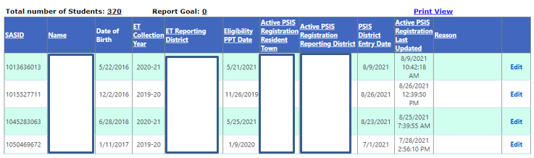

Private Pay Eligible Student Records

This report displays a student list with Eligibility status of Yes - students that are reported as Private Pay.

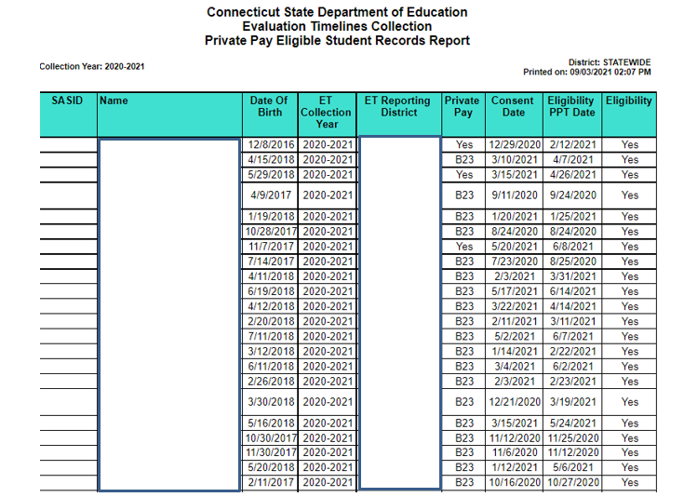

Birth to Three NOT Eligible – Follow-up Communication with Family Required (P.A. 21-46)
This report displays a count of students who were referred through the Birth to Three system and were found Not Eligible for Special Education. This report was created to comply with PA 21-46 which requires LEAs to contact the parents of any child who has not been registered for a developmental screening both at six months and one year.
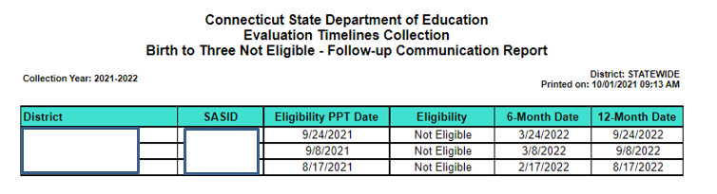

Reason for Delay Review

This report displays a count for each reason for delay with drill down to students that were reported with each reason for delay.

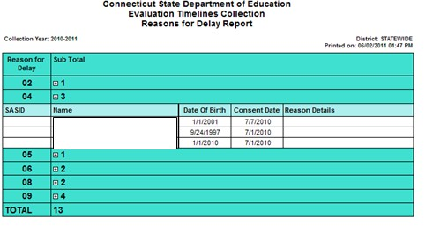

Student Data for Download

Download Student List for Analysis

This report provides your district with all data for each student record reported in your district, including calculated Evaluation Timelines fields, such as DAYS TO EVALUATE. This Exports to an excel (.XLS) file. Below are the fields (Column headers) that will be exported.

SASID | Last Name | First Name | Middle Name | Date Of Birth | Private Pay
Reporting  District | Referral ID | Eligibility | Date Of  Referral | Date Of  Parental Consent To Evaluate | Date Of  Eligibility PPT
Date Of  Eligibility PPT | Days To  Evaluate | Reason For  Delay | Reason Details | Denial Of Basic  Rights | Corrective  Action
District Student  ID | Date Created | Date Updated | Evaluated On  Time | Federal  Reporting  Indicator | Federal  Reporting  Change Date
Collection Year | Record Status | Consent + 60  Days Date | Foster Care  Indicator | SDE Review  Needed

Download Student Evaluation Data

This report provides your district with a file containing all of the submitted data for Evaluation Timelines, including the assigned REFERRAL ID. The format contains only collected fields in the same format as the upload record layout so this data may be imported back into any local system used to collect data at the LEA. This data may be downloaded for local maintenance and later uploaded for use in the next collection period. Below are the fields (Column Headers) that will be exported in the .xls file.

District ID | Private Pay | SASID | Referral ID | Formal Last  Name | Formal First  Name
Formal Middle  Name | Date Of Birth | Date Of  Referral | Date Of  Parental  Consent | Date Of  Eligibility PPT | Eligible?
Reason For  Delay | Reason - Other | Denial Of Basic  Rights | Corrective  Action | District Student  ID | End Of Record  Marker

Data Cleaning

SPP Indicator 11 Summary Report

This report displays the calculated percentage for Indicator 11 for your district and supporting aggregate data, based on the current data reported for this collection year.

Number of student records, then separated for Public and Private Pay records:
On-time Evaluations count
o Complete on-time plus Complete with acceptable reasons
Late Evaluations count
o Complete Beyond Timeline plus all Incomplete
Moved count
o Evaluations with a status of Moved
Parental Consents Received count
o Parental Consents Received minus Moved
Percentage
o On-time Evaluations divided by Parental Consents Received multiplied by 100

Number of student records for each status:
Complete
Complete Beyond Timeline
Moved
Incomplete
Incomplete Beyond Timeline
Total Evaluations

Number of days beyond the timeline for student records with a status of Complete Beyond Timeline

o Lowest number of days beyond timeline

o Highest number of days beyond timeline

NOTE: Incomplete and Moved status records are not considered in number of days.

Number of student records with a Denial of Basic Rights
Complete Beyond Timeline evaluations with a Denial of Basic Rights
Number of student records for each Reason for Delay
Complete Beyond Timeline or Incomplete Beyond Timeline evaluations with a
Reason for Delay

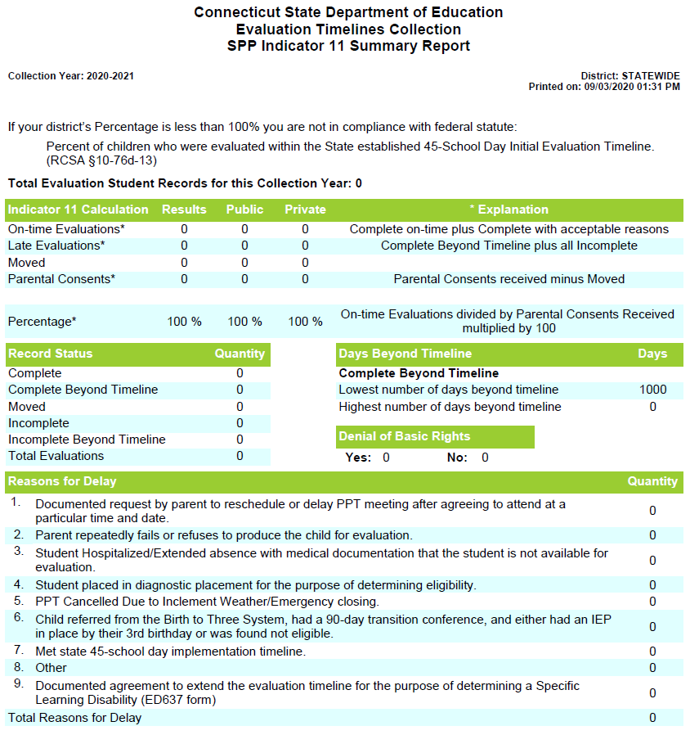

Certification Confirmation Report

This report is available after your district has certified your end of year data submission, and provides a copy of the results of this certification. If your calculated percentage was less than
100%, the citation and corrective action is presented for your records.

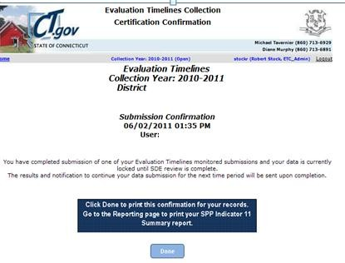This report is as-of your last certification for this collection year. If you have had your collection decertified, made any changes and recertified, this report is replaced with the last certification results. Please discard prior versions of this report, and save the most recent for your records.

Procedures

How to Access the Evaluation Timelines System

Prerequisites
• Authorization for the State of Connecticut Department of Education District website at https://www.csde.state.ct.us/
• Authorization for the Evaluation Timeline system

Step Action

1 Using Internet Explorer, go to https://www.csde.state.ct.us/. The system displays the State
Department of Education Home Page.

2 Select the ENTER button. The system displays the Connect to sdectw.doit.state.ct.us network login screen.

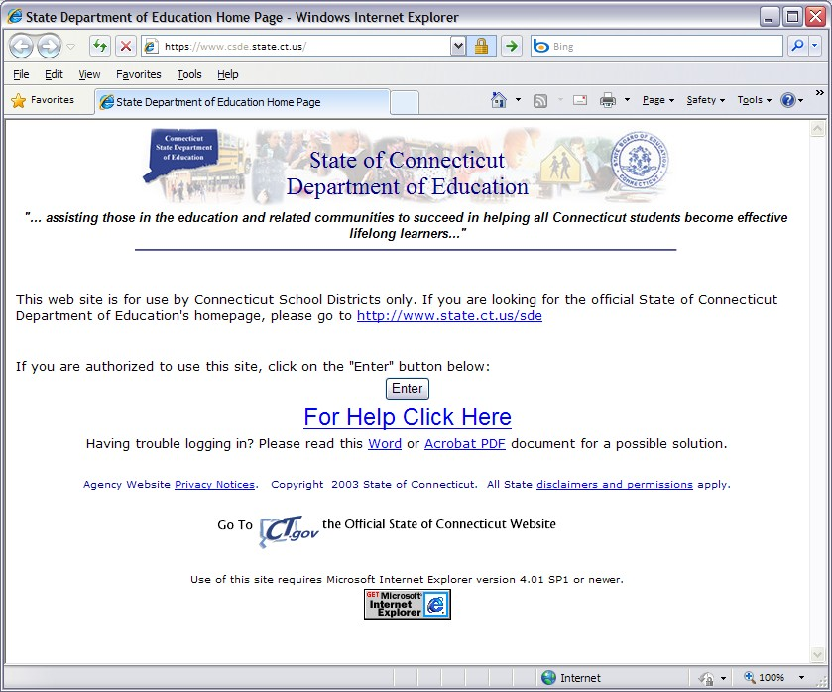

How to Access the Evaluation Timelines System (continued)

3 Enter your network User name and Password and select OK. If you are using Windows 7 or later, preface your User name with sdectw\ (Username is entered as sdectw\username). The system displays the State Department of Education Home Page.

NOTE: These are different login credentials than the ones used to log in to ETC system after this screen.

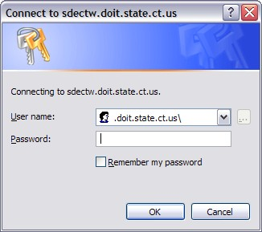

NOTE: If you do not have a network user name or password, please contact your Superintendent for authorization procedures.

4 Select the Performance Office: Evaluation Timelines Compliance menu option. The system displays the Evaluation Timelines Login screen.

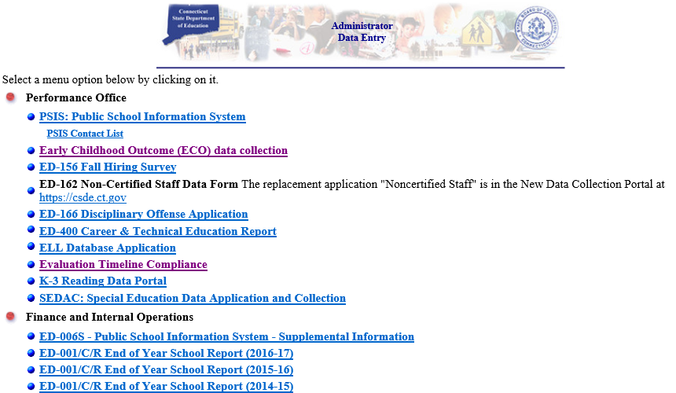

How to Access the Evaluation Timelines System (continued)

5 Enter your USER NAME and PASSWORD and select Log In. The system displays the
Evaluation Timelines welcome screen.

NOTE: District Directors have a login for the Certifier Role that gives them the ability to certify district data. Data Writers have different login credentials that allow for the entry or submission of data, but no certification.

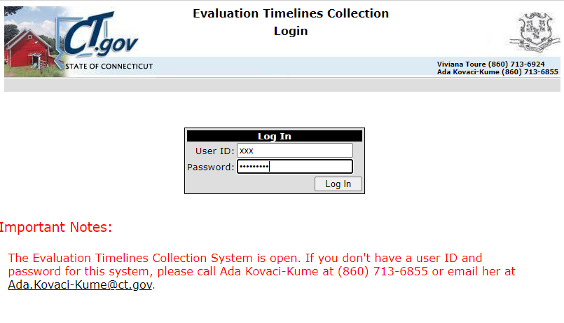

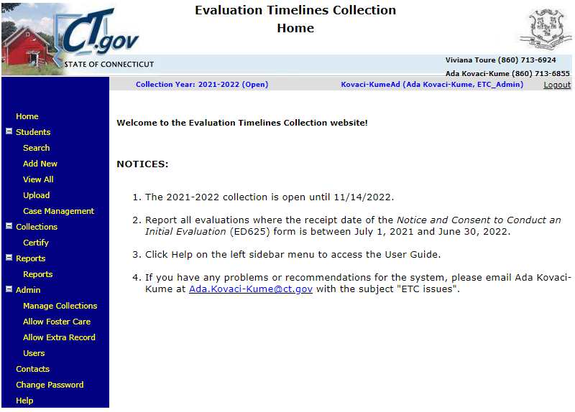

NOTE: If you do not have an Evaluation Timelines User ID or you need your Password reset, please contact the CSDE Evaluation Timelines Data Manager.

6 This procedure is complete.

How to Add an Individual Student Record

Use this procedure to create a new student record for public students or private pay children in your district.

Prerequisites
Access to the Evaluation Timeline system
Evaluation Timeline Collection open for the date range of your DATE OF PARENTAL CONSENT
TO EVALUATE
Your district has not yet certified the Evaluation Timelines Collection
The following data for a Public school student
o Student registered in PSIS in your Reporting District or Resident Town
o SASID
o DATE OF BIRTH
o DATE OF PARENTAL CONSENT TO EVALUATE between the PSIS REGISTRATION
DISTRICT ENTRY DATE and DISTRICT EXIT DATE
o DATE OF REFERRAL
The following data for Private Pay, not referred from Birth-to-Three
o SASID (optional)
o LAST NAME
o FIRST NAME
o DATE OF BIRTH
o DATE OF PARENTAL CONSENT TO EVALUATE
o DATE OF REFERRAL
The following data for Private Pay, Birth-to-Three
o SASID
o LAST NAME
o FIRST NAME
o DATE OF BIRTH
o DATE OF PARENTAL CONSENT TO EVALUATE
o DATE OF REFERRAL
No prior reported student evaluations where the student was found eligible
- Unless your new student record has an earlier DATE OF PARENTAL CONSENT TO EVALUATE.

How to Add an Individual Student Record (continued)

Step Action

NOTE: While following procedures contained in this guide, always proceed to the next step if not directed to go to another step.

1 Using the navigation menu on the left of the screen, select the Add New menu option. The system displays the Add Individual screen.

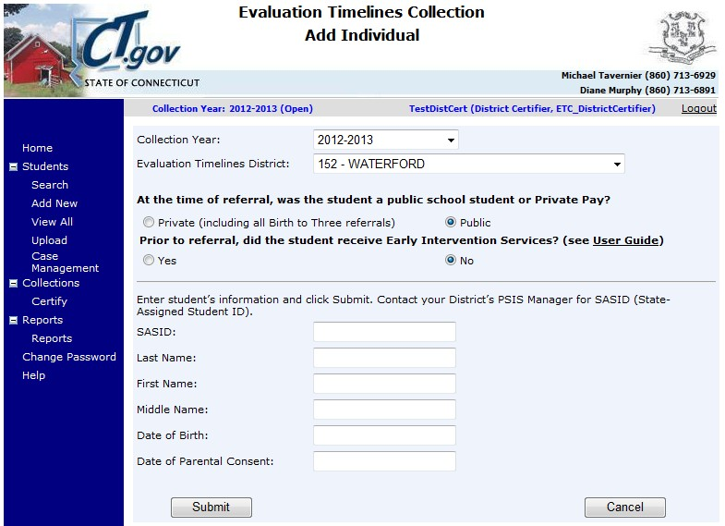

2 At the time of referral, was the student a public-school student or Private Pay?

➢ Private Pay - Go to Step 3.

➢ Public - Go to Step 6.

3 A dialog will appear with the question, “Was the student in Birth to Three on the date of Parental
Consent?” Click Yes or No to continue.

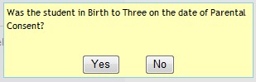

4 Enter the Private Pay student’s information and select Submit. The system displays the student information for your confirmation.
SASID (Required for referred from Birth-to-Three system; optional for Private Pay)
LAST NAME
FIRST NAME
DATE OF BIRTH
DATE OF PARENTAL CONSENT TO EVALUATE
5 Did you enter a SASID?
➢ Yes - Go to Step 7.
➢ No - Verify the student information that you entered is accurate and go to Step 7.

How to Add an Individual Student Record (continued)

6 Enter the Public school student’s information and select Submit.
SASID
DATE OF BIRTH
DATE OF PARENTAL CONSENT TO EVALUATE

7 Was a matching student found in PSIS REGISTRATION and is the information displayed for your confirmation?

➢ Yes - Verify the PSIS student information displayed matches your student. Go to Step 7.

➢ No, and the student is in Foster Care and is serviced by your district, but lives in another district - Contact the SDE Evaluation Timelines Data Manager for authorization to add this student to your district’s collection. This procedure is complete. Return to these procedures, and follow the How to Add a Foster Care Student not in my District procedure.

➢ No - Contact your PSIS Data Manager to determine why the student is not registered in PSIS or the data you have entered does not match in PSIS Registration. This procedure is complete. Return to Step 1 when errors are resolved.
Possible errors:
- Cannot add or update any evaluation in a Certified District. Must call SDE
Data Support line to decertify.
- Cannot be a future date.
- Date of Birth is required.
- Date of Parental Consent does not fall within the Consent Start and End
Dates of the selected Collection Year.
- Date of Parental Consent to Evaluate is required.
- Date of Referral must be on or before Date of Parental Consent.
- District or resident town must be selected.
- First Name is required.
- Invalid date format.
- Last Name is required.
- Please enter the Date of Birth.
- No student was found with matching SASID and DOB and your District as
Reporting District or Resident Town. Check SASID and DOB.
- No student was found with matching SASID and DOB. Check SASID and
DOB.
- Referral Date is required.
- SASID is required.
- SASID must be a 10 digit number.
- The student has your District as Resident Town, but Reporting district is not a Public District. The student can only be reported as Private.
- Date of Parental Consent to evaluate (ED625) is prior to the District Entry Date in PSIS. Should student be reported as PRIVATE PAY?
- Eligible record previously reported for this student. If student returned to general education and is re-referred you need send an email to SDE Data Manager and request an extra record, include SASID, date student returned to general education and date student was re-referred. SDE Data Manager will review/allow extra record, reply to email and district can re-upload data.

How to Add an Individual Student Record (continued)

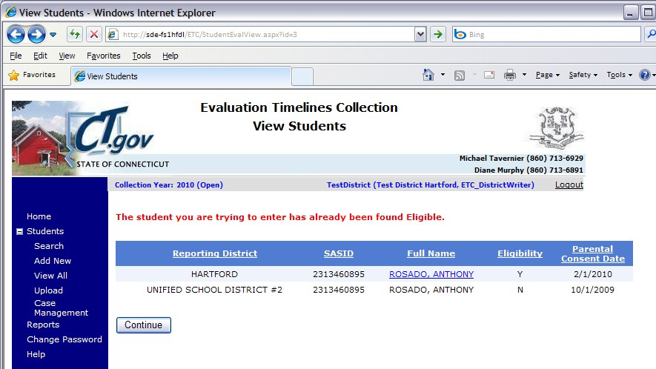8 Was another Evaluation Timeline record found for this student?

➢ Yes - Which message is displayed?

The student you are trying to enter has an incomplete record. Click the student’s name to edit the record or the student you are trying to enter has an incomplete record in another district.

To change the existing student record in your district, click the student’s name and use the How to Change an Individual Student Record procedure. This procedure is complete.

The student you are trying to enter has already been found Eligible or The student you are trying to enter has already been found Eligible and the Parental Consent Date of the record you are trying to add is after the existing record’s Parental Consent Date or The student you are trying to enter has already been found Eligible in other district.

- You may add another student record if the DATE OF PARENTAL CONSENT TO EVALUATE is less than the consent date for the existing student record. To add another student record, select Continue and go to Step 8.

If this or another student record exists already in your district, you may select to edit this record. To change the existing student record, select the student’s name and use the How to Change an Individual Student Record procedure. This procedure is complete.

The student you are trying to enter already has a record with a status of Not Eligible or Moved or The student you are trying to enter already has a record with a status of Not Eligible or Moved and the same Date of Parental Consent to Evaluate.

- To add another student record with a different DATE OF PARENTAL CONSENT TO EVALUATE, select Continue and go to Step 9.

How to Add an Individual Student Record (continued)

To change the existing student record, click the student’s name and use the How to Change an Individual Student Record procedure. This procedure is complete.

➢ No - Go to Step 9.

9 You have selected to add a student record.

➢ The system displays a list of fields for your verification.
SASID
LAST NAME
FIRST NAME
DATE OF BIRTH
PRIVATE PAY

➢ Enter the following data for the selected student.
DATE OF REFERRAL
DATE OF ELIGIBILITY PPT
ELIGIBILITY
DISTRICT STUDENT ID (optional)

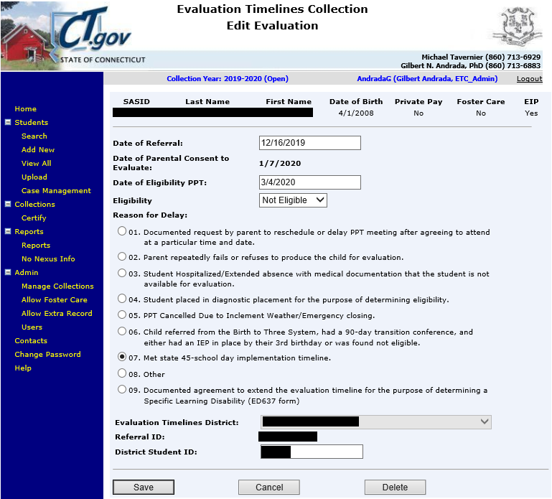
How to Add an Individual Student Record (continued)

10 Select the REASON FOR DELAY of this student record. Required for every record.

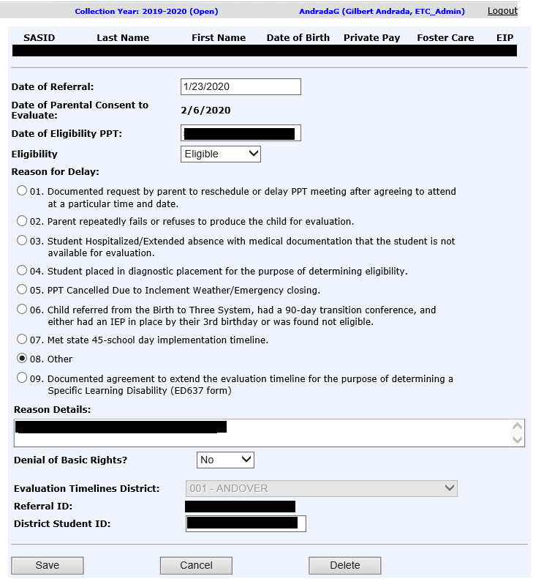➢

11 Did you select a REASON FOR DELAY of 08-Other?

➢ Yes - Enter a description of the reason for delay. This record reflects noncompliance.
Was the student denied basic rights due to delay in the evaluation process?

- Yes - Select Yes for DENIAL OF BASIC RIGHTS. The system enables the
CORRECTIVE ACTION field. Go to Step 12.

- No - Select No for DENIAL OF BASIC RIGHTS. Go to Step 13.

➢ No - Your student record is complete. Go to Step 13.

12 If Denial of Basic Rights = Yes, enter a CORRECTIVE ACTION describing the actions your district has taken or will take to correct the noncompliance.

13 Select Save. The system displays a confirmation that your student record was added successfully along with the assigned REFERRAL ID.

How to Add an Individual Student Record (continued)

14 Are errors displayed instead of the confirmation message?

➢ Yes -

- A Denial of Basic Rights value is required if “Other” is the Reason for Delay. Please select a value for Denial of Basic Rights.
- A text description of Corrective Action is required if Denial of Basic Rights is “Yes”.
Please enter a description in Corrective Action.
- A text explanation is required in Reason Details if “Other” is selected in Reason for
Delay.
- An Eligibility value is required if a Date of Eligibility PPT is provided. Please select
an Eligibility value.
- Date of Eligibility PPT cannot be before Date of Parental Consent to Evaluate.
- Date of Eligibility PPT is required if Eligibility is set to “Eligible” or “Not Eligible”.
Please enter a Date of Eligibility PPT.
- Date of Eligibility PPT must be blank if Eligible = Moved. Change ELIGIBILITY or
delete Date of Eligibility PPT.
- Date of Parental Consent to evaluate cannot be before Date of Referral.
- Delay Reason Details must be blank if “Other” is not selected in Reason for Delay.
- Description of Corrective Action has more than 200 characters.
- Description of Corrective Action must be blank if Denial of Basic Rights “Yes” is not
selected.
- Description of Corrective Action must be blank if “Other” is not selected in the
Reason for Delay.
- Found Eligible? (=Yes) for the student exists with an earlier date of Parental
Consent.
- If eligibility equals Moved, PPT date is not allowed.
- Invalid code for Reason for Delay.
- Reason for Delay - Other has more than 200 characters.
- The value of Denial of Basic Rights must be blank if “Other” is selected in Reason
for Delay.
- The Date of Eligibility PPT in Reason for Delay 6 cannot be more than 3 years past
the Date of birth

➢ No - This procedure is complete.

15 Correct each field entered in error and go to Step 9 until you have no more error messages.

16 This procedure is complete.

How to Add a Foster Care Student not in my District

Use this procedure to create a new student record for a public student that no longer resides in your district because of placement in foster care, but is still your nexus based on fiscal responsibility.

Prerequisites
Access to the Evaluation Timeline system
Evaluation Timeline Collection open for the date range of your DATE OF PARENTAL CONSENT
TO EVALUATE
Your district has not yet certified the Evaluation Timelines Collection
The following data for a Public school student
o SASID
o DATE OF BIRTH
o DATE OF REFERRAL
No prior reported student evaluations where the student was found eligible
o Unless your new student record has an earlier DATE OF PARENTAL CONSENT TO EVALUATE
Contact with CSDE Evaluation Timelines Data Managers for authorization to add this student to
your district’s collection

Step Action

1 Using the navigation menu on the left of the screen, select the Add Foster Care menu option.
The system displays the Add Foster Care screen. Click your browser’s Refresh button if you
cannot see the Add Foster Care menu option.
NOTE: If the Add Foster Care menu option is not displayed, and you have already contacted CSDE for authorization to add your student record, then verify your Collection Year, in the header of the screen, displays the year in which you asked for authorization. If it is not the same, then select either View All or Add New and select the proper year. The system now displays the Add Foster Care menu option. Select the menu option.

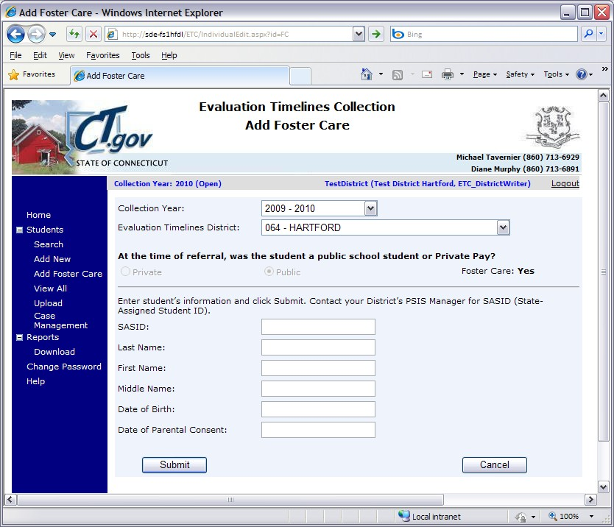
How to Add a Foster Care Student not in my District (continued)

2 Enter the Public school student’s information and select Submit.
• SASID
• DATE OF BIRTH
• DATE OF PARENTAL CONSENT TO EVALUATE

3 Was a matching student found in PSIS REGISTRATION and is the information displayed for your confirmation?

➢ Yes - Verify the PSIS student information displayed matches your student.

➢ No - Contact your PSIS Data Manager to determine why the student is not registered in PSIS or the data you have entered does not match in PSIS Registration. This procedure is complete. Return to Step 1 when errors are resolved.

Possible errors:
- This SASID is not authorized for Foster Care entry. Verify the SASID and
contact SDE if needed.
- Cannot add or update any evaluation in a Certified District. Must call SDE Data Support line to decertify.
- Cannot be a future date.
- Date of Birth is required.
- Date of Parental Consent does not fall within the Consent Start and End
Dates of the selected Collection Year.
- Date of Parental Consent to Evaluate is required.
- Date of Referral must be on or before Date of Parental Consent.
- District or resident town must be selected.
- First Name is required.
- Invalid date format.
- Last Name is required.
- No student was found with matching SASID and DOB. Check SASID and
DOB.
- Referral Date is required.
- SASID is required.
- SASID must be a 10 digit number.
- The student has your District as Resident Town, but Reporting district is not a Public District. The student can only be reported as Private.

4 Was another Evaluation Timeline record found for this student?

How to Add a Foster Care Student not in my District (continued)

➢ Yes - Which message is displayed?

• The student you are trying to enter has an incomplete record. Click the student’s name to edit the record or The student you are trying to enter has an incomplete record in another district.

To change the existing student record in your district, select Edit and use the How to Change an Individual Student Record procedure. This procedure is complete.
• The student you are trying to enter has already been found Eligible or
• The student you are trying to enter has already been found Eligible and the Parental Consent Date of the record you are trying to add is after the existing record’s Parental Consent Date or

• The student you are trying to enter has already been found Eligible in other district.

- You may add another student record if the DATE OF PARENTAL CONSENT TO EVALUATE is less than the consent date for the existing student record. To add another student record, select Continue and go to Step 8.

If this or another student record exists already in your district, you may select to edit this record. To change the existing student record, select
Edit and use the How to Change an Individual Student Record procedure.
This procedure is complete.

• The student you are trying to enter already has a record with a status of Not Eligible or Moved or The student you are trying to enter already has a record with a status of Not Eligible or Moved and the same Date of Parental Consent to Evaluate.

- To add another student record with a different DATE OF PARENTAL CONSENT TO EVALUATE, select Continue and go to Step 8.

To change the existing student record, select Edit and use the How to Change an Individual Student Record procedure. This procedure is complete.

➢ No - Go to Step 8.

5 You have selected to add a student record.

➢ The system displays a list of fields for your verification.
SASID
LAST NAME
FIRST NAME
DATE OF BIRTH
PRIVATE PAY

How to Add a Foster Care Student not in my District (continued)

➢ Enter the following data for the selected student.
DATE OF REFERRAL
DATE OF ELIGIBILITY PPT
ELIGIBILITY
DISTRICT STUDENT ID (optional)

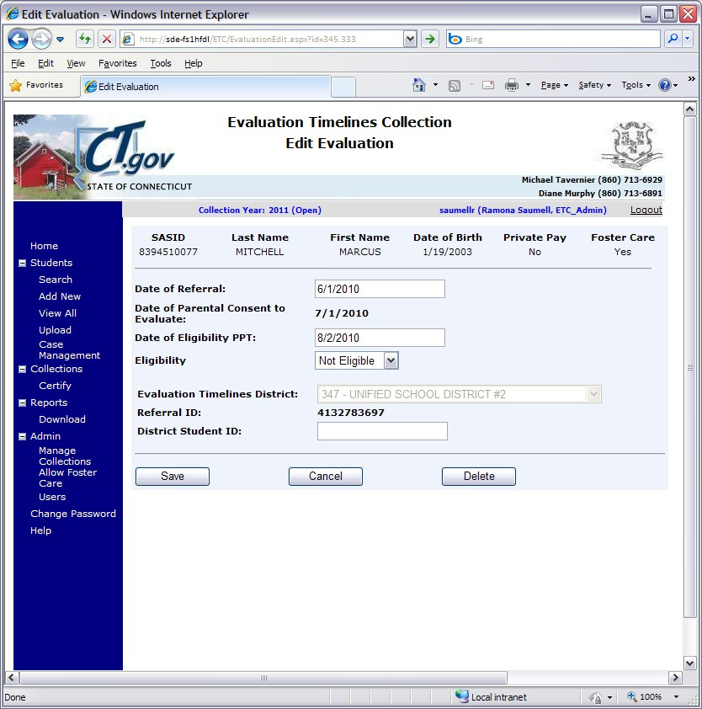

6 Is your DATE OF ELIGIBILITY PPT more than 60 days after the DATE OF PARENTAL CONSENT TO EVALUATE?

➢ Yes - Select the REASON FOR DELAY of this student record.

➢ No - Go to Step 12.

7 Did you select a REASON FOR DELAY of 08-Other?

➢ Yes - Enter a description of the reason for delay. Your student record does not comply with
IDEA.
• Was the student denied basic rights due to delay in the evaluation process?

- Yes - Select Yes for DENIAL OF BASIC RIGHTS. The system enables the
CORRECTIVE ACTION field. Go to Step 11.

- No - Select No for DENIAL OF BASIC RIGHTS. Go to Step 12.
How to Add a Foster Care Student not in my District (continued)

➢ No - Your student record is in compliance. Go to Step 12.

8 Enter a CORRECTIVE ACTION describing the actions your district has taken or will take to correct the noncompliance.

9 Select Save. The system displays a confirmation that your student record was added successfully along with the assigned REFERRAL ID.

10 Are errors displayed instead of the confirmation message?

➢ Yes -

• A Denial of Basic Rights value is required if “Other” is the Reason for Delay. Please select a value for Denial of Basic Rights.
• A text description of Corrective Action is required if Denial of Basic Rights is “Yes”.
Please enter a description in Corrective Action.
• A text explanation is required in Reason Details if “Other” is selected in Reason for
Delay.
• An Eligibility value is required if a Date of Eligibility PPT is provided. Please select
an Eligibility value.
• Date of Eligibility PPT cannot be before Date of Parental Consent to Evaluate.
• Date of Eligibility PPT is required if Eligibility is set to “Eligible” or “Not Eligible”.
Please enter a Date of Eligibility PPT.
• Date of Parental Consent to evaluate cannot be before Date of Referral.
• Delay Reason Details must be blank if “Other” is not selected in Reason for Delay.
• Description of Corrective Action has more than 200 characters.
• Description of Corrective Action must be blank if Denial of Basic Rights “Yes” is not
selected.
• Description of Corrective Action must be blank if “Other” is not selected in the
Reason for Delay.
• Found Eligible? (=Yes) for the student exists with an earlier date of Parental
Consent.
• If eligibility equals Moved, PPT date is not allowed.
• Invalid code for Reason for Delay.
• Reason for Delay - Other has more than 200 characters.
• The value of Denial of Basic Rights must be blank if “Other” is selected in Reason
for Delay.
• If Reason for delay is 6 and the date of Eligibility PPT is greater than the Date of
birth by three years Show error message: In order to use justifiable reason for
delay 6, the PPT to determine eligibility must be held on or before the child’s third
birthday.

➢ No - This procedure is complete.

11 Correct each field entered in error and go to Step 8 until you have no more error messages.

12 This procedure is complete.

How to Change an Individual Student Record

Use this procedure to change student data reported for public students or private pay children in your district.

Prerequisites
• Access to the Evaluation Timeline system
• Your district has not yet certified the Evaluation Timelines Collection

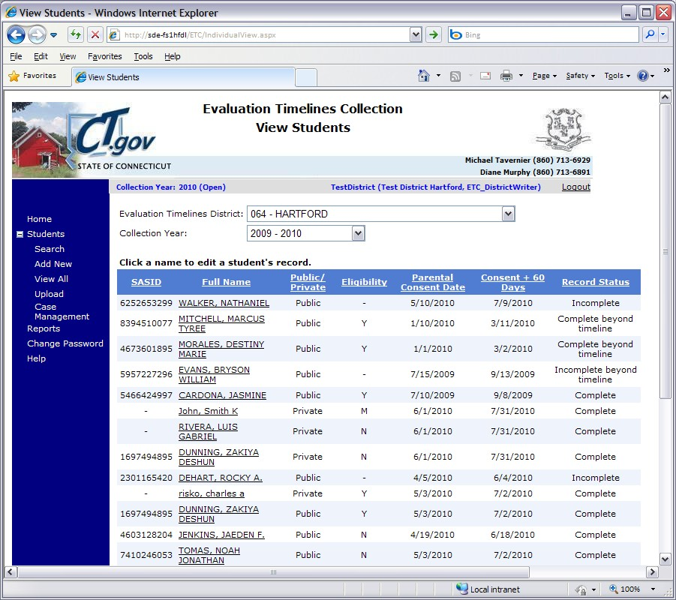Step Action

1 Using the navigation menu on the left of the screen, select the View All menu option. The system displays the View Students screen.

2 Select the FULL NAME link for the student record you need to change. The system displays the
Edit Evaluation screen

3 You have selected to change a student record.

➢ The system displays a list of fields for your verification.
SASID
LAST NAME
FIRST NAME
DATE OF BIRTH
PRIVATE PAY
DATE OF REFERRAL
DISTRICT STUDENT ID
How to Change an Individual Student Record (continued)

➢ Enter or change the following data for the selected student.
DATE OF REFERRAL
DATE OF ELIGIBILITY PPT
ELIGIBILITY
DISTRICT STUDENT ID
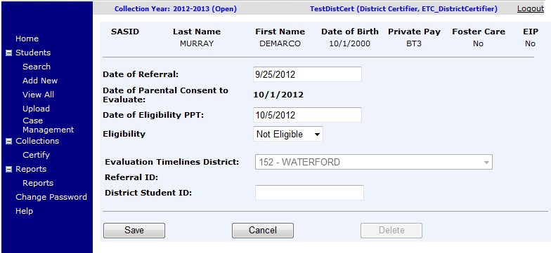

4 The system displays the REASON FOR DELAY and related fields. Select the
REASON FOR DELAY of this student record.

5 Did you select a REASON FOR DELAY of 08-Other?

➢ Yes - Enter a description of the reason for delay. Your student record does not comply with
IDEA.
• Was the student denied basic rights due to delay in the evaluation process?

- Yes - Select Yes for DENIAL OF BASIC RIGHTS. The system enables the
CORRECTIVE ACTION field. Go to Step 6.

- No - Select No for DENIAL OF BASIC RIGHTS. Go to Step 7.

➢ No - Your student record is in compliance. Go to Step 7.

6 Enter a CORRECTIVE ACTION describing the actions your district has taken or will take to correct the noncompliance.

7 Select Save. The system displays a confirmation that your student record was added successfully along with the assigned REFERRAL ID.

8 Are errors displayed instead of the confirmation message?

9 Correct each field entered in error and go to Step 3 until you have no more error messages.

10 This procedure is complete.

How to Upload a Group of Student Records

Prerequisites
- Your computer has the technical requirements to upload a file
- Verification your file is in proper format (Review the Evaluation Timelines Record Layout
section of this document for details on format and required data).
- All required fields are complete for each record in your file (at a minimum, Date of Referral and Date of Parental Consent are included). If one record fails edits, the whole file will be rejected and no data saved.
- Any entries in your file that contain changes to an existing record require the REFERRAL ID from the original entry, or an exact match of REPORTING DISTRICT, SASID, DATE OF BIRTH and DATE OF PARENTAL CONSENT TO EVALUATE.
- Evaluation student records must be complete, with Eligibility and Eligibility PPT Date.

Step Action

1 Using your worksheet program, save the file as a CSV file type by selecting Save As.

NOTE: The following screens are from Microsoft Office 2007. Your version may be different and therefore the steps may differ.

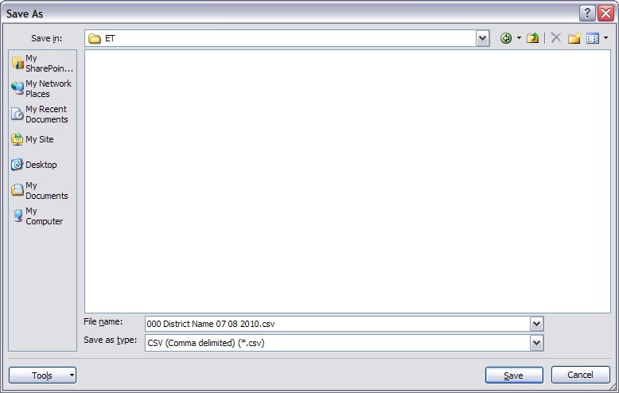

2 If your worksheet contains multiple sheets, the system displays the following message.

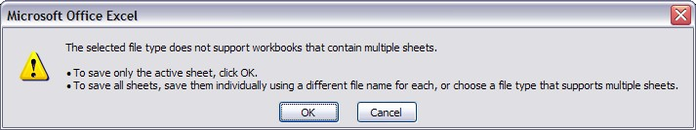

3 Select OK. The system continues the saving of the file and displays the following message.
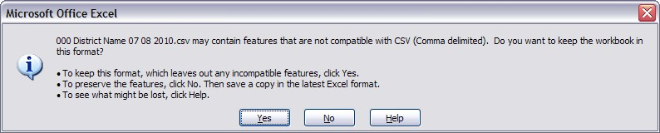

How to Upload a Group of Student Records (continued)

4 Select Yes. The system saves the file into the folder selected in Step 1.

5 Close the worksheet. The system displays the following message.
IMPORTANT: Do not forget to close the file. If you do not close the file, you may receive CSV file errors when attempting to upload into Evaluation Timelines.

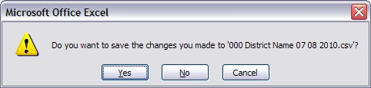

6 Select No. The system closes your file so that it is ready to upload.
IMPORTANT: If you select Yes instead, the file will need to be saved again, which may cause issues with the format. If you select Cancel, the file will not be closed, and therefore not accessible by Evaluation Timelines.

7 Using the navigation menu on the left of the screen, select the Upload menu option. The system displays the Upload Evaluation screen.

8 Select Browse and locate the file to upload. The system displays the Choose File to Upload dialog screen.

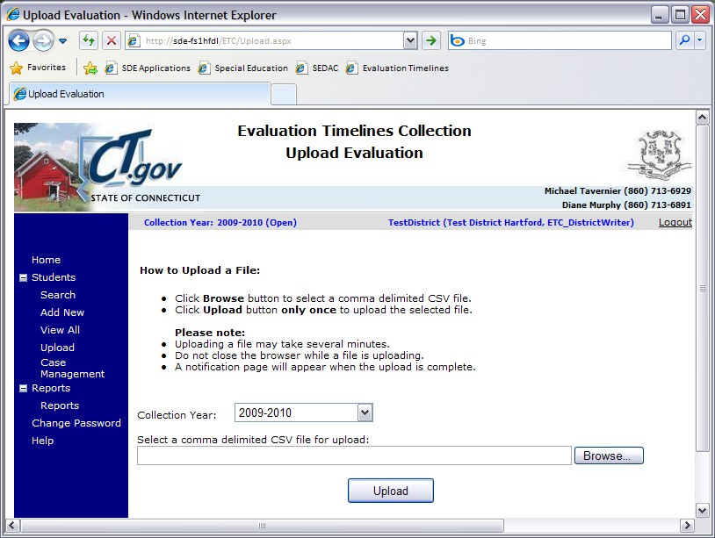

9 Locate and select your file and select Open. The system returns to the Upload Evaluation screen.
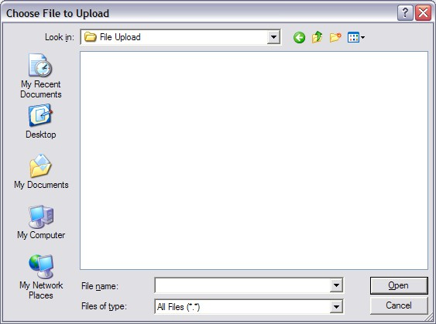
How to Upload a Group of Student Records (continued)

10 Select Upload. The system displays the Upload Results screen. Any errors encountered will be displayed on this screen.
CAUTION: Do not remove any student data from this file if errors were received. At this time, if one error occurred, the whole file was rejected.
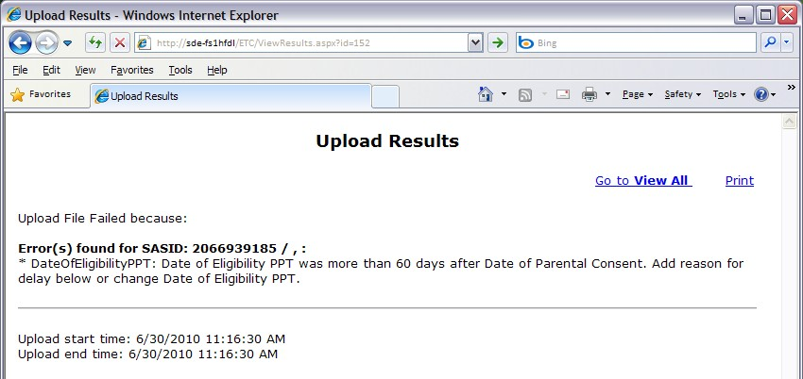

REMEMBER: If you do not print or save the errors displayed on the screen, you will need to re-run the upload to get the errors again. They are not saved on a report you can access at this time.

11 Select Print to print your errors. You may also copy and paste the data displayed into a separate file. Once you have resolved each of the errors in your data file, upload the file again.

12 Once your errors are resolved and you have uploaded the file again, the system displays the
Upload Results screen with a message indicating your upload was successful.

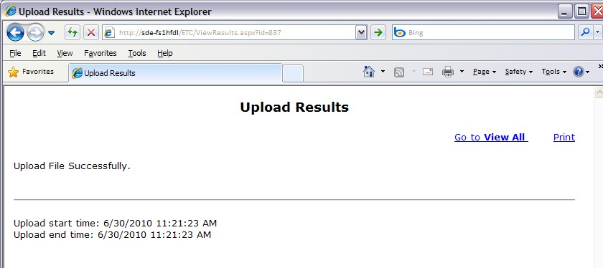

13 Select Go to View All to return to Evaluation Timelines to review your student data.

14 This procedure is complete.

How to Certify Your District’s End of Year Data Submission

Prerequisites
- Access to Evaluation Timelines with District Certifier authorization
- Today is after June 30th of the collection year.
- Each student record reported must have a RECORD STATUS of Complete or Complete
Beyond Timeline.
NOTE: Districts that have no reported data still must certify.

- Review your SPP Indicator 11 Summary Report, and each Data Cleaning report to analyze and verify your data are accurate and complete.

Step Action

1 Using the navigation menu on the left of the screen, select the Certify menu option. The system displays the Certify Evaluation screen.

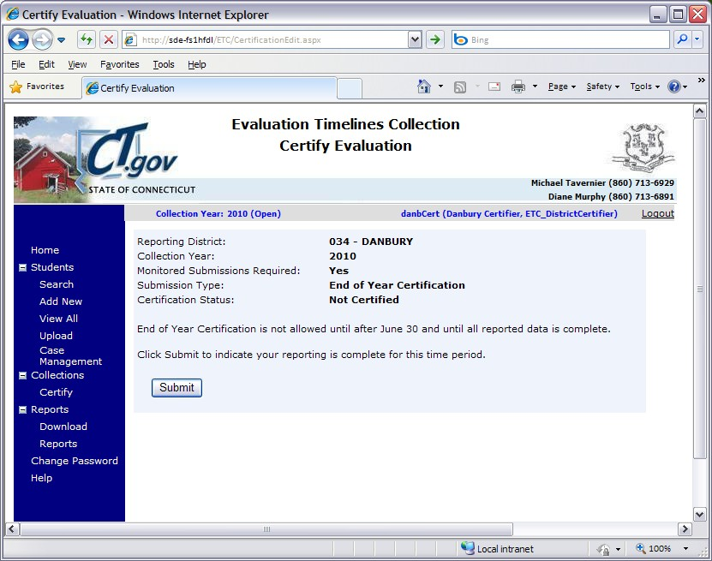
REMEMBER: Certification is available after June 30 of the collection year.

2 Select Submit to complete your reporting for this collection year. The system displays the Certify Confirmation screen. On the certification screen, during the time period of July 1 to June 30, the SUBMISSION TYPE displayed is Monitoring; and after June 30 until federal reporting is complete, the SUBMISSION TYPE displayed is End of Year Certification.
How to Certify your District’s Reported Data (continued)

3 Is your percentage of completed on-time evaluations 100%?

➢ Yes - Your certification is complete. Proceed to the next step to print the Certification
Confirmation report.
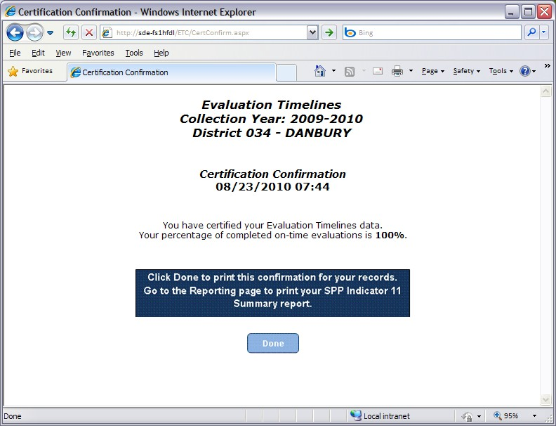

NOTE: This information may be reprinted after certification, from the Reports menu.

➢ No - Your district is out of compliance with the Connecticut State Performance Plan (SPP), Indicator 11. Your district has been cited and you are required to report individualized student data for monitored submission review using the Evaluation Timelines for the next collection year. Proceed to the next step to print and review the instructions on the Certification Confirmation report.

4 Select Done to print this confirmation for your records. The system displays the Print screen.

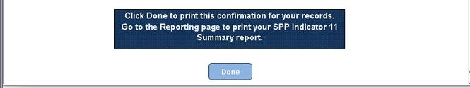

5 Select your printer and select Print and retrieve your documents from the selected printer.

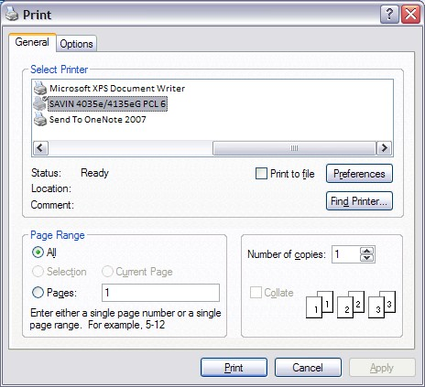

6 Select Home from the header of the screen to return to Evaluation Timelines or Logout to exit the system.
7 This procedure is complete.

How to Complete a Monitored Submission

Prerequisites
- Access to Evaluation Timelines with District Certifier authorization
- Your district is required to submit data every two months for administrative monitoring, due to
prior year noncompliance.
- Review your SPP Indicator 11 Summary Report, and each Data Cleaning report to analyze and verify your data is accurate and complete.

o It is recommended that each student record be complete for the designated DATE OF PARENTAL CONSENT TO EVALUATE range for this reporting period.

Step Action

1 Using the navigation menu on the left of the screen, select the Certify menu option. The system displays the Certify Evaluation screen.

REMEMBER: Monitored Submission is available for designated districts after November 15 of the collection year.
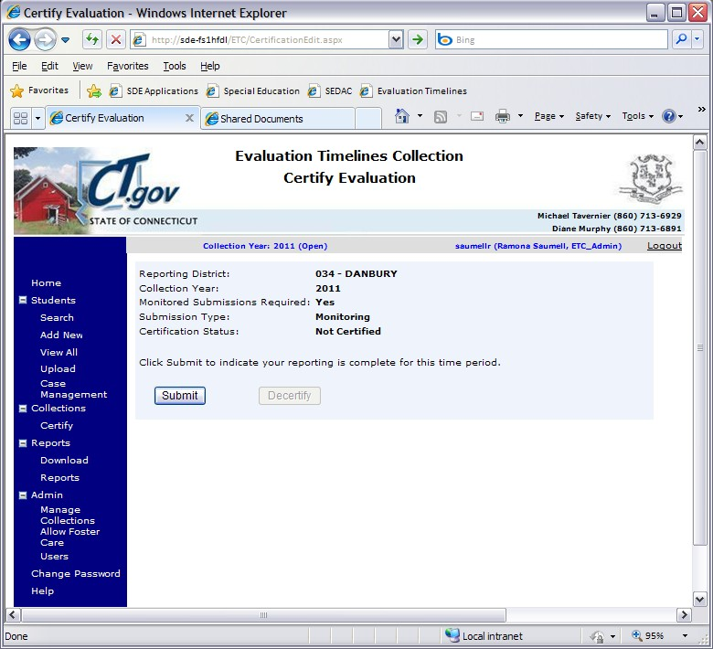

2 Select Submit to complete your reporting for this reporting period. The system displays the
Submission Confirmation screen.
How to Complete a monitored Submission (continued)

3 Select Done to print this confirmation page and the SPP Indicator 11 Summary report for your records. The system displays the Print screen.

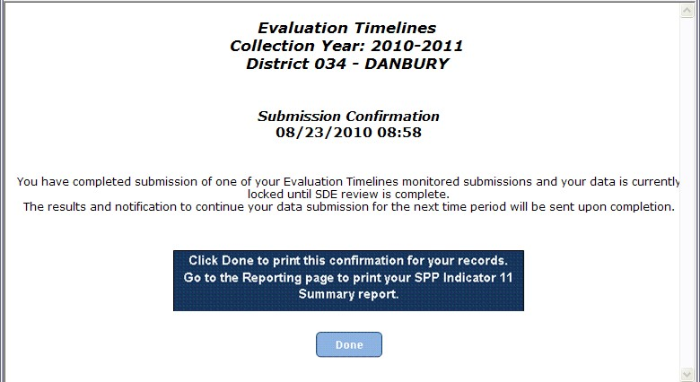

4 Select your printer and select Print and retrieve your documents from the selected printer.

5 This procedure is complete.

FAQs

General Questions

? Why do I have to report individual student data?

Federal law requires follow-up on every child-specific incidence of non-compliance. The previous aggregate collection did not accommodate this requirement.

? When should you obtain a SASID?

After you have evaluated, found eligible and determined you will be servicing a student. It is important to remember, if the parent requests delayed entry into school, you will obtain a SASID when the student is enrolled in your district and scheduled to start school. (e.g., a preschool student is found eligible on March 3rd, parent opts to delay entry until first day of school in September; a home schooled student is found eligible on Dec. 15th, parent opts to delay entry until first day of school in January; or a private school student is found eligible on June 5th, parent opts to delay entry until first day of school in September.)
Vendors cannot require SASIDs. Under NO circumstances should a student – whom has not yet been found eligible – be registered and unregistered in PSIS in order to obtain a SASID.
  - However, there are Birth to Three Notifications located in SEDAC under Mandatory Off-cycle Reports. The report is provided by the Office of Early Childhood (OEC), and notifies school districts about all children enrolled in Birth to Three who either reside in their district or who have nexus with their district (as determined by the Department of Children and Families). All students referred by Birth to Three are required to have a SASID#.
    - If the SEDAC Children with Signed B23 Approval (Form 3-8) to Include LEA report does NOT contain the SASID send us an email (Laura, Diane & Ada) with Subject “B-3 Missing SASID#” and we will reply with the SASID#.
    - If the district received the B-3 referral via email or mail and the student does NOT appear on the SEDAC Children with Signed B23 Approval (Form 3-8) to Include LEA report 1) FAX the B-3 referral to us at 860-326-0547 and 2) send us an email (Laura, Diane & Ada) with Subject “B-3 NOT on report” and we will follow-up with OEC.
  - If a child is not referred from Birth to Three some districts enter a value of “Ref#######” or a zero then the child’s DOB “0#########”.

Which Collection Year

? A student may be referred for evaluation at the end of the school year in which there are fewer than 45 school days left to evaluate, and the evaluation and eligibility determination will take place the following school year. Which year do I report him/her?

The collection a student is reported under is based on the DATE OF PARENTAL CONSENT TO EVALUATE. See the guidance under Collection Period section above.

? When do I have to have my student records completed and certified?

Your timely reporting deadline is typically June 30.
Your accurate reporting deadline is typically November 15.

You will receive an e-mail notifying you when the Evaluation Timelines system is open each collection year.

The system is available 24/7, and each collection will be open from July 1 of the reporting cycle until your district certifies your collection data. We anticipate each collection being open for 18 months.

The DATE OF PARENTAL CONSENT TO EVALUATE of each student must be between July 1 and June 30 for that school year.

Your district will not be able to certify your collection until all student records have a RECORD STATUS of Complete or Complete-Beyond Timeline. See the district certification section above.

When to Report a Student in the Evaluation Timelines Data Collection

? My student is being evaluated to determine ongoing eligibility. Do I report this student in Evaluation Timelines?

No. The purpose of the Evaluation Timelines data collection is to collect initial evaluations only. Any student found eligible will not be reported in Evaluation Timelines for subsequent evaluations.

A re-evaluation is used once a student is found eligible for special education and related services, to determine if the student remains eligible. These are to be tracked and recorded in the student’s IEP and reported to the state through SEDAC.

? My student had previously been evaluated, determined eligible and received services. Since that time, the student was exited and returned to regular education. Circumstances have changed and the student needs another evaluation. Do I report this student in Evaluation Timelines?

Yes. This situation requires a new initial evaluation and is collected within Evaluation Timelines. Note: If a previous ELIGIBLE record exists in the ETC system, districts must contact the CSDE ETC Data Manager with a request to authorize an additional record for the SASID.

? I have not received parental consent to evaluate within 10 days of it being sent, do I report this student in Evaluation Timelines?

No. If a parent fails to provide consent to evaluate within 10 school days and there is no parental request for delay, the LEA may consider this refusal of consent.

The LEA would not include this student in their data submission because there was no parental consent to evaluate, therefore no evaluation provided. This data collection concerns only students with parental consent to evaluate.

? The parent requested an extension before providing consent. Do I report this student in Evaluation Timelines?

Once you have received the parental consent, you may report the student record in Evaluation Timelines.

? The parent revoked their consent after the data was reported in Evaluation
Timelines. How do I remove this student from my collection?

Using the View All menu option, you may select a student and either edit or delete the student’s record.

? What do I report if a parent withdraws their child from public education?

If the student still resides in your district, you still have Child Find responsibilities. Your district should ask the parent if they are interested in continuing the evaluation or would prefer to submit a request to revoke consent for the evaluation. If consent is revoked in writing, do not report the record. If the evaluation proceeds, you must report this record in Evaluation Timelines.

? What do I report if a student moves prior to receiving services, but after the evaluation is complete?

Since the evaluation was completed in your district, you should report the student in Evaluation Timelines with their eligibility determination.

? How do I report a student who “officially” drops out-of-school during the evaluation timeline?

If the child officially drops out of school, (i.e., parent signs drop out papers if aged 16 or 17; student signs drop out papers if age 18 or older), report the child as MOVED.

? How do I report a student who becomes “truant” during the evaluation timeline?

If the child officially becomes truant, immediately implement the appropriate truancy/due process procedures required by state law. If the student eventually reappears in school, complete the evaluation and report the record using REASON FOR DELAY of 02-Parent repeatedly failed/refused to produce the child for evaluation.

If however, the district completes the truancy/due process procedures and has still not located the student, report the child as Not Eligible using the PSIS District Exit Date as DATE OF ELIGIBILITY PPT. If that date is beyond the 45-school day timeline, report REASON FOR DELAY of 02-Parent repeatedly failed/refused to produce the child for evaluation.

? We had a student enroll yesterday for whom an eligibility PPT was not completed by the prior district. The prior district is sending us the documentation. Is this considered a new referral for our district?

Yes. The prior district reports the student with ELIGIBILITY of Moved.

Your district also reports the student and uses the date the student entered your district as the DATE OF REFERRAL and DATE OF PARENTAL CONSENT TO EVALUATE. Evaluation Timelines will measure your compliance with the timeline based on the entry date of the transferred/mid-eligibility determination student.

It is important to note that the IDEA specifically addresses this issue in 34 C.F.R. Section 300.323(e). Essentially, the federal regulation states that the second district must expedite the evaluation as quickly as possible, but is not held to the original consent date for the 45-school day rule. Therefore, one would expect that any case like this would have a very short timeline in the second district and would be well within the count of days for federal compliance.

Which Date to Use

? There are three dates on the Referral to Determine Eligibility for Special Education and Related Services (ED621) form. Which one do I use as the DATE OF REFERRAL?

The Date Received. This date should have been stamped or written on the form in the upper right corner when the document was received by your district.

? If I received a letter of referral instead of the Referral to Determine Eligibility for Special Education and Related Services (ED621) form. What date do I
use for DATE OF REFERRAL?

Use the date the letter was received. This date should have been stamped or written on the letter when the document was received by your district.

? There are three dates on my Notice and Consent to Conduct an Initial Evaluation (ED625) form. Which one do I use as the DATE OF PARENTAL CONSENT TO EVALUATE?

Use either the date that was stamped on the form when it was received, or the date of signature if the form was signed by the parent during the referral PPT meeting.

? We received the Notice and Consent to Conduct an Initial Evaluation (ED625) form two days after the parent signed and dated the document. Which date do I use as the DATE OF PARENTAL CONSENT TO EVALUATE?

The form should have been stamped with a date received; this is recommended for use.

Private Pay or Public

? I have a student who was identified in need of evaluation through our pre- school screening process. The student was not in a public school or public school program on the DATE OF PARENTAL CONSENT TO EVALUATE. Is the student Private Pay or Public?

Private Pay. Until a student is registered in a public school and their data are reported in PSIS, they are not considered a public student. Regardless of whether a student was enrolled in day care, private preschool, or education at home at the time of referral, all of those cases are considered Private Pay for reporting purposes. If the child was found eligible and you registered and obtain a SASID you still report the evaluation as Private Pay, because at the time consent was received to evaluate, the child was private and not a public school student.

? When do I use Private Pay or Public?

The determining factor of whether a student is reported in Evaluation Timelines as Private Pay or Public is when the Notice and Consent to Conduct an Initial Evaluation (ED625) form was received. If parental consent was received prior to the student being registered in a public school (your DISTRICT ENTRY DATE), the child is reported as Private Pay regardless of whether a SASID has been obtained yet or not.

Denial of Basic Rights
? How do I determine if basic rights (FAPE) were denied?

If you selected a REASON FOR DELAY of 08-Other you must designate if the student’s
basic rights were denied.

Denial of basic rights is considered when more than a minimal procedural violation has taken place denying a student’s right to a Free Appropriate Public Education (FAPE).

At a minimum you must consider if the delay in determining eligibility
(i) Impeded the child's right to a FAPE;
(ii) Significantly impeded the parent's opportunity to participate in the decision- making process regarding the provision of a FAPE to the parent's child; or
(iii) Caused a deprivation of educational benefit.

? I have a student that was evaluated and found eligible. I want to report their data in this year’s collection, but I know another district also evaluated the student and found the student “eligible”. The other district reported the student in the collection already. Can I still report our evaluation so it is included in our Indicator 11 percentage?

If the DATE OF PARENTAL CONSENT TO EVALUATE of your evaluation occurred before the other district’s DATE OF PARENTAL CONSENT TO EVALUATE, you may report this student. This student is included in your Indicator 11.

If the DATE OF PARENTAL CONSENT TO EVALUATE of your evaluation occurred after the other district’s DATE OF PARENTAL CONSENT TO EVALUATE, you cannot report this student. This student is not included in your initial evaluation data.

? Why do I need to answer the Denial of Basic Rights question if the students evaluation is beyond the timeline, but he/she was found NOT ELIGIBLE?

The delay in completing the evaluation and eligibility determination within specified timelines, regardless of whether the child is found eligible or ineligible, could infringe on the parents’ right to request an Independent Educational Evaluation (IEE) in a timely manner. If the child is found ineligible based on the district’s evaluation, but found eligible based on the IEE, the delay in services due to the district’s failure to complete a timely evaluation may result in a denial of basic rights for the student (FAPE) for the student.

Closing or Holding Undetermined Evaluations

? The student has moved out of our district before the evaluation is complete. How do I remove the student from our collection?

Update the student record’s ELIGIBILITY to Moved. This designates the student record as Complete.

? A student enrolled in a school of another state agency after the 45-school day timeframe had begun, but prior to an eligibility determination made by our district (the child's previous public agency). How do we remove the student record from our collection?

Update the student record’s ELIGIBILITY to Moved. This designates the student record as Complete.

? How do I handle a case when a child dies during the evaluation timeline?

Update the student record’s ELIGIBILITY to Moved. This designates the student record as Complete.

? How do I designate a case as pending decision, when eligibility has not yet been determined?

Do not select an eligibility status until eligibility is determined. This designates the student record as Incomplete. The DATE OF ELIGIBILITY PPT is required to report an eligibility status unless the child moved from your district.

? I have a student whose evaluation is not complete and the timely and accurate deadlines are near. What do I do if I have an incomplete student record?

Individual cases may remain open or incomplete after the timely and accurate dates. However, your district will not be able to certify your collection until all cases are complete, either on-time or late.

By the Accurate Date for the collection, all or most student records will be reported and complete. Only a few student records should remain with an incomplete status after the Timely and Accurate dates, and all of these should have referral dates that are late in the school year (i.e., June referrals). Due to the state 45-school day rule, these evaluations can be carried over until the following school year. In no instance would we expect an evaluation to remain incomplete beyond early November, under this “late in the year referral” circumstance. These instances of late referrals carrying over into the fall will not affect a district’s Timely and Accurate determination, as long as the initial data is reported in the Evaluation Timelines Data Collection System prior to the Accurate Date, even though it is incomplete.

Any new Evaluation Timelines student records reported after the Accurate Date will be considered not reported in a timely manner and may affect the district’s Timely and Accurate determination.

All other student records with an incomplete status after the Accurate Date will be considered late and may affect a district’s Timely and Accurate determination.

Exceptions and Special Cases

? Federal Reporting is already complete, but I found an error on a student record that was reported. How do I correct the data?

Contact the ETC Data Manager to unlock your district’s collection so that you may make your changes.

Timeline Calculation

? When does the 45-school day timeline start?

The day after the district receives the referral is considered day 1 of the timeline.

? Does the new 45 school-day timeline include the summer vacation, holidays, or weekends?

No.

? How do emergency closures affect the 45-school day timeline?

During an emergency closure, school days cease, and timelines are suspended until school re-opens.

? I have a justifiable reason for the delay of evaluation. Is this still considered on time?

As long as one of the documented acceptable reasons is selected, the record is considered on time.

Connecticut Birth to Three

? Does the federal 45-school day rule apply to children referred by the Birth to Three program?

Referrals through the Birth to Three System have their own timeline – implementation on or before the child’s third birthday (Reason for Delay = 06). Data are collected for these children and reported under Indicator 11 in the SPP/APR. If the child is referred late (less than 90 days before their third birthday) then the 45-school day rule applies.

? Do I have to complete a Notice and Consent to Conduct an Initial
Evaluation (ED625) form for Birth-to-Three referrals?

Yes. Regardless of how a student is referred, doctor, LEA, parent or other source, this form must be completed for compliance with state regulations.

? How does the timeline work for children in Birth-to-Three referrals?

It will be important to understand that the State Department of Education and the Birth to Three System encourage that school districts are notified as early as possible that a child is receiving services in the Birth to Three System. Some families may elect to share information with their district very early but if they are enrolled in Part C when their child reaches age 2½, directory information (notification) will be sent without the need for consent of the family. Birth to Three Notifications are located in SEDAC under Mandatory Off-cycle Reports. This information in this report is provided by the Office of Early Childhood (OEC), and notifies school districts about all children enrolled in Birth to Three who either reside in their district or who have nexus with their district (as determined by the Department of Children and Families). If this report contains the SASID assigned through OEC it should be used on all documents developed in the referral process.

This notification is not a request for an evaluation but it act as a “referral” from Part C. The Birth to Three Programs then use a form to record that the family has approved including their LEA in transition planning (Form 3-8: Approval to Include my Local School District in Transition Planning) and on that form the family is able to consent to share specific documents.

The date the school district receives the Form 3-8 from the Birth to Three System is the date used in the Evaluation Timelines as the DATE OF REFERRAL.

The obligations of the school district upon receiving that form include: (1) completing the Referral to Determine Eligibility for Special Education and Related Services (ED621) form to which the Birth to Three Form 3-8 can be attached along with any accompanying information; (2) sending notice to the family that a referral has been received (ED622) and (3) sending a copy of the procedural safeguards. The Birth to Three provider must convene a transition conference at least 90 days prior to the child’s third birthday and will invite the school district. The school district is required to participate in the transition conference.

A district will at some point convene a planning and placement team (PPT) meeting to (1) review the referral and (2) to determine that an evaluation is/is not warranted. If an evaluation is to be conducted, the child’s PPT completes and has the parent sign the Notice and Consent to Conduct an Initial Evaluation (ED625) form. The date this form is signed and received by the district, is the date used in the Evaluation Timelines DATE OF PARENTAL CONSENT TO EVALUATE.

A subsequent PPT will review the evaluations and determine whether the child is eligible for special education. The date this meeting is held and eligibility determination made, is the date used in the Evaluation Timelines DATE OF ELIGIBILITY PPT.

As long as the IEP is implemented on or before the child’s third birthday, the district will be counted as timely (when the appropriate Reason for Delay is selected). If the district did not meet the timeline for IEP implementation by age 3, assess whether or not the district was in compliance with the 45-school day rule.



Appendix

Terminology

SPP/APR | State Performance Plan / Annual Performance Report to the Office of Special Education Programs
Birth to Three | A separate state system used to collect, analyze and monitor the data required for reporting of children under age three’s special education and related service needs. Requirements are covered under IDEA Part C.
Child Find | Requirement to identify, locate and evaluate all children with disabilities in the state who need special education and related services.
CSDE | Connecticut State Department of Education
IDEA | Individuals with Disabilities Education Improvement Act
Indicator 11 | SPP - Timeline for Eligibility
Initial evaluation | If a student is not found eligible during an initial evaluation, each new evaluation is considered a new initial evaluation.
Nexus | The Nexus District is the district that has the legal responsibility to identify, educate, and pay for a special education student under the IDEA.
PPT | Planning and Placement Team
PSIS | Public School Information System
PSIS Registration | Public School Information System - This application is used for year round registration of student enrollments.
Re-evaluation | A re-evaluation is used once a student is found eligible for special education and related services, to determine if eligibility still exists.
SASID | State Assigned Student ID
CSDE | Connecticut State Department of Education
SEDAC | Special Education Data Application and Collection  A state developed system used to collect, analyze and monitor the data required for reporting of children over the age of three’s special education and related services needs. Requirements are covered under IDEA Part B.

References

https://portal.ct.gov/SDE/Special-Education/Planning-and-Placement-Team-PPT-Process-and-Individualized-Education-Program-IEP-Forms/Documents

Referral To Determine Eligibility For Special Education And Related Services (ED621) form
Notice And Consent To Conduct An Initial Evaluation (ED625) form
Consent For Special Education Placement (ED626) form
State Performance Plan – Indicator 11: 20 U.S.C. 1416 (a)(3)(B)
Child Find: 20 U.S.C. 1412 (a)(3); 34 CFR §300.111

CSDE's Statement of Nondiscrimination

The Connecticut State Department of Education is committed to a policy of affirmative action/equal opportunity for all qualified persons. The Connecticut State Department of Education does not discriminate in any employment practice, education program, or educational activities on the basis of age, ancestry, color, civil air patrol status, criminal record (in state employment and licensing), gender identity or expression, genetic information, intellectual disability, learning disability, marital status, mental disability (past or present) national origin, physical disability (including blindness), race, religious creed, retaliation for previously opposed discrimination or coercion, sex (pregnancy or sexual harassment), sexual orientation, veteran status or workplace hazards to reproductive systems, unless there is a bona fide occupational qualification excluding persons in any of the aforementioned protected classes.

Inquiries regarding the Connecticut State Department of Education’s nondiscrimination policies should be directed to:

Levy Gillespie
Equal Employment Opportunity Director/Americans with Disabilities Act (ADA) Coordinator
Connecticut State Department of Education
450 Columbus Boulevard, Suite 505
Hartford, CT
06103
860-807-2071
levy.gillespie@ct.gov

