Directory Manager Portal Changes
Old DM New DM
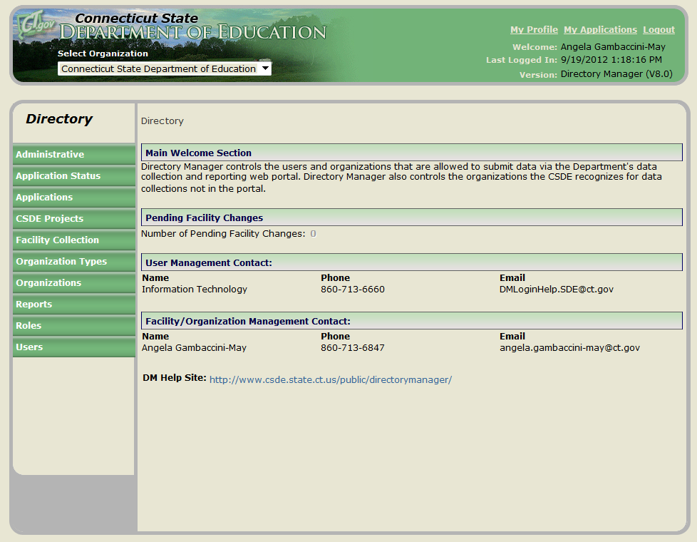
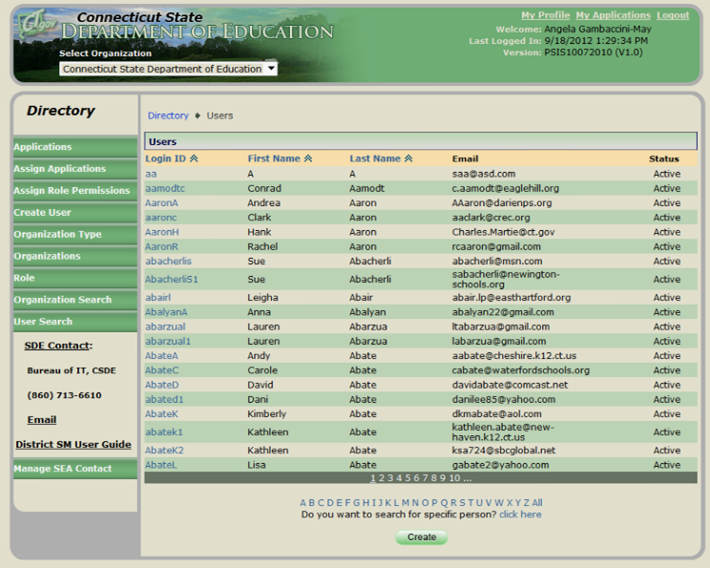
As you can see above, the look of the New Directory Manager is very similar. When you log in you will be brought to the Welcome Screen. There will be Pending Changes (if your roles allows this), who to contact with questions and the link to the DM Help Site.
The buttons on the left hand side of the portal have been enhanced. The major changes are:
Organization Search → found under Organizations
User Search → found under Users
CSDE Projects → Staff Responsibility, Sheff Maintenance and Title 1 Maintenance Page

