Participant Guide* for
Selecting Best Practices Using the Hexagon Tool

* Participant Guides are used during our time together to collect your thoughts, reflections and action items and engage in activities and learning fun. Please have them available to use in our learning session.

Structure for Participant Guide
- Your Experience
- Why and What of Implementation Science
- Maximizing your Potential Begins with Exploration
- Identifying the Team or Group
- Identify & Assess Need
- Hexagon Tool
- Resources for Extended Learning

Your Experience
Activity: Think, Pair, Share

In your experience, what is a key factor in the successful selection of a new program or initiative?

Why and What of Implementation Science
Science to Service Gap

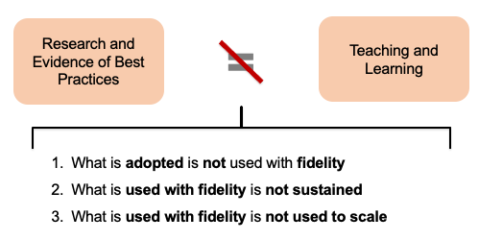
What we typically try to close that gap

Do you see these in your current work?

What impact do they have on outcomes?

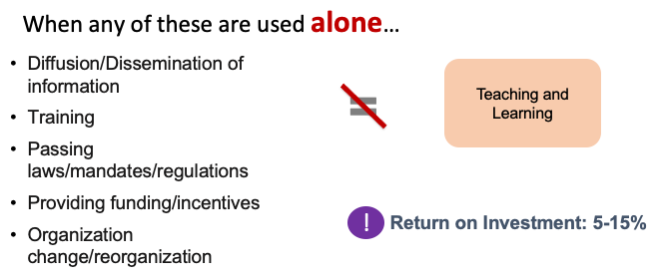

Implementation Science refers to the “methods or techniques used to enhance the adoption, implementation, and sustainability” of an intervention.  (Powell et al., 2015) |  | Equitable Implementation occurs when strong equity components (including explicit attention to the culture, history, values, assets, and needs of the community) are integrated into the principles and tools of implementation science to facilitate quality implementation of effective programs for a specific community or group of communities.  (DuMont, Metz, & Woo, 2019)

Your Experience
Activity: Think, Pair, Share

In your experience, what is a key factor in the successful selection of a new program or initiative?

Maximizing our Potential for Improved Outcomes Begins with Exploration

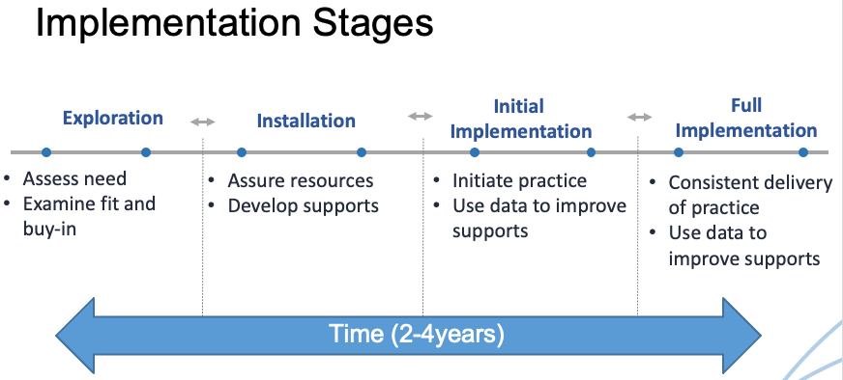

Implementation Stage | Description | Key Words You Heard  “When I think of this implementation stage,  I think of…”
Exploration | - Determine need and identify options  - Assess “fit” and “feasibility”  - Identify needed structural and functional changes  - Create readiness for the innovation and for implementation supports  - Dream and then move to reality (“go” or “no go”)
Installation | - Secure resources and develop support plans  - Develop selection protocols and select first practitioners  - Train first practitioners  - Develop coaching plans  - Evaluate readiness and sustainability of data systems
Initial Implementation | - Assess selection, training, and coaching  - Allocate supports so that training and coaching is provided with fidelity  - Use Practice-Policy Feedback cycles to communicate needs and successes
Full Implementation | - Schedule periodic data and systems reviews to address “drift”  - Monitor functioning (efficiency and effectiveness) of feedback loops  - Regularly review contextual factors/demands that may impact use of practices with fidelity  - Ensure data systems that are in use are valid, reliable, and efficient  - Examine outcomes

Implementation Stages Flow Chart from the Implementation Stages Planning Tool

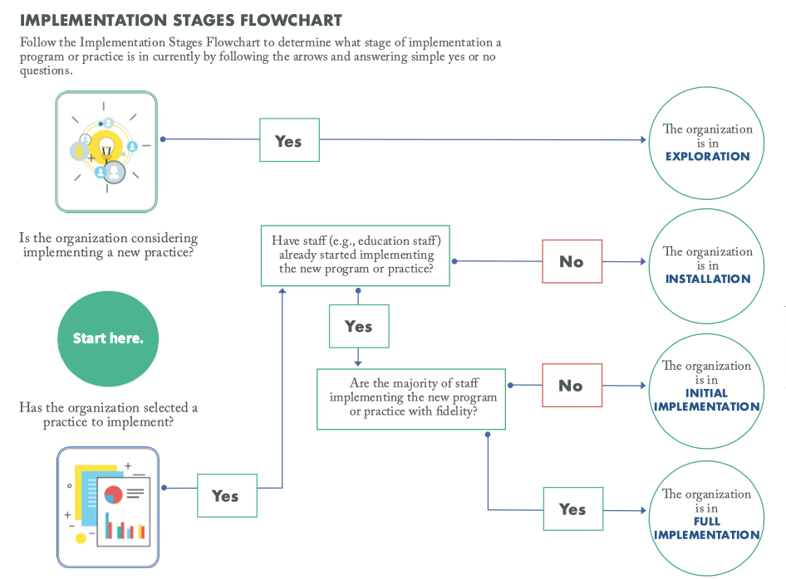

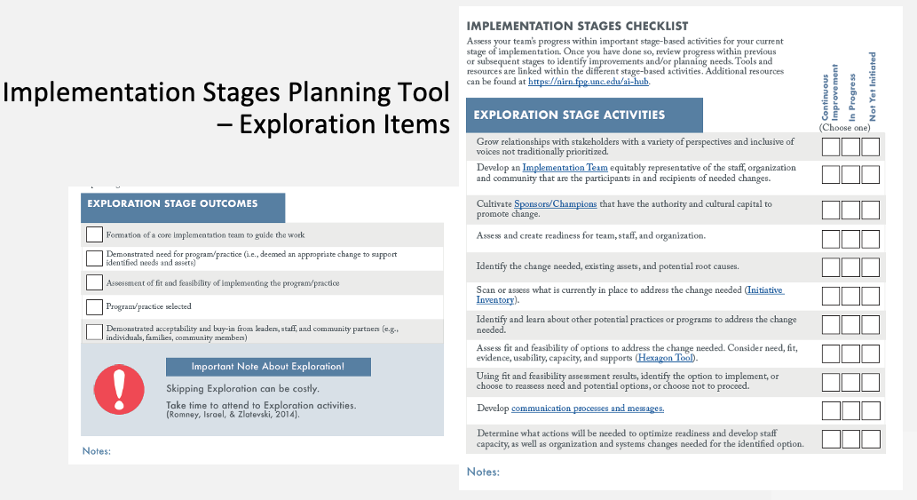

Identifying the Team or Group

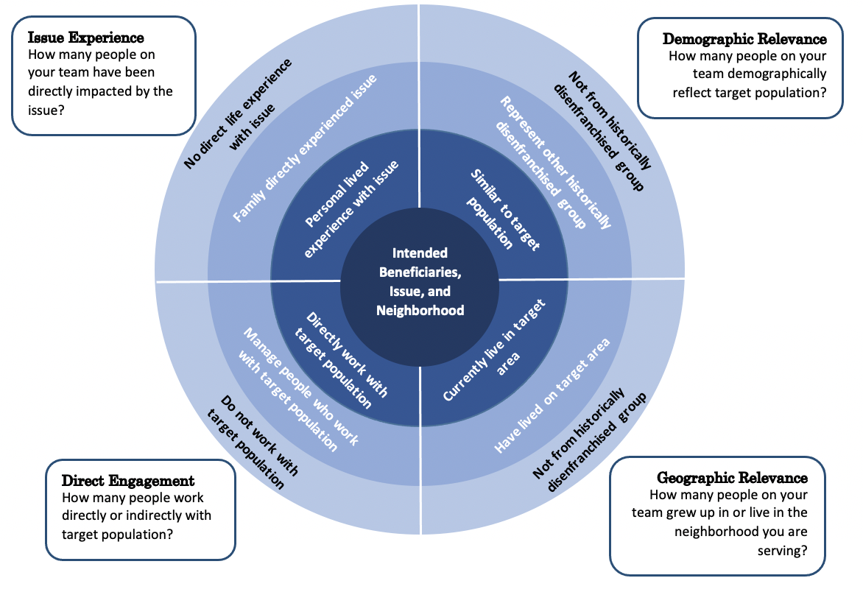

Activity: Think, Pair, Share

Who do you typically engage in the selection process?

Advantages and Disadvantages to WHO you have included?
Advantages | Disadvantages
Considerations for What to Keep and What to Lift Up for Change
Keep | Lift for Consideration of Change

Identify and Assess Need
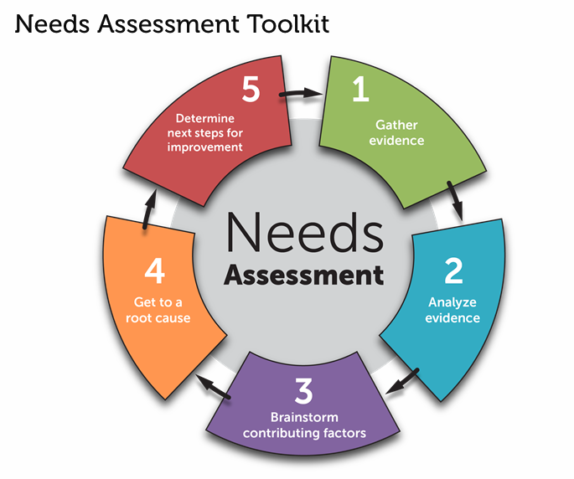
- Engage diverse collaborators – whiteness and those in power should not control the narrative
- Uses multiple methods and data sources (at least 3 sources; and disaggregated race/ethnicity and other identifying factors)
- Improves implementation and sustainability potential

Activity: Think -Pair- Share

In what ways does bias show up in your data analysis and discussions?

What strategies do you employ to acknowledge and counteract the bias?

Hexagon Tool

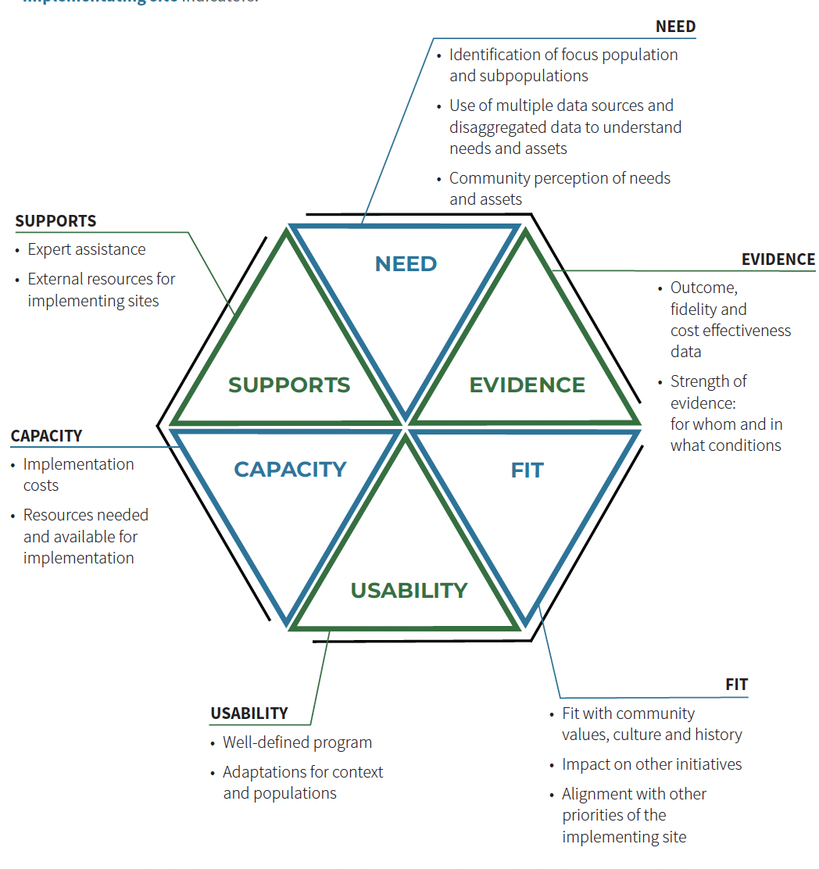
Activity: Which indicator(s) do you think LEA’s consider most frequently in their selection?

- Take 1 minute and reflect on current or past selection or adoption of EBPs.
- Access our poll at https://www.menti.com & enter the code on the screen to answer the following question: Which indicator(s) do you think LEA’s consider most frequently in their selection?
  - Need
  - Evidence
  - Fit
  - Supports
  - Capacity
  - Usability

- Why do you think that is?

Activity: Hexagon Tool: Jigsaw

You will also need the Hexagon Tool handout for this activity

Directions:
- You will be randomized into 1 of 12 groups by indicator (i.e., Need A, Need B, Capacity A, Capacity B, etc.)
- In your groups, select a facilitator and TWO reporters.
  - Facilitator: keep your group on task.
  - Reporters: jot down notes to share with the whole group.
- The groups should be able to answer 3 questions:
  - What is this indicator helping us to determine? (Reporter 1 on Menti)
  - Which questions do we already typically consider?
  - Which questions do we NOT typically consider and are excited to discuss? (Reporter 2 in Chat)
- Be prepared to help others understand your indicator!

Indicator | What is this indicator helping us to determine? (Reporter 1 on Menti) | Which questions do we already typically consider? | Which questions do we NOT typically consider and are excited to discuss?  (Reporter 2 in chat)
Need
Evidence
Fit
Usability
Capacity
Supports

Breakout Planning

Activity: Planning

Directions:
- You will be placed in a breakout room by school.
- In your groups, select a facilitator, a notetaker and a reporter.
  - Facilitator: keep your group on task.
  - Notetaker: take notes to document your action planning.
  - Reporter: be prepared to share out one action item.
- The groups should:
  - Determine who should be on a team to re-examine an existing program. Who might not be on a team but from whom you might need information? (Hint: Form a new team? Repurpose a team? Think of the stakeholder ‘circle’.)
  - For each indicator determine what data and/or data reports are needed to fully answer each question.
  - Determine action steps for getting the data needed.

Activity | Notes | By When | By Whom
Identify existing program to apply Hexagon with
Identify Team to apply Hexagon on existing program | Who might not be on a team but from whom you might need information? (Hint: Form a new team? Repurpose a team? Think of the stakeholder ‘circle’.)
For each indicator, determine what data and/or data reports are needed to fully answer each question | Need:
 | Evidence:
 | Fit:
 | Usability:
 | Capacity:
 | Supports:

Resources for Extended Learning

Podcasts
Follow Voices from the Field podcasts – linked is episode number one “Using the Hexagon Tool as you allocate recovery funds

Videos
SISEP Center on YouTube Voices from the Field on YouTube

Quick Reads
SISEP Center eNotes
Sign up for SISEP Center eNotes to be delivered directly to your Inbox
Active Implementation Practice and Science -- Fixsen, Blase, Metz & Van Dyke (2015)
What Big Medicine Can Learn from the Cheesecake Factory

Ai Hub Content
Active Implementation Hub – Free resources, modules, lessons, and activities - https://nirn.fpg.unc.edu/ai-hub
Interactive Lesson 1: The Hexagon Tool: https://nirn.fpg.unc.edu/ai-lessons-and-short-courses

Tools and Resources We Mentioned
The Hexagon Tool
Implementation Stages Planning Tool

