Connecticut State Department of Education- Bureau of Grants Management
Special Education Excess Cost User Guide

Version 1.2
11/1/2014

Table of Contents
Objective 2
Documentation Change Log 2
Contact Information 2

Handbook / Reference Guide 2
Brief Overview 2
Collection Grant 2
Non-Oct 1 Grant 2
Time Periods and Deadlines 2
District Certification 2
Managing Student Data 2
Reporting Student Data 2
Upload Requirements 2
Special Education Excess Cost Record Layout 2
Special Education Excess Cost Data Fields 2
District Reports 2
Summary of Grant Students 2
Download All Grant Records 2
Grant Summary Statistics Sign-off 2
Grant Overlapping Contracts 2
Procedures 2
Administrative Procedures 2
How to Access the Special Education Excess Cost Data Collection 2
SEDAC Data Collection Procedures 2
How to Add a Oct 1 Collection Grant Student 2
How to Add a Non Oct 1 Grant 2
How to Upload your Students 2
How to Resolve a Case on the Grant Overlapping Contract Report 2
How to Request an Administrative Override (AO) when a Facility Code Does Not Exist 2
How to Request an Administrative Override (AO) when a Facility is Not Approved 2
FAQs 2
General Questions 2
Reporting Students 2
Deleting Grants 2
Updating Grants 2
Educational/Residential Facility Codes 2
Reports 2
Appendix 2
Memo: LEA Excess Cost Grant and State Agency Placement Grant for Placements in Facilities Approved or Not Approved for Special Education Memorandum (2008) [PDF] 2
LEA Excess Cost and State Agency Grant Decision Tree [PDF] 2
Timeline for LEA Excess Cost and State Agency Placement Grants 2
December 1 Filing 2
March 1 Filing 2
ED001 Filing (audited Data) 2
Nexus Districts 2
State Agencies Responsible for Placement 2
LEA Excess Cost and State Agency Placement Grants 2
LEA Excess Cost (Grant Type 01) – Allowable Costs 2
Reporting Costs under the Single Cost Accounting System (SCAS) 2
Facility Codes 2
Connecticut Programs with Residential Components 2
In-state Approved Private Special Education Program Facility Codes 2
Age Appropriate Community Based Transition Program Facility Codes 2
Out of State Facility Codes 2
Approved Transition/Vocational Programs 2
Educational Responsibility for Children Committed as Delinquent to the Department of Children and Families 2
State Agency Placements Memorandum (1997) 2
Terminology 2
SEDAC References 2
CSDE's Statement of Nondiscrimination 2

Objective
This document’s purpose is to provide Districts with procedures and guidance for submitting data for this data collection.

The document is organized into four sections:

Handbook or reference guide on purpose of this collection and definition of data collected
Step by step procedures for use of the system
Frequently Asked Questions (FAQs)

Appendix of terminology and references

Documentation Standards
Standards used in this documentation include the following:

- FIELDS displayed on a screen are referenced using ALL CAPS
- Field values are highlighted in bold
- Screens are referenced using italics
- Buttons or menu selections are in bold
.
 Represents important information or cautionary instructions related to data reporting.
Represents helpful tips and references to other sections of documentation for related topics.
Represents reminders of information previously stated related to the current topic.

Documentation Change Log

Version | Section / Page | Date | Description
1.00.00 |  | 10/7/2011 | Published
 | Nondiscrimination Statement p. 81 | 10/15/14 | Updated with 9-30-2011 version
 | Facility Codes: Connecticut Programs with Residential Components p. 56 | 10/15/14
 | Facility Codes: In-state Approved Private Special Education Program Facility Codes p. 58 | 10/15/14 | Updated
 | Facility Codes: Age Appropriate Community Based Transition Program Facility Codes p. 63 | 10/15/14 | Updated
 | Facility Codes: Out of State Facility Codes p. 66 | 10/15/14 | Updated
 | How to Request an AO when a Facility Code Does Not Exist  p. 37 | 10/15/14 | Updated
 | How to Request an AO when a Facility is Not Approved p. 39 | 10/15/14 | Updated
1.2 |  | 11/1/14 | Published

Contact Information

Special Education Excess Cost Data Collection
Contact | Name | Email | Phone
Bureau of Grants Management (BGM) -Technical Support & Data/Grant Related Questions | Kevin Chambers | Kevin.Chambers@ct.gov | 860-713-6455
 | David Twedt | David.Twedt@ct.gov | 860-713-6492
Legal Questions | Gail Mangs | Gail.Mangs@ct.gov | 860-713-6938

Caution: The Family Educational Rights & Privacy Act (FERPA; 20 U.S.C. § 1232g; 34 CFR Part 99) prohibits disclosure of personally identifiable information from students' education records.
DO NOT EMAIL Student Names. You may email student SASIDs.

Handbook / Reference Guide

Overview
The Special Education Excess Cost Data Collection system is used to collect LEA Excess Cost and State Agency Placement Grant data from school districts. The data collected is used by the Bureau of Grants Management to calculate the school district’s LEA Excess Cost and/or State Agency Placement Grant, which provides state support for high cost special education placements and select regular education placements.

The initial threshold for which a student is eligible for the Excess Cost grant is referred to as the "Basic Contribution or per pupil expenditure". For LEA placements or students educated within the district the threshold is equal to the prior year’s Net Current Expenditures per Pupil (NCEP) x 4.5. For placements initiated by a state agency, e.g., the Department of Children and Families, the threshold is equal to the prior year's NCEP x 1. To find your districts’ threshold, see Net Current Expenditures (NCE) per Pupil (NCEP) and Basic Contributions in the Appendix under SEDAC References.

Contract information is only required for students with costs over the district’s threshold. See Appendix (Memo: LEA Excess Cost Grant and State Agency Placement Grant for Placements in Facilities Approved or Not Approved for Special Education) for guidance on LEA Excess Cost Grant and State Agency Placement Grant for Placements in Facilities Approved and Not Approved for Special Education.

Collection Grant
A student in your districts’ PSIS Database (See view Students link under student list) , who a district wants to enter a grant for reimbursement is referred to as a Collection Grant. If you need to enter a collection grant, but the student in not listed, work with PSIS to correct the PSIS Oct Collection. Do not add as a Non-Oct 1.

Non-Oct 1 Grant
A general education student placed by a State agency in a private residential facility OR an IEP student who was not your districts’ nexus on Oct 1 is referred to as a Non-Oct 1 Grant. General education students (special education=No) eligible for a State Agency Placement Grant should have Nexus District entered in PSIS Registration and Collection

Time Periods and Deadlines
Collection periods are defined by Connecticut General Statutes (C.G.S.) Section 10-76d. Districts will be notified when the system is available. See Appendix (Timeline for LEA Excess Cost and State Agency Placement Grants) for further information.
- Statutory Deadline is December 1 – First estimated costs
- Statutory Deadline is March 1 – Revised and Additional estimated costs

District Certification
The district will now be able to certify their data electronically. Before doing this it is the districts responsibility to verify each student entered a STATUS of 1 - Ready to Certify. To achieve this, all mandatory fields must be completed. Additionally, the Summary of Grant Students report must be reviewed for accuracy. Students with any other status are incomplete and will not be counted for the district’s grant file.

Managing Student Data

There are 2 basic sections: 1) Collection Grants and 2) Non-Oct 1 Grants (general education and not my nexus on Oct 1). The differences in reporting these two grant sections are subtle and only evident in the upload/reporting process, because all variables, fields, rules, edits and warnings are applicable to both grant sections.

- If reporting a grant for a student in your Oct 1 Child Count via hand entry, use the View Students link within the student list menu.
- If reporting a grant for a general education student OR a student who was not your Nexus on Oct 1, via hand entry, you must use the “Add a Non-Oct 1 Grant” via the Grants menu.
- If choosing the upload process, both collection and Non-Oct 1 grants need their own upload file.

Some Important Grant rules to note:

- Generic codes will not be allowed for Education or Residential fields. If you believe you have a grant for a student placed in a facility that does not have a specific education or resident facility code assigned via PSIS, contact the Bureau of Grants Management (BGM) for guidance on eligibility of this grant. The use of a generic code will require an Admin Override.

- If you have a grant for a student placed in unapproved EDUCATION FACILITY CODE due to a Parent Initiated Placement for other than educational reasons or ordered by a Due Process Hearing Officer or Court preceding this will also require an Admin Override. Contact BGM for guidance on eligibility of this grant.

- LEA Placement Grant students (Grant Type 01) cannot be in unapproved facilities. CGS Section 10-76d(10)(d) is clear that in order for a school district to receive payment under CGS Section 10-76g, “each such private school, agency or institution has been approved for special education by the Commissioner of Education or by the appropriate agency for facilities located out of State”. This means, if the student is in-state, the facility must be approved by the Department. If the student is out-of-state, the facility must be approved to provide special education and related services by the state in which it sits and the LEA is responsible for providing verification of the facility’s approved status.

- There will be a validation check for all reported grants against the Nexus field in PSIS Registration. Therefore, it is essential that all your general education students for whom you intend to apply for a Grant have a Nexus district reported in the PSIS Registration Nexus field. (This is true for all special education students as well, but their status as special education requires the reporting of Nexus.) The reporting of a Nexus district for General education students is a unique rule required for general education students for whom you plan to report a state agency placement grant.

- If an error in reporting is made, you can delete a grant using the delete button within the “View my Grants” list for the Dec. 1 submission. Records which have changes to costs should not be deleted, but instead should be revised to reflect actual costs for the March 1 submission. This will allow the Bureau of Grants Management to document a change in costs and will reduce follow-up calls regarding a “missing” grant that was paid in the February disbursement. Therefore, after Dec. 1 do not delete a grant; only update fields as appropriate.

- Multiple Contracts - Although a student may have multiple contracts in effect at the same time, this is very rarely the case. More likely, apparent concurrent contracts are the result of changes in a student's status with respect to one or more earlier contracts, leading to the appearance of multiple open contracts.

- It is of the utmost importance that any contracts that are ended prematurely be given a revised Contract End Date, Tuition Costs and total Tuition Days. Other associated data entry items may also need to be adjusted as needed.

Reporting Student Data

Upload Requirements
If districts choose they may upload data directly into the special education Excess Cost collection. Upload of data is accessible during specified periods during the year identified by the collections open and close dates.
Data may be collected using a third-party vendor, database or spreadsheet entry and then uploaded:
  - Using a State-defined CSV file format
  - Using upload tools accessible from the secure website.
There are two separate uploads, one for Collection grants and another for Non-Oct 1 grants.
All records (where a student’s SASID, LAST NAME, and DOB can be verified) that you upload will be entered into the system. If there are errors with a record, the record will be given a STATUS CODE of 4. Error messages for each of the student entries are displayed on the screen after the upload is processed. Save error messages report to your computer. You can correct the errors in the upload file and re-upload, or you can go into each student’s individual record in or request an admin override for the records when needed.
The upload process will not give you a report of students that would require an admin override.

Note: There are no naming conventions for the CSV file upload, but it should be easily recognizable to the district. There should be no header rows in the CSV file when uploading.

Districts can also use the Grant Template as a method for uploading information. This template can be found in Help/Information > Handbooks/Templates.
Caution: Every time you upload you replace the previously saved data. If corrections are made online, and the file is uploaded afterward, the online changes are overwritten with the data in the file. Please be sure to download your data each time changes are made online, if you want this data to be saved and updated on your local system for future use.
SUGGESTED: After your file is uploaded, save the error messages report to your computer.

Record Layout
Data Types:
Char - Character, Alphanumeric
Num - Numeric
Date - MM/DD/YYYY date where “MM” = Month, “DD” = Day, “YYYY” = Year

Requirements:
Mandatory – If this field is not complete an error is generated.
Optional –Districts have the option to report this field or leave it blank.
Recommended – We recommend that this field be reported, but the district has the option to or leave it blank.
Conditional – This field may be required depending upon the response to a related field.
Disallowed – Districts may not report this field for this submission.

 | Field Name | Excel Column | Data Type | Starting Position | Ending Position | Length | Requirements (M,O,R,C,D) | Valid Values / Default Value / Notes
 | SASID | A |  | 1 | 10 | 10 | M | 10-digit number. SASID must be assigned to a student prior to this collection.
 | Last Name | B |  | 11 | 45 | 35 | M | Character field allowing a dash, period, space and apostrophe. Must be the same as reported in PSIS.
 | Date Of Birth | C |  | 46 | 53 | 8 | M | MMDDYYYY. Must be the same as Reported in PSIS
 | Nexus District | D |  | 54 | 56 | 3 | M | PSIS Nexus District
 | Contract Sequence Number | E |  | 57 | 58 | 2 | M | Must be entered if there are multiple contracts for this grant.  Default = 01.
 | Contract Start | F |  | 59 | 66 | 8 | M | MMDDYYYY. First Day of the Contract.
 | Contract End | G |  | 67 | 74 | 8 | M | MMDDYYYY. Last day of the contract.
 | Primary Disability | H |  | 75 | 76 | 2 | M | See list under Data Fields.
 | No Nexus Status for Grant 3b | I |  | 77 | 77 | 1 | C | Y/N to identify no nexus status for Grant 3b only.
 | Placing Agency Code | J |  | 78 | 80 | 3 | M | Valid Nexus District or State Agency Code
 | Education Facility Code | K |  | 81 | 87 | 7 | M | Valid PSIS Facility Code.
 | Tuition Costs | L |  | 88 | 94 | 7 | M | Total tuition costs for the contract.
 | Tuition Days | M |  | 95 | 97 | 3 | M | Total educational days covered by the contract.
 | Transportation Costs | N |  | 98 | 103 | 6 | O | Transportation costs associated with fulfillment of contract.
 | Cost Over  Single Cost | O |  | 104 | 109 | 6 | D | This field must be blank
 | Residential Facility Code | P |  | 110 | 116 | 7 | C | Location student will live during contract.
 | Room / Board Costs | Q |  | 117 | 123 | 7 | C | Costs of housing student under this contract.
 | Room / Board Days | R |  | 124 | 126 | 3 | C | Total Days student will be housed under this contract.
 | End of Record Marker | S |  | 127 | 127 | 1 | M | X

Remember: Upload must be a Comma Separated Value (CSV) file format. All fields are character (Excel format of Text) and are to retain leading zeroes, especially dates. Remember to close the file before attempting to upload.

Note: There are no naming conventions for the CSV file upload, but it should be easily recognizable to the district. There should be no header rows in the CSV file and an X at the end of every case as a marker when uploading.

Districts may use the Grant Template that can be found in Help/Information > Handbooks/Templates as a method for uploading information.

Data Fields
Following is a list of fields and guidance for reporting data for your students with disabilities.
Note: Fields are presented in the order as displayed on SEDAC screens.
Nexus District | The District with financial responsibility for the student where costs may make the student eligible for LEA Excess Cost or State Agency Placement Grants.
Nexus District | Rules  - Required to certify a grant record.  - Must be a valid nexus district (001-219).  - If a student attends an Open Choice School District, the receiving open choice district is the nexus and reports the student for the SEDAC October 1 Federal Child Count. However, if the costs for educating the student are such that the student may be eligible for an LEA Excess Cost Grant, where the costs are more than four and one-half times the average per pupil expenditure, the district where the student resides (resident town) is responsible for these costs and eligible to report a grant. Contact the Bureau of Grants Management for instructions on how to apply for an Excess Cost Grant in this unique situation.  Values  - Nexus District 001-219  Source  - PSIS
SASID | The State Assigned Student Identifier (SASID) established in the PSIS Registration system for your student.  This is a unique 10-digit numeric code assigned to each student. Reporting in the field conforms to PSIS Registration rules.
SASID | Rules  - SASID must be assigned to a student before entry  Values  - N/A  Source  - PSIS
Last Name | The student’s legal last name.
Last Name | Rules  - Must match most recent PSIS Registration record  - Dash, period, space and apostrophe are allowed  Values  - N/A  Source  - PSIS

Date of Birth | Student’s date of birth.
Date of Birth | Rules  - Must match most recent PSIS Registration record  Values  - MMDDYYYY, where MM is Month, DD is Day, YYYY is Year  Source  - PSIS
Primary Disability | The disability which is most indicative of the student’s primary disability. Use one of the disabilities eligible for special education services under IDEA or Connecticut statutes.
Primary Disability | Rules  - Required to certify a grant record.  - If GRANT TYPE 01, 02, 3a or 3b, disability code cannot be 18-General education.  - If GRANT TYPE 04, PRIMARY DISABILITY must be 18-General education.  Values  - 01-Intellectual Disability  - 02-Hearing Impairment (Deaf or Hard of Hearing)  - 03-Speech or Language Impairment  - 04-Visual Impairment  - 05-Emotional Disturbance  - 06-Orthopedic Impairment  - 07-Other Health Impairment (OHI)  - 7A-ADD/ADHD - (Sub-Category of OHI)  - 08-Learning Disability  - 09-Deaf-Blindness  - 10-Multiple Disabilities  - 11-Autism  - 12-Traumatic Brain Injury (TBI)  - 15-Developmental Delay (Ages 3-5 only)  - 18-General education/State Agency Placed  - used only to apply for Grant Type 04  Source  - ED620 form / IEP Page 1

Contract Sequence Number | The number of contracts assigned to each student. Students can have more than one contract and Grant Type. See Prorated Excess Cost Grants section in Appendix (LEA Excess Cost and State Agency Placement Grants).
Contract Sequence Number | Rules  - Required to certify a grant record.  - Default is 01.  Values  - N/A  Source  - Hand-entry: System will generate CONTRACT SEQUENCE NUMBER.  - Upload: must be entered in upload file, start with 01. If there are multiple contracts for a student the CONTRACT SEQUENCE NUMBER should increase in sequential order (e.g. 01, 02, 03, 04 etc.). If a student has 4 contracts and the sequence number for each contract says 01, during the upload process each grant will upload over the previous grant, therefore only 1 contract will actually be uploaded.
Contract Start | The start date of contracted services for the current school year.
Contract Start | Rules  - Required to certify a grant record.  - Contract Start Date cannot be before July 1 of the current school year.  - Contract Start Date cannot be after March 1 of the current school year.  Values  - MMDDYYYY, where MM is Month, DD is Day, YYYY is Year  Source  - N/A
Contract End | The end date of contracted services for the current school year.
Contract End | Rules  - Required to certify a grant record.  - Contract End Date cannot be before Contract Start Date.  - Contract End Date cannot be after June 30 of the current school year.  Values  - MMDDYYYY, where MM is Month, DD is Day, YYYY is Year  Source  - N/A

Placing Agency Code | The PLACING AGENCY is the party that placed the student in the LEA, the Nexus District has the legal responsibility to identify and educate a student - regardless of where the education actually takes place. The Nexus District is responsible for completing and submitting to the Department for reimbursement.
Placing Agency Code | Rules  - Required to certify a grant record.  - When parents make a placement and the district accepts responsibility the LEA is the placing agency  - If Grant Type 01, must be the same as the Nexus District. Valid Nexus district codes range from 001 to 219. See Appendix (Nexus Districts). For example, if Andover (001) is the Nexus District, the correct Placing Agency Code is 001.  - If Grant Type 02, 3a, 3b or 04, the Placing Agency must be a valid State Agency code. See Appendix (State Agencies Responsible for Placement).  Values  - Nexus District 001-219 for Grant Type 01  - 337, 347, 349, 950, 954 for Grant Type 02, 3a, 3b or 04  Source  - N/A
No Nexus Status | The nexus status of Grant Type 3b students. See Appendix (LEA Excess Cost and State Agency Placement Grants) for further discussion of Grant Type 3b.
No Nexus Status | Rules  - Required if Grant Type 3b students only.  - This field must be blank for Grant Type 01, 02, 3a, and 04.  Values  - Y/N  Source  - DCF 603
Education Facility Code | The school attended by the student for the contract being entered.
Education Facility Code | Rules  - Required to certify a grant record.  - Districts can apply for an LEA Excess Cost Grant for high-cost students that attend school in the district.  - Districts cannot apply for an LEA Excess Cost Grant for students out-placed into in-state facilities that are not approved by the Connecticut State Department of Education.  - If the LEA places a student out-of-state, the LEA must provide proof that the facility is approved in that state.  Values  - Valid PSIS Facility Code. For a listing of facility codes refer to Facility Codes under References. Reference Table A: Facility Codes and Non Public and Out of State Facilities.  - Note: The facility codes in this list include generics which are not allowed, use of a generic code will require an Admin Override.  Source  - N/A

Tuition Costs | The Tuition Costs for education and related services. Do not report legal costs. Refer to Appendix (LEA Excess Cost (Grant Type 01) – Allowable Costs) for more guidance on reporting costs for high cost in-district students. Refer to Appendix (Reporting Costs under the Single Cost Accounting System (SCAS)) for more guidance on reporting costs under the Single Cost Accounting System). The latest list of programs that are subject to SCAS rate calculation is available at: http://www.sde.ct.gov/sde/lib/sde/pdf/fiscal/speced.pdf. To confirm a rate contact Paul Hayes at 860-713-6641 or paul.hayes@ct.gov.  Warning Messages about Tuition Costs  Users will receive and be required to verify Warning Messages if:  - Tuition Costs are below 1000.  - Tuition Costs are higher than 175000.
Tuition Costs | Rules  - Required to certify a grant record.  - If a student requires an aide/paraprofessional during both transportation and the school day, report costs in TUITION COSTS.  - If a student requires an aide/paraprofessional during transportation only (i.e. the aide/paraprofessional does not spend any time with the student during the school day), report the cost of the aide/paraprofessional in TRANSPORTATION COSTS.  Values  - 1 to 750000  - No characters (e.g. “$”, “,”) will be accepted in this field  Source  - N/A
Tuition Days | The Tuition Days covered by the contract.  Warning Messages about Tuition Days  Users will receive and be required to verify Warning Messages if:  - TUITION DAYS are greater than 250.  - TUITION DAYS are less than 10.  - TUITION COSTS divided by TUITION DAYS (daily tuition costs) is greater than 500.
Tuition Days | Rules  - Required to certify a grant record.  - TUITION DAYS cannot be blank if Tuition Costs are reported.  - TUITION DAYS cannot be greater than the number of days within the reported Contract period  - From CONTRACT START DATE to CONTRACT END DATE.  Values  - 1 to 366  Source  - N/A
Transportation Costs | The Transportation Costs covered by the contract.  Warning Messages about Transportation Costs  Users will receive and be required to verify Warning Messages if:  - TRANSPORTATION COSTS are greater than 50000.  - TRANSPORTATION COSTS divided by TUITION DAYS (daily transportation costs) is greater than 500.
Transportation Costs | Rules  - Can be blank.  - If a student requires an aide/paraprofessional during transportation only (i.e. the aide/paraprofessional does not spend any time with the student during the school day), report the cost of the aide/paraprofessional in TRANSPORTATION COSTS.  - If a student requires an aide/paraprofessional during both transportation and the school day, report costs in TUITION COSTS.  - Must be blank if Grant Type 4  Values  - 0 to 250000  - No characters (e.g. “$”, “,”) will be accepted in this field  Source  - N/A

Residential Facility Code | Where a student lives. In most cases, the Education Facility Code and the Residential Facility Code are the same.
Residential Facility Code | Rules  - This field is Conditional.  - Required for GRANT TYPE 02, 3a or 3b, and 04.  - Can be blank for GRANT TYPE 01.  - If student lives in a private foster or group home use 0000061.  - Residential Facility Code is required if ROOM AND BOARD COSTS and ROOM AND BOARD DAYS are reported.  Values  - Valid Facility Codes are listed in Appendix (Connecticut Programs with Residential Components).  - See Appendix for clarification on which Residential Facility Codes are eligible for which Grant Types.  Source  - N/A

Room and Board Costs | The cost of housing for a Grant Type 01 student only if the district is billed separately for room and board costs that are charged by the facility.  Warning Messages about Room and Board Costs  Users will receive and be required to verify Warning Messages if:  - Room and Board Costs are greater than 100000.
Room and Board Costs | Rules  - If Grant Type 01, this field may be used to report Room and Board Costs only if the district is billed separately for room and board costs that are charged by the facility.  - Must be blank if Grant Type 02, 3a, 3b and 04.  Values  - 0 to 250000  - No characters (e.g. “$”, “,”) will be accepted in this field  Source  - N/A

Room and Board Days | Total days student will be housed under this contract.
Room and Board Days | Rules  - Room and Board Days must be blank if Grant Type 02, 3a, 3b and 04.  - Room and Board Days are required if Room and Board Costs are reported.  Values  - 1 to 366  Source  - N/A

District Reports
The data collected within this application is used to determine how districts receive money for students who are eligible for LEA Excess Cost and State Agency Placement Grants during a given school year from the Connecticut State Department of Education.
The reports available should aid the district in their accuracy of this data collection.

District Reports
Grant Students
Summary of Grant Students
View / Download All Grant Records
Grant Overlapping Contracts
Grant Superintendent’s Sign-off
Note: All reports include Collection and Non-Oct 1 Grants.

Summary of Grant Students
This report is designed for data managers, directors of special education and superintendent review purposes of the official submission. This report allows districts to verify that students are accurately reported prior to submission of the December 1 – First estimated costs and March 1 – Final estimated costs files.
This report represents:
- Collection and Non-Oct 1 Grants with a STATUS of 1-Ready to Certify or 4-Needs Correction.

The purpose of this report is to provide districts with a summary list of the Collection and Non-Oct 1 Grant contracts they have reported to help ensure the accuracy of the:
- Student
- Placing Agency Code
- Total Cost
Source of data:
- Special Education Excess Cost Data Collection December 1 – First estimated costs
- Special Education Excess Cost Data Collection March 1 – Final estimated costs

Report Format: MS Excel file (*.xls)

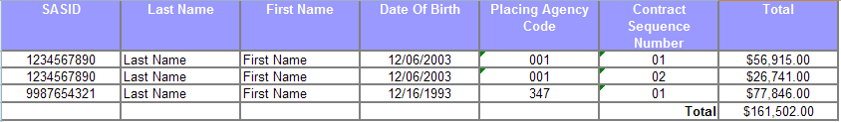

Download All Grant Records
This report is designed for data managers, directors of special education and superintendent review purposes of the official submission. This report allows districts to verify that students are accurately reported prior to submission of the December 1 – First estimated costs and March 1 – Final estimated costs.

The purpose of this report is to provide districts with a list of the Collection and Non-Oct 1 Grant contracts they have reported to help ensure the accuracy of every field reported in the contract.

Districts should ensure every field is reported accurately:
This report represents:
- Collection and Non-Oct 1 Grants with a STATUS code of 1-Ready to Certify or 4-Needs Correction.
Source of data:
- Special Education Excess Cost Data Collection December 1 – First estimated costs
- Special Education Excess Cost Data Collection March 1 – Final estimated costs

Report Format: MS Excel file (*.xls)

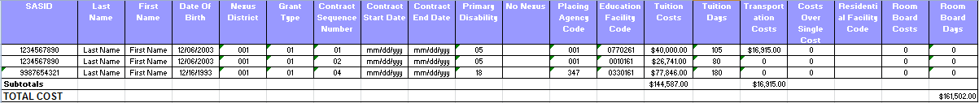

Grant Summary Statistics Sign-off

This report is designed for superintendent / designee.

This report is the official sign-off by the district to verify that students are accurately reported in the submission of the December 1 – First estimated costs and March 1 – Final estimated costs files.

Report Format: Adobe PDF file (*.pdf)
This report represents:
- Collection and Non-Oct 1 Grants with a STATUS code of 1-Ready to Certify
Source of data:
- Special Education Excess Cost Data Collection December 1 – First estimated costs
- Special Education Excess Cost Data Collection March 1 – Final estimated costs

Report Format: Adobe PDF file (*.pdf)

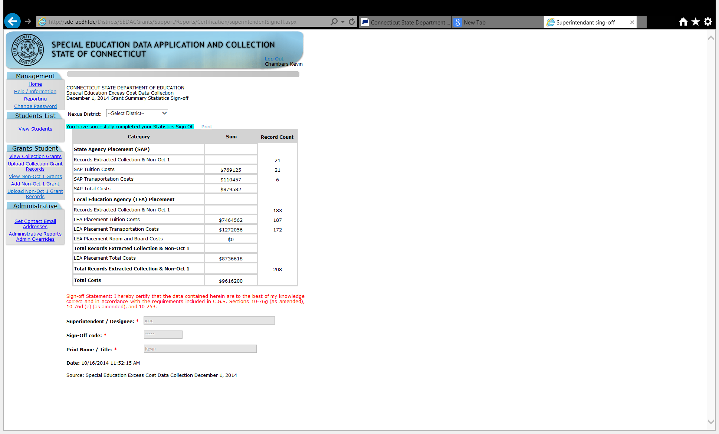

Grant Overlapping Contracts
This report is designed for data managers.

The purpose of this report is to provide districts with a list of the Collection and Non-Oct 1 Grant students that have multiple contracts for a specific student with overlapping dates. Districts review this report to:
- Delete duplicate contracts to resolve the overlap;
- Update contracts with errors to resolve the overlap;
- Where a contract crosses a different district, work with that district to resolve the overlap or
- verify the district has PPT documentation of each placement to support their multiple overlapping contracts. These contracts will remain on this report as the district’s verification that they are “legitimate overlapping contracts” (only use if the contracts belong to only your district)

This report represents:
- Collection and Non-Oct 1 Grants with a STATUS code of 1-Ready to Certify
Source of data:
- Special Education Excess Cost Data Collection December 1 – First estimated costs
- Special Education Excess Cost Data Collection March 1 – Final estimated costs

Report Format: MS Excel file (*.xls)

1234567890 : Last Name, First Name
Grant Type | Nexus Dist. | Placing Agency | Ed Facility Code | Seq. Num. | Contract Start | Contract End | Response
1-Oct | 001 | 001 | 0770261 | 1 | 7/5/2010 | 6/30/2011 | Legitimate Overlapping Contract
1-Oct | 001 | 001 | 0010161 | 2 | 7/5/2010 | 6/30/2011 | Legitimate Overlapping Contract

Procedures

Administrative Procedures

How to Access SEDAC
Prerequisites
- Authorization for the State of Connecticut Department of Education District website at https://www.csde.state.ct.us/
- Authorization for the Special Education Excess Cost Data Collection system
Step Action
- Using Internet Explorer, go to the https://www.csde.state.ct.us/ website. The system displays the State Department of Education Home Page.
- Select the ENTER button. The system displays the Connect to sdectw.doit.state.ct.us network login screen.

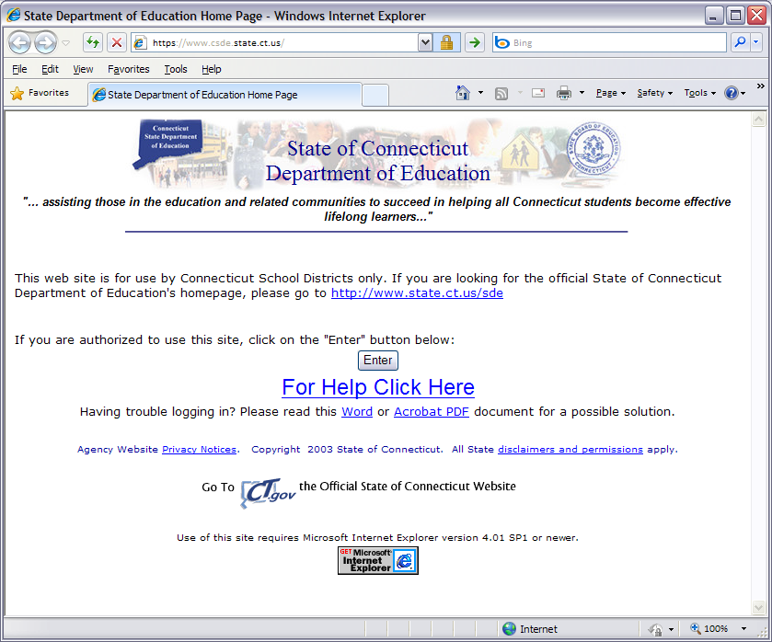

- Enter your network USER NAME and PASSWORD and select OK. The system displays the State Department of Education Home Page.
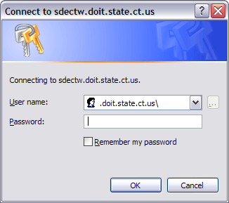
Note: If you do not have a network user name or password, please contact your Superintendent for authorization procedures.
- Select Special Education Excess Cost Data Application menu option. The system displays the Special Education Login.
Note: If you do not have a USER ID or you need your PASSWORD reset, please contact the Bureau of Grants Management.
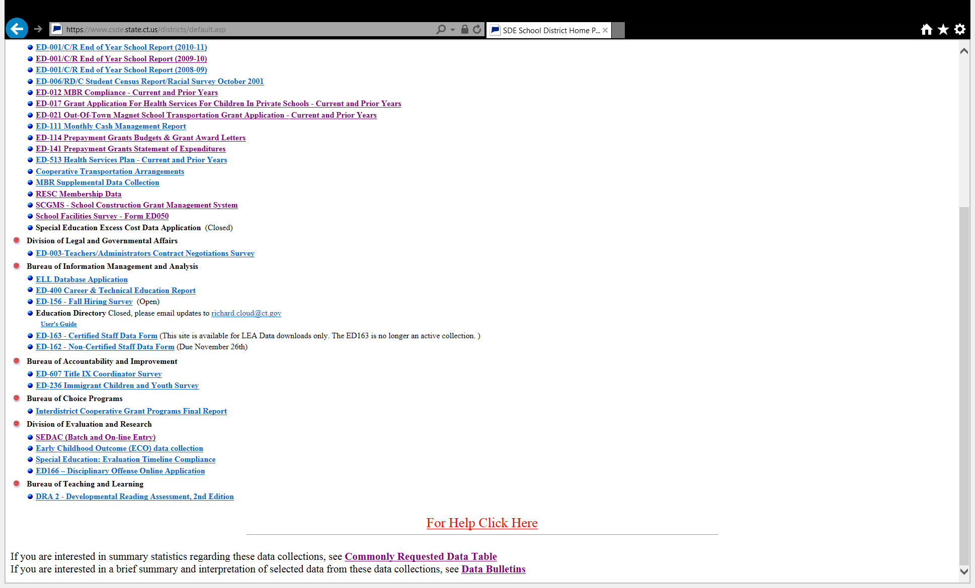

- Read the terms of use and select the check box to indicate you have read and agree to the terms of the site. Enter your USER ID and PASSWORD, and select Login. The system displays the Special Education Excess Cost Data Collection welcome screen.
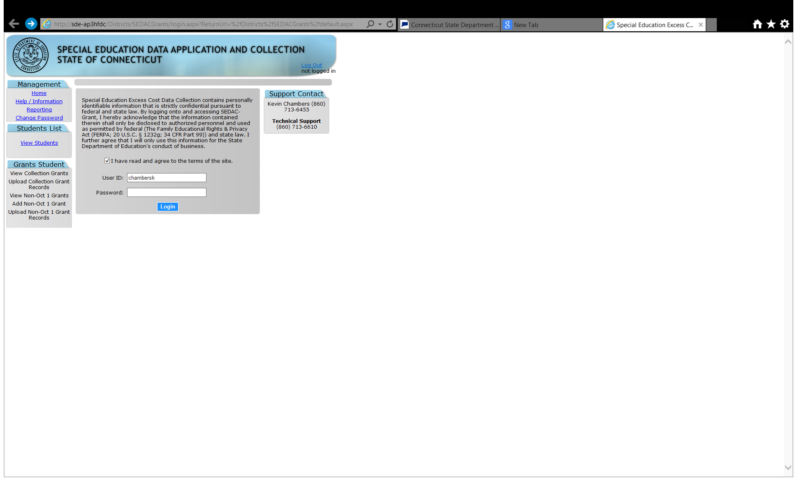
Note: All State systems have a 20 minute inactivity time-out period. If there is no activity, the system will display this screen for you to log-in again.
- Welcome to the Special Education Data Application and Collection.
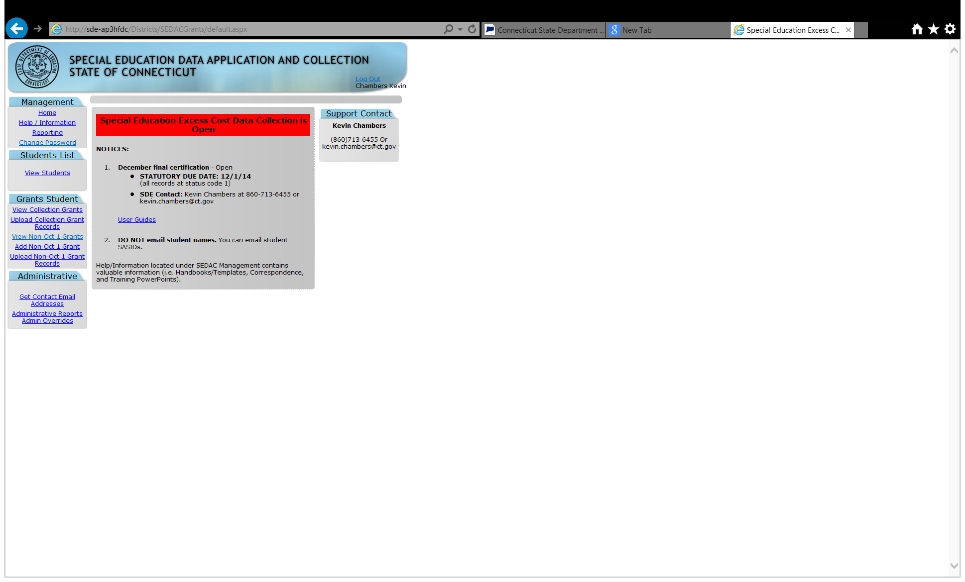
- This procedure is complete.

Special Education Excess Cost Data Collection Procedures

How to Add a Collection Grant for a Oct 1 Student
Use this procedure to submit your student data using online or hand entry. Students are available for entry based on data reported in PSIS Oct Collection.
Prerequisites
- Authorization for the Special Education Excess Cost Data Collection system
- Collection is open
- The collected data for entry into the system
Step Action
- Does the student display in your View Students screen?
  - Yes - Go to Step 4.
  - No - Go to Step 2.
- Was the student you are trying to enter a grant your Nexus District on 10/1?
  - Yes - Go to Step 3.
  - No - This procedure is complete. Refer to How to add a non-Oct 1 grant.

Steps for PSIS Data Manager
- Contact the reporting districts PSIS Data manager to have that student appropriately reported in the PSIS October collection. Once this is updated the student will appear in your View Students list. Do not add as a Non-Oct 1.

Steps for Special Education Data Manager
- Select the NAME of your student. The system displays the Viewing your student’s details screen.
- On the Viewing your student’s details screen,
  - Review the student information to insure you have selected the intended student.
- Enter the appropriate data.
- Select Save Record at the top of the screen when changes are complete. The system redisplays the Grant Record screen.

- Did the Record Saved Successfully message display at the top of the Grant Record screen?
  - Yes – This procedure is complete.
  - No – Go to the next step.
- Did a WARNING(s) message display at the top of the Grant Record screen?
- Yes – Go to the next step.
- No – This procedure is complete.
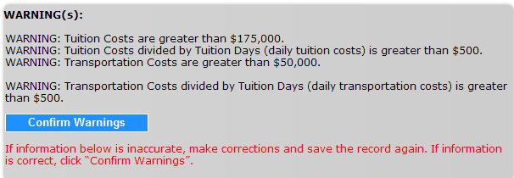
- Are the data accurate that require you to Confirm Warnings?
  - Yes – select Confirm Warnings
  - No – scroll down and correct the data entered. Then repeat step 9.
- This procedure is complete.

How to Add a Non Oct 1 Grant
Use this procedure to submit your Non-Oct 1 Grant student data using online or hand entry. Students are available for entry based on data reported in PSIS Registration.
 A Non-Oct 1 Grant is submitted for a general education student placed by a State agency in a private residential facility OR an IEP student who was not your districts’ nexus on Oct 1.
Prerequisites
- Authorization for the Special Education Excess Cost Data Collection system
- Collection is open
- The collected data for entry into the system
Step Action
- Log-in to Special Education Excess Cost Data Collection system .
- Select Add Non-Oct 1 Grant from the Grants menu. The system displays the Search for a Student to add screen.
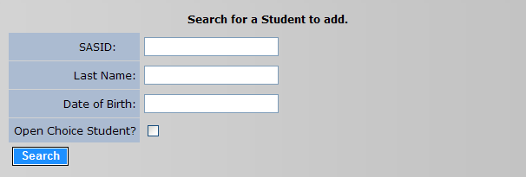
- Enter the student’s SASID, LAST NAME and DATE OF BIRTH and select Search.
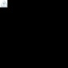 If a student attends an Open Choice School District, the receiving open choice district is the nexus and reports the student for the SEDAC October 1 Child Count. However, if the costs for educating the student are such that the student may be eligible for an LEA Excess Cost Grant, the district where the student resides (resident town) is responsible for these costs and eligible to report a grant. Contact the Bureau of Grants management for instructions on how to apply for a grant in this unique situation.
- Does the student display on the Search for a Student to add screen?
  - Yes – Go to Step 9.
  - No – Go to the next step.
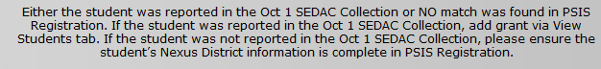
- Was the student you are trying to enter a Non Oct 1 Grant?
  - Yes – This procedure is complete. Refer to How to add a Collection grant.
  - No – Go to the next step.
- Was the student you are trying to enter a Non Oct 1 Grant for a general education student placed by a State agency in a private residential facility?
- Yes – Go to Step 7
- No – Contact the CSDE Data Manager.

Steps for PSIS Data Manager
- Log-in to PSIS Registration.
Important: General education students (special education=No) eligible for a State Agency Placement Grant should have Nexus District entered in PSIS Registration and Collections where appropriate.
- Enter student’s SASID and complete the NEXUS DISTRICT fields in PSIS Registration and Collections where appropriate.

Steps for SEDAC Data Manager
- Select Add. The system displays the Grant Record screen
- Enter the appropriate data.
- Select Save Record at the top of the screen when changes are complete. The system redisplays the Grant Record screen.
- Did the Record Saved Successfully message display at the top of the Grant Record screen?
  - Yes – This procedure is complete.
  - No – Go to the next step.
- Did a WARNING(s) message display at the top of the Grant Record screen?
- Yes – Go to the next step.
- No – This procedure is complete.
- Are the data accurate that require you to Confirm Warnings?
  - Yes – select Confirm Warnings
  - No – scroll down and correct the data entered. Then repeat step 11.
- This procedure is complete.

How to Upload your Students
Use this procedure to submit your Collection Grants or Non-Oct 1 Grants student data using a batch upload to the Special Education Excess Cost collection.
Prerequisites
- Authorization for the Special Education Excess Cost collection
- Collection is open
- Your computer has the technical requirements to upload a CSV file.
- Verification your file is in proper format.
Reference: Review the Record Layout section of this document for details on format and required data.
- All required fields are complete for each record in your file.
- The following fields in your upload file must match PSIS Registration:
  - Nexus District
  - SASID
  - Last Name
  - Date of Birth

When uploading a file the data needs to be in the correct format. Refer to the Data Fields section of this document for valid values. If the data is not in the correct format when you upload the file the records will be a STATUS of 4-Corrections Needed. For example:
- Date fields are MMDDYYYY
- Primary Disability ##
Step Action
- Using your worksheet program, save the file as a CSV file type by selecting Save As.
Note: The following screens are from Microsoft Office 2007. Your version may be different and therefore the steps may differ.
- If your worksheet contains multiple sheets, the system displays the following message.
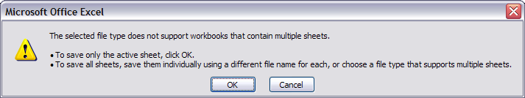
- Select OK. The system continues the saving of the file and displays the following message.
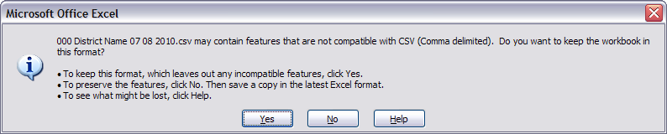
- Select Yes. The system saves the file into the folder selected in Step 1.
- Close the worksheet. The system displays the following message.
Important: Do not forget to close the file. If you do not close the file, you will receive CSV file errors when attempting to upload.
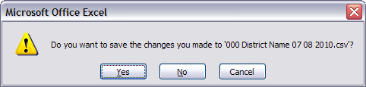

- Select No. The system closes your file so that it is ready to upload.
Important: If you select Yes instead, the file will need to be saved again, which may cause issues with the format. If you select Cancel, the file will not be closed, and therefore not accessible.
- Using the navigation menu on the left of the screen, select the Upload menu option. The system displays the Upload screen.
- Select Browse and locate the file to upload. The system displays the Choose File to Upload dialog screen.
- Locate and select your file and select Open. The system returns to the Upload screen.
- Select Upload. The system displays the Upload Results screen. Any errors encountered will be displayed on this screen.
Important: Save error messages report to your computer.
Remember: If you do not save the errors displayed on the screen, you will need to re-run the upload to get the errors again. They are not saved on a report at this time.
- Save error messages report to your computer. In addition you can select Print to print your errors. You may also copy and paste the data displayed into a separate file. Once you have resolved each of the errors in your data file, upload the file again.
- Once your errors are resolved and you have uploaded the file again, the system displays the Upload Results screen with a message indicating your upload was successful.
- Select View Collection [or Non-Oct 1] Grants to review your student data.
- This procedure is complete.

How to Resolve a Case on the Grant Overlapping Contract Report
Use this procedure to resolve multiple contracts with overlapping dates for a specific student.
Prerequisites
- Authorization for the Special Education Excess Cost Data Collection
- Collection is open
- The collected data for entry into the system
Step Action
- Select Reporting from the Management menu.
- Select Grant Students.
- Select Grant Overlapping Contracts
- Does a student display in on your district’s Grant Overlapping Contracts report?
  - Yes - Go to Step 5.
  - No - This procedure is complete.
- Are the contracts displayed, duplicate contracts?
  - Yes - verify each contract
    - Select View Collection Grants or Non-Oct 1 Grants.
    - Select Del to delete the duplicate contract.
    - The case will be removed from this report.
    - This procedure is complete.
  - No - Go to the next step.
- Is there an error on one of the contracts displayed?
  - Yes - verify each contract
    - Select View Collection Grants or Non-Oct 1 Grants.
    - Adjust the contract as needed.
    - As long as the adjustment resolves the "conflict,” the case will be removed from this report.
    - This procedure is complete.
  - No - Go to the next step.

- Are the contracts displayed cross different districts?
  - Yes - each district needs to verify their contract dates and costs.
    - If the contract dates and costs are accurate select “Contract is accurate”
    - If the contract dates and costs are inaccurate
    - Select View Collection Grants or Non-Oct 1 Grants.
      - Adjust the contract as needed.
      - As long as the adjustment resolves the "conflict" the case will be removed from this report.
Note: you may need to contact the other district to resolve the overlap. Click on Contact List for a list of all data managers.
    - This procedure is complete.
  - No - Go to the next step.
- Are the contracts displayed, legitimate overlapping contracts?
  - Yes – select "legitimate overlapping contract", these contracts will remain on this report as the district’s verification that they are legitimate overlapping contracts.
Note: District must maintain detailed, accurate documentation (i.e. PPT documentation of each placement) to support their claim.
  - No - This procedure is complete.

How to Request an AO when a Facility Code Does Not Exist
Use this procedure when the LEA has a student attending a facility where the Department does not have a facility code available. These Generic codes include, 9990199 - In State, 9990299 - Out of State and 9990399 - Prekindergarten Program.
Note: Refer to the LEA Excess Cost Grant and State Agency Placement Grant for Placements in Facilities Approved or Not Approved for Special Education memo from Anne Louise Thompson, Bureau Chief 10/31/08 in the Appendix. *Section IB. Facilities not approved for special education: School District Not Eligible for the Excess Cost Grant
Important: The LEA must provide proof that the facility is approved in that state
Note: The record will remain at a status code 4 until the override is approved or withdrawn.
Prerequisites:
- Authorization for the Special Education Excess Cost Data Collection
- Collection is open
- Request for AO requires all other data fields to have passed edit checks and WARNING messages confirmed
Step Action
- On the View Collection or Non-Oct 1 Grants Student Record screen select Save Record at the top of the screen. The system redisplays the Grant Record screen.
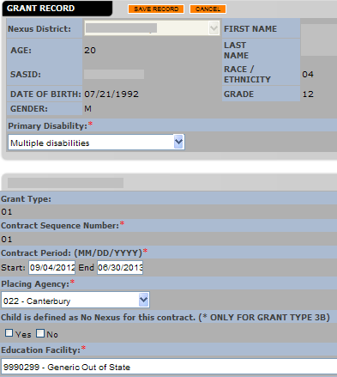
- Check “Request Administrative Override”
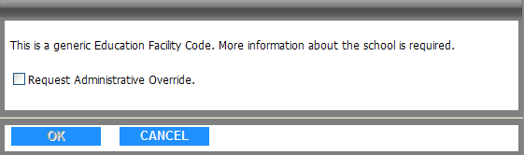
- Click OK
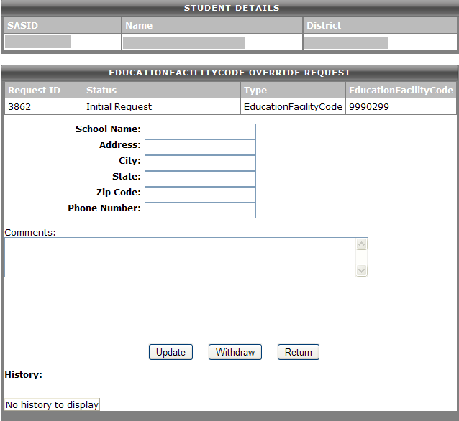
- Enter the Name, Address, City, State, Zip and Phone of the School the student is attending
- Click Update
- LEA must provide proof that the facility is approved, fax this to the attention of “ Verification of Grant AO” 860-713-7013, Attention: Kevin Chambers.
- CSDE will verify the approval status and make an appropriate status change

How to Request an AO when a Facility is Not Approved
Use this procedure when this is a Parent Initiated Placement for other than educational reasons in a facility approved or not approved for special education.
Note: Refer to the LEA Excess Cost Grant and State Agency Placement Grant for Placements in Facilities Approved or Not Approved for Special Education memo from Anne Louise Thompson, Bureau Chief 10/31/08 in the Appendix. *Section IIB Parent initiated placement for other than educational reasons in a facility approved or not approved for special education: School District Eligible for the Excess Cost Grant under special circumstances
Note: The record will remain at a status code 4 until the override is approved or withdrawn.
Prerequisites:
- Authorization for the Special Education Excess Cost Data Collection
- Collection is open
- Request for AO requires all other data fields to have passed edit checks and WARNING messages confirmed
Step Action
- On the View Collection or Non-Oct 1 Grants Student Record screen select Save Record at the top of the screen. The system redisplays the Grant Record screen
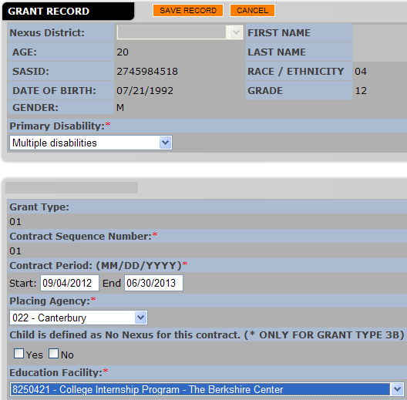
- Check “Request Administrative Override”
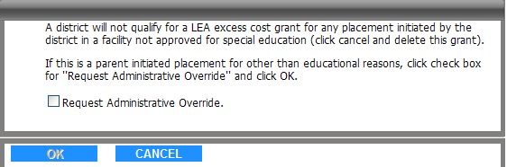
- Click OK
- In the comments box enter 'parent initiated placement for other than educational reasons'
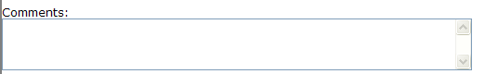
- Click Update
- LEA must fax the supporting documentation to the attention of 'Verification of Grant AO' to 860-713-7013, Attention: Kevin Chambers.
  - CSDE will verify the documentation and make the appropriate status change

FAQs

General Questions
- What is the difference between the December 1 and March 1 reporting?
All variables, fields, rules, edits and warnings are applicable to both grant sections. March 1 includes students placed after 12/1 and corrections/adjustments to existing collection and non-Oct 1 grants.

Reporting Students
- Where do I add a grant for a Oct 1 Student?
Use the View Student tab and then select the student.
- Where do I add a grant for a general education student?
Via hand entry you must use the Add Non-Oct 1 Grant. *REMEMBER: Due to rules associated with reporting State Agency Placement Grants, general education students (Special Education = “N”) must have a reported Nexus district in PSIS Registration.
- Where do I add a grant for a student who was not my Nexus on Oct 1?
Via hand entry you must use the Add Non-Oct 1 Grant.
- I’m trying to add a Non-Oct 1 grant and it says “Either the student was reported in the Oct 1 SEDAC Collection or NO match was found in PSIS Registration “?
If the student was reported in the Oct 1 Collection with your district as Nexus, add grant via the View Student tab and then select the student.If the student was not reported in the Oct 1 Collection with your district as Nexus, contact the PSIS data manager to ensure the student’s Nexus District and Nexus District Entry Date information is complete in PSIS Registration Module.

- Do I report a contract for all students placed out-of-district?
NO. Contract information is only required for students with costs that are near or over the district’s threshold (Basic Contribution).

- Can I report excess cost for a student educated in-district?
YES, Please note, with an out-of-district placement you have the bill. In terms of in-district placements, while they are still eligible for reimbursement under Excess Cost, the requirement for cost documentation is clearly more onerous. DO NOT include the net Current Expenditures per Pupil for your district. Costs must be documented and based on the costs needed to provide the services to the child as outlined in the IEP. With in-district placements use caution in how you pro-rate costs if the student is in a group setting.
- Can I report excess cost for a student who is close to, but does not exceed the threshold?
YES, a district will only qualify for either an LEA excess cost or State Agency Placement grant and receive reimbursement if all criteria are met. Remember, once the March 1 collection is closed you can no longer enter a contrac.
- Can a student have more than 1 contract?
YES. Students can have more than one contract.
- Can I report legal costs?
NO.

Deleting Grants
- How do I delete a grant I entered in error in the 12/1 submission?
If an error in reporting is made, you can delete a grant reported before 12/1 by using the delete button within the “View Collection and View Non-Oct 1 Collection” list.
- How do I delete a grant I entered in error in the 3/1 submission?
If an error in reporting is made, you can delete a grant reported after 12/1 by using the delete button within the “View Collection and View Non-Oct 1 Collection” list.
- I entered a grant in the 12/1 submission, but the student is no longer eligible for excess cost. How do I delete?
- You cannot delete this grant. (The delete button is dimmed)
- Grants reported about Dec. 1 which have changes to dates and/or costs should be revised to reflect actual dates and/or costs for the March 1 submission. This will allow the Bureau of Grants Management to document a change in costs and will reduce follow-up calls regarding a “missing” grant that was paid in the February disbursement. Therefore, once the 12/1 data is frozen you will not be allowed to delete a grant; only make updates.

Updating Grants
- I entered a grant but it has errors, how can I make changes to a grant?
View the students grant under the appropriate collection, either “View Collection or View Non-Oct 1 Collection” list. Make corrections and save.
- Can I adjust a contract for a student who had a change in placement (and are still eligible for excess cost)?
Yes, you can revise contracts entered in the December 1 submission to reflect actual dates and/or costs. You can also add additional contracts as needed.

Educational/Residential Facility Codes
- What if an Education Facility Code does not exist for where our student attends school?
If a student is attending a facility that has not been assigned a code, please use one of the following new codes:
New Facility Code | Description
9990199 | Generic Other In-State
9990299 | Generic Other Out of State
9990399 | Generic Other PreK Program
GENERICS CODES WILL SAVE AS A STATUS CODE 4. Districts cannot apply for an LEA Excess Cost Grant for students out-placed into in-state facilities that are not approved by the Connecticut State Department of Education and if the LEA places a student out-of-state, the LEA must provide proof that the facility is approved in that state. This will require and administrative override.
- What is the Residential Facility Code used for a student living in a foster or group home?
If student lives in a private foster or group home use 0000061.

Reports
- How can I see a summary of the grants I reported?
- On the Special Education Website
- Click Reporting
- Click Grant Students
- Click Summary of Grant Students
- Click on File Print
- How can I see all fields for the grants I reported?
- On the Special Education Website
- Click Reporting
- Click Grant Students
- Click View / Download All Grant Records
- How can I save reports?
- Click on File Save As
- Save in: select where you want to save this document
- File name: enter a name for this document
- Click Save
- How can I print the “Download All Grant Records” report on 1 page?
You can print all fields for each student on legal size paper by changing the page setup.
- Click on File Page Setup
- Change Orientation to Landscape
- Change Scaling to Fit to
- Change the Paper size to legal
- Change the left and right margins to .25
- Click OK
- Click on File Print
Excel shrunk the data and I cannot read it.
You can print a report on multiple pages by increasing the number of pages on which you print.

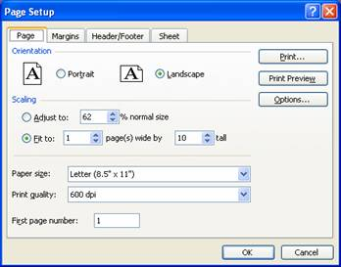

Appendix

Memo: LEA Excess Cost Grant and State Agency Placement Grant for Placements in Facilities Approved or Not Approved for Special Education Memorandum (2008) [PDF]
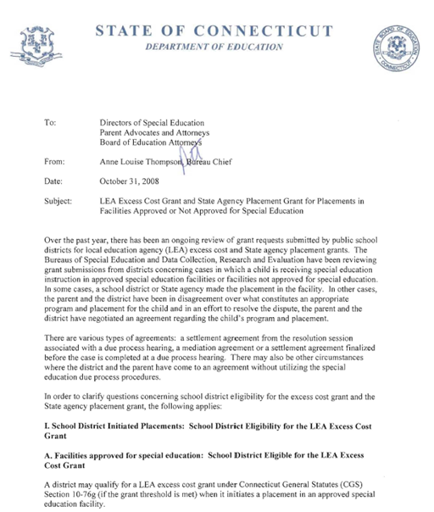

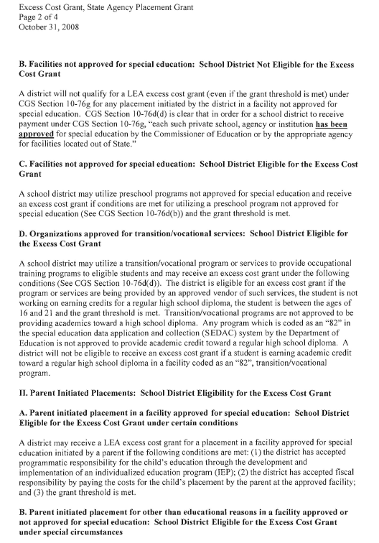
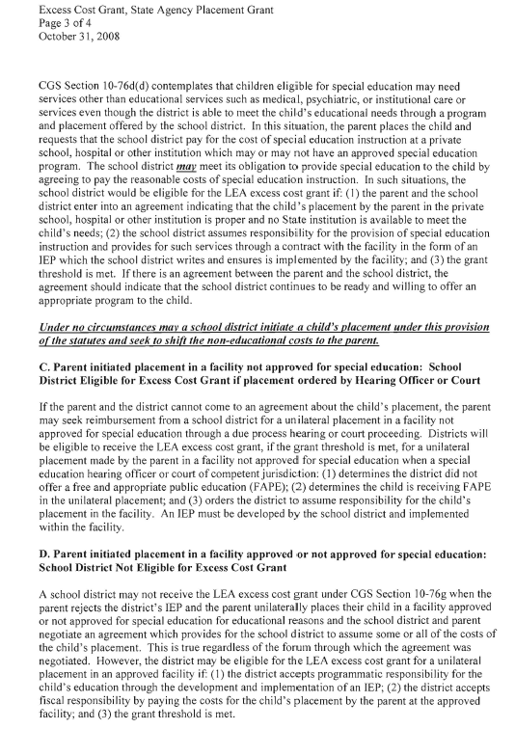
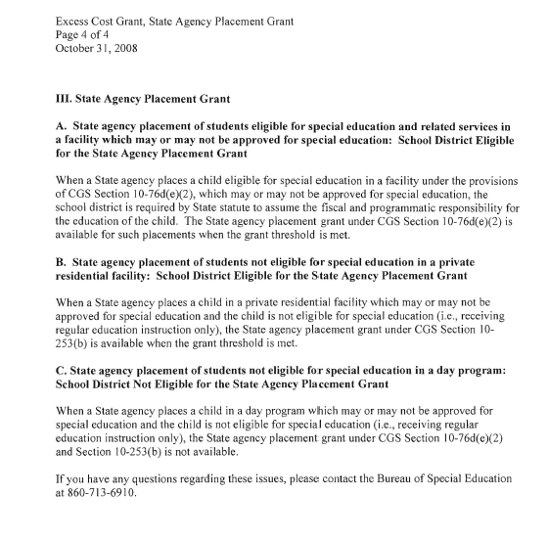

LEA Excess Cost and State Agency Grant Decision Tree [PDF]
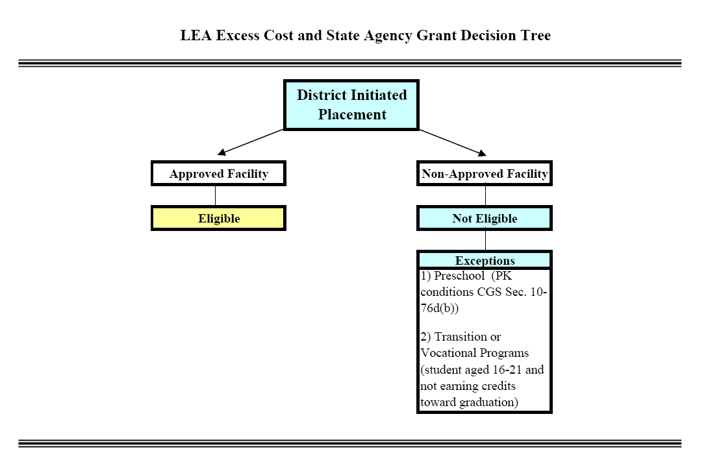
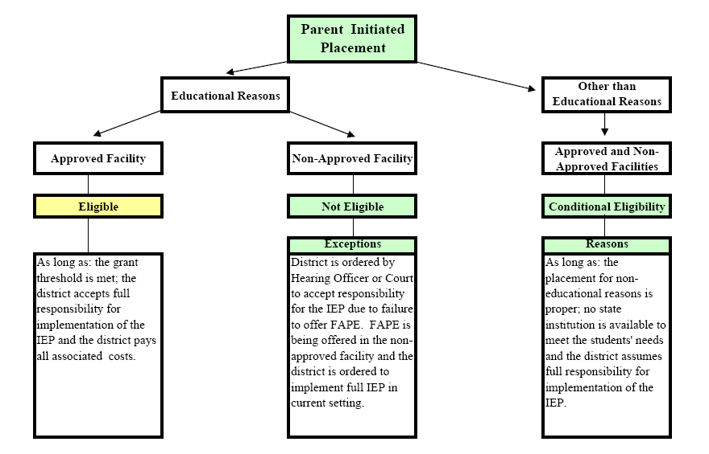
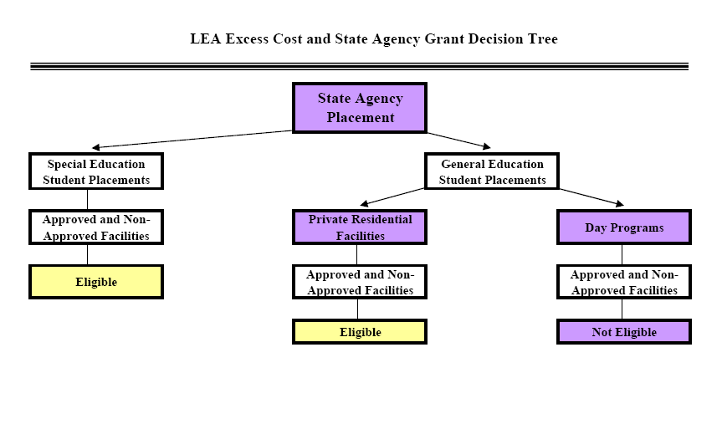

Timeline for LEA Excess Cost and State Agency Placement Grants

The following briefly describes how districts apply for and receive money for students who are eligible for LEA Excess Cost and State Agency Placement Grants during a given school year from the Connecticut State Department of Education.

Special Education Excess Cost December 1
Step 1: The district reports first estimated costs and receives 75% of eligible grants.
- December – First estimated costs are reported through the Special Education Excess Cost Collection to the Bureau of Grants Management (BGM). Grants with start dates on or before December 1 of the reporting year are due December 1.
- January – Grant information is processed and reviewed by the BGM. Districts are contacted if there are questions about the data submitted. BGM determines the amount available based on the number of eligible applicants.
- End of February – The district’s Treasurer receives 75% of the estimated entitlement.

Special Education Excess Cost March 1
Step 2: The district reports final estimated costs and receives balance of the estimated entitlement.
- March – Final estimated costs are reported through the Special Education Excess Cost Collection to the BGM. Grants with start dates on or before March 1 are due March 1 of the reporting year.
- March – Grant information is processed and reviewed by the BGM. Districts are contacted if there are questions about the data submitted. BGM determines the amount available based on the number of eligible applicants.
- End of May – The District’s Treasurer receives balance of the estimated entitlement.

ED001 Special Education Excess Cost
Step 3: In the ED001 the district reports actual costs and final grant adjustments are made.
- September of the next school year - Actual costs for students where grant type was entered in the Special Education Excess Cost Collection are displayed through an electronic submission of ED001 tables available. District staff enters the actual costs for the students. Information is due September.
- April of the next school year – Prior year adjustments are calculated and applied to the Education Cost Sharing grant’s April payment.

Nexus Districts
Code | Value/Label | Code | Value/Label | Code | Value/Label | Code | Value/Label
001 | Andover | 048 | Ellington | 098 | Norfolk | 144 | Trumbull
002 | Ansonia | 049 | Enfield | 099 | North Branford | 145 | Union
003 | Ashford | 050 | Essex | 100 | North Canaan | 146 | Vernon
004 | Avon | 051 | Fairfield | 101 | North Haven | 147 | Voluntown
005 | Barkhamsted | 052 | Farmington | 102 | N. Stonington | 148 | Wallingford
007 | Berlin | 053 | Franklin | 103 | Norwalk | 151 | Waterbury
008 | Bethany | 054 | Glastonbury | 104 | Norwich | 152 | Waterford
009 | Bethel | 056 | Granby | 106 | Old Saybrook | 153 | Watertown
011 | Bloomfield | 057 | Greenwich | 107 | Orange | 154 | Westbrook
012 | Bolton | 058 | Griswold | 108 | Oxford | 155 | West Hartford
013 | Bozrah | 059 | Groton | 109 | Plainfield | 156 | West Haven
014 | Branford | 060 | Guilford | 110 | Plainville | 157 | Weston
015 | Bridgeport | 062 | Hamden | 111 | Plymouth | 158 | Westport
017 | Bristol | 063 | Hampton | 112 | Pomfret | 159 | Wethersfield
018 | Brookfield | 064 | Hartford | 113 | Portland | 160 | Willington
019 | Brooklyn | 065 | Hartland | 114 | Preston | 161 | Wilton
021 | Canaan | 067 | Hebron | 116 | Putnam | 162 | Winchester
022 | Canterbury | 068 | Kent | 117 | Redding | 163 | Windham
023 | Canton | 069 | Killingly | 118 | Ridgefield | 164 | Windsor
024 | Chaplin | 071 | Lebanon | 119 | Rocky Hill | 165 | Windsor Locks
025 | Cheshire | 072 | Ledyard | 121 | Salem | 166 | Wolcott
026 | Chester | 073 | Lisbon | 122 | Salisbury | 167 | Woodbridge
027 | Clinton | 074 | Litchfield | 123 | Scotland | 169 | Woodstock
028 | Colchester | 076 | Madison | 124 | Seymour | 201 | Region 1
029 | Colebrook | 077 | Manchester | 125 | Sharon | 204 | Region 4
030 | Columbia | 078 | Mansfield | 126 | Shelton | 205 | Region 5
031 | Cornwall | 079 | Marlborough | 127 | Sherman | 206 | Region 6
032 | Coventry | 080 | Meriden | 128 | Simsbury | 207 | Region 7
033 | Cromwell | 083 | Middletown | 129 | Somers | 208 | Region 8
034 | Danbury | 084 | Milford | 131 | Southington | 209 | Region 9
035 | Darien | 085 | Monroe | 132 | South Windsor | 210 | Region 10
036 | Deep River | 086 | Montville | 133 | Sprague | 211 | Region 11
037 | Derby | 088 | Naugatuck | 134 | Stafford | 212 | Region 12
039 | Eastford | 089 | New Britain | 135 | Stamford | 213 | Region 13
040 | East Granby | 090 | New Canaan | 136 | Sterling | 214 | Region 14
041 | East Haddam | 091 | New Fairfield | 137 | Stonington | 215 | Region 15
042 | East Hampton | 092 | New Hartford | 138 | Stratford | 216 | Region 16
043 | East Hartford | 093 | New Haven | 139 | Suffield | 217 | Region 17
044 | East Haven | 094 | Newington | 140 | Thomaston | 218 | Region 18
045 | East Lyme | 095 | New London | 141 | Thompson | 219 | Region 19
046 | Easton | 096 | New Milford | 142 | Tolland
047 | East Windsor | 097 | Newtown | 143 | Torrington

State Agencies Responsible for Placement
337 | DMHAS | 349 | DDS (formerly DMR) | 954 | Court
347 | DCF | 950 | Indian Nation

LEA Excess Cost and State Agency Placement Grants

Grant Type 01 –LEA Excess Cost (CGS Section 10-76g):Applicable to each special education student for whom the costs of education services, provided or arranged by the student’s Local Education Agency (LEA), exceed the legislatively-determined reimbursement threshold. (The “threshold” is currently four and one-half times the LEA’s average per pupil expenditure for the prior school year). Reported costs may include “room and board” if a residential placement in a residential facility or group home is required for educational reasons. No judicial facility codes are allowed under this Grant Type. (Such facilities are only eligible for Grant Types 02 and 04.) Reimbursement will be made for services provided to students who remain in their home schools provided the reasonable costs of such services exceed the reimbursement threshold. LEA placements into unapproved facilities will not be reimbursed.
Grant Type 02 – State Agency Placement (CGS Section 10-76d(e)(2)): Applicable to each special education student who has been placed out-of-home by a state agency, including the judicial branch, who does not reside on or in a licensed permanent family residence (PFR) (See Facility Codes ending in 70 in the Appendix (Facility Codes - Connecticut Programs with Residential Components)), and whose education costs exceed the LEA’s average per pupil expenditure for the prior school year. Such costs are limited to the reasonable costs of special education and related services. Any Educational Facility Code is acceptable for this grant type. The Residential Facility, however, cannot be a state owned or operated property (Residential Facility Codes ending in 70 (PFR) or Residential Facility Codes ending in 15 with a district code of 337 (DMHAS) or 347(DCF)).
Grant Type 3a – State Property (CGS Section 10-76d(e)(3)): Applicable to each special education student who has been placed by a state agency either in a licensed permanent family residence (See Facility Codes ending in 70 in the Appendix (Facility Codes - Connecticut Programs with Residential Components)), as defined by C.G.S. Section 17a-154, or in a facility located on state-owned or state-leased property (See Residential Facility Codes ending in 15 with a district code of 337 (DMHAS) or 347(DCF)).
Grant Type 3b – No-Nexus Residential (CGS Section 10-76g(a)(1): Applicable to each special education student who 1) has no-nexus status, 2) has been placed by a state agency in a residential facility operated by the Department of Children and Families or a private residential facility (Residential Facility Code ending in 61, except for “Private Foster or Group Home 0000061”), and 3) receives special education in a program operated by a town, region, or Regional Education Service Center (RESC). The reasonable costs of special education and related services are fully reimbursable.
Grant Type 04 – General Ed Residential (CGS Section 10-253(b): Applicable to each student 1) who has been placed by a state agency in a private residential facility (Residential Facility Code ending in 61), 2) who is not eligible to receive special education services, and 3) whose education costs exceed the LEA’s average per pupil expenditure for the prior school year. Such costs are limited to the reasonable costs of education services.
Prorated Excess Cost Grants: Applicable to each special education student who has a change in placement status during the school year (e.g., from “excess cost” eligibility to “state agency placement”) and whose aggregate costs exceed the prior year’s average per pupil expenditure for the student’s LEA. In this event, the basic contribution of each grant is prorated based on the number of educational days in each situation. A separate grant application is needed for each placement. Separate payment is based on the prorated contribution of each of the grants.
To find your districts’ threshold, see Net Current Expenditures (NCE) per Pupil (NCEP) and Basic Contributions in the Appendix under SEDAC References.
If necessary, contact Kevin Chambers at the Bureau of Grants Management, CSDE, 860-713-6455.

LEA Excess Cost (Grant Type 01) – Allowable Costs

The purpose of this document is to provide guidance to districts when reporting special education and related services for a student educated in the district, which may be eligible for Grant 01 (LEA Placement). A child with disabilities qualifies if the costs, when combined, exceed the local district’s basic contribution threshold by four and one half times. To find your districts’ threshold, see Net Current Expenditures (NCE) per Pupil (NCEP) and Basic Contributions in the Appendix under SEDAC References.
Before applying you should be aware of the following:
- Report student’s actual expenditures supported by local tax dollars.
- DO NOT include:
  - the Net Current Expenditures per Pupil (NCEP) for your district
  - federal source funds such as IDEA Part B (611/619)
  - any state funds such as BESB
  - any portion of the Special Education Director’s Salary
  - any costs related to running the building
  - legal costs related to the student
- As with out-of-district costs, all are subject to Department audit requirements.
- Districts must maintain detailed, accurate documents for each student to support their claim.
Reporting Costs for In-district Staff
The most challenging costs to report are for staff within the district. One formula may not work for all students. Furthermore, each grant application is based on one child’s Individual Education Program (IEP), making it difficult to give specific examples. Therefore, each district must develop a methodology to calculate staff costs that is reasonable, and can be allocated to the student. These must be documented and based on the costs needed to provide the services to the child as outlined in the IEP.
It is also reasonable in most cases to include only the cost of those staff members who work with a very small number of students with high needs rather than include a staff member who works with a large number of students. Costs typically reported are for salary and benefits for teachers, related service personnel and paraprofessionals.
Reporting Other Costs
Other non-staff related costs are easier to report as they are billed to your district. These must be documented and based on the costs needed to provide the services to the child as outlined in the IEP. The following list provides some examples and guidelines for calculation.
- District contractor for provision of special education/related services (i.e. Physical Therapy (PT) Services, Occupational Therapy (OT) Services, Speech Services)
- Equipment: purchased, leased, repaired and maintained for one student (for the year purchased or leased)
- Other outside services: nursing, interpreter, consulting, and evaluations
- Home training
- Items to Report under Transportation Costs
  - Special Education Transportation (divided by the number of children on the van)

Reporting Costs under the Single Cost Accounting System (SCAS)

The following information is applicable to reporting education costs for students who are attending an approved private special education program located within a private residential treatment program and, therefore, whose daily education rate has been calculated by the State Department of Education under the Single Cost Accounting System (SCAS). The Department monitors the tuition and related services costs reported in the Tuition Cost Field for each SCAS facility. The Bureau of Grants Management limits the amount that can be included in the district’s State Agency Placement or Excess Cost Grant computation. This daily rate, multiplied by the number of tuition days entered, is the maximum amount that the Department will reimburse your school district under either a State Agency Placement grant or an Excess Cost Grant. For the latest list of programs that are subject to SCAS rate calculations see the Approved Private Special Education Programs Per Diem Rates in the Appendix under SEDAC References
There are three fields to report costs for students: Tuition Cost (which includes tuition and related services excluding transportation), Transportation Cost, and Room and Board Cost. The SCAS-calculated rate is an all-inclusive rate. If a student is placed by a state agency take the approved daily SCAS rate, and multiply it by the number of tuition days. If the student is placed by the LEA and the facility charges a daily rate for the same tuition and related services that is different from the SCAS rate, report the actual cost in the Tuition Cost field. Any payment in excess of these rates is ineligible for reimbursement by the Department. If the student attends as a day student, fill in transportation costs in the Transportation Cost field.
If a student receives services that are not typically provided by the program and the program believes that the SCAS-calculated rate will not cover the cost of such services, the program may request that the State Department of Education adjust the rate (which is an average rate and applicable to all students within the program). If the student receives services through a source other than the special education program, such as placement in an additional separate program, costs for these services can be reported by entering a second contract.
To report residential services in a SCAS facility (if your local school district places a student in a SCAS facility and pays for residential services), fill in the costs in the Room and Board Cost field. More typically, however, the student is placed in a SCAS facility by a state agency, such as the Department of Children and Families or the Judicial Branch. In these cases, you are not responsible for any residential costs, so the Room and Board Cost field is left blank.

Facility Codes

Connecticut Programs with Residential Components
APSEP = Approved Private Special Education Program | RTC = Residential Treatment Center
PFR = Permanent Family Residence | SCAS = Single Cost Accounting System
If a facility is not listed, please contact Laura Guerrera at Laura.Guerrera@ct.gov or 860-713-6898 to obtain a code.
Name | TOWN |  | Code | Type
American School for the Deaf | West Hartford | 1550361 |  | APSEP
Arch Bridge School | Bethlehem | 0100161 |  | APSEP, RTC, SCAS
Capitol Region Mental Health Center | Hartford (DMHAS) | 3370615
Chapel Haven | New Haven | 0930661 |  | APSEP
Connecticut Children’s Place | East Windsor (DCF) | 3470115
Connecticut Junior Republic | Litchfield | 0740161 |  | APSEP
Connecticut Mental Health Center | New Haven (DMHAS) | 3370415
Connecticut Valley Hospital | Middletown (DMHAS) | 3370215
Devereaux Glenholme School | Washington | 1500161 |  | APSEP
Eagle Hill School | Greenwich | 0570161 |  | APSEP
Eagle House Education Program | Hartford | 0642061 |  | APSEP
Greater Bridgeport Community Mental Health Center | Bridgeport (DMHAS) | 3370515
Grove School | Madison | 0760161 |  | APSEP
High Hopes Group Home | Meriden (DCF) | 0800170 |  | PFR
Judicial Center - BRAVE | Hamden | 3481115
Judicial Center - Bridgeport Detention Center | Bridgeport | 3480115
Judicial Center - Girl’s Care 2 | Waterbury | 3480915
Judicial Center - Grace Alternative Detention Center | Hartford | 3480615
Judicial Center - Hartford Detention Center | Hartford | 3480315
Judicial Center - Litchfield Community Residential Program | Litchfield | 3481315
Judicial Center - SAGE Detention Center | Hamden | 3480415
Judicial Center – SOAR | Hamden | 3481215
Judicial Center - Washington Street Detention Center | Hartford | 3480515
Judicial Center - Youth Boy’s Care | New Haven | 3481015
Adelbrook – Children’s Home of Cromwell | Cromwell | 0330161 |  | APSEP, RTC, SCAS
The Learning Clinic | Brooklyn | 0190161 |  | APSEP, RTC, SCAS
Natchaug Hospital Journey School | Mansfield | 0780361 |  | APSEP, RTC, SCAS
PACES (at American School for Deaf) | West Hartford | 1550861 |  | APSEP, RTC, SCAS
Private Foster or Group Home (Grant Type 1, 2, or 4) | All towns | 0000061

Name | TOWN |  | Code | Type
Raymond Hill School (Formerly Klingberg) | New Britain | 0890361 |  | APSEP
River Valley Services (RVS) | Middletown (DMHAS) | 3370815
Riverview Hospital | Middletown (DCF) | 3470315
Rushford Academy | Durham | 0380261 |  | APSEP, RTC, SCAS
Southeast Mental Health Authority (SMHA) | Norwich (DMHAS) | 3370715
Susan Wayne Center | Thompson | 1410161 |  | APSEP, RTC, SCAS
There’s No Place Like Home, Eichler | New Haven (DCF) | 0930170 |  | PFR
Touchstone School | Litchfield | 0740461 |  | APSEP, RTC, SCAS
Walter G. Cady at Connecticut Juvenile Training | Middletown (DCF) | 3476715
Waterford Country School | Waterford | 1520161 |  | APSEP, RTC, SCAS
Whitney Hall School | Hamden | 0620361 |  | APSEP, RTC, SCAS

In-state Approved Private Special Education Program Facility Codes
SEDAC uses the facility coding structure used in the Public School Information System (PSIS). See SEDAC References for Facility Codes - Non Public and Out of State Facilities link. In-State APSEP tab at the bottom of the excel document is a list of In-State Approved Private Special Education Program Facility Codes.
CONNECTICUT STATE DEPARTMENT OF EDUCATION
BUREAU OF GRANTS MANAGEMENT
LIST OF IN-STATE APPROVED PRIVATE SPECIAL EDUCATION PROGRAMS
2014-15 DIR LAN
Revised: October 16, 2014
Facility Code | Town | Facility Name
0100161 | Bethlehem School District | Arch Bridge School
0170221 | Bristol School District | Oak Hill School at Bristol North
0170561 | Bristol School District | Oak Hill School at Bristol South
0190161 | Brooklyn School District | The Learning Clinic
0250161 | Cheshire School District | The Webb School at Cheshire
0330161 | Cromwell School District | Adelbrook - The Learning Center
0360161 | Deep River School District | Academy at Mount Saint John
0380261 | Durham School District | Rushford Academy
0450161 | East Lyme School District | The Lighthouse on Main Street
0450261 | East Lyme School District | The Lighthouse on Pennsylvania Ave
0460161 | Easton | The Speech Academy
0490161 | Enfield School District | Natchaug Hospital School Joshua Center - Enfield
0510261 | Fairfield School District | Giant Steps CT School
0516061 | Fairfield School District | Saint Catherine Academy
0570161 | Greenwich School District | Eagle Hill School
0620261 | Hamden School District | Cedarhurst School
0620361 | Hamden School District | Whitney Hall School
0626161 | Hamden School District | Lorraine D. Foster Day School
0640261 | Hartford | Grace S. Webb School
0642061 | Hartford | Eagle House Education Program
Facility Code | Town | Facility Name
0642161 | Hartford | Road School of Hartford High
0642261 | Hartford | High Road School of Hartford - Primary
0646061 | West Hartford | Futures School
0646161 | Hartford | OPTIONS Educational Services
0690161 | Killingly School District | Natchaug Hospital School Joshua Center NE - Danielson
0740161 | Litchfield School District | Connecticut Junior Republic
0740461 | Litchfield School District | Touchstone School
0760161 | Madison School District | Grove School
0770161 | Manchester School District | Community Child Guidance Clinic School
0770361 | Manchester School District | Manchester Memorial Clinical Day School
0780161 | Mansfield School District | Natchaug Hospital Inpatient School
0780261 | Mansfield School District | Natchaug Hospital School CDT - Mansfield
0780361 | Mansfield School District | Natchaug Hospital Journey School
0800161 | Meriden School District | Meliora Academy
0830561 | Middletown School District | The Academy of The Wheeler Clinic
0840161 | Milford School District | Charles F. Hayden School at Boys & Girls Village
0840461 | Milford School District | CCCD – Bridgeport Ave.
0840561 | Milford School District | CCCD – Wolf Harbor Road
0846061 | Milford School District | The Foundation School - Milford
0846161 | Milford School District | Woodhouse Academy
0890261 | New Britain School District | Oak Hill School at New Britain
0890361 | New Britain School District | Raymond Hill School
0890461 | New Britain School District | CCMC School
0895161 | New Britain School District | Oak Hill School at Holcomb Street
0920161 | New Hartford School District | Oak Hill School at Ann Antolini-New Hartford
0930661 | New Haven School District | Chapel Haven, Inc.
0931461 | New Haven School District | Yale Child Study Center School
0950161 | New London School District | Connecticut College Children's Program
1010161 | North Haven School District | Elizabeth Ives School for Special Children
Facility Code | Town | Facility Name
1036261 | Norwalk School District | High Road School of Norwalk
1040721 | Norwich School System | Natchaug Hospital School Joshua Center Thames Valley CDT
1060161 | Old Saybrook School District | Natchaug Hospital School - Shoreline
1070161 | Orange School District | The Foundation School - Orange
1075061 | Orange School District | Hope Academy
1100261 | Plainville School District | Northwest Village School/Wheeler Clinic
1100361 | Plainville School District | Oak Hill School at Toffolon
1105261 | Plainville School District | Oak Hill School at Middle School of Plainville
1106161 | Plainville School District | Oak Hill School at Haddam/Killingworth High School
1350161 | Stamford School District | Villa Maria Education Center
1356721 | Stamford School District | Pinnacle School
1380121 | Stratford School District | IPP Lower and Upper Program
1410161 | Thompson School District | Susan Wayne Center of Excellence
1440161 | Trumbull School District | Saint Vincent's Special Needs School Program
1480161 | Wallingford School District | Benhaven School
1480261 | Wallingford School District | High Road Academy
1480461 | Wallingford School District | Benhaven Academy
1485061 | Wallingford School District | High Road School Of Wallingford
1500161 | Washington School District | Devereux Glenholme
1516161 | Waterbury School District | High Roads School of Waterbury
1520161 | Waterford School District | Waterford Country School, Inc.
1550161 | West Hartford School District | The Gengras Center
1550261 | West Hartford School District | Intensive Education Academy, Inc.
1550361 | West Hartford School District | American School for the Deaf
1550561 | West Hartford School District | Ben Bronz Academy
1550861 | West Hartford School District | PACES-at American School for the Deaf
1590161 | New Britain School District | CCMC School
1630661 | Windham School District | Natchaug Hospital School CDT-Willimantic

Age Appropriate Community Based Transition Program Facility Codes
SEDAC uses the facility coding structure used in the Public School Information System (PSIS). See SEDAC References for Facility Codes - Non Public and Out of State Facilities link. Once opened click on the Transition Programs tab at the bottom of the excel document.

CONNECTICUT STATE DEPARTMENT OF EDUCATION
BUREAU OF GRANTS MANAGEMENT
LIST OF AGE APPROPRIATE COMMUNITY BASED TRANSITION PROGRAMS
2013-2014 DIR LAN
Revised: October 16, 2014
Facility Code | Town | Facility Name
0020382 | Ansonia | Birmingham Group Health Services-
0020482 | Ansonia | Disability Resource Network
0090182 | Bethel | Ability beyond Disability
0100282 | Bethlehem | Employment Options, LLC
0150582 | Bridgeport | Goodwill Industries
0150682 | Bridgeport | Disability Resource Network - Bridgeport
0150782 | Bridgeport | Marrakech Inc. - Transition Services
0170182 | Bristol | Young Parent Program - Bristol Family Center
0170282 | Bristol | Bristol ARC
0230282 | Canton | ARC of Farmington Valley, Inc. (FAVARH)
0250182 | Cheshire | Alliance Staffing of CT
0250282 | Cheshire | Secondary Transition Collaborative, Quinnipiac University
0280182 | Colchester | Alternative Services-Connecticut Inc. (Vocational Program)
0280282 | Colchester | New Beginnings For Life LLC
0280382 | Colchester | Alternative Services-Connecticut Inc. (Mobile Vocational Program)
0300182 | Columbia | Tri-County ARC
0330182 | Cromwell | MARC Community Resources, Ltd
0340282 | Danbury | Western Connection
0450182 | East Lyme | Eastern Community Development Corporation Day Program
0450282 | East Lyme | Lighthouse Transition Academy
0490182 | Enfield | Allied Rehabilitation Center
0500182 | Essex | Southeastern Employment Services, LLC
0510282 | Fairfield | CLASP Career and Community Options
0510382 | Fairfield | Fairfield School/Community Partnership
0570182 | Greenwich | Abilis-Greenwich
0590182 | Groton | Seabird Enterprises - Puffins Restaurant
0590382 | Groton | Lighthouse Voc-Ed Center - Groton
0590482 | Groton | The ARC of New London County
0600182 | Guilford | SARAH, Inc.-
0600282 | Guilford | Roses for Autism - Ability Beyond Disability
Facility Code | Town | Facility Name
0620182 | Hamden | Hamden Transition Academy @ Southern CSU - (AACPB)
0620282 | Hamden | Oak Hill Day Transition Program-Hamden
0620382 | Hamden | Cedarhurst School Passage Program
0640282 | Hartford | HARC
0640382 | Hartford | Options Employment & Educational Services
0640682 | Hartford | Sunrise Northeast
0640782 | Hartford | Oak Hill Day Transition Program-Hartford
0644182 | Hartford | CRT - Jumoke Academy
0670182 | Hebron | The Allen Institute
0690182 | Killingly | The ARC of Quinebaug Valley
0700182 | Killingworth | Behavior Management, LLC
0720282 | Ledyard | Eastern Community Development Corporation Day Program
0720382 | Ledyard | Community Enterprises - Gales Ferry Transition Program
0740182 | Litchfield | Project Succeed
0770182 | Manchester | MARC
0770282 | Manchester | Supported Education Program - MCC/Community Enterprises
0770382 | Manchester | New Seasons Inc. - Manchester Group Home
0780182 | Mansfield | RSD#19/UCONN-Storrs (AACBP)
0800182 | Meriden | ARC of Meriden-Wallingford, Inc.
0800282 | Meriden | Kuhn Employment Opportunities, Inc.
0830182 | Middletown | Futures, Inc.
0830282 | Middletown | Middlesex Transition Academy (AACBP)
0890182 | New Britain | CW Resources, Inc.
0890282 | New Britain | Transition/Vocational Center at Raymond Hill
0930182 | New Haven | Easter Seals Rehabilitation Center
0930782 | New Haven | Chapel Haven - Vocational Transition Program
0930882 | New Haven | Off Campus Classroom Program (OCC)
0950182 | New London | First Step Program
0950282 | New London | Sharp Training
0950382 | New London | Buckingham Community
0950482 | New London | Thames Academy, Mitchell Academy
1010182 | North Haven | Gateway Community College (AACBP)
1040282 | Norwich | Guide, Inc
1040382 | Norwich | Easter Seals - Ct.
1060182 | Old Saybrook | United Cerebral Palsy (UCP)
1080182 | Oxford | Corporation for Public Management (CPM) - Voc't Services
1100182 | Plainville | Ability Beyond Disability - Discover, Learn, Work
1190182 | Rocky Hill | REM Community Services INC Vocational Program
1350282 | Stamford | Abilis-Stamford
1380282 | Stratford | Volunteers of America
Facility Code | Town | Facility Name
1430282 | Torrington | Transitional Employment Unlimited
1430382 | Torrington | LARC School to Community Transition Program
1430482 | Torrington | Community Systems Inc.
1440182 | Trumbull | Kennedy Center
1440382 | Trumbull | Educating Learners in Transitional Environments (ELITE)
1460182 | Vernon | Hockanum Industries, Inc.
1480182 | Wallingford | ACORD, Inc.
1510182 | Waterbury | Easter Seals Rehabilitation Center
1510282 | Waterbury | ICES (Innovative Children's Environmental Services, Inc.)
1510382 | Waterbury | Bidwell Center (under Prime Care, Inc.),
1510482 | Waterbury | Waterbury Transition Learning Center
1520282 | Waterford | Eastern Community Development Corporation Day Program
1540182 | Westbrook | VISTA Vocational and Life Skills Center
1550282 | West Hartford | Farmington Valley Transition Academy @ Univ Hartford - (AACBP)
1630182 | Windham | Project Genesis
1630282 | Windham | Camp Horizons
1630382 | Windham | Horizons Educational Support Services
1640182 | Windsor | Easter Seals Rehabilitation Center
1640282 | Windsor | Vinfen Corporation
1660182 | Wolcott | Prime Care Inc.
1670282 | Woodbridge | Institute of Professional Practice
1690182 | Woodstock | Northeast Placement Services
2070182 | Regional District 07 | Highlander Transition Academy - NCCC
2070282 | Regional District 07 | Highlander Transition Academy - UCONN
8250182 | Massachusetts | New England Business Associates, Inc
8250282 | Massachusetts | Center of Hope
8440182 | Rhode Island | Napatree Vocational Services

Out of State Facility Codes
SEDAC uses the facility coding structure used in the Public School Information System (PSIS). See SEDAC References for Facility Codes - Non Public and Out of State Facilities link. Once opened click on the Out of State tab at the bottom of the excel document.

CONNECTICUT STATE DEPARTMENT OF EDUCATION
OFFICE OF RESEARCH AND EVALUATION
LIST OF OUT-OF-STATE FACILITIES
(Note: Red/Bolded Facilities are NOT approved)
2012-2013
Revised: October 16, 2014
Facility Code | State | Facility Name | Notes
8010261 | Alabama | Alabama Clinical Schools
8080261 | Colorado | Children's Ark
8100121 | Delaware | Cedars Academy
8120761 | Florida | National Deaf Academy
8120861 | Florida | Devereaux Florida
8130111 | Georgia | Butler High School
8170261 | Illinois | Chaddock
8170361 | Illinois | Timberline Knolls Academy
8170461 | Illinois | Indian Oaks Academy
8170561 | Illinois | Brehm Preparatory School
8190161 | Iowa | Clarinda Academy
8190261 | Iowa | Woodward Academy
8230121 | Maine | Beckett Family of Services
8230221 | Maine | Spurwink School - Cornville
8230261 | Maine | ELAN
8230321 | Maine | Ironwood
8230661 | Maine | KidsPeace Graham Lake School
8230761 | Maine | Spurwink School - Brunswick
8230861 | Maine | Spurwink School - Chelsea
8230961 | Maine | Spurwink School - Cummings
8231061 | Maine | Central Maine Learning Center
8231161 | Maine | Spurwink School - South Portland
8231261 | Maine | Spurwink School - Casco
8250111 | Massachusetts | Project COFFEE - Oxford Public Schools
8250121 | Massachusetts | Academy at Swift River
8250182 | Massachusetts | New England Business Associates, Inc
8250221 | Massachusetts | Children's Center
8250261 | Massachusetts | Boston Higashi School, Inc.
8250311 | Massachusetts | Mahar Regional
Facility Code | State | Facility Name | Notes
8250321 | Massachusetts | Eagle Hill School
8250361 | Massachusetts | Brightside School
8250411 | Massachusetts | Oxford Middle School
8250421 | Massachusetts | College Internship Program - The Berkshire Center
8250511 | Massachusetts | West Springfield High School
8250521 | Massachusetts | Valley View School
8250611 | Massachusetts | Swampscott High School
8250621 | Massachusetts | Aditus Inc.
8250661 | Massachusetts | Children's Study Home - Mill Pond School
8250711 | Massachusetts | Holland Elementary School
8250721 | Massachusetts | Bellingham Employment Program
8250811 | Massachusetts | Waltham High School
8250821 | Massachusetts | Justice Resource Institute - Butler Center
8250911 | Massachusetts | Palmer High School
8250921 | Massachusetts | Kennedy Hope Academy Franciscan Hospital for Children
8251011 | Massachusetts | Ware High School
8251021 | Massachusetts | The Center School
8251061 | Massachusetts | Devereux Massachusetts Treatment Center
8251121 | Massachusetts | Willie Ross School for Deaf
8251111 | Massachusetts | Farmington River Regional School District
8251211 | Massachusetts | Turners Falls High School
8251261 | Massachusetts | Evergreen Center School
8251311 | Massachusetts | Merrimack Alternative Vocational High School
8251361 | Massachusetts | F. L. Chamberlain School
8251411 | Massachusetts | Holyoke High School
8251461 | Massachusetts | Germaine Lawrence School.
8251511 | Massachusetts | Quarry Hill Community School
8251561 | Massachusetts | Hillcrest Education Centers - Hillcrest Center
8251611 | Massachusetts | Alfred M. Chaffee School
8251661 | Massachusetts | Institute for Developmental Disabilities Crystal Springs School
8251711 | Massachusetts | Robert H. Goddard
8251761 | Massachusetts | Justice Resource Institute - Berkshire Meadows
8251861 | Massachusetts | Lake Grove at Maple Valley
8251961 | Massachusetts | Landmark School, Inc.
8252061 | Massachusetts | Latham School
8252161 | Massachusetts | League School of Greater Boston
8252361 | Massachusetts | Melmark New England
8252461 | Massachusetts | NECC - New England Center for Children
Facility Code | State | Facility Name | Notes
8252561 | Massachusetts | Perkins School for the Blind
8252661 | Massachusetts | Protestant Guild School
8252861 | Massachusetts | Northeast Center for Youth and Families, Inc. Tri-County Schools
8252961 | Massachusetts | Valleyhead School
8253161 | Massachusetts | Judge Rotenburg Center
8253461 | Massachusetts | Curtis Blake School
8253561 | Massachusetts | White Oak School
8253861 | Massachusetts | Stetson School
8254061 | Massachusetts | Whitney Academy School.
8254161 | Massachusetts | Gifford School
8254361 | Massachusetts | Walker School
8254561 | Massachusetts | Stevens School
8254661 | Massachusetts | Hillcrest Education Centers - Brookside
8254761 | Massachusetts | Hillcrest Education Centers - Highpoint
8254861 | Massachusetts | Ivy Street School
8255061 | Massachusetts | Brandon School and Residential Treatment Center
8255161 | Massachusetts | Hillcrest Education Center - Intensive Treatment Unit
8255261 | Massachusetts | Kolburne School
8255361 | Massachusetts | Riverview School
8255561 | Massachusetts | Eagleton, Inc
8255661 | Massachusetts | Harbor School
8255861 | Massachusetts | May Institute West Springfield
8255961 | Massachusetts | May Institute Randolph
8256061 | Massachusetts | Cardinal Cushing School at Hanover
8256161 | Massachusetts | Justice Resource Institute-Centerpoint
8256261 | Massachusetts | Justice Resource Institute-Glenhaven Academy
8256361 | Massachusetts | Justice Resource Institute-Meadowridge Behavioral Health Center
8256461 | Massachusetts | Justice Resource Institute-Walden Street School
8256561 | Massachusetts | The Baird Center - The Home for Little Wanderers
8256661 | Massachusetts | Wayside Academy School
8259014 | Massachusetts | S.W.C.E.C. - Grow School
8259114 | Massachusetts | S.W.C.E.C. - Project Smile
8290121 | Missouri | Change Academy Lake of the Ozarks (CALO)
8290261 | Missouri | Niles Home for Children
8330121 | New Hampshire | Shortridge Academy
8330161 | New Hampshire | Crotched Mountain Rehabilitation Center
8330221 | New Hampshire | Becket Family of Services – Haverhill Academy
8330321 | New Hampshire | Oliverian School
Facility Code | State | Facility Name | Notes
8330361 | New Hampshire | Lakeview Neurorehabilitation Center
8330461 | New Hampshire | Wediko School
8330561 | New Hampshire | Spaulding Youth Center
8330761 | New Hampshire | Hunter School
8330861 | New Hampshire | Easter Seals of New Hampshire Robert B Jolicoeur School
8340161 | New Jersey | Bancroft NeuroHealth
8350121 | New Mexico | Del Rio Academy
8360121 | New York | Family Foundation School
8360161 | New York | Children's Village Greensburgh - #11 UFSD
8360221 | New York | Kildonan School
8360311 | New York | Blind Brook High School
8360321 | New York | Maplebrook School
8360421 | New York | Supervised Lifestyle Health Services (SLS)
8360521 | New York | Arms Acres
8360561 | New York | Green Chimneys School
8360621 | New York | Gow School
8360721 | New York | Gersh Academy
8360821 | New York | McCarton School
8361761 | New York | Pathfinder Village
8362061 | New York | New York School for the Deaf
8362661 | New York | Karafin
8363361 | New York | Center for Discovery (Sullivan Diagnostic Treatment Ctr)
8363461 | New York | Westchester Exceptional Children
8363561 | New York | Summit School
8369014 | New York | BOCES Putnam/Northern Westchester
8369114 | New York | BOCES Dr Kenneth B Clark Academy
8370161 | North Carolina | Stone Mountain
8390721 | Ohio | The Village Network - Boys Village Campue - Wooster
8420121 | Pennsylvania | Glen Mills School
8420161 | Pennsylvania | Camphill Special Schools, Inc
8420211 | Pennsylvania | Bucks County Schools Intermediate Unit # 22
8420221 | Pennsylvania | KidsPeace Broadway Campus
8420311 | Pennsylvania | Eliza Butler Kirkbride Elementary School
8420321 | Pennsylvania | KidsPeace Orchard Hills Campus
8420421 | Pennsylvania | Abraxas Youth Center/Cornell Companies
8420461 | Pennsylvania | Devereaux Kanner Center in West Chester
8420961 | Pennsylvania | Melmark School
Facility Code | State | Facility Name | Notes
8421161 | Pennsylvania | Pathway School
8421361 | Pennsylvania | Woods Services
8421461 | Pennsylvania | Devereux Beneto - Mapleton Schools
8421561 | Pennsylvania | Devereux Beneto - Brandywine
8421661 | Pennsylvania | George Junior Republic
8440111 | Rhode Island | Smithfield Senior High School
8440121 | Rhode Island | Caritas Inc Corkery House
8440161 | Rhode Island | Groden Center
8440182 | Rhode Island | Napatree Vocational Services**
8440221 | Rhode Island | Cornerstone School
8440261 | Rhode Island | Harmony Hill
8440321 | Rhode Island | The Wheeler School
8440461 | Rhode Island | Bradley School-East Providence
8440561 | Rhode Island | Mount Pleasant Academy
8440661 | Rhode Island | Wolf School
8440761 | Rhode Island | Meeting Street School
8440861 | Rhode Island | Bradley School - Westerly
8450111 | South Carolina | Dutch Fork Elementary
8450121 | South Carolina | Palmetto Pines Behavioral Health
8470761 | Tennessee | Natchez Trace Youth Academy
8470861 | Tennessee | Peninsula Village School
8480121 | Texas | Devereux - League City
8490121 | Utah | Logan River Academy
8490221 | Utah | New Haven School
8490321 | Utah | Island View Residential
8500111 | Vermont | Porters Point School
8500161 | Vermont | Bennington School
8500361 | Vermont | Pine Ridge
8500461 | Vermont | Rock Point School
8500561 | Vermont | Austine School for the Deaf
8500661 | Vermont | Greenwood School
8500861 | Vermont | Brattleboro Retreat (Retreat Healthcare) Meadows Educational Center
8510361 | Virginia | Pines RTC - Crawford Campus
8510561 | Virginia | Keystone Academy
8510661 | Virginia | Pines Residential Treatment Center - Brighton Campus
**Napatree Vocational Services in Rhode Island and New England Business Associates, Inc in Massachussetts have been listed on the Transition Programs Worksheet and the Out-of-State Worksheet, for your convenience.

Approved Transition/Vocational Programs
Source: Bureau Bulletin December 2008/January 2009 - Page 4

Over the past several years there has been an increase in the number of school districts contracting with rehabilitation facilities and adult service providers for the provision of transition/vocational services for high school students with disabilities. These services include, but are not limited to, vocational evaluations, job development, job‐coaching support, job placement and life/social skills assessment and training. This article will expand upon previous Bureau guidance issued in December, 2000, and help to clarify current Bureau practices and procedures related to the approval, coding and use of new and existing adult services to assist students in meeting IEP transition goals and objectives.

Facility Code Components for Transition/Vocational Programs and Services

The use of transition/vocational programs and services is allowed under Connecticut General Statute Section 10 ‐76d(d): “Any local or regional board of education may enter into a contract with the owners or operators of any sheltered workshop or rehabilitation center for provision of an education occupational training program for children requiring special education who are at least sixteen years of age, provided such workshop or institution shall have been approved by an appropriate state agency.” In the Public School Information System (PSIS), when reporting about students, every program is given a separate Facility Code, which is a seven‐digit number indicating the educational location of each student. The first three digits of the Facility code is the District Code, the fourth and fifth digits are the School Code and the last two digits refer to the Institution Code. All existing and new transition/vocational programs must fit into one of the three Facility Code categories listed below:

A. Transition/Vocational Programs Coded as “82”

The Bureau interprets “approved by an appropriate state agency” as any rehabilitation center or adult service provider that holds a current and valid contract as a vendor with state agencies such as the Board of Education and Services for the Blind (BESB); Bureau of Rehabilitation Services (BRS); Department of Developmental Services (DDS); and the Department of Mental Health and Addiction Services (DMHAS). These service providers (often called Community Rehabilitation Providers – CRPs) as well as transition services provided to students with disabilities in a college or university setting (e.g., Hamden Transition Academy, Western Connection, Middlesex Transition Academy) have an Institution Code of “82” in the PSIS system. For example, the Hamden Transition Academy is 062‐01‐82 and the Kennedy Center in Trumbull is 144‐01‐82.

- District‐wide Special Education Programs that Provide Transition/Vocational Services

District operated special education programs that provide only transition/vocational services and are in a location other than a public school (e.g., apartment, church, municipal administration building, private school campus) are assigned a School Code (4th and 5th digits of the Facility Code) of “90” (may be “90 ‐ 98” if the district has more than one program) with an Institution Code of “11,” designating that it is operated by a public school. For example, West Hartford’s WAAVE Program (Applied Academic/Vocational Experience) that is on the campus of Northwest Catholic High School has a code of 155‐90‐11. These programs have separate reporting requirements and a Program Status Report must be signed by the superintendent and returned to Rick Cloud ( richard.cloud@ct.gov ) in the Bureau of Data Collection, Research, and Evaluation.

*Updated Contact Information
Program Status Report must be signed by the superintendent and returned to Rick Cloud (richard.cloud@ct.gov) in the Bureau of Data Collection, Research, and Evaluation.

- Transition/Vocational Programs Located within Public High Schools

Transition/vocational programs that are operated by a district and the base of operation is located within a public high school, are coded the same as the high school (Institution Code of “11”). Students in these programs may spend the majority of their time out in the community as long as some time is spent in the school on a regular basis. The School Code for these programs would be in the “60s,” indicating a specific high school. For example, the transition/vocational program, Academy of Western Connecticut that is based at Danbury High School, is coded as 034‐61‐11.

Locating Appropriate Codes for Transition/Vocational Programs

When reporting a Facility Code in PSIS or the Special Education Data Application and Collection system (SEDAC) for students who are between the ages of 17 and 21, districts can locate the “82” or “90” codes for such programs in the Public School Information System (PSIS) Facility Code List. If a program in which a district has placed a student to receive transition/vocational services does not have a Facility Code in PSIS, please contact Kevin Chambers at kevin.chambers@ct.gov . Districts must supply the name and address (street, town, zip code) of the program and its primary contact person with a phone number and email address. Department personnel will contact the transition/vocational program, determine if it is an approved vendor of a state agency, and assign a Facility Code to be posted in PSIS. Programs with which a district is currently contracted that are not an approved vendor of a state agency, will be informed about the vendor approval process and will have until June 30, 2009 to become an approved provider of transition/vocational services for students with disabilities. If these programs do not become an approved vendor, their current Facility Code will be closed as of June 30, 2009 and districts may report such students using a generic code as of July 1, 2009.

Applying for Excess Cost Grants for Transition/Vocational Services

As indicated in the October, 2008 memo regarding Excess Cost Grants (see October 2008 Bulletin), a district may utilize a transition/vocational program or services to provide occupational training programs to eligible students and may receive an excess cost grant under the following conditions (See CGS §10‐76d(d):
  - The district is eligible for an excess cost grant if the program or services are being provided by an approved vendor of such services (i.e., approved vendor of a CT state agency),
  - The student is not working on earning credits for a regular high school diploma,
  - The student is between the ages of 16 and 21, and
  - The grant threshold is met.
Students in a transition/vocational program that is reported using a generic code are not in an approved program and therefore, districts are not eligible for an excess cost grant for students attending those programs.

In addition, transition/vocational programs are not approved to be providing academics toward a high school diploma. Any program that is coded as an ʺ82ʺ in the SEDAC system by the Department of Education is not approved to provide academic credit toward a regular high school diploma. A district will not be eligible to receive an excess cost grant if a student is earning academic credit toward a regular high school diploma in a facility coded as an ʺ82ʺ, transition/vocational program.

A district has the authority (per CGS §10‐76d(d)) to place a child in a non‐approved program; however, the costs of such placements are ineligible for any State reimbursement. Furthermore, for placement in any program, it is the district’s responsibility to ensure a free appropriate public education (FAPE) for all students, including access to the general education curriculum, instruction provided by highly qualified teachers, progress on IEP goals and objectives that are measured and documented on a prescribed schedule, participation in statewide and district testing, and education in the least restrictive environment (LRE).

Determining Home School for Students in Transition/Vocational Programs

In SEDAC, the Home Facility Code is defined as the public school the student would normally attend if not a special education student. This item can be found on page one of the IEP and in most cases the Facility Code 1 and Home Facility Code are the same number. However, in the case of students in age‐appropriate community based transition programs and other transition/vocational programs (Institution Code of the Facility Code 1 is “82” or the School Code of the Facility Code 1 is 90‐98) the following criteria apply:
• If the student is greater than or equal to age 17 and the time with non‐disabled peers (TWNDP) is greater than or equal to 80%, then the Facility Code 1 is allowed to be the home school.
• If the student is greater than or equal to age 17 and the TWNDP is less than 80% then the Facility Code 1 cannot be the home school.

When determining if community‐based job placements or skills training programs should count as TWNDP, all of the following apply:
- The job placement occurs in an inclusive setting where individuals with and without disabilities are present. Think about the “look around” rule – when you are in the setting in which the student is being educated, “look around” to see if there are individuals without disabilities present;
- The job experience is one at which any student could potentially work; It is not a job placement that has been designed just for students with disabilities; and
- The community‐based job placement and/or skills training program is part of the student’s educational program (i.e., not just an after‐school job).

Further information to assist districts in defining TWNDP for transition‐aged students is available in the November 2008 Bureau Bulletin.

Contact Dr. Patricia Anderson at 860‐713‐6923 or patricia.anderson@ct.gov if you have additional questions about the coding or use of transition/vocational programs and services to assist students in meeting their postsecondary goals or post‐school outcome goal statements.

Educational Responsibility for Children Committed as Delinquent to the Department of Children and Families
Source: Bureau Bulletin September 2009 - Page 5

A child may be committed to the Department of Children and Families (DCF) as delinquent. Subsequent to this delinquency commitment, the child may be returned home or may be removed from the home to any one of several placement options, including but not limited to residential treatment, placement in a group home or placement in foster care. A child who is committed as delinquent may experience more than one type of placement during the period of commitment. For example, the child may be placed at a residential facility and then may be discharged from the residential facility to a group home. Each of these placements qualifies as a state agency placement under the provisions of Sections 10-76d (e) (2) and Section 10-253(a) of the state statutes. Under the state agency placement educational jurisdiction system, the town where the child would otherwise be attending school is the town where the child’s parent(s) or guardian(s) resides.

For a child who is not eligible for special education, the responsibility for educational services is with the town where the child is residing as a result of the placement. There is no provision for the town providing services to bill tuition expenses to the town where the child would otherwise be attending school.

For a child who is eligible or may be eligible for special education, the town where the child would otherwise be attending school (the nexus district) is responsible for the child’s individualized education plan (IEP) and may be billed by the town where the child is attending school for the reasonable costs of special education instruction.

Under the Individuals with Disabilities Education Act (IDEA) 2004 revisions, the child’s current IEP must be implemented with comparable services until the nexus district convenes a planning and placement team (PPT) meeting with the town where the child is attending school to revise the IEP.

Once a child is placed in a community, the town where the child will be attending school must immediately register the child in PSIS. The PSIS system will work to resolve any concurrent registration concerns. No child is to be held out of school waiting for a PPT meeting to be held to revise the child’s IEP or for the town where the child will be attending school to register the child in PSIS. Participation of the nexus district and the town where the child will be attending school in discharge planning is crucial to ensuring a smooth transition from a residential facility to a community placement.

For data reporting purposes, please note that both the PSIS and SEDAC handbook have a procedure for reporting state agency placed children from a data reporting standpoint. Whenever a child is placed by a state agency and is eligible for special education and will be attending public school, the district where the child is attending public school reports the student in PSIS.

For a child who has been committed delinquent, is placed at the Connecticut Juvenile Training School (CJTS) and is subsequently discharged from CJTS to a group home or other type of community placement, additional requirements for planning the transition from the residential facility to the community based placement are found in both the Smith v. Wheaton Memorandum of Decision, date September 30, 1998, and the Smith v. Wheaton Post Trial Stipulation (June 23, 1999). Smith v. Wheaton was a class action lawsuit against the State of Connecticut concerning services for juveniles who were placed at and discharged from the Long Lane School, the previous state run facility for adjudicated delinquents. As you know, the Long Lane School was closed and replaced by the Connecticut Juvenile Training School. The female students who are adjudicated delinquent are placed at various placements, including private residential facilities.1

Students at CJTS are covered by the Smith v. Wheaton provisions as CJTS is the successor facility for the Long Lane facility for boys. When it is time for the child to be discharged from CJTS into a community placement, such as a group home, the Post Trial Stipulated Agreement requires Unified School District II (USD II) of DCF, specifically, the Cady School of CJTS, to notify local education agencies (LEAs) in writing of the anticipated discharge date and to schedule a discharge meeting to which the parent(s) or guardian(s) and school district personnel from the child’s LEA are invited.

For a child eligible for special education who is placed by a state agency into a community placement such as foster care or a group home upon discharge from CJTS, LEA personnel from the town where the child would otherwise be attending school (the nexus district) or, LEA personnel from the town in which the child is residing as a result of the placement if the child has no-nexus, should participate in the discharge meeting. If the nexus district and the LEA in which the child will be attending school are different, school officials from both LEAs should participate in the discharge meeting and any subsequent PPT meetings to plan the child’s educational program.

The stipulated agreement requires that DCF encourage LEAs to hold PPT meetings immediately following the discharge meeting to plan for the child’s return to public school. If it is apparent that the LEA in which the child will attend school cannot meet the needs of the child in the district, the nexus LEA (or, if the child has no-nexus, the LEA personnel from the town in which the child is residing as a result of the placement) will place the child elsewhere. Under the terms of the Post Trial Stipulated Agreement, DCF is required to file a complaint with the State Department of Education (SDE) if an LEA fails to place the child elsewhere, if necessary, or when a child does not have an educational program in place upon discharge which implements the child's current IEP. DCF must also file a complaint with the SDE when the Cady School of CJTS does not receive the education records of a student from the student’s respective LEA pursuant to the Smith v. Wheaton Memorandum of Decision.

If you have any questions about this, please feel free to contact Terri DeFrancis at 860-713-6933.

1 DCF is currently building a facility for girls which will be the successor to Long Lane School. Once open, the requirements of Smith v. Wheaton will be applicable to that facility.

State Agency Placements Memorandum (1997)
Source: Bureau Updates October 8, 1997 - Page 7
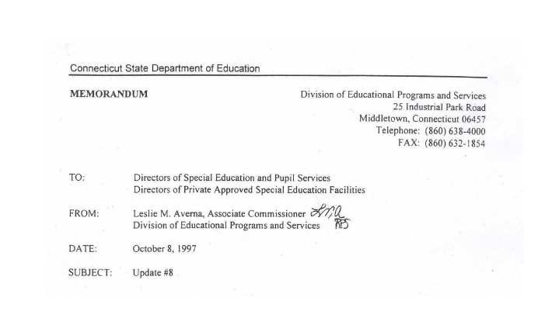
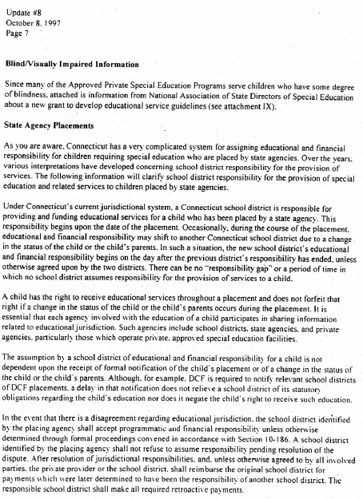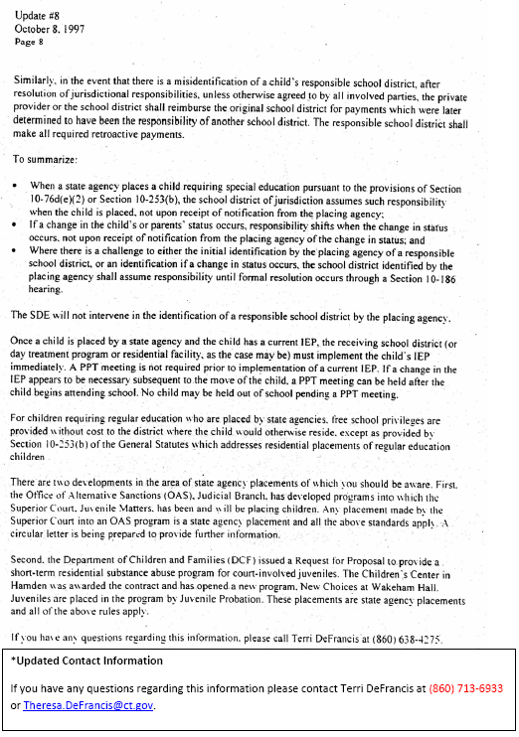

Terminology
Term | Definition
APSEP | Approved Private Special Education Program
CSDE | Connecticut State Department of Education
IEP | Individualized Education Program  A written education program for a child with a disability that is developed by a team of professionals (administrators, teachers, therapists, etc.) and the child’s parents; it is reviewed and updated at least yearly and describes the child’s present performance, what the child’s learning needs are, what services the child will {receive}, when and for how long, and identifies who provides the services.
LEA | Local Educational Agency - which is either a city or town’s board of education, or a regional school district.
Nexus | The Nexus District is the district that has the legal responsibility to identify, educate, and pay for a special education student under the Individuals with Disabilities Education Improvement Act (IDEA 2004).
Open Choice | Open Choice is an inter-district public school program intended to improve academic achievement; reduce racial, ethnic and economic isolation; and provide a choice of educational programs for public school students.  The Open Choice program allows urban students to attend public schools in nearby suburban towns. It also allows suburban and rural students to attend public schools in a nearby urban center. The program includes Hartford, Bridgeport, New Haven and their surrounding school districts.
PFR | Licensed Permanent Family Residence
PPT | Planning and Placement Team
PSIS | Public School Information System
PSIS October Collection | The database containing all student enrollment data as at October 1.
PSIS Registration | The database used for all student registrations and ongoing maintenance of student information.
Quasi-Public | Endowed and Incorporated Academies
RDC | Required Data Collection – Pages contained with the IEP Manual
RE | General Education (previously referred to as Regular Education)
RESC | Regional Education Service Center
SASID | State Assigned Student ID
SDE | State Department of Education
SEA | State Educational Agency
SEDAC | Special Education Data Application and Collection application used to collect and report on special education data.
SEDAC October 1 Child Count | The primary database used for SEDAC collection and reporting.

Special Education References
Reference | Website
Approved Private Special Education Programs  *Note: there is a list of Alternate Names of Programs, Affiliated Programs and Operating Agencies | http://www.sde.ct.gov/sde/lib/sde/PDF/DEPS/Special/Priv_SpEd_Progs.pdf
Approved Private Special Education Programs Per Diem Rates | http://www.sde.ct.gov/sde/lib/sde/pdf/fiscal/speced.pdf
Approved Transition/Vocational Programs  Source: Bureau Bulletin December 2008/January 2009 - Page 4 | http://www.sde.ct.gov/sde/lib/sde/PDF/DEPS/Special/ApprTransitionVocProgs_BB.pdf
Bureau of Special Education Website | http://www.sde.ct.gov/sde/cwp/view.asp?a=2678&Q=320730
Connecticut State Department of Education website | http://www.sde.ct.gov/sde/site/default.asp
Education Directory | http://www.csde.state.ct.us/public/csde/reports/reportsection.asp
Educational Responsibility for Children Committed as Delinquent to the Department of Children and Families  Source: Bureau Bulletin September 2009 - Page 5 | http://www.sde.ct.gov/sde/lib/sde/PDF/DEPS/Special/Updates/BulletinSeptember2009.pdf
ENTER BUTTON  Special Education Excess Cost Data Collection, ED166 and Evaluation Timelines system access | https://www.csde.state.ct.us/
Facility Codes - SEDAC uses the facility coding structure used in the Public School Information System (PSIS). See PSIS Table A: Facility Codes | http://www.csde.state.ct.us/public/psis/downloads.asp#codes.
Facility Codes - SEDAC uses the facility coding structure used in the Public School Information System (PSIS). See Non Public and Out of State Facilities. | http://www.csde.state.ct.us/public/psis/downloads.asp  - In-State APSEP tab at the bottom of the excel document is a list of IN-STATE APPROVED PRIVATE SPECIAL EDUCATION PROGRAM FACILITY CODES.  - Transition Programs tab at the bottom of the excel document is a list of AGE APPROPRIATE COMMUNITY BASED TRANSITION PROGRAM FACILITY CODES.  - Out of State tab at the bottom of the excel document is a list of OUT OF STATE FACILITY CODES. (Note: Red/Bolded Facilities are not approved by State in which it sits. This may impact SEDAC-G reimbursement)
Memo: LEA Excess Cost Grant and State Agency Placement Grant for Placements in Facilities Approved or Not Approved for Special Education Memorandum (2008)  Source: Bureau Bulletin October 2008– Page 3 | http://www.sde.ct.gov/sde/lib/sde/pdf/deps/special/LEA_Excess_Cost_Grant.pdf
Memo: LEA Excess Cost Grant and State Agency Placement Grant Decision Tree | http://www.sde.ct.gov/sde/lib/sde/pdf/deps/special/LEA_Excess_Cost_SAP_Grant_flowchart.pdf
Net Current Expenditures (NCE) per Pupil (NCEP) and Basic Contributions *This is updated by the Bureau of Grants Management in November of the collection year. | http://www.sde.ct.gov/sde/lib/sde/excel/dgm/report1/basiccon.xls
PSIS Tables | http://www.csde.state.ct.us/public/psis/downloads.asp
State Agency Placements Memorandum (1997)  Source: Bureau Updates October 8, 1997 - Page 7 | [PDF]

CSDE's Statement of Nondiscrimination

The State of Connecticut Department of Education is committed to a policy of equal opportunity/affirmative action for all qualified persons. The Department of Education does not discriminate in any employment practice, education program, or educational activity on the basis of race, color, religious creed, sex, age, national origin, ancestry, marital status, sexual orientation, gender identity or expression, disability (including, but not limited to, intellectual disability, past or present history of mental disorder, physical disability or learning disability), genetic information, or any other basis prohibited by Connecticut state and/or federal nondiscrimination laws. The Department of Education does not unlawfully discriminate in employment and licensing against qualified persons with a prior criminal conviction. Inquiries regarding the Department of Education’s nondiscrimination policies should be directed to:

Levy Gillespie
Equal Employment Opportunity Director
Title IX/ADA/ Section 504 Coordinator
State of Connecticut Department of Education
25 Industrial Park Road
Middletown, CT 06457
860-807-2071
Levy.Gillespie@ct.gov

