Connecticut State Department of Education - Grants Management
Education Financial System
User Guide

Table of Contents

1.1 Introduction 8
1.2 General Instructions 9
1.2.1 EFS Overview 9
1.2.2 Basis of Accounting 10
1.2.3 Inclusions and Exclusions 10
1.2.4 Charter School Reporting 11
1.2.5 RESC Reporting 11
1.2.6 Filing requirements 11
1.2.7 Audit 12
2.0 System Procedures 13
2.1 Logging in instructions 13
2.1.1 How to Access EFS data collection 13
2.2 Local File Upload Preparation Procedures 15
2.2.1 Extract data from local accounting system 15
2.2.2 Assigning EFS Codes to each record 15
2.2.3 Options for adding or modifying records before uploading to EFS website 15
2.2.4 Saving as *.csv (comma separated value) file 15
2.3 GL File Upload Procedures 16
2.3.1 Allocation process-Enter/Adjust 16
2.3.2 Upload steps 17
2.3.3 Validation rules 18
2.3.4 Correcting or deleting records 19
2.3.5 Process batch 21
2.4 Expenditure Screen 23
2.4.1 Introduction 23
2.4.2 Searching and Sorting Expenditures 24
2.4.3 Modifying Expenditures 25
2.4.4 Exporting Expenditures 27
2.4.5 Schedule Status 28
2.4.6 Data Issues Status 28
2.5 Expenditure Summary 29
2.5.1 Expenditure summary – Local and Regional School Districts 29
2.5.2 Expenditure summary – RESCs 35
2.5.3 Expenditure summary – Charter Schools 39
3.0 EFS Schedules 43
3.1 Applicability matrix 43
3.2 General schedule instructions 44
3.2.1 Expenditures from EFS database 44
3.2.2 Schedule Manual Entries 45
3.2.3 Prior year comparison 45
3.2.4 Marking a schedule as complete or not applicable 45
3.3 District Contact & Certification Information 46
3.3.1 Description 46
3.3.2 Line instructions 46
3.4 In-Kind Expenditure Schedule 48
3.4.1 In-Kind Expenditure Schedule Description 48
3.4.2 In-Kind Expenditure Schedule line instructions 49
3.5 Food services expenditure schedule 50
3.5.1 Food services expenditure schedule description 50
3.5.2 Food services expenditure schedule line instructions – Local and Regional School Districts 50
3.5.3 Food services expenditure schedule line instructions – Charter Schools 52
3.5.4 Food services expenditure schedule line instructions – RESCs 54
3.6 Special education expenditure schedule 56
3.6.1 Special education expenditure schedule description 56
3.6.2 Special education expenditure schedule line instructions – Local and Regional School Districts 56
3.6.4 Special education expenditure schedule line instructions – RESCs 59
3.7 Transportation expenditure schedule 60
3.7.1 Transportation expenditure schedule description 60
3.7.2 Transportation expenditure schedule line instructions – Local and Regional School Districts 60
3.7.3 Transportation expenditure schedule line instructions – Charter Schools 62
3.7.4 Transportation expenditure schedule line instructions – RESCs 63
3.8 Federal funding schedule 65
3.8.1 Federal funding schedule description 65
3.8.2 Federal funding schedule line instructions – Local and Regional School Districts 66
3.8.3 Federal funding schedule line instructions – Charter Schools 67
3.8.4 Federal funding schedule line instructions – RESCs 68
3.9 State funding schedule 70
3.9.1 State funding schedule description 70
3.9.2 State funding schedule line instructions – Local and Regional School Districts 71
3.9.3 State funding schedule line instructions – Charter Schools 72
3.9.4 State funding schedule line instructions – RESCs 73
3.10 Private/Miscellaneous funding schedule 75
3.10.1 Private/Miscellaneous funding schedule description 75
3.10.2 Private/Miscellaneous funding schedule line instructions – Local and Regional School Districts 75
3.10.3 Private/Miscellaneous funding schedule line instructions – Charter Schools 77
3.10.4 Private/Miscellaneous funding schedule line instructions – RESCs 78
3.11 Local funding schedule 81
3.11.1 Local funding schedule description 81
3.11.2 Local funding schedule line instructions – Local and Regional School Districts 81
3.11.3 Local funding schedule line instructions – Charter Schools 83
3.12 Tuition and transportation revenue schedules 84
3.12.1 Tuition and transportation revenue schedules description 84
3.12.2 Tuition and transportation revenue schedules line instructions – Local and Regional School Districts and RESCs 84
3.13 Regional High School Tuition Assessment & Detail of Pupils Sent Out of the District schedule 87
3.13.1 Regional High School Tuition Assessment & Detail of Pupils Sent Out of the District schedule description 87
3.13.2 Regional High School Tuition Assessment & Detail of Pupils Sent Out of the District schedule line instructions 87
3.14 Land, Buildings, Capital Construction and Debt Service schedule 89
3.14.1 Land, Buildings, Capital Construction and Debt Service schedule description 89
3.14.2 Land, Buildings, Capital Construction and Debt Service schedule line instructions- Local and Regional School Districts and RESCs 89
3.14.3 Land, Buildings, Capital Construction and Debt Service schedule line instructions- Charter Schools 91
3.15 Claim for Exceeding Statutory School Year schedule 92
3.15.1 Claim for Exceeding Statutory School Year schedule description 92
3.15.2 Claim for Exceeding Statutory School Year schedule line instructions – Local and Regional School Districts 92
3.16 Universal Service Fund Data 93
3.16.1 Universal Service Fund Data schedule description 93
3.16.2 Universal Service Fund Data schedule line instructions – All Districts 93
3.17 Federal Impact Aid schedule 95
3.17.1 Federal Impact Aid schedule description 95
3.17.2 Federal Impact Aid schedule line instructions – Local and Regional School Districts 95
3.18 State Charter School Grant and Reserve Fund Monitoring schedule 96
3.18.1 State Charter School Grant and Reserve Fund Monitoring schedule description 96
3.18.2 State Charter School Grant and Reserve Fund Monitoring schedule line instructions 96
3.19 Charter School Related Party and Management Organization Information schedule 98
3.19.1 Charter School Related Party and Management Organization Information schedule description 98
3.19.2 Charter School Related Party and Management Organization Information schedule line instructions 99
4.0 Data Specifications 100
4.1 EFS Upload Template 100
4.2 EFS Funding Source Code 101
4.3 EFS Function Code 108
4.4 EFS Object Code 116
4.5 EFS Education Type Code 127
4.6 EFS PreK Code 132
4.7 EFS Allocation Code 132
4.7.1 Allocation Basis - salary expenditures (for fringe benefit allocation only) 132
4.7.2 Allocation Basis – student enrollment 134
4.8 CSDE Location Code 135
5.0 Reports 136
5.1 General report information 136
5.2 Report details 137
5.2.1 Downloading or printing a report 137
5.2.2 View report detail 139
5.2.3 Refresh report 139
5.2.4 Change fiscal year 139
5.3 Report Specifications 140
5.3.1 DR1-Function/Object Summary Report 140
5.3.2 DR2-District Function/Object Prior Year Comparison Report 144
5.3.3 DR7-Expenditure Reconciliation Report 149
5.3.4 DR8-Per-Pupil Expenditure Summary Report 152
5.3.5 SR1-School Function/Object Summary Report 155
6.0 Data Issues 159
6.1.1 In-Schedule Trending Analyses 159
6.1.2 Trending Analyses 160
6.1.3 Desk Audits 161
7.0 Help Information 162
7.1 Contact Us 162
7.2 User Guide Revision table 162
Appendix B - Function/Object Valid Code Combinations 167
Appendix C - Land, Buildings, Capital Construction and Debt Service – Reporting Guidance 168
Appendix D - Approved Private Special Education Residential Facilities 173
Appendix E – 2023-24 CSDE Approved Interdistrict Magnet Schools 174
Appendix F – Worksheet For Determining Approved Charter School Application Expenditures 177

1.1 Introduction
The Education Finance System (EFS) is a financial data collection system to be used by local and regional boards of education, including charter schools and regional educational service centers (RESCs), to report data to the Connecticut State Department of Education (CSDE) supporting:
- State education financial reporting, including that required by Uniform Chart of Accounts (UCOA) legislation, and
- Federal education financial reporting, including that required by the Every Student Succeeds Act (ESSA) and the F-33 School-Level Finance Survey.

Sections 10-224 and 10-227 of the Connecticut General Statutes provide the legal authority for CSDE to collect financial data from local education agencies (LEAs).

The EFS is designed to allow LEAs to upload expenditure records obtained from local accounting systems to minimize manual data entry. However, prior to upload each record must be classified using EFS Codes as to:
- Funding Source
- Function
- Object
- Education Type
- PreK
- Allocation
- Location

Classifications, coding and definitions are based on National Center for Education Statistics (NCES) codes as listed in the publication FINANCIAL ACCOUNTING FOR LOCAL AND STATE SCHOOL SYSTEMS 2014 EDITION (NCES 2015-347). This document is available at: https://nces.ed.gov/pubs2015/2015347.pdf. The coding is intended to provide complete, uniform and comparable data for each school district and school. Where necessary, however, we have created additional detailed codes to allow for an appropriate reporting for our purposes.

1.2 General Instructions

1.2.1 EFS Overview


Education Financial System
LOGIN
(Section 2.1)
ALLOCATION
NO
YES
ENROLLMENT ALLOCATION PROCESS
(Section 2.3.1)
RE-UPLOAD - > CORRECTED GL FILE / DATA
UPLOAD GL FILE
Section 2.3.2
CORRECT ERRORS BY
DOWNLOADING BATCH FILE
(Section 1.0)
VALIDATION
(Section 2.3.3)
CORRECT ERRORS IN APPLICATION – EDIT / DELETE
(Section 2.3.4)

INVALID
DOWNLOAD BATCH
(Section 1.0)
(OPTIONAL)
VALID
PROCESS BATCH
(Section 2.3.5)

(OPTIONAL)
EXPENDITURES
(Section 2.4)
REPORTS
(Section 5.0)
SCHEDULES
(Section 3.0)
DOWNLOAD EXPENDITURES
(Section 1.0)
CERTIFY
(Section 1.0)

Note : Press Ctrl + Click on each of the Process to navigate to the respective sections in the document

1.2.2 Basis of Accounting
Reporting in the EFS must be based on either the full accrual or modified accrual basis of accounting. All expenditures must be reported for the period from July 1 through June 30, regardless of the LEA’s fiscal year. This includes encumbrances, such as purchase orders or contracts, for operating expenditures that have been charged to the LEA’s budgetary appropriations or grant awards within the reporting period. For school construction expenditures, do not include encumbrances for costs that will be incurred in a future fiscal period.

1.2.3 Inclusions and Exclusions
The EFS collects expenditure data, and limited revenue data, for all public prekindergarten through grade 12 education in Connecticut. This includes board of education expenditures and expenditures from state and federal grants as well as the value of in-kind services. In addition to records from the LEA’s accounting system, expenditure data may also include:
- In-kind services data provided by town officials.
- Expenditures for land, facilities acquisition and construction, debt service, interest, major remodeling and equipment, whether made from the board of education budget or from the town budget.

There are several categories of expenditures which are excluded from public PreK through grade 12 education expenditures, regardless of their funding source. Expenditures for the following must either be excluded from EFS reporting altogether or identified using the applicable EFS coding:
- Community services;
- Nonpublic school health services;
- Nonpublic school transportation services to nonmember students (except as required on the Transportation Schedule);
- Nonpublic expenditures from state and federal grant programs;
- Adult and adult basic education programs;
- Vocational agriculture services to adults and out-of-school youth;
- Continuing education programs;
- Volunteer services;
- Tuition summer school;
- Student activity funds;
- Salaries and fringe benefits for uncertified personnel in certified positions;
- Noneducational expenditures;
- Other nonpublic expenditures; and
- PTO and PTA contributions.
- Depreciation expense; in EFS, expenditures for school construction, property and equipment are reported in the year incurred.

Employee benefit expenditures reported such as retirement, health insurance, etc., must be reported “net” of related revenues from non-local tax sources (e.g., contributions from the State Teachers’ Retirement Board, employee co-payments, etc.).

1.2.4 Charter School Reporting
Charter school districts report expenditures in EFS consistently with the requirements for local and regional school districts. The schedule applicability matrix in Section 3.1 lists the EFS schedules applicable to each type of district. The following additional information applies to charter school districts:
- Before completing EFS, please complete the Worksheet for Determining Approved Charter School Application Expenditures (see Appendix F).
- To complete EFS, you will need, in addition to your regular accounting records, the details of services provided by your local school district or other town agencies. Report these in EFS as in-kind expenditures (see Section 4.2 instructions for EFS Funding Source Codes 12-17).
- For certain state and federal grants, the local board of education has the option to
  - Pass the grant money on to the charter school, or
  - Hold the money in an account, provide services to the charter school and pay for those services from that account. For the charter school district, this is considered an in-kind expenditure.

1.2.5 RESC Reporting
RESCs report expenditures in EFS consistently with the requirements for local and regional school districts, with the exception that for RESCs established as governmental entities, total expenditures from governmental funds, and for RESCs not established as governmental entities, total expenditures, must be reported. The following additional information applies to RESCs:
- The EFS expenditure codes allow classification of expenditures between those that apply to RESC schools/school district, vs. those that apply to other functions that RESCs perform. EFS Education Types 1, 2, and 3 identify expenditures for elementary and secondary education that apply to RESC schools/school districts. Other education types are used to indicate expenditures for other RESC activities.
- The EFS Federal, State, and Private/Miscellaneous Funding Schedules provide separate sections for total RESC expenditures and for RESC school/school district expenditures. The sources of funding need to be reconciled with EFS expenditure reporting separately for each section.
- Ensure that total expenditures reported in EFS are not duplicated. The effects of inter-fund transactions must be eliminated before entering expenditures in EFS. The expenditure should be reported where ultimately incurred. For example, for a school which is charged an internal fee for copier usage, the expenditure should be reported for that school.

1.2.6 Filing requirements
Section 10-227 of the Connecticut General Statutes requires that EFS data be submitted on or before September 1.

1.2.7 Audit
Section 10-227 of the Connecticut General Statutes requires that each LEA’s EFS submission be certified by an Independent Public Accountant. The CSDE Office of Internal Audit (OIA) annually publishes an Agreed-Upon Procedures package to be performed by the independent accountant. It is the LEA’s responsibility to ensure that the required Agreed-Upon Procedures reports are submitted to the CSDE on or before December 31. This report should be submitted in accordance with the instructions provided in the OIA package.

For local and state audit purposes, all supporting documentation and work papers generated in submitting the EFS data must be maintained. It is the Superintendent’s responsibility to maintain the supporting documentation necessary for a complete audit trail, including appropriate documentation for data provided by the town.

2.0 System Procedures

2.1 Logging in instructions

2.1.1 How to Access EFS data collection
Prerequisites: (An account in Directory Manager (DM) with an EFS role assigned.)
  - Your username and password are sent in two separate emails when you are first added to Directory Manager by your LEA Security Manager. Usernames and passwords should NOT be shared, as each are unique to the assigned individual.
- Using Google Chrome or Microsoft Edge, go to the https://csde.ct.gov website. The system displays the State of Connecticut Login screen.
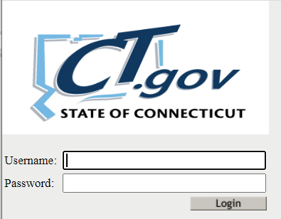
- Enter your Username and Password and select Login.
- If you only have access to EFS, the system displays the Grants Data System Acknowledgement screen.
- If you have access to more than one application, the system displays the CSDEHome Page.
  - Select Education Financial System from the Application drop-down menu and click Continue. The system displays the Grants Data System Acknowledgement screen.
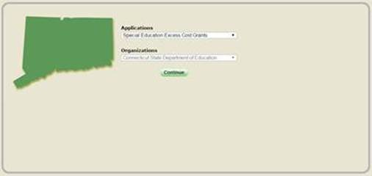
Note: If you do not have access to EFS, contact your LEA Security Manager. If you do not know who your Security Manager is, please click this link and contact one of them: List of LEA security liaison. If you have a user name and password created but forgot your user name or password or both, or if you want to change your password, please go to this website to change it: Reset your password.
Important: At this time, there are no school-level permissions. Permissions are only available at the DISTRICT-level.

2.2 Local File Upload Preparation Procedures

2.2.1 Extract data from local accounting system
- From your local accounting system, extract the expenditure account records, minimum fields to include:
  - Expenditure (expenditure to include encumbrances)
  - Account Number
  - Account Description
Tip: Local account codes may be parsed to aid in sorting records to assign EFS codes (refer to Appendix A for tutorial in using this function in Excel).
- Copy the three columns from your local accounting system data and paste into the EFS data entry template (column H, I, J). (Click here to obtain template: http://portal.ct.gov/SDE/Fiscal-Services/EFS/EducationFinancialSystem/Documents)

2.2.2 Assigning EFS Codes to each record
- Using the EFS data entry template fill in column A through J, where (column H, I, J) should be your expenditure data.
- Using the EFS codes provided in section 4, complete column A through G.
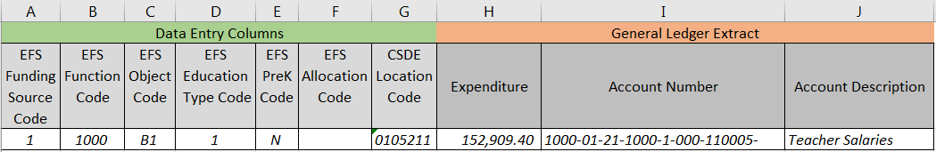

2.2.3 Options for adding or modifying records before uploading to EFS website

- Expenditures not recorded in the local accounting system may be added to the EFS template, as long as the appropriate EFS codes are used. We recommend that a description be included in the Account Description field (Column I), however the system will accept blank entries in Column I and J.
  - Example: Inkind funding expenditure…
- Expenditure line items can be modified/adjusted to suit the needs of the district, to give the most accurate reporting possible.
  - Example: Distributing/apportioning expenditure lines to different schools…
Tip: It will be helpful to refer to section 4.7.2 for allocation functions available in EFS.

2.2.4 Saving as *.csv (comma separated value) file
- Once all of the expenditure records have been assigned the proper EFS codes, also delete any data you may have used for sorting from columns K on, then save the Excel file.
- Saving to a *.csv file (this is the required format for upload)
  - Go to File > Save as > desktop (this will save the file to your desktop, but it could be saved anywhere that is accessible)
  - Under “Save as Type” select “CSV (Comma delimited) (*.csv)” from dropdown list
  - Click save
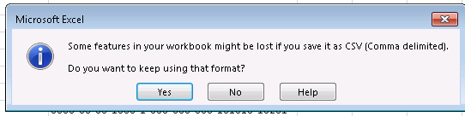
  - A message will appear, click yes.

2.3 GL File Upload Procedures

2.3.1 Allocation process-Enter/Adjust
- From the EFS home page, click on allocation groups
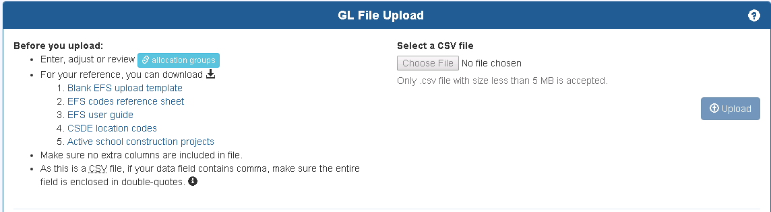
- Using the pre-populated information (using data from PSIS october collection), a maximum of 8 groupings are allowed (2-9) for enrollment allocation
  - Check applicable schools/programs for each grouping, when finished, click “Save”.
Example: For group 2 above, expenditure line will be allocated based on enrollment between Jack Jackter Intermediate, Colchester Elementary, William Middle school and Bacon Academy.
Tip: for further information, refer to section 4.7.2 Allocation Basis- student enrollment or click on the question mark icon (?) located on the page.
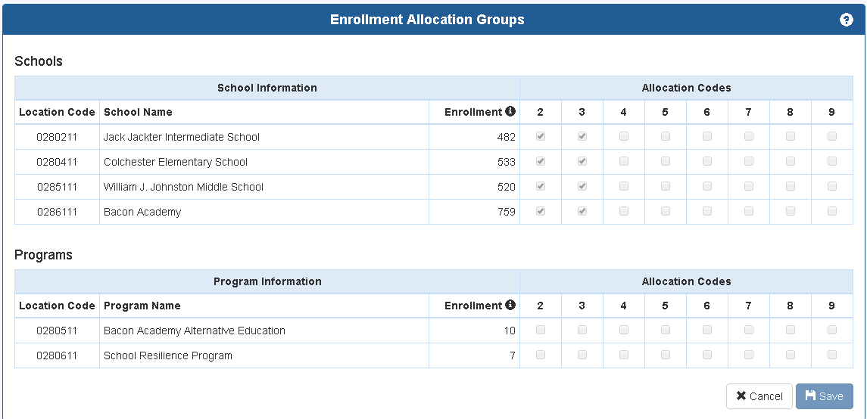

  - This grouping can be applied to the “EFS Allocation Code” field in the template.
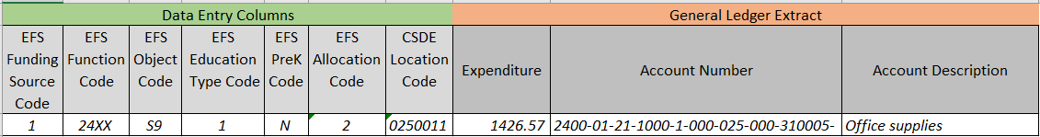

2.3.2 Upload steps
- Once the template has been completely filled in and in the required *.csv format, log into the EFS system, under select a csv file > choose file
> locate where the csv file was saved > select the csv file > click open
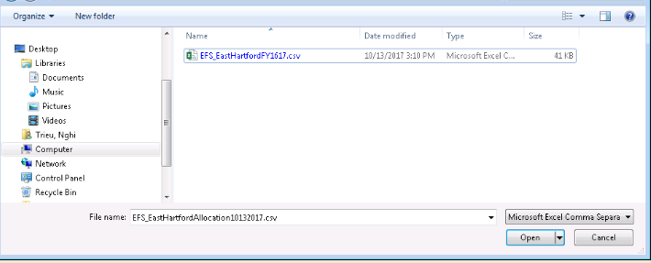
> Click “Upload” button
> If your csv file contains a header, select option one to ignore first row, if the csv file has no header, select option 2, first row is a data row.
> Click “Load data for validation”
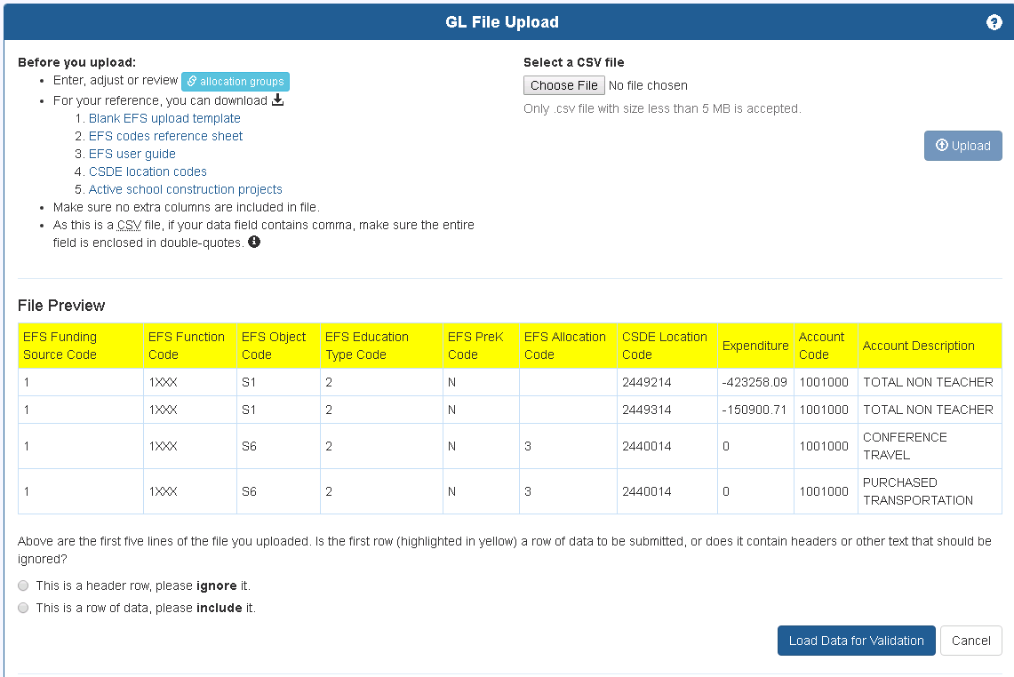

2.3.3 Validation rules
- Batch upload validation checklist:
  - Uploaded file must:
    - be a .csv file
    - be in the required format (see section 4.1)
    - have all required columns (A through J)
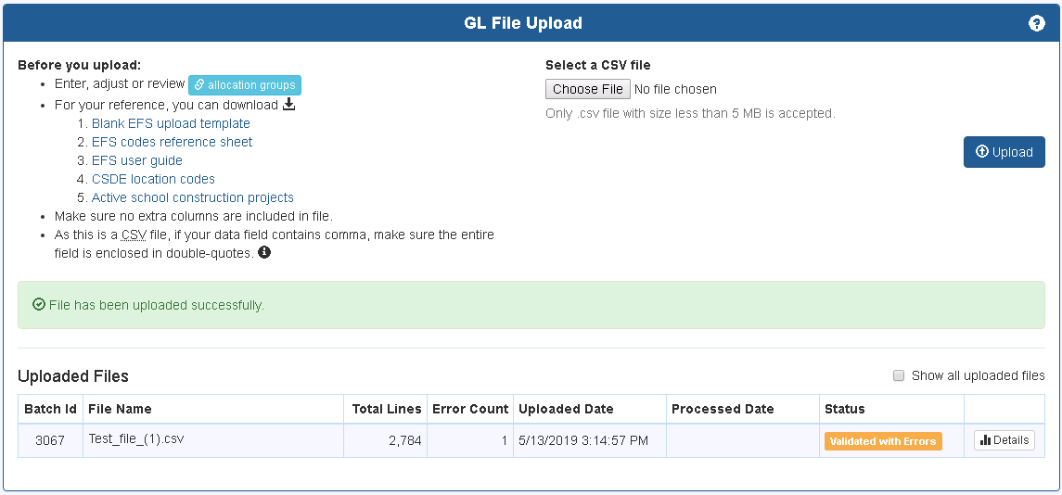
List of possible upload validation status:
Message | Description
Upload Failed | The file was unable to be properly uploaded.
Upload Cancelled | The file upload has been cancelled by user.
Validated without Errors | The batch has been successfully validated without any error(s).
Validated with Errors | The batch has been validated with error(s).
Validation Failed | The validation process failed. This is a system error, not a data error.
Processed | The batch has been processed successfully.
Processing Failed | The batch processing failed. This is most likely a system error, not a data error.
Overwritten | The batch has been at least partially overwritten by records from a newer batch.

2.3.4 Correcting or deleting records

- Click “Details” to view/correct errors
  - Tabs:
    - All Records- display all of the uploaded records in your csv file.
    - Error Records (correct error, action required)- display only records with errors, this will need to be corrected before moving on to the next step.
    - Duplicate Records (informational, no action required)- display records with the same data.
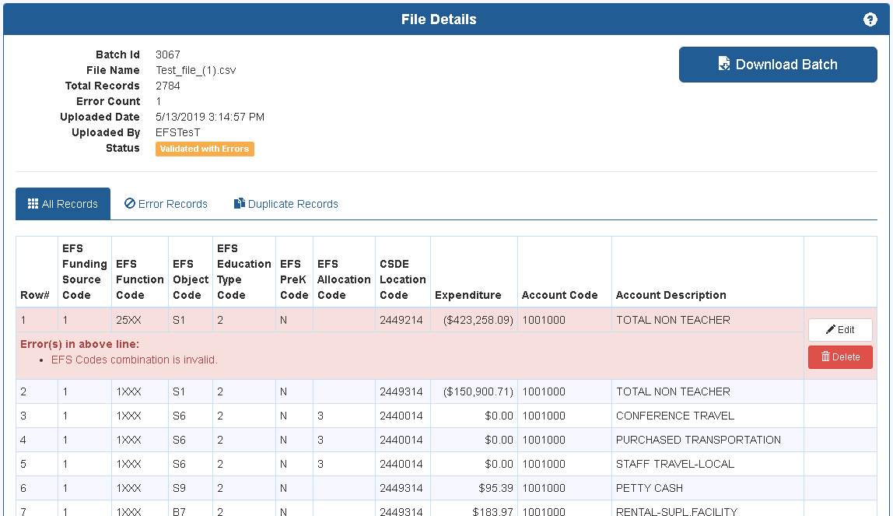
List of possible validation errors:
Type | Level | Error Message
1 | Error | EFS Function Code is missing
1 | Error | EFS Function Code is invalid
1 | Error | EFS Object Code is missing
1 | Error | EFS Object Code is invalid
1 | Error | EFS PreK Code is invalid
1 | Error | EFS Education Type Code is missing
1 | Error | EFS Education Type Code is invalid
1 | Error | EFS Funding Source Code is missing
1 | Error | EFS Funding Source Code is invalid
1 | Error | Location Code is missing
1 | Error | location code does not match DM
1 | Error | Expenditure amount can not be null/Blank.
1 | Error | EFS Allocation Code is Invalid.
2 | Error | EFS Codes combination is invalid. (See EFS Rules and Exceptions below)
2 | Error | District's central office location code must be used with allocation code
2 | Error | location code must be a school or an allocation code must be used
2 | Error | Allocation code used is not defined in enrollment allocation groups table
2 | Error | If combination between function and object results in a district level expenditure, do not allocate the cost.

EFS Rules and Exceptions:
EFS general rules
Validation Status | EFS Object Level | EFS Function Level
Valid | School/Both | School
Valid | ALL | District
Valid | ALL | Both
EFS special cases
Validation Status | EFS Object Code | EFS Function Code
If D1-D6 is used, it can only apply to 1XXX | D1-D6 | 1XXX
If S1-S2 is used, it can only apply to 1XXX-22XX | S1-S2 | 1XXX-22XX
Validation Status | EFS Function Code | EFS Object Code
Only B6 can be used for function code 5XXX | 5XXX | B6
Validation Status | EFS Ed Type | EFS Function Code
Only EFS Education Types 2 or 3 may be used with Function 27X2; and Functions 27XX, 27X1, 27X3, and 27X4 may not be used with EFS Education Types 2 or 3 | 2 or 3 | 27X2
Only EFS Education Types 4-9 may be used with Function 9XXX | 4-9 | 9XXX
Validation Status | EFS Ed Type | EFS Object Code
Only EFS Education Types 4-9 may be used with Object N1 | 4-9 | N1
Validation Status | EFS Function Code
If function 3121 or 3122 is used, then (Fund Source has to be 1, 11 or 12, Object Code can’t be S3 or S4, and Ed Type has to be 1,2 or 3) | 3121 or 3122
Validation status | EFS Ed Type
Education Type 3 are not allowed with funding sources 2,3,5,13,14 and 16 | 3
A grid showing valid function/object codes is provided in Appendix B.
  - To correct error:
    - Edit- depending on the error, correct each record accordingly, using the dropdown list provided.
    - Delete- delete the record from the expenditure batch.
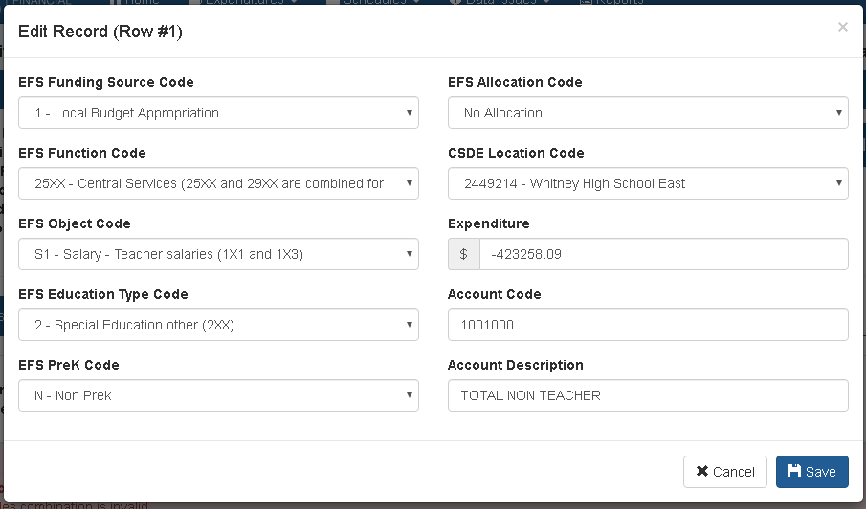

- Once the last error line has been cleared, the batch will need to be revalidated, click “Revalidate Batch”.

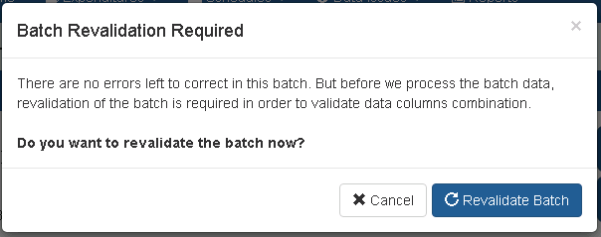

2.3.5 Process batch
- Once the batch has been validated without errors, click “Process Batch”.
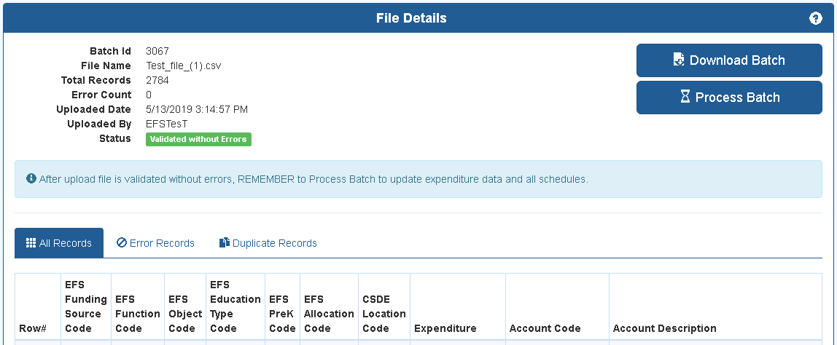
  - Warning prompt: if this is not the first time that the batch has been processed, proceeding with “process batch” will overwrite all previously processed batches and changes that have been made.
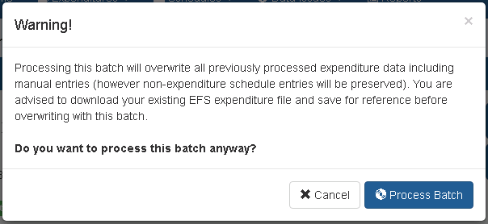
- Click “Process Batch”.

2.4 Expenditure Screen

2.4.1 Introduction
The expenditure screen shows all processed expenditure records from the uploaded file, as well as expenditure records added manually. This screen can be accessed only after an uploaded file has been processed per Section 2.3.5. The screen is accessed from the top of the application navigation menu.
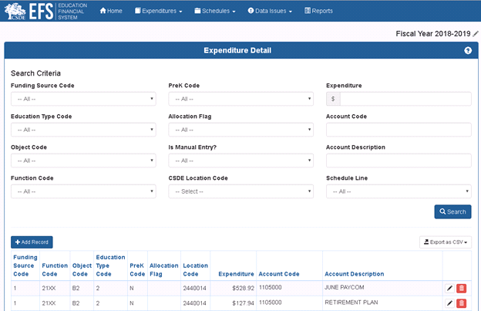
Figure 1 Expenditure screen
Additional batches may be processed, however will overwrite all expenditure records including manual entries. It may be useful to download existing expenditures before processing another batch by using the export functionality described in Section 2.4.4 below. The download file can be used in developing a revised upload file, to avoid errors experienced in the original upload.

2.4.2 Searching and Sorting Expenditures
As there could be hundreds or even thousands of expenditure records for most districts, searching and sorting capability is provided on this page to aid in locating specific expenditures.
There are 11 search criteria that can be specified for searching expenditures. Details are listed below:
Search Criteria | Type | Description
Funding Source Code | Dropdown of Pre-defined Values | Specifies the funding source code to search. Ex. 1, 2, 3, 4, etc.
Education Type Code | Dropdown of Pre-defined Values | Specifies the education type code to search. Ex. 1, 2, 3, 4, etc.
Object Code | Dropdown of Pre-defined Values | Specifies the object code to search. Ex. B1, B2, S1, S10, etc.
Function Code | Dropdown of Pre-defined Values | Specifies the function code to search. Ex. 1XXX, 27XX, etc. Note that any numeric values provided in the upload file are converted into EFS standard values while processing the batch.
PreK Code | Dropdown of Pre-defined Values | Specifies the pre-k code to search: ‘N’ for no and ‘Y’ for yes.
Allocation Flag | Dropdown of Pre-defined Values | Specifies the allocation flag to search. Ex. 1, 2, 3, 4, etc.
Is Manual Entry? | Dropdown of Pre-defined Values | Specifies whether to search for only manual entries. Manual entries are entries which have been added after batch processing.
CSDE Location | Dropdown of Pre-defined Values | Specifies the location codes to search. For example Hartford School District would have entries 0640011, 0641211, etc.
Expenditure | Free text of numeric values only | Specifies exact amount of expenditure to search. Ex. specifying 100 will show only expenditures of $100.00.
Account Description | Free text | Specifies wildcard keyword to search in account description. Ex. specifying “supplies” would return all expenditure records which contain that word in the account description such as “Instructional Supplies”.
Account Code | Free text | Specifies wildcard keyword to search in account code. Ex. specifying “2000” would return all expenditure records which contain that text in the account code such as “3000-41-23-2000-5-000-000-000”.
Table 1 Search criteria list
In addition to the search function, records may be sorted by any column.
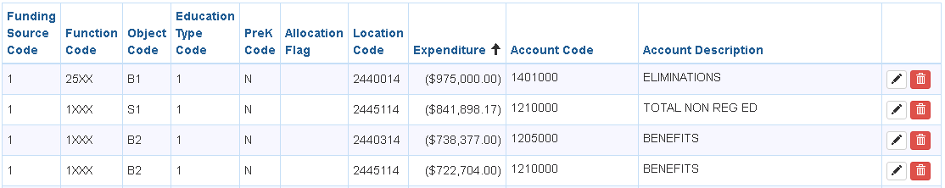
Figure 2 Sorting data by column
Clicking on the header of a particular column sorts the data by ascending and clicking it again sorts the data by descending. Note that the sort order is preserved when navigating to different pages of the expenditure screen, however is lost if the search criteria are changed.

2.4.3 Modifying Expenditures
This screen also allows modification (i.e. create, update and delete) of any expenditure record. Each expenditure record has two small buttons in the last column to Edit or Delete. There is a larger green button on the top left of data grid to Add expenditures.
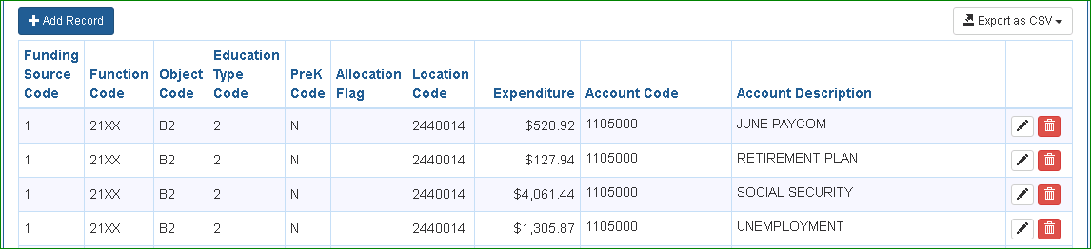
Add
Delete
Edit
Figure 3 Expenditure modify buttons
The Edit button opens a popup with existing values prefilled for that particular expenditure record. Any field except allocation flag may be revised (allocation may only be specified before processing the batch).
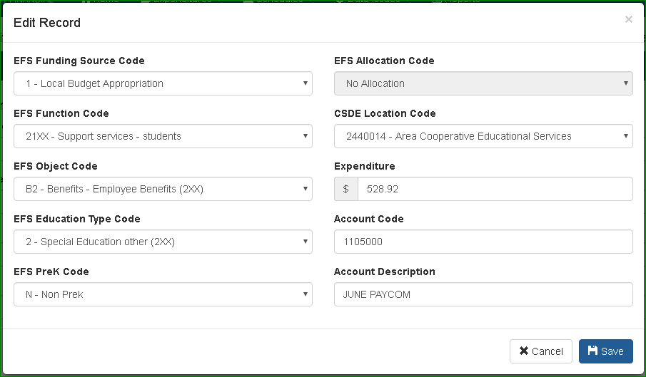
Figure 4 Edit record popup
If the changed values would result in an invalid combination of EFS codes, an error message will appear when the Save button is selected.
Keep in mind that changing the EFS code values on the Edit Record screen will also change relevant data on EFS schedules. For example, changing function code to “27X1” (Transportation to Out of Town Magnet Schools) in the above popup would move that expenditure from line TR2 to TR5 on the Transportation Schedule. This capability can be used to move records between different lines or schedules.
The Delete button removes the expenditure record from the system entirely; it cannot be restored.
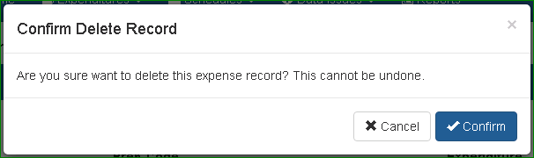
Figure 5 Delete record confirmation
Like editing, deleting will change schedule data if that expenditure was connected to any schedule line.
The Add Record button opens the same popup screen as does the Edit button, but with empty fields to create a new expenditure entry. Records added here will also automatically add to applicable EFS schedule lines. As on the Edit Record popup screen, validation rules will be checked on saving and an error message will appear if applicable.
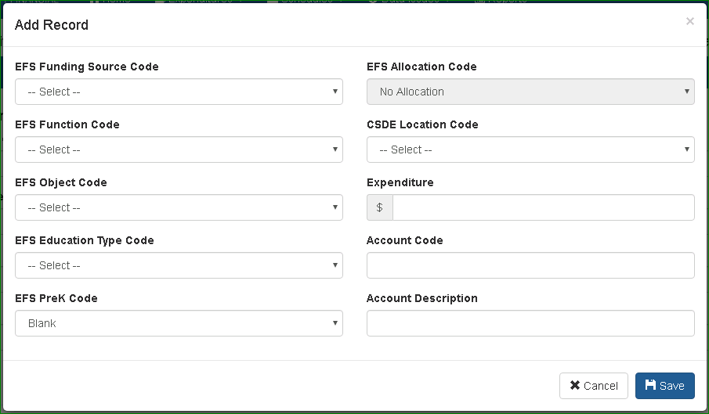
Figure 6 Add record popup

2.4.4 Exporting Expenditures
The system provides the capability to export expenditures into a downloadable CSV file. This data can then be saved for reference or used as the basis for a new revised upload file. One reason this can be helpful is that the download includes all manual entries made after processing the batch so that they can be included in a revised upload.
The button to export expenditures is located on the top right of the data grid. When this button is selected, two options, “Export All” and “Export Filtered”, will appear.
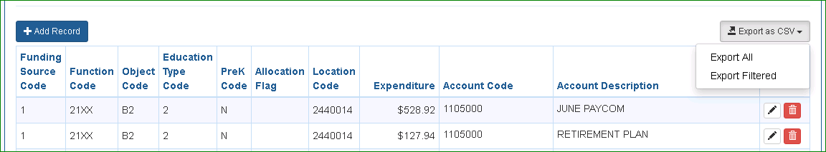
Export Expenditure
Figure 7 Export expenditures options
‘Export All’ will ignore any search filters currently on the page and exports all expenditure data into a single CSV file. This option can take time to export depending on the number of expenditure records. ‘Export Filtered’, on the other hand, will only export expenditures as currently filtered using the search criteria on the page. Only 20 records are visible per page but the export will include all applicable records from all pages.
The exported CSV file can be viewed and modified in Microsoft Excel or similar office applications and notepad. You can filter, sort or modify through columns in the Microsoft Excel or similar applications.
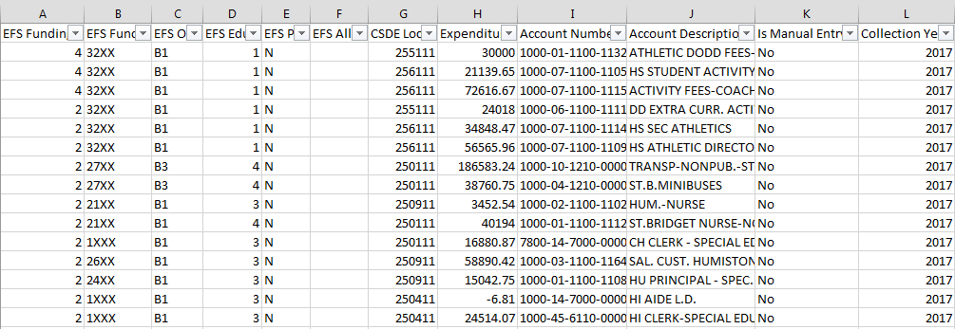
Figure 8 Exported file in MS Excel
Note that before uploading a file that was exported from EFS, the additional reference columns K and L must be deleted.

2.4.5 Schedule Status
The status of all schedules, as well as the general status of the collection, is shown on the Home page:
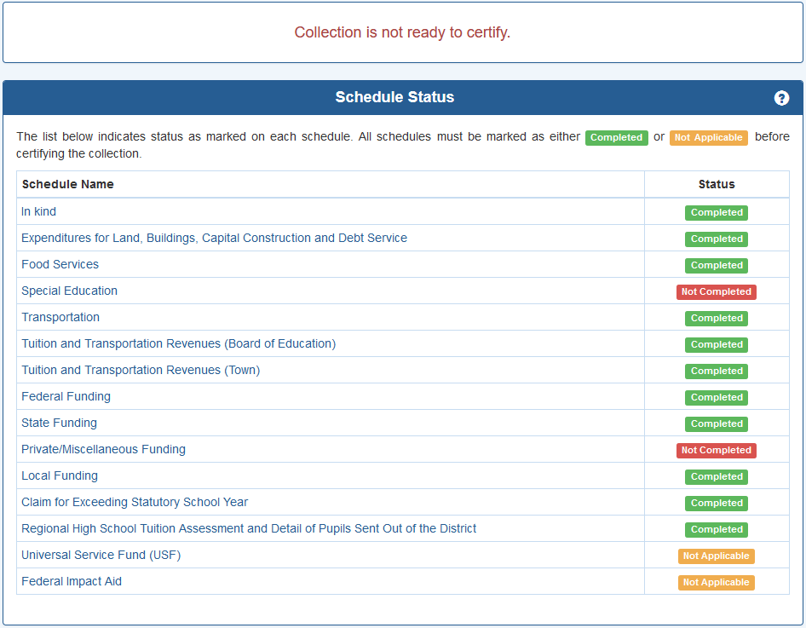

Each schedule may be accessed by clicking on the schedule name. The status is based on the checkboxes located on each schedule, as described in section 3.2.4. This page also indicates if the collection is ready to certify based on completion of all schedules. Note that if a new expenditure file is uploaded, the status of schedules previously marked as “Completed” will be changed to “Not Completed”.

2.4.6 Data Issues Status
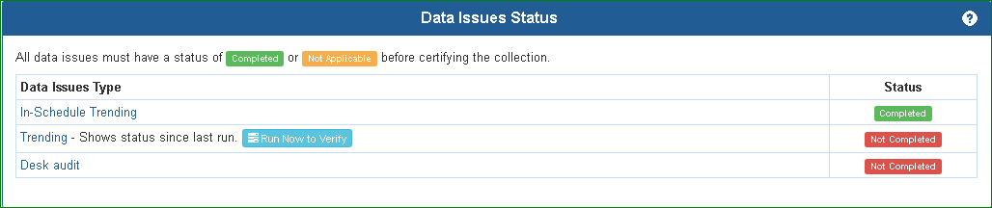
Each data issue type may be accessed by clicking on the name. The status is based on whether or not all questions within each type have been answered, refer to section 6.0 for further details. Please note, “Trending” data issues must be run manually, therefore, the status shows the last time they were run. Users can update the status by clicking on the “Run now to verify” button or directly go to the trending page to rerun the trending list.

2.5 Expenditure Summary

2.5.1 Expenditure summary – Local and Regional School Districts
The Elementary/Secondary Education section is similar to the old ED001 schedule 12, line 1213/1. The reconciliation to Total Expenditures section adds back the expenditures not included in the upper section, to arrive at the total expenditures reported. The “Total EFS Expenditures” line is the same amount as the total shown on the Expenditure Detail page.
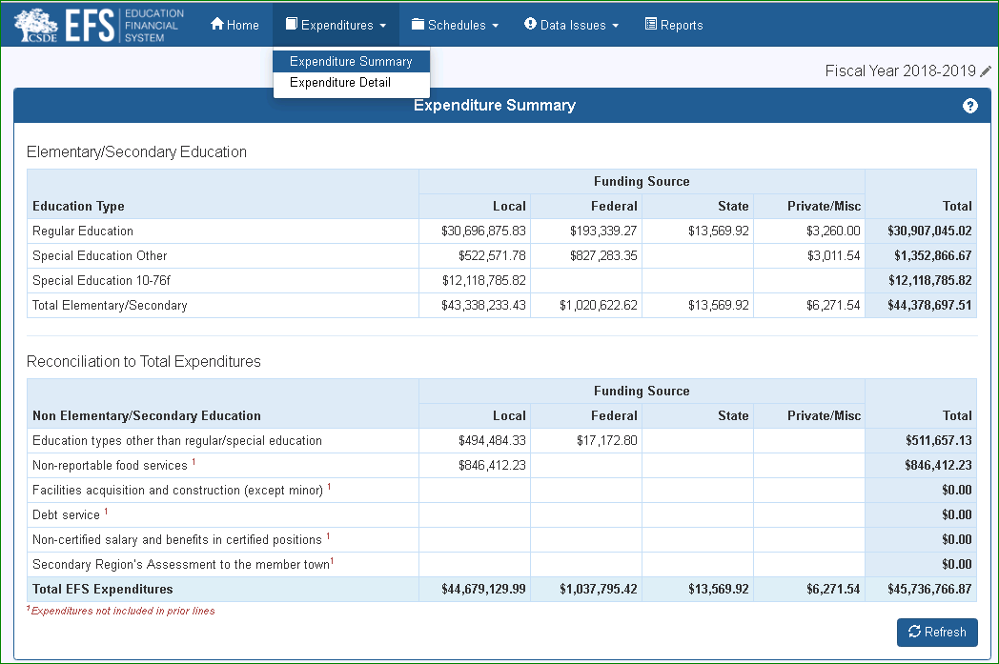

All data elements in the expenditure summary are from the EFS database. The records to be included on each line are based on EFS codes as listed in the table below. The EFS Codes are defined in Section 4.
Elementary/Secondary Education- District Expenditure Summary
Education Type | Local | Federal | State | Private/Misc | Total
Regular Education | ES101A | ES102A | ES103A | ES104A | ES105A
Special Education Other | ES101B | ES102B | ES103B | ES104B | ES105B
Special Education 10-76f | ES101C | ES102C | ES103C | ES104C | ES105C
Total Elementary/Secondary | ES101D | ES102D | ES103D | ES104D | ES105D

Reconciliation to Total Expenditures
Non Elementary/Secondary Education | Local | Federal | State | Private/Misc | Total
Education types other than regular/special education | ES201A | ES202A | ES203A | ES204A | ES205A
Non-reportable food services * | ES201B | ES202B | ES203B | ES204B | ES205B
Facilities acquisition and construction (except minor) * | ES201C | ES202C | ES203C | ES204C | ES205C
Debt service * | ES201D | ES202D | ES203D | ES204D | ES205D
Non-certified salary and benefits in certified positions * | ES201E | ES202E | ES203E | ES204E | ES205E
Secondary Region’s Assessment to the member town* | ES201F | ES202F | ES203F | ES204F | ES205F
Total EFS Expenditures | ES901A | ES902A | ES903A | ES904A | ES905A
* Expenditures not included in prior lines

Elementary/Secondary Education

Line | Description | Data Method | EFS Funding  Source ID | EFS Function Code | EFS Object Code | EFS Education Type Code
ES101A | Local Fund/Regular Education | Expenditure Database | 1, 6-10, 11, 12, 17 | All except 311X, 4XXX, 5XXX, and 9XXX | All except D1, N1, S3, S4 | 1
ES102A | Federal Fund/Regular Education | Expenditure Database | 2, 13 | All except 311X, 4XXX, 5XXX, and 9XXX | All except D1, N1, S3, S4 | 1
ES103A | State Fund/Regular Education | Expenditure Database | 3, 14 | All except 311X, 4XXX, 5XXX, and 9XXX | All except D1, N1, S3, S4 | 1
ES104A | Private Misc Fund/Regular Education | Expenditure Database | 4, 5, 15, 16 | All except 311X, 4XXX, 5XXX, and 9XXX | All except D1, N1, S3, S4 | 1
ES105A | Total Regular Education | Expenditure Database | All | All except 311X, 4XXX, 5XXX, and 9XXX | All except D1, N1, S3, S4 | 1
ES101B | Local Fund/Special Education Other | Expenditure Database | 1, 6-10, 11, 12, 17 | All except 311X, 4XXX, 5XXX, and 9XXX | All except D1, N1, S3, S4 | 2
ES102B | Federal Fund/Special Education Other | Expenditure Database | 2, 13 | All except 311X, 4XXX, 5XXX, and 9XXX | All except D1, N1, S3, S4 | 2
ES103B | State Fund/Special Education Other | Expenditure Database | 3, 14 | All except 311X, 4XXX, 5XXX, and 9XXX | All except D1, N1, S3, S4 | 2
ES104B | Private Misc Fund/Special Education Other | Expenditure Database | 4, 5, 15, 16 | All except 311X, 4XXX, 5XXX, and 9XXX | All except D1, N1, S3, S4 | 2
ES105B | Total Special Education Other | Expenditure Database | All | All except 311X, 4XXX, 5XXX, and 9XXX | All except D1, N1, S3, S4 | 2
ES101C | Local Fund/Special Education 10-76f | Expenditure Database | 1, 6-10, 11, 12, 17 | All except 311X, 4XXX, 5XXX, and 9XXX | All except D1, N1, S3, S4 | 3
ES102C | Federal Fund/Special Education 10-76f | Expenditure Database | 2, 13 | All except 311X, 4XXX, 5XXX, and 9XXX | All except D1, N1, S3, S4 | 3
ES103C | State Fund/Special Education 10-76f | Expenditure Database | 3, 14 | All except 311X, 4XXX, 5XXX, and 9XXX | All except D1, N1, S3, S4 | 3
ES104C | Private Misc Fund/Special Education 10-76f | Expenditure Database | 4, 5, 15, 16 | All except 311X, 4XXX, 5XXX, and 9XXX | All except D1, N1, S3, S4 | 3
ES105C | Total Special Education 10-76f | Expenditure Database | All | All except 311X, 4XXX, 5XXX, and 9XXX | All except D1, N1, S3, S4 | 3
ES101D | Total Local Fund | Expenditure Database | 1, 6-10, 11, 12, 17 | All except 311X, 4XXX, 5XXX, and 9XXX | All except D1, N1, S3, S4 | 1, 2, 3
ES102D | Total Federal Fund | Expenditure Database | 2, 13 | All except 311X, 4XXX, 5XXX, and 9XXX | All except D1, N1, S3, S4 | 1, 2, 3
ES103D | Total State Fund | Expenditure Database | 3, 14 | All except 311X, 4XXX, 5XXX, and 9XXX | All except D1, N1, S3, S4 | 1, 2, 3
ES104D | Total Private Misc Fund | Expenditure Database | 4, 5, 15, 16 | All except 311X, 4XXX, 5XXX, and 9XXX | All except D1, N1, S3, S4 | 1, 2, 3
ES105D | Grand Fund Total | Expenditure Database | All | All except 311X, 4XXX, 5XXX, and 9XXX | All except D1, N1, S3, S4 | 1, 2, 3

Reconciliation to total expenditures

ES201A | Education types other than regular special education/Local Fund | Expenditure Database | 1, 6-10, 11, 12, 17 | All | All | 4-9
ES202A | Education types other than regular special education/Federal Fund | Expenditure Database | 2, 13 | All | All | 4-9
ES203A | Education types other than regular special education/State Fund | Expenditure Database | 3, 14 | All | All | 4-9
ES204A | Education types other than regular special education/Private Misc Fund | Expenditure Database | 4, 5, 15, 16 | All | All | 4-9
ES205A | Education types other than regular special education/Total Fund | Expenditure Database | All | All | All | 4-9
ES201B | Non-reportable food services/Local Fund | Expenditure Database | 1, 6-10, 11, 12, 17 | 311X | All | 1, 2, 3
ES202B | Non-reportable food services/Federal Fund | Expenditure Database | 2, 13 | 311X | All | 1, 2, 3
ES203B | Non-reportable food services/State Fund | Expenditure Database | 3, 14 | 311X | All | 1, 2, 3
ES204B | Non-reportable food services/Private Misc Fund | Expenditure Database | 4, 5, 15, 16 | 311X | All | 1, 2, 3
ES205B | Non-reportable food services/Total Fund | Expenditure Database | All | 311X | All | 1, 2, 3
ES201C | Facilities acquisition and construction (except minor)/Local Fund | Expenditure Database | 1, 6-10, 11, 12, 17 | 4XXX | All | 1, 2, 3
ES202C | Facilities acquisition and construction (except minor)/Federal Fund | Expenditure Database | 2, 13 | 4XXX | All | 1, 2, 3
ES203C | Facilities acquisition and construction (except minor)/State Fund | Expenditure Database | 3, 14 | 4XXX | All | 1, 2, 3
ES204C | Facilities acquisition and construction (except minor)/Private Misc Fund | Expenditure Database | 4, 5, 15, 16 | 4XXX | All | 1, 2, 3
ES205C | Facilities acquisition and construction (except minor)/Total Fund | Expenditure Database | All | 4XXX | All | 1, 2, 3
ES201D | Debt service/Local Fund | Expenditure Database | 1, 6-10, 11, 12, 17 | 5XXX | All | 1, 2, 3
ES202D | Debt service/Federal Fund | Expenditure Database | 2, 13 | 5XXX | All | 1, 2, 3
ES203D | Debt service/State Fund | Expenditure Database | 3, 14 | 5XXX | All | 1, 2, 3
ES204D | Debt service/Private Misc Fund | Expenditure Database | 4, 5, 15, 16 | 5XXX | All | 1, 2, 3
ES205D | Debt service/Total Fund | Expenditure Database | All | 5XXX | All | 1, 2, 3
ES201E | Non-certified salary and benefits in certified positions/Local Fund | Expenditure Database | 1, 6-10, 11, 12, 17 | All except 311X, 4XXX, 5XXX, and 9XXX | S3, S4 | 1, 2, 3
ES202E | Non-certified salary and benefits in certified positions/Federal Fund | Expenditure Database | 2, 13 | All except 311X, 4XXX, 5XXX, and 9XXX | S3, S4 | 1, 2, 3
ES203E | Non-certified salary and benefits in certified positions/State Fund | Expenditure Database | 3, 14 | All except 311X, 4XXX, 5XXX, and 9XXX | S3, S4 | 1, 2, 3
ES204E | Non-certified salary and benefits in certified positions/Private Misc Fund | Expenditure Database | 4, 5, 15, 16 | All except 311X, 4XXX, 5XXX, and 9XXX | S3, S4 | 1, 2, 3
ES205E | Non-certified salary and benefits in certified positions/Total Fund | Expenditure Database | All | All except 311X, 4XXX, 5XXX, and 9XXX | S3, S4 | 1, 2, 3
ES201F | Secondary Region’s Assessment to the member town/Local Fund | Expenditure Database | 1, 6-10, 11, 12, 17 | All except 311X, 4XXX, 5XXX, and 9XXX | D1 | 1, 2, 3
ES202F | Secondary Region’s Assessment to the member town/Federal Fund | Expenditure Database | 2, 13 | All except 311X, 4XXX, 5XXX, and 9XXX | D1 | 1, 2, 3
ES203F | Secondary Region’s Assessment to the member town/State Fund | Expenditure Database | 3, 14 | All except 311X, 4XXX, 5XXX, and 9XXX | D1 | 1, 2, 3
ES204F | Secondary Region’s Assessment to the member town/Private Misc Fund | Expenditure Database | 4, 5, 15, 16 | All except 311X, 4XXX, 5XXX, and 9XXX | D1 | 1, 2, 3
ES205F | Secondary Region’s Assessment to the member town/Total Fund | Expenditure Database | All | All except 311X, 4XXX, 5XXX, and 9XXX | D1 | 1, 2, 3
ES901A | Local Fund Total EFS Expenditures | Expenditure Database | 1, 6-10, 11, 12, 17 | All | All | All
ES902A | Federal Fund Total EFS Expenditures | Expenditure Database | 2, 13 | All | All | All
ES903A | State Fund Total EFS Expenditures | Expenditure Database | 3, 14 | All | All | All
ES904A | Private Misc Fund Total EFS Expenditures | Expenditure Database | 4, 5, 15, 16 | All | All | All
ES905A | Grand Total EFS Expenditures | Expenditure Database | All | All | All | All

2.5.2 Expenditure summary – RESCs
The RESC expenditure summary layout is similar to that of the local and regional districts described in Section 2.5.1 The specifications are below:
Elementary/Secondary Education- RESC Expenditure Summary
Education Type | Local | Federal | State | Private/Misc | Total
Regular Education | ER101A | ER102A | ER103A | ER104A | ER105A
Special Education | ER101B | ER102B | ER103B | ER104B | ER105B
Total Elementary/Secondary | ER101C | ER102C | ER103C | ER104C | ER105C

Reconciliation to Total Expenditures
Non Elementary/Secondary Education | Local | Federal | State | Private/Misc | Total
Education types other than regular/special education | ER201A | ER202A | ER203A | ER204A | ER205A
Non-reportable food services * | ER201B | ER202B | ER203B | ER204B | ER205B
Facilities acquisition and construction (except minor) * | ER201C | ER202C | ER203C | ER204C | ER205C
Debt service * | ER201D | ER202D | ER203D | ER204D | ER205D
Non-certified salary and benefits in certified positions * | ER201E | ER202E | ER203E | ER204E | ER205E
Total EFS Expenditures | ER901A | ER902A | ER903A | ER904A | ER905A
* Expenditures not included in prior lines

Elementary/Secodary Education
Line | Description | Data Method | EFS Funding  Source ID | EFS Function Code | EFS Object Code | EFS Education  Type Code
ER101A | Local Fund/Regular Education | Expenditure Database | 1, 6-10, 11, 12, 17 | All except 311X, 4XXX, 5XXX, and 9XXX | All except D1, N1, S3, S4 | 1
ER102A | Federal Fund/Regular Education | Expenditure Database | 2, 13 | All except 311X, 4XXX, 5XXX, and 9XXX | All except D1, N1, S3, S4 | 1
ER103A | State Fund/Regular Education | Expenditure Database | 3, 14 | All except 311X, 4XXX, 5XXX, and 9XXX | All except D1, N1, S3, S4 | 1
ER104A | Private Misc Fund/Regular Education | Expenditure Database | 4, 5, 15, 16 | All except 311X, 4XXX, 5XXX, and 9XXX | All except D1, N1, S3, S4 | 1
ER105A | Total Regular Education | Expenditure Database | All | All except 311X, 4XXX, 5XXX, and 9XXX | All except D1, N1, S3, S4 | 1
ER101B | Local Fund/Special Education | Expenditure Database | 1, 6-10, 11, 12, 17 | All except 311X, 4XXX, 5XXX, and 9XXX | All except D1, N1, S3, S4 | 2 or 3
ER102B | Federal Fund/Special Education | Expenditure Database | 2, 13 | All except 311X, 4XXX, 5XXX, and 9XXX | All except D1, N1, S3, S4 | 2 or 3
ER103B | State Fund/Special Education | Expenditure Database | 3, 14 | All except 311X, 4XXX, 5XXX, and 9XXX | All except D1, N1, S3, S4 | 2 or 3
ER104B | Private Misc Fund/Special Education | Expenditure Database | 4, 5, 15, 16 | All except 311X, 4XXX, 5XXX, and 9XXX | All except D1, N1, S3, S4 | 2 or 3
ER105B | Total Special Education | Expenditure Database | All | All except 311X, 4XXX, 5XXX, and 9XXX | All except D1, N1, S3, S4 | 2 or 3
ER101C | Total Local Fund | Expenditure Database | 1, 6-10, 11, 12, 17 | All except 311X, 4XXX, 5XXX, and 9XXX | All except D1, N1, S3, S4 | 1, 2, 3
ER102C | Total Federal Fund | Expenditure Database | 2, 13 | All except 311X, 4XXX, 5XXX, and 9XXX | All except D1, N1, S3, S4 | 1, 2, 3
ER103C | Total State Fund | Expenditure Database | 3, 14 | All except 311X, 4XXX, 5XXX, and 9XXX | All except D1, N1, S3, S4 | 1, 2, 3
ER104C | Total Private Fund | Expenditure Database | 4, 5, 15, 16 | All except 311X, 4XXX, 5XXX, and 9XXX | All except D1, N1, S3, S4 | 1, 2, 3
ER105C | Grand Total | Expenditure Database | All | All except 311X, 4XXX, 5XXX, and 9XXX | All except D1, N1, S3, S4 | 1, 2, 3

Reconciliation to Total Expenditures
Line | Description | Data Method | EFS Funding  Source ID | EFS Function Code | EFS Object Code | EFS Education  Type Code
ER201A | Education types other than regular/special education/Local Fund | Expenditure Database | 1, 6-10, 11, 12, 17 | All | All | 4-9
ER202A | Education types other than regular/special education/Federal Fund | Expenditure Database | 2, 13 | All | All | 4-9
ER203A | Education types other than regular/special education/State Fund | Expenditure Database | 3, 14 | All | All | 4-9
ER204A | Education types other than regular/Private Misc Fund | Expenditure Database | 4, 5, 15, 16 | All | All | 4-9
ER205A | Education types other than regular/special education/Total Fund | Expenditure Database | All | All | All | 4-9
ER201B | Non-reportable food services/Local Fund | Expenditure Database | 1, 6-10, 11, 12, 17 | 311X | All | 1, 2, 3
ER202B | Non-reportable food services /Federal Fund | Expenditure Database | 2, 13 | 311X | All | 1, 2, 3
ER203B | Non-reportable food services/State Fund | Expenditure Database | 3, 14 | 311X | All | 1, 2, 3
ER204B | Non-reportable food services /Private Misc Fund | Expenditure Database | 4, 5, 15, 16 | 311X | All | 1, 2, 3
ER205B | Non-reportable food services /Total Fund | Expenditure Database | All | 311X | All | 1, 2, 3
ER201C | Facilities acquisition and construction (except minor)/Local Fund | Expenditure Database | 1, 6-10, 11, 12, 17 | 4XXX | All | 1, 2, 3
ER202C | Facilities acquisition and construction (except minor)/Federal Fund | Expenditure Database | 2, 13 | 4XXX | All | 1, 2, 3
ER203C | Facilities acquisition and construction (except minor)/State Fund | Expenditure Database | 3, 14 | 4XXX | All | 1, 2, 3
ER204C | Facilities acquisition and construction (except minor)/Private Misc Fund | Expenditure Database | 4, 5, 15, 16 | 4XXX | All | 1, 2, 3
ER205C | Facilities acquisition and construction (except minor)/Total Fund | Expenditure Database | All | 4XXX | All | 1, 2, 3
ER201D | Debt service/Local Fund | Expenditure Database | 1, 6-10, 11, 12, 17 | 5XXX | All | 1, 2, 3
ER202D | Debt service/Federal Fund | Expenditure Database | 2, 13 | 5XXX | All | 1, 2, 3
ER203D | Debt service /State Fund | Expenditure Database | 3, 14 | 5XXX | All | 1, 2, 3
ER204D | Debt service/Private Misc Fund | Expenditure Database | 4, 5, 15, 16 | 5XXX | All | 1, 2, 3
ER205D | Debt service/Total Fund | Expenditure Database | All | 5XXX | All | 1, 2, 3
ER201E | Non-certified salary and benefits in certified positions/Local Fund | Expenditure Database | 1, 6-10, 11, 12, 17 | All except 311X, 4XXX, 5XXX, and 9XXX | S3, S4 | 1, 2, 3
ER202E | Non-certified salary and benefits in certified positions/Federal Fund | Expenditure Database | 2, 13 | All except 311X, 4XXX, 5XXX, and 9XXX | S3, S4 | 1, 2, 3
ER203E | Non-certified salary and benefits in certified positions/State Fund | Expenditure Database | 3, 14 | All except 311X, 4XXX, 5XXX, and 9XXX | S3, S4 | 1, 2, 3
ER204E | Non-certified salary and benefits in certified positions/Private Misc Fund | Expenditure Database | 4, 5, 15, 16 | All except 311X, 4XXX, 5XXX, and 9XXX | S3, S4 | 1, 2, 3
ER205E | Non-certified salary and benefits in certified positions/Total Fund | Expenditure Database | All | All except 311X, 4XXX, 5XXX, and 9XXX | S3, S4 | 1, 2, 3
ER901A | Local Fund Total EFS Expenditures | Expenditure Database | 1, 6-10, 11, 12, 17 | All | All | All
ER902A | Federal Fund Total EFS Expenditures | Expenditure Database | 2, 13 | All | All | All
ER903A | State Fund Total EFS Expenditures | Expenditure Database | 3, 14 | All | All | All
ER904A | Private Misc Fund Total EFS Expenditures | Expenditure Database | 4, 5, 15, 16 | All | All | All
ER905A | Grand Total EFS Expenditures | Expenditure Database | All | All | All | All

2.5.3 Expenditure summary – Charter Schools
The Charter School expenditure summary layout is similar to that of the local and regional districts described in Section 2.5.1 The specifications are below:
Elementary/Secondary Education- RESC Expenditure Summary
Education Type | Local | Federal | State | Private/Misc | Total
Regular Education | EC101A | EC102A | EC103A | EC104A | EC105A
Special Education | EC101B | EC102B | EC103B | EC104B | EC105B
Total Elementary/Secondary | EC101C | EC102C | EC103C | EC104C | EC105C

Reconciliation to Total Expenditures
Non Elementary/Secondary Education | Local | Federal | State | Private/Misc | Total
Education types other than regular/special education | EC201A | EC202A | EC203A | EC204A | EC205A
Non-reportable food services * | EC201B | EC202B | EC203B | EC204B | EC205B
Facilities acquisition and construction (except minor) * | EC201C | EC202C | EC203C | EC204C | EC205C
Debt service * | EC201D | EC202D | EC203D | EC204D | EC205D
Non-certified salary and benefits in certified positions * | EC201E | EC202E | EC203E | EC204E | EC205E
Total EFS Expenditures | EC901A | EC902A | EC903A | EC904A | EC905A
* Expenditures not included in prior lines

Line | Description | Data Method | EFS Funding  Source ID | EFS Function Code | EFS Object Code | EFS Education  Type Code
EC101A | Local Fund/Regular Education | Expenditure Database | 1, 6-10, 11, 12, 17 | All except 311X, 4XXX, 5XXX, and 9XXX | All except D1, N1, S3, S4 | 1
EC102A | Federal Fund/Regular Education | Expenditure Database | 2, 13 | All except 311X, 4XXX, 5XXX, and 9XXX | All except D1, N1, S3, S4 | 1
EC103A | State Fund/Regular Education | Expenditure Database | 3, 14, 18 | All except 311X, 4XXX, 5XXX, and 9XXX | All except D1, N1, S3, S4 | 1
EC104A | Private Misc Fund/Regular Education | Expenditure Database | 4, 5, 15, 16 | All except 311X, 4XXX, 5XXX, and 9XXX | All except D1, N1, S3, S4 | 1
EC105A | Total Fund/Regular Education | Expenditure Database | All | All except 311X, 4XXX, 5XXX, and 9XXX | All except D1, N1, S3, S4 | 1
EC101B | Local Fund/Special Education | Expenditure Database | 1, 6-10, 11, 12, 17 | All except 311X, 4XXX, 5XXX, and 9XXX | All except D1, N1, S3, S4 | 2 or 3
EC102B | Federal Fund/Special Education | Expenditure Database | 2, 13 | All except 311X, 4XXX, 5XXX, and 9XXX | All except D1, N1, S3, S4 | 2 or 3
EC103B | State Fund/Special Education | Expenditure Database | 3, 14, 18 | All except 311X, 4XXX, 5XXX, and 9XXX | All except D1, N1, S3, S4 | 2 or 3
EC104B | Private Misc Fund/Special Education | Expenditure Database | 4, 5, 15, 16 | All except 311X, 4XXX, 5XXX, and 9XXX | All except D1, N1, S3, S4 | 2 or 3
EC105B | Total Fund/Special Education | Expenditure Database | All | All except 311X, 4XXX, 5XXX, and 9XXX | All except D1, N1, S3, S4 | 2 or 3
EC101C | Total Local Fund | Expenditure Database | 1, 6-10, 11, 12, 17 | All except 311X, 4XXX, 5XXX, and 9XXX | All except D1, N1, S3, S4 | 1, 2, 3
EC102C | Total Federal Fund | Expenditure Database | 2, 13 | All except 311X, 4XXX, 5XXX, and 9XXX | All except D1, N1, S3, S4 | 1, 2, 3
EC103C | Total State Fund | Expenditure Database | 3, 14, 18 | All except 311X, 4XXX, 5XXX, and 9XXX | All except D1, N1, S3, S4 | 1, 2, 3
EC104C | Total Private Misc Fund | Expenditure Database | 4, 5, 15, 16 | All except 311X, 4XXX, 5XXX, and 9XXX | All except D1, N1, S3, S4 | 1, 2, 3
EC105C | Grand Fund Total | Expenditure Database | All | All except 311X, 4XXX, 5XXX, and 9XXX | All except D1, N1, S3, S4 | 1, 2, 3
EC201A | Local Fund/Education types other than regular/special education | Expenditure Database | 1, 6-10, 11, 12, 17 | All | All | 4-9
EC202A | Federal Fund/Education types other than regular/special education | Expenditure Database | 2, 13 | All | All | 4-9
EC203A | State Fund/Education types other than regular/special education | Expenditure Database | 3, 14, 18 | All | All | 4-9
EC204A | Private Misc Fund/Education types other than regular/special education | Expenditure Database | 4, 5, 15, 16 | All | All | 4-9
EC205A | Education types other than regular/special education/Total Fund | Expenditure Database | All | All | All | 4-9
EC201B | Local Fund/Non-reportable food services | Expenditure Database | 1, 6-10, 11, 12, 17 | 311X | All | 1, 2, 3
EC202B | Federal Fund/Non-reportable food services | Expenditure Database | 2, 13 | 311X | All | 1, 2, 3
EC203B | State Fund/Non-reportable food services | Expenditure Database | 3, 14, 18 | 311X | All | 1, 2, 3
EC204B | Private Misc Fund/Non-reportable food services | Expenditure Database | 4, 5, 15, 16 | 311X | All | 1, 2, 3
EC205B | Non-reportable food services Total Fund | Expenditure Database | All | 311X | All | 1, 2, 3
EC201C | Local Fund/Facilities acquisition and construction (except minor) | Expenditure Database | 1, 6-10, 11, 12, 17 | 4XXX | All | 1, 2, 3
EC202C | Federal Fund/Facilities acquisition and construction (except minor) | Expenditure Database | 2, 13 | 4XXX | All | 1, 2, 3
EC203C | State Fund/Facilities acquisition and construction (except minor) | Expenditure Database | 3, 14, 18 | 4XXX | All | 1, 2, 3
EC204C | Private Misc Fund/Facilities acquisition and construction (except minor) | Expenditure Database | 4, 5, 15, 16 | 4XXX | All | 1, 2, 3
EC205C | Facilities acquisition and construction (except minor) Total Fund | Expenditure Database | All | 4XXX | All | 1, 2, 3
EC201D | Local Fund/Debt service | Expenditure Database | 1, 6-10, 11, 12, 17 | 5XXX | All | 1, 2, 3
EC202D | Federal Fund/Debt service | Expenditure Database | 2, 13 | 5XXX | All | 1, 2, 3
EC203D | State Fund/Debt service | Expenditure Database | 3, 14, 18 | 5XXX | All | 1, 2, 3
EC204D | Private Misc Fund/Debt service | Expenditure Database | 4, 5, 15, 16 | 5XXX | All | 1, 2, 3
EC205D | Debt service Total Fund | Expenditure Database | All | 5XXX | All | 1, 2, 3
EC201E | Local Fund/Non-certified salary and benefits in certified positions | Expenditure Database | 1, 6-10, 11, 12, 17 | All except 311X, 4XXX, 5XXX, and 9XXX | S3, S4 | 1, 2, 3
EC202E | Federal Fund/Non-certified salary and benefits in certified positions | Expenditure Database | 2, 13 | All except 311X, 4XXX, 5XXX, and 9XXX | S3, S4 | 1, 2, 3
EC203E | State Fund/Non-certified salary and benefits in certified positions | Expenditure Database | 3, 14, 18 | All except 311X, 4XXX, 5XXX, and 9XXX | S3, S4 | 1, 2, 3
EC204E | Private Misc Fund/Non-certified salary and benefits in certified positions | Expenditure Database | 4, 5, 15, 16 | All except 311X, 4XXX, 5XXX, and 9XXX | S3, S4 | 1, 2, 3
EC205E | Non-certified salary and benefits in certified positions Total Fund | Expenditure Database | All | All except 311X, 4XXX, 5XXX, and 9XXX | S3, S4 | 1, 2, 3
EC901A | Local Fund Total EFS Expenditures | Expenditure Database | 1, 6-10, 11, 12, 17 | All | All | All
EC902A | Federal Fund Total EFS Expenditures | Expenditure Database | 2, 13 | All | All | All
EC903A | State Fund Total EFS Expenditures | Expenditure Database | 3, 14, 18 | All | All | All
EC904A | Private Misc Fund Total EFS Expenditures | Expenditure Database | 4, 5, 15, 16 | All | All | All
EC905A | Grand Total EFS Expenditures | Expenditure Database | All | All | All | All

3.0 EFS Schedules

3.1 Applicability matrix
There are distinctions between reporting requirements for three types of school districts: local and regional school districts, charter school districts, and regional education service centers. The EFS schedules applicable to each type of district, and instruction section for line instructions are shown below:
EFS Schedule | Local and Regional School Districts | Charter School Districts | Regional Education Service Centers (RESCs)
District Contact & Certification Information | 3.3.2 | 3.3.2 | 3.3.2
In-Kind | 3.4.2
Food Services | 3.5.2 | 3.5.3 | 3.5.4
Special Education | 3.6.2 | 3.6.3 | 3.6.4
Transportation | 3.7.2 | 3.7.3 | 3.7.4
Federal Funding | 3.8.2 | 3.8.3 | 3.8.4
State Funding | 3.9.2 | 3.9.3 | 3.9.4
Private/Miscellaneous Funding | 3.10.2 | 3.10.3 | 3.10.4
Local Funding | 3.11.2 | 3.11.3
Tuition and Transportation Revenue | 3.12.2 |  | 3.12.2
Regional High School Tuition Assessment and Detail of Pupils Sent Out of the District | 3.13.2
Land, Buildings, Capital Construction and Debt Service | 3.14.2 | 3.14.3 | 3.14.2
Claim for Exceeding Statutory School Year | 3.15.2
Universal Service Fund Data | 3.16.2 | 3.16.2 | 3.16.2
Federal Impact Aid | 3.17.2
State Charter School Grant and Reserve Fund Monitoring |  | 3.18.2
Charter School Related Party and Management Organization Information |  | 3.19.1

3.2 General schedule instructions
EFS schedules contain data from the EFS expenditure database, manually entered on the schedule, and prior year data. The general functionality of the EFS schedules is explained below, using the Food Services Schedule as an example.
Comparison to prior year, 3.2.3.
Link to instructions

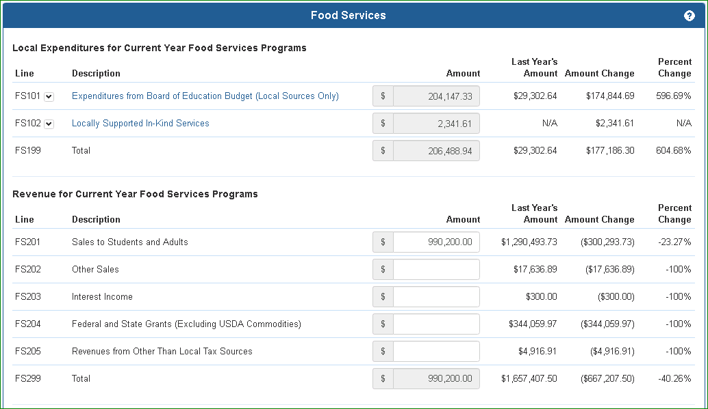
Schedule manual entry, 3.2.2.
Expenditure from database, 3.2.1.

3.2.1 Expenditures from EFS database
Expenditures shown are from the uploaded expenditure file, EFS allocation function, and manual entries made on this or other schedules that are saved in the EFS expenditure database. To expand to view the details or add entries to these lines, click on the expansion down arrow or description:
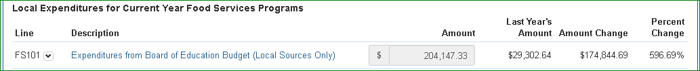
The details then appear:

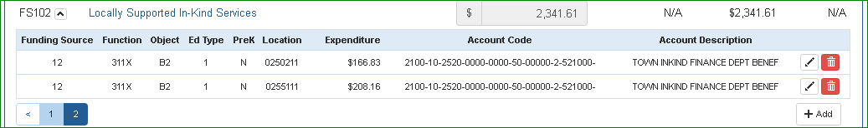
The edit button will open a pop-up window where the record may be revised:

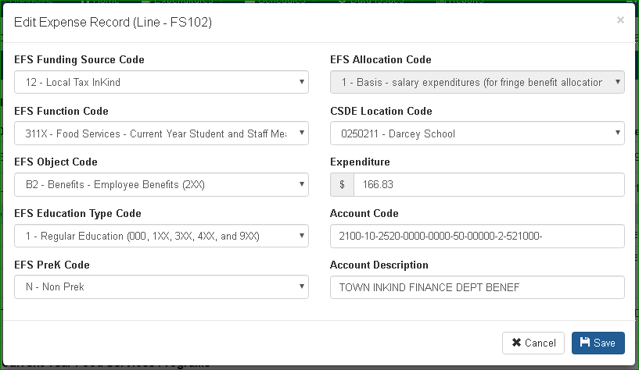
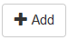
Use the drop down arrows on to revise the EFS codes; enter the expenditure amount and account code and description directly. Note that the only EFS Code options available will be those that apply to the particular line; other revisions may be made on the Expenditure Screen (see Section 2.4.3). Click the “Save” button to save the changes.

The add button will open the same pop-up, with no data prefilled.
The trash can (delete) button will delete the record.
The revised data will be saved in the EFS expenditure database and will update all schedules as applicable based on the EFS Codes.

3.2.2 Schedule Manual Entries
For lines with no expansion arrow, enter amounts directly on the screen.
Before leaving the page, click the save button at the bottom of the page.

3.2.3 Prior year comparison
The prior year amount, and the amount and percentage changes of the current amount from the prior year amount are shown for information.

3.2.4 Marking a schedule as complete or not applicable
Each schedule includes checkboxes for identifying if the schedule has been completed or is not applicable to your district. Before the collection can be certified, one of these boxes must be checked on every schedule.
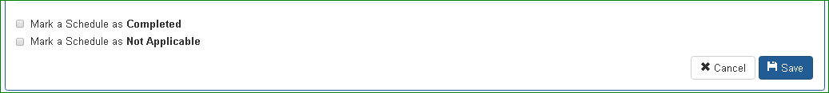
In order to mark a schedule as Completed, there must be no errors on that schedule. If a new expenditure file is uploaded, all “Mark a Schedule as Completed” checkboxes will be cleared.
In order to mark as schedule as Not Applicable, there must be no data appearing on the schedule, either those from expenditure records or manual entries.

3.3 District Contact & Certification Information
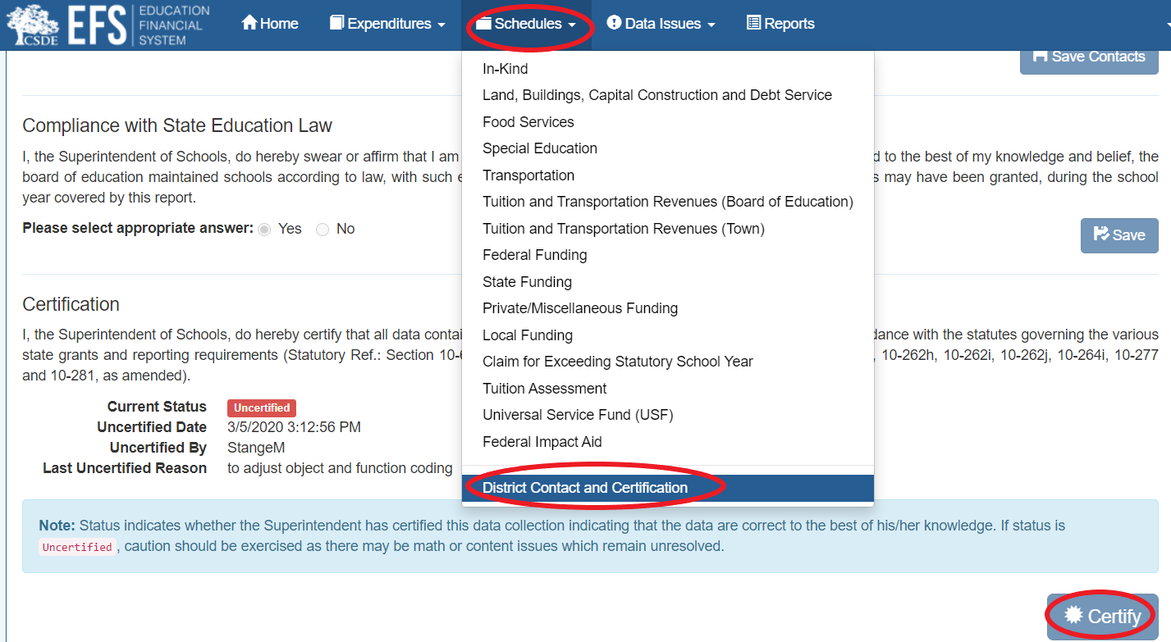
To enter contact information and certification, go to Schedules > District Contact and Certification

3.3.1 Description

The District Contact and Certification Schedule is applicable to local and regional school districts, charter schools, and RESCs.

3.3.2 Line instructions

Contact Information
Enter contact information for the person in the district who is best able to answer questions concerning information reported in EFS for:
- Expenditures
- Land, Buildings, Capital Construction and Debt Service
- Universal Service Fund

Compliance with State Education Law
Confirm compliance with state education law by clicking either the “yes” or “no” radio button. “No” answers will require follow-up by CSDE.

Certification
The initial state of the collection is “Uncertified”, which allows EFS data to be entered, modified, or deleted. When the district has completed all data entry in EFS and the status of all schedules is either “Completed” or “Not Applicable”, the Superintendent, Charter School Administrator, or RESC Director must certify the collection by clicking the “Certify” button, which changes the state of the collection to “Certified”. Data may not be entered, modified, or deleted when the collection is certified, however all schedules and reports are available for viewing.

Districts may request that the collection be uncertified to allow changes, by emailing SDE.efs@ct.gov.

3.4 In-Kind Expenditure Schedule

3.4.1 In-Kind Expenditure Schedule Description

In-kind expenditures reported in EFS are for services provided by other municipal agencies which directly support the public elementary and secondary educational programs of the school district. The school district reports these expenditures based on documentation obtained from the town’s chief municipal officer or designee. The Inkind excel worksheet (or similar) may be used to summarize in-kind services.

The worksheet(s) together with all supporting documentation must be kept on file by the school district. Any expenditure which fails to meet the necessary auditing tests will be disallowed for EFS reporting purposes.

EFS reporting may include the allocated portion of direct costs incurred by the town for both public elementary and secondary educational programs and other municipal functions. In this case, allocation documentation of the following must be made available, on request, to CSDE or its representatives:
    - Rationale for allocation including showing direct support of educational activities,
    - Allocation method used,
    - Percentage allocated,
    - Cost base against which the allocation has been made,
    - Worksheets which document staff time, fringe benefits and supplies used for those direct services, and
    - That if the town did not provide these services, then the board of education would have to contract these services from private vendors or perform these services with board of education employees.

Note that indirect costs for operating overhead are not reportable as in-kind expenditures in EFS.

3.4.2 In-Kind Expenditure Schedule line instructions
All entries on the In-Kind Schedule are expenditures from the EFS database. The records to be included on each line are based on EFS codes as listed in the table below. The EFS Codes are defined in Section 4.
 |  |  | EFS Codes / Description
Line | Description | Data Entry Method | EFS Funding  Source ID | EFS Function Code | EFS Object Code | EFS Education  Type Code | EFS PreK Code | CSDE Location Code | 2016-17 ED001 Reference (Line, Col)
IN-KIND SERVICES FROM LOCAL TAX REVENUES
IK101 | Salaries | Expenditure Database | 12 | All except 311X, 4XXX, 5XXX, 9XXX | S1,S2, B1 | 1,2,3 | All | School or District code | 101, 1
IK102 | Employee benefits | Expenditure Database | 12 | All except 311X, 4XXX, 5XXX, 9XXX | B2 | 1,2,3 | All | School or District code | 102, 1
IK103 | Purchased services | Expenditure Database | 12 | All except 311X, 4XXX, 5XXX, 9XXX | S5-S8, B3, B7, D2:D6 | 1,2,3 | All | School or District code | 103, 1 - 107, 1
IK104 | Supplies | Expenditure Database | 12 | All except 311X, 4XXX, 5XXX, 9XXX | S9-S11, B4 | 1,2,3 | All | School or District code | N/A
IK105 | Property | Expenditure Database | 12 | All except 311X, 4XXX, 5XXX, 9XXX | S12-S15, B5 | 1,2,3 | All | School or District code | 108, 1
IK106 | Other | Expenditure Database | 12 | All except 311X, 4XXX, 5XXX, 9XXX | S16, S17, B6 | 1,2,3 | All | School or District code | 110, 1 - 111, 1
IK199 | Total | Calculated by EFS | N/A |  |  |  |  |  | 112, 1

IN-KIND SERVICES FROM OTHER THAN LOCAL TAX REVENUES
IK201 | Salaries | Expenditure Database | 13-17 | All except 311X, 4XXX, 5XXX, 9XXX | S1,S2, B1 | 1,2,3 | All | School or District code | 101, 2
IK202 | Employee benefits | Expenditure Database | 13-17 | All except 311X, 4XXX, 5XXX, 9XXX | B2 | 1,2,3 | All | School or District code | 102, 2
IK203 | Purchased services | Expenditure Database | 13-17 | All except 311X, 4XXX, 5XXX, 9XXX | S5-S8, B3, B7, D2:D6 | 1,2,3 | All | School or District code | 103, 2 - 107, 2
IK204 | Supplies | Expenditure Database | 13-17 | All except 311X, 4XXX, XXX, 9XXX | S9-S11, B4 | 1,2,3 | All | School or District code | N/A
IK205 | Property | Expenditure Database | 13-17 | All except 311X, 4XXX, 5XXX, 9XXX | S12-S15, B5 | 1,2,3 | All | School or District code | 108, 2
IK206 | Other | Expenditure Database | 13-17 | All except 311X, 4XXX, 5XXX, 9XXX | S16, S17, B6 | 1,2,3 | All | School or District code | 110, 2 - 111, 2
IK299 | Total | Calculated by EFS | N/A |  |  |  |  |  | 112, 2

3.5 Food services expenditure schedule

3.5.1 Food services expenditure schedule description
This schedule is used to determine what amount, if any, of food service expenditures may be considered as a local contribution to education. This schedule must be completed only if local funds are expended to reduce or eliminate an operating deficit for the current or prior year. Entries on the Food Services Schedule are expenditures from the EFS database or manual entries on the schedule. The amounts to be included on each line are based on EFS codes, or described further as listed in the table below. The EFS Codes are defined in Section 4.

3.5.2 Food services expenditure schedule line instructions – Local and Regional School Districts
 |  |  | EFS Codes / Description
Line | Description | Data Entry Method | EFS Funding  Source ID | EFS Function Code | EFS Object Code | EFS Education  Type Code | EFS PreK Code | CSDE Location Code | 2016-17 ED001 Reference (Line, Col)
LOCAL EXPENDITURES FOR CURRENT YEAR FOOD SERVICES PROGRAMS
FS101 | Expenditures from Board of Education Budget (Local Sources Only) | Expenditure Database | 1, 11 | 311X, 3121 | All except D1, N1, S3, S4 | 1, 2, or 3 | All | School or District code | 302, 1
FS102 | Locally Supported In-Kind Services | Expenditure Database | 12 | 311X, 3121 | All except D1, N1, S3, S4 | 1, 2, or 3 | All | School or District code | 303, 1
FS199 | Total | Calculated by EFS | N/A |  |  |  |  |  | 304, 2
REVENUE FOR CURRENT YEAR FOOD SERVICES PROGRAMS
FS201 | Sales to Students and Adults | Screen entry | Revenue received from sales to students and adults for school breakfast, school lunch, and special milk food services. This may include revenues from a la carte, milk or breakfast programs, sales from special events or ice cream, summer feeding, child day care programs and federal grant programs like Headstart, sales to staff, special events such as the provision of coffee to PTO/PTA organizations, and sales under an elderly feeding program.  Do not include sales to students or adults from the operation of the Summer Food Service Program or the Child Care Food Program. These are programs which are not considered to support public elementary and secondary education. For the most part, these food service programs are not administered by the board of education; they are administered by a town agency. |  |  |  |  |  | 305, 1
FS202 | Other Sales | Screen entry | Other types of sales revenue, such as from equipment, food items or food supplies. |  |  |  |  |  | 306, 1
FS203 | Interest Income | Screen entry | Interest earnings of the food service program. |  |  |  |  |  | 307, 1
FS204 | Federal and State Grants (Excluding USDA Commodities) | Screen entry | Revenues from the following grant programs:  - Child Nutrition Public, State (16211)  - National School Lunch (Sections 4 and 11), Federal (20560)  - Special Milk Fund, Federal (20500)  - School Breakfast, Federal (20508)  - School Breakfast, State (17046)  - Health Foods Initiative, State (16212)  - Fresh Fruit and Vegetable Program, Federal (22051)  - School Meals Assistance Revenue for Transition (SMART) Funds, State (28105)  - School Meals Assistance Revenue for Transition (SMART) Funds 2.0, State (28105)  Do not report USDA commodities, Summer Food Service Program (20540 and 20548), or Child Care Food Program (20514, 20518 or 20544). |  |  |  |  |  | 308, 1
FS205 | Revenues from Other Than Local Tax Sources | Screen entry | Other revenues such as those from insurance and manufacturers’ rebates. |  |  |  |  |  | 309, 1
FS299 | Total | Calculated by EFS | N/A |  |  |  |  |  | 310, 2

 |  |  | EFS Codes / Description
Line | Description | Data Entry Method | EFS Funding  Source ID | EFS Function Code | EFS Object Code | EFS Education  Type Code | EFS PreK Code | CSDE Location Code | 2016-17 ED001 Reference (Line, Col)
REPORTABLE EXPENDITURES FOR CURRENT YEAR FOOD SERVICES PROGRAMS
FS301 | Expenditures for Current Year Food Service Program from EFS Expenditure Table | Expenditure Database | All | 311X, 3121 | All except D1, N1, S3, S4 | 1, 2, or 3 | All | School or District code | 311, 2
FS302 | Expenditures for Current Year Food Service Program not in EFS Expenditure Table | Screen entry | Do not include USDA Commodities expenditures
FS303 | Total Expenditures for Current Year Food Service Program (FS301 plus FS302) | Calculated | N/A
FS304 | Net Profit or Loss (FS299 minus FS303) | Calculated by EFS | N/A |  |  |  |  |  | 312, 2
FS305 | Reportable Current Year Food Service Local Expenditures (If FS304 is less than zero, the lesser of FS199 or the absolute value of FS304) | Calculated by EFS | N/A |  |  |  |  |  | 313, 2
CURRENT YEAR EXPENDITURES FOR PRIOR YEAR FOOD SERVICES PROGRAMS
FS401 | Local Contributions for Prior Year’s Food Service Program Deficit | Expenditure Database | 1, 11, 12 | 3122 | All except D1, N1, S3, S4 | 1, 2, or 3 | All | School or District code | 301, 2
TOTAL REPORTABLE FOOD SERVICE PROGRAM EXPENDITURES
FS901 | Total Reportable Food Service Program Expenditures (FS305 plus FS401) | Calculated by EFS | N/A |  |  |  |  |  | 314, 2
FS902 | Reportable local budget expenditures per EFS Expenditure Table | Expenditure Database | 1, 11 | 3121, 3122 | All except D1, N1, S3, S4 | 1, 2, or 3 | All | School or District code | N/A
FS903 | Reportable in-kind expenditures per EFS Expenditure Table | Expenditure Database | 12 | 3121, 3122 | All except D1, N1, S3, S4 | 1, 2, or 3 | All | School or District code | N/A
FS904 | Total (FS902 plus FS903) | Calculated by EFS | N/A |  |  |  |  |  | N/A
FS905 | Variance (FS901 minus FS904) | Calculated by EFS | N/A |  |  |  |  |  | N/A

3.5.3 Food services expenditure schedule line instructions – Charter Schools
 |  |  | EFS Codes / Description
Line | Description | Data Entry Method | EFS Funding  Source ID | EFS Function Code | EFS Object Code | EFS Education  Type Code | EFS PreK Code | CSDE Location Code | 2016-17 ED001C Reference (Line, Col)
LOCAL EXPENDITURES FOR CURRENT YEAR FOOD SERVICES PROGRAMS
CF101 | Expenditures from Board of Education Budget (Local Sources Only) | Expenditure Database | 1, 11 | 311X, 3121 | All except N1, S3, S4 | 1, 2, or 3 | All | School or District code | N/A
CF102 | Locally Supported In-Kind Services | Expenditure Database | 12 | 311X, 3121 | All except N1, S3, S4 | 1, 2, or 3 | All | School or District code | N/A
CF199 | Total | Calculated by EFS | N/A |  |  |  |  |  | N/A
REVENUE FOR CURRENT YEAR FOOD SERVICES PROGRAMS
CF201 | Sales to Students and Adults | Screen entry | Revenue received from sales to students and adults for school breakfast, school lunch, and special milk food services. This may include revenues from a la carte, milk or breakfast programs, sales from special events or ice cream, summer feeding, child day care programs and federal grant programs like Headstart, sales to staff, special events such as the provision of coffee to PTO/PTA organizations, and sales under an elderly feeding program.  Do not include sales to students or adults from the operation of the Summer Food Service Program or the Child Care Food Program. These are programs which are not considered to support public elementary and secondary education. For the most part, these food service programs are not administered by the board of education; they are administered by a town agency. |  |  |  |  |  | N/A
CF202 | Other Sales | Screen entry | Other types of sales revenue, such as from equipment, food items or food supplies. |  |  |  |  |  | N/A
CF203 | Interest Income | Screen entry | Interest earnings of the food service program. |  |  |  |  |  | N/A
CF204 | Federal and State Grants (Excluding USDA Commodities) | Screen entry | Revenues from the following grant programs:  - Child Nutrition Public, State (16211)  - National School Lunch (Sections 4 and 11), Federal (20560)  - Special Milk Fund, Federal (20500)  - School Breakfast, Federal (20508)  - School Breakfast, State (17046)  - Health Foods Initiative, State (16212)  - Fresh Fruit and Vegetable Program, Federal (22051)  - School Meals Assistance Revenue for Transition (SMART) Funds, State (28105)  - School Meals Assistance Revenue for Transition (SMART) Funds 2.0, State (28105)  Do not report USDA commodities, Summer Food Service Program (20540 and 20548), or Child Care Food Program (20514, 20518 or 20544). |  |  |  |  |  | N/A
CF205 | Revenues from Other Than Local Tax Sources | Screen entry | Other revenues such as those from insurance and manufacturers’ rebates. |  |  |  |  |  | N/A
CF299 | Total | Calculated by EFS | N/A |  |  |  |  |  | N/A

 |  |  | EFS Codes / Description
Line | Description | Data Entry Method | EFS Funding  Source ID | EFS Function Code | EFS Object Code | EFS Education  Type Code | EFS PreK Code | CSDE Location Code | 2016-17 ED001C Reference (Line, Col)
REPORTABLE EXPENDITURES FOR CURRENT YEAR FOOD SERVICES PROGRAMS
CF301 | Total Expenditures for Food Service Program | Expenditure Database | All | 311X, 3121 | All except N1, S3, S4 | 1, 2, or 3 | All | School or District code | N/A
CF302 | Net Profit or Loss (CF299 minus CF301) | Calculated by EFS | N/A |  |  |  |  |  | N/A
CF303 | Reportable Food Service Local Expenditures (If CF302 is less than zero, the lesser of CF199 or the absolute value of CF302) | Calculated by EFS | N/A |  |  |  |  |  | N/A
CURRENT YEAR EXPENDITURES FOR PRIOR YEAR FOOD SERVICES PROGRAMS
CF401 | Local Contributions for Prior Year’s Food Service Program Deficit | Expenditure Database | 1, 11, 12 | 3122 | All except N1, S3, S4 | 1, 2, or 3 | All | School or District code | N/A
TOTAL REPORTABLE FOOD SERVICE PROGRAM EXPENDITURES
CF901 | Total Reportable Food Service Program Expenditures (CF303 plus CF401) | Calculated by EFS | N/A |  |  |  |  |  | N/A
CF902 | Reportable local budget expenditures per EFS Expenditure Table | Expenditure Database | 1, 11 | 3121, 3122 | All except N1, S3, S4 | 1, 2, or 3 | All | School or District code | N/A
CF903 | Reportable in-kind expenditures per EFS Expenditure Table | Expenditure Database | 12 | 3121, 3122 | All except N1, S3, S4 | 1, 2, or 3 | All | School or District code | N/A
CF904 | Total (CF902 plus CF903) | Calculated by EFS | N/A |  |  |  |  |  | N/A
CF905 | Variance (CF901 minus CF904) | Calculated by EFS | N/A |  |  |  |  |  | N/A

3.5.4 Food services expenditure schedule line instructions – RESCs
Local Expenditures For Current Year Food Services Programs
Line | Description | Data Entry Method | EFS Funding  Source ID | EFS Function Code | EFS Object Code | EFS Education  Type Code | EFS PreK Code | CSDE Location Code | 2016-17 ED001R Reference (Line, Col)
RF101 | Expenditures from Board of Education Budget (Local Sources Only) | Expenditure Database | 1, 11 | 311X, 3121 | All except N1, S3, S4 | 1, 2, or 3 | All | School or District code | N/A
RF102 | Locally Supported In-Kind Services | Expenditure Database | 12 | 311X, 3121 | All except N1, S3, S4 | 1, 2, or 3 | All | School or District code | N/A
RF199 | Total | Calculated by EFS |  |  |  |  |  |  | N/A
Revenue For Current Year Food Services Programs
RF201 | Sales to Students and Adults | Screen entry | Revenue received from sales to students and adults for school breakfast, school lunch, and special milk food services. This may include revenues from a la carte, milk or breakfast programs, sales from special events or ice cream, summer feeding, child day care programs and federal grant programs like Headstart, sales to staff, special events such as the provision of coffee to PTO/PTA organizations, and sales under an elderly feeding program.  Do not include sales to students or adults from the operation of the Summer Food Service Program or the Child Care Food Program. These are programs which are not considered to support public elementary and secondary education. For the most part, these food service programs are not administered by the board of education; they are administered by a town agency. | N/A
RF202 | Other Sales | Screen entry | Other types of sales revenue, such as from equipment, food items or food supplies. | N/A
RF203 | Interest Income | Screen entry | Interest earnings of the food service program. | N/A
RF204 | Federal and State Grants (Excluding USDA Commodities) | Screen entry | Revenues from the following grant programs:  - Child Nutrition Public, State (16211)  - National School Lunch (Sections 4 and 11), Federal (20560)  - Special Milk Fund, Federal (20500)  - School Breakfast, Federal (20508)  - School Breakfast, State (17046)  - Health Foods Initiative, State (16212)  - Fresh Fruit and Vegetable Program, Federal (22051)  - School Meals Assistance Revenue for Transition (SMART) Funds, State (28105)  - School Meals Assistance Revenue for Transition (SMART) Funds 2.0, State (28105)  Do not report USDA commodities, Summer Food Service Program (20540 and 20548), or Child Care Food Program (20514, 20518 or 20544). | N/A
RF205 | Revenues from Other Than Local Tax Sources | Screen entry | Other revenues such as those from insurance and manufacturers’ rebates. | N/A
RF299 | Total | Calculated by EFS | N/A | N/A

Reportable Expenditures For Current Year Food Services Programs
Line | Description | Data Entry Method | EFS Funding  Source ID | EFS Function Code | EFS Object Code | EFS Education  Type Code | EFS PreK Code | CSDE Location Code | 2016-17 ED001R Reference (Line, Col)
RF301 | Total Expenditures for Food Service Program | Expenditure Database | All | 311X, 3121 | All except N1, S3, S4 | 1, 2, or 3 | All | School or District code | N/A
RF302 | Net Profit or Loss (RF299 minus RF301) | Calculated by EFS |  |  |  |  |  |  | N/A
RF303 | Reportable Food Service Local Expenditures (If RF302 is less than zero, the lesser of RF199 or the absolute value of RF302) | Calculated by EFS |  |  |  |  |  |  | N/A
Current Year Expenditures For Prior Year Food Services Programs
RF401 | Local Contributions for Prior Year’s Food Service Program Deficit | Expenditure Database | 1, 11, 12 | 3122 | All except N1, S3, S4 | 1, 2, or 3 | All | School or District code | N/A
Total Reportable Food Service Program Expenditures
RF901 | Total Reportable Food Service Program Expenditures (RF303 plus RF401) | Calculated by EFS |  |  |  |  |  |  | N/A
RF902 | Reportable local budget expenditures per EFS Expenditure Table | Expenditure Database | 1, 11 | 3121, 3122 | All except N1, S3, S4 | 1, 2, or 3 | All | School or District code | N/A
RF903 | Reportable in-kind expenditures per EFS Expenditure Table | Expenditure Database | 12 | 3121, 3122 | All except N1, S3, S4 | 1, 2, or 3 | All | School or District code | N/A
RF904 | Total (RF902 plus RF903) | Calculated by EFS |  |  |  |  |  |  | N/A
RF905 | Variance (RF901 minus RF904) | Calculated by EFS |  |  |  |  |  |  | N/A

3.6 Special education expenditure schedule

3.6.1 Special education expenditure schedule description
Special education expenditures to be included in this schedule are defined in Sections 10- 76a and 10-76f of the Connecticut General Statutes. Special education functions are those activities exclusively devoted to the task of identifying and implementing special education programs and services in conjunction with the activities of the planning and placement team (PPT). Costs not considered unique to a special education program such as heating, property insurance and food supplies are includable in this schedule, therefore, only if provided in a building devoted exclusively to special education programs, in which case they should be reported in Lines SE201 – SE210. Otherwise, such costs are considered nonspecial education and are not to be included on this schedule. Entries on this schedule all are expenditures from the EFS database. The amounts to be included on each line are based on EFS codes, or described further as listed in the table below. The EFS Codes are defined in Section 4.

3.6.2 Special education expenditure schedule line instructions – Local and Regional School Districts
Line | Description | Data Entry Method | EFS Funding  Source ID | EFS Function Code | EFS Object Code | EFS Education  Type Code | EFS PreK Code | CSDE Location Code | 2016-17 ED001 Reference (Line, Col)
Special education expenditures not eligible in the computation of “net costs of special education” per subsection (h) of section 10-76f of the Connecticut General Statutes.
SE101 | Teacher salaries | Expenditure Database | All | All except 27XX, 27X1, 27X3, 27X4, 311X, 4XXX, 5XXX, 9XXX | S1 | 2 | All | School code | 401, 1
SE102 | Instructional aide salaries | Expenditure Database | All | All except 27XX, 27X1, 27X3, 27X4, 311X, 4XXX, 5XXX, 9XXX | S2 | 2 | All | School code | N/A
SE103 | Other salaries | Expenditure Database | All | All except 27XX, 27X1, 27X3, 27X4, 311X, 4XXX, 5XXX, 9XXX | B1 | 2 | All | School or District code | 402, 1
SE104 | Employee benefits | Expenditure Database | All | All except 27XX, 27X1, 27X3, 27X4, 311X, 4XXX, 5XXX, 9XXX | B2 | 2 | All | School or District code | 403, 1
SE105 | Purchased services | Expenditure Database | All | All except 27XX, 27X1, 27X3, 27X4, 311X, 4XXX, 5XXX, 9XXX | B3, S5, S6, S8 | 2 | All | School or District code | sum of 404, 1 and 409, 1
SE106 | Special education tuition | Expenditure Database | All | All except 27XX, 27X1, 27X3, 27X4, 311X, 4XXX, 5XXX, 9XXX | D2-D6 | 2 | All | School or District code | 405, 1
SE107 | Supplies | Expenditure Database | All | All except 27XX, 27X1, 27X3, 27X4, 311X, 4XXX, 5XXX, 9XXX | B4, S9-S11 | 2 | All | School or District code | sum of 406, 1 and 407, 1
SE108 | Property services | Expenditure Database | All | All except 27XX, 27X1, 27X3, 27X4, 311X, 4XXX, 5XXX, 9XXX | B7 | 2 | All | School or District code | 408, 1
SE109 | Equipment | Expenditure Database | All | All except 27XX, 27X1, 27X3, 27X4, 311X, 4XXX, 5XXX, 9XXX | B5, S12-S15 | 2 | All | School or District code | 410, 1
SE110 | All other expenditures | Expenditure Database | All | All except 27XX, 27X1, 27X3, 27X4, 311X, 4XXX, 5XXX, 9XXX | B6, S16, S17 | 2 | All | School or District code | 411, 1
SE199 | Total | Calculated by EFS |  |  |  |  |  |  | 412, 1

Line | Description | Data Entry Method | EFS Funding  Source ID | EFS Function Code | EFS Object Code | EFS Education  Type Code | EFS PreK Code | CSDE Location Code | 2016-17 ED001 Reference (Line, Col)
Special education expenditures eligible in the computation of “net costs of special education” per subsection (h) of section 10-76f of the Connecticut General Statutes.
SE201 | Teacher salaries | Expenditure Database | All except 2, 3, 5, 13, 14, 16 | All except 27XX, 27X1, 27X3, 27X4, 311X, 4XXX, 5XXX, 9XXX | S1 | 3 | All | School code | 401, 2
SE202 | Instructional aide salaries | Expenditure Database | All except 2, 3, 5, 13, 14, 16 | All except 27XX, 27X1, 27X3, 27X4, 311X, 4XXX, 5XXX, 9XXX | S2 | 3 | All | School code | N/A
SE203 | Other salaries | Expenditure Database | All except 2, 3, 5, 13, 14, 16 | All except 27XX, 27X1, 27X3, 27X4, 311X, 4XXX, 5XXX, 9XXX | B1 | 3 | All | School or District code | 402, 2
SE204 | Employee benefits | Expenditure Database | All except 2, 3, 5, 13, 14, 16 | All except 27XX, 27X1, 27X3, 27X4, 311X, 4XXX, 5XXX, 9XXX | B2 | 3 | All | School or District code | 403, 2
SE205 | Purchased services | Expenditure Database | All except 2, 3, 5, 13, 14, 16 | All except 27XX, 27X1, 27X3, 27X4, 311X, 4XXX, 5XXX, 9XXX | B3, S5, S6, S8 | 3 | All | School or District code | sum of 404, 2 and 409, 2
SE206 | Special education tuition | Expenditure Database | All except 2, 3, 5, 13, 14, 16 | All except 27XX, 27X1, 27X3, 27X4, 311X, 4XXX, 5XXX, 9XXX | D2-D6 | 3 | All | School or District code | 405, 2
SE207 | Supplies | Expenditure Database | All except 2, 3, 5, 13, 14, 16 | All except 27XX, 27X1, 27X3, 27X4, 311X, 4XXX, 5XXX, 9XXX | B4, S9-S11 | 3 | All | School or District code | sum of 406, 2 and 407, 2
SE208 | Property services | Expenditure Database | All except 2, 3, 5, 13, 14, 16 | All except 27XX, 27X1, 27X3, 27X4, 311X, 4XXX, 5XXX, 9XXX | B7 | 3 | All | School or District code | 408, 2
SE209 | Equipment | Expenditure Database | All except 2, 3, 5, 13, 14, 16 | All except 27XX, 27X1, 27X3, 27X4, 311X, 4XXX, 5XXX, 9XXX | B5, S12-S15 | 3 | All | School or District code | 410, 2
SE210 | All other expenditures | Expenditure Database | All except 2, 3, 5, 13, 14, 16 | All except 27XX, 27X1, 27X3, 27X4, 311X, 4XXX, 5XXX, 9XXX | B6, S16, S17 | 3 | All | School or District code | 411, 2
SE299 | Total | Calculated by EFS |  |  |  |  |  |  | 412, 2
3.6.3 Special education expenditure schedule line instructions – Charter Schools
 |  |  | EFS Codes / Description
Line | Description | Data Entry Method | EFS Funding  Source ID | EFS Function Code | EFS Object Code | EFS Education  Type Code | EFS PreK Code | CSDE Location Code | 2016-17 ED001C Reference (Line, Col)
Special Education Expenditures
CS101 | Teacher salaries | Expenditure Database | All | All except 27XX, 27X1, 27X3, 27X4, 311X, 4XXX, 5XXX, 9XXX | S1 | 2 or 3 | All | School code | N/A
CS102 | Instructional aide salaries | Expenditure Database | All | All except 27XX, 27X1, 27X3, 27X4, 311X, 4XXX, 5XXX, 9XXX | S2 | 2 or 3 | All | School code | N/A
CS103 | Other salaries | Expenditure Database | All | All except 27XX, 27X1, 27X3, 27X4, 311X, 4XXX, 5XXX, 9XXX | B1 | 2 or 3 | All | School or District code | N/A
CS104 | Employee benefits | Expenditure Database | All | All except 27XX, 27X1, 27X3, 27X4, 311X, 4XXX, 5XXX, 9XXX | B2 | 2 or 3 | All | School or District code | N/A
CS105 | Purchased Services | Expenditure Database | All | All except 27XX, 27X1, 27X3, 27X4, 311X, 4XXX, 5XXX, 9XXX | B3, C2, C3, S5, S6, S8 | 2 or 3 | All | School or District code | N/A
CS106 | Special education tuition | Expenditure Database | All | All except 27XX, 27X1, 27X3, 27X4, 311X, 4XXX, 5XXX, 9XXX | D1-D6 | 2 or 3 | All | School or District code | N/A
CS107 | Supplies | Expenditure Database | All | All except 27XX, 27X1, 27X3, 27X4, 311X, 4XXX, 5XXX, 9XXX | B4, S9-S11 | 2 or 3 | All | School or District code | N/A
CS108 | Property Services | Expenditure Database | All | All except 27XX, 27X1, 27X3, 27X4, 311X, 4XXX, 5XXX, 9XXX | C1, B7 | 2 or 3 | All | School or District code | N/A
CS109 | Equipment | Expenditure Database | All | All except 27XX, 27X1, 27X3, 27X4, 311X, 4XXX, 5XXX, 9XXX | B5, S12-S15 | 2 or 3 | All | School or District code | N/A
CS110 | All other expenditures | Expenditure Database | All | All except 27XX, 27X1, 27X3, 27X4, 311X, 4XXX, 5XXX, 9XXX | B6, S16, S17 | 2 or 3 | All | School or District code | N/A
CS199 | Total | Calculated by EFS |  |  |  |  |  |  | N/A

3.6.4 Special education expenditure schedule line instructions – RESCs
Line | Description | Data Entry Method | EFS Funding  Source ID | EFS Function Code | EFS Object Code | EFS Education  Type Code | EFS PreK Code | CSDE Location Code | 2016-17 ED001R Reference (Line, Col)
Special Education Expenditures
RS101 | Teacher salaries | Expenditure Database | All | All except 27XX, 27X1, 27X3, 27X4, 311X, 4XXX, 5XXX, 9XXX | S1 | 2 or 3 | All | School code | sum of 401,1 and 401,2
RS102 | Instructional aide salaries | Expenditure Database | All | All except 27XX, 27X1, 27X3, 27X4, 311X, 4XXX, 5XXX, 9XXX | S2 | 2 or 3 | All | School code | N/A
RS103 | Other salaries | Expenditure Database | All | All except 27XX, 27X1, 27X3, 27X4, 311X, 4XXX, 5XXX, 9XXX | B1 | 2 or 3 | All | School or District code | sum of 402,1 and 402,2
RS104 | Employee benefits | Expenditure Database | All | All except 27XX, 27X1, 27X3, 27X4, 311X, 4XXX, 5XXX, 9XXX | B2 | 2 or 3 | All | School or District code | sum of 403,1 and 403,2
RS105 | Purchased Services | Expenditure Database | All | All except 27XX, 27X1, 27X3, 27X4, 311X, 4XXX, 5XXX, 9XXX | B3, S5, S6, S8 | 2 or 3 | All | School or District code | sum of 404,1, 404,2, 409,1 and 409,2
RS106 | Special education tuition | Expenditure Database | All | All except 27XX, 27X1, 27X3, 27X4, 311X, 4XXX, 5XXX, 9XXX | D1-D6 | 2 or 3 | All | School or District code | sum of 405,1 and 405,2
RS107 | Supplies | Expenditure Database | All | All except 27XX, 27X1, 27X3, 27X4, 311X, 4XXX, 5XXX, 9XXX | B4, S9-S11 | 2 or 3 | All | School or District code | sum of 406,1, 406,2, 407,1 and 407,2
RS108 | Property Services | Expenditure Database | All | All except 27XX, 27X1, 27X3, 27X4, 311X, 4XXX, 5XXX, 9XXX | B7 | 2 or 3 | All | School or District code | sum of 408,1 and 408,2
RS109 | Equipment | Expenditure Database | All | All except 27XX, 27X1, 27X3, 27X4, 311X, 4XXX, 5XXX, 9XXX | B5, S12-S15 | 2 or 3 | All | School or District code | sum of 410,1 and 410,2
RS110 | All other expenditures | Expenditure Database | All | All except 27XX, 27X1, 27X3, 27X4, 311X, 4XXX, 5XXX, 9XXX | B6, S16, S17 | 2 or 3 | All | School or District code | sum of 411,1 and 411,2
RS199 | Total | Calculated by EFS |  |  |  |  |  |  | sum of 412,1 and 412,2

3.7 Transportation expenditure schedule

3.7.1 Transportation expenditure schedule description
The Transportation Expenditure Schedule reports expenditures, numbers of students transported, and debt service for transportation from home to school to district public schools, out of town schools, and non-public schools, as well as other transportation provided by the district. Entries on the Transportation Expenditure Schedule are expenditures from the EFS database or manual entries on the schedule. The amounts to be included on each line are based on EFS codes, or described further as listed in the table below. The EFS Codes are defined in Section 4.

3.7.2 Transportation expenditure schedule line instructions – Local and Regional School Districts
Line | Description | Data Entry Method | EFS Funding  Source ID | EFS Function Code | EFS Object Code | EFS Education Type Code | EFS PreK Code | CSDE Location Code | 2016-17 ED001 Reference (Line, Col)
In-Town Regular Transportation Of Public School Students
TR101 | Number of students transported in-town to/from home not including special education students transported on special education vehicles | Screen entry |  |  |  |  |  |  | Sum of 505, 2 and 506, 2
TR102 | Transportation expenditures for students reported on line TR101 | Expenditure Database | All | All 27XX except 27X1, 27X2, 27X3, and 27X4 | All except D1, N1, S3, and S4 | 1, 2, or 3 | All | School or District code | Sum of 505, 3 and 506, 3
TR103 | Transportation debt service for students reported on line TR101 | Screen entry |  |  |  |  |  |  | Sum of 505, 4 and 506, 4
Out Of Town Magnet School Transportation
TR201 | Number of students transported to out of town magnet schools | Screen entry |  |  |  |  |  |  | 511, 2
TR202 | Transportation expenditures for students reported on line TR201 | Expenditure Database | All | 27X1 | All except D1, N1, S3, and S4 | 1, 2, or 3 | All | School or District code | 511, 3
TR203 | Transportation debt service for students reported on line TR201 | Screen entry |  |  |  |  |  |  | N/A
Special Education Students Transported On Special Education Vehicles
TR301 | Number of special education students transported on special education vehicles | Screen entry |  |  |  |  |  |  | 514, 2
TR302 | Transportation expenditures for students reported on line TR301 | Expenditure Database | All | 27X2 | All except D1, N1, S3, and S4 | 1, 2, or 3 | All | School or District code | 514, 3
TR303 | Transportation debt service for students reported on line TR301 | Screen entry |  |  |  |  |  |  | 514, 4

Line | Description | Data Entry Method | EFS Funding  Source ID | EFS Function Code | EFS Object Code | EFS Education Type Code | EFS PreK Code | CSDE Location Code | 2016-17 ED001 Reference (Line, Col)
Out-Of-Town Regular Transportation Of Public School Students
TR401 | Number of students transported out of town to/from home not including special education students transported on special education vehicles | Screen entry |  |  |  |  |  |  | Sum of 507, 2; 512, 2; and 515, 2
TR402 | Transportation expenditures for students reported on line TR401 | Expenditure Database | All | 27X3 | All except D1, N1, S3, and S4 | 1, 2, or 3 | All | School or District code | Sum of 507, 3; 512, 3; and 515, 3
TR403 | Transportation debt service for students reported on line TR401 | Screen entry |  |  |  |  |  |  | Sum of 507, 4; 512, 4; and 515, 4
Other Transportation Of Public School Students
TR501 | Transportation expenditures other than to/from home (field trips etc.) | Expenditure Database | All | 27X4 | All except D1, N1, S3, and S4 | 1, 2, or 3 | All | School or District code | 502, 3
TR502 | Transportation debt service other than to/from home (field trips etc.) | Screen entry |  |  |  |  |  |  | 502, 4
Total Transportation Of Public School Students
TR901 | Total public school students transported (Sum of lines TR101, TR201, TR301, and TR401) | Calculated by EFS |  |  |  |  |  |  | Sum of 505, 2; 506, 2; 507, 2; 511, 2; 512, 2; 514, 2; and 515, 2
TR902 | Total public school transportation expenditures (Sum of lines TR102, TR202, TR302, TR402, and TR501) | Calculated by EFS |  |  |  |  |  |  | Sum of 502, 3; 505, 3; 506, 3; 507, 3; 511, 3; 512, 3; 514, 3; and 515, 3
TR903 | Total public school transportation debt service (Sum of lines TR103, TR203, TR303, TR403, and TR502) | Calculated by EFS |  |  |  |  |  |  | Sum of 502, 4; 505, 4; 506, 4; 507, 4; 511, 4; 512, 4; 514, 4; and 515, 4
Non-Public School Transportation
TR601 | Number of non-public school students transported | Screen entry |  |  |  |  |  |  | 699, 5
TR602 | Transportation expenditures for students reported on line TR601 | Expenditure Database | All | 27XX | All except D1, N1, S3, and S4 | 4 | All | School or District code | 699, 6

3.7.3 Transportation expenditure schedule line instructions – Charter Schools

Line | Description | Data Entry Method | EFS Funding  Source ID | EFS Function Code | EFS Object Code | EFS Education  Type Code | EFS PreK Code | CSDE Location Code | 2016-17 ED001C Reference (Line, Col)
Regular Student Transportation
TC101 | Number of students transported to/from home not including special education students transported on special education vehicles | Screen entry |  |  |  |  |  |  | N/A
TC102 | Transportation expenditures for students reported on line TC101 | Expenditure Database | All | All 27XX except 27X1, 27X2, 27X3, and 27X4 | All except N1, S3, and S4 | 1 | All | School or District code | N/A
TC103 | Transportation debt service for students reported on line TC101 | Screen entry |  |  |  |  |  |  | N/A
Special Education Students Transported On Special Education Vehicles
TC201 | Number of special education students transported on special education vehicles | Screen entry |  |  |  |  |  |  | N/A
TC202 | Transportation expenditures for students reported on line TC201 | Expenditure Database | All | 27X2 | All except N1, S3, and S4 | 2 or 3 | All | School or District code | N/A
TC203 | Transportation debt service for students reported on line TC201 | Screen entry |  |  |  |  |  |  | N/A
Other Student Transportation
TC301 | Transportation expenditures other than to/from home (field trips etc.) | Expenditure Database | All | 27X4 | All except N1, S3, and S4 | 1 | All | School or District code | N/A
TC302 | Transportation debt service other than to/from home (field trips etc.) | Screen entry |  |  |  |  |  |  | N/A
Total Student Transportation
TC901 | Total students transported (TC101 plus TC201) | Calculated by EFS |  |  |  |  |  |  | N/A
TC902 | Total student transportation expenditures (Sum of lines TC102, TC202, and TC301) | Calculated by EFS |  |  |  |  |  |  | N/A
TC903 | Total public school transportation debt service (Sum of lines TC103, TC203, and TC302) | Calculated by EFS |  |  |  |  |  |  | N/A

3.7.4 Transportation expenditure schedule line instructions – RESCs
Line | Description | Data Entry Method | EFS Funding  Source ID | EFS Function Code | EFS Object Code | EFS Education  Type Code | EFS PreK Code | CSDE Location Code | 2016-17R ED001 Reference (Line, Col)
Out Of Town Magnet School Transportation - Total Expenditures
RT101 | Number of students transported to out of town magnet schools | Screen entry |  |  |  |  |  |  | N/A
RT102 | Transportation expenditures for students reported on line RT101 | Expenditure Database | All | 27X1 | All except N1, S3, and S4 | All | All | School or District code | N/A
RT103 | Transportation debt service for students reported on line RT101 | Screen entry |  |  |  |  |  |  | N/A
Regular Transportation Of Public School Students - Resc School District
RT201 | Number of students transported to/from home not including special education students transported on special education vehicles | Screen entry |  |  |  |  |  |  | N/A
RT202 | Transportation expenditures for students reported on line RT201 | Expenditure Database | All | All 27XX except 27X1, 27X2, and 27X4 | All except N1, S3, and S4 | 1 | All | School or District code | N/A
RT203 | Transportation debt service for students reported on line RT201 | Screen entry |  |  |  |  |  |  | N/A
Out Of Town Magnet School Transportation - Resc School District
TR301 | Number of students transported to out of town magnet schools | Screen entry |  |  |  |  |  |  | N/A
TR302 | Transportation expenditures for students reported on line RT301 | Expenditure Database | All | 27X1 | All except N1, S3, and S4 | 1 | All | School or District code | N/A
TR303 | Transportation debt service for students reported on line RT301 | Screen entry |  |  |  |  |  |  | N/A

Line | Description | Data Entry Method | EFS Funding  Source ID | EFS Function Code | EFS Object Code | EFS Education  Type Code | EFS PreK Code | CSDE Location Code | 2016-17R ED001 Reference (Line, Col)
Special Education Students Transported On Special Education Vehicles - Resc School District
RT401 | Number of special education students transported on special education vehicles | Screen entry |  |  |  |  |  |  | N/A
RT402 | Transportation expenditures for students reported on line RT401 | Expenditure Database | All | 27X2 | All except N1, S3, and S4 | 2 or 3 | All | School or District code | N/A
RT403 | Transportation debt service for students reported on line RT401 | Screen entry |  |  |  |  |  |  | N/A
Other Transportation Of Public School Students - Resc School District
RT501 | Transportation expenditures other than to/from home (field trips etc.) | Expenditure Database | All | 27X4 | All except N1, S3, and S4 | 1 | All | School or District code | N/A
RT502 | Transportation debt service other than to/from home (field trips etc.) | Screen entry |  |  |  |  |  |  | N/A
Total Transportation Of Public School Students - Resc School District
RT901 | Total public school students transported (Sum of lines RT201, RT301, and RT401) | Calculated by EFS |  |  |  |  |  |  | N/A
RT902 | Total public school transportation expenditures (Sum of lines RT202, RT302, RT402, and RT501) | Calculated by EFS |  |  |  |  |  |  | N/A
RT903 | Total public school transportation debt service (Sum of lines RT203, RT303, RT403, and RT502) | Calculated by EFS |  |  |  |  |  |  | N/A

3.8 Federal funding schedule

3.8.1 Federal funding schedule description
The Federal Funding Schedule reports details of expenditures from federal funds, and reconciles to the total expenditures from federal funds used for free public elementary and secondary education as reported in the EFS expenditure database.

Amounts on the Federal Funding Schedules may be manual screen entries, expenditures imported from the eGrants Management System (eGMS), or from the EFS expenditure table. The EFS Codes are defined in Section 4.

The expenditures from consortium grants imported from eGMS onto line FF102/ FC102/ FR302 represent all expenditures made on your district’s behalf as reported by the fiscal agent for the grant(s). Amounts shown may differ from actual payments received by your district. Description of the grants and fiscal agent are shown on the “Consortium Member Report Non-Fiscal Agent” report available in eGMS. The full consortium expenditure must be included in your district’s EFS expenditure table; contact the fiscal agent if you need more information or to correct discrepancies.

Ensure that only expenditures are included; do not report any unexpended portion of grants. Any reimbursements due should be reported on the modified accrual basis to the extent that they cover expenditures. Keep in mind that for federal grants, the liquidation period is sixty (60) days. Supporting documentation of the reported expenditures must be maintained on file.

3.8.2 Federal funding schedule line instructions – Local and Regional School Districts
Line | Description | Data Entry Method | EFS Funding  Source ID | EFS Function Code | EFS Object Code | EFS Education  Type Code | EFS PreK Code | CSDE Location Code | 2016-17 ED001 Reference (Line, Col)
Federal Grants Passed Through CSDE
FF101 | Total From EGMS | Import | Direct import from eGMS X001 lines. *When this amount has been changed in eGMS, a refresh button will appear. Click the refresh button to update the amount on this line, then be sure to save this schedule.  Detail by grant is available in eGMS, on the “ED141 EFS Expenditure Summary” report. | 819, 1
FF102 | Your portion of services/expenditures from consortium grant payment arrangement | Import | Direct import from eGMS - sum of consortium member expenditures. *When this amount has been changed in eGMS, a refresh button will appear. Click the refresh button to update the amount on this line, then be sure to save this schedule.  Detail by fiscal agent and grant is available in eGMS, on the “CMR Non-Fiscal Agent” report. | 820, 1
FF103 | Other (list below): | Calculated by EFS | Federal grants received from CSDE outside of eGMS. Sum of expenditures from detail lines below. | N/A
 |  | Screen entry | Enter name/description of grant; add lines as needed.
Direct Federal Grants
FF201 | List below: | Calculated by EFS | Federal grants received directly from the federal government. Sum of expenditures from detail lines below. | Sum of 803, 1; 804, 1; and 805, 1
 |  | Screen entry | Enter name/description of grant; add lines as needed.
Federal Grants Passed Through Non-CSDE Agencies
FF301 | List below: | Calculated by EFS | Federal grants received from agencies other than CSDE. Sum of expenditures from detail lines below. | 821, 1
 |  | Screen entry | Enter name/description of grant; add lines as needed.
Total Federal Expenditures Reconciliation
FF901 | Total Federal Expenditures (sum of lines above) | Calculated by EFS | N/A | Sum of 803, 1; 804, 1; 805, 1; 819, 1; 820, 1; and 821, 1

FF902 | Federal Funds per EFS Expenditure Table | Expenditure Database | 2 | All except 311X, 4XXX, 5XXX, and 9XXX | All except D1, N1, S3, and S4 | 1, 2, or 3 | All | School or District code | N/A
FF903 | Federal Inkind per EFS Expenditure Table | Expenditure Database | 13 | All except 311X, 4XXX, 5XXX, and 9XXX | All except D1, N1, S3, and S4 | 1, 2, or 3 | All | School or District code | N/A

FF904 | Total (FF902 plus FF903) | Calculated by EFS | N/A | N/A
FF905 | Variance (FF901 minus FF904) | Calculated by EFS | Difference between federal funding reported on this schedule and expenditures reported in the EFS database; should equal zero. | N/A

3.8.3 Federal funding schedule line instructions – Charter Schools
Line | Description | Data Entry Method | EFS Funding  Source ID | EFS Function Code | EFS Object Code | EFS Education  Type Code | EFS PreK Code | CSDE Location Code | 2016-17 ED001C Reference (Line, Col)
Federal Grants Passed Through CSDE
FC101 | Total From EGMS | Import | Direct import from eGMS X001 lines  *When this amount has been changed in eGMS, a refresh button will appear. Click the refresh button to update the amount on this line, then be sure to save this schedule.  Detail by grant is available in eGMS, on the “ED141 EFS Expenditure Summary” report. | N/A
FC102 | Your portion of services/expenditures from consortium grant payment arrangement | Import | Direct import from eGMS - sum of consortium member expenditures  *When this amount has been changed in eGMS, a refresh button 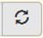 will appear. Click the refresh button to update the amount on this line, then be sure to save this schedule.  Detail by fiscal agent and grant is available in eGMS, on the “CMR Non-Fiscal Agent” report. | N/A
FC103 | Other (list below): | Calculated by EFS | Federal grants received from CSDE outside of eGMS. Sum of expenditures from detail lines below. | N/A
 |  | Screen entry | Enter name/description of grant; add lines as needed.
Direct Federal Grants
FC201 | List below: | Calculated by EFS | Federal grants received directly from the federal government. Sum of expenditures from detail lines below. | N/A
 |  | Screen entry | Enter name/description of grant; add lines as needed.
Federal Grants Passed Through Non-CSDE Agencies
FC301 | List below: | Calculated by EFS | Federal grants received from agencies other than CSDE. Sum of expenditures from detail lines below. | N/A
 |  | Screen entry | Enter name/description of grant; add lines as needed.
Total Federal Expenditures Reconciliation
FC901 | Total Federal Expenditures (sum of lines above) | Calculated by EFS | N/A | N/A

FC902 | Federal Funds per EFS Expenditure Table | Expenditure Database | 2 | All except 311X, 4XXX, 5XXX, and 9XXX | All except N1, S3 and S4 | 1, 2, or 3 | All | School or District code | N/A
FC903 | Federal Inkind per EFS Expenditure Table | Expenditure Database | 13 | All except 311X, 4XXX, 5XXX, and 9XXX | All except N1, S3 and S4 | 1, 2, or 3 | All | School or District code | N/A

FC904 | Total (FC902 plus FC903) | Calculated by EFS | N/A | N/A
FC905 | Variance (FC901 minus FC904) | Calculated by EFS | Difference between federal funding reported on this schedule and expenditures reported in the EFS database; should equal zero. | N/A

3.8.4 Federal funding schedule line instructions – RESCs
Line | Description | Data Entry Method | EFS Funding  Source ID | EFS Function Code | EFS Object Code | EFS Education  Type Code | EFS PreK Code | CSDE Location Code | 2016-17 ED001R Reference (Line, Col)
Direct Federal Grants - Total Expenditures
FR101 | List below: | Calculated by EFS | Federal grants received directly from the federal government. Sum of expenditures from detail lines below. | Sum of 802,1 - 804,1
 |  | Screen entry | Enter name/description of grant; add lines as needed.
Federal Grants Passed Through Non-CSDE Agencies - Total Expenditures
FR201 | List below: | Calculated by EFS | Federal grants passed through non-CSDE agencies. Sum of expenditures from detail lines below. | N/A
 |  | Screen entry | Enter name/description of grant; add lines as needed.
Federal Grants Passed Through CSDE - Total Expenditures
FR301 | Total From EGMS | Import | Direct import from eGMS Total expenditure lines  *When this amount has been changed in eGMS, a refresh button will appear. Click the refresh button to update the amount on this line, then be sure to save this schedule.  Detail by grant is available in eGMS, on the “ED141 EFS Expenditure Summary” report. | Sum of 821,1 and 823,1
FR302 | Your portion of services/expenditures from consortium grant payment arrangement | Import | Direct import from eGMS - sum of consortium member expenditures  *When this amount has been changed in eGMS, a refresh button will appear. Click the refresh button to update the amount on this line, then be sure to save this schedule.  Detail by fiscal agent and grant is available in eGMS, on the “CMR Non-Fiscal Agent” report. | 822,1
FR303 | Other (list below): | Calculated by EFS | Federal grants received from CSDE outside of eGMS. Sum of expenditures from detail lines below. | 824,1
 |  | Screen entry | Enter name/description of grant; add lines as needed.
Reconciliation - Total Federal Expenditures
FR401 | Total Federal Expenditures (sum of lines FR101 through FR303) | Calculated by EFS | N/A | Sum of 802,1 - 804,1, 821,1 - 824,1

FR402 | Federal Funds Per EFS Expenditure table | Expenditure Database | 2 | All | All | All | All | School or District code | N/A
FR403 | Federal Inkind Per EFS Expenditure table | Expenditure Database | 13 | All | All | All | All | School or District code | N/A

FR404 | Total (FR402 plus FR403) | Calculated by EFS | N/A | N/A
FR405 | Variance (FR401 minus FR404) | Calculated by EFS | Difference between federal funding reported on this schedule and expenditures reported in the EFS database; should equal zero. | N/A

 |  |  | EFS Codes / Description
Line | Description | Data Entry Method | EFS Funding  Source ID | EFS Function Code | EFS Object Code | EFS Education  Type Code | EFS PreK Code | CSDE Location Code | 2016-17 ED001R Reference (Line, Col)
DIRECT FEDERAL GRANTS - RESC SCHOOL DISTRICT
FR501 | List below: | Calculated by EFS | Federal grants received directly from the federal government. Sum of expenditures from detail lines below. |  |  |  |  |  | Sum of 802,2 - 804,2
 |  | Screen entry | Enter name/description of grant; add lines as needed.
FEDERAL GRANTS PASSED THROUGH NON-CSDE AGENCIES - RESC SCHOOL DISTRICT
FR601 | List below: | Calculated by EFS | Federal grants received directly from the federal government. Sum of expenditures from detail lines below. |  |  |  |  |  | N/A
 |  | Screen entry | Enter name/description of grant; add lines as needed.
FEDERAL GRANTS PASSED THROUGH CSDE - RESC SCHOOL DISTRICT
FR701 | Total From EGMS | Import | Direct import from eGMS X001 lines  *When this amount has been changed in eGMS, a refresh button 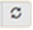 will appear. Click the refresh button to update the amount on this line, then be sure to save this schedule.  Detail by grant is available in eGMS, on the “ED141 EFS Expenditure Summary” report. |  |  |  |  |  | 821,2
FR702 | Your portion of services/expenditures from consortium grant payment arrangement | Screen entry | Enter portion of consortium expenditures from Line FR302 expended at RESC district schools. |  |  |  |  |  | 822,2
FR703 | Other (list below): | Calculated by EFS | Federal grants received from CSDE outside of eGMS for RESC district schools. Sum of expenditures from detail lines below. |  |  |  |  |  | 824,2
 |  | Screen entry | Enter name/description of grant; add lines as needed.
RECONCILIATION - RESC SCHOOL DISTRICT FEDERAL EXPENDITURES
FR901 | RESC School District Federal Expenditures (sum of lines FR501 through FR703) | Calculated by EFS | N/A |  |  |  |  |  | Sum of 802,2 - 804,2, 821,2, 822,2, and 824,2
FR902 | Federal Funds Per EFS Expenditure table | Expenditure Database | 2 | All except 311X, 4XXX, 5XXX, and 9XXX | All except N1, S3, and S4 | 1, 2, or 3 | All | School or District code | N/A
FR903 | Federal Inkind Per EFS Expenditure table | Expenditure Database | 13 | All except 311X, 4XXX, 5XXX, and 9XXX | All except N1, S3, and S4 | 1, 2, or 3 | All | School or District code | N/A
FR904 | Total (FR902 plus FR903) | Calculated by EFS | N/A |  |  |  |  |  | N/A
FR905 | Variance (FR901 minus FR904) | Calculated by EFS | Difference between federal funding reported on this schedule and expenditures reported in the EFS database; should equal zero. |  |  |  |  |  | N/A

3.9 State funding schedule

3.9.1 State funding schedule description
The State Funding Schedule reports details of expenditures from state funds, and reconciles to the total expenditures from state funds used for free public elementary and secondary education as reported in the EFS expenditure database.

Amounts on the State Funding Schedule may be manual screen entries, expenditures imported from the eGrants Management System (eGMS), or from the EFS expenditure table. The EFS Codes are defined in Section 4.

The expenditures from consortium grants imported from eGMS onto line SF102/ SC102/ SR302 represent all expenditures made on your district’s behalf as reported by the fiscal agent for the grant(s). Amounts shown may differ from actual payments received by your district. Description of the grants and fiscal agent are shown on the “Consortium Member Report Non-Fiscal Agent” report available in eGMS. The full consortium expenditure must be included in your district’s EFS expenditure table; contact the fiscal agent if you need more information or to correct discrepancies.

Ensure that only expenditures are included; do not report any unexpended portion of grants. Any reimbursements due should be reported on the modified accrual basis to the extent that they cover expenditures. Keep in mind that for state grants, the liquidation period is thirty (30) days. Supporting documentation of the reported expenditures must be maintained on file.

3.9.2 State funding schedule line instructions – Local and Regional School Districts
Line | Description | Data Entry Method | EFS Funding  Source ID | EFS Function Code | EFS Object Code | EFS Education  Type Code | EFS PreK Code | CSDE Location Code | 2016-17 ED001 Reference (Line, Col)
STATE GRANTS FROM CSDE
SF101 | Total From EGMS | Import | Direct import from eGMS X001 lines  *When this amount has been changed in eGMS, a refresh button will appear. Click the refresh button to update the amount on this line, then be sure to save this schedule.  Detail by grant is available in eGMS, on the “ED141 EFS Expenditure Summary” report. |  |  |  |  |  | 815, 1
SF102 | Your portion of services/expenditures from consortium grant payment arrangement | Import | Direct import from eGMS - sum of consortium member expenditures  *When this amount has been changed in eGMS, a refresh button will appear. Click the refresh button to update the amount on this line, then be sure to save this schedule.  Detail by fiscal agent and grant is available in eGMS, on the “CMR Non-Fiscal Agent” report. |  |  |  |  |  | 816, 1
SF103 | Other (list below): | Calculated by EFS | State grants received from CSDE outside of eGMS. Sum of expenditures from detail lines below. |  |  |  |  |  | N/A
 |  | Screen entry | Enter name/description of grant; add lines as needed.
Direct State Grants From Other State Agencies
SF201 | List below: | Calculated by EFS | State grants received from state agencies other than CSDE. Sum of expenditures from detail lines below. | Sum of 802, 1 and 806, 1
 |  | Screen entry | Enter name/description of grant; add lines as needed.
State Grants Passed Through Non-State Agencies
SF301 | List below: | Calculated by EFS | State grants received from non-state agencies. Sum of expenditures from detail lines below. | 817, 1
 |  | Screen entry | Enter name/description of grant; add lines as needed.
Total State Expenditures Reconciliation
SF901 | Total State Funding (sum of lines above) | Calculated by EFS |  |  |  |  |  |  | Sum of 802, 1; 806, 1; 815, 1; 816, 1; 817, 1
SF902 | State Funds per EFS Expenditure Table | Expenditure Database | 3 | All except 311X, 4XXX, 5XXX, and 9XXX | All except D1, N1, S3, and S4 | 1, 2, or 3 | All | School or District code | N/A
SF903 | State Inkind per EFS Expenditure Table | Expenditure Database | 14 | All except 311X, 4XXX, 5XXX, and 9XXX | All except D1, N1, S3, and S4 | 1, 2, or 3 | All | School or District code | N/A
SF904 | Total (SF902 plus SF903) | Calculated by EFS |  |  |  |  |  |  | N/A

SF905 | Variance (SF901 minus SF904) | Calculated by EFS | Difference between state funding reported on this schedule and expenditures reported in the EFS database; should equal zero. | N/A

3.9.3 State funding schedule line instructions – Charter Schools
Line | Description | Data Entry Method | EFS Funding  Source ID | EFS Function Code | EFS Object Code | EFS Education  Type Code | EFS PreK Code | CSDE Location Code | 2016-17 ED001C Reference (Line, Col)
State Grants From CSDE
SC101 | Total From EGMS | Import | Direct import from eGMS X001 lines  *When this amount has been changed in eGMS, a refresh button will appear. Click the refresh button to update the amount on this line, then be sure to save this schedule.  Detail by grant is available in eGMS, on the “ED141 EFS Expenditure Summary” report. |  |  |  |  |  | N/A
SC102 | Your portion of services/expenditures from consortium grant payment arrangement | Import | Direct import from eGMS - sum of consortium member expenditures  *When this amount has been changed in eGMS, a refresh button will appear. Click the refresh button to update the amount on this line, then be sure to save this schedule.  Detail by fiscal agent and grant is available in eGMS, on the “CMR Non-Fiscal Agent” report. |  |  |  |  |  | N/A
SC103 | State charter school operating grant (from EFS Expenditure Table) | Expenditure Database | 18 | All except 311X, 4XXX, 5XXX, and 9XXX | All except N1, S3, and S4 | 1, 2, or 3 | All | School or District code | N/A

SC104 | Other (list below): | Calculated by EFS | State grants received from CSDE outside of eGMS. Sum of expenditures from detail lines below. | N/A
 |  | Screen entry | Enter name/description of grant; add lines as needed.
Direct State Grants From Other State Agencies
SC201 | List below: | Calculated by EFS | State grants received from state agencies other than CSDE. Sum of expenditures from detail lines below. | N/A
 |  | Screen entry | Enter name/description of grant; add lines as needed.
State Grants Passed Through Non-State Agencies
SC301 | List below: | Calculated by EFS | State grants received from non-state agencies. Sum of expenditures from detail lines below. | N/A
 |  | Screen entry | Enter name/description of grant; add lines as needed.
Total State Expenditures Reconciliation
SC901 | Total State Expenditures (sum of lines above) | Calculated by EFS |  |  |  |  |  |  | N/A
SC902 | State Funds per EFS Expenditure Table | Expenditure Database | 3, 18 | All except 311X, 4XXX, 5XXX, and 9XXX | All except N1, S3, and S4 | 1, 2, or 3 | All | School or District code | N/A
SC903 | State Inkind per EFS Expenditure Table | Expenditure Database | 14 | All except 311X, 4XXX, 5XXX, and 9XXX | All except N1, S3, and S4 | 1, 2, or 3 | All | School or District code | N/A

SC904 | Total (SC902 plus SC903) | Calculated by EFS | N/A | N/A
SC905 | Variance (SC901 minus SC904) | Calculated by EFS | Difference between state funding reported on this schedule and expenditures reported in the EFS database; should equal zero. | N/A

3.9.4 State funding schedule line instructions – RESCs
Line | Description | Data Entry Method | EFS Funding  Source ID | EFS Function Code | EFS Object Code | EFS Education  Type Code | EFS PreK Code | CSDE Location Code | 2016-17 ED001R Reference (Line, Col)
Direct State Grants From Other State Agencies - Total Expenditures
SR101 | List below: | Calculated by EFS | State grants received from state agencies other than CSDE. Sum of expenditures from detail lines below. | Sum of 801,1, 805,1
 |  | Screen entry | Enter name/description of grant; add lines as needed.
State Grants Passed Through Non-Csde Agencies - Total Expenditures
SR201 | List below: | Calculated by EFS | State grants received from non-state agencies. Sum of expenditures from detail lines below. | N/A
 |  | Screen entry | Enter name/description of grant; add lines as needed.
State Grants Passed Through CSDE - Total Expenditures
SR301 | Total From EGMS | Import | Direct import from eGMS Total expenditure lines  *When this amount has been changed in eGMS, a refresh button will appear. Click the refresh button to update the amount on this line, then be sure to save this schedule.  Detail by grant is available in eGMS, on the “ED141 EFS Expenditure Summary” report. | Sum of 816,1, 818,1
SR302 | Your portion of services/expenditures from consortium grant payment arrangement | Import | Direct import from eGMS - sum of consortium member expenditures  *When this amount has been changed in eGMS, a refresh button will appear. Click the refresh button to update the amount on this line, then be sure to save this schedule.  Detail by fiscal agent and grant is available in eGMS, on the “CMR Non-Fiscal Agent” report. | 817,1
SR303 | Other (list below): | Calculated by EFS | State grants received from CSDE outside of eGMS. Sum of expenditures from detail lines below. | 819,1
 |  | Screen entry | Enter name/description of grant; add lines as needed.
Reconciliation - Total State Expenditures
SR401 | Total State Expenditures (sum of lines SR101 through SR303) | Calculated by EFS | N/A | Sum of 801,1, 805,1, 816,1 - 819,1

SR402 | State Funds Per EFS Expenditure table | Expenditure Database | 3 | All | All | All | All | School or District code | N/A
SR403 | State Inkind Per EFS Expenditure table | Expenditure Database | 14 | All | All | All | All | School or District code | N/A

SR404 | Total (SR402 plus SR403) | Calculated by EFS | N/A | N/A
SR405 | Variance (SR401 minus SR404) | Calculated by EFS | Difference between state funding reported on this schedule and expenditures reported in the EFS database; should equal zero. | N/A

Line | Description | Data Entry Method | EFS Funding  Source ID | EFS Function Code | EFS Object Code | EFS Education  Type Code | EFS PreK Code | CSDE Location Code | 2016-17 ED001R Reference (Line, Col)
Direct State Grants From Other State Agencies - Resc School District
SR501 | List below: | Calculated by EFS | State grants received from state agencies other than CSDE. Sum of expenditures from detail lines below. | N/A
 |  | Screen entry | Enter name/description of grant; add lines as needed.
State Grants Passed Through Non-State Agencies - Resc School District
SR601 | List below: | Calculated by EFS | State grants received from non-state agencies. Sum of expenditures from detail lines below. | N/A
 |  | Screen entry | Enter name/description of grant; add lines as needed.
State Grants Passed Through CSDE - Resc School District
SR701 | Total From EGMS | Import | Direct import from eGMS X001 lines  *When this amount has been changed in eGMS, a refresh button will appear. Click the refresh button to update the amount on this line, then be sure to save this schedule.  Detail by grant is available in eGMS, on the “ED141 EFS Expenditure Summary” report. | N/A
SR702 | Your portion of services/expenditures from consortium grant payment arrangement | Screen entry | Enter portion of consortium expenditures from Line SR302 expended at RESC district schools. | N/A
SR703 | Other (list below): | Calculated by EFS | State grants received from CSDE outside of eGMS for RESC district schools. Sum of expenditures from detail lines below. | N/A
 |  | Screen entry | Enter name/description of grant; add lines as needed.
Reconciliation - Resc School District State Expenditures
SR901 | RESC School District State Expenditures (sum of lines SR501 through SR703) | Calculated by EFS | N/A | N/A

SR902 | State Funds Per EFS Expenditure table | Expenditure Database | 3 | All except 311X, 4XXX, 5XXX, and 9XXX | All except N1, S3, and S4 | 1, 2, or 3 | All | School or District code | N/A
SR903 | State Inkind Per EFS Expenditure table | Expenditure Database | 14 | All except 311X, 4XXX, 5XXX, and 9XXX | All except N1, S3, and S4 | 1, 2, or 3 | All | School or District code | N/A

SR904 | Total (SR902 plus SR903) | Calculated by EFS | N/A | N/A
SR905 | Variance (SR901 minus SR904) | Calculated by EFS | Difference between state funding reported on this schedule and expenditures reported in the EFS database; should equal zero. | N/A

3.10 Private/Miscellaneous funding schedule

3.10.1 Private/Miscellaneous funding schedule description
The Private/Miscellaneous Funding Schedule reports details of expenditures from funds other than federal, state, or local, and reconciles to the total expenditures from private/miscellaneous funds used for free public elementary and secondary education as reported in the EFS expenditure database. Amounts on the Private/Miscellaneous Funding Schedule may be manual screen entries, expenditures imported from the eGrants Management System (eGMS), or from the EFS expenditure table. The EFS Codes are defined in Section 4.

3.10.2 Private/Miscellaneous funding schedule line instructions – Local and Regional School Districts
Line | Description | Data Entry Method | EFS Funding  Source ID | EFS Function Code | EFS Object Code | EFS Education  Type Code | EFS PreK Code | CSDE Location Code | 2016-17 ED001 Reference (Line, Col)
Expenditures Of Private/Miscellaneous Funds
PF101 | Medicaid Revenue Expended on Special Education Services | Expenditure Database | 5 or 16 | All except 311X, 4XXX, 5XXX, and 9XXX | All except D1, N1, S3, and S4 | 2 | All | School or District code | 807, 1
PF102 | Medicaid Revenue Expended on Regular Education Services | Expenditure Database | 5 or 16 | All except 311X, 4XXX, 5XXX, and 9XXX | All except D1, N1, S3, and S4 | 1 | All | School or District code | 808, 1

PF103 | Third Party Billing/Other Insurance | Screen entry | Expenditures supported by third party billing or other insurance revenues. | 809, 1
PF104 | Contributions | Screen entry | Expenditures from contributions or donations from private sources. DO NOT include contributions received from student activities. | 810, 1
PF105 | Rentals | Screen entry | Expenditures from revenues derived from the rental of school property. | 811, 1
PF106 | Endowment Funds | Screen entry | Expenditures made from endowment funds. DO NOT include student activity funds. DO NOT include expenditures for land, buildings and major remodeling. | 812, 1
PF107 | Miscellaneous Funds from EGMS | Import | Direct import from eGMS X001 lines.  *When this amount has been changed in eGMS, a refresh button will appear. Click the refresh button to update the amount on this line, then be sure to save this schedule.  Detail by grant is available in eGMS, on the “ED141 EFS Expenditure Summary” report. | 814, 1
PF108 | Other (list below): | Calculated by EFS | Expenditures from Private/Miscellaneous funds not listed above. Sum of expenditures from detail lines below. | 813, 1
 |  | Screen entry | Enter name/description of funding; add lines as needed.
Private/Miscellaneous Expenditures Reconciliation
PF901 | Total Private/Miscellaneous Expenditures (sum of lines above) | Calculated by EFS | N/A | Sum of 807, 1; 808, 1; 809, 1; 810, 1; 811, 1; 812, 1; 813, 1; and 814, 1

PF902 | Private Funds per EFS Expenditure Table | Expenditure Database | 4 or 5 | All except 311X, 4XXX, 5XXX, and 9XXX | All except D1, N1, S3, and S4 | 1, 2, or 3 | All | School or District code | N/A
Line | Description | Data Entry Method | EFS Funding  Source ID | EFS Function Code | EFS Object Code | EFS Education  Type Code | EFS PreK Code | CSDE Location Code | 2016-17 ED001 Reference (Line, Col)
PF903 | Private Inkind per EFS Expenditure Table | Expenditure Database | 15 or 16 | All except 311X, 4XXX, 5XXX, and 9XXX | All except D1, N1, S3, and S4 | 1, 2, or 3 | All | School or District code | N/A

Line | Description | Data Entry Method | EFS Funding  Source ID | EFS Function Code
PF904 | Total (PF902 plus PF903) | Calculated by EFS | N/A | N/A
PF905 | Variance (PF901 minus PF904) | Calculated by EFS | Difference between private/miscellaneous funding reported on this schedule and expenditures reported in the EFS database; should equal zero. | N/A

3.10.3 Private/Miscellaneous funding schedule line instructions – Charter Schools

Line | Description | Data Entry Method | EFS Funding  Source ID | EFS Function Code | EFS Object Code | EFS Education  Type Code | EFS PreK Code | CSDE Location Code | 2016-17 ED001 Reference (Line, Col)
Expenditures Of Private/Miscellaneous Funds
PC101 | Contributions | Screen entry | Expenditures from monetary contributions or donations from a philanthropic foundation, private individuals or private organizations for which no repayment or special service to the contributor is expected. (NCES Revenue Source Code 1920). | 125, 1
PC102 | Interest Income | Screen entry | Expenditures from interest income. | 129, 1
PC103 | Loans | Screen entry | Expenditures from loans. | 130, 1
PC104 | Retained Earnings | Screen entry | Expenditures from retained earnings. Do not report any negative amounts here in order to balance with financial statements. | 131, 1
PC105 | Rentals | Screen entry | Expenditures from revenues derived from the rental of real or personal property owned by the charter school. | N/A
PC106 | Endowment Funds | Screen entry | Expenditures made from endowment funds. DO NOT include student activity funds. DO NOT include expenditures for land, buildings and major remodeling. | N/A
PC107 | Miscellaneous Funds from EGMS | Import | Direct import from eGMS X001 lines.  *When this amount has been changed in eGMS, a refresh button will appear. Click the refresh button to update the amount on this line, then be sure to save this schedule.  Detail by grant is available in eGMS, on the “ED141 EFS Expenditure Summary” report. | N/A
PC108 | Other (list below): | Calculated by EFS | Expenditures from Private/Miscellaneous funds not listed above. Sum of expenditures from detail lines below. | 128, 1
 |  | Screen entry | Enter name/description of funding; add lines as needed.
Private/Miscellaneous Expenditures Reconciliation
PC901 | Total Private/Miscellaneous Expenditures (sum of lines above) | Calculated by EFS |  |  |  |  |  |  | N/A
PC902 | Private Funds per EFS Expenditure Table | Expenditure Database | 4 or 5 | All except 311X, 4XXX, 5XXX, and 9XXX | All except N1, S3 and S4 | 1, 2, or 3 | All | School or District code | N/A
PC903 | Private Inkind per EFS Expenditure Table | Expenditure Database | 15 or 16 | All except 311X, 4XXX, 5XXX, and 9XXX | All except N1, S3 and S4 | 1, 2, or 3 | All | School or District code | N/A

PC904 | Total (PC902 plus PC903) | Calculated by EFS | N/A | N/A
PC905 | Variance (PC901 minus PC904) | Calculated by EFS | Difference between private/miscellaneous funding reported on this schedule and expenditures reported in the EFS database; should equal zero. | N/A

3.10.4 Private/Miscellaneous funding schedule line instructions – RESCs
Line | Description | Data Entry Method | EFS Funding  Source ID | EFS Function Code | EFS Object Code | EFS Education  Type Code | EFS PreK Code | CSDE Location Code | 2016-17 ED001R Reference (Line, Col)
Private/Miscellaneous Funds - Total Expenditures
PR101 | Membership dues, fees | Screen entry | Report expenditures supported by the membership dues and fees assessed by the RESC. | 806,1
PR102 | Earnings on investments | Screen entry | Report expenditures supported by earnings on RESC investments. | 807,1
PR103 | Contributions | Screen entry | Report expenditures from contributions or donations from private sources. DO NOT include contributions received from student activities. | 808,1
PR104 | Rentals | Screen entry | Report expenditures from revenues derived from the rental of school property. | 809,1
PR105 | Endowment Funds | Screen entry | Report expenditures made from endowment funds. DO NOT include student activity funds. DO NOT include expenditures for land, buildings and major remodeling. | 810,1
PR106 | Miscellaneous Funds from EGMS | Import | Direct import from eGMS Total expenditure lines.  *When this amount has been changed in eGMS, a refresh button will appear. Click the refresh button to update the amount on this line, then be sure to save this schedule.  Detail by grant is available in eGMS, on the “ED141 EFS Expenditure Summary” report. | 814,1
PR107 | Food Service | Screen entry | Report here any expenditures from food service program receipts. | 811,1
PR108 | Tuition and Transportation Revenue for Regular and Special Education | Screen entry | The Tuition and Transportation Revenue Schedule collects total revenues from a variety of sources for tuition and transportation. Report here only the expended amount from these revenues. | 812,1
PR109 | Other funding from state or federal sources or Connecticut school districts (list below): | Calculated by EFS | Include here, and provide full details of, expenditures from receipts from LEAs for services for which there are no specific lines on this schedule.  If RESC budgeted funds were freed up based on receipt of unanticipated Universal Service Fund credits or refunds, then the expenditures made as a result of that unanticipated support would be reported here.
 |  | Screen entry | Enter name/description of funding; add lines as needed.
PR110 | Other funding not from state or federal sources or Connecticut school districts (list below): | Calculated by EFS | Include here, and provide full details of, expenditures from receipts from LEAs for services for which there are no specific lines on this schedule.  If RESC budgeted funds were freed up based on receipt of unanticipated Universal Service Fund credits or refunds, then the expenditures made as a result of that unanticipated support would be reported here.
 |  | Screen entry | Enter name/description of funding; add lines as needed.
Reconciliation - Total Private/Miscellaneous Expenditures
PR501 | Total Private/Miscellaneous Expenditures (sum of lines PR101 through PR110) | Calculated by EFS | N/A | Sum of 806,1 - 815,1

PR502 | Private/Miscellaneous Funds Per EFS Expenditure table | Expenditure Database | 1, 4-10 | All | All | All | All | School or District code | N/A
Line | Description | Data Entry Method | EFS Funding  Source ID | EFS Function Code | EFS Object Code | EFS Education  Type Code | EFS PreK Code | CSDE Location Code | 2016-17 ED001R Reference (Line, Col)
PR503 | Private/Miscellaneous Inkind Per EFS Expenditure table | Expenditure Database | 12, 15-17 | All | All | All | All | School or District code | N/A

PR504 | Total (PR502 plus PR503) | Calculated by EFS | N/A | N/A
PR505 | Variance (PR501 minus PR504) | Calculated by EFS | Difference between private/miscellaneous funding reported on this schedule and expenditures reported in the EFS database; should equal zero. | N/A
Private/Miscellaneous Funds - Resc School District
PR601 | Membership dues, fees | Screen entry | Report expenditures for RESC schools supported by the membership dues and fees assessed by the RESC. | N/A
PR602 | Earnings on investments | Screen entry | Report expenditures supported by earnings on RESC investments. | N/A
PR603 | Contributions | Screen entry | Report expenditures for RESC schools from contributions or donations from private sources. DO NOT include contributions received from student activities. | N/A
PR604 | Rentals | Screen entry | Report expenditures for RESC schools from revenues derived from the rental of school property. | N/A
PR605 | Endowment Funds | Screen entry | Report expenditures for RESC schools made from endowment funds. DO NOT include student activity funds. DO NOT include expenditures for land, buildings and major remodeling. | N/A
PR606 | Miscellaneous Funds from EGMS | Import | Direct import from eGMS X001 lines.  *When this amount has been changed in eGMS, a refresh button will appear. Click the refresh button to update the amount on this line, then be sure to save this schedule.  Detail by grant is available in eGMS, on the “ED141 EFS Expenditure Summary” report. | N/A
PR607 | Food Service | Screen entry | Report here any expenditures for RESC schools from food service program receipts. | N/A
PR608 | Tuition and Transportation Revenue for Regular and Special Education | Screen entry | The Tuition and Transportation Revenue Schedule collects total revenues from a variety of sources for tuition and transportation. Report here only the expended amount from these revenues for RESC schools. | N/A
PR609 | Other funding from state or federal sources or Connecticut school districts (list below): | Calculated by EFS | Include here, and provide full details of, expenditures for RESC schools from receipts from LEAs for services for which there are no specific lines on this schedule. If RESC budgeted funds were freed up based on receipt of unanticipated Universal Service Fund credits or refunds, then the expenditures made as a result of that unanticipated support would be reported here. | N/A
 |  | Screen entry | Enter name/description of funding; add lines as needed.
PR610 | Other funding not from state or federal sources or Connecticut school districts (list below): | Calculated by EFS | Include here, and provide full details of, expenditures for RESC schools from receipts from LEAs for services for which there are no specific lines on this schedule. If RESC budgeted funds were freed up based on receipt of unanticipated Universal Service Fund credits or refunds, then the expenditures made as a result of that unanticipated support would be reported here. | N/A
 |  | Screen entry | Enter name/description of funding; add lines as needed.

Line | Description | Data Entry Method | EFS Funding  Source ID | EFS Function Code | EFS Object Code | EFS Education  Type Code | EFS PreK Code | CSDE Location Code | 2016-17 ED001R Reference (Line, Col)
PR901 | RESC School District Private/Miscellaneous Expenditures (sum of lines PR601 through PR610) | Calculated by EFS |  |  |  |  |  |  | N/A
PR902 | Private/Miscellaneous Funds Per EFS Expenditure table | Expenditure Database | 1, 4-10 | All except 311X, 4XXX, 5XXX, and 9XXX | All except N1, S3, and S4 | 1, 2, or 3 | All | School or District code | N/A
PR903 | Private/Miscellaneous Inkind Per EFS Expenditure table | Expenditure Database | 12, 15-17 | All except 311X, 4XXX, 5XXX, and 9XXX | All except N1, S3, and S4 | 1, 2, or 3 | All | School or District code | N/A

PR904 | Total (PR902 plus PR903) | Calculated by EFS | N/A | N/A
PR905 | Variance (PR901 minus PR904) | Calculated by EFS | Difference between private/miscellaneous funding reported on this schedule and expenditures reported in the EFS database; should equal zero. | N/A

3.11 Local funding schedule

3.11.1 Local funding schedule description
The Local Funding Schedule reports details of expenditures from local funds, and reconciles to the total expenditures from local funds used for free public elementary and secondary education as reported in the EFS expenditure database.

Amounts on the Local Funding Schedule may be manual screen entries or expenditures from the EFS expenditure table. The EFS Codes are defined in Section 4.

3.11.2 Local funding schedule line instructions – Local and Regional School Districts
Line | Description | Data Entry Method | EFS Funding  Source ID | EFS Function Code | EFS Object Code | EFS Education  Type Code | EFS PreK Code | CSDE Location Code | 2016-17 ED001 Reference (Line, Col)
Total Expenditures From Appropriated Budget
LA199 | Total Expenditures from Appropriated Budget | Screen entry | The total amount expended, including encumbrances, from the appropriated board of education budget. Do not include expenditures from rental income account, endowment funds, contributions, federal grants (except impact aid), or state prepayment grants. | 901, 1
Deductions
LA201 | Adult & Continuing Education | Expenditure Database | 1 | All | All | 5 | All | School or District code | Sum of 902, 1; 905, 1; and 915,1
LA202 | Nonpublic School Services (e.g. Health, Transportation) | Expenditure Database | 1 | All | All | 4 | All | School or District code | Sum of 903, 1 and 904, 1
LA203 | Food Services | Expenditure Database | 1 | 311X, 3121 | All except S3,S4 | 1, 2, or 3 | All | School or District code | 906, 1
LA204 | Prior Year Food Services | Expenditure Database | 1 | 3122 | All except S3,S4 | 1, 2, or 3 | All | School or District code | 907, 1
LA205 | Community Services | Expenditure Database | 1 | All | All | 6 | All | School or District code | 908, 1
LA206 | Tuition Summer School | Expenditure Database | 1 | All | All | 7 | All | School or District code | 909, 1
LA207 | Debt Service (Including Interest) | Expenditure Database | 1 | 5XXX | All except S3,S4 | 1, 2, or 3 | All | School or District code | 910, 1
LA208 | Land, Buildings, and Major Remodeling | Expenditure Database | 1 | 4XXX | All except S3,S4 | 1, 2, or 3 | All | School or District code | Sum of 911, 1; 912, 1
LA209 | Salaries of Uncertified Staff in Certified Positions | Expenditure Database | 1 | All | S3 | 1, 2, or 3 | All | School or District code | 913, 1
LA210 | Fringe Benefits of Uncertified Staff in Certified Positions | Expenditure Database | 1 | All | S4 | 1, 2, or 3 | All | School or District code | 914, 1
LA211 | Noneducational Expenditures | Expenditure Database | 1 | All | All | 8 | All | School or District code | 916, 1
LA212 | Secondary Region’s Assessment to the Member Town | Expenditure Database | 1 | All | D1 | 1, 2, or 3 | All | School or District code | 917, 1
LA213 | Unliquidated Encumbrances from Prior Year (credits shown as positive values) | Expenditure Database; display -1 X (sum of records) | 11 | All except 311X, 4XXX, and 5XXX | All except S3, S4 and D1 | 1, 2, or 3 | All | School or District code | 927, 1

Line | Description | Data Entry Method | EFS Funding  Source ID | EFS Function Code | EFS Object Code | EFS Education  Type Code | EFS PreK Code | CSDE Location Code | 2016-17 ED001 Reference (Line, Col)
LA214 | Other Non-Reportable Expenditures and Adjustments | Expenditure Database | 1 | All | All | 9 | All | School or District code | 918, 1
LA299 | Total Deductions | Calculated by EFS |  |  |  |  |  |  | Sum of 919, 1 and 927, 1
Additions
LA301 | In-Kind Services (Local) | Expenditure Database | 12,17 | All except 311X, 3121, 3122, 4XXX, 5XXX, and 9XXX | All except D1, N1, S3, and S4 | All | All | School or District code | 929, 1
LA302 | Adjustment for Food Service | Expenditure Database | 1,12 | 3121, 3122 | All except D1, N1, S3, and S4 | 1,2, or 3 | All | School or District code | 931, 1
LA303 | Excess Cost Special Education Grant and/or State Agency Placement Grant | Expenditure Database | 6 | All except 311X, 3121, 3122, 4XXX, 5XXX, and 9XXX | All except D1, N1, S3, and S4 | 1, 2, or 3 | All | School or District code | 920, 1
LA304 | Additional Special Education Tuition | Expenditure Database | 7 | All except 311X, 3121, 3122, 4XXX, 5XXX, and 9XXX | All except D1, N1, S3, and S4 | 1, 2, or 3 | All | School or District code | 921, 1
LA305 | Magnet School Transportation Grant | Expenditure Database | 8 | All except 311X, 3121, 3122, 4XXX, 5XXX, and 9XXX | All except D1, N1, S3, and S4 | 1, 2, or 3 | All | School or District code | 922, 1
LA306 | Other Additions | Expenditure Database | 10 | All except 311X, 3121, 3122, 4XXX, 5XXX, and 9XXX | All except D1, N1, S3, and S4 | 1, 2, or 3 | All | School or District code | 924, 1
LA399 | Total Additions | Calculated by EFS |  |  |  |  |  |  | Sum of 925, 1; 929, 1; 931, 1
Total Local Expenditures Reconciliation
LA901 | Total Local Expenditures (LA199 minus LA299 plus LA399) | Calculated by EFS | N/A | Sum of -919, 1; -927,1; 925, 1; 929, 1; 931, 1

LA902 | Local Funds per EFS Expenditure Table | Expenditure Database | 1, 6, 7, 8, 9, 10, 11 | All except 311X, 4XXX, 5XXX, and 9XXX | All except D1, N1, S3, and S4 | 1, 2, or 3 | All | School or District code | N/A
LA903 | Local Inkind per EFS Expenditure Table | Expenditure Database | 12,17 | All except 311X, 4XXX, 5XXX, and 9XXX | All except D1, N1, S3, and S4 | 1, 2, or 3 | All | School or District code | N/A

LA904 | Total (LA902 plus LA903) | Calculated by EFS | N/A | N/A
LA905 | Variance (LA199 minus LA901) | Calculated by EFS | N/A | N/A

3.11.3 Local funding schedule line instructions – Charter Schools
Line | Description | Data Entry Method | EFS Funding  Source ID | EFS Function Code | EFS Object Code | EFS Education  Type Code | EFS PreK Code | CSDE Location Code | 2016-17C ED001 Reference (Line, Col)
Expenditures Of Local Funds
LC101 | Local Special Education Funding | Screen entry | 1, 6-11 | All except 311X, 4XXX, 5XXX, and 9XXX | All except N1, S3, and S4 | 2 or 3 | All | School or District code | N/A
LC102 | Regular Education In-Kind Services From Local School District | Expenditure Database | 12 or 17 | All except 311X, 4XXX, 5XXX, and 9XXX | All except N1, S3, and S4 | 1 | All | School or District code | 126, 1
LC103 | Special Education In-Kind Services From Local School District | Expenditure Database | 12 or 17 | All except 311X, 4XXX, 5XXX, and 9XXX | All except N1, S3, and S4 | 2 or 3 | All | School or District code | 127, 1

LC104 | Other (list below): | Calculated by EFS | Expenditures from local funds not listed above. Sum of expenditures from detail lines below. | N/A
 |  | Screen entry | Enter name/description of grant; add lines as needed.
Local Expenditures Reconciliation
LC901 | Total Local Expenditures (sum of lines above) | Calculated by EFS | N/A | N/A

LC902 | Local Funds per EFS Expenditure Table | Expenditure Database | 1, 6-11 | All except 311X, 4XXX, 5XXX, and 9XXX | All except N1, S3, and S4 | 1, 2, or 3 | All | School or District code | N/A
LC903 | Local Inkind per EFS Expenditure Table | Expenditure Database | 12 or 17 | All except 311X, 4XXX, 5XXX, and 9XXX | All except N1, S3, and S4 | 1, 2, or 3 | All | School or District code | N/A

LC904 | Total (LC902 plus LC903) | Calculated by EFS | N/A | N/A
LC905 | Variance (LC901 minus LC904) | Calculated by EFS | Difference between local funding reported on this schedule and expenditures reported in the EFS database; should equal zero. | N/A

3.12 Tuition and transportation revenue schedules

3.12.1 Tuition and transportation revenue schedules description
The Tuition and Transportation Revenue Schedules include all public elementary and secondary tuition and transportation paid by individuals, Connecticut school districts, other Connecticut government agencies, and out-of-state school districts and agencies. These schedules are completed by RESCs and local and regional school districts. For local and regional districts, there are two schedules, to separately report revenues received by the board of education and by the town.

Notes:
- Do not include nonpublic tuition or transportation revenues anywhere on this schedule.
- For the purposes of this schedule, gifted and talented programs are to be reported as regular or nonspecial education.
- Do not report on this schedule any revenues from state and federal grants or from regional district assessments paid by member towns.

All expenditures supported by these revenues must be reported in EFS using the appropriate EFS codes. Amounts on the Tuition and Transportation Revenue Schedules are manual screen entries. Note that each line below includes a reference to the revenue source codes listed in the U.S. Department of Education’s publication Financial Accounting for Local and State School Systems: 2014.

3.12.2 Tuition and transportation revenue schedules line instructions – Local and Regional School Districts and RESCs
Line references in the table below apply to each of the schedules, for local and regional districts, revenues received by the board of education and town, and to RESCs.

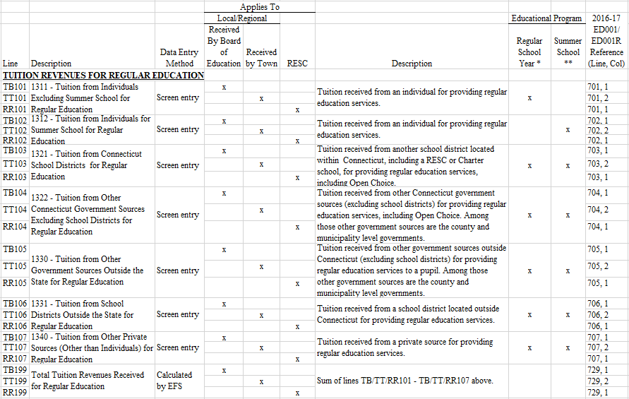

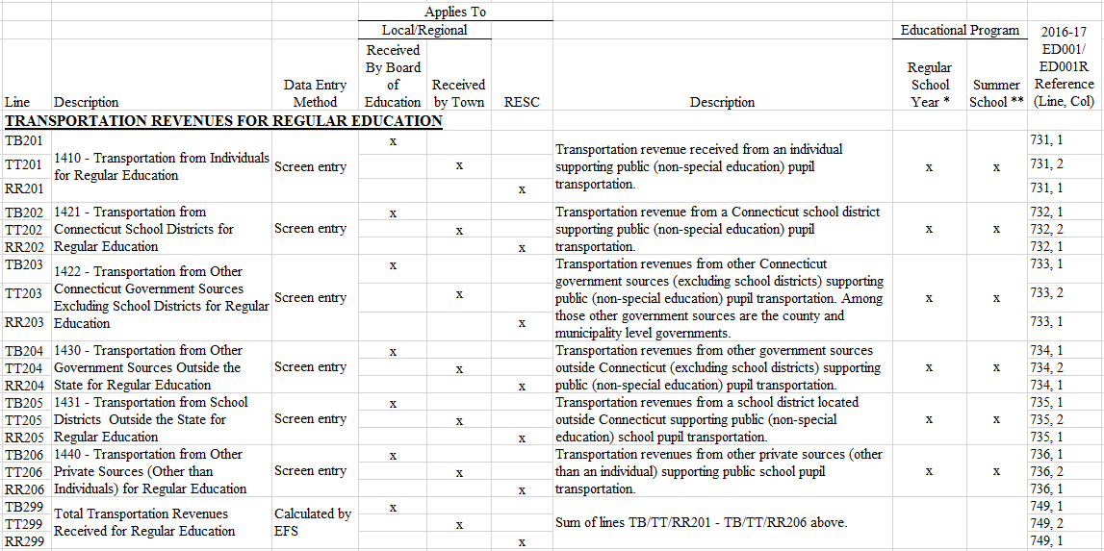

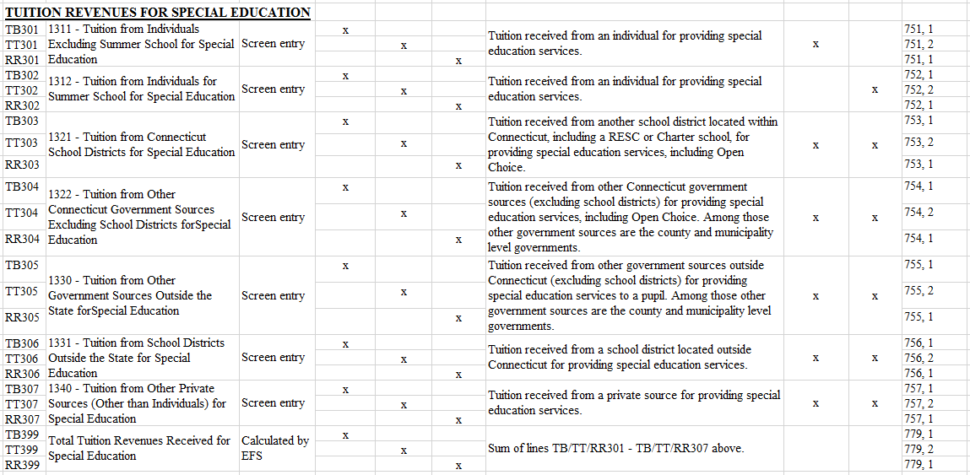
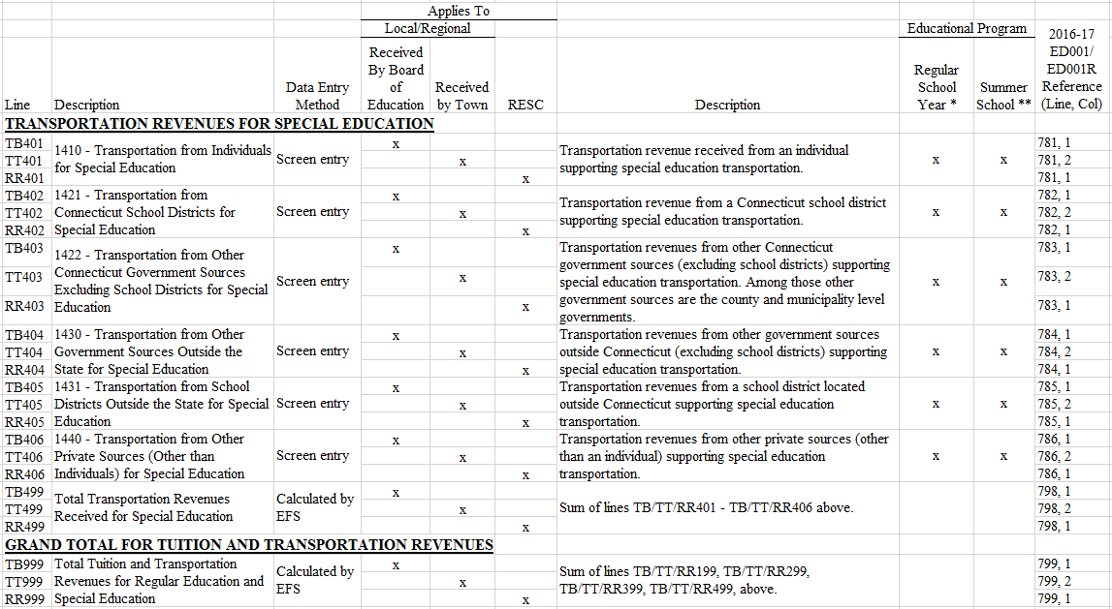

*Regular School Year: Revenue for the school year program traditionally beginning at the end of August or early September and ending in June. Do not include summer school revenue.

**Summer School: Revenue for nonresident pupils attending a summer school session where that summer school session is provided at no cost to a resident pupil attending the summer school session.

3.13 Regional High School Tuition Assessment & Detail of Pupils Sent Out of the District schedule

3.13.1 Regional High School Tuition Assessment & Detail of Pupils Sent Out of the District schedule description
The Regional High School Tuition Assessment & Detail of Pupils Sent Out of the District Schedule reports the details of the students sent out of the district. These are students that are the responsibility of the board of education, but for various reasons were sent out of the district to receive their education. These students were sent to another public school outside of the district or to a private school, in or out of town. Do not include transportation expenditures in this schedule.

3.13.2 Regional High School Tuition Assessment & Detail of Pupils Sent Out of the District schedule line instructions
Amounts on the Regional High School Tuition Assessment & Detail of Pupils Sent Out of the District Schedule may be manual screen entries or from the EFS expenditure table. The EFS Codes are defined in Section 4.

Line | Description | Data Entry Method | EFS Funding  Source ID | EFS Function Code | EFS Object Code | EFS Education  Type Code | EFS PreK Code | CSDE Location Code | 2016-17 ED001 Reference (Line, Col)
Member Towns' Regional High School Assessment (to be completed by secondary regional districts)
TA101 | Member Town's Regional High School Assessment Rate (Regular and Special Education Non-Vo-Ag Services) | Screen entry | Report an annual per pupil tuition rate for regular and special education students sent to a regional high school (and middle school if operated by the regional district). Do not include amounts for transporting students from home to school, or for school construction or debt service. | 1101, 1
TA102 | Member Town's Regional High School Assessment (Regular and Special Education Non-Vo-Ag Services) | Screen entry | Report the total tuition assessment for regular and special education students sent to a regional high school (and middle school if operated by the regional district). Do not include amounts for transporting students from home to school, or for school construction or debt service. | 1101, 2
Designated High School
TA201 | Designated High School Tuition Rate (Regular Education) | Screen entry | Report an annual per pupil tuition rate for regular education pupils sent to a designated high school. | 1102, 1

TA202 | Regular Education Tuition Expenditures for Pupils Sent to the district's Designated High School(s) | Expenditure Database | ALL | 1XXX | D2 | 1 | ALL | School or District code | 1102, 2
Private Or Residential Facilities (including out of state)
TA301 | Regular Education Tuition Expenditures for Pupils Sent to Private or Residential Facilities (including Out of State) | Expenditure Database | ALL | 1XXX | D3 | 1 | ALL | School or District code | 1103, 2

TA302 | Full Time Equivalent (FTE) Pupil count for the Expenditures reported on Line TA301 | Screen entry | Report a full time equivalent (FTE) pupil amount for regular education pupils sent to private or residential facilities. | 1103, 3

Line | Description | Data Entry Method | EFS Funding  Source ID | EFS Function Code | EFS Object Code | EFS Education  Type Code | EFS PreK Code | CSDE Location Code | 2016-17 ED001 Reference (Line, Col)
Approved Interdistrict Magnet Schools
TA401 | Regular Education Tuition Expenditures for Pupils Sent to an Approved Interdistrict Magnet School | Expenditure Database | ALL | 1XXX | D4 | 1 | ALL | School or District code | 1104, 2

TA402 | Full Time Equivalent (FTE) Pupil Count for the Expenditures reported on Line TA401 | Screen entry | Report a full time equivalent (FTE) pupil amount for regular education pupils sent to approved interdistrict magnet schools. | 1104, 3
Interdistrict Cooperative High Schools (established per C.G.S. 10-158a)
TA501 | InterDistrict Cooperative High School Tuition Rate (Regular Education) | Screen entry | Report an annual per pupil tuition rate for regular education pupils sent to an interdistrict cooperative high school. | 1105, 1

TA502 | Regular Education Tuition Expenditures for Pupils Sent to an Interdistrict Cooperative High School | Expenditure Database | ALL | 1XXX | D5 | 1 | ALL | School or District code | 1105, 2
All Other
TA601 | Regular Education Tuition Expenditures for Pupils Sent to Other Districts or Schools not included in the above groupings | Expenditure Database | ALL | 1XXX | D6 | 1 | ALL | School or District code | 1106, 2

TA602 | Full Time Equivalent (FTE) Pupil Count for the Expenditures reported on Line TA601 | Screen entry | Report a full time equivalent (FTE) pupil amount for pupils sent to other districts or schools not included in the above groupings. | 1106, 3
TA999 | Total Regular Education Tuition Expenditures(Sum of Lines TA202, TA301, TA401, TA502, and TA601) | Calculated by EFS | N/A | 1199, 2

3.14 Land, Buildings, Capital Construction and Debt Service schedule

3.14.1 Land, Buildings, Capital Construction and Debt Service schedule description
The Expenditures for Land, Buildings, Capital Construction and Debt Service Schedule reports all school facility acquisition and construction, and education debt service expenditures, made from board of education, town, or agency accounts. These expenditures may come from local, state, federal, or private source funds. This schedule includes four independent sections:
- Expenditures for Land, Buildings, and Capital Construction: Expenditures that support any activity involving school facility acquisition or construction, however they were financed.
- Funding source for Land, Buildings, and Capital Construction Expenditures: Specify the portions of the expenditures funded by long-term borrowing and by current funds. The total must equal the total expenditures reported.
- Expenditures for Debt Service and Selected Non-Debt Service Capital Construction: Education debt service and certain school construction expenditures. Expenditures in this section generally will not reconcile with the other sections of this schedule.
- School Construction Grant Payments Information: State grant payments related to school construction are shown by CSDE to assist the preparer in identifying projects and debt payments to be reported elsewhere on this schedule. Only a local official can determine if expenditures relating to these grant payments are eligible to be reported.
See Appendix C for further information and examples of expenditures to report on this schedule.

3.14.2 Land, Buildings, Capital Construction and Debt Service schedule line instructions- Local and Regional School Districts and RESCs
Expenditures For Land, Buildings, and Capital Construction:
Complete this section for any expenditures made for school facility acquisition and construction (NCES Function 4000) from board of education, town, or agency accounts from any funding source, for public elementary and secondary education. See Appendix C for further information and examples of expenditures to report in this section. Expenditures reported represent your best estimate of the gross costs of labor and materials for capital improvements, i.e. payments to contractors and vendors, not debt service payments. Detail expenditure reporting or record keeping is NOT required provided reasonable costs can be ascertained and reported.
Line | Description | Data Entry Method | Description
BT101  BR101 | School Construction with a State Project Number | Screen entry | Report expenditures for any school construction projects for which the state has issued a project number. Select projects as applicable from the dropdown menu. (The prefilled project data is pulled from the state school construction database), click "Add", this will add the project information to the list; enter the gross expenditure for the selected project.
BT102  BR102 | School Construction without a State Project Number | Screen entry | Report any school construction projects for which the state has not issued a project number, whether or not state funds are used. For the most part, the state provides school construction funding to a district through the School Construction Progress Payment system. Those projects are reported in BT101. Any other school construction projects are reported in this line. Enter the local reference number, project name, major type, and expenditure. Click “Add” to add lines to enter additional projects.
BT199  BR199 | Total | Calculated by EFS | (BT101 plus BT102) or (BR101 plus BR102)

Funding source for Land, Buildings, and Capital Construction Expenditures:
Line | Description | Data Entry Method | Description
BT201  BR201 | Bond funds, including short-term financing to be bonded. | Screen entry | Report the portion of expenditures reported in BT101-BT199 or BR101-BR199 funded through bonds or other long-term debt.
BT202  BR202 | Current funds, including amounts from state school construction grants. | Screen entry | Report the portion of expenditures reported in BT101-BT199 or BR101-BR199 not funded through bonds or other long-term debt. Include expenditures funded by federal or state grants including state school construction progress payments, municipal or school district budgets, or by municipal or school district capital reserve funds.
BT299  BR299 | Total | Calculated by EFS | (BT201 plus BT202) or (BR201 plus BR202)
Total School Construction Expenditures Reconciliation:
BT301  BR301 | Total expenditures | Calculated by EFS | Amount from BT199 or BR199
BT302  BR302 | Total funding | Calculated by EFS | Amount from BT299 or BR 299
BT399  BR399 | Variance | Calculated by EFS | (BT301 minus BT302) or (BR301 minus BR302); should be zero.
Expenditures for Debt Service - Report debt service expenditures supporting public elementary and secondary education and school construction.
BT401  BR401 | Redemption of Principal | Screen entry | Report principal payments by the board of education or the town to retire debt incurred for public elementary and secondary education including school construction, vehicles or equipment. Do not include equipment capital lease payments, see Section 4.4 instructions for reporting Property expenditures (Objects S12-S15 and B5).
BT402  BR402 | Interest on Bonds | Screen entry | Report interest on bonds or other long-term financing. Do not include equipment capital lease payments, see Section 4.4 instructions for reporting Property expenditures (Objects S12-S15 and B5).
BT403  BR403 | Interest on Current Loans | Screen entry | Report interest expenditures for any school construction short-term debt service (obligations not exceeding one year). Included here are Bond Anticipation Note (BANS) interest.
BT499  BR499 | Total | Calculated by EFS | Sum of (BT401 through BT403) or (BR401 through BR403)
School Construction Grant Payments Information – provided for information to assist in completing this schedule; some projects listed may not apply to expenditure reporting above.
BT501  BR501 | Current Year Progress Grant payments | Import | Import from state grant payments data.  Click on the line for detail payments report.

3.14.3 Land, Buildings, Capital Construction and Debt Service schedule line instructions- Charter Schools
Expenditures for Land, Buildings, and Capital Construction:
Complete this section for any expenditures made for school facility acquisition and construction (NCES Function 4000) from board of education, town, or agency accounts from any funding source, for public elementary and secondary education. See Appendix C for further information and examples of expenditures to report in this section. Expenditures reported represent your best estimate of the gross costs of labor and materials for capital improvements, i.e. payments to contractors and vendors, not debt service payments. Detail expenditure reporting or record keeping is NOT required provided reasonable costs can be ascertained and reported.
Line | Description | Data Entry Method | Description
BC101 | School Construction Projects | Screen entry | Enter the local reference number, project name, major type, and expenditure. Click “Add” to add lines to enter additional projects.
Funding source for Land, Buildings, and Capital Construction Expenditures
BC201 | Bond funds, including short-term financing to be bonded. | Screen entry | Report the portion of expenditures reported in BC101 funded through bonds or other debt service.
BC202 | Current funds, including amounts from state school construction grants. | Screen entry | Report the portion of expenditures reported in BC101 not funded through bonds or other long-term debt. Include expenditures funded by federal or state grants including state school construction progress payments, by local or private funding, or from capital reserve funds.
BC299 | Total | Calculated by EFS | (BC201 plus BC202)
Total School Construction Expenditures Reconciliation
BC301 | Total expenditures | Calculated by EFS | Amount from BC101
BC302 | Total funding | Calculated by EFS | Amount from BC299
BC399 | Variance | Calculated by EFS | (BC301 minus BC302); should be zero.
Expenditures for Debt Service - Report debt service expenditures supporting public elementary and secondary education and school construction.
BC401 | Redemption of Principal | Screen entry | Report principal payments by the board of education or the town to retire debt incurred for public elementary and secondary education including school construction, vehicles or equipment. Do not include equipment capital lease payments, see Section 4.4 instructions for reporting Property expenditures (Objects S12-S15 and B5).
BC402 | Interest | Screen entry | Report interest on bonds or other long-term financing. Do not include equipment capital lease payments, see Section 4.4 instructions for reporting Property expenditures (Objects S12-S15 and B5).
BC403 | Interest on Current Loans | Screen entry | Report interest expenditures for any school construction short-term debt service (obligations not exceeding one year). Included here are Bond Anticipation Note (BANS) interest.
BC499 | Total | Calculated by EFS | Sum of BC301 through BC303
School Construction Grant Payments Information:
The grant payments below have been provided by the CSDEas a guide to assist local school district and/or town officials in completing this schedule. Only a local official can determine if these payments were expended and meet the conditions to be reported in this schedule.
BC501 | Current Year Progress Grant payments | Import | Import from state grant payments data.  Click on the line for detail payments report.

3.15 Claim for Exceeding Statutory School Year schedule

3.15.1 Claim for Exceeding Statutory School Year schedule description
The Claim for Exceeding Statutory School Year schedule reports the details of any additional school days conducted by the district beyond the statutory school year of 180 days and 900 hours (450 hours for kindergarten). Note that hours of school work exclude lunch, recess and students’ time between classes. This information is used to adjust the district’s Average Daily Membership (ADM) and Resident Student counts in accordance with state statutes. Amounts on the Claim for Exceeding Statutory School Year schedule are manual screen entries.

3.15.2 Claim for Exceeding Statutory School Year schedule line instructions – Local and Regional School Districts
Line | Description | Data Entry Method | Description
CE101 | My district DID exceed the 180 days and 900 hours (450 for Kindergarten) statutory requirements for the current school year. Please select appropriate answer: | Screen entry | Select "Yes" or "No". If the response is "No", do not complete the remainder of this schedule.
CE102 | If Line CE101 is YES, enter the date on which your district satisfied both the 180 days and 900 hours (450 for kindergarten) statutory requirements for ALL public schools operated by the district for the school year. Then list the hours of school work for each school day ALL your public schools were in operation subsequent to this date in Lines CE103 to CE108 below as applicable. | Screen entry | Select calendar icon, then choose the applicable date on which all of your district’s public schools completed both  180 days and 900 hours of school work. If these two mandates were met on different dates, report the later date.
CE103 - CE108 | 1st - 6th Additional Days | Screen entry | Enter the number of hours and minutes of schoolwork for each day subsequent to the date entered on Line CE102. Data entry is in the format HH:MM, where MM is minutes to the nearest quarter-hour.

3.16 Universal Service Fund Data

3.16.1 Universal Service Fund Data schedule description
The purpose of the Universal Service Fund (USF) Schedule is to collect the amount of refunds, credits, or discounts received for the benefit of the school district via the Universal Service Administrative Company. A description of the USF and its operation is available at http://www.usac.org. The amount reported on the USF Schedule is not included in district expenditures reported in EFS. The CSDE will add the amount reported on this schedule to the expenditures reported in the EFS database for external reporting on total school district expenditures.

3.16.2 Universal Service Fund Data schedule line instructions – All Districts
Line | Description | Data Entry Method | Description | 2016-17 ED001/R/C Reference
US101/ UC101/ UR101 | Any Universal Service Fund (USF) source refunds, credits or service provider discounts received during the school year. | Screen entry | See detailed description below. | Data Item Sheet for USF, Line 4

Description of amount to report on Line US101/UC101/UR101
Report refunds paid to the school district/municipality, credits applied to school district/ municipality accounts, or discounts received by the service provider on behalf of the school district/municipality for public elementary and secondary education services. Note: The USF administers programs that provide assistance that goes beyond public elementary and secondary education, which are not eligible to be reported on this line. For example, the local public library is eligible to apply for USF support however that support is not reported on the USF Schedule because the use is for other than elementary and secondary education.
Do not include the amount reported on Line US101/UC101/UR101 in the expenditures reported in the EFS database. Further, expenditures reported in EFS must be net of any USF refunds received during the fiscal year, whether the refund relates to the current or a prior fiscal year.
To assist in determining the amount to be reported, the amounts committed for each year are available on the Universal Service Administrative Company website.
- From the Funding Year pull down menu select the applicable year.
- In the City field, enter the name of your town/city.
- From the State pull-down menu select Connecticut. Leave other fields blank (entering a zip code may erroneously omit some town funding, especially in towns with more than one zip code).
- Click the Search button. What will be displayed is a list of approved applicants (including public and private schools and/or districts, libraries, and some municipal offices) for your town.
- Select from the list those applicants that are from your school district, and add their total amounts (far right column) to arrive at your total commitment amount. In some cases, there may be only one applicant from your district. In other cases, each school and the district may file separately.
The website has the option to download the data into an Excel file to assist you in this process. Some adjustments to formatting the data may be required. Additional information regarding the search option is located at http://www.usac.org/sl/tools/default.aspx.
Please note that the commitment amount determined from the website may not match what you will report on this schedule, due to the timing of when the actual services were received or due to the difference between what level of services the commitment amount was based on versus the actual services that were received.

The CSDE does not receive commitment data from the Universal Service Administrative Company for public elementary and secondary education services. While we cannot answer specific questions regarding USF benefits received by your district, our Office of Information Systems, at (860) 713-6610, may be able to assist with general questions regarding technology.

3.17 Federal Impact Aid schedule

3.17.1 Federal Impact Aid schedule description
The purpose of the Federal Impact Aid Schedule is to collect the amount of impact aid revenue received for the benefit of the school district from the US Department of Education. Expenditures from these funds are typically included in a school district’s general fund appropriation.

3.17.2 Federal Impact Aid schedule line instructions – Local and Regional School Districts
Federal Impact Aid Revenue
Line | Description | Data Entry Method | Description
IA101 | Impact aid revenue from the U.S. Department of Education received by the school district or town during the school year. | Screen entry | Federal impact aid is intended to provide assistance to school districts educating students living on land that is exempt from property tax, such as military bases. Report revenue received by the school district or town during the school year.

3.18 State Charter School Grant and Reserve Fund Monitoring schedule

3.18.1 State Charter School Grant and Reserve Fund Monitoring schedule description
This schedule is designed to assist in monitoring the use of the Charter School State Operating Grant funds not spent in the current fiscal year. Funds not spent in the current fiscal year, within statutory limits, may be carried over to be expended in the following fiscal year or may be deposited in a reserve fund for certain projects for the charter school that can be expended beyond the next fiscal year.

3.18.2 State Charter School Grant and Reserve Fund Monitoring schedule line instructions
Amounts on the State Charter School Grant and Reserve Fund Monitoring schedule are manual screen entries.
Line | Description | Data Entry Method | Description
Expenditures From Prior Year'S Carryover Fund
MC101 | Carryover Balance from Prior Fiscal Year Source Funds (beginning of year) | Import from prior year | This is the carryover amount from the prior year grant source funds that was designated to be spent in the current fiscal year.  *When this amount has been changed from prior year, a refresh button will appear. Click the refresh button to update the amount on this line, then be sure to save this schedule.
MC102 | Current Expenditures from Prior Fiscal Year Carryover Funds | Screen entry | Report here the amount from Line MC101 that was expended during the current fiscal year.
MC199 | Balance (Lines MC101 minus MC102) (If Line MC199 is positive, this amount must be refunded to the CSDE) | Calculated by EFS
Expenditures From Reserve Fund For Capital Purchase, Equipment Purchase Or Other Projects Approved By Commissioner Of Education From Prior Year's Source Funds
MC201 | Reserve Fund Balance (beginning of year) | Import from prior year | This is the amount from the prior year grant source funds that was placed in the charter school reserve fund plus any unexpended reserve funds that were placed in the reserve fund from earlier years.  *When this amount has been changed from prior year, a refresh button will appear. Click the refresh button to update the amount on this line, then be sure to save this schedule.
MC202 | Current Expenditures from Line MC201 | Screen entry | Report here the amount from Line MC201 that was expended during the current fiscal year.
MC299 | Reserve Fund Balance from Prior Year Source Funds (Lines MC201 minus MC202) (Note: This excludes any current year contribution listed below in Line MC305) | Calculated by EFS
Current Year State Charter School Grant Funds
MC301 | Current Fiscal Year State Charter School Grant (CSDE) | Import | This is the current year State Operating Grant paid to the charter school.
MC302 | Statutory Maximum Current Fiscal Year Carryover to be Expended in Next Fiscal Year (Line MC301 x .1, rounded) | Calculated by EFS
MC303 | Statutory Maximum Amount for Capital, Equipment or Other Project Reserve Fund (Line MC301 x .05, rounded) | Calculated by EFS
MC304 | Actual Current Fiscal Year Carryover to be expended in Next Fiscal Year (Note: Line MC304 cannot exceed line MC302) | Screen entry | Report here the amount of the grant that is to be used for the expenses of the charter school in the next fiscal year.
MC305 | Actual Current Fiscal Year Amount for Capital, Equipment for Other Project Reserve Fund (Note: Line MC305 cannot exceed Line MC303) | Screen entry | The charter school may create a reserve fund to finance a specific capital or equipment purchase or another specified project for which the charter school must request approval from the Commissioner of Education. Report here the amount of the grant that was placed in the reserve fund.
MC306 | Amount of Line MC301 Expended During Current Fiscal Year Excluding Amounts Reported on Line MC304 and Line MC305 | Screen entry | Report here the amount of the grant that was expended in the current fiscal year excluding what was already reported on Lines MC304 and MC305.
MC398 | Total (Sum of Lines MC304 through MC306) | Calculated by EFS
MC399 | Amount of Current Fiscal Year Grant refunded to CSDE (MC301 minus MC398) | Calculated by EFS
Total State Charter School Grant Reconciliation
 |  |  | EFS Funding Source ID | EFS Function Code | EFS Object Code | EFS Education Type Code | CSDE Location Code
MC901 | Total State Charter School Grant Expenditures (sum of lines MC102, MC202, and MC306) | Calculated by EFS
MC902 | Elementary/Secondary Education expenditures from State Charter School Grant Funds per EFS Expenditure Table | Expenditure Database | 18 | All except 311X, 4XXX, 5XXX, and 9XXX | All except N1, S3, and S4 | 1, 2, or 3 | All
MC903 | Non-Elementary/Secondary Education expenditures from State Charter School Grant Funds per EFS Expenditure Table | Expenditure Database | 18 | All funding source 18 except those included on MC902A
MC904 | Total (MC902 plus MC903) | Calculated by EFS | 18 | All | All | All | All
MC905 | Variance (MC901 minus MC904) | Calculated by EFS

3.19 Charter School Related Party and Management Organization Information schedule

3.19.1 Charter School Related Party and Management Organization Information schedule description
The Charter School Related Party and Management Organization Information schedule collects information related to the management of the charter school.

All related party activity must be disclosed. FASB Statement No. 57 provides guidance on the definition of related parties. Related parties include persons or organizations related through marriage, ability to control, ownership, family or business association. Past exercise of influence or control need not be shown, only the potential or ability to directly or indirectly exercise influence or control for the current school year.

Your Certified Public Accountant (CPA) can provide assistance regarding the definition of related parties relative to FASB Statement No. 57. The CSDE requires that the CPA who reviews this schedule review all related party activity regardless of materiality. All related party activity is of equal importance, regardless of the amount, frequency or type of activity.

Unlike the other schedules in EFS, where expenditures are limited to only those activities relating to providing elementary and secondary education services, on this schedule report all charter school related party activity goods/services and/or payments to charter school management organizations.

When reporting the goods/services, report the annual amount by the type of good or service. If a related party provides more than one type of service during the fiscal year, e.g., bookkeeping services and transportation services, list both services and the annual amount for each service.

If a related party provides management-related type services, that information must be reported in both the Related Party and Charter School Management Organization sections of this schedule.

3.19.2 Charter School Related Party and Management Organization Information schedule line instructions
Line | Description | Data Entry Method | Description
Related Party Information
RC101 | Are any individuals receiving compensation from the charter school related through marriage, ability to control, ownership, family or business association to any of the owners, operators or officials of this charter school? | Screen entry | Select "Yes" or "No".
RC102 | Are any of the vendors that provide goods or services to the charter school, including the rental of property or the loaning of funds to this school, related through family association, common ownership, control or business association to any of the owners, operators or officials of this charter school? | Screen entry | Select "Yes" or "No".
RC103 | If you answered yes on Lines RC101 or RC102 above, then list the related individual or company, the goods or services provided and the amount paid. | Screen entry | Manually enter information in table. If more than one individual or organization provided goods or services, use an additional line to report that information separately. If an individual or organization provided multiple goods or services, use an additional line to report that information separately.
RC104 | Are any charter school Board members or management level employees also Board members or management level employees of the charter school management organization? | Screen entry | Select "Yes" or "No".
Charter School Management Organization Information
RC201 | Does the charter school make payments to a charter school management organization? | Screen entry | Select "Yes" or "No".
RC202 | If you answered yes on Line RC201 above, then list the name of the management organization, the services provided and the amount paid. | Screen entry | Manually enter information in table. If more than one organization was paid for management-related services, use an additional line to report each organization’s information separately.
Management Organization Expenditure Reconciliation
RC901 | Total Expenditures for management organizations (from RC202 above) | Calculated by EFS | N/A
 |  |  | EFS Funding Source ID | EFS Function Code | EFS Object Code | EFS Education Type Code | CSDE Location Code
RC902 | Expenditures for management organizations per EFS Expenditure Table | Calculated by EFS | All except 11 | All | C2 | All | All

RC903 | Variance (RC901 minus RC902) | Calculated by EFS | N/A

4.0 Data Specifications

4.1 EFS Upload Template
Below is an example of the upload template. Click here to obtain template:
http://portal.ct.gov/SDE/Fiscal-Services/EFS/EducationFinancialSystem/Documents.

Field Name | Excel Column | Maximum Field Length | Usage* | Valid Values
EFS Funding Source Code | A | 2 | M | See Instruction 4.2
EFS Function Code | B | 4 | M | See Instruction 4.3
EFS Object Code | C | 3 | M | See Instruction 4.4
EFS Education Type Code | D | 1 | M | See Instruction 4.5
EFS PreK Code | E | 1 | O | See Instruction 4.6
EFS Allocation Code | F | 1 | C | See Instruction 4.7
CSDE Location Code | G | 7 | M | See Instruction 4.8
Expenditure | H | 10.2** | M | 0-9, period, comma, dollar sign, hyphen, parentheses**
Local Account Code | I | 200 | R | a-z, 0-9, common punctuation***
Local Account Description | J | 200 | R | a-z, 0-9, common punctuation***
Field descriptions:

*Usage:
M - Mandatory - If this field is not complete an error is generated.
R - Recommended - We recommend that this field be reported but the district has the option to report this field or leave it blank.
C - Conditional – This field may be required depending upon your response to a related field.
O - Optional – This field may be left blank.

** limit 2 decimal places and 10 numbers to the left of the period; dollar sign optional; hyphen preceding a number will be interpreted as negative; a number in parentheses with no hyphen will be interpreted as negative.

*** common punctuation includes space, comma, colon, semi-colon, hyphen, period, parentheses, ampersand, pound/hash, dollar, slash, single- and double-quotes.

4.2 EFS Funding Source Code

Funding Source
Description | EFS Funding  Source Code
Local Budget Appropriation | 1
Federal Funds | 2
State Funds Not In Local Appropriation | 3
Private Funds | 4
Medicaid Funds | 5
Other Local Funds - Excess Cost Special Education Grant and/or State Agency Placement Grant | 6
Other Local Funds - Additional Special Education Tuition | 7
Other Local Funds - Magnet School Transportation Grant | 8
Other Local Funds - School Construction Progress Payment Grant for Minor Remodeling - N/A for 2019-20 | 9
Other Local Funds - Other | 10
Unliquidated Encumbrances from Prior Year | 11
Local Tax InKind | 12
Federal InKind | 13
State Inkind | 14
Private Inkind | 15
Medicaid Inkind | 16
Other Local InKind | 17
State Charter School Operating Grant (Charters Only) | 18

EFS Funding Source Code 1: Local Budget Appropriation
Use this EFS code to report amounts expended, including encumbrances, from the appropriated board of education budget.
For local and regional school districts, this would include expenditures from state grants that are included in the local budget appropriation. Examples of state grants to be reported as local funding include:
- Education Cost Sharing (ECS)
- Special Education Excess Cost; also see Funding Source 6 description below
- Agricultural Science and Technology Education (ASTE)
- Magnet School Transportation; also see Funding Source 8 description below
- Open Choice
An EFS Funding Source Code 1 type expenditure was part of the former ED001 Schedule 9 Line 901 Total Expenditures from Appropriated Budget (Include Encumbrances as at June 30).
EFS Funding Source Code 2: Federal Funds
Use this EFS code to report amounts expended from federal source funds.
This would include expenditures from federal funds that are managed through the eGrants Management System (eGMS).
- These would include those formerly reported on the 2016-17 ED001Schedule 8 Line 819 “Total from ED141 Summary Report, Column 3”
- These would include those formerly reported on the 2016-17 ED001Schedule 8 Line 820 “Your Portion of Services/Expenditures from Consortium Grant Payment Arrangement”
- These would include those formerly reported on the 2016-17 ED001 Schedule 8 Line 821 “Federal Grants Managed by a Nonpublic/Quasi-Public Organization Serving Public Education”

This would include expenditures from federal funds that do not pass through the State Department of Education, i.e., federal grants that go directly to the local Board of Education. Below are some examples.
- Bilingual Education (Federal) (formerly ED001 Schedule 8 Line 803 expenditure)
- Headstart (formerly Schedule 8 Line 804 type expenditure)
- Other Direct Federal Grants (formerly 2016-17 ED001 Schedule 8 Line 805 type expenditure)

EFS Funding Source Code 3: State Funds Not In Local Appropriation
Use this EFS code to report amounts expended from state source funds. This would include expenditures from state funds that are managed through the eGrants Management System (eGMS). Please refer to EFS Funding Source 1 description above for reporting of state grants included in the local budget appropriation.
- These would include those formerly reported on the 2016-17 ED001Schedule 8 Line 815 “Total from ED141 Summary Report, Column 3”
- These would include those formerly reported on the 2016-17 ED001Schedule 8 Line 816 “Your Portion of Services/Expenditures from Consortium Grant Payment Arrangement”
- These would include those formerly reported on the 2016-17 ED001 Schedule 8 Line 817 “State Grants Managed by a Nonpublic/Quasi-Public Organization Serving Public Education”

This would include expenditures from state funds that do not pass through the State Department of Education, e.g., state grants from other Connecticut state agencies that go directly to the local Board of Education. Below are some examples.
- Board of Education Services for the Blind (formerly Schedule 8 Line 802 type expenditure)
- Other Direct State Grants (formerly 2016-17 ED001 Schedule 8 Line 806 type expenditure)

EFS Funding Source Code 4 : Private Funds
Use this EFS code to report amounts expended from private source funds. Below are some examples.
- Third Party Billing/Other Insurance (formerly 2016-17 ED001 Schedule 8 Line 809 type expenditure: Third Party Billing/Other Insurance)
- Contributions (formerly 2016-17 ED001 Schedule 8 Line 810 type expenditure: Contributions) Report expenditures from contributions or donations from private sources.
- Rentals (formerly 2016-17 ED001 Schedule 8 Line 811 type expenditure: Rentals) Report expenditures from revenues derived from the rental of school property.
- Endowment Funds and Other Revenue (formerly 2016-17 ED001 Schedule 8 Line 812 type expenditure: Endowment Funds and Other Revenue) Report expenditures made from endowment funds.

EFS Funding Source Code 5: Medicaid Funds
Use this EFS code to report amounts expended from Medicaid source funds. Below are some examples.
- The Department of Social Services provides a grant to the local or regional board of education based on the federal portion of Medicaid claims processed for Medicaid eligible services provided to Medicaid eligible students (see C.G.S. 10-76d(a)(6)). The expenditures from these funds expended by the district to provide services are to be reported here.
  - formerly 2016-17 ED001 Schedule 8 Line 807 type expenditure: Medicaid Revenue Expended on Special Education Services.
  - formerly 2016-17 ED001 Schedule 8 Line 808 type expenditure: Medicaid Revenue Expended on Regular Education Services.
General Instructions for the next group of EFS Funding Codes -- EFS Funding codes 6, 7, 8, 9, and 10.
The EFS Funding codes 6, 7, 8, 9, and 10 below relate to the type of expenditures that had been previously reported in the 2016-17 ED001 Schedule 9 Lines 920, 921, 922, 923 and 924.01 through 924.99. These EFS Funding codes (like the former 2016-17 ED001 Schedule 9 Lines 920, 921, 922, 923 and 924.01 through 924.99) are applicable when the expenditures are designed by local officials to not be managed via the normal local appropriation process. EFS Funding codes 6, 7, 8, 9 (like the former 2016-17 ED001 Lines 920, 921, 922, 923) relate to specific funding sources of expenditures. EFS Funding Code 10 is a catch all code (like the former 2016-17 ED001 Lines 924.01 through 924.99), meaning it is used when the other EFS Funding Codes 6, 7, 8, 9 in this group is not applicable.
EFS Funding Source Code 6: Other Local Funds - Excess Cost Special Education Grant and/or State Agency Placement Grant
If the municipality received Excess Cost and/or State Agency Placement Grants this year and the entire amount(s) was appropriated, and you coded the expenditure(s) with an EFS Funding code of “1”, Local Budget Appropriation, then EFS Funding code of “6” does not apply to the expenditure(s).
EFS Funding code of “6” applies only when the expenditure was supported by the Excess Cost and/or State Agency Placement Grant and no appropriation of those funds was performed in managing those funds, then EFS Funding code of “6” does apply to the expenditure.
formerly 2016-17 ED001 Schedule 9 Line 920 type expenditure: Excess Cost and/or State Agency Placement Grants
EFS Funding Source Code 7: Other Local Funds - Additional Special Education Tuition
If the municipality received any additional special education tuition this year and the entire amount(s) was appropriated, and you coded the expenditure(s) with an EFS Funding code of “1”, Local Budget Appropriation, then EFS Funding code of “7” does not apply to the expenditure(s).
EFS Funding code of “7” applies only when the expenditure was supported by the Additional Special Education Tuition funds and no appropriation of those funds was performed in managing those funds, then EFS Funding code of “7” does apply to the expenditure.
formerly 2016-17 ED001 Schedule 9 Line 921 type expenditure: Additional Special Education Tuition
EFS Funding Source Code 8: Other Local Funds - Magnet School Transportation Grant
If the municipality received a Magnet School Transportation Grant this year and the entire amount was appropriated, and you coded the expenditure(s) with an EFS Funding code of “1”, Local Budget Appropriation, then EFS Funding code of “8” does not apply to the expenditure(s).
EFS Funding code of “8” applies only when the expenditure was supported by the Magnet School Transportation Grant funds and no appropriation of those funds was performed in managing those funds, then EFS Funding code of “8” does apply to the expenditure.
formerly 2016-17 ED001 Schedule 9 Line 922 type expenditure: Magnet School Transportation Grant.

EFS Funding Source Code 10: Other Local Funds - Other
EFS Funding code 10 is used when the expenditure is designed by local officials to not be managed via the normal local appropriation process.
EFS Funding code 10 is a catch all code used when the EFS Funding codes 6, 7, 8, and 9 can not be used.
- formerly 2016-17 ED001 Schedule 9 Lines 924.01 - 924.99: Other . These lines in the ED001 Schedule 9 were for the district to list other additional situations (other than those listed on lines 920, 921, 922, or 923) where a special situation existed in the management of funds among the municipality and the Board of Education’
Below is an example of when EFS Funding code 10 might be used.
- If the municipality received up to 2% of your Education Cost Sharing (ECS) Grant under the set-aside provisions of C.G.S. 10-262k for compensatory education programs this year, and the entire amount for the grant is not appropriated, and you did not code the expenditure(s) with an EFS Funding code of “1”, Local Budget Appropriation, then EFS Funding code of “10” does apply to the expenditure(s). If, however, the municipality did appropriate this grant, i.e., you coded the expenditure(s) with an EFS Funding code of “1”, Local Budget Appropriation, then you would not use EFS Funding code of “10”.
EFS Funding Source Code 11: Unliquidated Encumbrances from Prior Year
Reporting of Unliquidated Encumbrances from Prior Year (EFS Funding Source Code 11)
Expenditures reported in EFS must be reduced to reflect any encumbrances funded from the appropriated board of education budget reported as expenditures in the prior year that were not liquidated in part or in total. Report the unliquidated portion of these encumbrances as expenditure credit amounts using EFS Funding Source Code 11; EFS will reduce local funds by the amount of the unliquidated encumbrances on all applicable EFS schedules and reports.
EFS Funding code 11 is used when you need to report the unliquidated amount of encumbrances from 2016-17 which were committed against funds from the appropriated board budget.
Formerly 2016-17 ED001 Schedule 9 Line 927 type expenditure: Unliquidated Encumbrances from Prior Year
EFS Funding Source Code 12: Local Tax InKind
EFS Funding code of “12” is for an expenditure incurred by a municipal agency other than the Board of Education. Rather than the Board of Education managing various expenditures, municipal officials determine it is in the best interest of the municipality that other local officials manage the expenditure. Further, the expenditure is funded from a local tax source. For the most part, the local tax source is the local property tax. However, the municipality may have other local funding sources that are not state source funds, that are not federal source funds, that are not private source funds or that are not Medicaid source funds. An example may be an expenditure that is supported not by the local property tax, but rather by a fee charged by the municipal official as a substitute for the local property tax.
Under the direction of the town’s Chief Municipal Officer, documentation will need to be provided to the Superintendent that will enable the school district to code the expenditure. A worksheet(s) similar to the one shown in the user guide section labeled “In-Kind Expenditure Schedule” can be used to summarize in-kind services. The worksheet(s) together with all supporting documentation must be kept on file in the board of education office along with your file copy of the EFS.
Any expenditure which fails to meet the necessary auditing tests will be disallowed for EFS reporting purposes.
Proration or allocation documentation must be made available, on request, to the Department of Education or its representatives. Such documentation should include rationale, allocation methods, percentage allocated and cost base against which the allocation has been made.
DO NOT include as in-kind services, expenditures and/or revenues for:
- General Town Administration Services
- Indirect Costs
- Community Services
- Nonpublic School Health Services
- Nonpublic School Transportation Services to Nonmember Students
- Nonpublic Expenditures*** from Federal Grant Programs
- Adult and Adult Basic Education Programs
- Continuing Education Programs
- Volunteer Services
- Capital Expenditures for Land and Buildings (those not eligible for credit under C.G.S. 10-261 and C.G.S. 10-262f(20))
- Any Expenditures for Debt Service***
- Tuition Summer School

Employee benefit expenditures reported in the EFS such as retirement, health insurance, etc. must be reported “net” of related revenues from non-local tax sources (e.g., contributions from the State Teachers’ Retirement Board, employee co-payments, etc.).
The amount of employee benefit expenditures reported in the EFS must be the amount supported by local tax source funds only. For example, required payments to a town’s legally constituted self-insurance reserve fund for an employee health plan can be reported as an in-kind service. However, the amount reported in the EFS must 1) be properly allocatable to services directly supporting public elementary and secondary education, 2) be reasonable, and 3) be the amount supported by local tax source funds net of any third party revenue such as from the State Teachers’ Retirement Board and employee co-payment.
If you plan to allocate in-kind services provided directly for the support of the public elementary and/or secondary school of the district, you must be prepared to show:
- Direct support of educational activities;
- Worksheets which document staff time, fringe benefits and supplies used for those direct services; and
- That if the town did not provide these services, then the board of education would have to contract these services from private vendors or perform these services with board of education employees.

This would then include the possibility of reporting direct costs incurred by the town. INDIRECT COSTS FOR OPERATING OVERHEAD are NOT reportable.
The value of in-kind services provided to the school district funded from local tax revenues may include the following:
- Fiscal services provided for the school district such as data processing, payroll, purchases and accounts payable services.
- Legal services provided for the schools such as representation by Corporation Counsel.
- Police protection services provided within school buildings during the school day and/or school crossing guard services, when pay and fringe benefit programs are provided from the budget of the municipal police department.
- Grounds, driveways, roads and sidewalk maintenance services provided to the board of education property by the municipal highway department.
- School building cleaning, maintenance and/or repair services as furnished by employees of the municipality or as covered by town contracts.
- Property, liability and employee insurance coverage as included in municipal master policies. The school district’s share of total annual premium costs must be reported in this section. Payout of claims is not reportable, only the annual contributions made to the plans or the legally created self-insurance sinking funds are to be reported.
- The value of health services furnished to the school district by employees of the local municipal health department.
- Note: For EFS reporting purposes, like the former ED001, those expenditures are considered as coming from local tax source funds, so those expenditures are coded with EFS Funding Source Code 12 Local Tax InKind and not EFS Funding Source Code 14 State Inkind.
- Any other type of in-kind service supported by local tax revenues and made available to the school district by the municipality. Examples include the value of bookkeeping and accounting services furnished to the school district.

EFS Funding Source Code 12 was part of the former ED001 Schedule 1 Column 1: From Local Tax Revenues.
EFS Funding Source Code 13: Federal InKind
Like EFS Funding code of “12”, EFS Funding code of “13” is for an expenditure incurred by a municipal agency other than the Board of Education. Rather than the Board of Education managing various expenditures, municipal officials determine it is in the best interest of the municipality that other local officials manage the expenditure. However, unlike Like EFS Funding code of “12”, EFS Funding code of “13” is used for an expenditure that is funded from a federal funding source, e.g., grant from federal source funds, contract from federal source funds, etc.
Please refer above to the instructions for EFS Funding Source Code 12: Local Tax InKind regarding expenditure documentation, proration or allocation documentation, and the types of expenditure that can and can not be reported.
EFS Funding Source Code 13 was part of the former ED001 Schedule 1 Column 2: Other Than Local Tax Revenues.
EFS Funding Source Code 14: State Inkind
Like EFS Funding code of “12”, EFS Funding code of “14” is for an expenditure incurred by a municipal agency other than the Board of Education. Rather than the Board of Education managing various expenditures, municipal officials determine it is in the best interest of the municipality that other local officials manage the expenditure. However, unlike EFS Funding code of “12”, EFS Funding code of “14” is used for an expenditure that is funded from a state funding source, e.g., grant from state source funds, contract from state source funds, etc.
Note: Expenditures made from progress payments received for minor school construction projects managed by the town, for EFS reporting purposes, like the former ED001, are considered as coming from local tax source funds, so those expenditures are coded with EFS Funding Source Code 12 Local Tax InKind and not EFS Funding Source Code 14 State Inkind.
Please refer above to the instructions for EFS Funding Source Code 12: Local Tax InKind regarding expenditure documentation, proration or allocation documentation, and the types of expenditure that can and can not be reported.
EFS Funding Source Code 14 was part of the former ED001 Schedule 1 Column 2: Other Than Local Tax Revenues.

EFS Funding Source Code 15: Private Inkind
Like EFS Funding code of “12”, EFS Funding code of “15” is for an expenditure incurred by a municipal agency other than the Board of Education. Rather than the Board of Education managing various expenditures, municipal officials determine it is in the best interest of the municipality that other local officials manage the expenditure. However, unlike EFS Funding code of “12”, EFS Funding code of “15” is used for an expenditure that is funded from a private funding source, e.g., grant from a private educational foundation source funds, PTA/PTO source funds, booster club source funds, a private individual in the community, etc.
Please refer above to the instructions for EFS Funding Source Code 12: Local Tax InKind regarding expenditure documentation, proration or allocation documentation, and the types of expenditure that can and can not be reported.
EFS Funding Source Code 15 was part of the former ED001 Schedule 1 Column 2: Other Than Local Tax Revenues.
EFS Funding Source Code 16: Medicaid Inkind
Like EFS Funding code of “12”, EFS Funding code of “16” is for an expenditure incurred by a municipal agency other than the Board of Education. Rather than the Board of Education managing various expenditures, municipal officials determine it is in the best interest of the municipality that other local officials manage the expenditure. However, unlike EFS Funding code of “12”, EFS Funding code of “16” is used for an expenditure that is funded from Medicaid.
Please refer above to the instructions for EFS Funding Source Code 12: Local Tax InKind regarding expenditure documentation, proration or allocation documentation, and the types of expenditure that can and can not be reported.
EFS Funding Source Code 16 was part of the former ED001 Schedule 1 Column 2: Other Than Local Tax Revenues.
EFS Funding Source Code 17: Other Local InKind
This is a catch all EFS Funding Source Code if there is some funding source that is “other than” or not applicable to the previous EFS InKind funding codes 12, 13, 14, 15, 16.
EFS Funding Source Code 17 was part of the former ED001 Schedule 1 Column 2: Other Than Local Tax Revenues.
EFS Funding Source Code 18: State Charter School Operating Grant (Charters Only)
This EFS code is for use by charter schools only. Use this EFS code to report amounts expended from the state charter school operating grant. When you code your expenditures using this EFS Funding Source Code, after you upload your data to the EFS web application, those expenditures will appear in the State Charter School Grant and Reserve Fund Monitoring Schedule in either Line MC902 or MC903. This will assist in reconciling the current year expenditures that are also reported in the State Funding Schedule and also the current year expenditures with those funds the charter school chooses not to expend until a future school year(s). Funds not expended in accordance with the applicable statute must be refunded to the State Department of Education.

4.3 EFS Function Code
Expense Function
Description | Level | EFS Function Code* | Note
Instruction | Both | 1XXX
Support services - students | Both | 21XX
Improvement of instruction | Both | 221X
Library and media services | Both | 222X
Support services - instruction | Both | 22XX | 22XX except 221X and 222X
Support services - General Administration | District | 23XX
Support Services- School Based Administration | School | 24XX
Central Services | District | 25XX | 25XX, 29XX are combined for all reporting
Other Support Services | District | 29XX | 25XX, 29XX are combined for all reporting
Operation and Maintenance of Plant | Both | 26XX
Student Transportation Services | District | 27XX | 27XX except 27X1, 27X2, 27X3 and 27X4
Transportation to Out of Town Magnet Schools | District | 27X1
Special Education Transportation on Special Education Vehicles | District | 27X2
Regular transportation to out of town (non-magnet) schools | District | 27X3
Transportation other than to/from home | Both | 27X4
Food Services - Current Year Student and Staff Meals | District | 311X
Food Services - Current Year Reportable Student and Staff Meals | District | 3121
Food Services - Prior Year | District | 3122
Enterprise operations | Both | 32XX
Facilities Acquisition and Construction | District | 4XXX
Debt Service | District | 5XXX
Non-specified function | Both | 9XXX

* The “X” in the EFS function code is a wild card, it represent any numbers, for example for 1XXX, the X could have any value (1001, 1002, 1999…).

The table above lists a description for various function expense classifications. The applicable EFS
Function Codes follow, for the most part, the Function Codes provided in the federal publication
Financial Accounting for Local and State School Systems 2014 Edition document. That is to say that
the EFS Function Codes and NCES Handbook Function Codes are both a length of 4 positions. The first
position of the EFS Function Code corresponds to the first position of the NCES Handbook Function
Code. So for example, the EFS Function Code 1XXX corresponds to the NCES Handbook Function Code 1000. The second position of the EFS Function Code corresponds to the second position of the NCES Handbook Function Code. Again, for example, the EFS Function Code 21XX corresponds to the NCES Handbook Function Code 2100.

This pattern is true for the other EFS Function Codes, other than EFS Function Codes 27X1, 27X2, 27X3,
27X4, 311X, 3121, and 3122. These codes were developed to allow for appropriate reporting for
Connecticut purposes.

In order to limit the length of the EFS User Guide, the information in the NCES Handbook is not repeated
here (similar to the former End of Year School Report (ED001) Instruction Manuals).

For each EFS Function Code below, you will see a brief reference to the NCES Handbook Function Code
with a brief narrative. If applicable, you will see more specific instructions if the EFS Function Code is
unique to Connecticut. If applicable, you will also see some instructions from the former ED001 Schedule 12 functions instructions.

These NCES Classifications of Expenditures along with their narrative can be found in the federal publication Financial Accounting for Local and State School Systems: 2014 Edition document, pages 123 through 134, you will find guidance on the Function group of codes.

EFS Code 1XXX: Instruction

The Financial Accounting for Local and State School Systems: 2014 Edition lists the following code(s):
NCES Code 1000 Instruction.

EFS Code 1XXX is equivalent to former ED001 Schedule 12 Line 1202: Program Expenditures.
Below are some instructions formerly in the ED001 for Schedule 12 Line 1202.

Code 1000 Regular Programs - Report expenses for instruction of regular school year programs.
Include Vo-Ag programs here.

Code 1000 Special Education Instruction Only - Report expenses for special education instruction.
IDEA Part B expenditures should be reported here.

Code 1000 Culturally Disadvantaged Pupils - Report expenses for instruction of pupils whose backgrounds necessitate additional educational programs. Expenditures for programs for culturally disadvantaged pupils funded by the state under Section 10-262k (Compensatory Education) and federal funds from Title I, and Children in Low Income Families and Migratory Workers are included here.

Code 1000 Free Summer School Programs - Report expenses for instruction during summer school programs*** provided at no cost to resident pupils. Summer school programs for which resident pupils are charged are not to be reported on the ED001.

Below are some instructions formerly in the ED001 for APPENDIX 1: Glossary of Terms regarding Free Summer School Expenditures.

Free Summer School means expenses for instruction during summer school programs that are provided at no cost to resident pupils. Any summer school programs for which there is a charge are not reported on the ED001.

EFS Code 21XX: Support services - students

The Financial Accounting for Local and State School Systems: 2014 Edition lists the following code(s):
- NCES Code 2110 Attendance and Social Work Services.
- NCES Code 2120 Guidance Services.
- NCES Code 2130 Health Services.
- NCES Code 2140 Psychological Services.
- NCES Code 2150 Speech Pathology and Audiology Services.
- NCES Code 2160 Occupational Therapy-Related Services.
- NCES Code 2170 Physical Therapy-Related Services.
- NCES Code 2180 Visually Impaired/Vision Services.
- NCES Code 2190 Other Support Services—Student.

EFS Code 21XX is equivalent to former ED001 Schedule 12 Line 1203: Support Services - Students.

EFS Code 221X: Improvement of instruction

The Financial Accounting for Local and State School Systems: 2014 Edition lists the following code(s):

- NCES Code 2210 Improvement of Instruction.
- NCES Code 2212 Instruction and Curriculum Development.
- NCES Code 2213 Instructional Staff Training.
- NCES Code 2219 Other Improvement of Instruction Services.

EFS Code 221X was part of former ED001 Schedule 12 Line 1204: Improvement of Instructional
Services

EFS Code 222X: Library and media services

The Financial Accounting for Local and State School Systems: 2014 Edition lists the following code(s):
NCES Code 2220 Library/Media Services.

EFS Code 222X was part of former ED001 Schedule 12 Line 1204: Improvement of Instructional
Services

EFS Code 22XX: Support services – instruction 22XX except 221X and 222X

The Financial Accounting for Local and State School Systems: 2014 Edition lists the following code(s):
- NCES Code 2230 Instruction-Related Technology.
  - Student Computer Centers.
  - Technology Service Supervision and Administration.
  - Systems Analysis and Planning.
  - Systems Application Development.
  - Systems Operations.
  - Network Support.
  - Hardware Maintenance and Support.
  - Professional Development for Instruction-Focused Technology Personnel.
- NCES Code 2240 Academic Student Assessment.
- NCES Code 2290 Other Support Services—Instructional Staff.

EFS Code 22XX was part of former ED001 Schedule 12 Line 1204: Improvement of Instructional
Services
EFS Code 23XX: Support services - General Administration

The Financial Accounting for Local and State School Systems: 2014 Edition lists the following code(s):
- NCES Code 2310 Board of Education.
  - Supervision of Board of Education Services.
  - Board Secretary/Clerk Services.
  - Board Treasurer Services.
  - Election Services.
  - Tax Assessment and Collection Services.
  - Staff Relations and Negotiations.
  - Legal Services.
  - Other Board of Education Services.
- NCES Code 2320 Executive Administration.
  - Office of the Superintendent.
  - Community Relations.
  - State and Federal Relations.
  - Other Executive Administration.

EFS Code 23XX is equivalent to former ED001 Schedule 12 Line 1205: Support Services - General
Administrative. Below are some instructions formerly in the ED001 for Schedule 12 Line 1205.

Code 2300 Support Services - General Administration - Report expenditures for activities of the board, including, but not restricted to, such items as secretarial, financial, electoral, legal, tax and audit services. Superintendent’s office services - report expenditures for activities associated with the overall general administrative or executive responsibility for the entire school district, including, but not restricted to, negotiation services and state and federal relations services. Severance pay is reported in this function.

EFS Code 24XX: Support Services- School Based Administration

The Financial Accounting for Local and State School Systems: 2014 Edition lists the following code(s):
NCES Code 2410 Office of the Principal.
NCES Code 2490 Other Support Services—School Administration.
EFS Code 24XX is equivalent to former ED001 Schedule 12 Line 1206: School Based Administration. Below are some instructions formerly in the ED001 for Schedule 12 Line 1206.

Code 2400 Support Services - School Administration – Report expenditures for activities associated with a school accreditation process should be reported here.

EFS Code 25XX: Central Services

The Financial Accounting for Local and State School Systems: 2014 Edition lists the following code(s):
- NCES Code 2510 Fiscal Services.
- NCES Code 2520 Purchasing, Warehousing, and Distributing Services.
- NCES Code 2530 Printing, Publishing, and Duplicating Services.
- NCES Code 2540 Planning, Research, Development, and Evaluation Services.
  - Planning services
  - Research services
  - Development services
  - Evaluation services
- NCES Code 2560 Public Information Services.
- NCES Code 2570 Personnel Services.
  - Supervision of Personnel Services.
  - Recruitment and Placement.
  - Personnel Information.
  - Noninstructional Personnel Training.
  - Health Services.
  - Other Personnel Services.
- NCES Code 2580 Administrative Technology Services.
  - Technology Service Supervision and Administration.
  - Systems Planning and Analysis.
  - Systems Application Development.
  - Systems Operations.
  - Network Support Services.
  - Hardware Maintenance and Support Services.
  - Professional Development Costs for Administrative Technology Personnel.
  - Other Technology Services.
- NCES Code 2590 Other Support Services—Central Services.

EFS Code 25XX was part of former ED001 Schedule 12 Line 1209: Support Services. Below are some instructions formerly in the ED001 for Schedule 12 Line 1209.

Code 2500 Support Services - Business - Exclude salaries and fringe benefits of uncertified school
business officials.

Code 2500 Support Services - Central - Activities, other than general administration, which support
each of the other instructional and supporting services programs. These activities include:
planning, research, development, evaluation, information, staff and data processing services.

EFS Code 29XX: Other Support Services

The Financial Accounting for Local and State School Systems: 2014 Edition lists the following code(s):
NCES Code 2900 Other Support Services.

EFS Code 29XX was part of former ED001 Schedule 12 Line 1209: Support Services.

EFS Code 26XX: Operation and Maintenance of Plant

The Financial Accounting for Local and State School Systems: 2014 Edition lists the following code(s):
- NCES Code 2610 Operation of Buildings.
- NCES Code 2620 Maintenance of Buildings.
- NCES Code 2630 Care and Upkeep of Grounds.
- NCES Code 2640 Care and Upkeep of Equipment.
- NCES Code 2650 Vehicle Operation and Maintenance (Other Than Student Transportation Vehicles).
- NCES Code 2660 Security.
- NCES Code 2670 Safety.
- NCES Code 2680 Other Operation and Maintenance of Plant.

EFS Code 26XX is equivalent to former ED001 Schedule 12 Line 1207: Operation and Maintenance of
Plant Services. Below are some instructions formerly in the ED001 for Schedule 12 Line 1207.

Code 2600 Operation and Maintenance of Plant Services - Minor remodeling expenditures are included here. The cost of providing a crossing guard’s services required to get a pupil to and from the public school safely is reported in Line 1208. Other crossing guard services are reported in Line 1207. However, do not report expenditures funded from a grant included in the State Department of Education’s Prepayment Grant system that were used for any minor school construction remodeling activities. Those expenditures are reported in Line 1212.

EFS Code 27XX: Student Transportation Services

Function 27XX is used to report expenditures incurred to transport students between home and school, unless a more specific EFS Function code: 27X1, 27X2, 27X3 or 27X4 applies.

The Financial Accounting for Local and State School Systems: 2014 Edition lists the following code(s):
- NCES Code 2710 Vehicle Operation.
- NCES Code 2720 Monitoring Services.
- NCES Code 2730 Vehicle Servicing and Maintenance.
- NCES Code 2790 Other Student Transportation Services.

Report all types of expenditures for pupil transportation including vehicles, supplies, salaries, fringe benefits, contracted services, etc. Also include the cost of providing a crossing guard’s services required to get a pupil to and from the public school safely.

EFS Code 27X1: Transportation to Out of Town Magnet Schools
Note: EFS Function code 27X1 is unique to Connecticut.

Use Function 27X1 to report expenditures for transportation of your resident students to out-of-town interdistrict magnet schools, as well as transportation for other towns’ students to an interdistrict magnet school located in your town. Do not include expenditures for students transported within the same town (those should be reported using Function 27XX).

EFS Code 27X2: Special Education Transportation on Special Education Vehicles
Note: EFS Function code 27X2 is unique to Connecticut.

Use Function 27X2 to report expenditures for all public special education pupils transported to public and nonpublic schools, whether in-town or out-of-town, on special education vehicles. Do not include special education pupils riding with regular pupils. Note that these expenditure records must also use EFS Education Type 2 or 3.

EFS Code 27X3: Regular transportation to out of town (non-magnet) schools
Note: EFS Function code 27X3 is unique to Connecticut.

Use Function 27X3 to report regular transportation to all out of town schools except for interdistrict magnet schools. Include transportation to out-of-town vocational schools, agricultural science and technology centers, charter schools, designated high schools, etc.

EFS Code 27X4: Transportation other than to/from home
Note: EFS Function code 27X4 is unique to Connecticut.

Use Function 27X4 would to report expenditures for student transportation services other than to/from home, such as for field trips or athletic activities.

EFS Code 311X: Food Services - Current Year Student and Staff Meals
Note: EFS Function code 311X is unique to Connecticut.

EFS Code 311X are for those food service expenditures that are covered by the revenues from the food service program. Those revenues would be similar to those reported on the former ED001 Schedule 3 Line 305 Sales to Students and Adults, Line 306 Other Sales, Line 307 Interest Income, Line 308 Federal and State Grants (Excluding USDA Commodities) and Line 309 Revenues from Other Than Local Tax Sources. Do not report revenues or expenditures of USDA Commodities in EFS.

EFS Code 3121: Food Services - Current Year Reportable Student and Staff Meals
Note: EFS Function code 3121 is unique to Connecticut.

EFS Code 3121 are for those food service expenditures that are 1) not covered by the revenues from
the food service program and 2) are covered by any local appropriation funds to support the
food service program.

If your food service program did not receive any local appropriation funds to support the
food service program, then do not use the EFS Function code 3121.

EFS Function Code 3121 would only be used if the food service program ran a deficit for the school year, i.e. , expenditures exceed revenues. If any of that deficit were covered by any local appropriation funds to support the food service program, only those expenditures would be assigned/coded using EFS Function Code 3121.

EFS Function Code 3121 expenditures are equivalent to former ED001 Schedule 3 Line 313.

EFS Code 3122: Food Services - Prior Year
Note: EFS Function code 3122 is unique to Connecticut.

EFS Code 3122 is equivalent to former ED001 Schedule 3 Line 301: Local Contributions for Prior
Year Deficit. Below are some instructions formerly in the ED001 for Schedule 3 Line 301.

Report local contributions for prior years’ food service deficit reduction.

EFS Code 32XX: Enterprise operations

The Financial Accounting for Local and State School Systems: 2014 Edition lists the following code(s):
NCES Code 3200 Enterprise Operations.

EFS Code 32XX is equivalent to former ED001 Schedule 12 Line 1211: Enterprise Operations. Below are some instructions formerly in the ED001 for Schedule 12 Line 1211.
Code 3200 Enterprise Operations - Report only those expenditures that are made from local appropriations including capital expenditures. Examples:
- That portion of the salary of coaches, directors, supervisors, etc., of athletics, bands, dramatics and advisors of any school activity paid by local appropriations.
- The salaries of custodians, police, firemen, ticket takers and others paid from local appropriations.
- Equipment such as band uniforms and/or instruments provided by local appropriations.
- If the town paid for police, firemen, building supervisors, etc., from tax resources, the expenditure is reportable.
- Rental of facilities for student activities when paid from local appropriations. Nonprogrammed charges - Payments to other school districts and nonpublic schools for services provided to local resident pupils.
Do not include expenditures from student activity funds here or anywhere in The EFS application.

EFS Code 4XXX: Facilities Acquisition and Construction

The Financial Accounting for Local and State School Systems: 2014 Edition lists the following code(s):
- NCES Code 4100 Land Acquisition.
- NCES Code 4200 Land Improvement.
- NCES Code 4300 Architecture and Engineering.
- NCES Code 4400 Educational Specifications Development.
- NCES Code 4500 Building Acquisition and Construction.
- NCES Code 4600 Site Improvements.
- NCES Code 4700 Building Improvements.
- NCES Code 4900 Other Facilities Acquisition and Construction.

EFS Code 5XXX: Debt Service

The Financial Accounting for Local and State School Systems: 2014 Edition lists the following code(s):
- NCES Code 5000 Debt Service.
- NCES Code 5100 Issuance of Bonds.
- NCES Code 5110 Bond Principal.
- NCES Code 5120 Premium on the Issuance of Bonds.
- NCES Code 5200 Fund Transfers In.
- NCES Code 5300 Proceeds From the Disposal of Real or Personal Property.
- NCES Code 5400 Loan Proceeds.
- NCES Code 5500 Capital Lease Proceeds.
- NCES Code 5600 Other Long-Term Debt Proceeds.

EFS Code 9XXX: Non-specified function
Note: EFS Function code 9XXX is unique to Connecticut.

This EFS Code is used if none of the other EFS Codes is applicable.

4.4 EFS Object Code
Expense Object
Expense  Category | NCES Object Code | Description | Level | EFS Object Code
Salary | 1X1,1X3 | Teacher salaries | School | S1
Salary | 1X2 | Instructional aide salaries | School | S2
Salary | 1X4 | Salaries of uncertified staff in certified positions | School | S3
Salary | 1XX | Other salaries | Both | B1
Benefits | 2XX | Employee Benefits | Both | B2
Benefits | 2X4 | Benefits for uncertified staff in certified positions | School | S4
Purchased Services | 351,352,432, 443,53X | Technology related purchased services | School | S5
Purchased Services | 31X-34X,58X | Non-technology related purchased services | School | S6
Purchased Services | 4XX except 432,443 | Purchased property services | Both | B7
Purchased Services | 54X,55X | Advertising and printing and binding | School | S8
Purchased Services | 3XX,4XX,5XX, except 56X | Purchased services | Both | B3
Purchased Services | 56X | Regional HS Assessment (applicable to regional member towns only) | District | D1
Purchased Services | 56X | Tuition- for Designated HS | District | D2
Purchased Services | 56X | Tuition- for Private or Residential Facilities (including out of state) or out of state public schools | District | D3
Purchased Services | 56X | Tuition- for InterDistrict Magnet | District | D4
Purchased Services | 56X | Tuition- for Interdistrict Cooperative HS | District | D5
Purchased Services | 56X- All Others | Tuition | District | D6
Supplies | 61X,62X | General and Energy Supplies | School | S9
Supplies | 64X | Books and Periodicals | School | S10
Supplies | 65X | Technology Related Supplies | School | S11
Supplies | 6XX | Supplies | Both | B4
Property | 734 | Technology Related Hardware | School | S12
Property | 731,732,733 | Non-Technology Related Hardware | School | S13
Property | 735 | Technology Software | School | S14
Property | 739 | Other Equipment | School | S15
Property | 7XX | Property | Both | B5
Other | 81X | Dues and Fees | School | S16
Other | 89X | Misc. | School | S17
Other | 8XX and 9XX | Other | Both | B6
Non-specified | N/A | Non-specified Object | Both | N1
The table above has six (6) high level object classification groupings (Salary, Benefits, Purchased Services, Supplies, Property, Other), similar to the structure of the former school district ED001 Schedule 12 and former charter school ED001C Schedule 2. To the right under the column labeled “NCES Object Code” are illustrations of the applicable NCES Object codes for each of the EFS Object Codes listed on the far right of the table.
These NCES Object codes along with their narrative can be found in the federal publication Financial Accounting for Local and State School Systems: 2014 Edition document. Within the “Classification of Expenditures” area, on pages 135 through 148, you will find guidance on the NCES Object Code group of codes.
For each of the EFS Object Codes listed below, if applicable, you will see a listing of NCES Object Codes with the associated description. If applicable, you will see additional guidance similar to what is in the former ED001 Instruction Manual.
You will see a new CODE, a Connecticut specific code, in the Salary group. It is “1X4”. This code is not displayed in the Financial Accounting for Local and State School Systems: 2014 Edition. That code is used to identify, out of any of your Salary data, those Salaries of uncertified staff in certified positions.
You will see a new CODE in the Benefit group. It is “2X4”. This code is not displayed in the Financial Accounting for Local and State School Systems: 2014 Edition. This code is unique to Connecticut. That code is used to identify, out of any of your Benefit data, those Benefits for uncertified staff in certified positions.
EFS Code: S1 Teacher salaries
EFS Code S1 Teacher salaries includes NCES Object Codes 1X1 and 1X3. Remember the “X” can be assigned any number from 0 to 9.

The Financial Accounting for Local and State School Systems: 2014 Edition lists the following codes:
- NCES Code 101 Salaries Paid to Teachers.
- NCES Code 103 Salaries Paid to Substitute Teachers.
- NCES Code 111 Salaries of Regular Employees Paid to Teachers.
- NCES Code 113 Salaries of Regular Employees Paid to Substitute Teachers.
- NCES Code 121 Salaries of Temporary Employees Paid to Teachers.
- NCES Code 123 Salaries of Temporary Employees Paid to Substitute Teachers.
- NCES Code 131 Salaries for Overtime Employees Paid to Teachers.
- NCES Code 133 Salaries for Overtime Employees Paid to Substitute Teachers.
- NCES Code 141 Salaries for Sabbatical Leave Paid to Teachers.
- NCES Code 143 Salaries for Sabbatical Leave Paid to Substitute Teachers.
- NCES Code 151 Additional Compensation Paid to Teachers.
- NCES Code 153 Additional Compensation Paid to Substitute Teachers.

EFS Code: S2 Instructional aide salaries

EFS Code S2 Instructional aide salaries: This includes NCES Object Codes 1X2. Remember the “X” can be assigned any number from 0 to 9.

The Financial Accounting for Local and State School Systems: 2014 Edition lists the following codes:
- NCES Code 102 Salaries Paid to Instructional Aides or Assistants.
- NCES Code 112 Salaries of Regular Employees Paid to Instructional Aides and Assistants.
- NCES Code 122 Salaries of Temporary Employees Paid to Instructional Aides and Assistants.
- NCES Code 132 Salaries for Overtime Employees Paid to Instructional Aides and Assistants.
- NCES Code 142 Salaries for Sabbatical Leave Paid to Instructional Aides and Assistants.
- NCES Code 152 Additional Compensation Paid to Instructional Aides and Assistants.

EFS Code: S3 Salaries of uncertified staff in certified positions
For EFS Code S3 Salaries of uncertified staff in certified positions, there is no equivalent NCES Object Code for this EFS Object Code in The Financial Accounting for Local and State School Systems: 2014 Edition. Connecticut has created this 1X4 structure which leads with a value of “1” in the first position and a value of “4” in the third position if the school district wishes to create such a code. This code was created to continue to identify noncertified personnel occupying positions that require certification. In the past these salaries were included on a schedule (not in the ED001 web application) detailing these noncertified salaries along with benefits by funding source and were retained for audit purposes (the former APPENDIX 6 provided an example)

Questions regarding the status of an individual reported on the uncertified list must be referred to the Bureau of Educator Standards and Certification at 860-713-6723 or 860-713-6724.

EFS Code: B1 Other salaries

EFS Code B1 Other salaries is a catch all group. This includes any salaries not identified in EFS Object Codes S1, S2, or S3.

Collectively, EFS Code S1, S2, and B1 data is equivalent to former ED001 Schedule 12 Column 2:
Salaries. Below are some instructions formerly in the ED001 for Schedule 12 Column 2.
- 100-Personal Services-Salaries
- 110-Salaries of Regular Employees
- 120-Salaries of Temporary Employees
- 130-Salaries for Overtime
- 140-Salaries for Sabbatical Leave - Amounts paid by the LEA to employees on sabbatical leave.
- 150-Additional Compensation such as Bonuses, or Incentives

EFS Code: B2 Employee Benefits

EFS Code B2 Employee Benefits includes NCES Object Codes 2XX. Remember the “X” can be assigned any number from 0 to 9.

The Financial Accounting for Local and State School Systems: 2014 Edition lists the following codes:

- NCES Code 201 Employee Benefits for Teachers.
- NCES Code 202 Employee Benefits for Instructional Aides or Assistants.
- NCES Code 203 Employee Benefits for Substitute Teachers.
- NCES Code 210 Group Insurance. Employer’s share of any insurance plan.
- NCES Code 211 Group Insurance for Teachers.
- NCES Code 212 Group Insurance for Instructional Aides or Assistants.
- NCES Code 213 Group Insurance for Substitute Teachers.
- NCES Code 220 Social Security Contributions. Employer’s share of Social Security paid by the school district.
- NCES Code 221 Social Security Payments for Teachers.
- NCES Code 222 Social Security Payments for Instructional Aides or Assistants.
- NCES Code 223 Social Security Payments for Substitute Teachers.
- NCES Code 230 Retirement Contributions. Employer’s share of any state or local employee retirement system paid by the school district, including the amount paid for employees assigned to federal programs.
- NCES Code 231 Retirement Contributions for Teachers.
- NCES Code 232 Retirement Contributions for Instructional Aides or Assistants.
- NCES Code 233 Retirement Contributions for Substitute Teachers.
- NCES Code 240 On-Behalf Payments.
- NCES Code 241 On-Behalf Payments for Teachers.
- NCES Code 242 On-Behalf Payments for Instructional Aides or Assistants.
- NCES Code 243 On-Behalf Payments for Substitute Teachers.
- NCES Code 250 Tuition Reimbursement.
- NCES Code 251 Tuition Reimbursement for Teachers.
- NCES Code 252 Tuition Reimbursement for Instructional Aides or Assistants.
- NCES Code 253 Tuition Reimbursement for Substitute Teachers.
- NCES Code 260 Unemployment Compensation.
- NCES Code 261 Unemployment Compensation Paid for Teachers.
- NCES Code 262 Unemployment Compensation Paid for Instructional Aides or Assistants.
- NCES Code 263 Unemployment Compensation Paid for Substitute Teachers.
- NCES Code 270 Workers’ Compensation.
- NCES Code 271 Worker’s Compensation Paid for Teachers.
- NCES Code 272 Worker’s Compensation Paid for Instructional Aides or Assistants.
- NCES Code 273 Worker’s Compensation for Substitute Teachers.
- NCES Code 280 Health Benefits.
- NCES Code 281 Health Benefits Paid for Teachers.
- NCES Code 282 Health Benefits Paid for Instructional Aides or Assistants.
- NCES Code 283 Health Benefits Paid for Substitute Teachers.
- NCES Code 290 Other Employee Benefits.
- NCES Code 291 Other Employee Benefits Paid for Teachers.
- NCES Code 292 Other Employee Benefits Paid for Instructional Aides or Assistants.
- NCES Code 293 Other Employee Benefits for Substitute Teachers.

EFS Code B2 is equivalent to former ED001 Schedule 12 Column 3: Employee Benefits.
Below are some instructions formerly in the ED001 for Schedule 12 Column 3.

NCES Code 230 Retirement Contributions (Note: This does not include expenditures from funds provided to the LEA from the State Teachers’ Retirement Board. The retirement contribution expenditures may be managed from a budgeted line item that is included in the board of education general appropriation, or from some other municipal account. If the funding source of the expenditure can not be specifically identified as from a local tax source, then the gross expenditure for the line item must be reduced by the revenue received, e.g., State Teacher Retirement revenue, to determine a net expenditure, or the amount of the expenditure supported by local tax source funds.)

NCES Code 280 Health Benefits (Note: This does not include the co-pay that an employee provides to the LEA for Health Benefits. In addition, this does not include the expenditures from funds provided to the LEA from the State Teachers’ Retirement Board for Health Benefits. The expenditures may be managed from a budgeted line item that is included in the board of education general appropriation, or from some other municipal account. If the funding source of the expenditure can not be specifically identified as from a local tax source, then the gross expenditure for the line item must be reduced by the revenue received, e.g., employee co-payments or State Teacher Retirement revenue, to determine a net expenditure, or the amount of the expenditure supported by local tax source funds.)

EFS Code: S4 Benefits of uncertified staff in certified positions

S4 Benefits of uncertified staff in certified positions: There is no equivalent NCES Object Code for this EFS Object Code in The Financial Accounting for Local and State School Systems: 2014 Edition.
Connecticut has created this 2X4 structure which leads with a value of “2” in the first position and a value of “4” in the third position if the school district wishes to create such a code. This code was created to continue to identify noncertified personnel occupying positions that require certification. In the past these benefits were included on a schedule (not in the ED001 web application) detailing these noncertified benefits along with salaries by funding source and were retained for audit purposes (the former APPENDIX 6 provided an example)

Questions regarding the status of an individual reported on the uncertified list must be referred to the
Bureau of Educator Standards and Certification at 860-713-6723 or 860-713-6724.

EFS Code: S5 Technology related purchased services

EFS Code S5 includes NCES Object Codes 351, 352, 432, 443, and 53X. Remember the “X” can be assigned any number from 0 to 9.

The Financial Accounting for Local and State School Systems: 2014 Edition lists the following codes:
- NCES Code 351 Data-Processing and Coding Services.
- NCES Code 352 Other Technical Services.
- NCES Code 432 Technology-Related Repairs and Maintenance.
- NCES Code 530 Communications

EFS Code: S6 Non-technology related purchased services 31X-34X, 58X

EFS Code S6 includes NCES Object Codes 31X-34X, 58X. Remember the “X” can be assigned any number from 0 to 9.

The Financial Accounting for Local and State School Systems: 2014 Edition lists the following codes:
- NCES Code 310 Official/Administrative Services
- NCES Code 320 Professional Educational Services.
- NCES Code 330 Employee Training and Development Services.
- NCES Code 340 Other Professional Services
- NCES Code 580 Travel

EFS Code B7: Purchased property services 4XX except 432 and 443 Remember the “X” can be assigned any number from 0 to 9.

The Financial Accounting for Local and State School Systems: 2014 Edition lists the following codes:
- NCES Code 410 Utility Services, e.g., Water/Sewage
- NCES Code 420 Cleaning Services, e.g., Disposal Services, Snow Plowing Services, Custodial Services, or Lawn Care
- NCES Code 430 Repairs and Maintenance Services
- NCES Code 440 Rentals
- NCES Code 441 Renting Land and Buildings
- NCES Code 442 Rental of Equipment and Vehicles
- NCES Code 450 Construction Services
- NCES Code 490 Other Purchased Property Services

EFS Code C1: Rent 44X except 443 Remember the “X” can be assigned any number from 0 to 9.
The EFS Code C1 is only used by a Charter school.

The Financial Accounting for Local and State School Systems: 2014 Edition lists the following codes:
- NCES Code 440 Rentals
- NCES Code 441 Renting Land and Buildings
- NCES Code 442 Rental of Equipment and Vehicles

EFS Code C2: Whole school management services
The EFS Code C2 is only used by a Charter school.

EFS Code C3: Advertising 54X Remember the “X” can be assigned any number from 0 to 9.
The EFS Code C3 is only used by a Charter school.

The Financial Accounting for Local and State School Systems: 2014 Edition lists the following codes:
- NCES Code 540 Advertising

EFS Code S8: Advertising and printing and binding 54X,55X Remember the “X” can be assigned any number from 0 to 9.

The Financial Accounting for Local and State School Systems: 2014 Edition lists the following codes:
- NCES Code 540 Advertising
- NCES Code 550 Printing and Binding

EFS Code B3: Purchased services 3XX, 4XX, 5XX, except 56X Remember the “X” can be assigned any number from 0 to 9.

The Financial Accounting for Local and State School Systems: 2014 Edition lists the following codes:
- NCES Code 320 Professional-Educational Services
- NCES Code 330 Professional Employee Training and Development Services
- NCES Code 350 Technical Services
- NCES Code 510 Student Transportation Services
- NCES Code 511 Student Transportation Purchased from Another LEA Within the State
- NCES Code 512 Student Transportation Purchased from Another LEA Outside the State
- NCES Code 519 Student Transportation Purchased from Other Sources
- NCES Code 520 Insurance (Other Than Employee Benefits)
- NCES Code 570 Food Service Management
- NCES Code 590 Intereducational, Interagency Purchased Services
- NCES Code 591 Services Purchased from Another LEA Within the State
- NCES Code 592 Services Purchased from Another LEA Outside the State

EFS Object Code D1: Regional HS Assessment (applicable to member towns of secondary regional school districts)

Object Code D1 is used by member towns of secondary regional school districts to identify their regional assessment expenditures. This code does not apply to any other type of district.

EFS Object Code D2: Tuition- for Designated HS

Object Code D2 is used by districts not maintaining their own high school that send students to a high school designated by their board of education in accordance with Connecticut General Statutes Section 10-33. Use code D2 to identify tuition expenditures for the designated high school, including tuition for an agricultural science and technology education center operated by the designated high school.

Financial Accounting for Local and State School Systems: 2014 Edition lists the following code, however the EFS coding is at a more detailed level:
- NCES Code 561 Tuition to Other School Districts (Excluding Charter Schools) Within the State

EFS Object Code D3: Tuition- for Private or Residential Facilities (including out of state), or out of state Public Schools

Object Code D3 is used by all districts to identify tuition expenditures for pupils sent to any private or residential facility, or to an out of state public school district. For purposes of EFS, American School for the Deaf is considered a private facility.

Financial Accounting for Local and State School Systems: 2014 Edition lists the following applicable codes:
- NCES Code 562 Tuition to Other School Districts (Including Charter Schools) Outside the State
- NCES Code 563 Tuition to Private Schools

EFS Object Code D4: Tuition- for InterDistrict Magnet

Object Code D4 is used by all districts to identify tuition expenditures for pupils sent to a full-time Interdistrict Magnet School operated by another school district or RESC. This applies only to schools approved as Interdistrict Magnet Schools by the CSDE, listed in Appendix E. This code does not apply to tuition for part-time Interdistrict Magnet Schools (use D6 instead).

Financial Accounting for Local and State School Systems: 2014 Edition lists the following code, however the EFS coding is at a more detailed level:
- NCES Code 561 Tuition to Other School Districts (Excluding Charter Schools) Within the State

EFS Object Code D5: Tuition- for Interdistrict Cooperative HS

Object Code D5 is used by districts that are members of an interdistrict cooperative arrangement pursuant to Connecticut General Statutes Section 10-158a to identify tuition expenditures for pupils sent to a school operated by another member town. Based on current interdistrict cooperative arrangements, this code should be used only by the Salem and Sterling school districts; other districts that believe this code applies should contact us for guidance.

Financial Accounting for Local and State School Systems: 2014 Edition lists the following code, however the EFS coding is at a more detailed level:
- NCES Code 561 Tuition to Other School Districts (Excluding Charter Schools) Within the State

EFS Object Code D6: Tuition All Others

Object Code D6 is used by all districts to identify tuition expenditures other than those reported using codes D1-D5. Examples of tuition expenditures reported using this code are for:
- Agricultural science and technology education centers (other than those at your district’s Designated High School, see Object Code D2 above),
- Special education services provided by another Connecticut school district,
- Part-time Interdistrict Magnet Schools (full-time magnet schools see Object Code D4 above).

The Financial Accounting for Local and State School Systems: 2014 Edition lists the following codes:
- NCES Code 561 Tuition to Other School Districts (Excluding Charter Schools) Within the State
- NCES Code 564 Tuition to Charter Schools Within the State
- NCES Code 569 Tuition - Other

EFS Code S9: General and Energy Supplies 61X, 62X Remember the “X” can be assigned any number from 0 to 9.

The Financial Accounting for Local and State School Systems: 2014 Edition lists the following codes:
- NCES Code 610 General Supplies
- NCES Code 620 Energy
- NCES Code 621 Natural Gas
- NCES Code 622 Electricity
- NCES Code 623 Bottled Gas
- NCES Code 624 Oil
- NCES Code 625 Coal
- NCES Code 629 Other

EFS Code S9 was part of the former ED001 Schedule 12 Column 7: Supplies.

EFS Code S10: Books and Periodicals 64X Remember the “X” can be assigned any number from 0 to 9.

The Financial Accounting for Local and State School Systems: 2014 Edition lists the following codes:
- NCES Code 640 Books and Periodicals

EFS Code S10 was part of the former ED001 Schedule 12 Column 7: Supplies.

EFS Code S11: Technology Related Supplies 65X Remember the “X” can be assigned any number from 0 to 9.

The Financial Accounting for Local and State School Systems: 2014 Edition lists the following codes:
- NCES Code 650 Supplies – Technology Related

EFS Code S11 was part of the former ED001 Schedule 12 Column 7: Supplies.

EFS Code B4: Supplies 6XX Remember the “X” can be assigned any number from 0 to 9.

The Financial Accounting for Local and State School Systems: 2014 Edition lists the following codes:
- NCES Code 610 General Supplies
- NCES Code 620 Energy
- NCES Code 621 Natural Gas
- NCES Code 622 Electricity
- NCES Code 623 Bottled Gas
- NCES Code 624 Oil
- NCES Code 625 Coal
- NCES Code 626 Gasoline
- NCES Code 629 Other
- NCES Code 630 Food
- NCES Code 640 Books and Periodicals
- NCES Code 650 Supplies – Technology Related

EFS Code B4 was part of the former ED001 Schedule 12 Column 7: Supplies.

EFS Code S12: Technology Related Hardware 734

The Financial Accounting for Local and State School Systems: 2014 Edition lists the following codes:
- NCES Code 734 Technology – Related Hardware
Include payments on equipment capital leases if any.

EFS Code S12 was part of the former ED001 Schedule 12 Column 8: Property.

EFS Code S13: Non-Technology Related Hardware 731,732,733

The Financial Accounting for Local and State School Systems: 2014 Edition lists the following codes:
- NCES Code 731 Machinery
- NCES Code 732 Vehicles
- NCES Code 733 Furniture and Fixtures
Include payments on equipment capital leases if any.
EFS Code S13 was part of the former ED001 Schedule 12 Column 8: Property.

EFS Code S14: Technology Software 735

The Financial Accounting for Local and State School Systems: 2014 Edition lists the following codes:
- NCES Code 735 Technology – Software
Include payments on equipment capital leases if any.

EFS Code S14 was part of the former ED001 Schedule 12 Column 8: Property.

EFS Code S15: Other Equipment 739

The Financial Accounting for Local and State School Systems: 2014 Edition lists the following codes:
- NCES Code 739 Other Equipment
Include payments on equipment capital leases if any.

EFS Code S15 was part of the former ED001 Schedule 12 Column 8: Property.

EFS Code B5: Property 7XX Remember the “X” can be assigned any number from 0 to 9.

The Financial Accounting for Local and State School Systems: 2014 Edition lists the following codes:
- NCES Code 710 Land and Improvements
- NCES Code 720 Buildings
- NCES Code 731 Machinery
- NCES Code 732 Vehicles
- NCES Code 733 Furniture and Fixtures
- NCES Code 734 Technology – Related Hardware
- NCES Code 735 Technology – Software
- NCES Code 739 Other Equipment
- NCES Code 740 Infrastructure
Include payments on equipment capital leases if any.

EFS Code B5 was part of the former ED001 Schedule 12 Column 8: Property.
EFS Code S16: Dues and Fees 81X Remember the “X” can be assigned any number from 0 to 9.

The Financial Accounting for Local and State School Systems: 2014 Edition lists the following codes:
- NCES Code 810 Dues and Fees

EFS Code S16 was part of the former ED001 Schedule 12 Column 9: Other.

EFS Code S17: Misc. 89X Remember the “X” can be assigned any number from 0 to 9.

The Financial Accounting for Local and State School Systems: 2014 Edition lists the following codes:
- NCES Code 890 Miscellaneous Expenditures

EFS Code S17 was part of the former ED001 Schedule 12 Column 9: Other.

EFS Code B6: Other 8XX and 9XX Remember the “X” can be assigned any number from 0 to 9.

The Financial Accounting for Local and State School Systems: 2014 Edition lists the following codes:
- NCES Code 820 Judgments Against the LEA
- NCES Code 832 Interest
- NCES Code 900 Other Objects

EFS Code B6 was part of the former ED001 Schedule 12 Column 9: Other.

EFS Code N1: Non-specified Object
Note: EFS Code N1 is unique to Connecticut.
This EFS Code is used if none of the other EFS Codes is applicable.

4.5 EFS Education Type Code

NCES Education type Code | Description | EFS Education  Type Code
000,1XX,3XX,4XX,9XX | Regular Education | 1
2XX | Special Education other | 2
2XX | Special Education 10-76f | 3
5XX | Nonpublic Education | 4
6XX | Adult/Continuing Education | 5
8XX | Community Services | 6
N/A | Tuition-Based Summer School | 7
N/A | Non-Elementary/Secondary Educational Services | 8
N/A | Other Non-Reportable Expenditures | 9

The table above lists various EFS Education Type (NCES Program) classification groupings. Under the column labeled “NCES Program Code” are illustrations of the applicable NCES Program codes for each of the first six (6) EFS Object Codes listed on the far right of the table.
These NCES Program codes along with their narrative can be found in the federal publication Financial Accounting for Local and State School Systems: 2014 Edition document, pages 100 through 102, you will find guidance on the NCES Program Code group of codes.
The “Program area” has guidance for EFS Education Type Codes 1 through 6.
EFS Code: 1 Regular Education
EFS Code 1 Regular Education includes NCES Program Codes 000, 1XX, 3XX, 4XX, and 9XX.
Remember the “X” can be assigned any number from 0 to 9.
The Financial Accounting for Local and State School Systems: 2014 Edition lists the following codes:
NCES Code 100 Regular Elementary/Secondary Education Programs
NCES Code 300 Vocational and Technical Programs
NCES Code 400 Other Instructional Programs—Elementary/Secondary
NCES Code 900 Cocurricular and Extracurricular Activities

EFS Education Type Code 2 “Special Education other” and EFS Education Type Code 3 “Special Education 10-76f” general instructions.
Here are some general instructions regarding special education reporting. For the EFS data collection, you will see two EFS Education Type codes for Special Education. Those are EFS Education Type Code 2 “Special Education other” and EFS Education Type Code 3 “Special Education 10-76f”.
Special education expenditures to be included are defined in C.G.S. Sections 10-76a and 10-76f. Special education functions are those activities exclusively devoted to the task of identifying and implementing special education programs and services in conjunction with the activities of the planning and placement team (PPT). Costs not considered unique to a special education program such as heating, property insurance and food supplies are not reported using EFS Education Type Code “2” or EFS Education Type Code “3”, therefore, only if provided in a building devoted exclusively to special education programs, in which case they should be reported using EFS Education Type Code “3”. Otherwise, such costs are considered nonspecial education and are not to be reported using EFS Education Type Code “2” or EFS Education Type Code “3”.
C.G.S. Section 10-76d(e)(5) relating to educational costs of students placed by state agencies, and Section 10-76g(b) relating to special education costs for other exceptional children, each state that if such costs exceed the town’s board of education budgeted estimate of such expenditures, then any portion of the state grant which relates to such excess special education expenditures shall be treated by the town treasurer as a reduction in expenditures by crediting such expenditure account, rather than town revenue.
Our understanding of the intent of this language is that:
- If sufficient local funds are appropriated to cover the costs of these students, then there is no restriction on the town’s use of the state grant funds.
- If, however, insufficient local funds are appropriated to meet such special education expenditures, the town must turn over the state grant money to the local board of education or credit the amount to the appropriate board of education’s expenditures account, i.e., the state grant funds must be used to support those additional costs.
NOTE: This statutory language governs how such a transaction is to be recorded in the town’s accounting records. For EFS reporting purposes, TOTAL special education expenditures must still be reported in the EFS.
Again for the EFS data collection, you will see two EFS Education Type codes for Special Education. Those are EFS Education Type Code 2 Special Education other and EFS Education Type Code 3 Special Education 10-76f.
EFS Education Type Code 2 Special Education other is equivalent to the former ED001 Schedule 4 column 1 other expenditure data.
EFS Education Type Code 3 Special Education 10-76f is equivalent to the former ED001 Schedule 4 column 2 Special Education per C.G.S. 10-76f expenditure data.
EFS Code: 2 Special Education other
NCES Code 200: Special Programs
These instructions below for EFS Education Type Code “2”are similar to those found for the former ED001 Schedule 4 column 1 Special Education Expenditures Data.
Use EFS Education Type Code “2” for these types of Expenditures:
- Amounts by which tuition payments to approved private special education residential facilities exceed the education rates (see Appendix D) set by SDE.
- Personnel costs of special education supervisory personnel employed in excess of the number of such personnel required per C.G.S. Section 10-76dd.

- Apportioned cost of instructional and administrative personnel employed less than 50% of their time in special education. The balance (nonspecial education cost) does not get reported using EFS Education Type Code “2”. Those instructional and administrative personnel costs would be reported using EFS Education Type Code “1”.

- Apportioned cost of pupil personnel services staff employed less than one third of their time in special education. The balance (nonspecial education cost) would be reported using EFS Education Type Code “1”.

- Special education expenditures reimbursed from the following sources and reported on State or Federal Schedule. (Any expenditures in excess of the reimbursement received or due should be reported using EFS Education Type Code “3”):
- Board of Education Services for the Blind (Schedule 8, line 802)
- Medicaid (per C.G.S. 10-76d(a))*
- Third Party Billing/Insurance (Schedule 8, line 808)
- IDEA Part B
- Preschool Incentive Grant
*Per Connecticut General Statute 10-76d(a)- The Department of Social Services provides a
grant to the local board of education based on the federal portion of Medicaid claims
processed for Medicaid eligible services provided to Medicaid eligible students. The
expenditures from this revenue source should be reported using EFS Education Type Code “2”
if they are expended on special education services.

- Special education expenditures reimbursed from any other funding source reported on the State or Federal Funding Schedule.
- Expenditures for programs for gifted and talented students.
- Assistance is available from the Bureau of Special Education at 860-713-6910 if you have a question regarding a particular program expenditure.
EFS Code: 3 Special Education 10-76f
NCES Code 200: Special Programs
These general instructions below for EFS Education Type Code “3”are similar to those found for the former ED001 Schedule 4 column 2 Special Education Expenditures Data.
Use EFS Education Type Code “3” for these types of Expenditures:
- Actual expenditures for special education services supported by the State Agency Placement and Excess Cost Grants. Do not include expenditures for regular education pupils who are placed in private residential facilities by a state agency and have been included in the ED001 SEDAC – G system. These are among those pupils that are identified in the SEDAC – G system as grant type 4, which in the ED001 SEDAC – G database have a GRANT TYPE CODE of 4. These are not special education costs and do not belong on this schedule.
- All other expenditures for special education and related services as defined in the aforementioned sections of the Connecticut General Statutes. PPT records and IEP files may serve as a guide in this determination.
- Instructional and administrative personnel must participate at least one-half of their employment time in special education before any portion of their salary and fringe cost can be reported using EFS Education Type Code “3”. The comparable time requirement is one-third for pupil personnel services staff such as social workers, guidance, health, school psychologists, speech pathologists, occupational therapists and physical therapists. Employment time refers to the total job involvement, not just the school day.

It is recognized that pupil personnel services staff render substantial services to special education pupils. However, there is a presumption by SDE that the entire school system derives some benefit from these professional ancillary services. THEREFORE, NO MORE THAN 85% OF A PUPIL PERSONNEL SERVICES PERSON’S salary, fringe and travel costs can be reported using EFS Education Type Code “3”. The balance (nonspecial education cost) does not get reported using EFS Education Type Code “3” or EFS Education Type Code “2”.
Assistance is available from the Bureau of Special Education at 860-713-6910 if you have a question regarding a particular program expenditure.

EFS Code: 4 Nonpublic Education
NCES Code 500: Nonpublic School Programs
EFS Code 4 is equivalent to former ED001 Schedule 9 Line 903 Nonpublic Health Services and Schedule 9 Line 904 Nonpublic School Transportation.

Below are some instructions formerly in the ED001 for Schedule 9 Line 903 and Line 904.

Line 903: Nonpublic Health Services: Report all board of education expenditures for nonpublic health services whether or not such services are eligible for reimbursement under C.G.S. Section 10-217a. All such services must be excluded from the ED001.
Line 904: Nonpublic School Transportation: Report here amounts expended from the board budget for the transportation of nonpublic school students whether or not such services are eligible for reimbursement under C.G.S. Section 10-277 or 10-281. (See Schedule 6 instructions to determine if such expenditures are reportable for reimbursement on this schedule.)
EFS Code: 5 Adult/Continuing Education
NCES Code 600: Adult/Continuing Education Programs

EFS Code 5 is equivalent to former ED001 Schedule 9 Line 902 Adult Education and Schedule 9 Line 905 Continuing Education Programs.

Below are some instructions formerly in the ED001 for Schedule 9 Line 902 and Line 905.

Line 902: Adult Education: Report all board expenditures for adult education programs. (Note: For Lines 902 through 919, report only the amounts which were included as part of Line 901.) Example: A federal grant for adult education would not have been included in Line 901. Expenditures from that grant should likewise not be included here.
Line 905: Continuing Education Programs: Report all expenditures from the board budget for programs of continuing education. Continuing Education does not include costs by the school district for school district staff who are taking courses to increase or maintain their certification.
EFS Code: 6 Community Services
NCES Code 800: Community Services Programs

EFS Code 6 is equivalent to former ED001 Schedule 9 Line 908 Community Services

Below are some instructions formerly in the ED001 for Schedule 9 Line 908.

Line 908: Community Services: Report expended amounts for community services such as recreational programs.
These EFS Education Type codes listed below (7, 8, 9) do not have an equivalent Financial Accounting for Local and State School Systems: 2014 Edition “Program” code.
EFS Code: 7 Tuition-Based Summer School
The Financial Accounting for Local and State School Systems: 2014 Edition does not list an NCES code comparable to the EFS Code.
For EFS Education Code 7 Tuition-Based Summer School, there is no equivalent NCES Program Code for this EFS Education Type Code in The Financial Accounting for Local and State School Systems: 2014 Edition. This EFS Code was created to continue to identify activities for providing other than “Free Summer School” services to resident pupils. In the past these activities were included in the districts work papers documenting these activities, and if they were
comingled with expenditures reported in the former ED001 Schedule 9 line 901 Total Expenditures From Appropriated Board of Education Budget, they were specificaly identified in the former ED001 Schedule 9 line 909 Tuition Summer School.

Below are some instructions formerly in the ED001 for Schedule 9 Line 909.
Line 909: Tuition Summer School: If you expended funds from the board budget for summer school programs for which students included in your average daily membership (ADM) had to pay tuition, report those expenditures here. If your summer school program was tuition free to your ADM, make no entry here. Tuition charged to nonresident pupils has no bearing on this item.
Below are some instructions from the former ED001’s APPENDIX 1, the GLOSSARY OF TERMS.

Free Summer School means expenses for instruction during summer school programs that are provided at no cost to resident pupils.

So, if the municipality or school district chooses to operate any summer school program(s) for which there is a charge to resident pupils, those are reported using EFS Education Type Code “7”.
EFS Code: 8 Non-Elementary/Secondary Educational Services
The Financial Accounting for Local and State School Systems: 2014 Edition does not list an NCES code.
EFS Code 8 is equivalent to former ED001 Schedule 9 Line 916 Other.
Below are some instructions formerly in the ED001 for Schedule 9 Line 916.

Noneducational Expenditures: Report here any noneducational expenditures made from the appropriated board budget. (Example: Work performed by maintenance personnel paid by the board for maintenance of nonschool buildings, property or equipment.)
EFS Code: 9 Other Non-Reportable Expenditures
The Financial Accounting for Local and State School Systems: 2014 Edition does not list an NCES code.
This is a catch all EFS Education Type Code if something other than EFS Education Type Codes 1through 8 is not applicable.

EFS Code 9 is equivalent to former ED001 Schedule 9 Line 918 Other.

4.6 EFS PreK Code
Description | EFS PreK Code (Optional-can leave blank)
Prek | Y
Non Prek | N

4.7 EFS Allocation Code
Description | EFS Allocation Code
No allocation | 0
Basis - salary expenditures (for fringe benefit allocation only) | 1
Basis - student enrollment | 2 - 9

An EFS Allocation Code is required when the CSDE Location Code for the district central office is used with a school-level expenditure (discussed in Section 4.8). The two types of allocations are discussed in sections 4.7.1. and 4.7.2 below.

4.7.1 Allocation Basis - salary expenditures (for fringe benefit allocation only)
Employee fringe benefit expenditures must be reported in EFS consistently with the education type, location and function code of the associated salaries. For example, both the salary and benefits for a teacher providing regular education instruction at one school would be reported using EFS Education Type 1, EFS Function Code 1XXX, and the location code for the school. Benefits may be allocated as described below.

This allocation applies only to employee fringe benefits, EFS Object Code “B2”. The expenditure amount for a record identified with EFS Allocation Code “1” and a particular EFS Education Type will be allocated to EFS expenditure segments based on salary expenditures reported with the same EFS Education Type. The allocation ignores the EFS codes included in the records for EFS Object Code “B2”; codes are assigned based on the salary records. For example, suppose a district is reporting five salary records:

EFS Funding Source Code | EFS Function Code | EFS Object Code | EFS Education Type Code | EFS PreK Code | EFS Allocation Code | CSDE Location Code | Expenditure | Account Code | Account Description
1 | 21XX | B1 | 1 | N |  | 1700011 | 48172.00 | 2121-15-2243-87 | Cent Svcs Sp Ed
1 | 26XX | B1 | 1 | N |  | 1700011 | 24135.00 | 2630-15-2243-22 | Staff Maint
1 | 21XX | S2 | 3 | N |  | 1700211 | 272972.00 | 2121-02-2243-87 | Staff Special Ed
1 | 21XX | S2 | 3 | N |  | 1700411 | 13587.00 | 2121-02-2243-87 | Staff Special Ed
1 | 222X | S1 | 2 | N |  | 1700211 | 82971.00 | 2220-02-2243-87 | Teachers Special Ed
 |  |  |  |  |  |  | 441837.00

If the district reports three fringe benefit records with EFS Allocation Code “1”:
EFS Funding Source Code | EFS Function Code | EFS Object Code | EFS Education Type Code | EFS PreK Code | EFS Allocation Code | CSDE Location Code | Expenditure | Account Code | Account Description
1 | 26XX | B2 | 1 | N | 1 | 1700011 | 21295.00 | 2121-15-5522-81 | Health
1 | 26XX | B2 | 1 | N | 1 | 1700011 | 50870.00 | 2121-15-5522-83 | FICA
1 | 26XX | B2 | 3 | N | 1 | 1700011 | 68855.00 | 2121-15-5522-87 | Benefits Special Ed
 |  |  |  |  |  |  | 141020.00

The fringe benefits will be allocated based on the salary records:
EFS Funding Source Code | EFS Function Code | EFS Object Code | EFS Education Type Code | EFS PreK Code | EFS Allocation Code | CSDE Location Code | Expenditure | Account Code | Account Description
1 | 21XX | B2 | 1 | N | 1 | 1700011 | 14187.50 | 2121-15-5522-81 | Health
1 | 26XX | B2 | 1 | N | 1 | 1700011 | 7107.95 | 2121-15-5522-81 | Health
1 | 21XX | B2 | 1 | N | 1 | 1700011 | 33890.35 | 2121-15-5522-83 | FICA
1 | 26XX | B2 | 1 | N | 1 | 1700011 | 16979.65 | 2121-15-5522-83 | FICA
1 | 21XX | B2 | 3 | N | 1 | 1700211 | 65590.29 | 2121-15-5522-87 | Benefits Special Ed
1 | 21XX | B2 | 3 | N | 1 | 1700411 | 3264.71 | 2121-15-5522-87 | Benefits Special Ed
 |  |  |  |  |  |  | 141020.00

Note that no benefits are allocated based on EFS Education Type 2 salaries because there were no benefit records with that type. Also note that this allocation excludes the salary and benefits of uncertified staff in certified positions, EFS Object Codes S3 and S4. Districts must separately identify expenditures for these objects and assign the proper EFS coding.

4.7.2 Allocation Basis – student enrollment

This allocation allows minor school-level expenditures not identified to individual schools on the district’s accounting records to be allocated to schools based on student enrollment. See Section 4.8 for a description of expenditures that should be identified to a location on the district’s accounting records and must be reported in EFS using a CSDE Location Code for a school (i.e. not allocated).

To allocate an expenditure to particular schools based on student enrollment, an EFS Allocation Code must be assigned to those schools on the Enrollment Allocation Group schedule described in Section 2.3.1. For example, using EFS Allocation Code 2 to allocate an expenditure to the three schools checked:

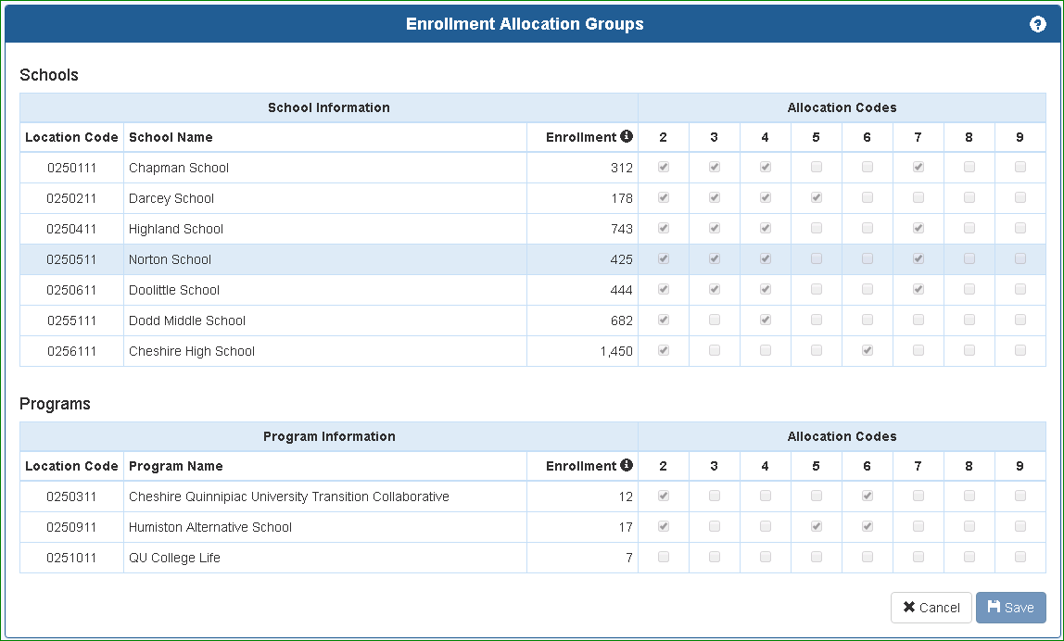

The expenditure record to be allocated must use the CSDE Location Code for the district central office, along with the EFS Allocation Code chosen on the Enrollment Allocation Group schedule. In the above example, to allocate an expenditure record to the three schools identified, use EFS Allocation Code “2”:

The expenditure will be allocated in EFS to the three schools based upon enrollment: 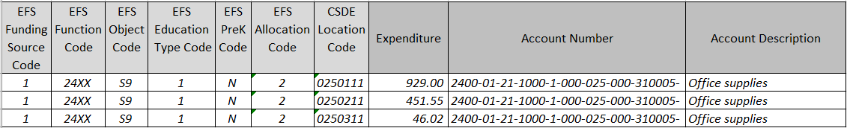

4.8 CSDE Location Code
District | Location Name | CSDE Location Code
DDD | District | DDDSSXX
DDD | Example Elementary School | DDDSSXX

The CSDE Location Codes are assigned by CSDE in the Directory Manager application. The Location Code has 3 segments:
DDD – Three-digit code for your district. Leading zeros in the location code are optional (ex. for 0640411, either 0640411 or 640411 is valid).
SS – Two-digit school code to identify the school or program within your district: 00 for district central office, 01 or greater for school or program.
XX – Two-digit institution code, same for your district central office, schools and programs.
The codes applicable to each district school and program are shown on the CSDE Location Code table for your district, described in Section 2.3.1.
A CSDE Location Code must be included on each expenditure record. The code for a school or program may be used for any record. The code for your district central office may be used for district-level expenditures only (unless an allocation code is also used, see section 4.7). The distinction between a district and school-level expenditure is determined by the level of the function and object codes used. The following are district-level expenditures:
Function Level | Object Level
District | District
District | School
District | Both
Both | District
Both | Both

Expenditures must be reported separately for, and/or allocated to, each school listed on the Allocation Groups page described in Section 2.3.1. Expenditures may or may not be reported separately for the programs listed on the Allocation Groups page, depending on how the program is accounted for on the district’s records. In some cases, small programs are physically located within a larger school building; there is no requirement to separate expenditures between the school and program.

The following school-level expenditures should be identified to particular schools on the district’s accounting records and must be reported in EFS using a CSDE Location Code for a school:
- Salaries for school staff assigned to one school; e.g. principals, school office staff, teachers, teacher aides, librarians, custodians.
- Significant direct expenditures reasonably identifiable by school.

5.0 Reports

5.1 General report information
EFS includes several district and school-level expenditure reports, select the “Reports” header to open the Reports menu shown below. The functionality of the reports is similar, we will show using the District-Level Function/Object Summary Report as an example.
Current year is shown. Click here to select an earlier year.
Click here to open report.
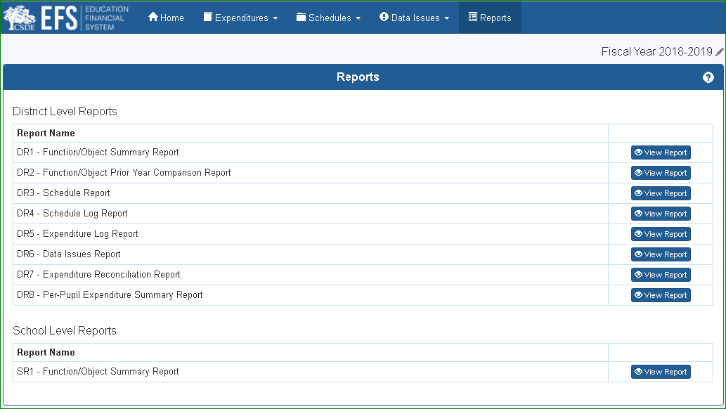

5.2 Report details
Choose fiscal year, 5.2.4.
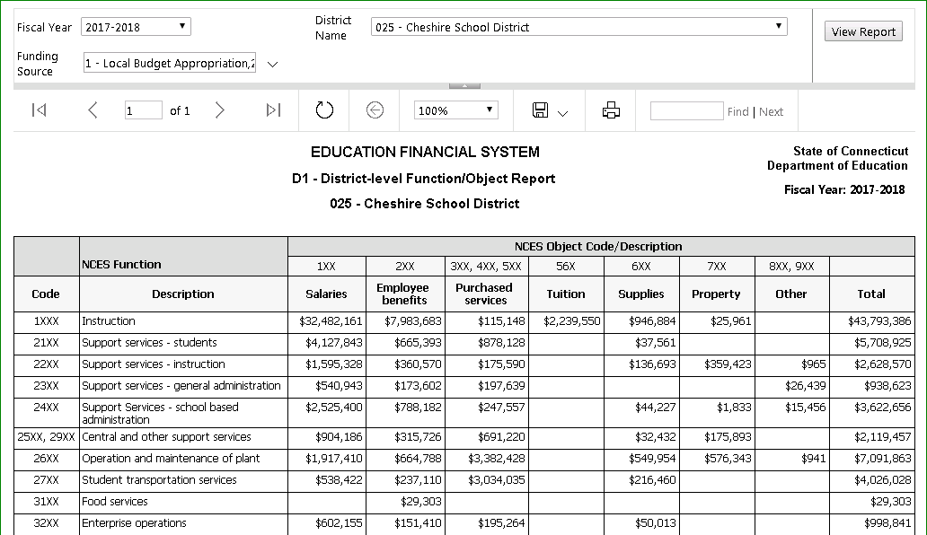
Filter by funding source
View detail, 5.2.2.
Download or print report, 5.2.1.
Refresh report, 5.2.3.

5.2.1 Downloading or printing a report
EFS reports may be downloaded by selecting the desired format from the drop-down menu below the down load icon. The PDF option provides the best format for presentation and printing. You may also directly print a report using the print icon.
Download icon
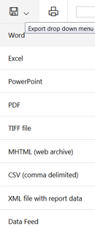
Print icon

We recommend using the “fit” printer setting to ensure adequate margin.

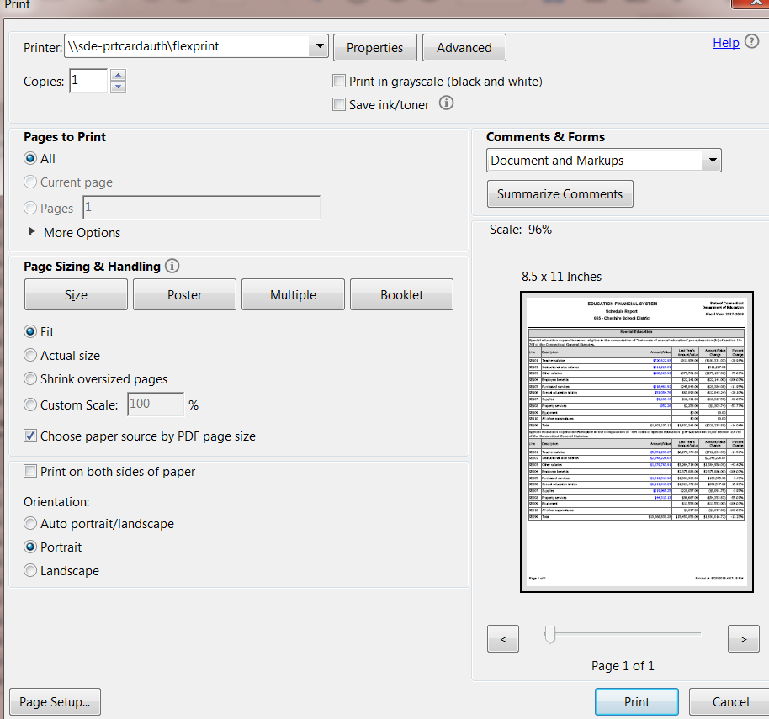

5.2.2 View report detail
Click on any expenditure amount on an EFS Report to open a detail report of the expenditure records included in that amount. This report has the same download and print features as the summary report. Use the back button to return to the summary report.
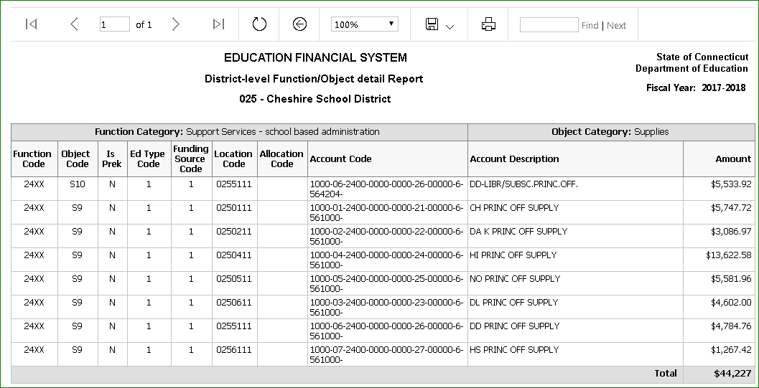
Back button

5.2.3 Refresh report
Reports open on a new browser tab. If you make changes in EFS with a report open, the report will not update unless it is refreshed. Use the Refresh button to update.

5.2.4 Change fiscal year
The report being viewed may be opened for a different fiscal year by selecting the desired year from the drop-down menu, then click on the View Report button.
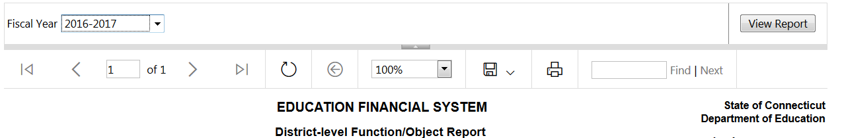

5.3 Report Specifications

5.3.1 DR1-Function/Object Summary Report
DR1 - Example Report
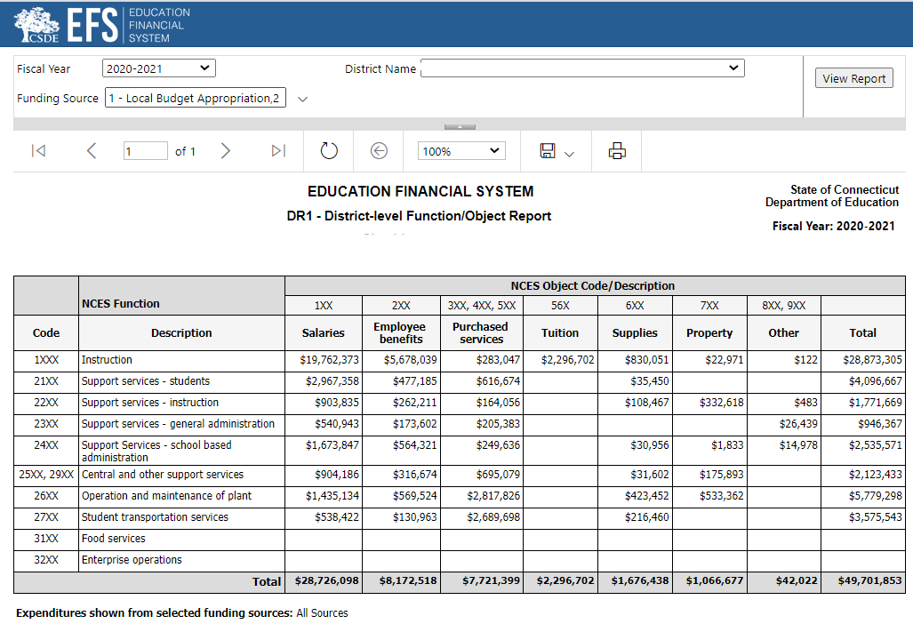
DR1 - Report Specifications – List of Data Fields
 |  | NCES object code | 1XX | 2XX | 3XX, 4XX, 5XX | 56X | 6XX | 7XX | 8XX, 9XX
NCES Function Code | Function Description | Total | Salaries | Employee benefits | Purchased services | Tuition | Supplies | Property | Other
1XXX | Instruction | DFO1A | DFO1B | DFO1C | DFO1D | DFO1E | DFO1F | DFO1G | DFO1H
21XX | Support services - students | DFO2A | DFO2B | DFO2C | DFO2D | DFO2E | DFO2F | DFO2G | DFO2H
22XX | Support services - instruction | DFO3A | DFO3B | DFO3C | DFO3D | DFO3E | DFO3F | DFO3G | DFO3H
23XX | Support services - general administration | DFO4A | DFO4B | DFO4C | DFO4D | DFO4E | DFO4F | DFO4G | DFO4H
24XX | Support Services- school based administration | DFO5A | DFO5B | DFO5C | DFO5D | DFO5E | DFO5F | DFO5G | DFO5H
25XX, 29XX | Central and other support services | DFO6A | DFO6B | DFO6C | DFO6D | DFO6E | DFO6F | DFO6G | DFO6H
26XX | Operation and maintenance of plant | DFO7A | DFO7B | DFO7C | DFO7D | DFO7E | DFO7F | DFO7G | DFO7H
27XX | Student transportation services | DFO8A | DFO8B | DFO8C | DFO8D | DFO8E | DFO8F | DFO8G | DFO8H
31XX | Food services | DFO9A | DFO9B | DFO9C | DFO9D | DFO9E | DFO9F | DFO9G | DFO9H
32XX | Enterprise operations | DFO10A | DFO10B | DFO10C | DFO10D | DFO10E | DFO10F | DFO10G | DFO10H
 | Total | DFO12A | DFO12B | DFO12C | DFO12D | DFO12E | DFO12F | DFO12G | DFO12H

DR1 - Report Specifications – Definition of Data Fields
Line | EFS Funding  Source ID | EFS Function Code | EFS Object Code | EFS Education  Type Code
DFO1A | All | 1XXX | All except D1, N1, S3,S4 | 1, 2, or 3
DFO2A | All | 21XX | All except D1, N1, S3,S4 | 1, 2, or 3
DFO3A | All | 221X, 222X, 22XX | All except D1, N1, S3,S4 | 1, 2, or 3
DFO4A | All | 23XX, 23X1 | All except D1, N1, S3,S4 | 1, 2, or 3
DFO5A | All | 24XX | All except D1, N1, S3,S4 | 1, 2, or 3
DFO6A | All | 25XX, 29XX | All except D1, N1, S3,S4 | 1, 2, or 3
DFO7A | All | 26XX | All except D1, N1, S3,S4 | 1, 2, or 3
DFO8A | All | 27XX, 27X1, 27X2, 27X3, 27X4 | All except D1, N1, S3,S4 | 1, 2, or 3
DFO9A | 1, 11, 12 | 3121, 3122 | All except D1, N1, S3,S4 | 1, 2, or 3
DFO10A | All | 32XX | All except D1, N1, S3,S4 | 1, 2, or 3
DFO12A | All | All except 311X, 4XXX, 5XXX, 9XXX | All except D1, N1, S3,S4 | 1, 2, or 3
DFO1B | All | 1XXX | S1, S2, B1 | 1, 2, or 3
DFO2B | All | 21XX | S1, S2, B1 | 1, 2, or 3
DFO3B | All | 221X, 222X, 22XX | S1, S2, B1 | 1, 2, or 3
DFO4B | All | 23XX, 23X1 | S1, S2, B1 | 1, 2, or 3
DFO5B | All | 24XX | S1, S2, B1 | 1, 2, or 3
DFO6B | All | 25XX, 29XX | S1, S2, B1 | 1, 2, or 3
DFO7B | All | 26XX | S1, S2, B1 | 1, 2, or 3
DFO8B | All | 27XX, 27X1, 27X2, 27X3, 27X4 | S1, S2, B1 | 1, 2, or 3
DFO9B | 1, 11, 12 | 3121, 3122 | S1, S2, B1 | 1, 2, or 3
DFO10B | All | 32XX | S1, S2, B1 | 1, 2, or 3
DFO12B | All | All except 311X, 4XXX, 5XXX, 9XXX | S1, S2, B1 | 1, 2, or 3
DFO1C | All | 1XXX | B2 | 1, 2, or 3
DFO2C | All | 21XX | B2 | 1, 2, or 3
DFO3C | All | 221X, 222X, 22XX | B2 | 1, 2, or 3
DFO4C | All | 23XX, 23X1 | B2 | 1, 2, or 3
DFO5C | All | 24XX | B2 | 1, 2, or 3
DFO6C | All | 25XX, 29XX | B2 | 1, 2, or 3
DFO7C | All | 26XX | B2 | 1, 2, or 3
DFO8C | All | 27XX, 27X1, 27X2, 27X3, 27X4 | B2 | 1, 2, or 3
DFO9C | 1, 11, 12 | 3121, 3122 | B2 | 1, 2, or 3
DFO10C | All | 32XX | B2 | 1, 2, or 3
DFO12C | All | All except 311X, 4XXX, 5XXX, 9XXX | B2 | 1, 2, or 3
DFO1D | All | 1XXX | S5, S6, S8, B3, B7, C1, C2, C3 | 1, 2, or 3
DFO2D | All | 21XX | S5, S6, S8, B3, B7, C1, C2, C3 | 1, 2, or 3
DFO3D | All | 221X, 222X, 22XX | S5, S6, S8, B3, B7, C1, C2, C3 | 1, 2, or 3
DFO4D | All | 23XX, 23X1 | S5, S6, S8, B3, B7, C1, C2, C3 | 1, 2, or 3
DFO5D | All | 24XX | S5, S6, S8, B3, B7, C1, C2, C3 | 1, 2, or 3
DFO6D | All | 25XX, 29XX | S5, S6, S8, B3, B7, C1, C2, C3 | 1, 2, or 3
DFO7D | All | 26XX | S5, S6, S8, B3, B7, C1, C2, C3 | 1, 2, or 3
DFO8D | All | 27XX, 27X1, 27X2, 27X3, 27X4 | S5, S6, S8, B3, B7, C1, C2, C3 | 1, 2, or 3
DFO9D | 1, 11, 12 | 3121, 3122 | S5, S6, S8, B3, B7, C1, C2, C3 | 1, 2, or 3
DFO10D | All | 32XX | S5, S6, S8, B3, B7, C1, C2, C3 | 1, 2, or 3
DFO12D | All | All except 311X, 4XXX, 5XXX, 9XXX | S5, S6, S8, B3, B7, C1, C2, C3 | 1, 2, or 3
DFO1E | All | 1XXX | D2, D3, D4, D5, D6 | 1, 2, or 3
DFO2E | All | 21XX | D2, D3, D4, D5, D6 | 1, 2, or 3
DFO3E | All | 221X, 222X, 22XX | D2, D3, D4, D5, D6 | 1, 2, or 3
DFO4E | All | 23XX, 23X1 | D2, D3, D4, D5, D6 | 1, 2, or 3
DFO5E | All | 24XX | D2, D3, D4, D5, D6 | 1, 2, or 3
DFO6E | All | 25XX, 29XX | D2, D3, D4, D5, D6 | 1, 2, or 3
DFO7E | All | 26XX | D2, D3, D4, D5, D6 | 1, 2, or 3
DFO8E | All | 27XX, 27X1, 27X2, 27X3, 27X4 | D2, D3, D4, D5, D6 | 1, 2, or 3
DFO9E | 1, 11, 12 | 3121, 3122 | D2, D3, D4, D5, D6 | 1, 2, or 3
DFO10E | All | 32XX | D2, D3, D4, D5, D6 | 1, 2, or 3
DFO12E | All | All except 311X, 4XXX, 5XXX, 9XXX | D2, D3, D4, D5, D6 | 1, 2, or 3
DFO1F | All | 1XXX | S9, S10, S11, B4 | 1, 2, or 3
DFO2F | All | 21XX | S9, S10, S11, B4 | 1, 2, or 3
DFO3F | All | 221X, 222X, 22XX | S9, S10, S11, B4 | 1, 2, or 3
DFO4F | All | 23XX, 23X1 | S9, S10, S11, B4 | 1, 2, or 3
DFO5F | All | 24XX | S9, S10, S11, B4 | 1, 2, or 3
DFO6F | All | 25XX, 29XX | S9, S10, S11, B4 | 1, 2, or 3
DFO7F | All | 26XX | S9, S10, S11, B4 | 1, 2, or 3
DFO8F | All | 27XX, 27X1, 27X2, 27X3, 27X4 | S9, S10, S11, B4 | 1, 2, or 3
DFO9F | 1, 11, 12 | 3121, 3122 | S9, S10, S11, B4 | 1, 2, or 3
DFO10F | All | 32XX | S9, S10, S11, B4 | 1, 2, or 3
DFO12F | All | All except 311X, 4XXX, 5XXX, 9XXX | S9, S10, S11, B4 | 1, 2, or 3
DFO1G | All | 1XXX | S12, S13, S14, S15, B5 | 1, 2, or 3
DFO2G | All | 21XX | S12, S13, S14, S15, B5 | 1, 2, or 3
DFO3G | All | 221X, 222X, 22XX | S12, S13, S14, S15, B5 | 1, 2, or 3
DFO4G | All | 23XX, 23X1 | S12, S13, S14, S15, B5 | 1, 2, or 3
DFO5G | All | 24XX | S12, S13, S14, S15, B5 | 1, 2, or 3
DFO6G | All | 25XX, 29XX | S12, S13, S14, S15, B5 | 1, 2, or 3
DFO7G | All | 26XX | S12, S13, S14, S15, B5 | 1, 2, or 3
DFO8G | All | 27XX, 27X1, 27X2, 27X3, 27X4 | S12, S13, S14, S15, B5 | 1, 2, or 3
DFO9G | 1, 11, 12 | 3121, 3122 | S12, S13, S14, S15, B5 | 1, 2, or 3
DFO10G | All | 32XX | S12, S13, S14, S15, B5 | 1, 2, or 3
DFO12G | All | All except 311X, 4XXX, 5XXX, 9XXX | S12, S13, S14, S15, B5 | 1, 2, or 3
DFO1H | All | 1XXX | S16, S17, B6 | 1, 2, or 3
DFO2H | All | 21XX | S16, S17, B6 | 1, 2, or 3
DFO3H | All | 221X, 222X, 22XX | S16, S17, B6 | 1, 2, or 3
DFO4H | All | 23XX, 23X1 | S16, S17, B6 | 1, 2, or 3
DFO5H | All | 24XX | S16, S17, B6 | 1, 2, or 3
DFO6H | All | 25XX, 29XX | S16, S17, B6 | 1, 2, or 3
DFO7H | All | 26XX | S16, S17, B6 | 1, 2, or 3
DFO8H | All | 27XX, 27X1, 27X2, 27X3, 27X4 | S16, S17, B6 | 1, 2, or 3
DFO9H | 1, 11, 12 | 3121, 3122 | S16, S17, B6 | 1, 2, or 3
DFO10H | All | 32XX | S16, S17, B6 | 1, 2, or 3
DFO12H | All | All except 311X, 4XXX, 5XXX, 9XXX | S16, S17, B6 | 1, 2, or 3

5.3.2 DR2-District Function/Object Prior Year Comparison Report
DR2 - Example Report
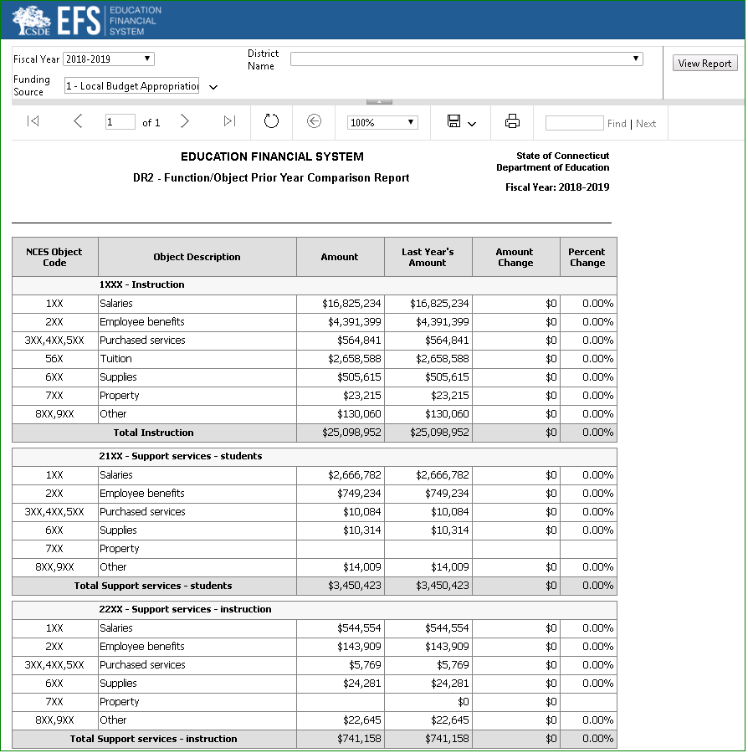
DR2 - Report Specifications – List of Data Fields
NCES Object Code | Function / Object Description | Line Reference
 | 1XXX - Instruction
1XX | Salaries | DC011A
2XX | Employee benefits | DC012A
3XX,4XX,5XX | Purchased services | DC013A
56X | Tuition | DC014A
6XX | Supplies | DC015A
7XX | Property | DC016A
8XX,9XX | Other | DC017A
 | Total Instruction | DC018A
 | 21XX - Support services - students
1XX | Salaries | DC021A
2XX | Employee benefits | DC022A
3XX,4XX,5XX | Purchased services | DC023A
6XX | Supplies | DC024A
7XX | Property | DC025A
8XX,9XX | Other | DC026A
Total | Support services - students | DC027A
 | 22XX - Support services - instruction
1XX | Salaries | DC031A
2XX | Employee benefits | DC032A
3XX,4XX,5XX | Purchased services | DC033A
6XX | Supplies | DC034A
7XX | Property | DC035A
8XX,9XX | Other | DC036A
Total | Support services - instruction | DC037A
 | 23XX - Support services - general administration
1XX | Salaries | DC041A
2XX | Employee benefits | DC042A
3XX,4XX,5XX | Purchased services | DC043A
6XX | Supplies | DC044A
7XX | Property | DC045A
8XX,9XX | Other | DC046A
Total | Support services - general administration | DC047A
 | 24XX - Support Services- school based administration
1XX | Salaries | DC051A
2XX | Employee benefits | DC052A
3XX,4XX,5XX | Purchased services | DC053A
6XX | Supplies | DC054A
7XX | Property | DC055A
8XX,9XX | Other | DC056A
Total | Support Services- school based administration | DC057A
 | 25XX,29XX - Central and other support services
1XX | Salaries | DC061A
2XX | Employee benefits | DC062A
3XX,4XX,5XX | Purchased services | DC063A
6XX | Supplies | DC064A
7XX | Property | DC065A
8XX,9XX | Other | DC066A
Total | Central and other support services | DC067A
 | 26XX - Operation and maintenance of plant
1XX | Salaries | DC071A
2XX | Employee benefits | DC072A
3XX,4XX,5XX | Purchased services | DC073A
6XX | Supplies | DC074A
7XX | Property | DC075A
8XX,9XX | Other | DC076A
Total | Operation and maintenance of plant | DC077A
 | 27XX - Student transportation services
1XX | Salaries | DC081A
2XX | Employee benefits | DC082A
3XX,4XX,5XX | Purchased services | DC083A
6XX | Supplies | DC084A
7XX | Property | DC085A
8XX,9XX | Other | DC086A
Total | Student transportation services | DC087A
 | 31XX - Food services
1XX | Salaries | DC091A
2XX | Employee benefits | DC092A
3XX,4XX,5XX | Purchased services | DC093A
6XX | Supplies | DC094A
7XX | Property | DC095A
8XX,9XX | Other | DC096A
Total | Food services | DC097A
 | 32XX - Enterprise operations
1XX | Salaries | DC101A
2XX | Employee benefits | DC102A
3XX,4XX,5XX | Purchased services | DC103A
6XX | Supplies | DC104A
7XX | Property | DC105A
8XX,9XX | Other | DC106A
Total | Enterprise operations | DC107A
 | All Functions - Total Expenditures
1XX | Salaries | DC121A
2XX | Employee benefits | DC122A
3XX,4XX,5XX | Purchased services | DC123A
56X | Tuition | DC124A
6XX | Supplies | DC125A
7XX | Property | DC126A
8XX,9XX | Other | DC127A
Total | All Functions | DC128A

DR2 - Report Specifications – Definition of Data Fields
Line | EFS Funding  Source ID | EFS Function Code | EFS Object Code | EFS Education  Type Code
DC011A | All | 1XXX | S1, S2, B1 | 1, 2, or 3
DC012A | All | 1XXX | B2 | 1, 2, or 3
DC013A | All | 1XXX | S5, S6, S8, B3, B7, C1, C2, C3 | 1, 2, or 3
DC014A | All | 1XXX | D2, D3, D4, D5, D6 | 1, 2, or 3
DC015A | All | 1XXX | S9, S10, S11, B4 | 1, 2, or 3
DC016A | All | 1XXX | S12, S13, S14, S15, B5 | 1, 2, or 3
DC017A | All | 1XXX | S16, S17, B6 | 1, 2, or 3
DC018A | All | 1XXX | All except D1, N1, S3,S4 | 1, 2, or 3
DC021A | All | 21XX | S1, S2, B1 | 1, 2, or 3
DC022A | All | 21XX | B2 | 1, 2, or 3
DC023A | All | 21XX | S5, S6, S8, B3, B7, C1, C2, C3 | 1, 2, or 3
DC024A | All | 21XX | S9, S10, S11, B4 | 1, 2, or 3
DC025A | All | 21XX | S12, S13, S14, S15, B5 | 1, 2, or 3
DC026A | All | 21XX | S16, S17, B6 | 1, 2, or 3
DC027A | All | 21XX | All except N1, S3,S4 | 1, 2, or 3
DC031A | All | 221X, 222X, 22XX | S1, S2, B1 | 1, 2, or 3
DC032A | All | 221X, 222X, 22XX | B2 | 1, 2, or 3
DC033A | All | 221X, 222X, 22XX | S5, S6, S8, B3, B7, C1, C2, C3 | 1, 2, or 3
DC034A | All | 221X, 222X, 22XX | S9, S10, S11, B4 | 1, 2, or 3
DC035A | All | 221X, 222X, 22XX | S12, S13, S14, S15, B5 | 1, 2, or 3
DC036A | All | 221X, 222X, 22XX | S16, S17, B6 | 1, 2, or 3
DC037A | All | 221X, 222X, 22XX | All except N1, S3,S4 | 1, 2, or 3
DC041A | All | 23XX, 23X1 | S1, S2, B1 | 1, 2, or 3
DC042A | All | 23XX, 23X1 | B2 | 1, 2, or 3
DC043A | All | 23XX, 23X1 | S5, S6, S8, B3, B7, C1, C2, C3 | 1, 2, or 3
DC044A | All | 23XX, 23X1 | S9, S10, S11, B4 | 1, 2, or 3
DC045A | All | 23XX, 23X1 | S12, S13, S14, S15, B5 | 1, 2, or 3
DC046A | All | 23XX, 23X1 | S16, S17, B6 | 1, 2, or 3
DC047A | All | 23XX, 23X1 | All except N1, S3,S4 | 1, 2, or 3
DC051A | All | 24XX | S1, S2, B1 | 1, 2, or 3
DC052A | All | 24XX | B2 | 1, 2, or 3
DC053A | All | 24XX | S5, S6, S8, B3, B7, C1, C2, C3 | 1, 2, or 3
DC054A | All | 24XX | S9, S10, S11, B4 | 1, 2, or 3
DC055A | All | 24XX | S12, S13, S14, S15, B5 | 1, 2, or 3
DC056A | All | 24XX | S16, S17, B6 | 1, 2, or 3
DC057A | All | 24XX | All except N1, S3,S4 | 1, 2, or 3
DC061A | All | 25XX, 29XX | S1, S2, B1 | 1, 2, or 3
DC062A | All | 25XX, 29XX | B2 | 1, 2, or 3
DC063A | All | 25XX, 29XX | S5, S6, S8, B3, B7, C1, C2, C3 | 1, 2, or 3
DC064A | All | 25XX, 29XX | S9, S10, S11, B4 | 1, 2, or 3
DC065A | All | 25XX, 29XX | S12, S13, S14, S15, B5 | 1, 2, or 3
DC066A | All | 25XX, 29XX | S16, S17, B6 | 1, 2, or 3
DC067A | All | 25XX, 29XX | All except N1, S3,S4 | 1, 2, or 3
DC071A | All | 26XX | S1, S2, B1 | 1, 2, or 3
DC072A | All | 26XX | B2 | 1, 2, or 3
DC073A | All | 26XX | S5, S6, S8, B3, B7, C1, C2, C3 | 1, 2, or 3
DC074A | All | 26XX | S9, S10, S11, B4 | 1, 2, or 3
DC075A | All | 26XX | S12, S13, S14, S15, B5 | 1, 2, or 3
DC076A | All | 26XX | S16, S17, B6 | 1, 2, or 3
DC077A | All | 26XX | All except N1, S3,S4 | 1, 2, or 3
DC081A | All | 27XX, 27X1, 27X2, 27X3, 27X4 | S1, S2, B1 | 1, 2, or 3
DC082A | All | 27XX, 27X1, 27X2, 27X3, 27X4 | B2 | 1, 2, or 3
DC083A | All | 27XX, 27X1, 27X2, 27X3, 27X4 | S5, S6, S8, B3, B7, C1, C2, C3 | 1, 2, or 3
DC084A | All | 27XX, 27X1, 27X2, 27X3, 27X4 | S9, S10, S11, B4 | 1, 2, or 3
DC085A | All | 27XX, 27X1, 27X2, 27X3, 27X4 | S12, S13, S14, S15, B5 | 1, 2, or 3
DC086A | All | 27XX, 27X1, 27X2, 27X3, 27X4 | S16, S17, B6 | 1, 2, or 3
DC087A | All | 27XX, 27X1, 27X2, 27X3, 27X4 | All except N1, S3,S4 | 1, 2, or 3
DC091A | 1, 11, 12 | 3121, 3122 | S1, S2, B1 | 1, 2, or 3
DC092A | 1, 11, 12 | 3121, 3122 | B2 | 1, 2, or 3
DC093A | 1, 11, 12 | 3121, 3122 | S5, S6, S8, B3, B7, C1, C2, C3 | 1, 2, or 3
DC094A | 1, 11, 12 | 3121, 3122 | S9, S10, S11, B4 | 1, 2, or 3
DC095A | 1, 11, 12 | 3121, 3122 | S12, S13, S14, S15, B5 | 1, 2, or 3
DC096A | 1, 11, 12 | 3121, 3122 | S16, S17, B6 | 1, 2, or 3
DC097A | 1, 11, 12 | 3121, 3122 | All except N1, S3,S4 | 1, 2, or 3
DC101A | All | 32XX | S1, S2, B1 | 1, 2, or 3
DC102A | All | 32XX | B2 | 1, 2, or 3
DC103A | All | 32XX | S5, S6, S8, B3, B7, C1, C2, C3 | 1, 2, or 3
DC104A | All | 32XX | S9, S10, S11, B4 | 1, 2, or 3
DC105A | All | 32XX | S12, S13, S14, S15, B5 | 1, 2, or 3
DC106A | All | 32XX | S16, S17, B6 | 1, 2, or 3
DC107A | All | 32XX | All except N1, S3,S4 | 1, 2, or 3
DC121A | All | All except 311X, 4XXX, 5XXX, 9XXX | S1, S2, B1 | 1, 2, or 3
DC122A | All | All except 311X, 4XXX, 5XXX, 9XXX | B2 | 1, 2, or 3
DC123A | All | All except 311X, 4XXX, 5XXX, 9XXX | S5, S6, S8, B3, B7, C1, C2, C3 | 1, 2, or 3
DC124A | All | All except 311X, 4XXX, 5XXX, 9XXX | D2, D3, D4, D5, D6 | 1, 2, or 3
DC125A | All | All except 311X, 4XXX, 5XXX, 9XXX | S9, S10, S11, B4 | 1, 2, or 3
DC126A | All | All except 311X, 4XXX, 5XXX, 9XXX | S12, S13, S14, S15, B5 | 1, 2, or 3
DC127A | All | All except 311X, 4XXX, 5XXX, 9XXX | S16, S17, B6 | 1, 2, or 3
DC128A | All | All except 311X, 4XXX, 5XXX, 9XXX | All except D1, N1, S3,S4 | 1, 2, or 3

5.3.3 DR7-Expenditure Reconciliation Report
DR7 - Example Report
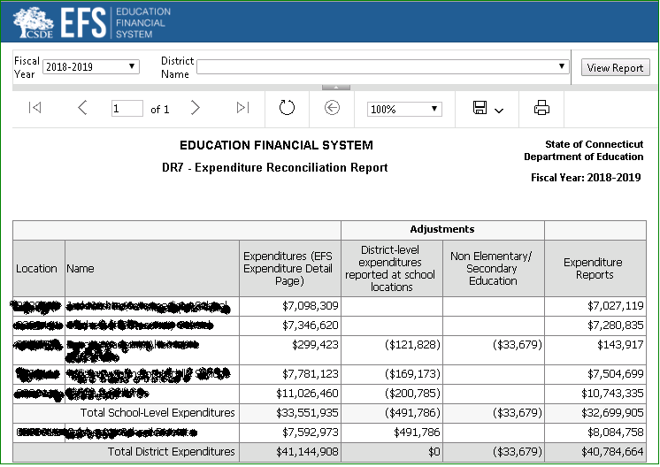
DR7 - Report Specifications – List of Data Fields
Adjustments

Location | School Name | Expenditures (EFS Expenditure Detail Page) | District-level expenditures reported at school locations | Non Elementary/ Secondary Education | Expenditure Reports
School-Level Expenditures
XR01.1A | XR01.1B | XR01.1C | XR01.1D | XR01.1E | XR01.1F
XR01.XA | XR01.XB | XR01.XC | XR01.XD | XR01.XE | XR01.XF
 |  | XR01C | XR01D | XR01E | XR01F
Distict-Level Expenditures
XR02A |  | XR02C | XR02D | XR02E | XR02F
Total District Expenditures |  | XR99C | XR99D | XR99E | XR99F

DR7 - Report Specifications – Definition of Data Fields
Report Specs

Line | Formula or reference | EFS Function Code | EFS Object Code | EFS Education  Type Code | EFS Location Code | Notes
XR01.1A | EFS Location Code |  |  |  | All except XXX00XX | Coded to school, not district
XR01.XA | EFS Location Code |  |  |  | All except XXX00XX | Coded to school, not district. Add a line for each school with expenditures: XR01.2, XR01.3, etc.
XR01.1B | School Name from DM
XR01.XB | School Name from DM
XR01.1C |  | All | All | All | XR01.1A
XR01.XC |  | All | All | All | XR01.XA
XR01C | Sum(XR01.1C through XR01.XC)
XR02C |  | All | All | All | XXX00XX | Coded to district, not school
XR99C | Sum(XR01C, XR02C)
If any of these functions or objects:
XR01.1D | = (-1) x Amount | 23XX, 23X1, 25XX, 29XX,27XX, 27X1, 27X2, 27X3,3121, or 3122 | D1, D2, D3, D4, D5, or D6 | 1, 2, or 3 | XR01.1A
XR01.XD | = (-1) x Amount | 23XX, 23X1, 25XX, 29XX,27XX, 27X1, 27X2, 27X3,3121, or 3122 | D1, D2, D3, D4, D5, or D6 | 1, 2, or 3 | XR01.XA
XR01D | Sum(XR01.1D through XR01.XD)
XR02D | = (-1) x XR01D
XR99D | Sum(XR01D, XR02D)

If any of these functions, objects or education types:
XR01.1E | = (-1) x Amount | 311X, 4XXX, 5XXX, or 9XXX | S3, S4, or N1 | 4, 5, 6, 7, 8, or 9 | XR01.1A
XR01.XE | = (-1) x Amount | 311X, 4XXX, 5XXX, or 9XXX | S3, S4, or N1 | 4, 5, 6, 7, 8, or 9 | XR01.XA
XR01E | Sum(XR01.1E through XR01.XE)
XR02E | = (-1) x Amount | 311X, 4XXX, 5XXX, or 9XXX | S3, S4, or N1 | 4, 5, 6, 7, 8, or 9 | XXX00XX | Coded to district, not school
XR99E | Sum(XR01E, XR02E)
XR01.1F |  | 1XXX, 21XX, 221X, 222X, 22XX, 24XX, 26XX, 27X4, 32XX | All except D1-D6, S3, S4, or N1 | 1, 2, or 3 | XR01.1A
XR01.XF |  | 1XXX, 21XX, 221X, 222X, 22XX, 24XX, 26XX, 27X4, 32XX | All except D1-D6, S3, S4, or N1 | 1, 2, or 3 | XR01.XA
XR01F | Sum(XR01.1F through XR01.XF)
XR02F | SUM(XR02C, XR01D, XR02E)
XR99F | Sum(XR01F, XR02F)

5.3.4 DR8-Per-Pupil Expenditure Summary Report
DR8 - Example Report
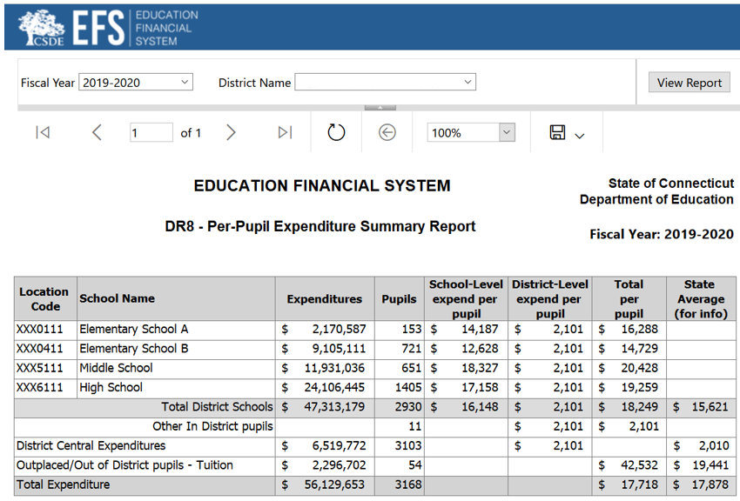

DR8 - Report Specifications – List of Data Fields
Location | School Name | Expenditures | Pupils | School-Level expend per pupil | District-Level expend per pupil | Total per pupil | State Average (for info)
PP01.1A | PP01.1B | PP01.1C | PP01.1D | PP01.1E | PP01.1F | PP01.1G
PP01.XA | PP01.XB | PP01.XC | PP01.XD | PP01.XE | PP01.XF | PP01.XG
Total | District Schools | PP01C | PP01D | PP01E | PP01F | PP01G | PP01H
Other In | District pupils |  | PP04D |  | PP04F | PP04G
District Central Expenditures |  | PP03C | PP03D |  | PP03F |  | PP03H
Outplaced/Out of District pupils - Tuition |  | PP02C | PP02D |  |  | PP02G | PP02H
Total Expenditures |  | PP99C | PP99D |  |  | PP99G | PP99H

DR8 - Report Specifications – Definition of Data Fields
 |  | Report Specs
Field |  | EFS Function Code | EFS Object Code | EFS Education  Type Code | EFS Location Code
PP01.1A | EFS Location Code for school with expenditures reported |  |  |  | All except XXX00XX
PP01.XA | Add lines for each school |  |  |  | All except XXX00XX
PP01.1B | School Name
PP01.XB | School Name
PP01.1C |  | 1XXX, 21XX, 221X, 222X, 22XX, 24XX, 26XX, 27X4, 32XX | All except D1, D2, D3, D4, D5, D6, S3, S4, or N1 | 1, 2, or 3 | PP01.1A
PP01.XC |  | 1XXX, 21XX, 221X, 222X, 22XX, 24XX, 26XX, 27X4, 32XX | All except D1, D2, D3, D4, D5, D6, S3, S4, or N1 | 1, 2, or 3 | PP01.XA
PP01C | Sum(PP01.1C through PP01.XC)
PP02C |  | 1XXX | D2, D3, D4, D5, or D6 | 1, 2, or 3 | All
PP03C | Sum (P99C, -PP01C, -PP02C)
PP99C |  | All except 311X, 4XXX, 5XXX, 9XXX | All except D1, N1, S3,S4 | 1, 2, or 3 | All
PP01.1D | School enrollment (same as on allocation screen) |  |  |  | PP01.1A
PP01.XD | School enrollment (same as on allocation screen) |  |  |  | PP01.XA
PP01D | Sum(PP01.1D through PP01.XD)
PP02D | Number of outplaced students
PP03D | Sum(all enrollments from allocation screen)
PP04D | PP03D - PP01D
PP99D | Sum(PP03D,PP02D)
PP01.1E | = PP01.1C/PP01.1D
PP01.XE | = PP01.XC/PP01.XD
PP01E | = PP01C/PP01D
PP01.1F | = PP03C/PP03D
PP01.XF | = PP03C/PP03D
PP01F | = PP03C/PP03D
PP03F | = PP03C/PP03D
PP04F | = PP03C/PP03D
PP01.1G | = Sum(PP01.1E, PP01.1F)
PP01.XG | = SUM(PP01.XE, PP01.XF)
PP01G | = Sum(PP01E, PP01F)
PP02G | = PP02C/PP02D
PP04G | =PP04F
PP99G | = PP99C/PP99D
PP01H | State-wide average of expenditures per student, educated in district schools. Same number for all districts.
PP02H | State-wide average of expenditures per outplaced student. Same number for all districts
PP03H | State-wide average of district central expenditures per student. Same number for all districts
PP99H | State-wide average of total expenditures per student. Same number for all districts

5.3.5 SR1-School Function/Object Summary Report
SR1 - Example Report
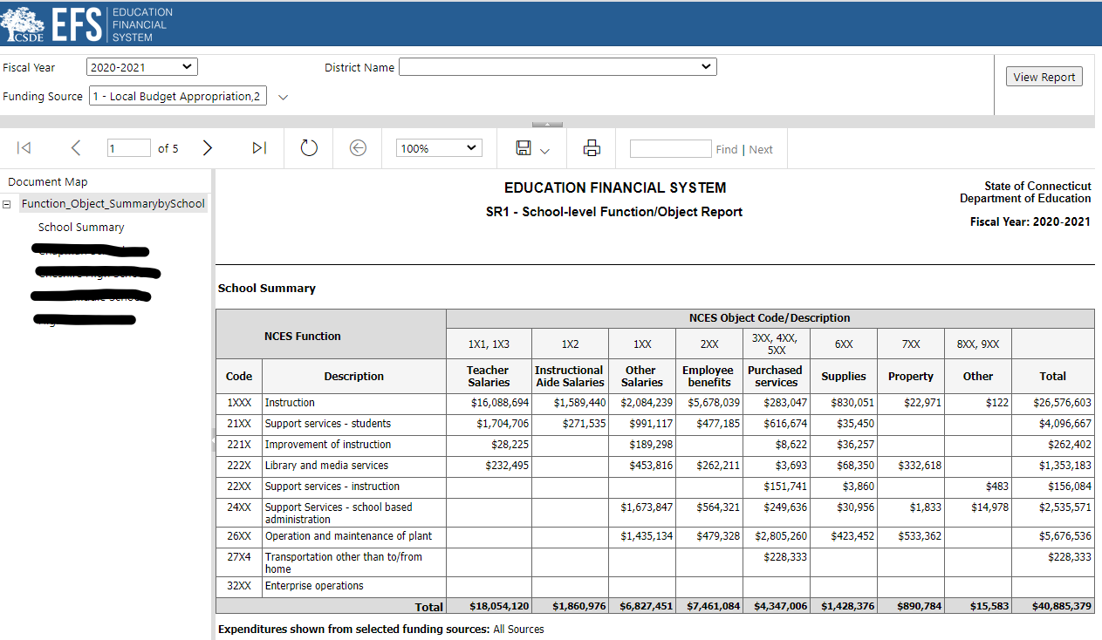
SR1 - Report Specifications – List of Data Fields
 | NCES Object Code/ Description | 1X1,1X3 | 1X2 | 1XX | 2XX | 3XX,4XX,5XX | 6XX | 7XX | 8XX,  9XX
NCES Function Code | Function Description | Teacher Salaries | Instructional Aide Salaries | Other Salaries | Employee benefits | Purchased services | Supplies | Property | Other | Total
1XXX | Instruction | SFO1B | SFO1C | SFO1D | SFO1E | SFO1F | SFO1G | SFO1H | SFO1I | SFO1A
21XX | Support services - students | SFO2B | SFO2C | SFO2D | SFO2E | SFO2F | SFO2G | SFO2H | SFO2I | SFO2A
221X | Improvement of instruction | SFO3B | SFO3C | SFO3D | SFO3E | SFO3F | SFO3G | SFO3H | SFO3I | SFO3A
222X | Library and media services | SFO4B | SFO4C | SFO4D | SFO4E | SFO4F | SFO4G | SFO4H | SFO4I | SFO4A
22XX | Support services - instruction | SFO5B | SFO5C | SFO5D | SFO5E | SFO5F | SFO5G | SFO5H | SFO5I | SFO5A
24XX | Support Services- school based administration | SFO6B | SFO6C | SFO6D | SFO6E | SFO6F | SFO6G | SFO6H | SFO6I | SFO6A
26XX | Operation and maintenance of plant | SFO7B | SFO7C | SFO7D | SFO7E | SFO7F | SFO7G | SFO7H | SFO7I | SFO7A
27X4 | Transportation other than to/from home | SF10B | SF10C | SF10D | SF10E | SF10F | SF10G | SF10H | SF10I | SF10A
32XX | Enterprise operations | SF11B | SF11C | SF11D | SF11E | SF11F | SF11G | SF11H | SF11I | SF11A
 | Total | SFO9B | SFO9C | SFO9D | SFO9E | SFO9F | SFO9G | SFO9H | SFO9I | SFO9A

SR1 - Report Specifications – Definition of Data Fields
Line | EFS Function Code | EFS Object Code | EFS Education  Type Code
SFO1A | 1XXX | All except N1, S3, S4 | 1, 2, or 3
SFO2A | 21XX | All except N1, S3, S4 | 1, 2, or 3
SFO3A | 221X | All except N1, S3, S4 | 1, 2, or 3
SFO4A | 222X | All except N1, S3, S4 | 1, 2, or 3
SFO5A | 22XX | All except N1, S3, S4 | 1, 2, or 3
SFO6A | 24XX | All except N1, S3, S4 | 1, 2, or 3
SFO7A | 26XX | All except N1, S3, S4 | 1, 2, or 3
SF10A | 27X4 | All except N1, S3, S4 | 1, 2, or 3
SF11A | 32XX | All except N1, S3, S4 | 1, 2, or 3
SFO9A | 1XXX, 21XX, 221X, 222X, 22XX, 24XX, 26XX,27X4, 32XX | All except N1, S3, S4 | 1, 2, or 3
SFO1B | 1XXX | S1 | 1, 2, or 3
SFO2B | 21XX | S1 | 1, 2, or 3
SFO3B | 221X | S1 | 1, 2, or 3
SFO4B | 222X | S1 | 1, 2, or 3
SFO5B | 22XX | S1 | 1, 2, or 3
SFO6B | 24XX | S1 | 1, 2, or 3
SFO7B | 26XX | S1 | 1, 2, or 3
SF10B | 27X4 | S1 | 1, 2, or 3
SF11B | 32XX | S1 | 1, 2, or 3
SFO9B | 1XXX, 21XX, 221X, 222X, 22XX, 24XX, 26XX,27X4, 32XX | S1 | 1, 2, or 3
SFO1C | 1XXX | S2 | 1, 2, or 3
SFO2C | 21XX | S2 | 1, 2, or 3
SFO3C | 221X | S2 | 1, 2, or 3
SFO4C | 222X | S2 | 1, 2, or 3
SFO5C | 22XX | S2 | 1, 2, or 3
SFO6C | 24XX | S2 | 1, 2, or 3
SFO7C | 26XX | S2 | 1, 2, or 3
SF10C | 27X4 | S2 | 1, 2, or 3
SF11C | 32XX | S2 | 1, 2, or 3
SFO9C | 1XXX, 21XX, 221X, 222X, 22XX, 24XX, 26XX,27X4, 32XX | S2 | 1, 2, or 3
SFO1D | 1XXX | B1 | 1, 2, or 3
SFO2D | 21XX | B1 | 1, 2, or 3
SFO3D | 221X | B1 | 1, 2, or 3
SFO4D | 222X | B1 | 1, 2, or 3
SFO5D | 22XX | B1 | 1, 2, or 3
SFO6D | 24XX | B1 | 1, 2, or 3
SFO7D | 26XX | B1 | 1, 2, or 3
SF10D | 27X4 | B1 | 1, 2, or 3
SF11D | 32XX | B1 | 1, 2, or 3
SFO9D | 1XXX, 21XX, 221X, 222X, 22XX, 24XX, 26XX,27X4, 32XX | B1 | 1, 2, or 3
SFO1E | 1XXX | B2 | 1, 2, or 3
SFO2E | 21XX | B2 | 1, 2, or 3
SFO3E | 221X | B2 | 1, 2, or 3
SFO4E | 222X | B2 | 1, 2, or 3
SFO5E | 22XX | B2 | 1, 2, or 3
SFO6E | 24XX | B2 | 1, 2, or 3
SFO7E | 26XX | B2 | 1, 2, or 3
SF10E | 27X4 | B2 | 1, 2, or 3
SF11E | 32XX | B2 | 1, 2, or 3
SFO9E | 1XXX, 21XX, 221X, 222X, 22XX, 24XX, 26XX,27X4, 32XX | B2 | 1, 2, or 3
SFO1F | 1XXX | S5, S6, S8, B3, B7, C1, C2, C3 | 1, 2, or 3
SFO2F | 21XX | S5, S6, S8, B3, B7, C1, C2, C3 | 1, 2, or 3
SFO3F | 221X | S5, S6, S8, B3, B7, C1, C2, C3 | 1, 2, or 3
SFO4F | 222X | S5, S6, S8, B3, B7, C1, C2, C3 | 1, 2, or 3
SFO5F | 22XX | S5, S6, S8, B3, B7, C1, C2, C3 | 1, 2, or 3
SFO6F | 24XX | S5, S6, S8, B3, B7, C1, C2, C3 | 1, 2, or 3
SFO7F | 26XX | S5, S6, S8, B3, B7, C1, C2, C3 | 1, 2, or 3
SF10F | 27X4 | S5, S6, S8, B3, B7, C1, C2, C3 | 1, 2, or 3
SF11F | 32XX | S5, S6, S8, B3, B7, C1, C2, C3 | 1, 2, or 3
SFO9F | 1XXX, 21XX, 221X, 222X, 22XX, 24XX, 26XX,27X4, 32XX | S5, S6, S8, B3, B7, C1, C2, C3 | 1, 2, or 3
SFO1G | 1XXX | S9, S10, S11, B4 | 1, 2, or 3
SFO2G | 21XX | S9, S10, S11, B4 | 1, 2, or 3
SFO3G | 221X | S9, S10, S11, B4 | 1, 2, or 3
SFO4G | 222X | S9, S10, S11, B4 | 1, 2, or 3
SFO5G | 22XX | S9, S10, S11, B4 | 1, 2, or 3
SFO6G | 24XX | S9, S10, S11, B4 | 1, 2, or 3
SFO7G | 26XX | S9, S10, S11, B4 | 1, 2, or 3
SF10G | 27X4 | S9, S10, S11, B4 | 1, 2, or 3
SF11G | 32XX | S9, S10, S11, B4 | 1, 2, or 3
SFO9G | 1XXX, 21XX, 221X, 222X, 22XX, 24XX, 26XX,27X4, 32XX | S9, S10, S11, B4 | 1, 2, or 3
SFO1H | 1XXX | S12, S13, S14, S15, B5 | 1, 2, or 3
SFO2H | 21XX | S12, S13, S14, S15, B5 | 1, 2, or 3
SFO3H | 221X | S12, S13, S14, S15, B5 | 1, 2, or 3
SFO4H | 222X | S12, S13, S14, S15, B5 | 1, 2, or 3
SFO5H | 22XX | S12, S13, S14, S15, B5 | 1, 2, or 3
SFO6H | 24XX | S12, S13, S14, S15, B5 | 1, 2, or 3
SFO7H | 26XX | S12, S13, S14, S15, B5 | 1, 2, or 3
SF10H | 27X4 | S12, S13, S14, S15, B5 | 1, 2, or 3
SF11H | 32XX | S12, S13, S14, S15, B5 | 1, 2, or 3
SFO9H | 1XXX, 21XX, 221X, 222X, 22XX, 24XX, 26XX,27X4, 32XX | S12, S13, S14, S15, B5 | 1, 2, or 3
SFO1I | 1XXX | S16, S17, B6 | 1, 2, or 3
SFO2I | 21XX | S16, S17, B6 | 1, 2, or 3
SFO3I | 221X | S16, S17, B6 | 1, 2, or 3
SFO4I | 222X | S16, S17, B6 | 1, 2, or 3
SFO5I | 22XX | S16, S17, B6 | 1, 2, or 3
SFO6I | 24XX | S16, S17, B6 | 1, 2, or 3
SFO7I | 26XX | S16, S17, B6 | 1, 2, or 3
SF10I | 27X4 | S16, S17, B6 | 1, 2, or 3
SF11I | 32XX | S16, S17, B6 | 1, 2, or 3
SFO9I | 1XXX, 21XX, 221X, 222X, 22XX, 24XX, 26XX,27X4, 32XX | S16, S17, B6 | 1, 2, or 3

6.0 Data Issues
There are three types of Data Issues: “In-Schedule Trending Analyses”, “Trending Analyses”, and “Desk Audits”. Select a data issue type from the drop-down menu, then reply by selecting one or more of the potential answers provided, and/or entering text in the “Other” box:
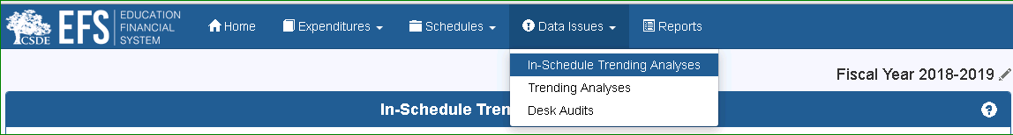

6.1.1 In-Schedule Trending Analyses
In-Schedule Trending Analyses compare amounts reported on one schedule line to the prior year amount; variances which fall outside of defined parameters generate a question which requires an answer and/or data revision. These analyses are created whenever a schedule is saved.
Reply by selecting one or more of the potential answers provided, and/or entering text in the “Other” box. Be sure to save your responses by clicking the “Save” button in the lower right-hand corner of the page.

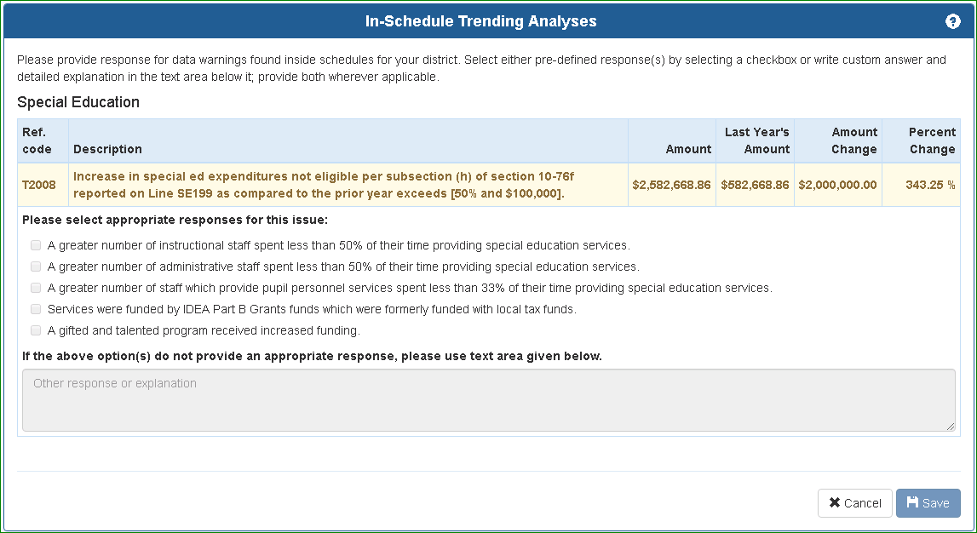

6.1.2 Trending Analyses
Trending Analyses compare amounts reported on more than one schedule line to each other or to prior year amounts; variances which fall outside of defined parameters generate a question which requires an answer and/or data revision. To run these analyses, click on the “Perform Analyses” button.
Districts should recheck the trending analyses whenever EFS data have been revised, by clicking on the “Perform Analyses” button. Trending analyses will also be run automatically when EFS is certified, however it is recommended that they be run in advance of that step.
Reply by selecting one or more of the potential answers provided, and/or entering text in the “Other” box. Be sure to save your responses by clicking the “Save” button in the lower right-hand corner of the page.
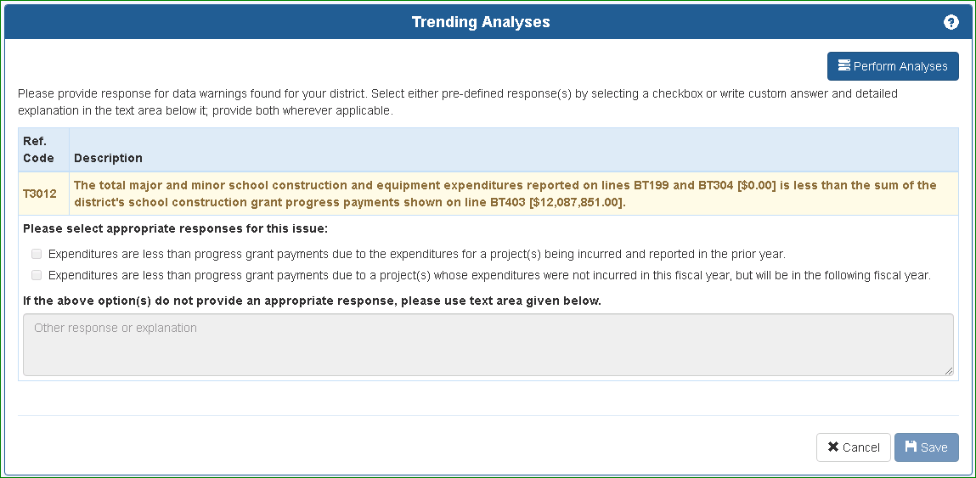

6.1.3 Desk Audits
Desk Audits are prepared by CSDE staff based on review of EFS data. These become available when the EFS is re-opened for all districts for review of data issues, and to allow districts to revise data. Districts will be notified when these are available, estimated to be in late October.
Reply by selecting one or more of the potential answers provided, and/or entering text in the “Other” box. Be sure to save your responses by clicking the “Save” button in the lower right-hand corner of the page.
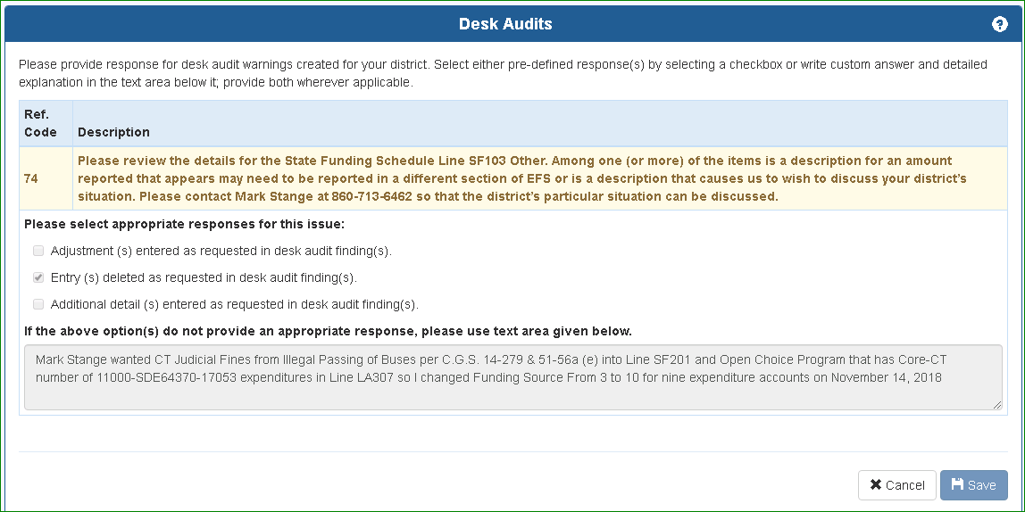

7.0 Help Information

7.1 Contact Us
Please send any issues or questions to our mailbox at SDE.efs@ct.gov.

7.2 User Guide Revision table
Version | Section | Description | Date
7.0 | 1.2.3 | Clarified that depreciation expense not to be reported in EFS. | 4/2023
 | 2.3.4 | Update EFS Rules and Exceptions for Education Type 3
 | 3.11.2 | Update Function/Object exception for LA213
 | 3.4 | Update In-Kind excel template
 | 3.5 | Update definition for FS204, CF204, and RF204.
 | 3.6.2 | Update Funding Source specs for Lines SE201 - SE210 on Special Education Schedule
 | 3.8, 3.9 & 3.10 | Added references to grant expenditure reports available in eGrants Management System.
 | 3.10.2 | Update Education Type specs for Line PF101 on Private/Miscellaneous Funding Schedule
 | 4.5 | Removed reference to Federal Funding Schedule for Medicaid expenditures.
 | Appendix B | Validation grid
 | Appendix D | Updated list of approved private special education residential facility rates.
 | Appendix E | Updated list of magnet schools.
8.0 | Appendix D | Updated list of approved private special education residential facility rates. | 7/2024
 | Appendix E | Updated list of magnet schools.
9.0 | 1.2.2 | Clarified encumbrance reporting requirements. | 7/2025
 | Appendix D | Updated list of approved private special education residential facility rates.
 | Appendix E | Updated list of magnet schools.
10.0 | Appendix D | Updated list of approved private special education residential facility rates. | 6/1/2026
 | Appendix E | Updated list of magnet schools.

Appendix A - Tutorial: Excel functions

Using the Mid function to extract/separate account numbers

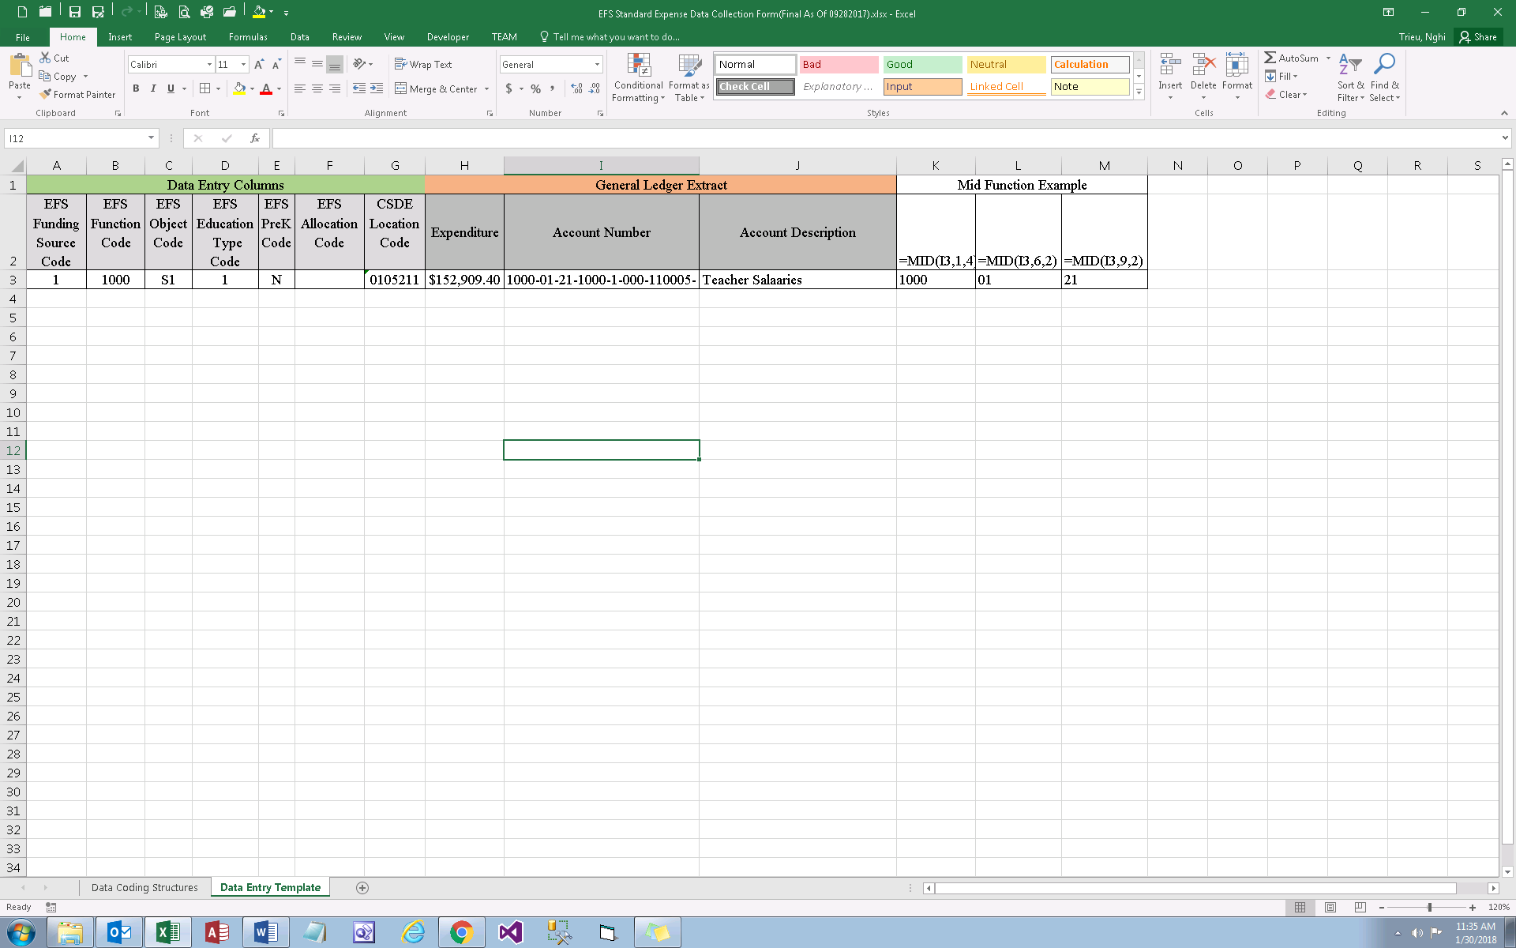
- The Excel MID function extracts a given number of characters from the middle of a supplied text string or cell.
For example, =MID(I3,1,4) returns "1000"; where “MID” is the function, “I3” is the cell to extract the information from, “1” is the location of the first character to extract, and “4” the number of characters to extract.

Syntax:
=MID (text, start_num, num_chars)
=MID (I3, 1, 4)

Breakdown:
text - The text or cell to extract from.
start_num - The location of the first character to extract.
num_chars - The number of characters to extract.

Copying and pasting values

Before sorting the file to assign EFS codes, it is recommended that cell formulas be replaced with values. To copy and paste only the values of the cell (omiting formula), highlight the columns or range of the cell that you want to copy; right click and choose copy or control c on the keyboard
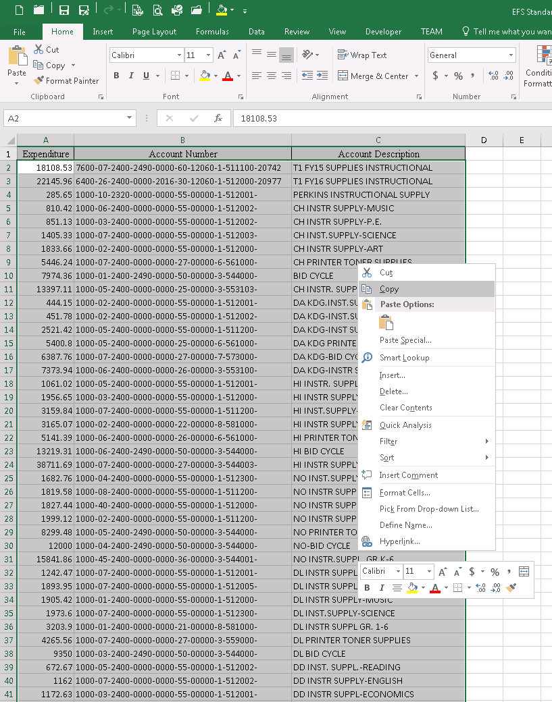

Navigate to the worksheet that you want to copy to, right click on the cell you want it to paste to > select paste special > select values > ok
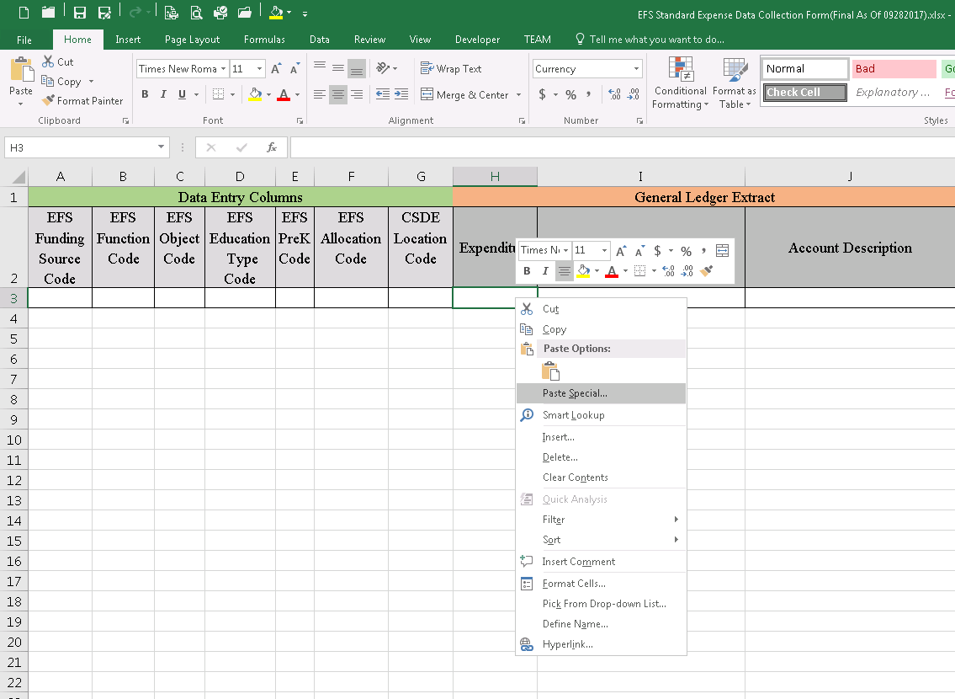

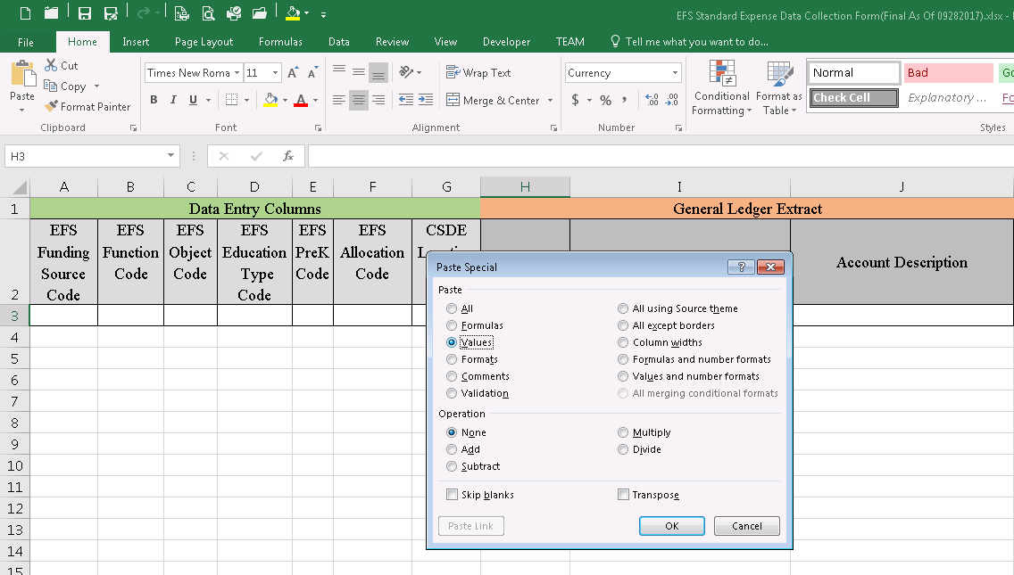

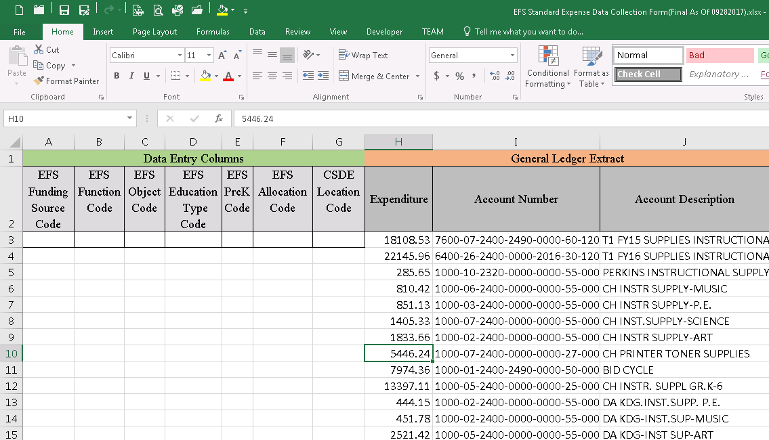

Sorting

Sorting the whole worksheet, click on the cell that has data, go to Data > Sort
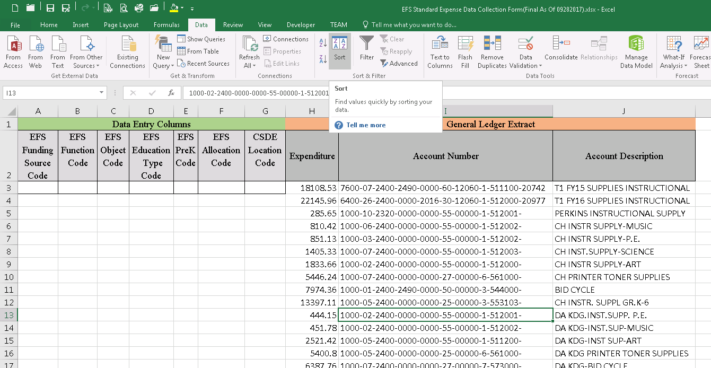

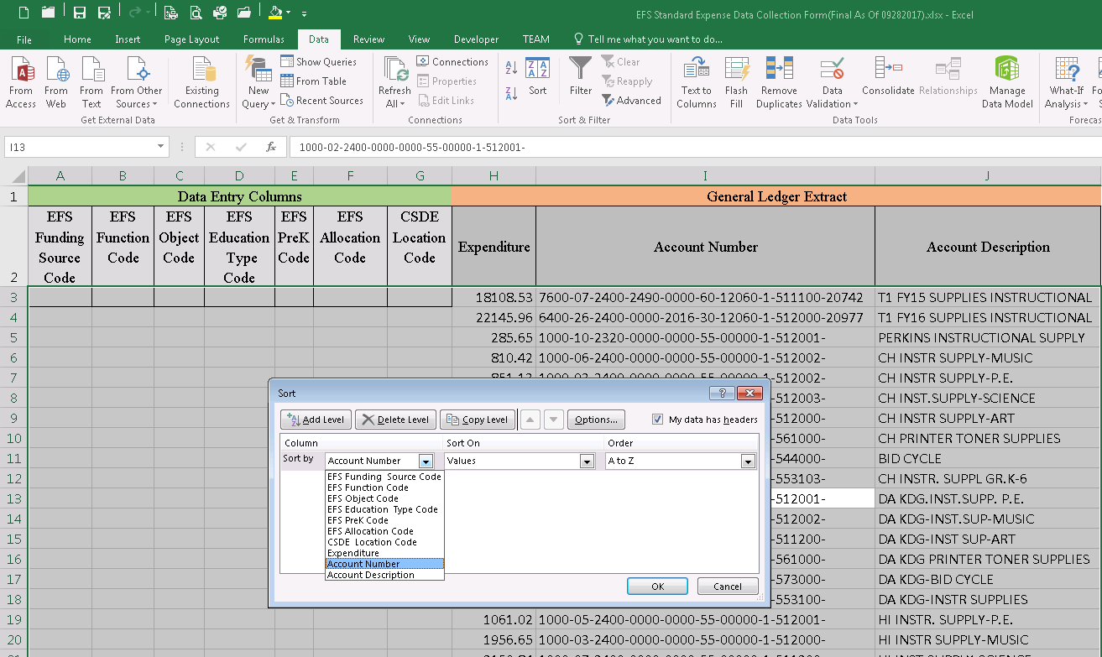

Appendix B - Function/Object Valid Code Combinations
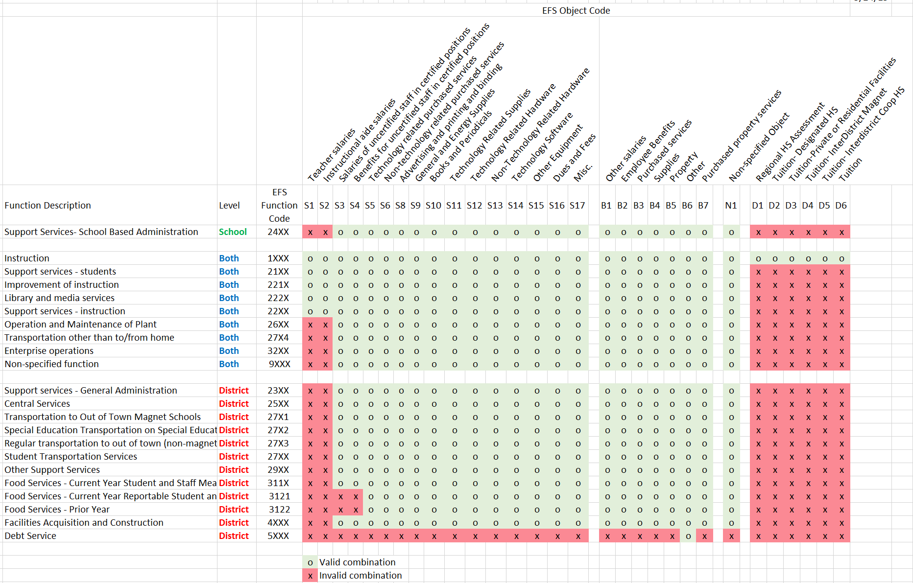

Appendix C - Land, Buildings, Capital Construction and Debt Service – Reporting Guidance

Reporting requirements for land, buildings, and capital construction depends on how the expenditures were financed. Section I below defines terms, Section II describes how the expenditures are to be reported in EFS, Section III provides reporting examples, and Section IV lists project type codes.

- Definitions
School Construction - includes the following:
- New building construction
Consists of all costs for the construction of an entire new facility, including:
- site acquisition,
- site improvements,
- outdoor athletic facilities,
- equipment (including kitchen and grounds) necessary for the facility (desks, chairs, computers, etc.),
- professional fees (legal, design, etc.).

Does not include operating costs such as:
- supply items such as books and paper,
- software purchased separately,
- maintenance contracts.

- Purchase of an existing building
- costs associated with purchase of an existing building for use as a school,
- costs for expansion, alterations, or remodeling of purchased buildings,
- other costs consistent with guidelines for New Building Construction listed above.

- Building additions
All costs necessary for the completion of adding new space to a facility, including:
- equipment purchases that are required for the added space (desks, chairs, computers, etc.),
- relocatable (a.k.a. portable, demountable) buildings that are purchased or included in a lease/purchase agreement (these are considered a site improvement, see item 6 below),
- other costs related to the addition consistent with guidelines for New Building Construction listed above.

- Site acquisition

- Major Remodeling
Permanent structural improvements or alterations. Does not include routine maintenance and repair costs for keeping the building in its original condition of completeness or efficiency.

Examples:
- “substantial” replacements (replace all lockers, replace gym floor, repaint entire wings, resurface entire parking lots, replace sections of bleachers),
- athletic facility upgrades (resurfacing track, adding artificial surfaces, adding sprinkler systems, regrading playing surfaces, etc.),
- large scale replacement of doors and windows for energy conservation measures.
- roof replacements
- code conformity upgrades
- oil tank replacements
- interior structural alterations
- technology wiring
- installation or upgrades of service systems.

School construction does not include costs for limited or routine repairs and maintenance including:
- minor roof repairs/patches
- parking lot patches
- oil tank repairs
- playing surface resurfacing
- replacing a section of wiring
- painting existing walls/ceiling
- repairing floors in existing rooms
- replacing a limited number of windows as part of maintenance program
- replacing a row or section of lockers in a building.

- Installation or extension of a service system and other built-in equipment.
Service systems include heating, cooling, water, disposal, mechanical, electrical, communications, safety and security. Extension of a service system is the enlargement or expansion of an existing service system. Examples:
- replacing a heating system with a heating/cooling system,
- replacing the electrical system in four rooms and extending the wiring into a new fifth room.

- Improvements to sites
The permanent and structural alteration to the surface of the land, or any additional item permanently affixed to the land. Examples:
- initial grading, landscaping, seeding, and planting of shrubs and trees; constructing new sidewalks, roadways, overpasses, retaining walls, sewers and storm drains are improvements to sites,
- installing water mains, field hydrants and sprinkling systems, and outdoor drinking fountains are improvements to sites,
- original surfacing and soil treatment of athletic fields and tennis courts are improvements to sites,
- furnishing and installing, for the first time, playground or playing-field apparatus built into the grounds, flagpoles, gateways, fences and underground storage tanks that are not part of building service systems are improvements to sites,
- off site improvements necessitated by improvements made on the site, such as installing sewer lines and building roads, are improvements to sites,
- purchase or lease/purchase of a relocatable classroom.

Improvements to a site do not include a leased relocatable classroom or maintenance activities such as:
- maintaining the existing landscaping, shrubs and trees, sidewalks and roadways of school grounds,
- maintaining playing fields and related grounds.

- Reporting in EFS
- Land, Buildings, Capital Construction, and Debt Service Schedule
  - Expenditures for land, buildings, and capital construction section on Lines BT101 (or BR101 or BC101) and BT102 (or BR102). Report costs for all school construction. It is noted that costs for regular building maintenance performed over the years are not reported on this schedule, however, if the district did not perform a maintenance program over the years and had to renovate a deteriorated building, renovation expenditures would be reported here.

  - Funding Source for Land, Buildings, and Capital Construction Expenditures, in lines BT201 and BT202 (or BR201 and BR202, or BC201 and BC202). Report the funding source for the expenditures described in 1. above, either funded by long-term borrowing, or from current funds. The total should reconcile to the total expenditures.

  - Expenditures for Debt Service on Lines BT401-BT403 (or BR401-BR403 or BC401-BC403). Report principal and interest payments by the board of education, town, or agency on long-term loans including bonds that financed School Construction, and equipment for education, and interest on short-term loans. Debt service for transportation equipment should also be reported on the Transportation Schedule.

- EFS Expenditure Data
School construction expenditures are not required to be reported in the EFS Expenditure database, as the reporting must be done manually on the Land, Buildings, Capital Construction, and Debt Service Schedule as described above. If expenditures are reported in the EFS Expenditure database, Function 4XXX must be used.

- Reporting examples
- School Construction project – no borrowing
      - Example project for an addition to a school building for which the town does not borrow funds:
- The total expected cost of the addition is $1,000,000.
- The town will cover its part of the cost from local tax revenue.
- The town applies to the State Department of Administrative Services for a school construction grant. The state assigns a school construction project number.
- The state commits $750,000 (or 75% of $1,000,000) to support the project. The town will support the remaining $250,000 with local funds.
- The town asks for and receives $375,000 in Progress Payment Grant funds from the State Department of Administrative Services during Year 1. The town places the funds in an account.
- Over Year 1, the school district/town pays the contractor $500,000. This was funded by $125,000 from local funds and $375,000 from Progress Payment Grant funds.

      - The amounts would be reported on the EFS Land, Buildings, Capital Construction and Debt Service Schedule as follows:
- On Line BT101 (or BR101), select the project from the drop-down listing and report expenditures of $500,000. For a charter school, report all data on Line BC101.
- On Line BT202 (or BR202 or BC202), report the $500,000 expenditure from current funds.

- School Construction project with borrowing.
      - Example project for an addition to a school building for which a town needs to borrow funds:
- The total expected cost of the addition is $5,000,000.
- The town will issue bonds to cover its part of the cost.
- The town applies to the state for a school construction grant. The state assigns a school construction project number.
- The state commits $3,000,000 (or 60% of $5,000,000) to support the project. The town will support the remaining $2,000,000 with the proceeds of a bond issue.
- The town’s bank sells bonds on behalf of the town. The town places the proceeds from the sale of bonds in an account. The town agrees to the following the bond repayment schedule:
Fiscal Year | Principal payment | Interest payment
Year 1 | $500,000 | $20,000
Year 2 | $500,000 | $15,000
Year 3 | $500,000 | $10,000
Year 4 | $500,000 | $5,000

- The town asks for and receives $600,000 in Progress Payment Grant funds from the State Department of Administrative Services during Year 1. The town places the funds in an account.
- Over Year 1, the school district/town pays the contractor $1,000,000. This was funded by $400,000 from bond proceeds and $600,000 from Progress Payment Grant funds. In addition, the school district/town makes debt service payments of $500,000 for principal and $20,000 for interest.

      - The amounts would be reported on the EFS Land, Buildings, Capital Construction and Debt Service Schedule as follows:
- On Line BT101 (or BR101), select the project from the drop-down listing and report expenditures of $1,000,000. For a charter school, report all data on Line BC101.
- On Line BT201 (or BR201 or BC201), report the $400,000 funded from bond proceeds.
- On Line BT202 (or BR202 or BC202), report the $600,000 funded from state grant progress payments
- On Line BT401 (or BR401 or BC401), report the $500,000 principal payment.
- On Line BT402 (or BR402 or BC402), report the $20,000 interest payment.

- School Construction Project Type Abbreviations
Below is a list of the possible abbreviations that appear in the On the EFS Land, Buildings, Capital Construction and Debt Service Schedule on Line BT101 (or BR101) under Major Type. These abbreviations may be used to complete the Major Type field for projects added to Line BT102 (or BR102 or BC101):

Project Types Authorized by the General Assembly
Abbreviation | Project Designation
A | Alteration
A/TCH | Technology Infrastructure
BE | Board of Education/Central Administration Facility
D | Diversity School
E | Extension
EA | Extension/Alteration
EC | Energy Conservation
MAG | Interdistrict Magnet Facility
IC | Interdistrict Co-operative
N | New Construction
PF | Purchase of Facility
PS | Purchase of Site
RNV | Approved Renovation
SP | Regional Special Education
VA | Agricultural Science and Technology Education Center Construction
VE | Agricultural Science and Technology Education Equipment
VT | Vocational Technical School Facility
Project Types Authorized by the Commissioner
Abbreviation | Project Designation
CV | Code Violation
HV | Health Violation (includes Asbestos)
IAQ | Certified Indoor Air Quality
OT | Oil Tank Replacement
PV | Photovoltaic
RE | Relocatable Classrooms
RR | Roof Replacement
Note: A project’s Major Type may consist of a combination of abbreviations, for example:
Abbreviation | Project Designation
SP/N | Special Education project for New Construction
EA/RR | Extension/Alteration project with a Roof Replacement
A/CV | Alteration project with a Code Violation

Appendix D - Approved Private Special Education Residential Facilities

Approved Private Special Education Residential Facilities With
Education Rates Set by the State Department of Education

Fiscal Year July 1, 2025 to June 30, 2026
As of July 1, 2025

Facility Code | Per Diem 2024-2025 | Special Education Facility/Town Name
0100161 | 543.43 ** | Arch Bridge School – Wellspring – Bethlehem
1550861 | 786.54 * | PACES – American School for Deaf – West Hartford
1410161 | 497.04 | River Run Academy at the Susan Wayne Center of Excellence – Thompson

* Indicates the Single Cost Accounting Report has not been received by the Department of Education
and rate held constant from prior year.
** Rate held constant from prior year because of approved facility request

Appendix E – 2025-26 CSDE Approved Interdistrict Magnet Schools

FULL-TIME MAGNET SCHOOLS
District | School |  |  | Organization  Code
Bloomfield | Wintonbury Early Childhood |  |  | 0110811
 | Global Experience Magnet School |  |  | 0116311
Bridgeport | Biotechnology, Research and Zoological Studies HS |  |  | 0150611
 | Aerospace/Hydrospace, Engineering and Physical Sciences HS |  |  | 0150811
 | Information Technology and Software Engineering HS |  |  | 0151511
 | Interdistrict Discovery Magnet School |  |  | 0153711
Danbury | Western CT Academy of International Studies |  |  | 0341911
East Hartford | Connecticut IB Academy |  |  | 0436311
Hartford | Montessori Magnet at Batchelder School |  |  | 0640511
 | Dwight-Bellizzi Dual Language Academy |  |  | 0640711
 | Environmental Sciences Magnet at Hooker School |  |  | 0640911
 | Kinsella Magnet School of Performing Arts: PK-8 Campus |  |  | 0641111
 | Hartford PreKindergarten Magnet School: North Campus |  |  | 0641311
 | Hartford PreKindergarten Magnet School: South Campus |  |  | 0641610
 | Kinsella Magnet School of Performing Arts: High School Campus |  |  | 0641710
 | Webster Micro Society Magnet School |  |  | 0642011
 | STEM Magnet at Annie Fisher School |  |  | 0642511
 | Betances Learning Lab Magnet School |  |  | 0642811
 | Breakthrough Magnet School, South |  |  | 0643311
 | Breakthrough Magnet School, North |  |  | 0643511
 | Montessori Magnet at Fisher School |  |  | 0643711
 | Betances STEM Magnet School |  |  | 0643811
 | Hartford Magnet Trinity College Academy |  |  | 0645411
 | Classical Magnet School |  |  | 0646411
 | Sport and Medical Sciences Academy |  |  | 0646511
 | Pathways Academy of Technology and Design(Located in East Hartford) |  |  | 0646611
 | University High School of Science and Engineering |  |  | 0646711
 | Capital Preparatory Magnet School |  |  | 0646911
 | Great Path Academy at MCC (Located in Manchester) |  |  | 0647911
New Haven | Barnard Environmental Magnet School |  |  | 0930211
 | Beecher Museum Magnet |  |  | 0930311
 | Davis Academy for Arts & Design Innovation |  |  | 0930911
 | Ross-Woodward Magnet |  |  | 0931011
 | John Daniels Magnet |  |  | 0931311
 |  | FULL-TIME MAGNET SCHOOLS
New Haven |  | Engineering and Science University Magnet (Located in West Haven) | 0931711
 |  | Benjamin Jepson Magnet School | 0931811
 |  | Mauro-Sheridan Magnet School | 0931911
 |  | King/Robinson Magnet School | 0933011
 |  | Betsy Ross Arts Magnet School | 0935511
 |  | Metropolitan Business Academy | 0936011
 |  | Hill Regional Career High School | 0936311
 |  | Cooperative Arts and Humanities High School | 0936411
 |  | High School in the Community | 0936611
 |  | New Haven Academy | 0937011
New London |  | C.B. Jennings International Elementary Magnet | 0950311
 |  | Winthrop STEM Elementary Magnet School | 0950811
 |  | Nathan Hale Arts Magnet School | 0950911
 |  | Preschool Program at B.P. Learned Mission | 0951111
 |  | Science and Technology Magnet Pathway (Gr 6-8) | 0951211
 |  | Science and Technology Magnet Pathway (Gr 9-12) | 0951311
 |  | Visual and Performing Arts Magnet School | 0951411
Norwalk |  | Center for Global Studies | 1030511
Stamford |  | Strawberry Hill an ext. of Rogers International | 1350711
 |  | Rogers International School | 1350811
 |  | Academy of Information Technology & Engineering | 1356411
Waterbury |  | Maloney Interdistrict Magnet | 1513111
 |  | Rotella Interdistrict Magnet | 1513311
 |  | Waterbury Arts Magnet School | 1516011
Windham |  | Charles H. Barrows STEM Academy | 1630411
Goodwin University |  | Connecticut River Academy at Goodwin University | 2310118
Educational Services |  | Riverside Magnet School at Goodwin University | 2310218
(GUES) |  | RiverTech at Goodwin University | 2310418
CREC |  | Glastonbury/East Hartford Magnet School | 2410114
 |  | University of Hartford Magnet School | 2410214
 |  | Reggio Magnet School of the Arts | 2410314
 |  | Academy of International Studies Elementary School | 2410414
 |  | Museum Academy | 2410514
 |  | Ana Grace Academy of the Arts | 2410614
 |  | Academy of Aerospace & Engineering Elementary | 2410714
 |  | PreK at Progress Drive | 2412114
 |  | Montessori Magnet School | 2413114
 |  | Academy of Computer Science and Engineering Middle School | 2415014
 |  | Academy of Aerospace and Engineering | 2415114
 |  | Academy of Computer Science and Engineering | 2415214

FULL-TIME MAGNET SCHOOLS

CREC | Academy of International Studies 6-12 | 2416114
 | Greater Hartford Academy of the Arts High School | 2416414
 | Academy of Science and Innovation | 2416514
 | Discovery Academy | 2418114
CES | Six to Six Interdistrict Magnet | 2430114
ACES | Wintergreen Interdistrict Magnet School | 2440314
 | ACES at Chase | 2445114
LEARN | Regional Multicultural Magnet School | 2450114
 | The Friendship School | 2450214
 | Marine Science Magnet High School | 2456114
 | Three Rivers Middle College Magnet School | 2456214
EASTCONN | Arts at the Capitol Theatre Magnet School | 2536014
 | Quinebaug Middle College | 2536114

PART-TIME MAGNET SCHOOLS

Goodwin University Educational Services (GUES) | Early College Advanced Manufacturing Pathway at Goodwin | 2310318
CREC | Greater Hartford Academy of the Arts | 2419900
CES | Regional Center for the Arts | 2439900
ACES | ACES Education Center for the Arts | 2449900

Appendix F – Worksheet For Determining Approved Charter School Application Expenditures

Instructions
This worksheet must be completed to reconcile the expenditures reported in EFS to the Charter School District’s accounting records, and retained for audit.

Line A: Total of expenditures generated from the approved activities contained in the charter school application from all sources and other charter school expenditures not included in the approved charter school application.

Report here the total amount expended, including encumbrances, for all charter school activities. This includes those approved activities contained in the charter school application from all sources and also any other charter school activities not included in the approved charter school application. For example, assume a charter school was approved to provide a kindergarten to grade four education program and the expenditures for that program were $500,000. In addition to that approved program, some time during the year, the charter school was asked by community leaders to run a recreational arts and crafts program for high school kids. The charter school agrees to run the arts and crafts program. It was offered at night and cost $10,000. That program was not part of the approved charter school application. On Line A, the charter school would report $510,000 (the $500,000 for the approved activities contained in the charter school application and the $10,000 for the activities not contained in the charter school application).

Line B: DEDUCTIONS (Expenditures only, including encumbrances as at June 30)

List below the amounts included in the total expenditures (Line A) for the following categories of expenditures. The expenditures listed in Lines B1 through B8 are related to activities that were not part of the charter school’s approved application. These are not reportable as education expenditures in EFS. If these expenditures are included in the EFS expenditure database, they must be coded as identified in the brackets below to avoid being counted as education expenditures.

B1. Adult Education Services: Report expended amounts for adult education services. [EFS Education Type Code 5]

B2. Before and After School Daycare: Report expended amounts for before and after school daycare services. [EFS Education Type Code 8]

B3. Community Services: Report expended amounts for community services such as recreational programs. For example, assume a charter school was approved to provide a kindergarten to grade four education program. In addition to that program, the charter school was asked by community leaders to run a recreational arts and crafts program for high school kids. The charter school agrees to run the arts and crafts program. It was offered at night and cost $10,000. That program was not part of the approved charter school application. On Line B3, the charter school would report the $10,000 for the activities not contained in the charter school application. [EFS Education Type Code 6]

B4. Salaries of Uncertified Staff in Certified Positions: Report here the salaries or portions of salaries of staff that were not certified during all or part of the school year. C.G.S. 10-66dd has some provisions for charter schools regarding employees who are seeking certification. Salaries and employee benefits for noncertified personnel occupying positions that require certification are not reportable as education expenditures in EFS. If you have a question regarding an employee’s certification status, contact the Bureau of Educator Standards and Certification at 860-713-6770. A schedule detailing these noncertified salaries and benefits by funding source must be retained for audit purposes. [EFS Object Code S3]

A sample format is:

Staff Person’s Name Salary Fringe Benefits Funding Source

B5. Fringe Benefits of Uncertified Staff Occupying Certified Positions: Report any charter school expenditures for fringe benefits for the employees whose salaries were reported on Line B4. [EFS Object Code S4]

B6 - B8. Other: Use these lines to report other deductions of expenditures not specifically covered in Lines B1 through B5.

B9. Total of Lines B1 through B8.

Line C: Approved Charter School Application Expenditures: Enter the result of subtracting Line B9 from Line A.

The Approved Charter School Application Expenditures (Line C), plus any in-kind services (EFS Funding Source Codes 12-19), must equal the total public elementary and secondary expenditures as shown on the District-level Function/Object Summary Report.

WORKSHEET FOR DETERMINING APPROVED CHARTER SCHOOL APPLICATION EXPENDITURES

IMPORTANT: THIS RECONCILIATION MUST BE COMPLETED AND KEPT ON FILE FOR STATE AND/OR LOCAL AUDIT.

A. Total of expenditures generated from the approved activities contained in the charter school application from all sources and other charter school expenditures not included in the approved charter school application. (Include encumbrances as at June 30.)
B. DEDUCTIONS (Expenditures only, including encumbrances as at June 30).
1. Adult Education Services
2. Before and After School Daycare
3. Community Services
4. Salaries of Uncertified Staff in Certified Positions
5. Fringe Benefits of Uncertified Staff in Certified Positions
6. Other (describe)
7. Other (describe)
8. Other (describe)
9. TOTAL DEDUCTIONS (Sum of Lines 1 through 8)
C. APPROVED CHARTER SCHOOL APPLICATION EXPENDITURES
(Line A minus Line B9)

