Connecticut

Leader and Educator Evaluation and Support Plans 2024

Connecticut State Department of Education

Connecticut
Leader and Educator Evaluation and Support Plans 2024

State of Connecticut
Ned Lamont, Governor

Connecticut State Department of Education
Charlene Russell-Tucker, Commissioner Charles Hewes, Deputy Commissioner Sinthia Sone-Moyano, Deputy Commissioner

State Board of Education
Karen DuBois-Walton, Chair Erin D. Benham, Vice Chair Bonnie E. Burr
Terrence Cheng, Ex Officio Erik M. Clemons
Connor Cowan, Student Member Elwood Exley, Jr.
Yasmeen Galal, Student Member Donald F. Harris, Jr.
Patricia Keavney-Maruca, Ex Officio Martha Paluch Prou
Malia K. Sieve Allan B. Taylor
Kelli-Marie Vallieres, Ex Officio Seth D. Zimmerman
Acknowledgments
Educator Evaluation and Support Council:
American Association of Colleges for Teacher Education of Connecticut (AACTE-CT)
American Federation of Teachers of Connecticut (AFT-CT) Connecticut Association of Boards of Education (CABE)
Connecticut Association of Public School Superintendents (CAPSS)
Connecticut Association of Schools (CAS) Connecticut Education Association (CEA)
Connecticut Association of School Administrators (CASA) Connecticut Federation of School Administrators (CFSA) Increasing Educator Diversity (IED) Policy Oversight Council Regional Educational Service Center (RESC) Alliance

Special recognition to the Connecticut State Department of Education Talent Office staff for their work with
the Educator Evaluation and Support Council in the development of these plans.

The Connecticut State Department of Education is committed to a policy of equal opportunity/affirmative action for all qualified persons. The Connecticut Department of Education does not discriminate in any employment practice, education program, or educational activity on the basis of race; color; religious creed; age; sex; pregnancy; sexual orientation; workplace hazards to reproductive systems, gender identity or expression; marital status; national origin; ancestry; retaliation for previously opposed discrimination or coercion, intellectual disability; genetic information; learning disability; physical disability (including, but not limited to, blindness); mental disability (past/present history thereof); military or veteran status; status as a victim of domestic violence; or criminal record in state employment, unless there is a bona fide occupational qualification excluding persons in any of the aforementioned protected classes. Inquiries regarding the Connecticut State Department of Education’s nondiscrimination policies should be directed to: Attorney Louis Todisco, Connecticut State Department of Education, by mail 450 Columbus Blvd., Hartford, CT 06103-1841; by telephone 860-713-6594; or by email at louis.todisco@ct.gov.

Contents
Leader Evaluation and Support Plan

Vision 3
The Purpose of this Model Guide 3
Guiding Principles 3
Connecticut Guidelines for Educator and Leader Evaluation and Support 2023 Components: Reimagining Educator and Leader Evaluation and Support 4
Standards and Criteria for Leaders 4
Professional Learning Standards and Structures 5
The Continuous Learning Process: Goal Setting, Professional Practice, and
Evaluator/Observer/ Stakeholder Feedback and Engagement 5
Growth Criteria 10
Tiered Support and Corrective Support Planning 10
Corrective Support Plan 10
Dispute Resolution 11
The Role of the Professional Development and Evaluation Committee (PDEC) 12
Local and State Reporting 13
Technical Assistance and Professional Learning 13
Appendices — Leader: Information and Resources to Support Effective Implementation 14
Appendix A: Sample Reflection Questions – Leader 15
Appendix B: Definition of Cohorts – Leader 17
Appendix C: Growth Criteria and Sources of Evidence – Leader 18
Appendix D: General Glossary – Leader 19
Appendix E: Glossary of Professional Learning Opportunities – Leader 23
Appendix F: Continuous Learning Process – Leader 25
Appendix G: Observation/Site Visit Forms – Leader 30
Appendix H: Sample Corrective Support Plan – Leader 34
Educator Evaluation and Support Plan
Vision 38
The Purpose of this Model Guide 38
Guiding Principles 38
Connecticut Guidelines for Educator and Leader Evaluation and Support 2023 Components: Reimagining Educator and Leader Evaluation and Support 39
Standards and Criteria for Educators 39
Professional Learning Standards and Structures 40
The Continuous Learning Process: Goal Setting, Professional Practice and
Evaluator/Observer/ Stakeholder Feedback and Engagement 40

Growth Criteria 45
Tiered Support 45
Corrective Support Plan 45
Dispute Resolution 46
The Role of the Professional Development and Evaluation Committee (PDEC) 47
Local and State Reporting 48
Technical Assistance and Professional Learning 48
Appendices — Educator: Information and Resources to Support Effective Implementation 49
Appendix I: Sample Reflection Questions – Educator 50
Appendix J: Definition of Cohorts – Educator 52
Appendix K: Growth Criteria and Sources of Evidence – Educator 53
Appendix L: General Glossary – Educator 54
Appendix M: Glossary of Professional Learning Opportunities – Educator 58
Appendix N: Continuous Learning Process – Educator 60
Appendix O: Observation Forms – Educator 65
Appendix P: Sample Corrective Support Plan – Educator 69
Bibliography 71

Leader Evaluation and Support Plan

Insert Date District Name, Logo and Members

Date | Logo

District Board of Education Members | District PDEC Members

Vision
All Connecticut educators and leaders have the opportunity for continuous learning and feedback, to develop and grow, both individually and collectively, through the educator and leader evaluation and support system so that all Connecticut students experience growth and success.

The Purpose of this Model Guide
The Connecticut (CT) Model Evaluation and Support Plan is designed to support a comprehensive educator and leader evaluation system adopted by the Connecticut State Board of Education in concert with a wide range of stakeholders and pursuant to educator evaluation regulations. Connecticut General Statutes 10-151b requires that “the superintendent of each local or regional board of education shall annually evaluate or cause to be evaluated each teacher.”
The CT Model Evaluation and Support Plan includes tools, guidance, and rubrics to support the evalu- ation of all educators and leaders. Professional Development and Evaluation Committees (PDECs) can adopt the model plan, adapt the model plan, or revise their own evaluation system to align with the CT Guidelines for Educator and Leader Evaluation and Support 2023. It is the intent that this model can serve as a foundation of evaluation and support practice aligned to the 2023 guidelines beginning in the initial year of implementation (2024-25) allowing for PDECs to develop an action plan from self-assess- ment toward best practices and innovation that will evolve over time. This plan will:
- introduce key components of the leader evaluation framework and the requirements set forth in the regulations;
- outline specific action steps, forms, and tools from the Model Evaluation and Support Plan spe- cific to the evaluation of leaders; and
- highlight considerations, conditions, and systems necessary for effective implementation at the school/district level.

Guiding Principles
The transformational design of the leader evaluation and support model is grounded in six guiding princi- ples that use high quality professional learning to advance leader practice, educator practice, and stu- dent learning, growth, and achievement.
- Allow for differentiation of roles (for example for leaders: assistant superintendents, director of pupil services, various leaders in central office, principal, assistant principal; or for educators: teachers, counselors, instructional coaches, student support staff).
- Simplify and reduce the burden (eliminate technical challenges, paperwork, steps).
- Focus on things that matter (identify high leverage goal focus areas).
- Connect to best practices aimed at the development of the whole child (including, but not limited to, academic, social, emotional, and physical development).
- Focus on leader growth and agency (meaningfully engage professionals by focusing on growth and practice in partnership with others aligned to a strategic focus).
- Meaningful connections to professional learning (provide multiple pathways for participants to improve their own practice in a way that is meaningful and impactful).
- Specific, timely, accurate, actionable, and reciprocal feedback.

Connecticut Guidelines for Educator and Leader Evaluation and Support 2023 Components: Reimagining Educator and Leader Evaluation and Support
The design of the Connecticut Guidelines for Educator Evaluation and Support 2023 (CT Guidelines 2023) are representative of research-based effective practice and include six elements.
- Standards and criteria
- Goal setting process
- Professional practice and educator growth
- Evaluator/observer/stakeholder feedback and engagement
- Process elements
- Dispute resolution
The combined vision, guiding principles, and overall framework for educators and leaders’ evaluation and support describe a systematic process of continuous improvement and professional learning leading to high quality professional practice and improved outcomes for students. While components are similar for educators and leaders, there are components specific to educators and to leaders, resulting in two sections with similar processes within a district’s evaluation and support system.

Standards and Criteria for Leaders
One of the primary goals of the leader evaluation and support system is to ensure the growth and de- velopment of their staff so they in turn may develop and enhance personal and professional strengths to meet the needs of all the students they serve. Leader practice discussions are based on a set of national or state performance standards set by professional organizations and mutually agreed upon by the PDEC. The following professional practice standards ground this model’s framework. It is recommended that each PDEC create a process to review the standards and ensure a rubric accompanies the standards.
While a rubric serves as support for self-evaluation, dialogue, and feedback, it is recommended that a single point rubric is used to provide focus for high leverage goal(s) setting and professional learning.

Leader
- Professional Standards for School Leaders (PSEL)
- Learning Forward’s Professional Learning Standards (2022)

Professional Learning Standards and Structures
Professional learning is essential to the CT Guidelines 2023 model. Learning Forward Professional Learning Standards 2022, serve as a useful tool to illustrate how professional learning can deepen educator and leader knowledge, promote reflection, and maximize leader impact. As a tool, the profes- sional learning standards help educators and leaders intentionally design learning, address content, and consider how to accomplish the expected learning transformation desired. Together the professional standards for leaders, educators and professional learning serve as the three visions that work together to lay the foundation for meaningful feedback and continuous learning.
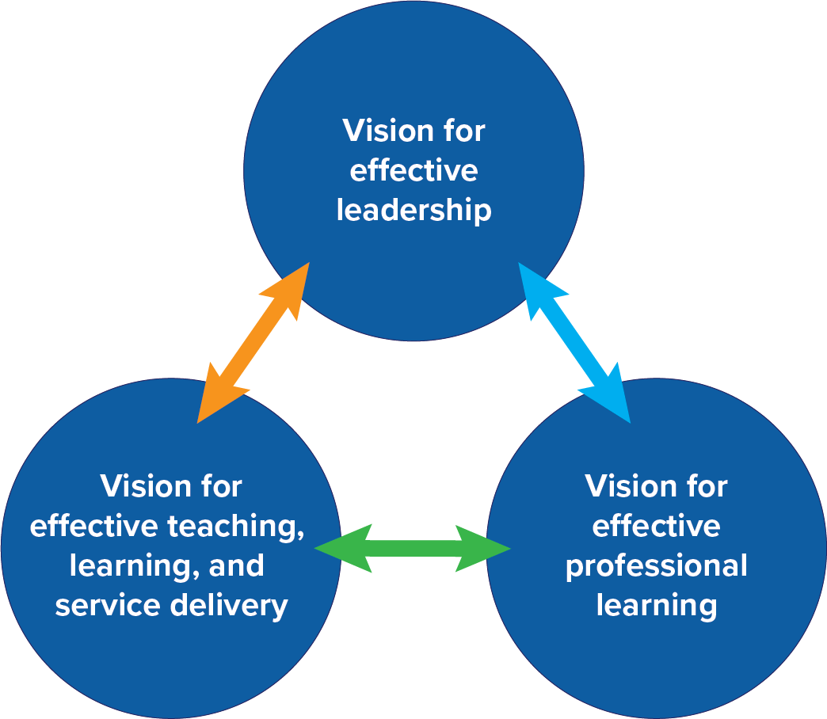

The Continuous Learning Process: Goal Setting, Professional Practice, and Evaluator/Observer/ Stakeholder Feedback and Engagement
The evaluation and support model is designed as a continuous learning process. The goal of the con- tinuous learning process is to provide leaders with continuous learning opportunities for professional growth through self-directed analysis and reflection, planning, implementation, and collaboration. Reg- ular dialogue and feedback, coupled with the opportunity to reflect on and advance practice, drive the continuous learning process. The process provides an opportunity for leaders to address organizational system and structure questions. In this process, the leader serves as the learner who actively engages in and directs their learning and feedback. The evaluator serves as a learning partner who supports the leader through the learning and growth process. Within the process, the leader collaborates and serves as a reflective practitioner to determine mutually agreed upon leader goal(s), professional practice and leader growth, and observation/site visit and feedback focus.
Within the continuous learning process, leaders check in with their evaluator a minimum of three times a year (fall goal setting, midyear check-in, and end-of-year reflection) to provide an opportunity for a reciprocal discussion of what is happening in the school or district, a sharing of evidence of professional learning and impact on growth, and identification of needs and mutually agreed upon next steps. The meetings are approached in a spirit of continuous improvement, reflection, and collaboration. Dialogue is important, however, there must be a balance of written and verbal feedback provided between check-ins based on observations/site visits, reviews of practice, and artifacts as required by the district plan, which must be provided periodically. Effective feedback is tied to standards and identifies strengths and areas of focus for growth.
At the core, educators and students learn best when educational leaders foster safe, caring, supportive learning communities, and promote rigorous curricula and instructional and assessment systems. This work requires educational leaders to build and strengthen a network of organizational supports — the professional capacity of teachers and staff; the professional community in which they learn and work; family and community engagement; and effective, efficient management and operations of the school/ district. In all their work, educational leaders are driven by the district/school’s mission, vision, and por- trait of a graduate. They are called to act ethically and with professional integrity, and they promote equi- ty and cultural responsiveness. Finally, educational leaders believe their district/schools, educators, and they themselves, can continuously grow. They are tenacious change agents who model transformational leadership (adapted from PSEL Standards).
The graphic below, adapted from Learning Forward’s Standards for Professional Learning 2022, shows the relationship between professional learning for leaders, educators, and students.

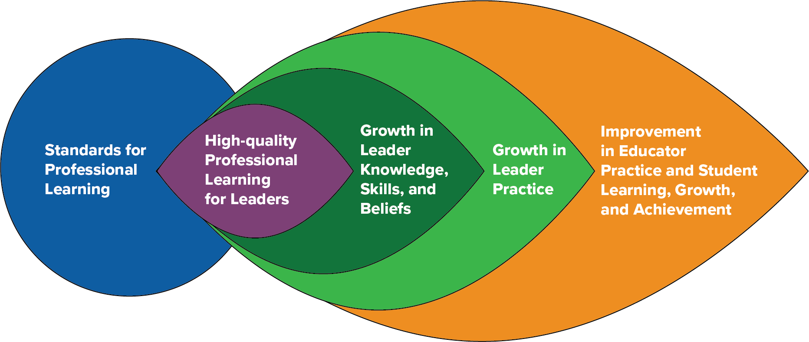

Below is a graphic with the associated steps, reflections, and linked resources associated with each step of the process to assist leaders and evaluators through the process. All leaders are assigned a primary evaluator (092 or 093).

Leader Continuous Learning Process
Evaluation Orientation
Completed prior to the start of the Continuous Learning Process
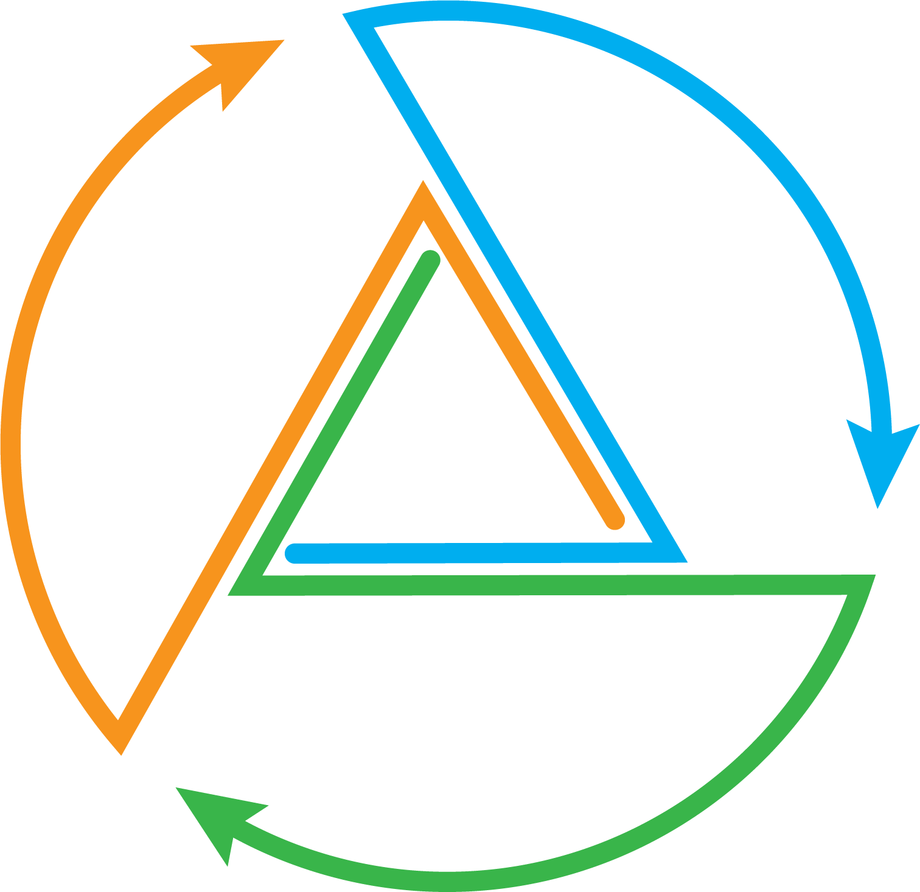
Site Visit/ Observation of professional practice, reflection and feedback
Goal Setting Completed by November 1
Mid-Year Check-in Completed by March 1
Organizational Health
Site Visit/ Observation of professional
practice, reflection and
feedback
End-of-Year Reflection
Completed by June 30

Goal Setting

Completed by November 1
Beginning of the Year Goal(s) and Planning
- Self reflect
- Review evidence
Goal(s), Rationale, Alignment, and Professional Learning Plan
- Draft goal(s), rationale, alignment, professional learning plan
Goal Setting Conference
- Mutually agree on 1-, 2-, or 3-year goal(s)
- Determine individual or group goal(s)
- Mutually agree on professional learning needs and support

Mid-year Check-in

Completed by March 1
Mid-Year Check-in: Reflection, Adjustments, and Next Steps
- Review & discuss currently collected evidence towards goal(s) and of practice
- Review professional learning, evidence, and impact on organization health, educator and student learning, growth and achievement
Mid-Year Conference
- Discuss evidence, reflection, and feedback from evaluator
- Adjust and revise as needed

End-of-Year Reflection

Completed by June 30
End-of-Year Reflection and Feedback Process
- Self-reflection: Review & discuss professional
learning, evidence of impact on organizational health, educator and student learning, growth and achievement
End-of-Year Conference/ Summative Feedback and Growth Criteria
- Evaluator provides written summative feedback and guides next steps
- Annual Summary sign-off

Orientation on the leader evaluation and support process shall take place prior to the start of the process, no later than October 15. The orientation shall include:
  - High leverage goal setting and professional learning plans
  - Use of rubrics and standards
  - Observation of practice/site visits
  - Tiered supports
  - Dispute resolution
Annual training for evaluators as required by C.G.S. 10-151b will include engaging in and providing reciprocal feedback tied to standards and evidence of professional practice.

Goal(s) Setting (Completed by November 1)
Leaders and their evaluators mutually agree upon a high leverage professional practice one-, two-, or three-year goal(s) and develop a plan for professional learning and support that is consistent with their professional status and goals (see appendix B). Goals should always be connected to standards recommended by the PDEC and approved by the local board of education.
This is a process of feedback, reflection, goal setting, opportunities for professional learning, observations by an evaluator, and collection of multiple measures of leader growth, educator growth, and impact on student learning, growth, and achievement. Within this process, the leader collaborates in a learning partnership with their evaluator. The continuous learning process begins with dialogue around leaders’ self-reflection (based on review of evidence and practice) to the identified rubric while collecting and analyzing evidence to identify and support an area for leader practice, educator and student outcomes, and organizational growth.
The leader will:
  - Self-assess using the identified rubric.
  - Identify a high leverage goal that impacts leadership practice and educator and organizational growth.
  - Identify an individual or a collaborative goal.
  - Develop a proposed professional learning plan to build knowledge and skill.
The leader shares the above with their evaluator during an initial goal setting conference that consists of dia- logue around the proposed goal(s) and professional learning plan. During this conference, reciprocal dialogue between the evaluator and leader takes place to refine the proposed goal and professional learning plan as needed. In partnership, the leader and evaluator come to mutual agreement on the goal(s), multiple measures of evidence, professional learning plan, and support to drive progress toward goal attainment.

Midyear Check-in (Completed by March 1):
The midyear check-in provides an opportunity for the leader to self-reflect and review multiple and varied qualitative and quantitative indicators of evidence of impact on professional leadership practice; organizational growth; educator growth; and impact on student learning, growth, and achievement.
Through reciprocal dialogue, the evaluator provides specific feedback based on evidence, standards, and the leader’s goal(s). This is an overview of where the leader is in the process and what steps need to be taken to assist in continuous learning. During this check-in, revisions to the goal or learning plan, direction to tiered support, and next steps are documented.

End-of-Year Reflection/Summative Review (Completed by June 30)
End-of-year reflection provides an opportunity for the leader and evaluator to engage in reciprocal dialogue, similar to the midyear check-in, to discuss progress toward the leader’s goal(s); professional learning as it re- lates to the leader’s professional growth and professional practice; and impact on student learning, growth, and achievement as evidenced by multiple and varied qualitative and quantitative indicators of evidence. A written end-of-year summary includes the impact on leader practice and growth; possible next steps for the upcoming year; any concerns with the continuous learning process; new learning; and highlights of impact on educators, students, and school community; and completion of current goal or rationale for continuing the goal the following year. Analysis of evidence from the end-of-year summary is important for the leader’s subsequent self-assessment and goal setting revisions or new goal(s).

This summary is based upon the mutually agreed upon goal(s) and identified standards and will make a distinction regarding the leader’s successful completion of the professional learning process.
All forms for documentation are hyperlinked within the graphic of the continuous learning process, with further detail for each step.

Professional Practice and Leader Growth
The implementation of the continuous learning process is shared between the leader and evaluator. For the duration of the learning process, leaders pursue learning and attainment of their goal(s), collecting evidence of practice related to their high leverage professional learning goal. Evaluators will provide leaders with feedback from observations of professional practice/site visits and dialogue, ensure timely access to support and collect evidence of leader performance and practice toward goal(s) through multi- ple sources, including site visits, student and staff feedback, or family engagement (see appendix B).

Observation of Professional Practice/Site Visits and Feedback
Observation of professional practice or site visits occur throughout the continuous learning process. The identified high leverage goal(s) provides a focus for strategic evidence collection and feedback. Evaluators provide leaders with feedback based on evidence, standards, and the educator’s goal(s); ensure timely access to planned support(s); and collect evidence of leader practice and progress toward goal(s) through multiple sources of evidence including site visits, feedback, written or verbal, that is provided within five school days.
“Feedback is defined as a dynamic, dialogic process that uses evidence to engage a learner, internally or with a learning partner, in constructing knowledge about practice and self. Its primary purpose is learning that guides change” (Killion, 2019).
Quality feedback:
  - Is based on multiple and varied quantitative and qualitative indicators of evidence, standards, and goal(s)
  - Is personalized
  - Is learning-focused or growth-oriented
  - Provides questions for reflection to refine or revise strategies
  - Expands understanding of one’s experiences and their implications for future experiences
  - Provides reflective opportunities to rework, refine, and reorder knowledge, attitudes, skills, and/or practices
  - Is timely, frequent, and reciprocal

Definition of Cohorts
Cohort 1 Cohort 2
Who: Who:
- New to leadership role (e.g., principal from • Leaders who have successfully completed assistant principal etc.; first three years) Cohort 1 in their current LEA
- New to LEA (first three years) What:
What: • Two observations of professional practice
- Three observations of professional practice and/or site visits
and/or site visits • Feedback written and verbal within five
- Feedback written and verbal within five school days
school days • Additional observations of professional
- Additional observations of professional practice and/or site visits as mutually agreed practice and/or site visits as mutually agreed upon or deemed necessary
upon or deemed necessary

Growth Criteria
Successful completion of the learning process is determined through multiple forms of evidence and reflection that is demonstrated by:
  - Reflection supported with evidence of the impact of the leader’s new learning on their practice/goal
  - The impact the leader’s new learning and practice had on the leader’s practice, organizational growth, educator growth, and student outcomes.
  - Next steps
See appendix C for further detail.

Tiered Support and Corrective Support Planning
All leaders require access to high-quality, targeted professional learning support to improve practice over time. Leaders and their evaluators thoughtfully consider and apply three tiers of support, as appropriate, with an evaluation process. All three tiers of support must be implemented prior to the development of a Corrective Support Plan.
A pattern of persistent lack of growth and reflection or resistance to growth-oriented feedback should lead to advancing levels of support with a defined process for placing a leader on a Corrective Support Plan with indicators of success for transitioning out of it. Evaluators must utilize and document all three tiers of support prior to the development of a Corrective Support Plan. The Corrective Support Plan shall be devel- oped in consultation with the evaluator, leader and their exclusive bargaining representative if applicable.

Tier 1
It is the expectation that all leaders consistently access opportunities for professional growth within their district. Tier 1 supports are broadly accessible professional learning opportunities for all, inclusive of, but not limited to, collegial conversations, school site visits, available district resources (e.g., books, articles, videos, etc.), formal professional learning opportunities developed and designed by your district PDEC and other leader supports (e.g., leadership coaching). These resources should be identified through a goal setting process by mutual agreement.

Tier 2
In addition to Tier 1, Tier 2 supports are more intensive in duration, frequency, and focus (e.g., observation of specific leadership practices, etc.) that can be either suggested by the leader and/or recommended by an evaluator.

Tier 3
In addition to Tier 1 and Tier 2, Tier 3 supports are responsive to unresolved, previously discussed concerns that are collaboratively discussed and may be assigned by an evaluator. Tier 3 supports have clearly articulated areas of focus, duration of time, and criteria for success, and may include a decision to move to a Corrective Support Plan. Tier 3 supports shall be developed in consultation with the evaluator, leader and their exclusive bargaining representative for certified leaders chosen pursuant to C.G.S. §10- 153b. The start date and duration of time an educator is receiving this level of support should be clearly documented (see appendix H).

Corrective Support Plan
A pattern of persistent lack of growth and reflection or resistance to growth-oriented feedback should lead to advancing levels of support with a defined process for placing a leader on a Corrective Support Plan with indicators of success for transitioning out of it. Evaluators must utilize and document all three tiers of support prior to the development of a Corrective Support Plan. The Corrective Support Plan shall be developed in consultation with the evaluator, leader and their exclusive bargaining representative for certified leaders chosen pursuant to C.G.S. §10-153b.

The Corrective Support Plan must contain:
  - clear objectives specific to the well documented area of concern;
  - resources, support, and interventions to address the area of concern;
  - timeframes for implementing the resources, support, and interventions; and
  - supportive actions from the evaluator.
At the conclusion of the Corrective Support Plan period, a number of outcomes are possible as determined in consultation with the evaluator, leader and bargaining unit representative.
See appendix H for a Corrective Support Plan form and example.

Dispute Resolution
The purpose of the dispute resolution process is to secure at the lowest possible administrative level eq- uitable solutions to disagreements, which from time to time may arise related to the evaluation process. The right of appeal is available to all in the evaluation and support system. As our evaluation and support system is designed to ensure continuous, constructive and cooperative processes among professional educators, educators/leaders and their evaluators are encouraged to resolve disagreements informally.
Ultimately, should a leader disagree with the evaluator’s assessment and feedback, the parties are encouraged to discuss these differences and seek common understanding of the issues. As a result of these discussions, the evaluator may choose to adjust the report but is not obligated to do so. The
leader being evaluated has the right to provide a statement identifying areas of concern with the goals/ objectives, evaluation period, feedback, and/or professional development plan, which may include the individual professional learning plan or a Corrective Support Plan.
Any such matters will be handled as expeditiously as possible, and in no instance will a decision exceed thirty (30) workdays from the date the leader initiated the dispute resolution process. Confidentiality throughout the resolution process shall be conducted in accordance with the law.

Process
The leader being evaluated shall be entitled to collective bargaining representation at all levels of the process.
- Within three school days of articulating the dispute in writing to his/her/their evaluator, the leader being evaluated and the evaluator will meet with the objective of resolving the matter informally.
- If there has been no resolution, the individual may choose to continue the dispute resolution process in writing to the superintendent or designee within three workdays of the meeting with his/her/their evaluator (step 1). The leader being evaluated may choose between two options.
  - Option 1:
The issue in dispute may be referred for resolution to a subcommittee of the Professional Development and Evaluation Committee (PDEC), which will serve as a neutral party.* The superintendent or designee and the respective collective bargaining unit for the district may each select one representative from the PDEC to constitute this subcommittee, as well as a neutral party as mutually agreed upon between the superintendent and the collective bargaining unit. It is the role of the subcommittee to determine the resolution of the dispute and to identify any actions to be taken moving forward and to notify the superintendent of the decision.
*In the instance that a district is too small to have a full PDEC from which to select three individuals, the superintendent and leader may select three mutually agreed upon persons to serve as the neutral party for resolving the dispute. Each individual must be a Connecticut certified leader and may or may not be from within the district.

  - Option 2:
The leader being evaluated requests that the superintendent or designee solely arbitrate the issue in dispute. In this case, the superintendent will review all applicable documenta- tion and meet with both parties (evaluator and leader being evaluated) as soon as possi- ble, but no longer than five school days from the date of the written communication to the superintendent. The superintendent will act as arbitrator and make a final decision, which shall be binding.

Time Limits
- Since it is important that appeals be processed as rapidly as possible, the number of days indi- cated within this plan shall be considered maximum. The time limits specified may be extended by written agreement of both parties.
- Days shall mean workdays. Both parties may agree, however, to meet during breaks at mutually agreed upon times.
- The leader being evaluated must initiate the appeals procedure within five workdays of the scheduled meeting in which the feedback was presented. If no written initiation of a dispute is received by the evaluator within five workdays, the leader shall be considered to have waived the right of appeal.
- The leader being evaluated must initiate each level of the appeal process within the number of days indicated. The absence of a written appeal at any subsequent level shall be considered as waiving the right to appeal further.

The Role of the Professional Development and Evaluation Committee (PDEC)
The PDEC serves as the collaborative decision maker using the consensus protocol to create, revise, and monitor the evaluation and support model, as well as the professional learning plan to propose to the local board of education for mutual agreement.
Pursuant to Connecticut General Statute 10-220a and Public Act 23-159 Section 11(b)(3), each local and regional board of education must establish a professional development and evaluation committee to include at least one teacher and one administrator, selected by the exclusive bargaining representative for certified employees, at least one paraeducator selected by their exclusive bargaining representative, and other personnel as the local board deems appropriate. It is vital that individuals selected as delegates for administrators, teachers, paraeducators, and other school personnel are representative of the various classifications within the groups (see examples below).

Other School Personnel | Educator | Leader
- Attendance counselor  - Paraeducator (required)  - Behavior technician  - Parent and family liaison  - Social emotional support staff | - Classroom teacher  - CTE teacher  - Library media specialist  - Reading interventionist  - Instructional coach  - Special education teacher  - Social worker  - School psychologist  - Speech pathologist | - Principal  - Assistant principal  - TESOL supervisor  - Special education supervisor  - Assistant superintendent  - Curriculum coordinator  - Talent development super- visor

The duties of PDECs shall include, but are not limited to,
  - participation in the development or adoption of a teacher evaluation and support program for the district, pursuant to section 10-151b;
  - the development, evaluation, and annual updating of a comprehensive local professional development plan for certified employees of the district; and
  - the development and annual updating of a comprehensive local professional development plan for paraeducators of the district.
The educator and leader evaluation and support program shall be developed through mutual agreement between the local or regional board of education and the PDEC. If the local or regional board of education and the PDEC are unable to come to mutual agreement, they shall consider the state
model evaluation and support plan adopted by the State Board of Education and may, through mutual agreement, adopt such model educator and leader evaluation and support programs.
If the local or regional board of education and the PDEC are unable to mutually agree on the adoption of the State Board of Education’s model program, then the local or regional board of education shall adopt and implement an educator and leader evaluation and support program developed by such board, pro- vided that the program is consistent with the guidelines adopted by the State Board of Education.

Local and State Reporting
The superintendent shall report:
- the status of teacher evaluations to the local or regional board of education on or before June 1 of each year; and
- the status of the implementation of the teacher evaluation and support program, including the frequency of evaluations, the number of teachers who have not been evaluated, and other requirements as determined by the Department of Education, to the Commissioner of Education on or before September 15 of each year.
For purposes of this section, the term “teacher” shall include each professional employee of a board of education, below the rank of superintendent, who holds a certificate or permit issued by the State Board of Education.

Technical Assistance and Professional Learning
The CSDE works closely with schools and districts to learn what support is most needed for effective implementation of the CT Guidelines 2023 framework. To that end, the CSDE continues to develop resources in partnership with the six regional educational service centers, ACES, CES, CREC, EASTCONN, EdAdvance, and LEARN along with CAS and feedback from districts. You are encouraged to reach out for technical assistance and professional support during the transition to this new framework.

Appendices — Leader:
Information and Resources to Support Effective Implementation

Appendix A: Sample Reflection Questions – Leader

Self-Reflection Sample Questions
- Thinking about the success and challenges you may have encountered last year, or at the start of this year, what questions do you have about leadership and organizational well-being? What new learning might you want to explore to inform your understanding of these questions and professional leadership practice?
- In reviewing the rubric, what areas emerge as opportunities for your professional learning and practice?
- Based on your current organization’s strengths and needs, and/or knowledge of district/school/ program goals, what new learning might you explore to address the needs?
- Based on knowledge of your students/adult learners, and/or knowledge of school/program goals, are there any new strategies or methods you’d like to explore and implement this year?
- How do you see yourself contributing to the school or district’s mission, vision, and/or Portrait of a Graduate and what strategies can you learn more about to support that focus?
- What are you considering for your learning goal?
- What will it look like when you achieve your goal?

Professional Learning and Action Questions

Indicators of success
- What question will you focus on to address your goals?
- What are the criteria for an accomplished practice?
- How do you plan to collect and analyze evidence to assess progress toward your goals?
- What research/professional readings might you explore to support your professional learning and achieve your goal?
- What specific professional learning might you need to achieve your goal?
- What support might you need from your colleagues, supervisor, others? How frequently?
- How might you apply your learning to practice? How often?

Determine Evidence
- What evidence might you collect and analyze to understand progress toward your goal? Quantitative or qualitative or both?
- What ways would you like me as your evaluator to collect data/evidence for feedback?
- From how many different situations should we examine data/evidence?
- What are the advantages and disadvantages of the identified evidence?
- How will the data help us to analyze your practice?
- What is your timeline for collecting this evidence and measuring impact?
- What are the anticipated challenges or obstacles, and how do you plan to address them?
- How might you communicate/share your professional learning to your colleagues or families?
- What opportunities for professional learning do you believe would be beneficial for your growth as an educator?
- In what ways can we encourage collaboration and communication among colleagues to promote a culture of sharing best practices?

Analysis of Evidence
- What do you observe in your evidence?
- What patterns, themes, or outliers do you notice?
- What does the evidence say about how you are doing in relation to your goal and indicators of success?
- Based on the evidence and your practice overall, what are your strengths?
- In what aspect do you want to continue to grow or refine your knowledge, skill, practice?

Learning Reflection and Next Steps
- What is clear to you now?
- What are you learning?
- What do you understand now that you didn’t understand as clearly before?
- How will this learning influence future actions?
- What is a single sentence conclusion that represents your learning?
- Under what circumstance might this conclusion not be true?
- What are ways you continue to refine your practice?
- What more do you want to learn and practice?
- How might you accomplish that? What is your next plan?
- What resources and support do you want or need?
- Once learning has been implemented: What effect did the learning have on practice, students?

Reflect on the Feedback Process
- In what ways did my engagement with you support your learning?
- What did I do as a learning partner that helped you as a learner and how did it help?

Appendix B: Definition of Cohorts – Leader

Definition of Cohorts
Cohort 1  Who:  - New to leadership role (e.g., principal from assistant principal, etc.; first three years)  - New to LEA (first three years)  What:  - Three observations of professional  practice and/or site visits  - Feedback written and verbal within five  school days  - Additional observations of professional  practice and/or site visits as mutually agreed upon or deemed necessary | Cohort 2  Who:  - Leaders who have successfully completed Cohort 1 in their current LEA  What:  - Two observations of professional practice and/or site visits  - Feedback written and verbal within five school days  - Additional observations of professional practice and/or site visits as mutually agreed upon or deemed necessary

Appendix C: Growth Criteria and Sources of Evidence – Leader

Development of New Learning and Impact on Practice
- The leader can demonstrate how they developed new learning within the continuous learning process through multiple sources (e.g., observational feedback, data, walkthroughs, etc.) and how they used their new learning to improve practice.
Impact on the Organization
- The leader can demonstrate how they positively impacted the organizational health and can articulate connections/rationale between the improved learning and their own changes in practice.
Impact on Community
- The leader can demonstrate how they worked effectively with colleagues/families/community.
- Information from site visits
- Strategic plans
- Learning walk/instructional rounds
- Self-reflection (e.g., journals, learning logs)
- Leader created professional learning materials
- Operational artifacts (e.g., schedules, procedural revisions)
- Educator learning outcomes
- Policy updates
- Community communications
- Constituent feedback
- Program development and implementation
- Quantitative measure of whole child development (including, but not limited to, academic, social, emotional, and physical development)
- Systems and structures
Growth Criteria Possible Sources of Evidence

Appendix D: General Glossary – Leader

consensus protocol: Consensus decision-making is a creative and dynamic way of reaching agreement in a group. Instead of simply voting for an item and having the majority getting their way, a consensus group is committed to finding solutions that everyone actively supports — or at least can live with.
By definition, in consensus no decision is made against the will of an individual or a minority. If significant concerns remain unresolved, a proposal can be blocked and prevented from going ahead. This means that the whole group has to work hard to find win-win solutions that address everyone’s needs.
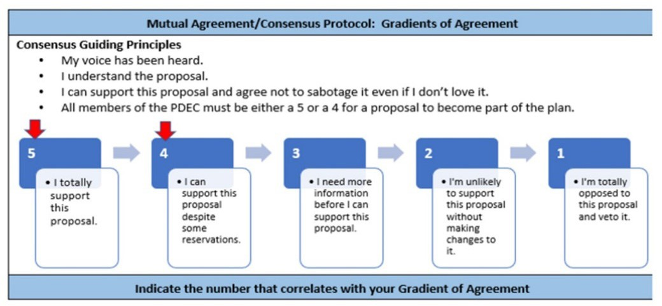

From Consensus decision making. Seeds for Change. (n.d.). https://www.seedsforchange.org.uk/consensus

Corrective Support Plan: A pattern of persistent lack of growth and reflection or resistance to growth- oriented feedback should lead to advancing levels of support with a defined process for placing an educator on a Corrective Support Plan with indicators of success for transitioning out of it. The Corrective Support Plan shall be developed in consultation with the educator and their exclusive bargaining representative for certified teachers chosen pursuant to C.G.S. §10-153b. Corrective Support Plans
shall include clear objectives specific to the well documented area of concern; resources, support, and interventions to address the area of concern; timeframes for implementing the resources, support, and interventions; supportive actions from the evaluator; and outcomes or further action as determined in consultation with the evaluator, leader, and bargaining unit representative.
check-ins: Formal or informal meetings or conferences held in the spirit of collaboration between the leader and evaluator and to engage in reciprocal dialogue regarding what is happening in one’s practice at that moment in time including goal(s), professional learning, multiple and varied forms of quantitative and qualitative evidence, adjustments, and next steps (i.e., classroom/school/building or district). During each school year, a minimum of three check-ins provide an opportunity for discussions to set and adjust goals, celebrate growth and positive impact, identify needs, assess and discuss evidence and learning, and next steps in one’s learning.
community: A school community typically refers to the localized group of students, educators, parents, and staff within a specific school, fostering a sense of belonging and shared objectives within that school.
A district community encompasses a broader scope, involving multiple schools within a school district, and often includes administrators, teachers, students, and families collaborating across various educational schools and programs within that district. The district community addresses overarching educational policies, resource allocation, and coordination among multiple schools and programs to promote consistent and effective education across a larger administrative unit.

continuous learning process: The continuous learning process is a cycle of feedback, reflection, goal setting, opportunities for professional learning, feedback from observations (peers or evaluators), and a collection of multiple measures of evidence. There are multiple models of continuous learning including, but not limited to:
- The Supporting Teacher Effectiveness Project (STEP)
- Massachusetts Department of Elementary and Secondary Education 5-Step Cycle and Model System for Educator Evaluation
- Ohio Department of Education – Ohio Teacher Evaluation System (OTES 2.0) Framework
- Tennessee Educator Acceleration Model
- Connecticut TEAM Process (CAPA)
dispute resolution: A process for resolving disputes in cases where the evaluator and leader being evaluated cannot agree on goals/objectives, the evaluation period, feedback, or the professional learning plan or other outcomes of the evaluation process.
evidence: Evidence collected and presented as a part of the evaluation system may include (but is not limited to) artifacts, observations of practice, site visit feedback, and reflections of the leader impact on organizational health, educator growth, and student learning, growth, and achievement as part of the leader feedback process.
feedback: “Feedback is defined as a dynamic, dialogic process that uses evidence to engage a learner, internally or with a learning partner, in constructing knowledge about practice and self. Its primary purpose is learning that guides change” (Killion, 2019).
Quality feedback:
- Is based on multiple and varied quantitative and qualitative indicators of evidence, standards, and goal(s)
- Is personalized
- Is learning-focused or growth-oriented
- Provides questions for reflection to refine or revise strategies
- Expands understanding of one’s experiences and their implications for future experiences
- Provides reflective opportunities to rework, refine, and reorder knowledge, attitudes, skills, and/ or practices
- Is timely, frequent, and reciprocal
From Killion, J. (2019). The feedback process: Transforming Feedback for Professional Learning. Learning Forward.
formal observations: A formal observation is a structured and planned process of watching, assessing, and evaluating a leader’s performance. This typically includes a pre-conference and post-conference and results in a written evaluation within five school days.
goals and standards: Should be a high leverage goal based on professional practice standards and consistent with the goals of the district. Clear alignment between district, school, and certified staff goals (departments, grade-level teams, or collaborations) improves the collective effectiveness of practice.
growth criteria: Successful completion of the Continuous Improvement Process, supported with evidence that includes the impact the leader’s new learning had on their practice/goal, along with a reflection on challenges and next steps; and the impact the leader’s new learning and practice had on organizational health, educator growth, student learning, growth, and/or achievement, supported by evidence.
high leverage goals: High leverage goals are based on professional practice standards and are transferable across roles, disciplines, and positions and aligned to a strategic focus. They address strategies for development of human capital (people), instruction (knowledge and skills), and organizational management that transcends schools (Grissom, et al., 2021).

informal observations: An informal observation is an unplanned visit intended to evaluate educator performance. This typically includes either verbal or written feedback provided to the educator within five school days.
leader: A leader is defined as someone in a leadership position who has attained the 092 certification. This may include assistant superintendent, principal, dean of students, assistant/vice principal, pupil services director, department chair. This is not an exhaustive list, rather to illustrate the definition.
Superintendents will confirm district leaders with evaluation roles.
multiple measures: Can include, but is not limited to, structures and systems to support educator learn- ing and growth, culture and climate changes, student learning, growth, and achievement as mutually agreed upon during the goal-setting process. Additional evidence relative to one or more competencies.
mutual agreement: An agreement or condition that is reciprocal or agreed upon by all parties.
organizational health: Organizational health in schools and districts means how well the whole school system is functioning. It encompasses various interconnected elements that contribute to a positive and thriving learning environment, including leadership, culture and climate, communication, professional learning, resource management, collaboration and teamwork, student-centered focus, continuous improvement, community engagement, and innovation.
PDEC (Professional Development and Evaluation Committee): The Professional Development and Evaluation Committee serves as the collaborative decision maker to create, revise, and monitor the evaluation and support program for the district, as well as the professional learning plan for certified employees of the district.
professional learning: Professional learning and growth are centered on accelerating personal and collective learning and closing the knowing-doing gap for leaders and teachers. This includes co- designing interactive, sustained, and customized learning growth opportunities that are grounded in the evidence that is most needed and most effective. See also appendix E, Glossary of Professional Learning Opportunities.
review of practice: Reviews of practice are non-classroom observations and may include, but are not limited to, observation of delivery of professional learning, facilitation of meetings, coaching/mentoring other leaders or teachers, review of leader or educator work, or review of other leader artifacts.
rubric: A rubric is a systematic and standardized tool, designed as a continuum, and is used to communicate the performance of educators based on specific criteria. It can be used to evaluate a single criterion to emphasize specific expectations and provide targeted feedback for improvement. It can encourage a growth mindset.
single point competency: A description of a standard of behavior or performance that is framed only as a single set of desired outcomes rather than laid out across a rating or scale of performance like a more traditional rubric.
site visits: A site visit provides an opportunity for observation and dialogue with the leader that may in- clude but is not limited to leader engagement with educators, families or other partners in the work with a focus on the leader’s goal.
student outcomes: Student outcomes include multiple measures of student learning, growth, and achievement as mutually agreed upon during the goal setting process.

tiered support:
Tier 1
It is the expectation that all leaders consistently access opportunities for professional growth within their district. Tier 1 supports are broadly accessible professional learning opportunities for all, inclusive of, but not limited to, collegial conversations, school site visits, available district resources (e.g., books, articles, videos, etc.), formal professional learning opportunities developed and designed by your dis- trict PDEC and other leader supports (e.g., leadership coaching). These resources should be identified through a goal setting process by mutual agreement.

Tier 2
In addition to Tier 1, Tier 2 supports are more intensive in duration, frequency, and focus (e.g., observation of specific leadership practices, etc.) that can be either suggested by the leader and/or recommended by an evaluator.

Tier 3
Tier 3 supports are responsive to previously discussed concerns and are assigned by an evaluator. Tier 3 supports have a clearly articulated area of focus, duration of time, and criteria for success, and may include a decision to move to a Corrective Support Plan.

Appendix E: Glossary of Professional Learning Opportunities – Leader

High quality professional learning enhances both leader practice and outcomes for each and every educator and student. High quality professional learning integrates research on effective adult learning and uses interactive, flexible designs to achieve intended outcomes.
advanced coursework: Courses offered at a college, university, or other institution, in person or online, which further educator skills and/or provide professional training.
case study: A team that engages in a case study using information in a student’s cumulative folder or other documented information with the intention of determining next steps, i.e., IEP review or attendance records.
coaching: A process based on trust in which professional colleagues work together to reflect on current practices; expand, refine, and build new skills; share ideas; teach one another; conduct classroom research; or solve problems.
examination of student work: Individuals or groups of educators review samples of work from various students. They identify strengths, areas for improvement, and design instructional plans as a result of the examination.
job-embedded: Any activity that is tied in with authentic classroom practice. May include, but is not limited to:
- Examining student data
- Mentoring
- Book study (see below)
- Co-planning
- Investigating print and online resources
- Self-reflection
- Visitations/observations within a school
lesson study: Groups of teachers planning a lesson, observing one present the lesson, and then reflecting on it afterwards.
mentoring: A relationship between a less experienced educator and a more experienced mentor, in which the mentor provides guidance and feedback regarding practice.
peer observation: An opportunity for teachers to observe each other during classroom instruction. Teachers may want to observe peers to see a new teaching strategy in action, learn a new model of instruction, or analyze classroom processes and procedures.
personal professional reading: Individual, self-driven reading and processing of texts in order to improve one’s own teaching practice.
professional literature study: Structures and collaborative processes in which individuals or groups of professionals engage in the examination and discussion of a relevant and informative text. The purpose of this study is to promote continuous learning, professional development, and the exchange of ideas and best practices within a specific field or industry. By engaging in a professional book study, individuals can deepen their understanding of key concepts, stay current in their field, and enhance their ability to apply new knowledge to their professional practice. This collaborative and structured approach to learning helps foster a culture of continuous improvement and professional growth within a community of practitioners.

protocols: A learning tool that is rule-based. Often implemented to aid in new learning for groups or individuals. May include article discussions, case studies, book reviews, and other procedures used in its workshops and other learning designs.
school visits: Observation of practice or teaching at a different school or institution to gain new knowledge, ideas, or activities.
student shadow: Follow a particular student during the academic day for a designated time, for a particular identified purpose, i.e., engagement.
walkthroughs: A team of leaders who visit classrooms to find evidence for a particular problem of practice. This evidence is reviewed, and next steps are determined as a result of this practice.
web-based learning: Use of online resources or learning activities to develop new learning or techniques for the classroom.
workshops: Meetings where participants are involved in group discussions or learning experiences and are normally organized around one or more theme areas. Workshops allow participants with differing values and priorities to build a common understanding of the problems and opportunities confronting them. May take place at school or outside.

Appendix F: Continuous Learning Process – Leader

Evaluation Orientation
Orientation to Leader Evaluation was Completed on:
Date
Non-negotiable Process Element of the CT Guidelines (2023)

Download these forms:

Leader Goal-Setting Form Leader/Site Visit Form
Leader Mid-Year Check-In Form
Leader End-of-Year Self-Reflection Form Leader End-of-Year Conference Form

Download this form
Leader Information

Name: |  | Location:
Select One:  - Cohort 1  *New to leader role or first three years in LEA  - Cohort 2  *Years 4 (in LEA) | Select One:  - Individual goal  - Collaborative goal  Decided upon mutual agreement. | Select One:  - 1-year goal  - 2-year goal  - 3-year goal  Decided upon mutual agreement. | Select One:  - PSEL Rubric
Download this form

Beginning-of-the-Year Goals and Planning
Self-Reflection
Completed by Leader
See Sample Reflection Questions
Capture your self-reflection here; consider using the Sample Questions linked above to guide your thinking.
See Examples of Evidence Types
Goal, Rationale, Alignment and Professional Learning Plan
Completed by Leader
Based on your analysis above, what is/are your goal(s)? Include a rationale for the length of your goal (1, 2, 3 year).
What evidence of leader learning, educator learning, and/or student growth and achievement, and/or organizational measures will you use to reflect, monitor, and adjust your goal? What is your learning plan to support achieving your goal?
See professional learning and action questions to guide your plan.
For multi-year goal(s), what might be the potential focus of years 2 and 3 (to be revisited and revised annually and as needed throughout the learning process)?
In what ways might this goal(s) contribute to the school and/or district’s vision, mission, and strategic goals?

Goal Setting Conference Completed by Evaluator (By November 1) Date
Notes: | Supports Required/Suggested  - Tier 1  - Tier 2 (Link to Examples of Supports)  - Tier 3 (Link to Examples of Supports)

Download this form

Planned Site Visit/Observation of Professional Practice
Non-negotiable Process Element of the CT Guidelines (2023)
Observation of Professional Practice/Site Visit #1 - Required
Additional Observation of Professional Practice/Site Visit

Midyear Check-in: Reflection, Adjustment(s), and Next Steps
Completed by Leader
Non-negotiable Process Element of the CT Guidelines (2023)
See Sample Reflection Questions and Professional Learning and Action Questions
What has been your progress to date on your professional learning plan and your goal(s), and how do you know? What are your next steps and why? | Self-Reflection:
Links to Evidence:

Midyear Conference
Completed by Evaluator (by March 1)
Date
Feedback to Leader (Feedback regarding progress on professional learning and progress toward goal(s). Include change in tiered supports, if recommended.):

Observation of Professional Practice/Site Visit #2 - Required
Additional Observation of Professional Practice/Site Visit

Download this form

End-of-Year Reflection and Feedback Process
Non-negotiable Process Element of the CT Guidelines (2023)
Self-Reflection
Completed by Leader
See Sample Reflection Questions and Professional Learning and Action Questions
What impact did your new learning have on your practice/goal(s), and how do you know?  What impact did your new learning have on your leadership practice, on educator and/or student  learning, growth, and/ or achievement, and/or  on organizational health, and how do you know?  What challenges did you encounter and what are your next steps  with your professional learning? | Self-Reflection:
Links to Evidence:

Download this form

End-of-Year Conference
Completed by Evaluator (by June 30)
Date
Summative Feedback and Growth Criteria
Completed by Evaluator
See appendix for full description
Summative Feedback
Development of new learning and impact on leadership practice related to goal(s).
Impact of new learning and leadership practice on key partners and or organizational outcomes.
Impact of new learning on greater community.
Successful Completion of the Evaluative Cycle | - Yes • No
Supports Required/Suggested  Are tiered supports required above and beyond tier 1 (included in feedback above)?  - Not applicable  - Tier 2 (Specify below)  - Tier 3 (Specify below) | If Tier 2 and/or Tier 3, please specify strategies:
For multi-year goals only:  - What adjustments are needed to the goal(s)?  - Why?  - How might adjustments impact the timing of the goal(s)? | - Leader will continue multi-year goal.  - Leader will adjust multi-year goal.  - Leader completed multi-year goal. Notes:
Leader Signature | Date:
Evaluator Signature | Date:

Appendix G: Observation/Site Visit Forms – Leader
Download this form

Leader Evaluation Observation/Site Visit #1 – Required
Name: |  | Location:
Administrator Role: |  | Leader Goal/Observation Focus:
- Cohort 1 (Pre-/Post-Conference Required)
- Cohort 2 (Post-Conference Required)
- Additional Site Visit (Pre-/Post-Conference Optional)
Pre-Observation/Visit
Completed by Leader (as needed/required)
Meeting Plan and/or Context | Upload and provide hyperlink here, as appropriate
Pre-Conference Notes
Observation/Site Visit Evidence
Completed by the Evaluator
Post-Observation/Visit Reflection
Completed by the Leader
What does today’s evidence tell you?
Are there patterns, trends, or outliers?
How will our collaborative reflection help you move forward and apply your learning in your next steps?
Post-Observation/Visit Conference Feedback
Completed by the Evaluator
Areas of Strengths | Single-Point Competencies  Completed by the Evaluator |  | Areas for Growth and/or Next Steps
 | Insert competencies

Download this form

Leader Evaluation Observation/Site Visit #2 – Required
Name: |  | Location:
Leadership Role: |  | Leader Goal/Observation Focus:
- Cohort 1 (Pre-/Post-Conference Required)
- Cohort 2 (Post-Conference Required)
- Additional Site Visit (Pre-/Post-Conference Optional)
Pre-Observation/Visit
Completed by Leader (as needed/required)
Meeting Plan and/or Context | Upload and provide hyperlink here, as appropriate
Pre-Conference Notes
Observation/Site Visit Evidence
Completed by the Evaluator
Post-Observation/Visit Reflection
Completed by the Leader
What does today’s evidence tell you?
Are there patterns, trends, or outliers?
How will our collaborative reflection help you move forward and apply your learning in your next steps?
Post-Observation/Visit Conference Feedback
Completed by the Evaluator
Areas of Strengths | Single-Point Competencies  Completed by the Evaluator |  | Areas for Growth and/or Next Steps
 | Insert competencies

Download this form

Leader Evaluation Observation/Site Visit #3
Name: |  | Location:
Leadership Role: |  | Leader Goal/Observation Focus:
- Cohort 1 (Pre-/Post-Conference Required)
- Cohort 2 (Post-Conference Required)
- Additional Site Visit (Pre-/Post-Conference Optional)
Pre-Observation/Visit
Completed by Leader (as needed/required)
Meeting Plan and/or Context | Upload and provide hyperlink here, as appropriate
Pre-Conference Notes
Observation/Site Visit Evidence
Completed by the Evaluator
Post-Observation/Visit Reflection
Completed by the Leader
What does today’s evidence tell you?
Are there patterns, trends, or outliers?
How will our collaborative reflection help you move forward and apply your learning in your next steps?
Post-Observation/Visit Conference Feedback
Completed by the Evaluator
Areas of Strengths | Single-Point Competencies  Completed by the Evaluator |  | Areas for Growth and/or Next Steps
 | Insert competencies

Download this form

Leader Evaluation Observation/Site Visit #4
Name: |  | Location:
Leadership Role: |  | Leader Goal/Observation Focus:
- Cohort 1 (Pre-/Post-Conference Required)
- Cohort 2 (Post-Conference Required)
- Additional Site Visit (Pre-/Post-Conference Optional)
Pre-Observation/Visit
Completed by Leader (as needed/required)
Meeting Plan and/or Context | Upload and provide hyperlink here, as appropriate
Pre-Conference Notes
Observation/Site Visit Evidence
Completed by the Evaluator
Post-Observation/Visit Reflection
Completed by the Leader
What does today’s evidence tell you?
Are their patterns, trends or outliers
How will our collaborative reflection help you move forward and apply your learning in your next steps?
Post-Observation/Visit Conference Feedback
Completed by the Evaluator
Areas of Strengths | Single-Point Competencies  Completed by the Evaluator |  | Areas for Growth and/or Next Steps
 | Insert competencies

Appendix H: Sample Corrective Support Plan – Leader

(Sample)
Leader A has consistently struggled with communicating appropriately with a variety of constituents. Tiered supports have been provided by the evaluator throughout the year. Leader A has demonstrated a lack of growth/improvement, which has led the evaluator to assign a Corrective Support Plan.

Objective:
To improve engagement with families in communities (PSEL – Standard 8) and to improve operations in management (PSEL – Standard 9)

Resources:
- All communications previewed by the evaluator for content and timeliness.
- Collaboration with other district leaders for exemplars of communication.

Timeframes:
- Leader A will remain on this Corrective Support Plan for six weeks.
- Improvements in communication within this six-week duration will serve as criteria for successful completion of this plan.

Supportive Actions:
- Weekly, bi-weekly meetings with progress reporting from Leader A and written feedback from evaluator (dependent upon need for plan).
- All resources made available.
- Modeling of effective communication practices with role play opportunities.
- Timely feedback in person and in writing (weekly/bi-weekly meetings).
- Management of access to learning opportunities in and out of building, as appropriate.

Corrective Support Plan Template
(Leader being evaluated) has consistently struggled with
. Tiered supports have been provided by the evaluator throughout the year. (Leader being evaluated) has demonstrated a lack of growth/improvement, which has led the (Evaluator) to assign a Corrective Support Plan.

Objective:
To improve
(Indicate specific standard in your objective language)

(Possible) Resources:
A blend of opportunities and resources should be extended to the Leader being evaluated being supported on the Corrective Support Plan
- Mentor
- Coach
- Reading as appropriate

Timeframes:
- (Length of the Corrective Support Plan – typically six to eight weeks in length)
- Improvements in (standard) within this (Length of Corrective Support Plan) will serve as criteria for successful completion of this plan

Supportive Actions:
(Suggested supportive actions)
- Weekly, bi-weekly meetings with progress reporting from Leader A and written feedback from evaluator (dependent upon need for plan)
- All resources made available
- Timely feedback in person and in writing (weekly/bi-weekly meetings)
- Management of access to learning opportunities in and out of building, as appropriate.

Educator Evaluation and Support Plan

Insert District name, logo and members

Date | Logo

District Board of Education Members | District PDEC Members

Vision
All Connecticut educators and leaders have the opportunity for continuous learning and feedback, to develop and grow, both individually and collectively, through the educator and leader evaluation and support system so that all Connecticut students experience growth and success.

The Purpose of this Model Guide
The Connecticut (CT) Model Evaluation and Support Plan is designed to support a comprehensive educator and leader evaluation system adopted by the Connecticut State Board of Education in concert with a wide range of stakeholders and pursuant to educator evaluation regulations. Connecticut General Statutes 10-151b requires that “the superintendent of each local or regional board of education shall annually evaluate or cause to be evaluated each teacher.”
The CT Model Evaluation and Support Plan includes tools, guidance, and rubrics to support the evaluation of all educators and leaders. Professional Development and Evaluation Committees (PDECs) can adopt the CT Model Plan, adapt the CT Model Plan, or revise their own evaluation system to align with the CT Guidelines for Educator and Leader Evaluation and Support 2023. It is the intent that this model can serve as a foundation of evaluation and support practice aligned to the 2023 guidelines beginning in the initial year of implementation (2024-25) allowing for PDECs to develop an action plan from self-assessment toward best practices and innovation that will evolve over time. This plan will:
- introduce key components of the educator evaluation framework and the requirements set forth in the regulations;
- outline specific action steps, forms, and tools from the CT Model Evaluation and Support Plan specific to the evaluation of educators; and
- highlight considerations, conditions, and systems necessary for effective implementation at the school/district level.

Guiding Principles
The transformational design of the educator evaluation and support model is grounded in six guiding principles that use high quality professional learning to advance educator practice and student learning, growth, and achievement.
- Allow for differentiation of roles (for example for leaders: assistant superintendents, director of pupil services, various leaders in central office, principal, assistant principal; or for educators: teachers, counselors, instructional coaches, student support staff).
- Simplify and reduce the burden (eliminate technical challenges, paperwork, steps).
- Focus on things that matter (identify high leverage goal focus areas).
- Connect to best practices aimed at the development of the whole child (including, but not limited to, academic, social, emotional, and physical development).
- Focus on educator growth and agency (meaningfully engage professionals by focusing on growth and practice in partnership with others aligned to a strategic focus).
- Meaningful connections to professional learning (provide multiple pathways for participants to improve their own practice in a way that is meaningful and impactful).
- Specific, timely, accurate, actionable, and reciprocal feedback.

Connecticut Guidelines for Educator and Leader Evaluation and Support 2023 Components: Reimagining Educator and Leader Evaluation and Support
The design of the Connecticut Guidelines for Educator Evaluation and Support 2023 (CT Guidelines 2023) are representative of research-based effective practice and include six elements.
- Standards and criteria
- Goal setting process
- Professional practice and educator growth
- Evaluator/observer/stakeholder feedback and engagement
- Process elements
- Dispute resolution
The combined vision, guiding principles, and overall framework for educators and leaders’ evaluation and support describe a systematic process of continuous improvement and professional learning leading to high quality professional practice and improved learning, growth, and achievement for students. While components are similar for educators and leaders, there are components specific to educators and to leaders, resulting in two sections with similar processes within a district’s evaluation and support system.

Standards and Criteria for Educators
The primary goal of the educator evaluation and support system is to strengthen individual pedagogy and collective practices to increase student learning, growth, and achievement. Educator practice discussions are based on a set of national or state performance standards set by professional organizations and mutually agreed upon by the PDEC. The following professional practice standards ground this model’s framework. It is recommended that each PDEC create a process to review the standards and ensure a rubric accompanies the standards. The rubric serves as support for self- evaluation, dialogue, and feedback. While a rubric serves as support for self-evaluation, dialogue, and feedback, it is recommended that a single point rubric is used to provide focus for high leverage goal(s) setting and professional learning.

Educator
- CCT Rubric for Effective Teaching 2017
- CCT Rubric for Effective Service Delivery 2017
- Learning Forward’s Professional Learning Standards (2022)
- Teacher Leader Model Standards (2008)

Professional Learning Standards and Structures
Professional learning is essential to the CT Guidelines 2023 model. Learning Forward Professional Learning Standards 2022, serve as a tool for how professional learning happens to deepen one’s knowl- edge of their practice to impact student learning, growth, and achievement. As a tool, the professional learning standards help educators and leaders intentionally design learning, address content and consid- er how to accomplish the expected learning transformation desired. Together the professional standards for educators, leaders and professional learning serve as the three visions that work together to lay the foundation for meaningful feedback in a continuous learning process.

The Continuous Learning Process: Goal Setting, Professional Practice and Evaluator/Observer/ Stakeholder Feedback and Engagement
The evaluation and support model is designed as a continuous learning process The goal of the contin- uous learning process is to provide educators with continuous learning opportunities for professional growth through self-directed analysis and reflection, planning, implementation, and collaboration. Reg- ular dialogue and feedback, coupled with the opportunity to reflect on and advance practice, drive the continuous learning process. In this process, the educator serves as the learner who actively engages in and directs their learning and feedback. The evaluator serves as a learning partner who supports the educator through the learning and growth process. Within the process, the educator collaborates and serves as a reflective practitioner to determine mutually agreed upon educator goals, professional prac- tice and educator growth, and observation and feedback focus.

During each school year, a minimum of three check-ins provide an opportunity for a reciprocal discus- sion of what is happening in the classroom or school, a sharing of evidence of professional learning and impact on growth, and identification of needs and mutually agreed upon next steps. The meetings are approached in a spirit of continuous improvement, reflection, and collaboration. Dialogue is important, however, there must be a balance of written and verbal feedback provided between check-ins based on observations and reviews of practice as required by the district plan.
The graphic below, adapted from Learning Forward’s Standards for Professional Learning 2022, shows the relationship between professional learning for leaders, educators and students.
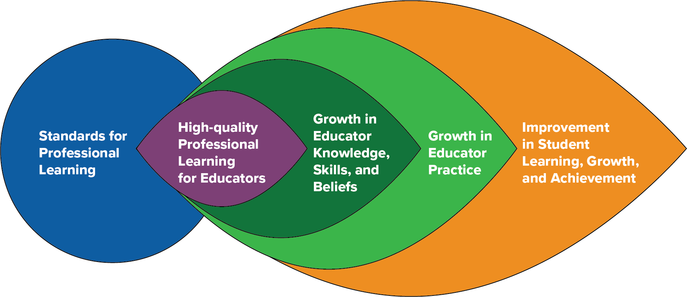

Below is a graphic with the associated steps, reflections, and linked resources associated with each step of the process to assist educators and evaluators through the process. All educators are assigned a primary evaluator (092) who has completed comprehensive orientation on this model and relevant rubrics.

Educator Continuous Learning Process
Evaluation Orientation
Completed prior to the start of the Continuous Learning Process
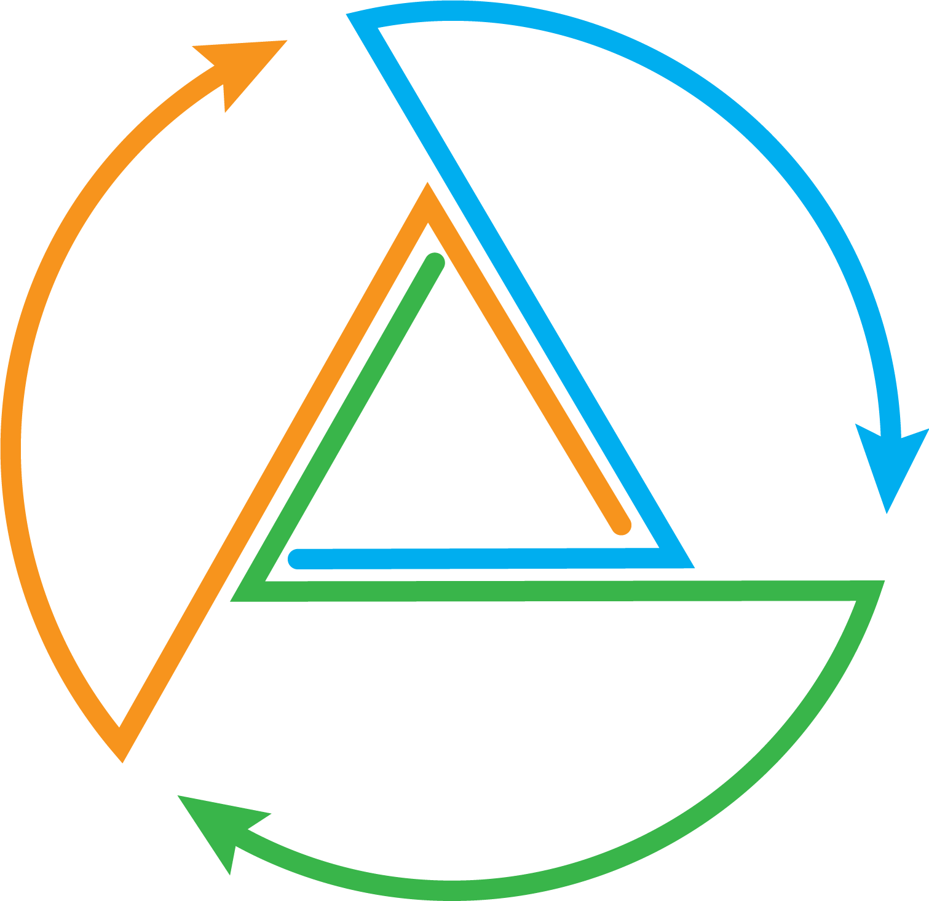
Observations of professional practice, reflection and feedback
Goal Setting Completed by Mid-October
Educator & Student Learning, Growth, and
Achievement
Mid-Year Check-in Completed by Mid-February
Observations
of professional
practice, reflection and
feedback
End-of-Year Reflection
Completed by June 1

Goal Setting
Completed by Mid-October
Beginning of the Year Goal(s) and Planning
- Self reflect
- Review evidence
Goal(s), Rationale, Alignment, and Professional Learning Plan
- Draft goal(s), rationale, alignment, professional learning plan
Goal Setting Conference
- Mutually agree on 1-, 2-, or 3-year goal(s)
- Determine individual or group goal(s)
- Mutually agree on professional learning needs and support

Mid-year Check-in
Completed by Mid-February
Mid-Year Check-in: Reflection, Adjustments, and Next Steps
- Review and discuss currently collected evidence towards goal(s) and of practice
- Review professional learning, evidence, and impact on educator practice, student learning, growth, and achievement
Mid-Year Conference
- Discuss evidence, reflection, and feedback from evaluator
- Adjust and revise as needed

End-of-Year Reflection
Completed by June 1
End-of-Year Reflection and Feedback Process
- Self-reflection: Review and discuss professional learning, evidence of impact on practice, student learning, growth and achievement
End-of-Year Conference/ Summative Feedback and Growth Criteria
- Evaluator provides written summative feedback and guides next steps
- Annual Summary sign-off

Orientation on the educator evaluation and support process shall take place prior to the start of the process, no later than October 15. The orientation shall include:
  - High leverage goal setting and professional learning plans
  - Use of rubrics and standards
  - Observation of practice/Review of practice
  - Tiered supports
  - Dispute resolution
Annual training for evaluators as required by C.G.S. 10-151b will include engaging in and providing reciprocal feedback tied to standards and evidence of professional practice.

Goal(s) Setting (Completed by mid-October)
The initial goal setting meeting includes a dialogue between the educator and their evaluator around the educator’s initial self-reflection, which is based on a review of evidence and an analysis of their own practice to identify and support an area for educator practice and growth, and student learning, growth, and achievement. The educator and evaluator come to mutual agreement on high leverage professional practice one-, two- or three-year goal(s), multiple measures of evidence (at least two measures), professional learning plan, and support that is consistent with their professional status and goals to drive progress toward goal attainment (see appendix K).
For beginning educators in the Teacher Education and Mentoring (TEAM) Program, consideration for align- ment between professional learning and their TEAM modules would enhance their learning and practice.

Midyear Check-in (Completed by mid-February):
The midyear check-in consists of reciprocal dialogue between the educator and evaluator and includes an educator self-reflection on their progress toward their goal(s) so far. The reflection shall include an analysis of the impact of their learning on their practice, student learning, growth and achievement and the school community.
  - Educators self-reflect and review multiple and varied qualitative and quantitative indicators of evidence of impact on educator’s growth, professional practice, and impact on student learning, growth, and achievement with their evaluator.
  - The evaluator provides specific, standards-based feedback related to the educator’s goal. Observation feedback and evidence aligned to the single point rubric.
  - The midyear conversation is a crucial progress check-in. The midyear check-in provides an opportunity to discuss evidence, learning, and next steps. It is at this point that revisions to the educator’s goal(s) may be considered based on multiple measures of evidence.

End-of-Year Reflection/Summative Review (Completed by June 1)
End-of-year reflection provides an opportunity for the educator and evaluator to engage in reciprocal dia- logue, similar to the midyear check-in, to discuss progress toward the educator’s goal(s); professional learn- ing as it relates to the educator’s professional growth and professional practice; and impact on student learning, growth, and achievement as evidenced by multiple and varied qualitative and quantitative indica- tors of evidence. A written end-of-year summary includes the impact of new learning on educator practice and growth, impact on student learning, growth and achievement, school community, strengths and con- cerns, and possible next steps for the upcoming year. Analysis of evidence from the end-of-year summary is important for the educator’s subsequent self-assessment and goal setting revisions or new goal.
The evaluator provides a concise summary based upon evidence related to the mutually agreed upon educator goal(s) and identified standards and will make a distinction regarding the educator’s successful completion of the professional learning process.
All forms for documentation are hyperlinked within the graphic of the continuous learning process with further detail for each step.

Professional Practice and Educator Growth
The implementation of the continuous learning process is shared between the educator and evaluator. For the duration of the learning process, educators pursue learning and attainment of their goal(s), collecting evidence of practice related to their high leverage professional learning goal. Evaluators will provide educators with feedback from observation and dialogue, ensure timely access to supports, and collect evidence of educator performance and practice toward goal(s) through multiple sources, which include observation and may include student, staff, or family feedback (see appendix J).

Observation of Professional Practice and Feedback
Observations occur throughout the continuous learning process. The identified high leverage goal(s) provides a focus for strategic evidence collection and feedback. Evaluators provide educators with specific feedback based on evidence, standards, and the educator’s goal; ensure timely access to planned support(s); and continue to collect evidence of educator practice and progress toward goal(s) through multiple sources of evidence, including observation. Feedback, written or verbal, is provided within five school days.
“Feedback is defined as a dynamic, dialogic process that uses evidence to engage a learner, internally or with a learning partner, in constructing knowledge about practice and self. Its primary purpose is learning that guides change” (Killion, 2019).
Quality feedback:
  - Is based on multiple and varied quantitative and qualitative indicators of evidence, standards, and goal(s)
  - Is personalized
  - Is learning-focused or growth-oriented
  - Provides questions for reflection to refine or revise strategies
  - Expands understanding of one’s experiences and their implications for future experiences
  - Provides reflective opportunities to rework, refine, and reorder knowledge, attitudes, skills, and/ or practices
  - Is timely, frequent and reciprocal

Definition of Cohorts
Cohort 1 | Cohort 2
Who: | Who:
- New to profession (first four years) | - Educators who have successfully
- New to LEA (first two years) | completed Cohort 1 in their current LEA
What: | What:
- Three observations of Professional | - Two reviews of practice with one being
Practice (minimum 30 minutes in length) | Observations of Professional Practice
with pre and post meetings | (minimum 20 minutes in length) with post
– One observation of professional | meetings.
practice may be substituted for a | – One observation of professional
review of practice | practice may be substituted for a
- Verbal and written feedback within five | review of practice
school days | - Verbal and written feedback within five
- Additional observations of professional | school days
practice as mutually agreed upon or | - Additional observations of profession-
deemed necessary | al practice as mutually agreed upon or
 | deemed necessary

Growth Criteria
An educator is determined to have successfully completed the learning process by demonstrating:
  - Reflection supported with evidence of the impact of the educators’ new learning on their practice/goal.
  - The impact the educators’ new learning and practice had on student learning, growth, and/or achievement, supported by evidence.
  - Next steps. (See appendix K)

Tiered Support
All educators require access to high-quality, targeted professional learning support to improve practice over time. Educators and their evaluators thoughtfully consider and apply three tiers of support, as appropriate, within an evaluation process. All three tiers of support must be implemented prior to the development of a corrective plan.
A pattern of persistent lack of growth and reflection or resistance to growth-oriented feedback should lead to advancing levels of support with a defined process for placing an educator on a Corrective Support Plan with indicators of success for transitioning out of it. Evaluators must utilize and document all three tiers of support prior to the development of a Corrective Support Plan. The Corrective Support Plan shall be devel- oped in consultation with the evaluator, educator, and their exclusive bargaining representative if applicable.

Tier 1
It is the expectation that all educators consistently access opportunities for professional growth within their district. Tier 1 supports are broadly accessible professional learning opportunities for all, inclusive of, but not limited to, collegial professional conversations, classroom visits, available district resources (e.g., books, articles, videos etc.), formal professional learning opportunities developed and designed by district PDEC, and other general support for all educators (e.g., instructional coaching). These resources should be identified through a goal setting process by mutual agreement.

Tier 2
In addition to Tier 1, Tier 2 supports are more intensive in duration, frequency, and focus (e.g., engaging in a professional learning opportunity, observation of specific classroom practices, etc.) that can be either suggested by the educator and/or recommended by an evaluator.

Tier 3
In addition to Tier 1 and Tier 2, Tier 3 supports are responsive to unresolved, previously discussed concerns and are developed in collaboration with the educator and may be assigned by the evaluator. Tier 3 supports have clearly articulated areas of focus, duration of time, and criteria for success, and may include a decision to move to a Corrective Support Plan. Tier 3 supports shall be developed in consultation with the evaluator, educator, and their exclusive bargaining representative for certified educators chosen pursuant to C.G.S. §10-153b. The start date and duration of time an educator is receiving this level of support should be clearly documented.

Corrective Support Plan
A pattern of persistent lack of growth and reflection or resistance to growth-oriented feedback should lead to advancing levels of support with a defined process for placing an educator on a Corrective Support Plan with indicators of success for transitioning out of it. Evaluators must utilize and document all three tiers of support prior to the development of a Corrective Support Plan. The Corrective Support Plan shall be developed in consultation with the educator and their exclusive bargaining representative for certified teachers chosen pursuant to C.G.S. §10-153b.

The Corrective Support Plan is separate from the normal educator growth model and must contain:
  - clear objectives specific to the well documented area of concern;
  - resources, support, and interventions to address the area of concern;
  - well defined timeframes for implementing the resources, support, and interventions; and
  - supportive actions from the evaluator.
At the conclusion of the Corrective Support Plan period, a number of outcomes are possible as deter- mined in consultation with the evaluator, educator, and bargaining unit representative.
See appendix P for a Corrective Support Plan form and example.

Dispute Resolution
The purpose of the dispute resolution process is to secure at the lowest possible administrative level eq- uitable solutions to disagreements, which from time to time may arise related to the evaluation process. The right of appeal is available to all in the evaluation and support system. As our evaluation and support system is designed to ensure continuous, constructive, and cooperative processes among professional educators, educators/leaders and their evaluators are encouraged to resolve disagreements informally.
Ultimately, should an educator disagree with the evaluator’s assessment and feedback, the parties are encouraged to discuss these differences and seek common understanding of the issues. As a result of these discussions, the evaluator may choose to adjust the report but is not obligated to do so. The ed- ucator being evaluated has the right to provide a statement identifying areas of concern with the goals/ objectives, evaluation period, feedback, and/or professional development plan, which may include the individual professional learning plan or a Corrective Support Plan.
Any such matters will be handled as expeditiously as possible, and in no instance will a decision exceed 30 workdays from the date the educator initiated the dispute resolution process. Confidentiality through- out the resolution process shall be conducted in accordance with the law.

Process
The educator being evaluated shall be entitled to collective bargaining representation at all levels of the process.
- Within three school days of articulating the dispute in writing to his/her/their evaluator, the educator being evaluated and the evaluator will meet with the objective of resolving the matter informally.
- If there has been no resolution, the individual may choose to continue the dispute resolution process in writing to the superintendent or designee within three workdays of the meeting with his/her/their evaluator (step 1). The educator being evaluated may choose between two options.

  - Option 1:
The issue in dispute may be referred for resolution to a subcommittee of the Professional Development and Evaluation Committee (PDEC), which will serve as a neutral party*. The superintendent and the respective collective bargaining unit for the district may each se- lect one representative from the PDEC to constitute this subcommittee, as well as a neutral party as mutually agreed upon between the superintendent and the collective bargaining unit. It is the role of the subcommittee to determine the resolution of the dispute and to identify any actions to be taken moving forward.
*In the instance that a district is too small to have a full PDEC from which to select three individuals, the superintendent and educator may select three mutually agreed upon persons to serve as the neutral party for resolving the dispute. Each individual must be a Connecticut certified educator and may or may not be from within the district.

  - Option 2:
The educator being evaluated requests that the superintendent solely arbitrate the issue in dispute. In this case, the superintendent will review all applicable documentation and meet with both parties (evaluator and educator being evaluated) as soon as possible, but no longer than five school days from the date of the written communication to the superintendent. The superintendent will act as arbitrator and make a final decision, which shall be binding.

Time Limits
- Since it is important that appeals be processed as rapidly as possible, the number of days indi- cated within this plan shall be considered maximum. The time limits specified may be extended by written agreement of both parties.
- Days shall mean workdays. Both parties may agree, however, to meet during breaks at mutually agreed upon times.
- The educator being evaluated must initiate the appeals procedure within five workdays of the scheduled meeting in which the feedback was presented. If no written initiation of a dispute is received by the evaluator within five workdays, the educator shall be considered to have waived the right of appeal.
- The educator being evaluated must initiate each level of the appeal process within the number of days indicated. The absence of a written appeal at any subsequent level shall be considered as waiving the right to appeal further.

The Role of the Professional Development and Evaluation Committee (PDEC)
The PDEC serves as the collaborative decision maker using the consensus protocol to create, revise, and monitor the evaluation and support model, as well as the professional learning plan.
Pursuant to Connecticut General Statute 10-220a and Public Act 23-159 Section 11 (b) (3), each local and regional board of education must establish a professional development and evaluation committee (PDEC) to include at least one teacher and one administrator, selected by the exclusive bargaining representative for certified employees, at least one paraeducator selected by their exclusive bargaining representative, and other personnel as the local board deems appropriate. It is vital that individuals selected as delegates for administrators, teachers, and other school personnel are representative of the various classifications within the groups (see examples below).

Other School Personnel | Educator | Leader
- Attendance counselor  - Paraeducator (required)  - Behavior technician  - Parent and family liaison  - Social emotional support staff | - Classroom teacher  - CTE teacher  - Library media specialist  - Reading interventionist  - Instructional coach  - Special education teacher  - Social worker  - School psychologist  - Speech pathologist | - Principal  - Assistant principal  - TESOL supervisor  - Special education supervisor  - Assistant superintendent  - Curriculum coordinator  - Talent development super- visor

The duties of PDECs shall include, but are not limited to:
  - participation in the development or adoption of a teacher evaluation and support program for the district, pursuant to section 10-151b;
  - the development, evaluation, and annual updating of a comprehensive local professional devel- opment plan for certified employees of the district; and
  - the development and annual updating of a comprehensive local professional development plan for paraeducators of the district.
The educator and leader evaluation and support program shall be developed through mutual agreement between the local or regional board of education and the PDEC. If the local or regional board of edu- cation and the PDEC are unable to come to mutual agreement, they shall consider the model educator and leader evaluation and support program adopted by the State Board of Education and may, through mutual agreement, adopt such model educator and leader evaluation and support programs.
If the local or regional board of education and the PDEC are unable to mutually agree on the adoption of the State Board of Education’s model program, then the local or regional board of education shall
adopt and implement an educator and leader evaluation and support program developed by such board, provided that the program is consistent with the CT Guidelines 2023 adopted by the State Board of Education.

Local and State Reporting
The superintendent shall report:
- the status of teacher evaluations to the local or regional board of education on or before June 1 of each year; and
- the status of the implementation of the teacher evaluation and support program, including the frequency of evaluations, the number of teachers who have not been evaluated, and other requirements as determined by the Department of Education, to the Commissioner of Education on or before September 15 of each year.
For purposes of this section, the term “teacher” shall include each professional employee of a board of education, below the rank of superintendent, who holds a certificate or permit issued by the State Board of Education.

Technical Assistance and Professional Learning
The CSDE works closely with schools and districts to learn what support is most needed for effective implementation of the CT Guidelines 2023 framework. To that end, the CSDE continues to develop re- sources in partnership with the six regional educational service centers, ACES, CES, CREC, EASTCONN, EdAdvance, and LEARN along with CAS and feedback from districts. You are encouraged to reach out for technical assistance and professional support during the transition to this new framework.

Appendices — Educator:
Information and Resources to Support Effective Implementation

Appendix I: Sample Reflection Questions – Educator

Self-Reflection Sample Questions
- Thinking about the success and challenges you may have encountered last year, or at the start of this year, what questions do you have about teaching and learning? What new learning might you want to explore to inform your understanding of these questions and professional practice?
- In reviewing the rubric, what areas emerge as opportunities for your professional learning and practice?
- Based on your current students’/adult learners’ strengths and needs, what new learning might you explore to address the needs?
- Based on knowledge of your students/adult learners, and/or knowledge of school/program goals, are there any new strategies or methods you’d like to explore and implement this year?
- How do you see yourself contributing to the school or district’s mission, vision, and/or Portrait of a Graduate and what strategies can you learn more about to support that focus?
- What are you considering for your learning goal?
- What will it look like when you achieve your goal?

Professional Learning and Action Questions

Indicators of Success
- What question will you focus on to address your goals?
- What are the criteria for an accomplished practice?
- How do you plan to collect and analyze evidence to assess progress toward your goals?
- What research/professional readings might you explore to support your professional learning and achieve your goal?
- What specific professional learning might you need to achieve your goal?
- What support might you need from your colleagues, supervisor, others? How frequently?
- How might you apply your learning to practice? How often?

Determine Evidence
- What evidence might you collect and analyze to understand progress toward your goal? Quantitative or qualitative or both?
- What ways would you like me as your evaluator to collect data/evidence for feedback?
- From how many different situations should we examine data/evidence?
- What are the advantages and disadvantages of the identified evidence?
- How will the data help us to analyze your practice?
- What is your timeline for collecting this evidence and measuring impact?
- What are the anticipated challenges or obstacles, and how do you plan to address them?
- How might you communicate/share your professional learning to your colleagues or families?
- What opportunities for professional learning do you believe would be beneficial for your growth as an educator?
- In what ways can we encourage collaboration and communication among colleagues to promote a culture of sharing best practices?

Analysis of Evidence
- What do you observe in your evidence?
- What patterns, themes, or outliers do you notice?
- What does the evidence say about how you are doing in relation to your goal and indicators of success?
- Based on the evidence and your practice overall, what are your strengths?
- In what aspect do you want to continue to grow or refine your knowledge, skill, practice?

Learning Reflection and Next Steps
- What is clear to you now?
- What are you learning?
- What do you understand now that you didn’t understand as clearly before?
- How will this learning influence future actions?
- What is a single sentence conclusion that represents your learning?
- Under what circumstance might this conclusion not be true?
- What are ways you continue to refine your practice?
- What more do you want to learn and practice?
- How might you accomplish that? What is your next plan?
- What resources and support do you want or need?
- Once learning has been implemented: What effect did the learning have on practice, students?

Reflect on the Feedback Process
- In what ways did my engagement with you support your learning?
- What did I do as a learning partner that helped you as a learner and how did it help?

Appendix J: Definition of Cohorts – Educator

Definition of Cohorts
Cohort 1 | Cohort 2
Who: | Who:
- New to profession (first four years) | - Educators who have successfully complet-
- New to LEA (first two years) | ed Cohort 1 in their current LEA
What: | What:
- Three observations of Professional Prac- | - Two reviews of practice with one being
tice (minimum 30 minutes in length) with | Observations of Professional Practice
pre and post meetings | (minimum 20 minutes in length) with post
– One observation of professional | meetings.
practice may be substituted for a | – One observation of professional
review of practice | practice may be substituted for a
- Verbal and written feedback within five | review of practice
school days | - Verbal and written feedback within five
- Additional observations of profession- | school days
al practice as mutually agreed upon or | - Additional observations of profession-
deemed necessary | al practice as mutually agreed upon or
 | deemed necessary

Appendix K: Growth Criteria and Sources of Evidence – Educator

Growth Criteria | Possible Sources of Evidence
- Required observational evidence
- Required student learning evidence aligned to high-leverage indicator focus
- Implementation plans/lesson plan(s)
- Educator learning logs/impact on practice reflection
- Educator created learning materials
- Evidence from Observation of Educator Practice
- Numeric information about schedule, time, educator practice, student participation, resource use, classroom environment, frequency of meetings/communications, etc.
- Educator and/or student self-reflection
- Student learning artifacts
- Mastery-based demonstrations of achievement
- Observational evidence of students’ words, actions, interactions (including quotations when appropriate)
- Rubrics, interim or benchmark assessments, other assessments
- Other artifacts/sources

Development of New Learning and Impact on Practice
- Educator can demonstrate how they developed new learning within the continuous learning process through multiple sources (e.g., analyzing student learning, observational feedback, etc.) and how they used their new learning to improve practice aligned to their continuous learning process goal/strategy focus.
Impact on Students
- Educator can demonstrate how they positively impacted student learning within the continuous learning process using example evidence and can articulate connections/rationale between the improved learning and their own changes in practice.

Appendix L: General Glossary – Educator

consensus protocol: Consensus decision-making is a creative and dynamic way of reaching agreement in a group. Instead of simply voting for an item and having the majority getting their way, a consensus group is committed to finding solutions that everyone actively supports — or at least can live with.
By definition, in consensus no decision is made against the will of an individual or a minority. If significant concerns remain unresolved, a proposal can be blocked and prevented from going ahead. This means that the whole group has to work hard to find win-win solutions that address everyone’s needs.
From Consensus decision making. Seeds for Change. (n.d.).
https://www.seedsforchange.org.uk/consensus
continuous learning process: The continuous learning process is a cycle of feedback, reflection, goal setting, opportunities for professional learning, feedback from observations (peers or evaluators), and a collection of multiple measures of evidence. There are multiple models of continuous learning including, but not limited to:
- The Supporting Teacher Effectiveness Project (STEP)
- Massachusetts Department of Elementary and Secondary Education 5-Step Cycle and Model System for Educator Evaluation
- Ohio Department of Education - Ohio Teacher Evaluation System (OTES 2.0) Framework
- Tennessee Educator Acceleration Model
- Connecticut TEAM Model (CAPA)
Corrective Support Plan: A pattern of persistent lack of growth and reflection or resistance to growth- oriented feedback should lead to advancing levels of support with a defined process for placing an educator on a Corrective Support Plan with indicators of success for transitioning out of it. The Corrective Support Plan shall be developed in consultation with the educator and their exclusive bargaining representative for certified teachers chosen pursuant to C.G.S. §10-153b. Corrective Support Plans shall include clear objectives specific to the well documented area of concern; resources, support, and interventions to address the area of concern; timeframes for implementing the resources, support, and interventions; and supportive actions from the evaluator.
check-ins: Formal or informal meetings or conferences held in the spirit of collaboration between the leader and evaluator and to engage in reciprocal dialogue regarding what is happening in one’s practice at that mo- ment in time including goal(s), professional learning, multiple and varied forms of quantitative and qualitative evidence, adjustments, and next steps (i.e., classroom/school/building or district). During each school year, a minimum of three check-ins provide an opportunity for discussions to set and adjust goals, celebrate growth and positive impact, identify needs, assess and discuss evidence of learning, and next steps in one’s learning.

community: A school community typically refers to the localized group of students, educators, parents, and staff within a specific school, fostering a sense of belonging and shared objectives within that school.
A district community encompasses a broader scope, involving multiple schools within a school district, and often includes administrators, teachers, students, and families collaborating across various educational schools and programs within that district. The district community addresses overarching educational policies, resource allocation, and coordination among multiple schools and programs to promote consistent and effective education across a larger administrative unit.
dispute resolution: A process for resolving disputes in cases where the evaluator and educator being evaluated cannot agree on goals/objectives, the evaluation period, feedback, or the professional learning plan or other outcomes of the evaluation process.
evidence: Evidence collected and presented as a part of the evaluation system may include (but is not limited to) artifacts, observations of practice, student feedback, and reflections of the educator on student learning, growth, and achievement as part of the educator feedback process.
feedback: “Feedback is defined as a dynamic, dialogic process that uses evidence to engage a learner, internally or with a learning partner, in constructing knowledge about practice and self. Its primary purpose is learning that guides change” (Killion, 2019).
Quality Feedback:
- Is based on multiple and varied quantitative and qualitative indicators of evidence, standards, and goal(s)
- Is personalized
- Is learning-focused or growth-oriented
- Provides questions for reflection to refine or revise strategies
- Expands understanding of one’s experiences and their implications for future experiences
- Provides reflective opportunities to rework, refine, and reorder knowledge, attitudes, skills, and/or practices
- Is timely, frequent, and reciprocal
From Killion, J. (2019). The feedback process: Transforming Feedback for Professional Learning. Learning Forward.
formal observations: A formal observation is a structured and planned process of watching, assessing, and evaluating an educator’s performance. This typically includes a pre-conference and post-conference and results in a written evaluation within five school days.
goals and standards: Goals and standards should be based on an evidence based, high leverage strategy or practice aligned with professional practice standards and consistent with the goals of the district. Clear alignment between district, school, and certified staff goals (departments, grade-level teams, or collaborations) improves the collective effectiveness of professional practice.
growth criteria: Successful completion of the Continuous Learning Process, supported with evidence that includes the impact the educators’ new learning had on their practice/goal, along with a reflection on challenges and next steps, and the impact the educators’ new learning and practice had on student learning, growth, and or achievement, supported by evidence.
high leverage goal: High leverage goals are based on professional practice standards and are transferable across roles, disciplines, and positions and aligned to a strategic focus (i.e., a portrait of a graduate). They address strategies for developing conceptual understanding and have a high standard deviation effect size (Hattie 2009).

informal observations: An informal observation is an unplanned visit intended to evaluate educator per- formance. This typically includes either verbal or written feedback provided to the educator within five school days.
leader: A leader is defined as someone in a leadership position who has attained the 092 certification. This may include superintendent, principal, dean of students, assistant/vice principal, pupil services director, department chair. This is not an exhaustive list, rather to illustrate the definition. Superintendents will confirm district leaders with evaluation roles.
multiple measures: Can include, but is not limited to, student learning, educator learning, cultural changes, growth, and achievement as mutually agreed upon during the goal-setting process and may include additional evidence relative to one or more competencies.
mutual agreement: An agreement or condition that is reciprocal or agreed upon by all parties.
organizational health: Organizational health in schools and districts means how well the whole school system is functioning. It encompasses various interconnected elements that contribute to a positive and thriving learning environment, including leadership, culture and climate, communication, professional learning, resource management, collaboration and teamwork, student-centered focus, continuous improvement, community engagement, and innovation.
PDEC (Professional Development and Evaluation Committee): The Professional Development and Evaluation Committee serves as the collaborative decision maker to create, revise, and monitor the evaluation and support program for the district, as well as the professional learning plan for certified employees of the district.
professional learning: Professional learning and growth are centered around accelerating personal and collective learning and closing the knowing-doing gap for leaders and educators. This includes co-designing interactive, sustained, and customized learning growth opportunities that are grounded in the evidence that is most needed and most effective. See also appendix M, Glossary of Professional Learning Opportunities.
review of practice: Reviews of practice are non-classroom observations and may include, but are not lim- ited to, observation of delivery of professional learning, data team meetings, observations of coaching/ mentoring sessions, review of educator work and student work, or review of other educators’ artifacts.
rubric: A rubric is a systematic and standardized tool, designed as a continuum, and is used to communicate the performance of educators based on specific criteria. It can be used to evaluate a single criterion to emphasize specific expectations and provide targeted feedback for improvement. It can encourage a growth mindset.
single point competency: A description of a standard of behavior or performance that represents the enduring understanding of content and skill from a specific domain that is framed only as a single set of desired outcomes rather than laid out across a rating or scale of performance.
student outcomes: Student outcomes include multiple measures of student learning, growth, and achievement as mutually agreed upon during the goal setting process.

tiered support:
Tier 1
It is the expectation that all educators consistently access opportunities for professional growth within their district. Tier 1 supports are broadly accessible professional learning opportunities for all, inclusive of, but not limited to, collegial professional conversations, classroom visits, available district resources (e.g., books, articles, videos etc.), formal professional learning opportunities developed and designed by your district PDEC, and other general support for all educators (e.g., instructional coaching). These resources should be identified through a goal setting process by mutual agreement.

Tier 2
In addition to Tier 1, Tier 2 supports are more intensive in duration, frequency and focus (e.g., attending a workshop, observation of specific classroom practices, etc.) that can be either suggested by the educator and/or recommended by an evaluator.

Tier 3
Tier 3 supports are responsive to previously discussed concerns and are assigned by an evaluator. Tier 3 supports have a clearly articulated area of focus, duration of time, and criteria for success, and may include a decision to move to a Corrective Support Plan.

Appendix M: Glossary of Professional Learning Opportunities – Educator

High quality professional learning enhances both educator practice and outcomes for each and every student. High quality professional learning integrates research on effective adult learning and uses interactive, flexible designs to achieve intended outcomes.
advanced coursework: Courses offered at a college, university, or other institution, in person or online, which further educator skills and/or provide professional training.
case study: A team that engages in a case study using information in a student’s cumulative folder or other documented information with the intention of determining next steps, i.e., IEP review or attendance records.
coaching: A process based on trust in which professional colleagues work together to reflect on current practices; expand, refine, and build new skills; share ideas; teach one another; conduct classroom re- search; or solve problems.
examination of student work: Individuals or groups of educators review samples of work from various students. They identify strengths, areas for improvement, and design instructional plans as a result of the examination.
job-embedded: Any activity that is tied in with authentic classroom practice. May include, but is not limited to:
- Examining student data
- Mentoring
- Book study (see below)
- Co-planning
- Investigating print and online resources
- Self-reflection
- Visitations/observations within a school
lesson study: Groups of teachers planning a lesson, observing one present the lesson, and then reflecting on it afterwards.
mentoring: A relationship between a less experienced educator and a more experienced mentor, in which the mentor provides guidance and feedback regarding practice.
peer observation: An opportunity for teachers to observe each other during classroom instruction. Teachers may want to observe peers to see a new teaching strategy in action, learn a new model of instruction, or analyze classroom processes and procedures.
personal professional reading: Individual, self-driven reading and processing of texts, in order to improve one’s own teaching practice.
professional literature study: Structures and collaborative processes in which individuals or groups of professionals engage in the examination and discussion of a relevant and informative text. The purpose of this study is to promote continuous learning, professional development, and the exchange of ideas and best practices within a specific field or industry. By engaging in a professional book study, individuals can deepen their understanding of key concepts, stay current in their field, and enhance their ability to apply new knowledge to their professional practice. This collaborative and structured approach to learning helps foster a culture of continuous improvement and professional growth within a community of practitioners.

protocols: A learning tool that is rule-based. Often implemented to aid in new learning for groups or individuals. May include article discussions, case studies, book reviews, and other procedures used in its workshops and other learning designs.
school visits: Observation of practice or teaching at a different school or institution to gain new knowledge, ideas, or activities.
student shadow: Follow a particular student during the academic day for a designated time, for a particular identified purpose, i.e., engagement.
walkthroughs: A team of leaders who visit classrooms to find evidence for a particular problem of practice. This evidence is reviewed, and next steps are determined as a result of this practice.
web-based learning: Use of online resources or learning activities to develop new learning or techniques for the classroom.
workshops: Meetings where participants are involved in group discussions or learning experiences and are normally organized around one or more theme areas. Workshops allow participants with differing values and priorities to build a common understanding of the problems and opportunities confronting them. May take place at school or outside.

Appendix N: Continuous Learning Process – Educator

Evaluation Orientation
Orientation to Educator Evaluation was completed on:
Date
Non-negotiable Process Element of the CT Guidelines (2023)

Download these forms:

Educator Goal-Setting Form
Educator Observation Form
Educator Mid-Year Check-In Form
Educator End-of-Year Self-Reflection Form Educator End-of-Year Conference Form

Download this form

Educator Information

Name: |  | Location:
Select One:  - Cohort 1  *New to Profession (first four years) or New to LEA (first two years)  - Cohort 2  *Educators who have successfully completed Cohort 1 | Select One:  - Individual goal  - Collaborative goal  Decided upon mutual agreement. | Select One:  - 1-year goal  - 2-year goal  - 3-year goal  Decided upon mutual agreement. | Select One:  - CCT Teacher Rubric  - CCT Service Delivery Rubric
Download this form

Beginning-of-the-Year Goals and Planning
Self-Reflection
Completed by Educator
See Sample Reflection Questions
Capture your self-reflection here; consider using the Sample Questions linked above to guide your thinking.
See Examples of Evidence Types
Goal, Rationale, Alignment and Professional Learning Plan
Completed by Educator
Based on your analysis above, what is/are your goal(s)? Include a rationale for the length of your goal (1, 2, 3 year).
What evidence of leader learning, educator and/or student growth and achievement, and/or organizational measures will you use to reflect, monitor, and adjust your goal? What is your learning plan to support achieving your goal?
See professional learning and action questions to guide your plan.
For multi-year goal(s), what might be the potential focus of years 2 and 3 (to be revisited and revised annually and as needed throughout the learning process)?
In what ways might this goal(s) contribute to the school and/or district’s vision, mission, and strategic goals?

Goal Setting Conference Completed by Evaluator (By November 1) Date
Notes: | Supports Required/Suggested  - Tier 1  - Tier 2 (Link to Examples of Supports)  - Tier 3 (Link to Examples of Supports)

Download this form

Planned Observation of Professional Practice
Non-negotiable Process Element of the CT Guidelines (2023)
Observation of Professional Practice #1 - Required
Additional Observation of Professional Practice

Midyear Check-in: Reflection, Adjustment(s), and Next Steps
Completed by Educator
Non-negotiable Process Element of the CT Guidelines (2023)
See Sample Reflection Questions and Professional Learning and Action Questions
What has been your progress to date on your professional learning and how do you know? | Self-Reflection:
Links to Evidence:

Midyear Conference
Completed by Evaluator (by March 1)
Date
Feedback to Educator (Feedback regarding progress on professional learning and progress toward goal(s). Include change in tiered supports, if recommended.):

Observation of Professional Practice #2 - Required
Additional Observation of Professional Practice

Download this form

End-of-Year Reflection and Feedback Process
Non-negotiable Process Element of the CT Guidelines (2023)
Self-Reflection
Completed by Educator
See Sample Reflection Questions and Professional Learning and Action Questions
What impact did your new learning have on your practice/goal(s), and how do you know?  What impact did your new learning and practice have on your student learning, growth, and/or achievement, and how do you know?  What challenges did you encounter and what are your next steps  with your professional learning? | Self-Reflection:
Links to Evidence:

Download this form

End-of-Year Conference
Completed by Evaluator (by June 1)
Date
Summative Feedback and Growth Criteria
Completed by Evaluator
See appendix for full description
Summative Feedback
Development of new learning and impact on practice related to goal(s).
Impact on student learning, growth, and achievement
Successful Completion of the Evaluative Cycle | - Yes • No
Supports Required/Suggested  Are tiered supports required above and beyond tier 1 (included in feedback above)?  - Not applicable  - Tier 2 (Specify below)  - Tier 3 (Specify below) | If Tier 2 and/or Tier 3, please specify strategies:
For multi-year goals only:  - What adjustments are needed to the goal(s)?  - Why?  - How might adjustments impact the timing of the goal(s)? | - Educator will continue multi-year goal.  - Educator will adjust multi-year goal.  - Educator completed multi-year goal. Notes:
Educator Signature | Date:
Evaluator Signature | Date:

Appendix O: Observation Forms – Educator
Download this form

Educator Evaluation Observation #1 – Required
Name: |  | Time/Location:
Grade/Role: |  | Discipline/Focus:
- Cohort 1 (Pre-/Post-Conference Required)
- Cohort 2 (Post-Conference Required)
- Additional Observation of Professional Practice (Pre-/Post-Conference Optional)
Pre-Observation
Completed by the Educator (as needed/required)
Lesson Plan/Meeting Plan | Upload and provide hyperlink here
Pre-Conference Notes including the identified competency focus for the observation
Observation Evidence
Completed by the Evaluator
Post-Observation Reflection
Completed by the Leader
What worked and how do you know?
What didn’t work and how do you know?
What have you learned (about your practice and your learners based on what evidence) and how will you apply that learning in the future?
Post-Observation Conference Feedback
Completed by the Evaluator
Evidence of Strengths | Single-Point Competencies  Completed by the Evaluator |  | Evidence for Growth and/or Next Steps
 | Insert competencies

Download this form

Educator Evaluation Observation #2 – Required
Name: |  | Location:
Grade/Role: |  | Discipline/Focus:
- Cohort 1 (Pre-/Post-Conference Required)
- Cohort 2 (Post-Conference Required)
- Additional Observation of Professional Practice (Pre-/Post-Conference Optional)
Pre-Observation
Completed by Educator (as needed/required)
Lesson Plan/Meeting Plan | Upload and provide hyperlink here
Pre-Conference Notes including the identified competency focus for the observation
Observation Evidence
Completed by the Evaluator
Post-Observation Reflection
Completed by the Leader
What worked and how do you know?
What didn’t work and how do you know?
What have you learned (about your practice and your learners based on what evidence) and how will you apply that learning in the future?
Post-Observation Conference Feedback
Completed by the Evaluator
Evidence of Strengths | Single-Point Competencies  Completed by the Evaluator |  | Evidence for Growth and/or Next Steps
 | Insert competencies

Download this form

Educator Evaluation Observation #3
Name: |  | Location:
Grade/Role: |  | Discipline/Focus:
- Cohort 1 (Pre-/Post-Conference Required)
- Cohort 2 (Post-Conference Required)
- Additional Observation of Professional Practice (Pre-/Post-Conference Optional)
Pre-Observation/Visit
Completed by Educator (as needed/required)
Lesson Plan/Meeting Plan | Upload and provide hyperlink here
Pre-Conference Notes including the identified competency focus for the observation
Observation/Site Visit Evidence
Completed by the Evaluator
Post-Observation Reflection
Completed by the Educator
What worked and how do you know?
What didn’t work and how do you know?
What have you learned (about your practice and your learners based on what evidence) and how will you apply that learning in the future?
Post-Observation Conference Feedback
Completed by the Evaluator
Evidence of Strengths | Single-Point Competencies  Completed by the Evaluator |  | Evidence for Growth and/or Next Steps
 | Insert competencies

Download this form

Educator Evaluation Observation #4
Name: |  | Location:
Grade/Role: |  | Discipline/Focus:
- Cohort 1 (Pre-/Post-Conference Required)
- Cohort 2 (Post-Conference Required)
- Additional Observation of Professional Practice (Pre-/Post-Conference Optional)
Pre-Observation
Completed by Leader (as needed/required)
Lesson Plan/Meeting Plan | Upload and provide hyperlink here, as appropriate
Pre-Conference Notes including the identified competency focus for the observation
Observation Evidence
Completed by the Evaluator
Post-Observation Reflection
Completed by the Educator
What worked and how do you know?
What didn’t work and how do you know?
What have you learned (about your practice and your learners based on what evidence) and how will you apply that learning in the future?
Post-Observation/Visit Conference Feedback
Completed by the Evaluator
Evidence of Strengths | Single-Point Competencies  Completed by the Evaluator |  | Evidence for Growth and/or Next Steps
 | Insert competencies

Appendix P: Sample Corrective Support Plan – Educator

(Sample)
Educator A has consistently struggled with classroom management. Tiered supports have been provided by the evaluator throughout the year. Educator A has demonstrated a lack of growth/improvement, which has led the evaluator to assign a Corrective Support Plan.

Objective:
To improve classroom management practices in order to improve a positive learning environment (CCT – 1A) to support learning.

(Suggested) Resources:
- Observe a mutually agreed peer for structures, systems, and dispositions that support positive classroom management skills.
- Read and discuss “The First Six Weeks of School” - Center for Responsive Classroom with evaluator.
- Training in Restorative Practices.

Timeframes:
- Educator A will remain on this Corrective Support Plan for six weeks.
- Improvements in classroom management within this six-week duration will serve as criteria for successful completion of this plan.

Supportive Actions:
- All resources made available
- Timely feedback in person and in writing (weekly/bi-weekly meetings)
- Management of access to learning opportunities in and out of building, as appropriate.
- Modeling of effective classroom management strategies
- Weekly, bi-weekly meetings with progress reporting from Teacher A and written feedback from evaluator (dependent upon need for plan)

Corrective Support Plan Template
(Educator being evaluated) has consistently struggled with
. Tiered supports have been provided by the evaluator throughout the year. (Educator being evaluated) has demonstrated a lack of growth/improvement, which has led the (Evaluator) to assign a Corrective Support Plan.

Objective:
To improve
(Indicate specific standard in your objective language)

(Possible) Resources:
A blend of opportunities and resources should be extended to the Educator being evaluated being supported on the Corrective Support Plan
- Mentor
- Coach
- Reading as appropriate

Timeframes:
- (Length of the Corrective Support Plan - typically six to eight weeks in length)
- Improvements in (standard) within this (Length of Corrective Support Plan) will serve as criteria for successful completion of this plan

Supportive Actions:
(Suggested supportive actions)
- Weekly, bi-weekly meetings with progress reporting from Educator A and written feedback from evaluator (dependent upon need for plan)
- All resources made available
- Timely feedback in person and in writing (weekly/bi-weekly meetings)
- Management of access to learning opportunities in and out of building, as appropriate.

Bibliography

Connecticut State Department of Education. 2023. Connecticut Guidelines for Educator Evaluation and Support. Hartford, CT.
Grissom, Jason A. , Anna J. Egalite, and Constance A, Lindsay. 2021. How Principals Affect Students and Schools. The Wallace Foundation.
Hattie, John. 2009. Visible Learning. Routledge Publishing.
Killion, Joellen. 2019. The Feedback Process: Transforming Feedback for Professional Learning.
Learning Forward.
Learning Forward. 2022. Learning Forward Professional Learning Standards.
MacDonald, Elisa B. 2023. Intentional Moves, How Skillful Team Leaders Impact Learning. Corwin Press. Seeds for Change. n.d. Consensus Decision Making. https://www.SeedsforChange.org.UK/Consensus.

