Universal Screeners in CT and English Learners

Universal screening measures are a critical component of a comprehensive, standards-aligned reading instructional program. Pursuant to Section 10-14t(a) of the Connecticut General Statutes (C.G.S.), the Connecticut State Department of Education (CSDE) has approved reading assessments for use by local and regional boards of education to identify students in kindergarten to grade three, inclusive, who are below proficiency in reading, and published the Approved Menu of Research-based Grades K–3 Universal Screening Reading Assessments. Commencing July 1, 2016, these reading assessments have been approved for use by districts to “assist in identifying, in whole or in part, students at risk for Dyslexia, as defined in Section 10-3d of the C.G.S., or other reading-related learning disabilities.”

Hickey, M. (2018). Memo. Retrieved from https://portal.ct.gov/-/media/SDE/Digest/2017-18/22118Memo-and-Guidelines-for-Open-Review.pdf?la=en

Below is a list of a sampling of Universal Screeners used in Connecticut and their validity and reliability information for English learners.

AIMSWebPlus
“Sampling was conducted at the school level, by grade. Schools indicated the grade(s) that would participate in testing and were then assigned to reading, math, or both content areas. Participating schools were required to assess to all students in the selected grades except those with moderate to severe intellectual disabilities or moderate to severe motor impairment and those who are blind, deaf, or had an English Language Proficiency score of less than 3.

The standardization sample at each grade level reflects adequate representation across each demographic category, enabling the selection of normative samples that are representative of the U.S. population.”

Ten percent of all students assessed were classified as ELs in the norming sample.

SOURCE: Pearson. (2018). AIMSWebPlus Efficacy Research Report. Retrieved from https://www.pearson.com/content/dam/one-dot-com/one-dot-com/global/Files/efficacy-and-research/reports/efficacy-assessment-reports/aimsweb-Plus-research-report.pdf.

Pearson. (2017). AIMSWebPlus Technical Manual.

DIBELS 8th Edition
“DIBELS are designed to provide information about the progress of children in acquiring literacy skills for reading in English. For children who are learning to read in languages other than English, it would be most meaningful and appropriate to assess their reading skills in the language in which they are being instructed. For English language learners who are learning to read in English, DIBELS are appropriate for assessing and monitoring progress in acquisition of early reading skills. DIBELS have been used successfully with English language learners (Haagar & Windmueller, 2001).

In addition, research findings on English learners indicates that children who are non-English speakers can learn to read as well in English as their English-speaking peers ( Chiappe, Siegel, & Wade-Wooley, 2002; Geva, Yaghoub-Zadeh, & Schuster, 2000) and, in fact, often outperform their peers in phonemic awareness skills (Lesaux & Siegel, 2003).”

SOURCE: Kaminski & Cummings. (2007). DIBELS: Myths and Facts. Retrieved from https://acadiencelearning.org/papers/Myths_0208.pdf

University of Oregon Center for Teaching and Learning. (2020). DIBELS 8th Edition Technical Manual. Retrieved from https://dibels.uoregon.edu/docs/techreports/DIBELS8-TechnicalManual_04152020.pdf

iReady Assessment
The iReady diagnostic assessment shows the average deviation between ELs and other special groups.
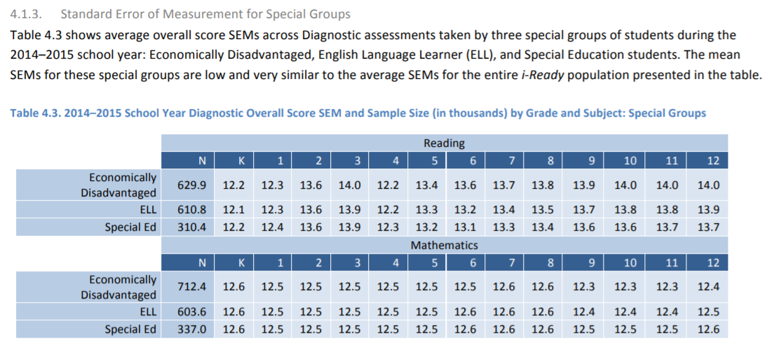
SOURCE: Curriculum Associates (2015). i-Ready® Assessments Technical Manual. Retrieved from http://www.dmschools.org/wp-content/uploads/2016/07/Curriculum-Associates_Des-Moines-Public-Schools_Interim-Assessment_RFP-7478.pdf

NWEA MAP Test
The NWEA MAP Growth assessment has studied the norming assessment data, but they do not delineate or disaggregate norming data based on English learner status. NWEA reports samples disaggregate data by gender, race and ethnicity only.

SOURCE: NWEA. (2019). MAP® Growth™ Technical Report. Portland, OR. https://www.nwea.org/resource/product/map-growth/

Star Assessment
“The reference data and goal types in the goal-setting wizard were calculated based on a heterogeneous sample of students. They may not be applicable to English language learners and students with learning or other disabilities. Make your best estimate when setting goals for these students. After a few years of experience, you will be better able to define moderate and ambitious goals for them” (p.48).
“While a grade-level screening report tells you how a student’s current achievement level compares to grade-level benchmarks, it does not tell you if that is a reasonable expectation, given the student’s current level of English proficiency. This leads to the second important question.

How are your English Learners doing compared to their “true” peers—other EL students in the same grade and at the same English language proficiency (ELP) level? The benefit of sorting students in the same grade by ELP level is that you can clearly see the relationship between their English language proficiency and their academic achievement.”
SOURCE: Renaissance Reading, Inc. (2019). Connecting Instruction to Assessment for English Learners. Retrieved from https://www.renaissance.com/2019/04/11/blog-assessment-instruction-english-learners/

