Completing State Bilingual Annual Evaluation Report and Title III Annual Evaluation Reports

The Title III Annual Evaluation Report (AER) and State Bilingual Annual Evaluation Report (AER) are now in eGMS, the system where you have been completing your funding applications.
- Individuals with permissions for the Title III EL and Immigrant Subgrant applications have the permissions to complete the Title III Annual Evaluation Report and the persons with the LEA Grant Contact for State Bilingual Grant will have permission for the State bilingual Annual Evaluation Report. Please see the Address Book tab on the blue Main Menu to identify persons with these roles.
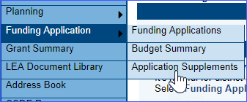
- In EGMS these reports are referred to as Application Supplements. To access them, select the Funding Application tab and then the Application Supplement tab.
- Select the Fiscal Year (2025), select the Application Supplement and as with the funding application, move the report to Report Started.
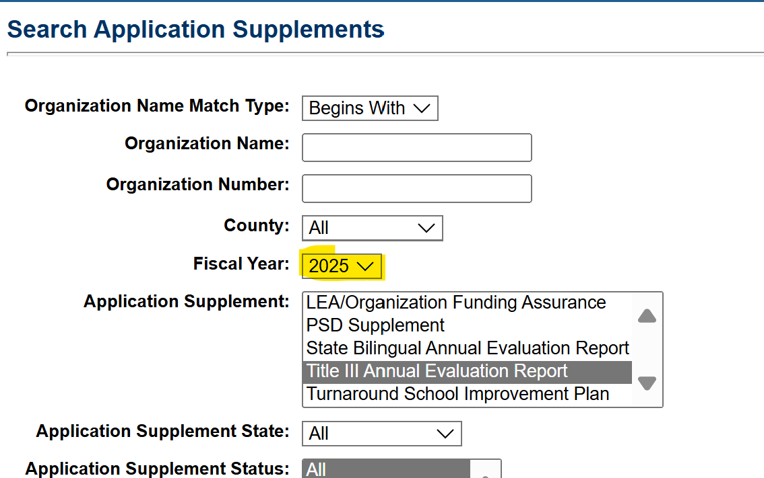

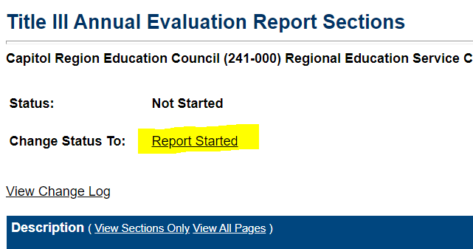
- The Report has similar functions to the funding application – a comment area, validation message and print functions.

- After the report is complete, move the status to Report Submitted. No other approvals are necessary.

- If changes are needed to the report after it is submitted, click on Revision Started and you will be able to edit the application.

