Family and Consumer Sciences-Connecticut
Understanding by Design (UbD)
Culinary and Nutrition Model Curriculum Unit

FCS Area of Study  Unit Title | Culinary and Nutrition  Real Food Education | Possible  Course(s)  When during course? | Introduction to Culinary, Advanced Foods, Nutrition and Wellness, Independent Living, or Consumer Education with food component  __beginning_X__middle___end
Designed by | Ms. Karen Redanz, CFCS  FCS Educator | Unit Length/  Time Frame | ___X___ 90-minute block classes

BIG IDEAS
Despite ongoing efforts in the U.S. to prevent chronic diseases such as heart disease, obesity, stroke, hypertension, diabetes, tooth decay, and cancer, children today suffer short- and long-term consequences of their diets. Many children eat food that is high in calories, fat and salt, but deprived of life-sustaining nutrients that provide the nourishment necessary to meet the demands of their growth and development.

Real Food Education teaches children to be lifelong critical food consumers who are prepared to analyze daily food choices to make healthier choices in all settings, including home, school, work and in social settings.

FOCUS STANDARDS

CTE Standards:
Nutrition and Food Production

A. Family and Consumer Sciences Skills: Develop a common core of skills related to Family and Consumer Sciences Education.
1. Analyze ways in which individuals and families manage resources to meet goals related to food acquisition, production, and nutrition.
B. Nutrition and Wellness Practices: Analyze factors that influence nutrition and wellness practices across the lifespan.
2. Explain the impact of physical, psychological, cultural, spiritual, and social influences on food choices.
3. Describe the impact of global and local events and conditions on the cost and availability of foods.
C. Nutritional Needs: Evaluate the nutritional needs of individuals and families in relation to health and wellness across the lifespan.
4. Describe the effect of nutrients on health, appearance, and peak performance.
5. Explain the relationship of nutrition and wellness to individual and family health throughout the lifespan addressing the diversity of people, culture, and religions.
6. Describe the impact of food and diet fads, food addictions, and eating disorders on wellness.
7. Evaluate sources of food and nutrition information, including food labels, related to health and wellness.

Culinary and Food Production
D.11. Apply menu-planning principles to develop and modify menus.
D.12. Analyze food, equipment, and supplies needed for menus.

FCS National Standards:
8.4.2 Apply menu-planning principles to develop and modify menus.
8.4.3 Analyze food, equipment, and supplies needed for menus.
8.4.7 Apply principles of Measurement, Portion Control, Conversions, Food Cost Analysis and Control, Menu Terminology, and Menu Pricing to menu planning.
9.3.2 Analyze nutritional data.
9.3.6 Critique the selection of foods to promote a healthy lifestyle.

Nutrition and Wellness
14.0 Comprehensive Standard: Demonstrate nutrition and wellness practices that enhance individual and family well-being.
National FCS Content Standard
14.1 Analyze factors that influence nutrition and wellness practices across the lifespan.
Performance Competencies
14.1.2 Analyze the effects of psychological, cultural, and social influences on food choices and practices.
14.1.3 Analyze the governmental, economic, and technological influences on food choices and practices.
14.1.4 Analyze the effects of global and local events and conditions on food choices and practices.

Common Core Standards:
Reading

Standard 8: Delineate and evaluate the argument and specific claims in a text, including the validity of the reasoning as well as the relevance and sufficiency of the evidence.

Literacy.RST.11-12.7 Integrate and evaluate multiple sources of information presented in diverse formats and media in order to address a question or solve a problem.

Writing
Literacy.WHST.11-12.4 Produce clear and coherent writing in which the development, organization, and style are appropriate to task, purpose, and audience.
Literacy.WHST.11-12.5 Develop and strengthen writing as needed by planning, revising, editing, rewriting, or trying a new approach, focusing on addressing what is most significant for a specific purpose and audience.

Speaking and Listening
Literacy.SL.11-12.1b Work with peers to promote civil, democratic discussions and decision-making, set clear goals and deadlines, and establish individual roles as needed.

Language
Literacy.L.11-12.2 Demonstrate command of the conventions of standard English capitalization, punctuation, and spelling when writing.
Literacy.L.11-12.6 Acquire and use accurately general academic and domain-specific words and phrases, sufficient for reading, writing, speaking, and listening at the college and career readiness level; demonstrate independence in gathering vocabulary knowledge when considering a word or phrase important to comprehension or expression.

Math
Math.HSA-CED.A.1 Create equations and inequalities in one variable and use them to solve problems.
Math.HSF-BF.A.1 Write a function that describes a relationship between two quantities.

ENDURING UNDERSTANDINGS:  Students will understand that…  Real food provides life sustaining nutrients free of added sugar, salt, fat, and chemicals and associated with its whole form from a plant or animal.  Health benefits of diets based on plant foods each day and supplemented with animal foods help prevent chronic disease.  People regularly consume meals and snacks with little thought to the amount of sugar, fat, and salt present, leading to overconsumption that may cause nutrient deficiencies and, eventually, chronic disease.  The environments in which we have access to and interact with daily directly impact our food choices.  As consumers, we have the power to effect change in our overall health by the conscious decisions we make each day in our food choices. | ESSENTIAL QUESTIONS:  Students will keep considering….  What is Real Food?  What are the benefits of a plant-based diet?  How much is too much sugar, fat and salt each day?  What challenges do we face when trying to make better choices for good health?  What are the benefits of preparing family meals at home and eating together? | PERFORMANCE TASKS:  Summative Assessments  Activity: What’s Real?  Students sort pictures and/or food packages to identify real foods.  Activity: What does a plant-based meal look like anyway?  Students identify plant foods and create a plant-based menu for a day.  Activity: Students identify the amount of sugar, salt, and fat in their favorite drinks and snacks.  Students will review Nutrition Facts label and ingredient list. In small groups, they will learn to how to translate grams to teaspoons and measure how much sugar is in popular sweetened beverages and snacks and items in their refrigerator at home.  Activity: Better Shop Around  Students identify where they can purchase food in their communities and the kinds of food available. They learn how to make the best choices by being an informed consumer on the lookout.  Formative Assessment  Activity: Meal Planning Project

Learning Task Calendar | Family & Consumer Sciences  Unit Title:  Real Food Education | Designed By: Karen Redanz, CFCS

DAY 1  NITIATION:  Begin by asking students why we eat food? Responses will vary. Food is a needed for survival, growth and development, pleasure, because it takes good, maintain good health. Project images of the inside of super grocery stores. Today, there are over 50,000 choices available in the chain Super Grocery stores for purchase. Have students share where they shop for food and choices available to them. What types of food do they purchase? Record all student responses encouraging them to be as specific as possible. Discuss with students the concepts of "food deserts" or food insecurity. Many families, particularly those in urban locations, do not have the same access to food choices.  Activity 1: Ask students What is Real Food? Give students time to share their ideas. Define Real Food as foods that come directly from plants and animals. Use the list students generated from initiation to identify Real Foods they purchase such as chicken, milk, fruit and vegetable examples. Explain, that when Real Foods are processed they are changed either a little or a lot. Often other ingredients are added such as sugar, salt and fat. Again, go back to their original list and identify foods that are processed a little such as yogurt and foods that are highly processed such as a strawberry granola bar. Use student examples to for further understanding and clarification.  DOK Level 1  Activity 2. Class Wall Mural  Have students work in small groups to find pictures of all different kinds of foods in resources provided (magazines, weekly grocery flyers, newspapers, advertisements). Students will use food pictures to create a class wall mural of foods in the three different categories: Real Foods, Foods Minimally Processed or changes a little and Highly Processed foods or foods changed a lot.  DOK Level 2  Activity 3: Survey students where they regularly shop for weekly groceries and then create small groups based on where they shop. Give each group a large piece of paper to create a sketch outlining how the store is organized. Frozen food, dairy, meats, canned goods, snacks, fruits, vegetables etc. Allow time for them to think about aisles where they buy their favorite foods.  Once the students have completed the sketch of their grocery store, have each group present sketch and explain how the store is organized. Once all groups have presented, ask students to list the similarities and differences of how each store was organized. Help students to see patterns in how grocery stores are designed.  For example, all the fresh food is around the perimeter of the store and the processed foods are grouped together in the center aisles of the stores. Ask students if the food they purchase is more from the aisles or from around the perimeter of the store.  Have students understand that, regardless of the store they shop in weekly, they will find Real Food (foods directly from plants and animals) around the perimeter of the store. Foods that are minimally processed and highly processed will be food in the aisles. Students should conclude that the majority of food purchases should be from the perimeter of the store and fewer purchases from the center aisles.  DOK 2  Activity 3: Individual Daily Food Intake  Have students complete the Daily Food Intake Log, listing their food intake for a typical day. What do they have for breakfast? Snacks? Lunch? Dinner? What beverages did they consume? Dessert/treats? Have them reflect on the proportion of Real Food to Processed food they consume and discuss their reaction.  DOK 2  Activity 4: 14 Questions Things that Could Save your Life and the Planet.  Ask for a student volunteer to input responses to the online quiz from the www.foodday.org website. As time allows additional students can complete quiz and discuss results.  DOK Level; 2  CLOSURE:  How would you summarize today's lesson for someone who wasn't here? | DAY 2  INITIATION: Whole class: Ask students what it means to be literate. If someone is not literate how would impact his/her life. Answers will vary. If to be literate is to know how to read and write then what would it mean to be Food Literate?  DOK 1  Activity 1: Dependent on resources available in class, students may test their Food Literacy by taking 15-question Food Literacy Quiz, developed in partnership with Nourish, a nonprofit educational initiative, to test your food literacy. It can be accessed on the www.Foodday.org website. If computers or other electronic devices are available, students can complete the quiz and generate an individual grade.  Another option that works well is to complete the quiz together as a class projecting the questions to the entire class. Have students read the question and discuss the possible best answer based on choices given. As each question answered correctly is provided with a brief explanation which engages students in further discussion. The results of the Food Literacy Quiz would be given for class.  Once students have completed the Food Literacy Quiz ask, Why is it important to be Food Literate today? Answers will vary. How might food choices be different for a Food Literate individual?  DOK 2  Activity 2: Deciphering the Food Nutrition Facts Food Label  Another important tool to helping us make good food choices as food literate consumers is the Nutrition Facts and Ingredient List on food labels.  Distribute food labels from various packages of processed foods so that every student has one food label. Ask them to list what kinds of information is provided on the label that would help them make a healthy choice.  Pair each student with a partner to share what information they found using a Venn Diagram. Information students each found important in the center of the Venn diagram.  Distribute the Deciphering the Nutrition Facts.  Have students use this resource to compare and contrast with what they found helpful. Depending on student familiarity with label teacher may emphasize new concepts such as what the Daily Values are and how they can be used. Be sure students also know the importance of the ingredient list as a useful tool to make healthy decisions.  DOK 3  Activity 3: Create a Poster for One of the Dirty Dozen Food Additives  Explain how ingredients should be good for you but there are more than 10,000 ingredients approved by the FDA called food additives allowed in food. Increasingly we learn about people who have allergic reactions or may have a food sensitivity to food additives or how some ingredients may have negative consequences on our health.  By food additives, we mean substances that are added to food products and their packaging. Ask students to think about why food additives are used in food. Answers will vary but may include: to improve, flavor, color, texture, and nutritional quality.  Use the Environmental Working Group web site to research Dirty Dozen Additives. Review what the FDA is responsible for and the term GRAS. Generally Recognized as Safe.  Depending on size of class use small groups of 2 or 3 to create a Wanted Poster.  Use the list of 12 additives that EWG calls the “Dirty Dozen to choose from for this poster. The EWG website will tell you why, which foods contain them and what you can do to avoid them. (A good place to start is by looking up your food in EWG’s Food Scores database).  See handout on Wanted Poster for project instructions.  DOK 3  CLOSURE: Have students complete an exit ticket. What does Food Literacy mean to you? | INITIATION:  Whole class: Video Clip The Real Bears (found on Youtube by CSPI approx. 4 min.) This animated video clip emphasizes the serious consequences of the consumption of sugary drinks citing important health statistics.  Have students watch video together and then share their reactions after viewing with the class. What was the message of this PSA? Was it effective?  Americans love their sweetened beverages with average American consuming on average 60 gallons per year and 64 pounds of sugar. One soda a day can lead to an increase of 10 pounds in a year. One or two sodas increase risk of diabetes by 25%.  DOK 1  Activity 1: Class discussion. Record student responses.  What kinds of beverages do you like to drink?  How much do you drink in a day? (Ex. one 20oz. bottle, two cans soda, large latte, can of Monster). How many sodas and sport drinks have you consumed in the past week?  Why are sugary beverages and snacks considered “empty” calories? (high in sugar, fat and salt and have little to no additional nutrients such as vitamins, minerals, protein)  Explain, for children, that the recommendation for empty calories is 150 per day.  Do you know how much sugar you consume in your favorite beverage? Nutrition Facts lists sugar as grams which is not understood since Americans don’t use the metric system. So use the conversion formula.  4 grams of sugar = 1 teaspoon of sugar  DOK 1  Activity 2: Compare amount of sugar in sweetened beverage and snack with recommended maximum daily intake of 150 calories.  Separate students into small groups of 3 or 4 depending on class size. Each group is given one 20 oz. bottle and one 12 oz. can of popular sweetened beverages. (An alternative would be to print or photocopy the Nutrition Facts labels of these products to acquire the same information).  Additional supplies for each group. One set of measuring spoons, bowl with 2 cups of sugar, and clear drinking glass or jar.  Ask students how much sugar they think are in a can of soda and have them measure it.  Have students then calculate the amount of sugar using the conversation formula and then correct the measure from their guess into the glass. (May range from 9-10 tsp.)  Have students repeat this for the 20 oz. bottle. Have student check the serving size as it often is listed as more than one serving so the amount of sugar is adjusted accordingly.  Have students do this one more time but with a favorite snack/candy of their choice. Using the classroom computer or electronic devices students can look up the Nutrition Facts information and find the sugar amount. Have students measure the sugar after completing the conversation again.  Point out that often students will drink soda with a sugary snack, increasing the amount of total sugar consumed. *Remind students that their daily recommendation for empty calories is 150 and this is exceeded with one 20 oz. beverage.  DOK 2  Activity 3. Advocacy, sharing your knowledge. In small groups of 2 or 3 instruct students to make a poster, advertisement, or public service announcement that encourages kids to choose water over soda and sport drinks.  Or students may work together to develop and teach a short lesson that encourages younger kids to choose healthy drinks and why they should limit sweetened beverages.  Students must answer the essential questions of this lesson for this assessment.  DOK 3  CLOSURE:  Homework: Where are the Hidden Sugars? (see handout)  Explain that sugar can be found in many different forms in processed foods so a consumer must be on the lookout for additional hidden sugars. Complete the Hidden Sugars Lurking handout. | DAY 4  INITIATION:  Ask students, “If there were no plants in the world, would we have food to eat?” Give students time to consider this question and trace different foods back to plants.” Continue the discussion until students understand that all food can be traced back to plant foods.  Activity 1:  Plant foods are nutrient dense rich sources of vitamins, minerals, fiber, protein, phytochemicals are low in saturated fat and have no cholesterol by nature. Diets high in plant-based foods can help to maintain good health and prevent diseases such as diabetes, cancer, stroke, hypertension and obesity.  Animal products such as beef, pork, eggs, dairy are rich in proteins, vitamins and minerals but are also high in saturated fat and cholesterol and have no fiber. Diets high in animal products with little to no plant foods can lead to increased risk of lifestyle disease.  Ask students create a typical dinner plate they would prepare at home using the blank template. Discuss what food items are included and whether they are from an animal or plant source. What color are the vegetables? Is there variety? Have students estimate what percent of their meal is plant-based.  Project Jamie Oliver’s Causes of Death Graphic or distribute a copy from his Ted Talk.  Give students time to analyze all of the causes of death. Ask students to describe the top 5 causes of death. Can an inference be made regarding the causes of death? They are all related to negative food choices.  Distribute the handout Rethink Your Plate. Source: www.FoodFight.org.  In pairs, have students discuss and rethink their plate and plan a meal that is plant-based using the blank plate template. They may use electronic devices and/or classroom computers to research ideas for new plant-based recipes. Students fill in their blank plates with their recipe ideas. Have students share their plate ideas.  DOK 3  Activity 2: Nutritional Benefits of Various Parts of Plants  Using the www.foodday.org resource Mostly Plants pictures discuss with students how chefs and botanists classify plant food differently. A chef defines a plant as sweet or savory. A botanist classifies vegetables and fruits by the part of the plant we eat. For example, tomatoes, cucumbers, peppers, zucchini, and string beans are the fruit of a plant.  Distribute vegetable cards to students and discuss examples of the six parts of a plant that our vegetables come from and what their nutritional benefits. Have students identify which part of the plant their favorite vegetables are from.  Activity 3: Unpacking the Plate Nutrients That Feed Our Bodies  This resource can be found in the education guide from www.foodfight.org  This is a brief overview of the basic nutrients that are important to maintain good health. Discuss with students how a plant-based diet will provide them with all the basic nutrients needed for growth, development and survival.  CLOSURE:  Students will display their plant-based plates on the walls. | DAY 5  INITIATION: Ask students how often they have a family style meal prepared at home and then eaten together at the table? Have them elaborate on the kinds of foods prepared and barriers that prevent families from sitting together each night.  Activity 1: Discuss the benefits of preparing home cooked meals and eating family style.  Responses may include: Save money, more nutritious, do not eat as many calories, smaller portions, families can share experiences of the day or family stories. Give students time to share experiences so other students can understand the significance of family meals and the different ways families dine together.  DOK Level: 1  Activity 2: Distribute the Meal Planning Project handout  Discuss each component of the project in detail. Answer questions. Share sample projects from previous years or a teacher sample so students will confident they can complete this project successfully.  DOK Level 4  Activity 3: Setting up the Project  Using an electronic (computer, laptop, chromebooks) devices have students create a google document to be shared immediately with the teacher setting up a page for each component of the project  Allow students time to work on each component of this project and be available to assist as needed.  DOK Level 3  CLOSURE:  Have students share recipes they selected with the class and date they will prepare the meal for their family to help motivate other students in class.  DOK Level: 4
BUFFER DAY 1  re teach kitchen math concepts with practice | BUFFER DAY 2

Key Terms/Vocabulary

- Real food
- Highly processed foods
- Minimally processed foods
- Food additives
- Food literacy
- Food insecurity
- Food desert
- Nutrient deficiencies
- Plant-based diet
- GRAS
- Nutrient Facts label
- FDA
- Daily Recommendation
- Phytochemical
- Grocery store perimeter

UbD Unit Planner is adapted from Wiggins, Grant and McTighe, Jay. Understanding by Design Guide to Creating High-Quality Units. Alexandria, VA: Association for Supervision and Curriculum Development. 2011.

FAMILY AND CONSUMER SCIENCES LESSON PLAN
LESSON: #1 | TITLE: What is Real Food?
 | SUBJECT: Culinary
 | AUTHOR: Karen Redanz
 | GRADE LEVEL: 9-12
STANDARDS: | CTE Standards:  A. Family and Consumer Sciences Skills: Develop a common core of skills related to Family and Consumer Sciences Education.  1. Analyze ways in which individuals and families manage resources to meet goals related to food acquisition, production, and nutrition.  B. Nutrition and Wellness Practices: Analyze factors that influence nutrition and wellness practices across the lifespan.  2. Explain the impact of physical, psychological, cultural, spiritual, and social influences on food choices.  3. Describe the impact of global and local events and conditions on the cost and availability of foods.  C. Nutritional Needs: Evaluate the nutritional needs of individuals and families in relation to health and wellness across the lifespan.  4. Describe the effect of nutrients on health, appearance, and peak performance.  5. Explain the relationship of nutrition and wellness to individual and family health throughout the lifespan addressing the diversity of people, culture, and religions.  6. Describe the impact of food and diet fads, food addictions, and eating disorders on wellness.  7. Evaluate sources of food and nutrition information, including food labels, related to health and wellness.  FCS National Standards:  A. Family and Consumer Sciences Skills: Develop a common core of skills related to Family and Consumer Sciences Education.  1. Analyze ways in which individuals and families manage resources to meet goals related to food acquisition, production, and nutrition.  B. Nutrition and Wellness Practices: Analyze factors that influence nutrition and wellness practices across the lifespan.  2. Explain the impact of physical, psychological, cultural, spiritual, and social influences on food choices.  3. Describe the impact of global and local events and conditions on the cost and availability of foods.  Common Core Standards:  Speaking and Listening  Literacy.SL.11-12.1b Work with peers to promote civil, democratic discussions and decision-making, set clear goals and deadlines, and establish individual roles as needed.  Language  Literacy.L.11-12.2 Demonstrate command of the conventions of standard English capitalization, punctuation, and spelling when writing.  Literacy.L.11-12.6 Acquire and use accurately general academic and domain-specific words and phrases, sufficient for reading, writing, speaking, and listening at the college and career readiness level; demonstrate independence in gathering vocabulary knowledge when considering a word or phrase important to comprehension or expression.
LESSON OBJECTIVE (in language students can understand): | Students will be able to:  - Distinguish between foods that are “Real” foods, foods that are minimally processed and foods that are highly processed.  - Describe the benefits of eating more whole foods and fewer overly processed foods  - List foods that are whole, foods that are minimally processed (changed a little), and foods that are overly processed (changed a lot).  - Create a personal action plan to increase consumption of whole food and reduce consumption of a highly processed foods.
PRIOR KNOWLEDGE & CONNECTIONS TO STUDENT NEEDS &/OR  INTERESTS | Culinary I is an introductory course. Students will have had basic foods in middle school. With the growing popularity in local farmer’s markets and supporting local farms, some students can connect to the benefits of fresh food as a healthier option. WIC families can now shop at farmers markets. Many students have favorite food shows on TV.
ESSENTIAL QUESTIONS: | ESSENTIAL QUESTIONS:  What is real food?  What are the benefits of increasing my consumption of real food and reducing highly processed foods?
FORMATIVE AND SUMMATIVE ASSESSMENTS: | FORMATIVE ASSESSMENTS:  (learning tasks)  Activity 1: Introductory activity to distinguish between real and processed foods with typical day of food intake on chart and explanation.  Activity 2: Students will create a class mural exhibiting a wall of Real Food, a wall of minimally processed food, and a wall of highly processed food.  Activity 3: Better Shop Around  Activity 4: Complete online food quiz 14 Questions Things that Could Save your Life and the Planet. Discuss responses.
DESCRIPTION OF LEARNING &  PERFORMANCE TASKS: | INITIATION:  Begin by asking students why we eat food? Responses will vary. Food is a needed for survival, growth and development, pleasure, because it takes good, maintain good health. Project images of the inside of super grocery stores. Today, there are over 50,000 choices available in the chain Super Grocery stores for purchase. Have students share where they shop for food and choices available to them. What types of food do they purchase? Record all student responses encouraging them to be as specific as possible. Discuss with students the concepts of "food deserts" or food insecurity. Many families, particularly those in urban locations, do not have the same access to food choices.  Activity 1: Ask students What is Real Food? Give students time to share their ideas. Define Real Food as foods that come directly from plants and animals. Use the list students generated from initiation to identify Real Foods they purchase such as chicken, milk, fruit and vegetable examples. Explain, that when Real Foods are processed they are changed either a little or a lot. Often other ingredients are added such as sugar, salt and fat. Again, go back to their original list and identify foods that are processed a little such as yogurt and foods that are highly processed such as a strawberry granola bar. Use student examples to for further understanding and clarification.  DOK Level 1  Activity 2. Class Wall Mural  Have students work in small groups to find pictures of all different kinds of foods in resources provided (magazine's, weekly grocery flyers, newspapers, advertisements). Students will use food pictures to create a class wall mural of foods in the three different categories: Real Foods, Foods Minimally Processed or changes a little and Highly Processed foods or foods changed a lot.  DOK Level 2  Activity 3: Survey students where they regularly shop for weekly groceries and then create small groups based on where they shop. Give each group a large piece of paper to create a sketch outlining how the store is organized. Frozen food, dairy, meats, canned goods, snacks, fruits, vegetables etc. Allow time for them to think about aisles where they buy their favorite foods.  Once the students have completed the sketch of their grocery store have each group present sketch and explain how the store is organized. Once all groups have presented ask students to list the similarities and differences of how each store was organized. Help students to see patterns in how grocery stores are designed.  For example, all the fresh food is around the perimeter of the store and the processed foods are grouped together in the center aisles of the stores. Ask students if the food they purchase is more from the aisles or from around the perimeter of the store.  Have students understand that regardless of the store they shop in weekly they will find Real Food (foods directly from plants and animals) around the perimeter of the store. Foods that are minimally processed and highly processed will be food in the aisles. Students should conclude that the majority of food purchases should be from the perimeter of the store and fewer purchases from the center aisles.  DOK 2  Activity 3: Individual Daily Food Intake  Have students complete the Daily Food Intake Log listing their food intake for a typical day. What do they have for breakfast? Snacks? Lunch? Dinner? What beverages did they consume? Dessert/treats? Have them reflect on the proportion of Real Food to Processed food they consume and discuss their reaction.  DOK 2  Activity 4: 14 Questions Things that Could Save your Life and the Planet  Ask for a student volunteer to input responses to the online quiz from the www.foodday.org website. As time allows additional students can complete quiz and discuss results.  DOK Level; 2  CLOSURE:  How would you summarize today's lesson for someone who wasn't here?
MATERIALS, RESOURCES, TECHNOLOGY NEEDED: | Food Rules by Michael Pollan  Magazines, local grocery store flyers, newspapers, scissors, tape, scissors  Computer, LCD for projection, Access to wifi for online quiz  Scissors, large paper, markers, glue sticks for mural of food
INSTRUCTIONAL STRATEGIES/  GROUPINGS: | Individual  Partner  Whole Class
ADAPTATIONS & EXTENSIONS | Extensions:  Students could continue Food Intake Log with a S.M.A.R.T. Goal to increase real Food consumption and reduce Highly Processed Food consumption over a designated period of time.
INTERDISCIPLINARY CONNECTIONS: | Botany, Health, Nutrition
TEACHER REFLECTIONS: | For background information for teacher or if time allows in the classroom there are many resources for information.  Documentaries: A Place at the Table, Food Inc., Super Size Me,  Books by Michael Pollan such as Food Rules, Omnivore's Dilemma  Website with free teacher resources: www.foodfight.org  www.nourish.org www.foodday.org  Online quizzes: http://www.foodday.org/quizzes

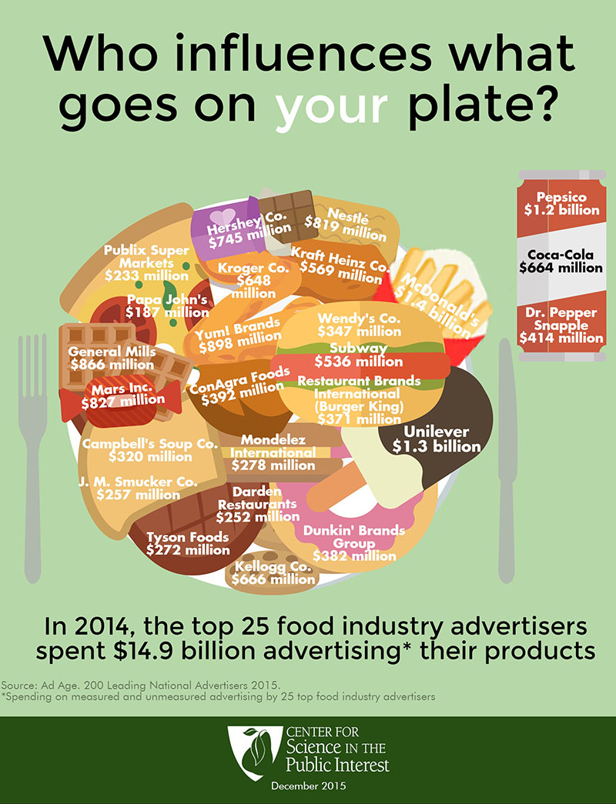

FAMILY AND CONSUMER SCIENCES LESSON PLAN
LESSON: #2 | TITLE: What’s Really in Your Lunch?
 | SUBJECT: Culinary I
 | AUTHOR: Karen Redanz
 | GRADE LEVEL: 9-12
STANDARDS: | CTE Standards:  FCS National Standards:  Common Core Standards:  Math  Math.HSA-CED.A.1 Create equations and inequalities in one variable and use them to solve problems.  Math.HSF-BF.A.1 Write a function that describes a relationship between two quantities.  Speaking and Listening  Literacy.SL.11-12.1b Work with peers to promote civil, democratic discussions and decision-making, set clear goals and deadlines, and establish individual roles as needed.  Language  Literacy.L.11-12.2 Demonstrate command of the conventions of standard English capitalization, punctuation, and spelling when writing.  Literacy.L.11-12.6 Acquire and use accurately general academic and domain-specific words and phrases, sufficient for reading, writing, speaking, and listening at the college and career readiness level; demonstrate independence in gathering vocabulary knowledge when considering a word or phrase important to comprehension or expression.
LESSON OBJECTIVE (in language students can understand): | The students will be able:  - Define what it means to be food literate and cite specific examples.  - Decipher the Nutrition Facts label  - Identify the Environmental Working Group’s Dirty Dozen Ingredients and critique why they should be avoided on a regular basis.
PRIOR KNOWLEDGE & CONNECTIONS TO STUDENT NEEDS &/OR  INTERESTS: | Culinary I is an introductory class with no prerequisite. Students receive basic nutrition information in health classes and science classes. Students are familiar with the Nutrition Facts label and where it can be found on a packaged food.
ESSENTIAL QUESTIONS: | ESSENTIAL QUESTIONS:  What does it mean to be Food Literate?  How can you use the Nutrition Facts label to make healthier decisions with food choices?
FORMATIVE ASSESSMENTS: | FORMATIVE ASSESSMENTS:  (learning tasks)  Activity 1: Test Your Food Literacy. 15-question Food Literacy Quiz, developed in partnership with Nourish, a nonprofit educational initiative, to test your food literacy.  Activity 2: Deciphering the Nutrition Facts Label  Activity 3 Dirty Dozen Wanted Poster
DESCRIPTION OF LEARNING &  PERFORMANCE TASKS: | INITIATION: Whole class: Ask students what it means to be literate. If someone is not literate how would impact his/her life. Answers will vary. If to be literate is to know how to read and write then what would it mean to be Food Literate?  DOK 1  Activity 1: Dependent on resources available in class, students may test their Food Literacy by taking 15-question Food Literacy Quiz, developed in partnership with Nourish, a nonprofit educational initiative, to test your food literacy. It can be accessed on the www.Foodday.org website. If computers or other electronic devices are available, students can complete the quiz and generate an individual grade.  Another option that works well is to complete the quiz together as a class projecting the questions to the entire class. Have students read the question and discuss the possible best answer based on choices given. As each question answered correctly is provided with a brief explanation which engages students in further discussion. The results of the Food Literacy Quiz would be given for class.  Once students have completed the Food Literacy Quiz ask, Why is it important to be Food Literate today? Answers will vary. How might food choices be different for a Food Literate individual?  DOK 2  Activity 2: Deciphering the Food Nutrition Facts Food Label  Another important tool to helping us make good food choices as food literate consumers is the Nutrition Facts and Ingredient List on food labels.  Distribute food labels from various packages of processed foods so that every student has one food label. Ask them to list what kinds of information is provided on the label that would help them make a healthy choice.  Pair each student with a partner to share what information they found using a Venn Diagram. Information students each found important in the center of the Venn diagram.  Distribute the Deciphering the Nutrition Facts.  Have students use this resource to compare and contrast with what they found helpful. Depending on student familiarity with label teacher may emphasize new concepts such as what the Daily Values are and how they can be used. Be sure students also know the importance of the ingredient list as a useful tool to make healthy decisions.  DOK 3  Activity 3: Create a Poster for One of the Dirty Dozen Food Additives  Explain how ingredients should be good for you but there are more than 10,000 ingredients approved by the FDA called food additives allowed in food. Increasingly we learn about people who have allergic reactions or may have a food sensitivity to food additives or how some ingredients may have negative consequences on our health.  By food additives, we mean substances that are added to food products and their packaging. Ask students to think about why food additives are used in food. Answers will vary but may include: to improve, flavor, color, texture, and nutritional quality.  Use the Environmental Working Group web site to research Dirty Dozen Additives. Review what the FDA is responsible for and the term GRAS. Generally Recognized as Safe.  Depending on size of class use small groups of 2 or 3 to create a Wanted Poster.  Use the list of 12 additives that EWG calls the “Dirty Dozen to choose from for this poster. The EWG website will tell you why, which foods contain them and what you can do to avoid them. (A good place to start is by looking up your food in EWG’s Food Scores database).  See handout on Wanted Poster for project instructions.  DOK 3  CLOSURE: Have students complete an exit ticket. What does Food Literacy mean to you?
MATERIALS, RESOURCES, TECHNOLOGY NEEDED: | Activity 1: Teacher computer and LCD to project quiz  15 question food literacy quiz link  http://www.foodday.org/food_literacy_quiz
INSTRUCTIONAL STRATEGIES/  GROUPINGS: | Whole class  Small groups
DIFFERENTIATION STRATEGIES:  ADAPTATIONS & EXTENSIONS | Adaptations: Students that are tech savvy may opt to do a powerpoint or use a creative app like Photoshop or Sway to create their project.
INTERDISCIPLINARY CONNECTIONS:
TEACHER REFLECTIONS: | It is recommended that the teacher take the Food Literacy quiz prior to lesson. There is a variety of content in the 15 question related to food literacy which will prepare the teacher to elaborate on what it means to be food literate.  Students will need additional class time to finish researching their additive and complete their poster.
Learning to Decipher the Nutrition Facts
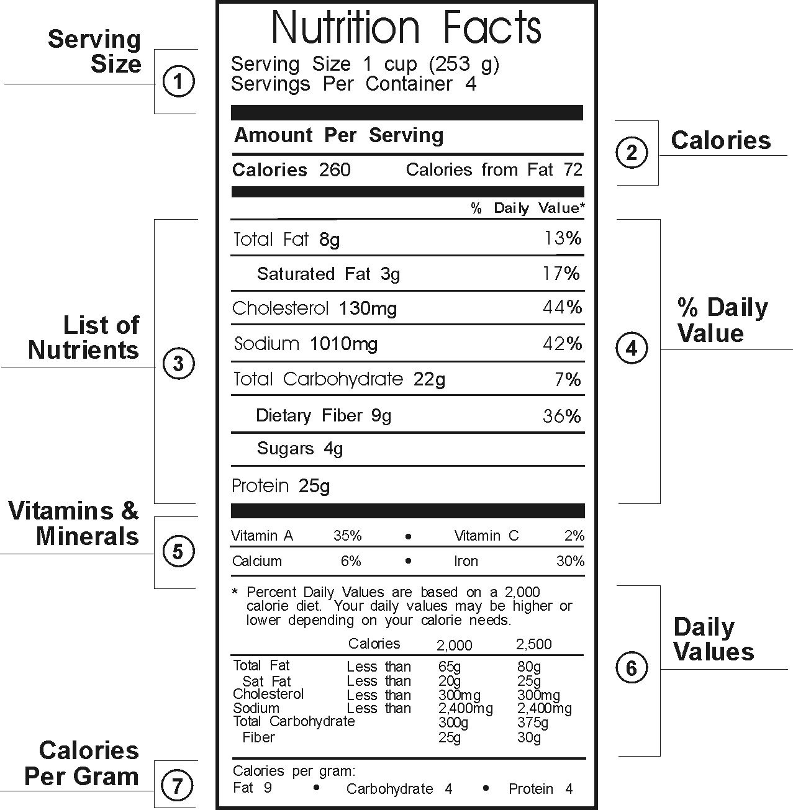
Step 1
Look at the serving size.
Be aware that the serving size is
not always the whole package.

Step 2
Look at how many calories are in a single serving.

Step 3
Look at the fat and cholesterol, limit these. “Total fat”
includes saturated, polyunsaturated and monounsaturated fats.
Avoid saturated and trans fats and limit cholesterol to 300mg.

Step 4
Limit Sodium. Too much sodium or salt can lead to high blood pressure.
Sodium intake should be no more than 2,400 mg per day. Choose foods low in sodium.

Step 5
Look at fiber. Aim for foods with at least 3 grams of fiber per serving. 5 grams per serving is considered high.

Step6
Look at sugars. Choose foods low in sugar. Foods that contain more than 10 grams of sugar per serving should be limited. Avoid processed sugars.

Step 7
Look at nutrients. Make sure to get enough vitamins A, C Calcium, Iron.

Step 8
Read the % Daily Value (DV). A food item with 5 % DV for fat means 5% of the amount of fat that a person is consuming 2,000 calories a day would eat. The DV is for the entire day not just one meal.

SOURCE: Food Fight

Learning to Decipher the Nutrition Facts
Step 1
Look at the serving size.
Be aware that the serving size is
not always the whole package.
Step 2
Look at how many calories are in a single serving.
Step 3
Look at the fat and cholesterol, limit these. “Total fat”
includes saturated, polyunsaturated and monounsaturated fats.
Avoid saturated and trans fats and limit cholesterol to 300mg.
Step 4
Limit Sodium. Too much sodium or salt can lead to high blood pressure.
Sodium intake should be no more than 2,400 mg per day. Choose foods low in sodium.
Step 5
Look at fiber. Aim for foods with at least 3 grams of fiber per serving. 5 grams per serving is considered high.
Step 6
Look at sugars. Choose foods low in sugar. Foods that contain more than 10 grams of sugar per serving should be limited. Avoid processed sugars.
Step 7
Look at nutrients. Make sure to get enough vitamins A, C Calcium, Iron.
Step 8
Read the % Daily Value (DV). A food item with 5 % DV for fat means 5% of the amount of fat that a person is consuming 2,000 calories a day would eat. The DV is for the entire day not just one meal.
SOURCE: Food Fight

Food Additives Poster
When we purchase food it is assumed that it will be good for us but the truth is this is not always the case. Today, there are over *10,000 additives allowed either directly into our food or that can get into our food during the processing and packaging of the food.
Using the Environmental Working Group (EWG) website research why your assigned food additive should be avoided. Create a colorful, informative poster stating why your additive raises concerns and what health problems it is linked to and if banned in other countries.The poster must be neat, free of errors, creative and colorful. You will present your findings to the class.

The Dirty Dozen Food Additives
Butylated Hydroxyanisole (BHA) Theobromine
BytlatedHydroxytoluene (BHT) Secret Flavor Ingredients
Propyl Gallate Artificial Colors
Nitrites and Nitrates Diacetyl
Potassium Bromate Phosphate Food Additives
Propyl Paraben Aluminum Additives

**By food additives, we mean substances that are added to food products and their packaging. Under federal law, the term “food additive” is used to describe just one category of these substances, but we are using the term as it is commonly understood. (EWG)

- Name of Additive
- Include pictures of foods additive can be found
- Description of why additive is used
- Is it GRAS?
- Concerns/health issues related to your additive
- Is it banned in other countries?
- Your conclusion/ what should you do?
- How can the EWG Food Score be helpful?

FAMILY AND CONSUMER SCIENCES LESSON PLAN
LESSON: #3 | TITLE: Sugar How Much is Too Much?
 | SUBJECT: Culinary I
 | AUTHOR: Karen Redanz
 | GRADE LEVEL: 9-12
STANDARDS: | FCS National Standards:  9.3.2 Analyze nutritional data.  9.3.6 Critique the selection of foods to promote a healthy lifestyle.  Common Core Standards:  Math  Math.HSA-CED.A.1 Create equations and inequalities in one variable and use them to solve problems.  Math.HSF-BF.A.1 Write a function that describes a relationship between two quantities.  Literacy.RST.11-12.7 Integrate and evaluate multiple sources of information presented in diverse formats and media in order to address a question or solve a problem.  Writing  Literacy.WHST.11-12.4 Produce clear and coherent writing in which the development, organization, and style are appropriate to task, purpose, and audience.  Literacy.WHST.11-12.5 Develop and strengthen writing as needed by planning, revising, editing, rewriting, or trying a new approach, focusing on addressing what is most significant for a specific purpose and audience.  Speaking and Listening  Literacy.SL.11-12.1b Work with peers to promote civil, democratic discussions and decision-making, set clear goals and deadlines, and establish individual roles as needed.  Language  Literacy.L.11-12.2 Demonstrate command of the conventions of standard English capitalization, punctuation, and spelling when writing.  Literacy.L.11-12.6 Acquire and use accurately general academic and domain-specific words and phrases, sufficient for reading, writing, speaking, and listening at the college and career readiness level; demonstrate independence in gathering vocabulary knowledge when considering a word or phrase important to comprehension or expression.
LESSON OBJECTIVE (in language students can understand): | The students will be able:  - Explain empty calorie recommendations for a day and how that translates into snacks and beverages.  - Calculate grams of sugar on the Nutrition Facts label into teaspoons.  - Develop a logical argument supporting a direct relationship between consuming too many sugary drinks and obesity, which promotes diabetes, heart disease, stroke, and many other health problems.
PRIOR KNOWLEDGE & CONNECTIONS TO STUDENT NEEDS &/OR  INTERESTS: | Culinary I is an introductory class with no prerequisite. Students receive basic nutrition information in health classes and science classes. Students are familiar with the Nutrition Facts label and where it can be found on a packaged food.
ESSENTIAL QUESTIONS: | ESSENTIAL QUESTIONS:  Why is it essential to limit beverages and snacks with added sugar?  How does including more Real Foods in your diet help limit empty calories?
FORMATIVE ASSESSMENTS: | FORMATIVE ASSESSMENTS:  (learning tasks)  Activity 1: How to convert grams of sugar into teaspoons. Class discussion of popular beverages consumed by students and how much they consume daily/weekly.  Activity 2: Compare and contrast amount of sugar consumed daily with daily recommendation of 150 calories or 10 teaspoons.  Activity 3 Advocacy, sharing your knowledge.
DESCRIPTION OF LEARNING &  PERFORMANCE TASKS: | INITIATION:  Whole class: Video Clip The Real Bears (found on Youtube by CSPI aprox. 4 min.) This animated video clip emphasizes the serious consequences of the consumption of sugary drinks citing important health statistics.  Have students watch video together and then share their reactions after viewing with the class. What was the message of this PSA? Was it effective?  Americans love their sweetened beverages with average American consuming on average 60 gallons per year and 64 pounds of sugar. One soda a day can lead to an increase of 10 pounds in a year. One or two sodas increase risk of diabetes by 25%.  DOK 1  Activity 1: Class discussion. Record student responses.  What kinds of beverages do you like to drink?  How much do you drink in a day? (Ex. one 20oz. bottle, two cans soda, large latte, can of Monster). How many sodas and sport drinks have you consumed in the past week?  Why are sugary beverages and snacks considered “empty” calories? (high in sugar, fat and salt and have little to no additional nutrients such as vitamins, minerals, protein)  Explain, for children, that the recommendation for empty calories is 150 per day.  Do you know how much sugar you consume in your favorite beverage? Nutrition Facts lists sugar as grams which is not understood since Americans don’t use the metric system. So use the conversion formula.  4 grams of sugar = 1 teaspoon of sugar  DOK 1  Activity 2: Compare amount of sugar in sweetened beverage and snack with recommended maximum daily intake of 150 calories.  Separate students into small groups of 3 or 4 depending on class size. Each group is given one 20 oz. bottle and one 12 oz. can of popular sweetened beverages. (An alternative would be to print or photocopy the Nutrition Facts labels of these products to acquire the same information).  Additional supplies for each group. One set of measuring spoons, bowl with 2 cups of sugar, and clear drinking glass or jar.  Ask students how much sugar they think are in a can of soda and have them measure it.  Have students then calculate the amount of sugar using the conversation formula and then correct the measure from their guess into the glass. (May range from 9-10 tsp.)  Have students repeat this for the 20 oz. bottle. Have student check the serving size as it often is listed as more than one serving so the amount of sugar is adjusted accordingly.  Have students do this one more time but with a favorite snack/candy of their choice. Using the classroom computer or electronic devices students can look up the Nutrition Facts information and find the sugar amount. Have students measure the sugar after completing the conversation again.  Point out that often students will drink soda with a sugary snack increasing the amount of total sugar consumed. *Remind students that their daily recommendation for empty calories is 150 and this is exceeded with one 20 oz. beverage.  DOK 2  Activity 3. Advocacy, sharing your knowledge. In small groups of 2 or 3 instruct students to make a poster, advertisement, or public service announcement that encourages kids to choose water over soda and sport drinks.  Or students may work together to develop and teach a short lesson that encourages younger kids to choose healthy drinks and why they should limit sweetened beverages.  Students must answer the essential questions of this lesson for this assessment.  DOK 3  CLOSURE:  Homework: Where are the Hidden Sugars? (see handout)  Explain that sugar can be found in many different forms in processed foods so a consumer must be on the lookout for additional hidden sugars. Complete the Hidden Sugars Lurking handout.
MATERIALS, RESOURCES, TECHNOLOGY NEEDED: | FOR INITIATION:  Computer, LCD for projection of video  Activity 1: Something to record student responses such as a white board, easel and paper, appropriate writing implement or computer access to record and project responses..  Activity 2: Each group will need bowl with sugar, measuring spoons, glass to put measured sugar in, either empty bottles and cans of sweetened beverages or copies of the food labels  Activity 3: Materials needed dependent upon which advocacy project is chosen. Material could include; poster paper, markers, magazine pictures, scissors, glue sticks and computer and printer access.  FOR CLOSURE:  Sugar Alias and Hidden Sugars handouts
INSTRUCTIONAL STRATEGIES/  GROUPINGS: | Whole class  Small group  Individual
DIFFERENTIATION STRATEGIES:  ADAPTATIONS & EXTENSIONS: | An example of differentiation of product is in Activity 3 where students can choose to make a poster, advertisement, or public service announcement. Differentiation of process is shown in Activity 3 where students can choose to work on a short lesson for younger students.  Extensions:  If time allows show the documentary Fed Up which addresses obesity in America with a special focus on children and the addictive power of sugar. Sugar found in most cheap processed foods and all beverages consumed by children increases the risk of diabetes,  obesity and other health issues . A free classroom guide is available online for pre-viewing topics and discussion. http://paf-4o-personal-health--fitness.stachs.schoolfusion.us/modules/locker/files/get_group_file.phtml?gid=4759972&fid=27146798.  Another documentary that addresses the effects of consuming fast food is Morgan Spurlock’s Super Size Me. Study guide questions are available online. Two versions of this video can be purchased.
INTERDISCIPLINARY CONNECTIONS: | Health, addiction, anatomy & physiology
TEACHER REFLECTIONS: | If it is not practical to have students measure sugar in small groups teacher may demonstrate with student assistance. This would lessen the amount of materials needed.  For background information for teacher or if time allows in the classroom there are many resources for information.  Documentaries: Food Inc., Super Size Me, Fed UP!  Books by Michael Pollan such as Food Rules, Omnivore's Dilemma  Website with teacher resources: www.foodfight.org  www.nourish.org www.foodday.org  Online quizzes: http://www.foodday.org/quizzes

FAMILY AND CONSUMER SCIENCES LESSON PLAN
LESSON: #4 | TITLE: Plant Based Meals
 | SUBJECT: Culinary I
 | AUTHOR: Karen Redanz
 | GRADE LEVEL: 9-12
STANDARDS: | CTE Standards:  C. Nutritional Needs: Evaluate the nutritional needs of individuals and families in relation to health and wellness across the lifespan.  4. Describe the effect of nutrients on health, appearance, and peak performance.  5. Explain the relationship of nutrition and wellness to individual and family health throughout the lifespan addressing the diversity of people, culture, and religions.  6. Describe the impact of food and diet fads, food addictions, and eating disorders on wellness.  FCS National Standards:  9.3.6 Critique the selection of foods to promote a healthy lifestyle.  14.1 Analyze factors that influence nutrition and wellness practices across the lifespan.  Common Core Standards:  Speaking and Listening  Literacy.SL.11-12.1b Work with peers to promote civil, democratic discussions and decision-making, set clear goals and deadlines, and establish individual roles as needed.  Literacy.RST.11-12.7 Integrate and evaluate multiple sources of information presented in diverse formats and media in order to address a question or solve a problem.
LESSON OBJECTIVE (in language students can understand): | The students will be able:  - Describe how a diet high in plant foods is good for our health.  - Identify and give examples of the edible parts of plants.  - List the health benefits of eating roots, stems, leaves, flowers, fruits, and seeds.  - Create a meal for four people that is mostly plant-based.
PRIOR KNOWLEDGE & CONNECTIONS TO STUDENT NEEDS &/OR  INTERESTS: | Culinary I is an introductory class with no prerequisite. Students are typically familiar with a small assortment of vegetables and have strong preferences for particular vegetables and fruits.
ESSENTIAL QUESTIONS: | ESSENTIAL QUESTIONS:  What are the health benefits of increasing more plant foods into our diet?  What are the health consequences of too many animal foods in our diet?
FORMATIVE AND SUMMATIVE ASSESSMENTS: | Formative Assessment:  Activity 1: Rethink Your Plate  Students will create a plant-based meal on a blank plate template with 75% of meal from plants and 25% may be animal source foods..  Activity 2: Students will identify which part of the plant their favorite vegetables come from using the Mostly Plants lesson 2 resource from lesson plan activities from the website www.foodday.org
DESCRIPTION OF LEARNING &  PERFORMANCE TASKS | INITIATION:  Ask students, “If there were no plants in the world, would we have food to eat?” Give students time to consider this question and trace different foods back to plants.” Continue the discussion until students understand that all food can be traced back to plant foods.  Activity 1:  Plant foods are nutrient dense rich sources of vitamins, minerals, fiber, protein, phytochemicals are low in saturated fat and have no cholesterol by nature. Diets high in plant-based foods can help to maintain good health and prevent diseases such as diabetes, cancer, stroke, hypertension and obesity.  Animal products such as beef, pork, eggs, dairy are rich in proteins, vitamins and minerals but are also high in saturated fat and cholesterol and have no fiber. Diets high in animal products with little to no plant foods can lead to increased risk of lifestyle disease.  Ask students create a typical dinner plate they would prepare at home using the blank template. Discuss what food items are included and whether they are from an animal or plant source. What color are the vegetables? Is there variety? Have students estimate what percent of their meal is plant-based.  Project Jamie Oliver’s Causes of Death Graphic or distribute a copy from his Ted Talk.  Give students time to analyze all of the causes of death. Ask students to describe the top 5 causes of death. Can an inference be made regarding the causes of death? They are all related to negative food choices.  Distribute the handout Rethink Your Plate. Source: www.FoodFight.org.  In pairs have students discuss and rethink their plate and plan a meal that is plant-based using the blank plate template. They may use electronic devices and/or classroom computers to research ideas for new plant-based recipes. Students fill in their blank plates with their recipe ideas. Have students share their plate ideas.  DOK 3  Activity 2: Nutritional Benefits of Various Parts of Plants  Using the www.foodday.org resource Mostly Plants pictures discuss with students how chefs and botanists classify plant food differently. A chef defines a plant as sweet or savory. A botanist classifies vegetables and fruits by the part of the plant we eat. For example, tomatoes, cucumbers, peppers, zucchini, and string beans are the fruit of a plant.  Distribute vegetable cards to students and discuss examples of the six parts of a plant that our vegetables come from and what their nutritional benefits. Have students identify which part of the plant their favorite vegetables are from.  Activity 3: Unpacking the Plate Nutrients That Feed Our Bodies  This resource is included but can be found in the education guide from www.foodfight.org in teacher resource.  This is a brief overview of the basic nutrients that are important to maintain good health. Discuss with students how a plant-based diet will provide them with all the basic nutrients needed for growth, development and survival.  CLOSURE:  Students will respond to, “ What was the most difficult concept in today's lesson? Students will display their plant-based plates on the walls.
MATERIALS, RESOURCES, TECHNOLOGY NEEDED: | Computer and LCD for projection  Handouts: Rethink Your Plate, Unpacking Your Plate, Jamie Oliver's Causes of Death
INSTRUCTIONAL STRATEGIES/  GROUPINGS: | Whole class  Small group
DIFFERENTIATION STRATEGIES:  ADAPTATIONS & EXTENSIONS: | Students can add the nutrients to their plates provided by different types of plant and animal foods. For example, protein can be found in both plant and animal foods.
INTERDISCIPLINARY CONNECTIONS: | Health, addiction, anatomy & physiology
TEACHER REFLECTIONS: | For background information for teacher or if time allows in the classroom there are many resources for information.  Documentary: Forks Over Knives documents  Books by Michael Pollan such as Food Rules, Omnivore's Dilemma  Website with teacher resources: www.foodfight.org  www.nourish.org www.foodday.org  Jamie Oliver’s Ted Talk discusses why Americans are dying related to their food consumption is a great resource for teachers or if time allows students.

Causes of Death, United States

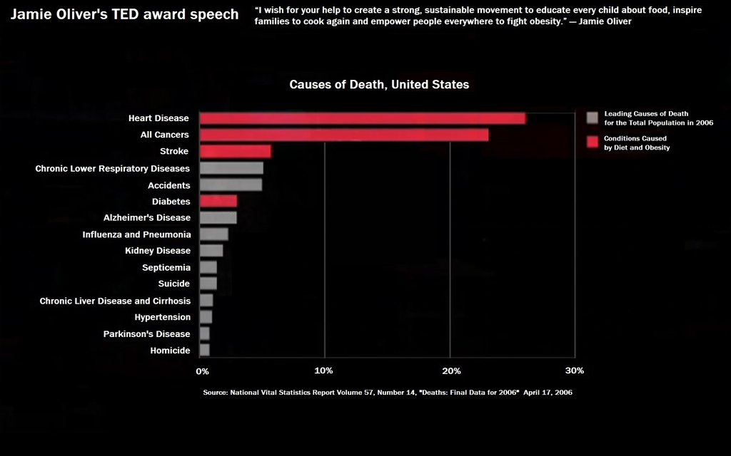

FAMILY AND CONSUMER SCIENCES LESSON PLAN
LESSON: #5 | TITLE: Meal Planning Project
 | SUBJECT: Culinary I
 | AUTHOR: Karen Redanz
 | GRADE LEVEL: 9-12
STANDARDS: | CTE Standards:  Culinary and Food Production  D.11. Apply menu-planning principles to develop and modify menus.  D.12. Analyze food, equipment, and supplies needed for menus.  FCS National Standards:  8.4.2 Apply menu-planning principles to develop and modify menus.  8.4.3 Analyze food, equipment, and supplies needed for menus.  8.4.7 Apply principles of Measurement, Portion Control, Conversions, Food Cost Analysis and Control, Menu Terminology, and Menu Pricing to menu planning.  Common Core Standards:  Writing  Literacy.WHST.11-12.4 Produce clear and coherent writing in which the development, organization, and style are appropriate to task, purpose, and audience.  Literacy.WHST.11-12.5 Develop and strengthen writing as needed by planning, revising, editing, rewriting, or trying a new approach, focusing on addressing what is most significant for a specific purpose and audience.  Speaking and Listening  Literacy.SL.11-12.1b Work with peers to promote civil, democratic discussions and decision-making, set clear goals and deadlines, and establish individual roles as needed.  Language  Literacy.L.11-12.2 Demonstrate command of the conventions of standard English capitalization, punctuation, and spelling when writing.  Literacy.L.11-12.6 Acquire and use accurately general academic and domain-specific words and phrases, sufficient for reading, writing, speaking, and listening at the college and career readiness level; demonstrate independence in gathering vocabulary knowledge when considering a word or phrase important to comprehension or expression.
LESSON OBJECTIVE (in language students can understand): | The students will be able to:  - independently prepare a nutritious, plant-based meal for a minimum of four people using skills and knowledge acquired in Culinary I.  - Calculate the cost of a meal.
PRIOR KNOWLEDGE & CONNECTIONS TO STUDENT NEEDS &/OR  INTERESTS: | Culinary I is an introductory class with no prerequisite. SOme students assist with food preparation at home. Students in culinary I learn to prepare food together in a small group then sit together family style to evaluate their assigned recipe.
ESSENTIAL QUESTIONS: | ESSENTIAL QUESTIONS:  What are the benefits of preparing family meals at home and eating together?
FORMATIVE AND SUMMATIVE ASSESSMENTS: | Formative Assessment:  Completion of specific criteria to complete Meal Planning Project  Summative assessment:  Final Project: Meal Planning Project  (see attached)
DESCRIPTION OF LEARNING &  PERFORMANCE TASKS | INITIATION: Ask students how often they have a family style meal prepared at home and then eaten together at the table? Have them elaborate on the kinds of foods prepared and barriers that prevent families from sitting together each night.  Activity 1: Discuss the benefits of preparing home cooked meals and eating family style.  Responses may include: Save money, more nutritious, do not eat as many calories, smaller portions, families can share experiences of the day or family stories. Give students time to share experiences so other students can understand the significance of family meals and the different ways families dine together.  DOK Level: 1  Activity 2: Distribute the Meal Planning Project handout  Discuss each component of the project in detail. Answer questions. Share sample projects from previous years or a teacher sample so students will confident they can complete this project successfully.  DOK Level 4  Activity 3: Setting up the Project  Using the electronic (computer, laptop, chromebooks) devices have students create a google document to be shared immediately with the teacher setting up a page for each component of the project  Allow students time to work on each component of this project and be available to assist as needed.  DOK Level: 3  CLOSURE:  Have students share recipes they selected with the class and date they will prepare the meal for their family to help motivate other students in class.
MATERIALS, RESOURCES, TECHNOLOGY NEEDED: | Access to media center/ computer lab or classroom set of electronic devices so ensure every student has ability to set up project.
INSTRUCTIONAL STRATEGIES/  GROUPINGS: | Whole class  Individual
DIFFERENTIATION STRATEGIES:  ADAPTATIONS & EXTENSIONS: | Students unable for any reason to prepare their meal at home may prepare meal in the food lab inviting teachers as guests to evaluate the meal.  Life skill students can successfully complete this project with little to no assistance other than close supervision. Use of the culinary lab after school may be a good option. Recipes must be carefully selected with limited steps and clear instructions. In some cases, using frozen vegetables already prepped may be substituted for fresh.
INTERDISCIPLINARY CONNECTIONS: | Math, writing, reading
TEACHER REFLECTIONS: | Prior to beginning this project students must have selected recipes and have parent and teacher approval. This project cannot move forward without student recipes. When choosing recipes it is best to consider the student's skill and prior experience to select recipes that challenge but are not too difficult. Student recipe choice will vary due to their enthusiasm, skill level, and affordability.  Access to the media center or class set of electronic devices is important to kick off this project starting students together. Teacher can check that everyone understands expectations of the project.  Have students create a google document for Meal Planning Project and share with teacher so it can be easily assessed at various checkpoints and progress reviewed. Students typically need about 3 days in class to work with teacher assistance on calculating the cost of the meal, nutritional analysis and time schedule.

REAL FOOD MEAL PLANNING PROJECT
200 points Due: ____________

Objective: To independently prepare a nutritious, plant-based meal using skills and knowledge acquired in Culinary I.

Requirements for project:
    - 4 people must attend meal, including one adult
    - Box mixes/convenience, and processed foods may not be used
    - Consider plant-based recipes with fresh vegetables, fruits, legumes, nuts, and seeds.

Entrée, vegetable side, beverage, healthy dessert
    - Photographs required and must be mounted and labeled
    - Recipes must be approved by teacher and parent

Project Component | Possible Points | Actual Points | Comments
Title Page | 5
Menu Selection | 10
Recipes Complete | 15
Market Order  List of items to be purchased | 10
Cost Analysis of every ingredient used | 20
Time Schedule  estimated in advance | 15
Nutritional Analysis  Sugar, Fat and Salt per serving | 20
Table Setting  (photograph) | 10
Meal Evaluation Adult  Complete rubric | 10
Meal Self-Evaluation  Complete rubric | 10
Photographs must include mis en place and final products | 30
Reflection of your process - 2 pages typed | 40
Total points

Project Component | Requirements
Title Page | Neatly presented  Typed  Title, name and date
Menu Selection | Plant-based recipes  Minimum 3 recipes  Includes dessert  No sugary beverages
Recipes Complete | Neatly typed with list of ingredients and steps  Approved by teacher and parent
Market Order | List only items needed to be purchased
Cost Analysis of every ingredient used | Using Peapod.com or another on-line tool look up cost of every ingredient in each recipe. Students will use basic math calculations to determine cost of specified amount used in recipe. For example, if student used ¼ cup of olive oil then cost is determined by calculating how much each Tablespoon cost and then multiplying this amount by 4T used in recipe.
Time Schedule  estimated in advance | Students may use their textbook Food for Today to review how to create a time schedule. A table or excel sheet can be created to write the steps to execute their meal planning project.
Nutritional Analysis  Sugar, Fat and Salt per serving | Student will create a table or excel sheet that lists each ingredient of every recipe with a column for sugar, salt and fat. Students may calculate total amount from food label or online source. Peapod.com has most ingredient labels available to collect this information to determine the amount of fat, salt, and sugar in their meal.
Table Setting  (photograph) | This page includes a photograph of your table appropriately set for your menu choice. Table must be free of clutter and display a center piece.
Meal Evaluation Adult  Complete rubric | Rubric completed and signed by an adult attending meal.
Meal Self Evaluation  Complete rubric | Rubric completed by student.
Photographs must include mis en place and final products | Students should have a minimum of 15 pictures that include mis en place, final products, table setting, guests, and clean up. Student should be visible in pictures.
Reflection of your process - 2 pages typed | Students will reflect on the process and execution of Meal Planning Project. Respond to the following questions: What went well? What went wrong? Did you like your recipe choices? What did you learn from this project? Were you surprised by anything? What did you like about this project? Didn't like? What would you do differently next time?

