Activity 5.2.5b Locating the Center of a Circle using Geogebra

The Perpendicular Bisector of a Chord Theorem – The perpendicular bisector of any chord of a circle passes through the center

Part 1 – Find the center of the circle.

- Open a new Geogebra document

- Draw a circle without the center given.
- Press the down-arrow button on the bottom right of the circle icon.
- Click on the option “Circle through 3 Points”
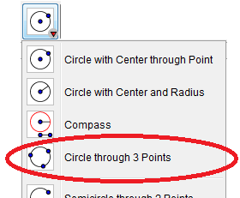
- Click three times on the screen to create the three points. Make sure they don’t lie on a line. Otherwise you won’t get a circle.
- You should see a circle.

- Draw a chord on the circle
- Press the down-arrow button on the bottom right of the line icon. 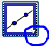
- Click on the “Segment” option
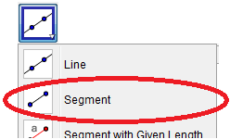
- Click two points on the circle.
- You should see a chord
- Draw the perpendicular bisector of the chord
- Press the down-arrow button on the perpendicular icon. 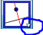
- Click on the “Perpendicular Bisector” option
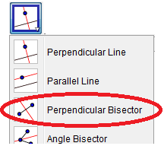
- Click anywhere on the chord.
- You should see a perpendicular bisector.
- (According to the perpendicular bisector of a chord theorem, this line passes through the center however you don’t know exactly where on this line is the center of the circle.)

- Draw a second chord on the circle that is not parallel to the first. Follow the direction from Step 3 to complete this.

- Draw the perpendicular bisector of the second chord Follow the direction from Step 4 to complete this.
- (According to the perpendicular bisector of a chord theorem, this line passes through the center of the circle as well!)

- Plot a point at the center of the circle.
- Press the down-arrow button on the Point icon.
- Click on the “Intersect” option
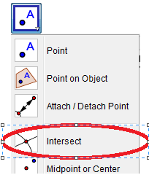
- Click once on each of the perpendicular bisectors.
- The result is the ____________________ of the ______________________

Part 2 – Find the diameter of a circle if you are only given an arc.

- Open a new Geogebra document
- Draw a circular arc.
- Press the down-arrow button on the bottom right of the circle icon.
- Click on the option “Circumcircular Arc”
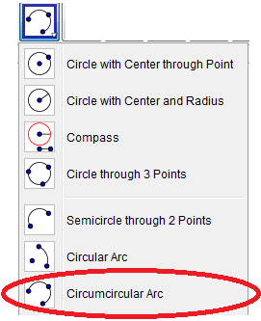
- Click three times on the screen. You should see an arc.

- Draw 2 chords on the arc. Use the directions for making a segment from PART 1, Step 3 to help.
- Click two points on the arc. You should see a chord
- Click two more points on the arc. You should see a second chord

- Draw the perpendicular bisectors of both chords. Use the directions for making a perpendicular bisector from PART 1, Step 4 to help.

- Plot a point at the center of the circle. Use the directions for finding an intersection from PART 1, Step 7 to help.

- Draw the circle to complete the arc .
- Click on the down-arrow on the arc button.
- Click on the “Circle with Center through Point”
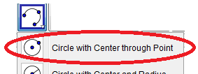
- Click once on the center and once on a point on the arc.
- You should have a completed circle!
- Find the length of the radius and diameter .
- Click on the Segment button.
- Draw a segment from the center to any point on the circle. This is the radius.
- Find the length of the radius by clicking the down-arrow of the Angle button
- Select “Distance or Length” button
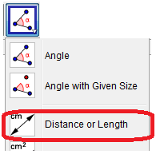
- Click on the radius. The length will appear.

- Double the length of the _____________ to get the length of the ______________

- Answer this question: Is there an alternate way to find the length of the diameter?

Part 3 – Explain what you learned

- Explain why the intersection of the two perpendicular bisectors of two nonparallel chords is always the center of the circle

- Explain why the chords need to be nonparallel.

- You have a circular table and want to find its center. How can you do that?

- Archaeologists find part of a broken plate. Explain how can they determine its diameter?

