Activity 6.2.2 Nets for Cylinders and Cones

Note: In this activity we will consider only right circular cylinders and right circular cones.

Cylinders

Your teacher has provided you with a small can. Your task is to make a net of a cylinder that duplicates the surface of the cylindrical can.

  - Measure the diameter of the base of the can. Use half of the diameter for the radius of the base. What is the length of your radius?

  - On a separate piece of paper or card stock use your compass to draw two circles with this radius. These circles will form the bases of our model can.

  - Now we need to make a rectangle that will provide the lateral surface of the can. Think of this rectangle as the label of the can, once it has been peeled off.

a. How tall should our rectangle be?
b. To find the width of the rectangle we need to find the circumference of our circular base. Show your calculations here.

  - Now use your protractor and ruler to draw a rectangle with these dimensions.

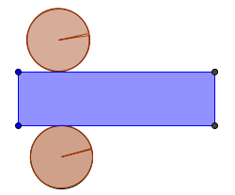
  - Cut out your rectangle and circles. We can arrange these to form a net for a cylinder that looks something like this: Note that in practice we may want to add some tabs for glue.

  - The sum of the areas of the two circles and the area of the rectangle is the surface area of your cylinder. Calculate the total surface area of your cylinder here:

  - Now make another net for a cylinder. This time start with a radius that is twice as large as the radius of the net above. Make the two circular bases. Then make a rectangle using a segment that is the length of the circumference of your circle and a height double the length of your previous cylinder. Construct the net for your cylinder and assemble a second cylinder.

  - Find the total surface area of this new cylinder. Show your work here:

  - Use your measurements from these two cylinders to complete this chart:

 | radius | height | Area of each base | Lateral area | Total surface area
First Cylinder

Second Cylinder

  - Answer these questions using data from the chart.
a. What is the ratio of the radii of the two cylinders? (Compare second cylinder to first cylinder)

b. What is the ratio of the heights of the two cylinders?

c. What is the ratio of their lateral areas?

d. What is the ratio of the total surface areas?

e. Make a prediction about the total surface area if we double the dimensions again.

  - Work with a partner to create a right cylinder (including both bases) from a single 8.5 by 11 in sheet of paper. Try to make the cylinder with the largest surface area that you can!
a. Draw a net of your right cylinder on a single sheet of 8.5 by 11 inch paper.

b. Measure the dimensions of your net and use them to calculate the surface area of your right cylinder. Show your work here:

c. Share your cylinder, its dimensions and total surface area with your classmates.
Find out who has the largest surface area and what dimensions they used.
Cones
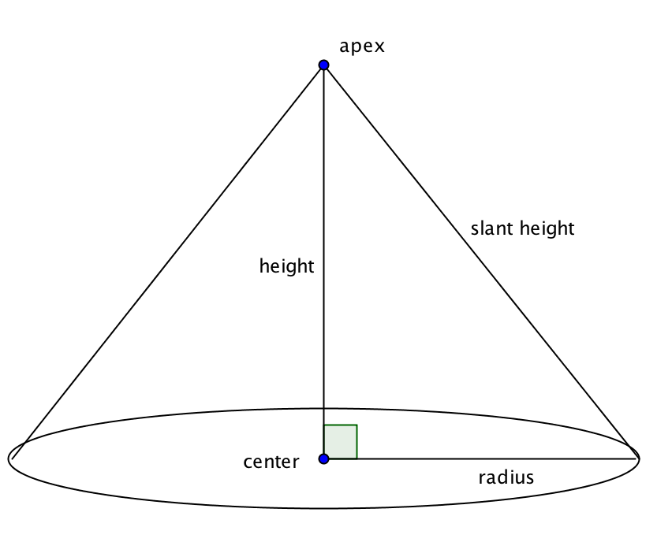
  - Another important solid shape that is not polyhedral is the cone.
Open the GeoGebra file ctcoregeomACT622. Use the sliders to change the radius and height of the cone. Notice how the sliders affect right triangle ABC at the left of the screen as well as the circular base and sector used to form the cone’s lateral surface.

        - How is the circular base related to the triangle?
        - How is the sector for the lateral surface related to the triangle?
        - How is the radian measure of the central angle related to the triangle?
        - How can you make the sector cover almost its entire circle?

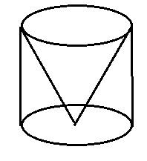
        - How can you make the sector cover only a small fraction of its circle?
  - Find an empty can with a missing lid. Work with a partner to try to make a paper cone that will fit exactly inside this can as in this picture.

a. The net below shows the base and the lateral surface. How is the arc length of the sector related to the circumference of the base? Explain.

b. How would you find the radius of the sector that forms the lateral surface?

c. How would you find central angle for the sector?

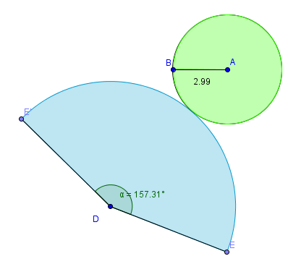

d. Show the calculations you and your partner made to create the cone that fits exactly inside the can.

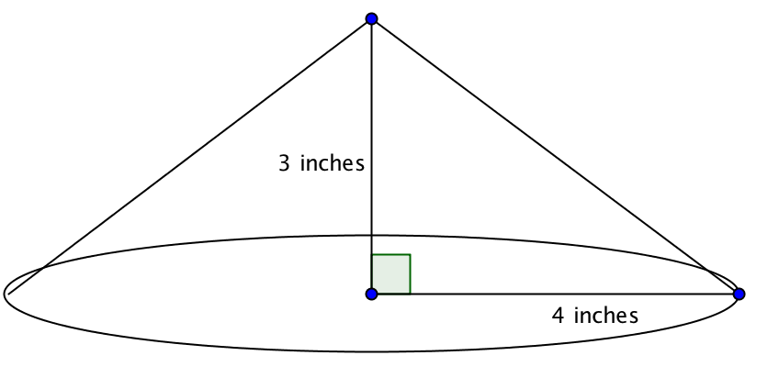
14. A cone has a height of 3 inches and the radius of its
base is 4 inches.

a. Find its slant height.

b. Find the central angle for the sector that forms the lateral surface.

c. Find the lateral surface area.

d. Find the area of the base.

e. Find the total surface area.

f. How does the surface area of this cone compare with one that has a height of 4 inches and a radius of 3 inches for its base?

