Activity 6.1.3 How Many Regular Polyhedra are There?

Your group will work together to assemble a set of Platonic solids. You may ask, “What is a Platonic solid?” It is a polyhedron that is completely constructed of copies of one regular polygon. Each vertex is the intersection of the same number of edges. The same number of faces surrounds each vertex. Platonic solids are also called regular polyhedra.

1. Recall what you learned about regular polygons in Unit 3. Use that information to complete this table:

Name of the polygon | Sum of the interior angle measures | Measure of one interior angle
Equilateral triangle
Square
Regular Pentagon
Regular Hexagon
Regular Octagon | 1080º | 135º

2. Begin with an easy construction. Use Geogebra or Geometer’s Sketchpad to design a net that uses squares to completely enclose space.

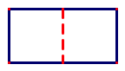
Start with two connected squares. Can the two units enclose space? ___________

In the diagram we will cut on the solid lines and fold on the dashed lines.

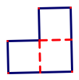
If we connect three squares at one vertex we will be able to imagine that we could enclose space. Here we are using three 90º angles about a vertex. Note that 3 times 90 are 270, which is less than 360 degrees. Continue adding faces so that each vertex is surrounded by three squares.

How many units did it take to complete a cube?__________

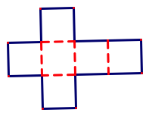
The parts of your cube could lie flat on the table like this:

3. What other arrangements of your squares could fold into a cube? Sketch some here:

These different arrangements are called nets.

4. Could we make a net with squares so there are four squares around each vertex? ______

Would this net enclose space? ________
Why or why not? ____________________________

We want to keep this cube together so tape the edges and the cube will stay together.

We can name this polyhedron using a Cundy/Rollett symbol. The Cundy/Rollett symbol for the cube is 4.4.4. This means that there are three squares at each vertex. The number of numbers indicates how many faces come together at a vertex; the numbers themselves indicate the number of sides of the regular polygon.
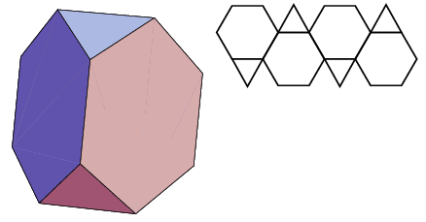
Note that in addition to the Platonic solids there are also Archimedean solids (also called semi-regular polyhedral), which have more than one regular polygon around a vertex. The symbol for a truncated tetrahedron would be 3.6.6 because it has three polygons around each vertex and they are a triangle and two hexagons. Image from mathworld.wolfram.com
5. How many faces does your finished cube have? __________How many edges does it have? ______________How many vertices does it have? _______________

6. Let’s begin another table to collect this information.

Name of the Platonic Solid | Type of polygon used | Number of faces | Number of edges | Number of vertices | Cundy/Rollett  symbol
Cube or Regular Hexahedron | Squares | 6

We will now extend our experiments to different polygons. We will work with the triangles next. Start by trying to design a solid that has two equilateral triangles around each vertex.

7. We cannot enclose space with two triangles at each vertex. Can we do it with:

Three at each vertex? _________________________
Four at each vertex?___________________________
Five at each vertex?___________________________
Six at each vertex? ____________________________

8.Your group should find three more polyhedra that work! Why doesn’t the fourth one work?

Add these to your table. You may notice that the names of the polyhedra come from the number of faces in Greek. Thus the cube can be called a hexahedron because it has six faces.

Here is a list of some Greek number words. Which ones will you use to add your polyhedra made of triangles to the table?

3 = tri
4 = tetra
5 = penta
6 = hexa
7 = hepta
8 = octa
9 = ennia or nona
10 = deca
12 = dodeca
14 = tetradeca
16 = hexadeca
18 = octadeca
20 – icosa

9.What might you call a 15-sided polyhedron? ___________________________________

Looking at your table, which should now have four rows nearly completed.

10. How should we name these new polyhedra constructed from triangles? Add the names to the table.

11. What should the Schläfli symbols be? Add these to the table too.

If you have not already added tape to some of your edges, do so now, so your polyhedra will not fall apart!

12. We are now going to see what we can do with regular pentagons. Can we fit three of them around a vertex? ____________________
Add your findings about this polyhedron to your table.

What would happen if we tried to place four regular pentagons around a vertex? _____________________________________________________

13. Now the question is, “Are there any more?” We have found polyhedra using triangles, squares and pentagons. Explain why we cannot use regular polygons with more than five sides to construct regular polyhedra

14.Now that you have created a full set of Platonic Solids, draw nets for each of them (note, you may want to use Geometer’s Sketchpad or Geogebra to help you with this task.)

15. See if you can draw a two dimensional sketch of each three dimensional polyhedron here:

Be certain to save your regular polyhedra for more activities in this investigation.

