Activity 8.5.3 Koch Snowflake

Look at a piece of Connecticut coastline around Indiantown Harbor in Middlesex County Connecticut (Figure 1). If you have difficulty seeing the image, go to the following web address:

www.google.com/maps/@41.2719169,-72.3859057,3275m/data=!3m1!1e3

If we took a measuring stick of a particular length and measured the coastline, we would get a value for the length. (Figure 2 shows the beginning of measuring the coastline with one measuring stick.) However, if we cut the length of the measuring stick in half, we would get a somewhat longer length because that measuring stick could fit into more of the coastline’s nooks and crannies. The more you zoom in on the coastline, the more nooks and crannies you will find.

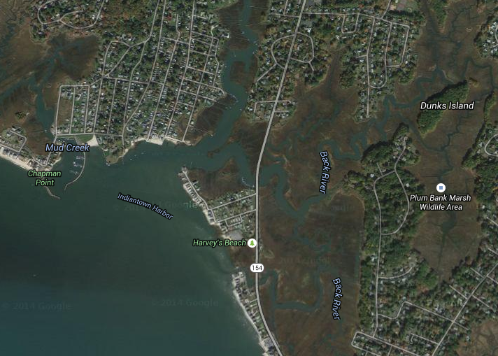
Figure 1. Satellite view of Indiantown Harbor.
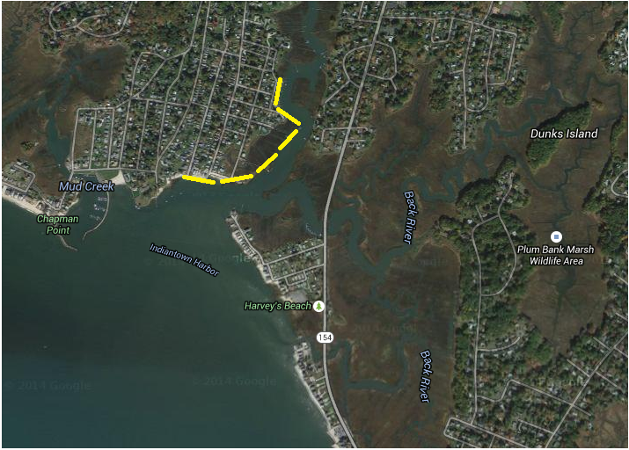
Figure 2. Measuring the coastline using a measuring stick of a fixed length.

Fractals can help describe mathematically this type of pattern and the problem of determining the length of a coastline. In this activity, you will use GeoGebra to create several Stages in a fractal called the Koch Snowflake. As in Activity 8.6.2, you will create a tool in GeoGebra to speed up the construction process.

A Koch Snowflake

A Koch Snowflake begins at Stage 0 with an equilateral triangle. To create Stage 1, each side of the triangle is divided into thirds and an equilateral triangle is constructed using the middle segment as a base. The process is repeated to create the next stages.

Tip: To avoid clutter on the screen, go to Options Labeling and select “No New Objects.”

1. The first step is to create a tool. The tool will divide a line segment in thirds, and then draw an equilateral triangle using the middle segment as the base. Here’s how to create the tool:
- Close the algebra panel and click on the axes icon to remove the axes.
- Click on the Segment icon 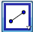. Then click two points to draw the segment.
- Divide your line segment into thirds. Click on the dilate icon 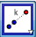 (below Reflect in the Transform menu. Then click on the endpoints of the segment. Enter $\frac{1}{3}$in the factor box and click OK. Repeat this step but this time click on the two points in the reverse order.
- Next, you will create an equilateral triangle using the middle segment as the base. Click the regular polygon icon 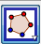. Then click on the middle two points, enter 3 for the number of sides, and then click OK.
- Click Tools and select Create New Tool.
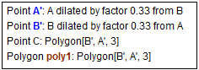
- Click on the down arrow of the “Select objects” bar and select each of the following:

- Click Next. Your screen should indicate that Point A and Point B are the input objects.
- Click Next again. Name your tool: Koch. For Tool help write: Select two points. Your Name & Icon box should match the one in Figure 3.
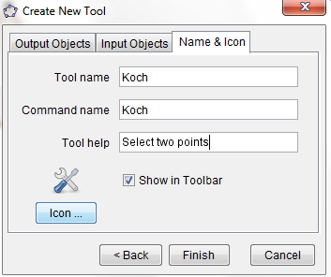

Figure 3. Completed Name & Icon step.

- Click Finish.

2. Stage 0: An equilateral triangle.

a. In preparation for creating Stage 0 of the Koch Snowflake, delete the figure that you created for the tool so that you can start with a blank screen.

b. Use the regular polygon tool to create an equilateral triangle. Adjust the triangle so that it fills about half of your screen and is located in the center of your screen.

c. Assume that the side lengths of your equilateral triangle are 1 unit. What is the perimeter of Stage 0?

3.
a. For Stage 1 you will use your Koch tool to add equilateral triangles to each side of Stage 0’s triangle.
- Click the Tool icon 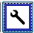.
- Click on the endpoints of one side to form a new triangle. If the triangle appears in the interior of your Stage 0 triangle, undo and repeat the process clicking on the endpoints in reverse order.
- Repeat the process to draw triangles on the other two sides of the Stage 0 triangle.

b. The boundary of Stage 1 is the shape that you would get by tracing around the outside of your figure. Make a sketch by hand of Stage 1.

c. What is the measure of each side in Stage 1?

d. How many sides are there in Stage 1?

e. What is the perimeter of Stage 1?

4.
a. To create Stage 2, use your Koch tool to affix equilateral triangles on each side of Stage 1.

b. Stage 2 is the shape that you would get by tracing around the outside of your figure. Make a sketch by hand of Stage 2.
c. What is the measure of each side in Stage 2?

d. How many sides are there in Stage 2?

e. What is the perimeter of Stage 2?

5.
a. Use GeoGebra to construct Stage 3 by inserting a triangle on each of the sides of
Stage 2.

b. Stage 3 is the shape that you would get by tracing around the outside of your figure. What is the measure of each side in Stage 3?
c. How many sides are there in Stage 3?

d. What is the perimeter of Stage 3?

6. From the circle menu select “Circle through 3 points.” Now select the three vertices of your original (Stage 0 triangle.) Based on this circle, do you think that the area of the Koch Snowflake (imagine adding stages to your construction) is finite or grows beyond bound? Explain.

7. Complete Table 1 for Stages 1–6 of the Koch Snowflake.

Stage | Side lengths | Number of sides | Perimeter (units)
0 | 1 | 3 | 3
1
2
3
4
5
6

8. Use the information from Table 6 to help answer the following questions.

a. Determine an expression for the side lengths of Stage n.

b. How many sides are there in Stage n?

c. What is the perimeter of stage n?

d. Do the values in the perimeter column form an arithmetic or geometric sequence? What is the common difference or common ratio?

e. As n gets larger and larger, what happens to the perimeters?

