Activity 8.5.2 Sierpinski Triangles Using GeoGebra

In Activity 8.5.1, you drew the first three stages of a Sierpinski triangle starting with an equilateral triangle. You might wonder whether you could generalize the same process that you completed by hand starting with a triangle that is not equilateral. In this activity you will create a GeoGebra tool to speed up the work and allow you to start with any triangle at Stage 0.

Before you try this yourself you may want to watch this video:
www.youtube.com/watch?v=dJhtLVvtsj4.

1. Open GeoGebra. Click the axes icon to hide the axes.

2. First, you need to create Stage 0 of Sierpinski’s triangle.
- Click the Polygon icon.
- Draw a non-equilateral triangle that fills most of the screen by clicking on three points. Complete the triangle by clicking on your first point again.
- Make a rough sketch of your Stage 0 triangle here.

3. Next, you will create Stage 1 and select the colors.

a. Here’s how to construct Stage 1:
- Select the Midpoint or Center icon 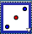 (below the Point icon).
- Click on each side of the triangle to create its midpoint.
- Click the Polygon icon. Going counterclockwise, click on the three midpoints and then click again on the first midpoint to create a triangle.

b. Adjust the color:
- Right click inside the Stage 0 triangle and select Object Properties.
- Select poly1 and click the color tab. Click on any color other than white. Then slide the Opacity slider to the right to darken the color.
- Now, select poly 2. Click on white and slide the slider all the way to the right so that the triangle interior is white. (This indicates that the triangle’s interior has been removed.)
- Point to Segment and click to highlight all of the segments. Then select the color black. Close out of Object Properties.
- Make a rough sketch of your Stage 1 triangle here.

4. Next, you will create a tool that can be used to create Stage 2 and later stages. Here’s how:
- Click the Tools tab and select Create New Tool.
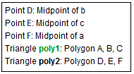
- Click the down arrow on the “Select objects” bar.
- Click on the first object “Point D: Midpoint of b” to select it.
- Repeat the process of clicking on the arrow of the “Select objects” bar and then selecting each of the objects shown in Figure 1.
Figure 1. Selecting objects for tool

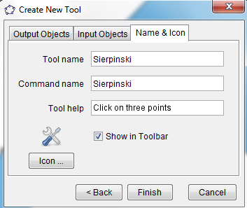
- Click Next. You should now see a list of the Input Objects, which consists of the first three points used to create your Stage 0 triangle.
- Click Next. Give the tool a name: Sierpinski. Then for Tool help write: Click on three points. Your “Create New Tool” box should look like Figure 2.
- Click Finish. GeoGebra should respond: New tool created successfully! Click OK.

Figure 2. Create New Tool box for Sierpinski Triangle.

This would be a good time to save your work, which will also save the tool that you have just created.

5. Next, you will use your tool from question 4 to create Stage 2.
- Click on Tool icon . (If you have created more than one tool, you will have to select the tool you want to use.)
- Stage 1 should show three triangles with interiors of your chosen color. Click on the three points at the vertices of one of these triangles. Repeat the process on the other two triangles.
- Click the Move icon . Move one or more of the vertices of your original triangle. Notice that all of the smaller triangles remain similar to the original triangle.

6. a. How many small triangles with interiors of your chosen color are in Stage 2?

b. For Stage 3, you will need to apply the Sierpinski tool to the vertices of each of the triangles that you counted in (a). Create Stage 3.

7. a. How many small triangles with interiors of your chosen color are in Stage 3?

b. For Stage 4, you will need to apply the Sierpinski tool to the vertices of each of the triangles that you counted in (a). Create Stage 4.

8. a. How many small triangles with interiors of your chosen color are in Stage 4?

b. For Stage 5, you will need to apply the Sierpinski tool to the vertices of each of the triangles that you counted in (a). Create Stage 5.

9. a. How many small triangles with interiors of your chosen color are in Stage 5? Given the number of triangles, you probably don’t want to apply your tool to each of these triangles to form Stage 6.

b. Click the Move icon and use it to change the shape of your Stage 0. What happens to Stage 5 when you do this?

