Activity 8.5.1 Sierpinski Triangle
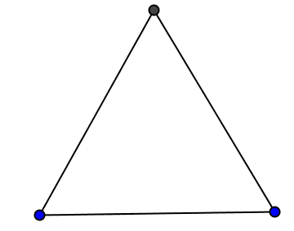
Use the triangle on the template at the end of this activity.

1. The equilateral triangle in Figure 1 is Stage 0 in the construction of a Sierpinski triangle. Assume that the side length of this triangle is 1 unit.

- What is its perimeter? Show calculation here.
Figure 1
- What is its area? Show calculation here.

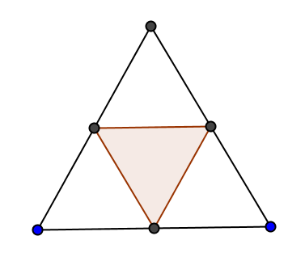
2. a. Next, you will draw Stage 1 in the construction of a Sierpinski triangle on the template. Here is how:
- Using a compass, construct the midponts for each of the sides. Explain how you accomplished this task.
- Connect the midpoints with line segments, forming another triangle.

- Shade the area of the interior of the middle triangle to indicate that this area has been removed. (See Figure 2)

Figure 2

b. Prove that your construction in (a) divides the Stage 0 triangle into 4 congruent triangles that are similar to the triangle in Stage 0.

c. Calculate the perimeter of Stage 1. This consists of the perimeter of the Stage 0 triangle plus the perimeter of the middle triangle constructed in part (a).

- Calculate the area of Stage 1, which equals the area of the triangular region in Stage 0 minus the area of the triangular region removed in Stage 1.

3. a. Next, you will construct Stage 2. Notice that there are 3 triangles that do not have shaded interiors. For each of these triangles:
- Construct the midpoints of each side.
- Connect the midpoints with line segments to form a center triangle.
- Shade the region inside the center triangle to indicate that this region has been removed.
Notice that each of the constructions completed on these three triangles results in a figure similar to Stage 1.

b. Calculate the perimeter of Stage 2. Explain how you arrived at your answer.

c. Calculate the area of Stage 2. Explain how you arrived at your answer.

4. a. Next, you will construct Stage 3. Notice in Stage 2, there are 9 triangles that do not have shaded interiors. For each of these triangles apply the directions in the bullets from 3(a). Again, notice that each of the constructions completed on these nine triangles results in a figure similar to Stage 1.

b. Calculate the perimeter of Stage 3. Explain how you arrived at your answer.

c. Calculate the area of Stage 3. Explain how you arrived at your answer.

5. Table 1 shows the number of triangles constructed for Stages 1–3. Fill in the remaining entries in Table 1.

Stage | Number of triangles constructed
1 | 1
2 | 3
3 | 9
4
5
n
Table 1. Number of triangles constructed at each stage.

6. Let P_{n} represent the perimeter of Stage n and A_{n} represent the area of Stage n.
a. Write a recursive formula for P_{n} in terms of P_{n–1.}
b. Write a recursive formula for A_{n} in terms of A_{n–1.}

7. Look at your answers for the perimeters and areas of Stages 0–3.

a. Find a pattern for the perimeters and use it to complete the entries of the second column in Table 2. (Hint: Factor a 3 from the perimeters from Stages 0–3 and express the second factor as a fraction, or use the recursive formula you found in question 6a.)

Stage | Perimeter (units) | Area (units²)
0
1
2
3
4
5
n
Table 2. Perimeters and areas at various stages.

b. Find a pattern for the areas and use it to complete the entries of the third column in Table 2. (Hint: Express as the product of the Stage 0 triangle’s area times a fraction or use the recursive formula you found in question 6b.)

8. Look at your explicit formulas from the last row of completed Table 2.

a. As n gets very large, what can you say about the perimeter?

b. As n gets very large, what can you say about the area?

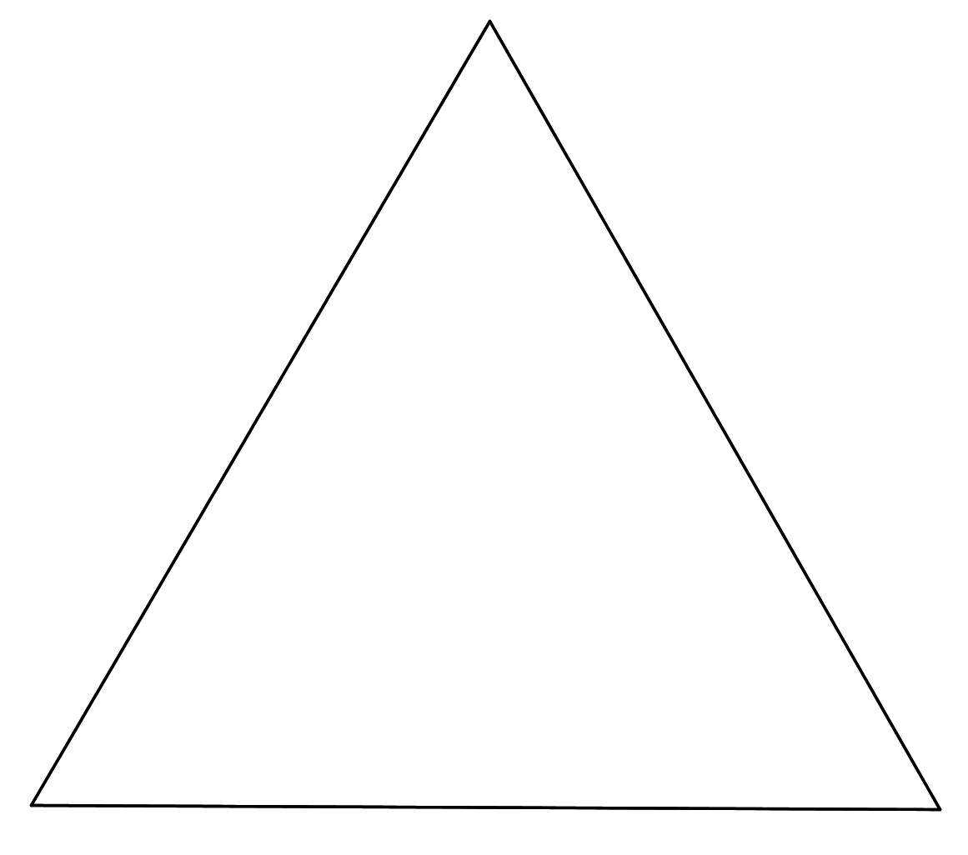
Temple: Stage 0 of a Sierpinski triangle.

