**Activity 6.4.4 Interpreting Real World Sinusoidal Models**

1. Given the displacement of a pendulum from its equilibrium position as it swings back and forth as shown below (negative numbers represent left of equilibrium, positive numbers represent the right)

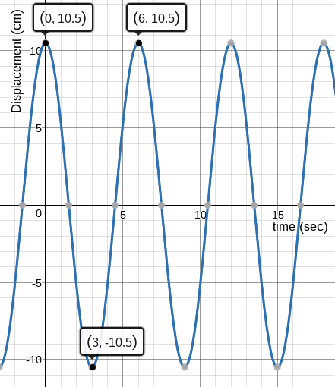

* 1. Find a function *f(t)* that models the displacement of the pendulum as a function of time.
  2. Interpret the meaning of the amplitude and period in the context of this problem.
  3. In the first 30 seconds of swinging, how many times will the pendulum reach a point 9 cm to the left of equilibrium?
  4. At exactly 46 seconds after the swinging starts, where is the pendulum compared to its equilibrium?

1. Given the graph below representing the depth of the water near a pier (t = 0 represents midnight on Monday):

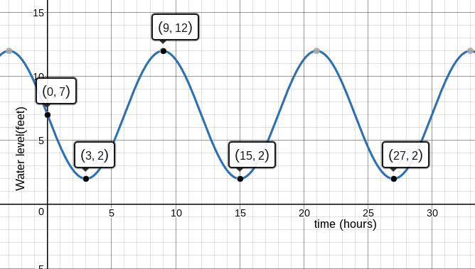

* 1. Create with a function *h(t)* to model the water level as a function of time.
  2. Interpret the meaning of the amplitude and period in the context of this problem.
  3. Use your function to predict the water level at 8 p.m. on Monday night.
  4. If local fishermen are seeking low tides for the next few days, what times should they fish on Tuesday, Wednesday, and Thursday?

Given the height above ground of a Ferris wheel as a function of time shown below:

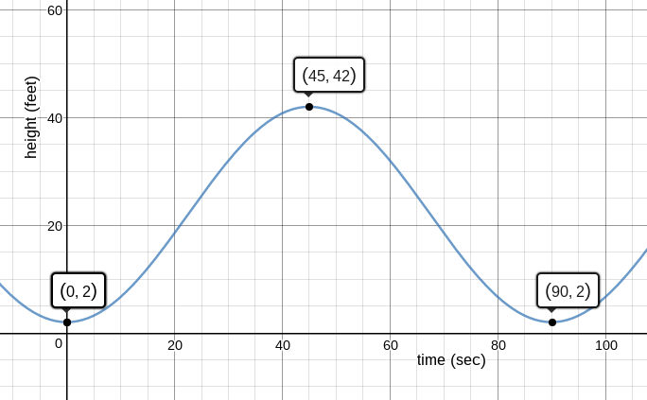

* 1. Find a function *h(t)* that represents the height of the Ferris wheel rider as a function of time.
  2. Interpret the meaning of the amplitude and period in the context of this problem.
  3. What speed is a rider on the Ferris wheel experiencing in feet per second? Note that the rider follows a circular path.
  4. After one minute of riding, how high above the ground is the rider?

1. A point on the edge of a water wheel’s height above water is modeled by the wave below.

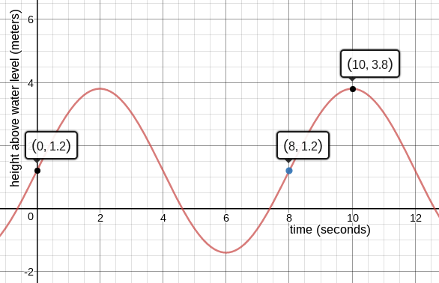

* 1. Create a function *h(t)* to model the height as a function of time.
  2. Interpret the meaning of the amplitude and period in the context of this problem.
  3. What is the circumference of the water wheel?
  4. At 23 seconds, what is the height of the point on the wheel? What does this mean in context?