**Activity 3.6.2b Explore Exponential versus Polynomial Functions Using GeoGebra**

**Part 1:**

1. Which option is better?

1. Getting paid an initial amount of $10 and then receiving an amount in dollars each day equal to the day number cubed.
2. Getting paid with an initial amount of $10 which is then compounded by an interest rate compounded of 30% per day.

2. Write a function, *a(x)* to model option *a* and *b(x)* to model option *b* above.

3. Compare the functions using GeoGebra or a graphing calculator and sketch the graph on the axes below for x from 0 to 5 only. Scale the *y*-axis to fit the data.



4. What do you notice about the two functions for *x’s* from 0 to 5?

5. Which option would you choose to earn you the most money and why do you believe that?

6. Let’s compare the two functions for greater values of *x* using the spreadsheet feature of GeoGebra. Open the Spreadsheet View and enter the values of x as shown below in column A and the equations for the two functions *a(x)* and *b(x)* in column B and C as a function of the cells in column A. GeoGebra will compute the corresponding outputs for the values of x.

|  |  |  |
| --- | --- | --- |
| *x* | *a* (*x*) | *b* (*x*) |
| 10 |  |  |
| 20 |  |  |
| 30 |  |  |
| 40 |  |  |
| 50 |  |  |

7. Estimate where the *a(x)* function overtakes the *b(x).*

8. Does the graph of the function confirm your conclusion?

9. For what range of values was *a*(*x*) > *b*(*x*)?

10. For what range of value was *a*(*x*) < *b*(*x*)?

11. Going back to question 5, now which option would you choose to give you the most money and explain why?

12. What conjecture can you make about polynomial functions versus exponential functions based on this example?

**Part 2:**

We want to investigate whether your conjecture in Part 1 will be true no matter what base we use for the exponential function and the degree we use for the polynomial function.

We will compare the functions  and  by varying the values of *a* and *b* using sliders in [GeoGebra](http://geogebra.org). [Click here](https://drive.google.com/a/danbury.k12.ct.us/file/d/0B0N9CEOerTFuTUFEbmlrSElWSEE/view?usp=sharing) for a tutorial video on setting up sliders for this example on GeoGeobra.

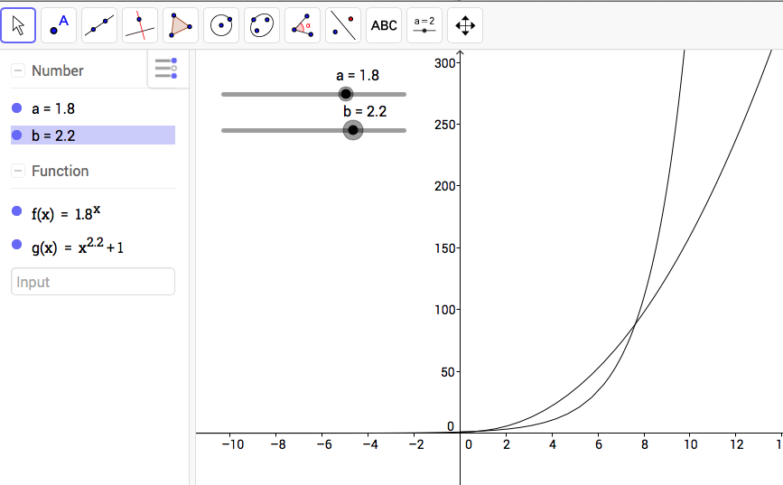

13. First, we will hold the value of *b*in the polynomial function constantwhile we vary the value of *a*, the base of the exponential function. In GeoGebra, you can scale the axes by clicking on the  icon, moving the cursor over either axis and the dragging along the axis to rescale the axis. This will in turn rescale the drawing.

a. Set *b* = 4. Is there a value of *a* that makes the exponential function greater than the polynomial function as *x* increases to ∞?

b. Set *b* = 6. Is there a value of *a* that makes the exponential function greater than the polynomial function as x increases to ∞?

14. Whatever value you set b equal to, is it always true that the exponential function overtakes the polynomial function?