**Activity 3.6.1 How Fast Will it Grow?**

Gordon E. Moore, co-founder of the Intel Corporation, in 1965, made the following statement that became known as “Moore’s Law”: *the number of transistors in a dense integrated circuit doubles approximately every two years*. Answer the following questions assuming that there is 1 transistor in the circuit in 1965.

1. If in 1965 there was one transistor per circuit, write the exponential function that models the growth in the number of transistors per circuit *x* years after 1965.

2. Complete the table and graph the exponential function. Scale the graph to fit the data.

|  |  |  |  |  |  |  |  |  |  |  |  |  |  |  |  |  |  |  |  |  |  |  |  |
| --- | --- | --- | --- | --- | --- | --- | --- | --- | --- | --- | --- | --- | --- | --- | --- | --- | --- | --- | --- | --- | --- | --- | --- |
| |  |  | | --- | --- | | ***x*** | ***f* (*x*) =** | | 0 |  | | 1 |  | | 2 |  | | 3 |  | | 4 |  | | 5 |  | | 6 |  | | 7 |  | | 8 |  | | 9 |  | |  |

Another computer expert said: *the number of transitions would be better modeled by*

3. Fill in the table below to compare the functions  and .

|  |  |  |
| --- | --- | --- |
| *x* |  |  |
| 2 |  |  |
| 4 |  |  |
| 6 |  |  |
| 8 |  |  |
| 10 |  |  |
| 12 |  |  |

4. As *x* increases which function is greater?

5. Using your answer to question 4, will that function always be greater?

6. Graph *f*(*x*) and *g*(*x*) using a graphing utility in a 12 x 12 window in the first quadrant, and then draw a sketch on the axes below.

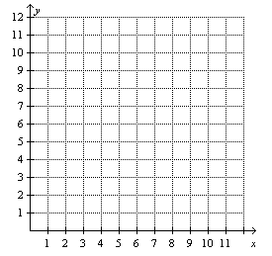

7. Which function is greater?

8. Zoom out to graph *f*(*x*) and *g*(*x*) in a 24 x 24 window in the first quadrant, and then draw a sketch on the axes below.

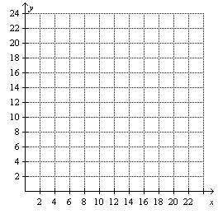

9. Which function is greater?

10. Keep the x-axis scale the same, and rescale the y-axis to increase the maximum value of y. Does the relationship still hold regardless of the maximum value of y? If not, when does the relationship change?

11. As *x* continues to increase, how do the exponential function and the quadratic function compare?

12. As x approaches +∞, will there be a change in the comparison between the quadratic function and the exponential function? Explain your answer.