Activity 3.1.5b Tabular Functions - Investigating Multiplicities of Roots

1) Given a partial table of values for each of the following polynomial functions, discuss their roots’ multiplicities. Use your knowledge of the polynomial’s roots to factor completely:
- $g(x)=x^{3}-13x^{2}+34x+48$

-1.1 | -6.461
-1.01 | -0.631601
-1.001 | -0.063016001
-1 | 0
-0.999 | 0.062984001
-0.99 | 0.628401
-0.9 | 6.141
5.9 | 1.449
5.99 | 0.140499
5.999 | 0.014004999
6 | 0
6.001 | -0.013994999
6.01 | -0.139499
6.1 | -1.349
7.9 | -1.691
7.99 | -0.178901
7.999 | -0.017989001
8 | 0
8.001 | 0.018011001
8.01 | 0.181101
8.1 | 1.911

- $h(x)=x^{4}+6x^{3}-11x^{2}-60x+100$

-5.1 | 0.5041
-5.01 | 0.00491401
-5.001 | 0.000049014001
-5 | 0
-4.999 | 0.000048986001
-4.99 | 0.00488601
-4.9 | 0.4761
1.9 | 0.4761
1.99 | 0.00488601
1.999 | 0.000048986001
2 | 0
2.001 | 0.000049014001
2.01 | 0.00491401
2.1 | 0.5041

c) $k(x)=x^{3}-9x^{2}+15x+25$

-1.1 | -3.721
-1.01 | -0.361201
-1.001 | -0.036012001
-1 | 0
-0.999 | 0.035988001
-0.99 | 0.358801
-0.9 | 3.481
4.9 | 0.059
4.99 | 0.000599
4.999 | 0.000005999
5 | 0
5.001 | 0.000006001
5.01 | 0.000601
5.1 | 0.061

2) Use the given tables to write each polynomial function in factored form. Justify.
(Note: Each polynomial has a leading coefficient of 1 or -1)
- A third degree polynomial:
x | y
0.9 | -0.441
0.99 | -0.040401
0.999 | -0.004004001
1 | 0
1.001 | 0.003996001
1.01 | 0.039601
1.1 | 0.361
2.9 | 0.019
2.99 | 0.000199
2.999 | 0.000001999
3 | 0
3.001 | 0.000002001
3.01 | 0.000201
3.1 | 0.021

- A fourth degree polynomial:
x | y
-2.1 | 0.2601
-2.01 | 0.00251001
-2.001 | 0.000025010001
-2 | 0
-1.999 | 0.000024990001
-1.99 | 0.00249001
-1.9 | 0.2401
2.9 | 0.2401
2.99 | 0.00249001
2.999 | 0.000024990001
3 | 0
3.001 | 0.000025010001
3.01 | 0.00251001
3.1 | 0.2601

- A third degree polynomial:

x | y
0.9 | -0.609
0.99 | -0.060099
0.999 | -0.006000999
1 | 0
1.001 | 0.005998999
1.01 | 0.059899
1.1 | 0.589
-2.1 | 1.581
-2.01 | 0.150801
-2.001 | 0.015008001
-2 | 0
-1.999 | -0.014992001
-1.99 | -0.149201
-1.9 | -1.421
2.9 | 0.931
2.99 | 0.099301
2.999 | 0.009993001
3 | 0
3.001 | -0.010007001
3.01 | -0.100701
3.1 | -1.071

3) In the space below, summarize what you have learned about the numerical values of polynomial functions near roots of even or odd multiplicities.

4) Based on the factored form of the corresponding polynomial function, can you justify your generalization made in your response to the previous question?

Check your understanding:
Match the polynomial function below (numbered) to the appropriate choice (lettered).
- $f(x)=(x+5)(x-3)^{2}$
- $f(x)=(x+5)^{2}(x-3)$
- $f(x)=(x+5)^{2}(x-3)^{2}$
- $f(x)=(x+5)^{3}(x-3)$

A) B) $f(-10)$ and $f(10)$are positive, $f(0)$is positive.
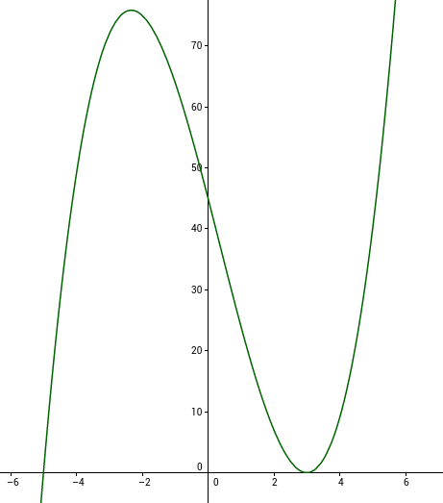

C) D)
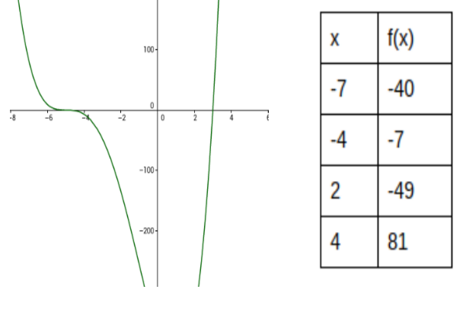

EXTENSION ACTIVITY:
Based on the generalizations made in 3) and 4) above and your knowledge of the end behavior of polynomial functions, predict what the sign of the value of the polynomial function will be in each interval. Choose several key x-values to justify your conclusions. Use your findings to solve the given inequalities.
- $(x+3)^{2}(x-6)>0$
x | Value of ${f\left(x\right)=\left(x+3\right)}^{2}(x-6)$
$$x<-3$$
$$x=-3$$
$$-3<x<6$$
$$x=6$$
$$x>6$$

- $(x-1)(x-4)(x-5)<0$
x | Value of $f\left(x\right)=(x-1)(x-4)(x-5)$
$$x<1$$
$$x=1$$
$$1<x<4$$
$$x=4$$
$$4<x<5$$
$$x=5$$
$$x>5$$

- $(x+1)^{3}>0$
x | Value of ${f\left(x\right)=\left(x+1\right)}^{3}$
$$x<-1$$
$$x=-1$$
$$x>-1$$

- $(x+4)^{2}(x-9)^{2}(x+1)>0$

x | Value of $f\left(x\right)={\left(x+4\right)}^{2}(x-9)(x+1)$
$$x<-4$$
$$x=-4$$
$$-4<x<-1$$
$$x=-1$$
$$-1<x<9$$
$$x=0$$
$$x>9$$

