Activity 2.5.1b Tracking Projectiles Using Quadratic Functions

- An arrow is shot from a cliff, 40 feet above the ground. It reaches its highest point, 30 feet away, 120 feet above the ground. (A graph of its height above the ground vs horizontal distance traveled is shown below.)

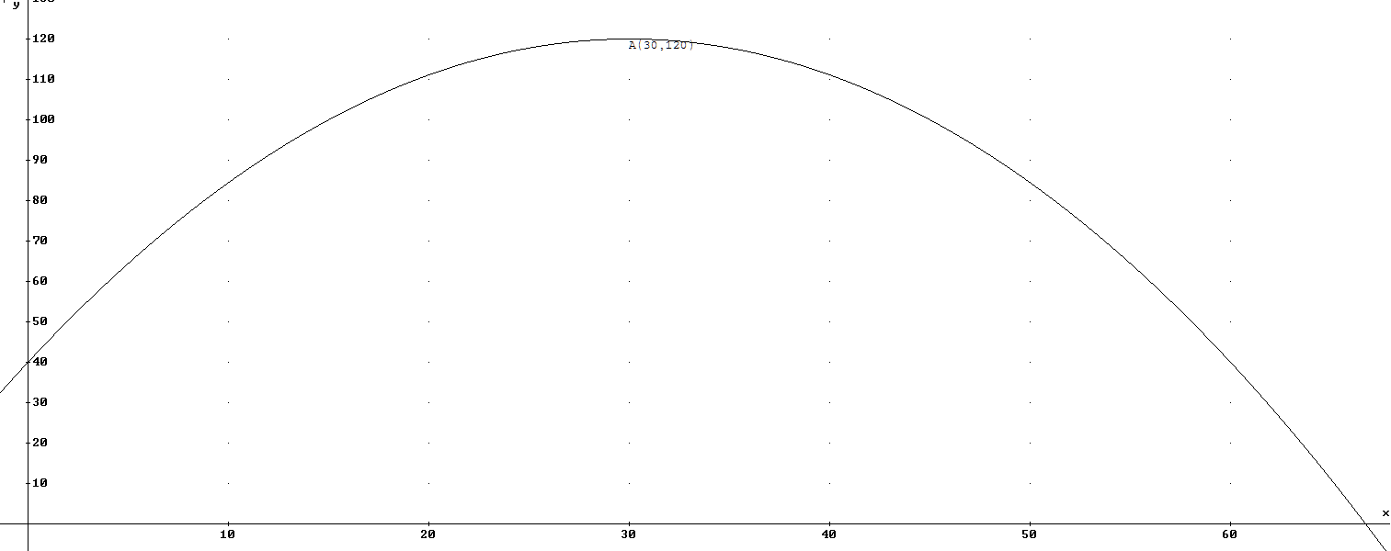

- Use the given information to find a quadratic model in the vertex form where x represents horizontal distance (ft.) and y represents vertical distance (ft.).

- Based on the function found in part (a), do you believe that the arrow would strike a balloon that is hovering 50 feet away from the base of the cliff, 80 feet above the ground? Justify.

- Algebraically find the spot in the ground where the arrow is likely to land. How far away from the base of the cliff will it be?

2) A golf ball is driven from a tee at ground level to land 250 yards away. It achieves a maximum height of 40 yards in the air as it travels.
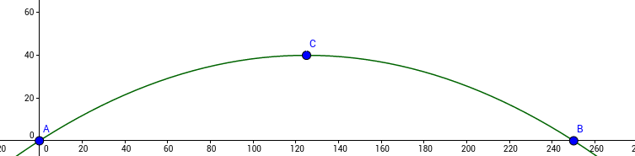

- Find an equation for the quadratic function this represents. Write your final answer in standard form.

- There is a tree that is 100 yards away from the tee. If it’s 36 feet tall, how much will the ball clear it by?

- What’s the minimum distance away from the tee that a 6-foot tall person can stand away from the tee in the ball’s path to have it not hit them?

3) A basketball player releases her shot towards the hoop. A foot away, the ball is 8 feet in the air. Eleven feet away, the ball is 16 feet in the air, and the ball falls through the 10-foot tall hoop 21 feet away shortly after.
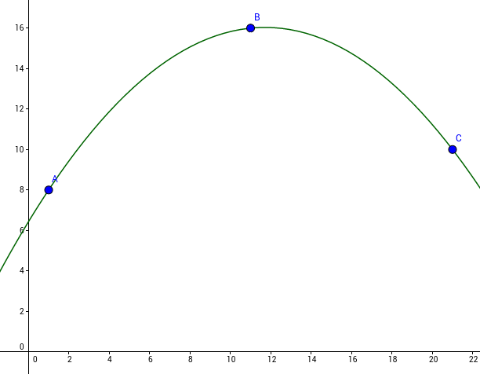
- Use the given information to find the equation of the ball’s path in standard form where x represents distance from the shooter along the ground (ft.) and y represents the ball’s height above the ground (ft.)

- Use your equation from part (a) to find:

  - the height the ball was released from.

  - the highest height that the ball reaches.

  - How high a reach would a defender standing 2 feet away from the hoop have to have to block the shot?

4) Find the equation of each quadratic function below based on the description or graph provided:

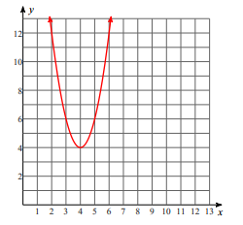
b) The parabola passes through the points (-2, 1), (-3, -10), and (-1, -10)

c)
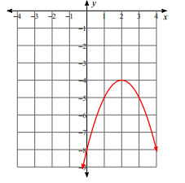

d) Parabola passes through the points (-6,0), (0, -6), and (4,10)

