Activity 2.3.2b Angles in Isosceles Triangles

In the following activity, triangles will be constructed with compass and straight edge by drawing a circle. At this point, it is known that isosceles triangles are triangles with at least two congruent sides.

The two congruent sides of an isosceles triangle are called legs. The third side is called the base.
Using this vocabulary, label the triangles below.

a) b) ______

______ _____ _______
_______

_______

You will be asked to use inductive reasoning (reasoning that allows you to reach a conclusion based on a pattern of specific examples) to form a conjecture about the angles in isosceles triangles.

1. Cut out the triangles from the templates below or one given to you by your teacher. 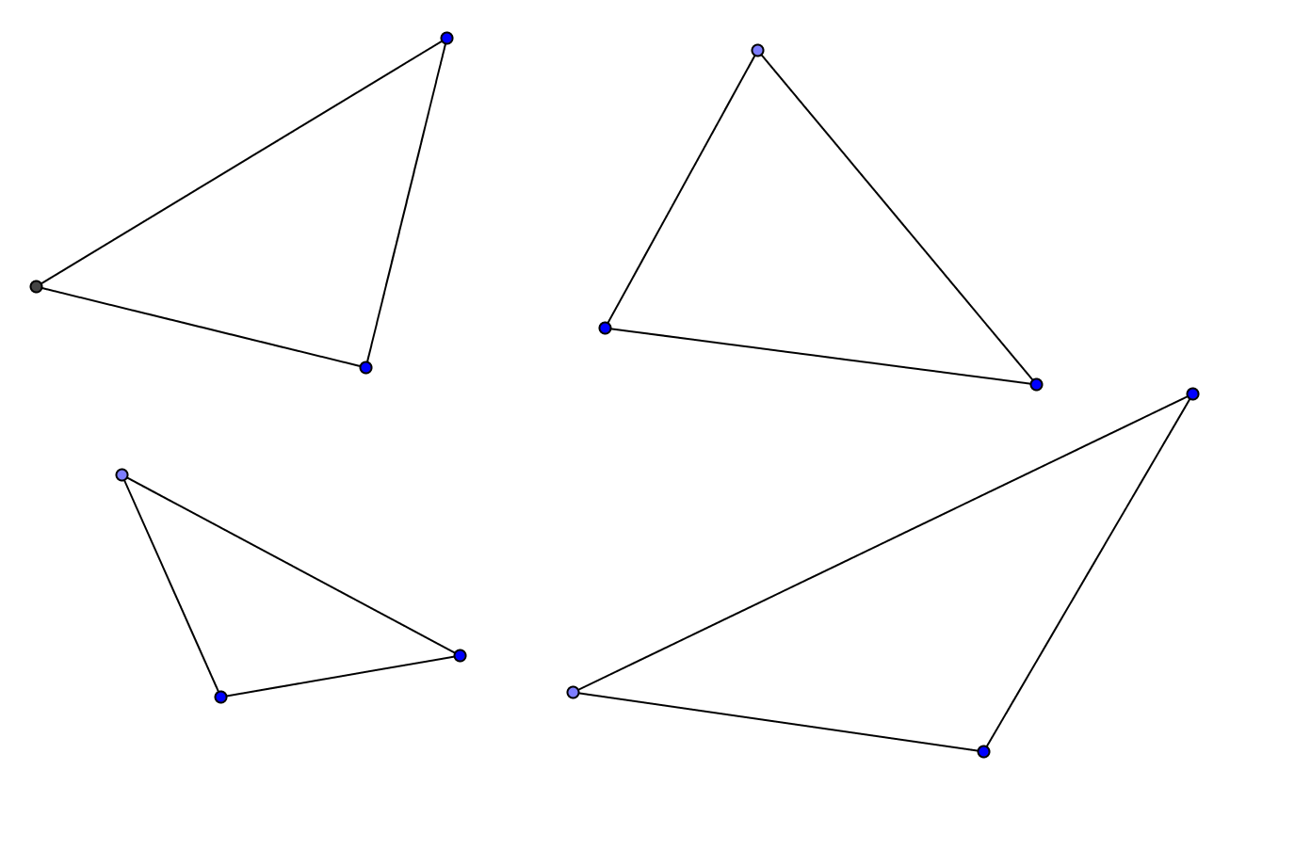

This page left intentionally blank
2. Now fold all of the triangles you created on their axis of symmetry.
What do you notice about the sides and the angles that overlap?

Line of symmetry

3. The overlapping sides are ______________________________.
4. The overlapping angles are _____________________________.

5. Now form a conjecture (a generalization using inductive reasoning).

**If two sides of a triangle are _______________________, then the angles opposite these sides
are ____________________________.

6. What transformation was used in this activity?

Vocabulary related to Isosceles triangles
Legs: the two congruent sides
Base: the third side of and isosceles triangle that is not necessarily congruent to the other sides
Base angles: the angles opposite from the legs and adjacent to the base
Vertex angle: the angle opposite from the base in an isosceles triangle

7. Now label the isosceles triangle below with the above vocabulary.

