Activity 2.2.7 Solving Non-Linear Systems of Equations

To solve systems of non-linear equations we will use substitution or will graph, ideally using technology.

The solution to a non-linear system is the set all ordered pairs that satisfy both equations simultaneously.

In this activity we will be working only with systems that contain a quadratic and a linear equation and we can have a variety of numbers of solutions. The graphs can intersect at one point, two points, or not at all so there may be no ordered pair, one or two ordered pairs of coordinates.

Example 1: Solve by substitution. $x^{2}-y= -2$ 2x – y = $-$ 10

Solve for one variable for the linear equation: y = 2x + 10
Substitute y into the first equation $x^{2}-(2x+10)= -2$
Simplify $x^{2}-2x-8 = 0$
Factor (x + 2)( x – 4) = 0
Solve for x x = -2 x = 4

Back-substitute these values of x into the equation y = 2x + 10
For x = -2 y = 2(-2) + 10 y = 6
For x = 4 y = 2(4) + 10 y = 18

Solution: (-2, 6), (4, 18)

Example 2: Solve Graphically. $x^{2}-y= -2$
2x – y = $-$ 10

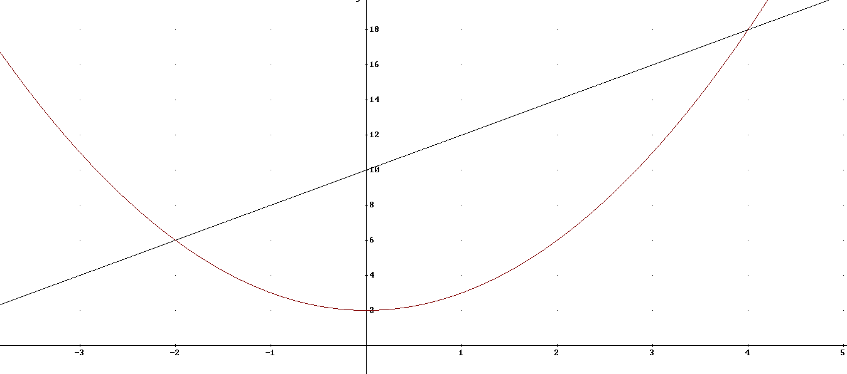
Solution: (-2, 6), (4, 18)

Solve by Graphing. If technology is available feel free to use it:

1. ${-x}^{2}+y=8x$ 2. $y-5x= x^{2}-10$ 3. $y+ x^{2}=3x+2$
$y-$ 2x = 16 2 y – 4x = 16 y – 3x = 5

Solve by Substitution:

4. $6x+ y^{2}=10$ 5. $x- y^{2}= -4$ 6. $x^{2}-y=2$
3x – y = 5 3x + y = $-$8 $2x -y=-1$

7. A Porsche 911 begins at rest and accelerates at a constant rate of 4 meters per second every second. Its distance in meters (d) is a function of time in seconds (t) and can be modeled by the formula: d = 2$t^{2}$
A Toyota Camry, traveling at a constant speed of 22 meters per second is 552 meters ahead of the Porsche when the Porsche begins to accelerate. The distance of the Camry relative to the Porsche as a function of time in seconds can be modeled by the formula: d = 22t + 552

a) How long will it take the Porsche to catch up to the Camry?

b) Find the distance the Porsche traveled.

.
8. Patty Proffit owns a factory that manufactures cell phones. The cost of manufacturing x phones per week is modeled by the equation $C\left(x\right)=97.60x+106,000$
The revenue for selling x phones per week can be modeled by the equation$R\left(x\right)=340x-0.08x^{2}$.

- Find the breakeven point(s) by graphing the equations on your calculator.

b) There are two breakeven points. What does this mean?

c) How many phones will produce a profit each week?

