Activity 2.2.4 Applying the ASA and SAS Congruence Theorems
In this activity you will use the ASA and SAS Congruence Theorems to make claims about triangles.

Section 1: Use the ASA Congruence Theorem to prove that the triangles shown are congruent
 | Triangle #1 | Triangle #2 | Proof
1. | 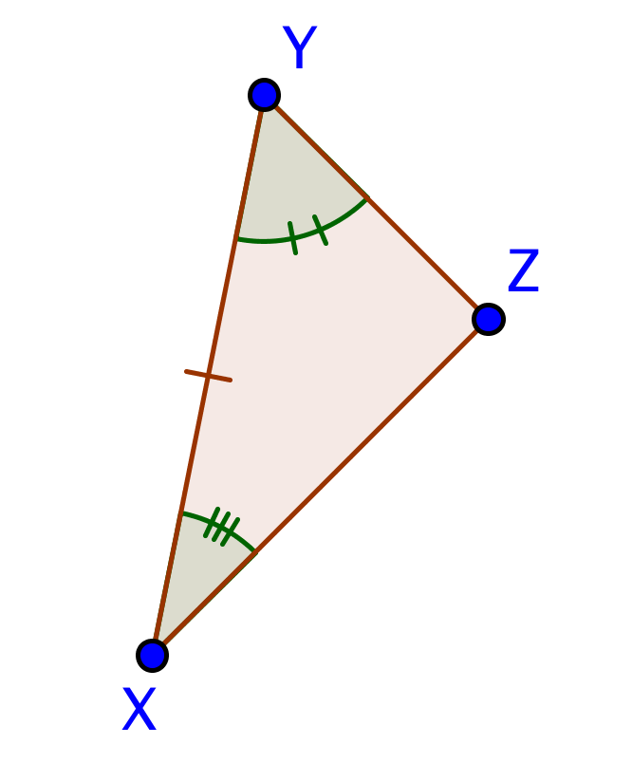 | 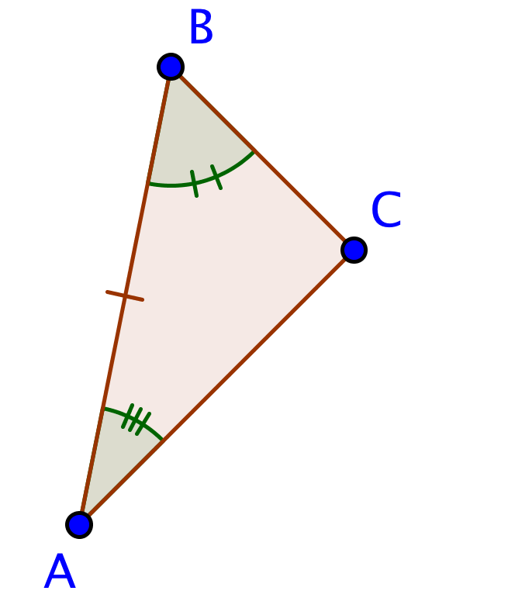
2. |  | 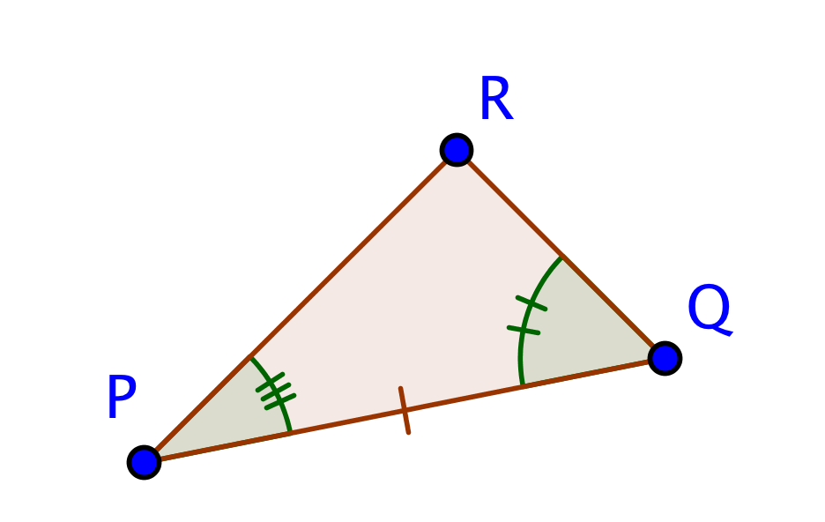
3. |  | 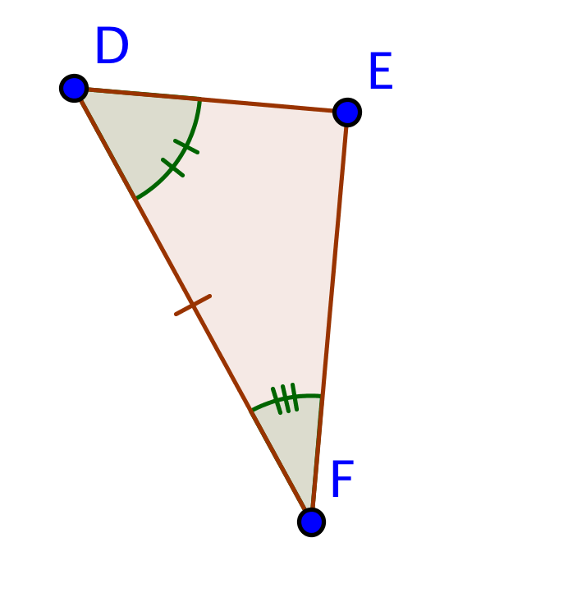
4. | 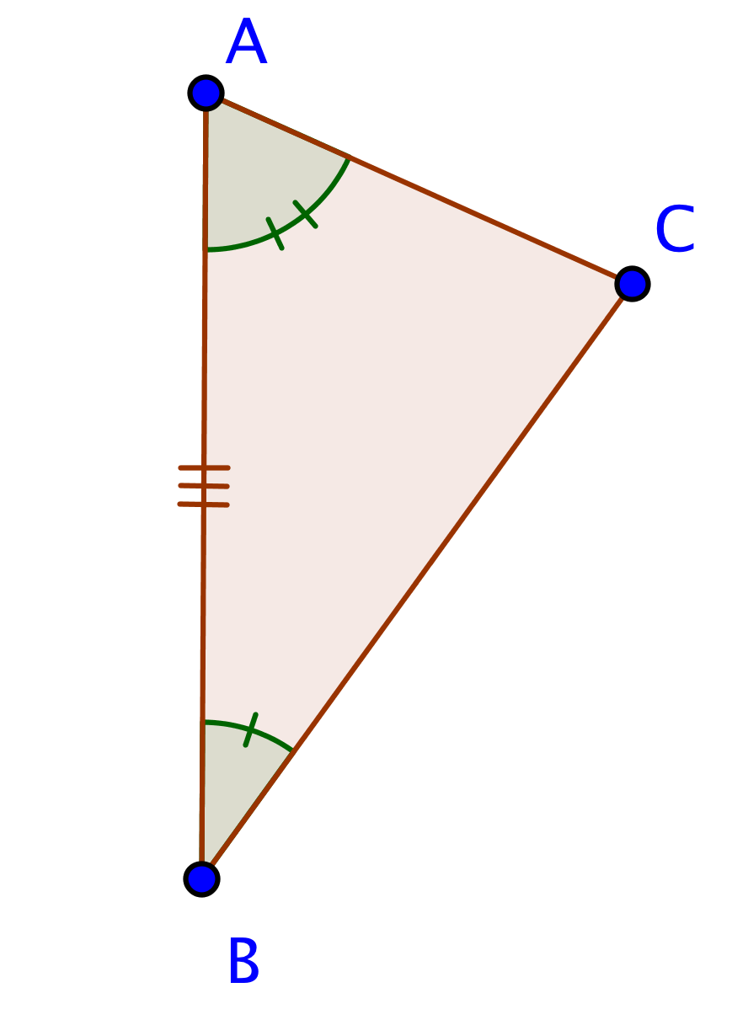 | 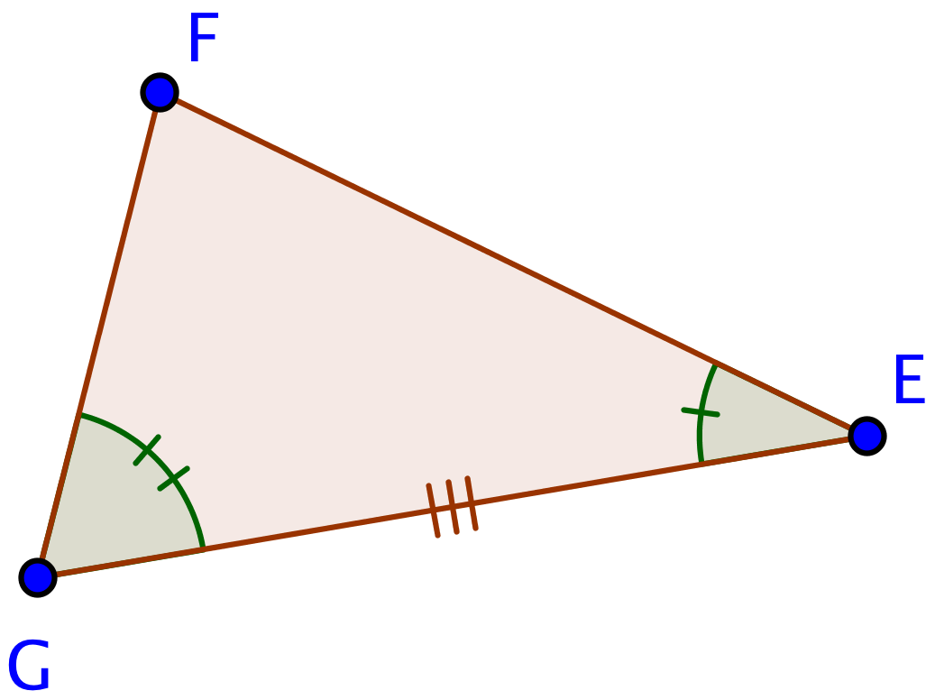
Section 2: Prove that the specified angles or segments are congruent
 | Triangle #1 | Triangle #2 | Proof
5. |  |  | Prove: $\overline{AC}≅\overline{FG}$
6. | 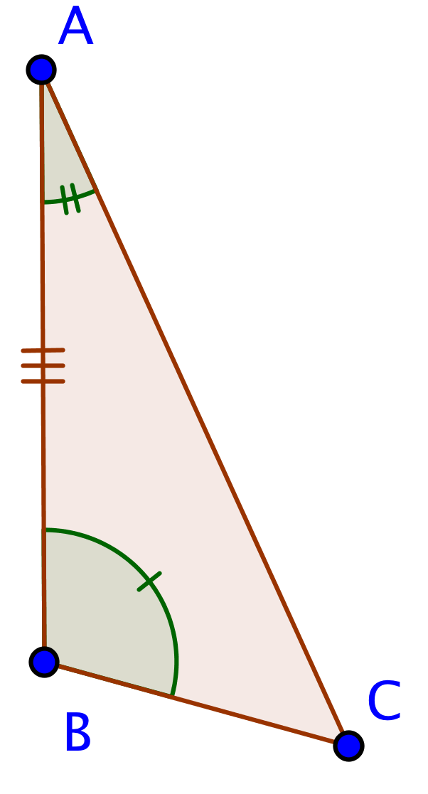 | 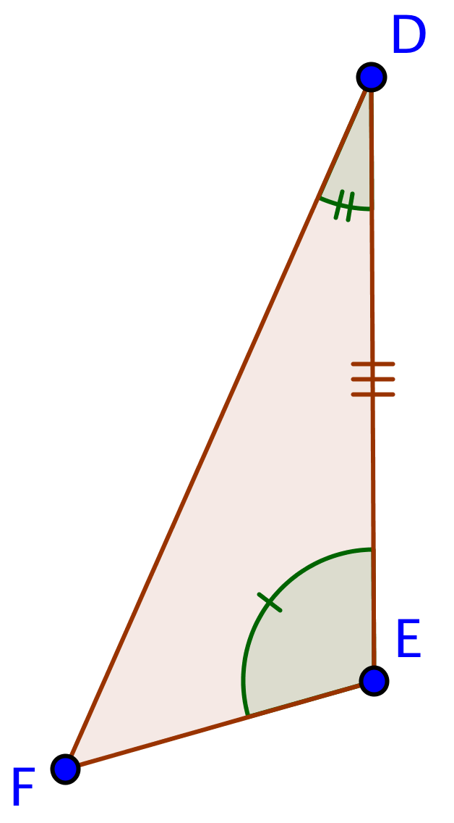 | Prove: $\overline{BC}≅\overline{EF}$
7. | 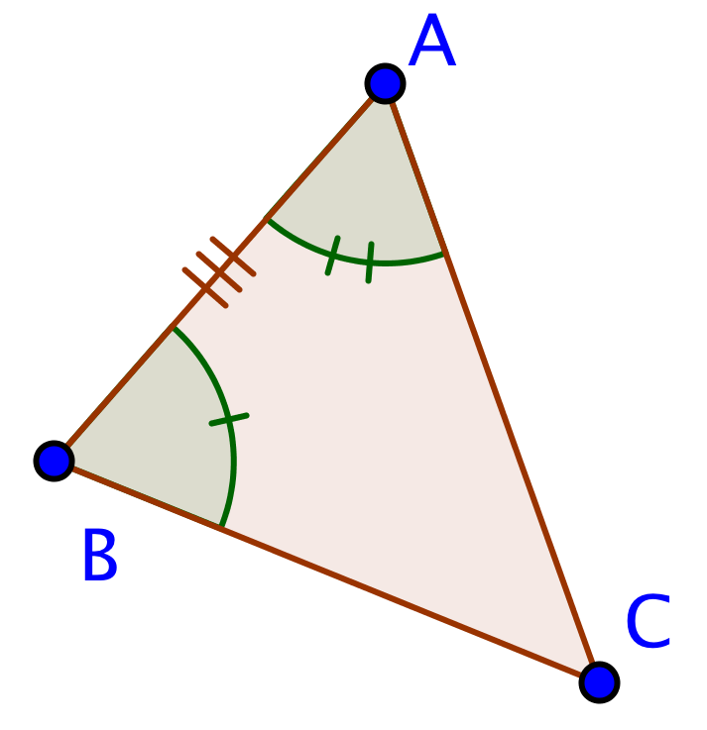 | 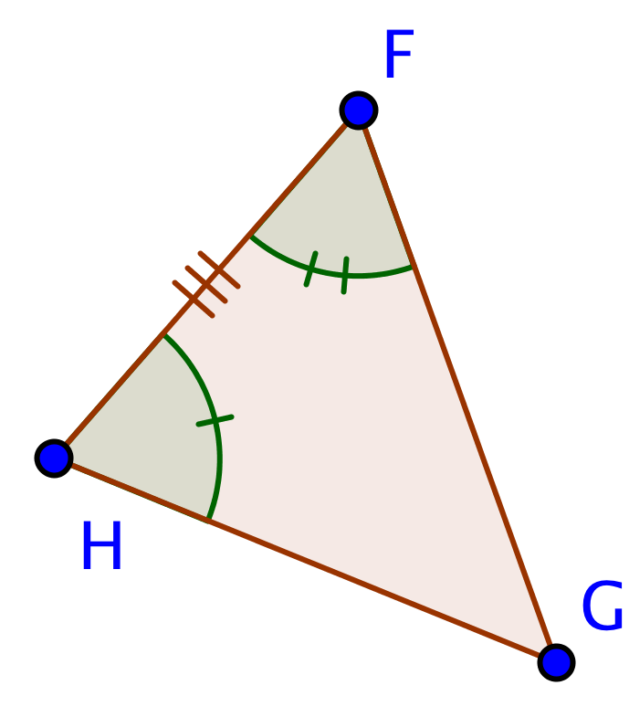 | Prove: $∡ACB≅∡FGH$
8. | 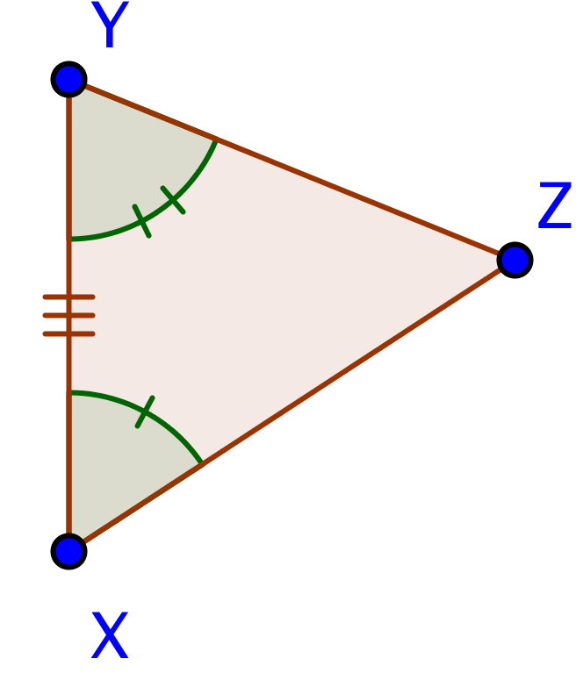 | 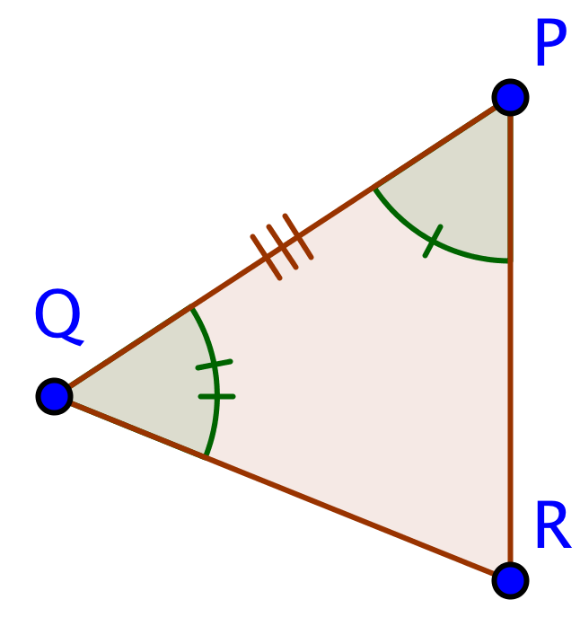 | Prove: $∡PRQ≅∡XZY$
Section 3: Prove that the triangles shown are congruent using SAS or ASA, or explain why the information given is not sufficient to prove that the triangles are congruent.
 | Triangle #1 | Triangle #2 | Proof
9. | 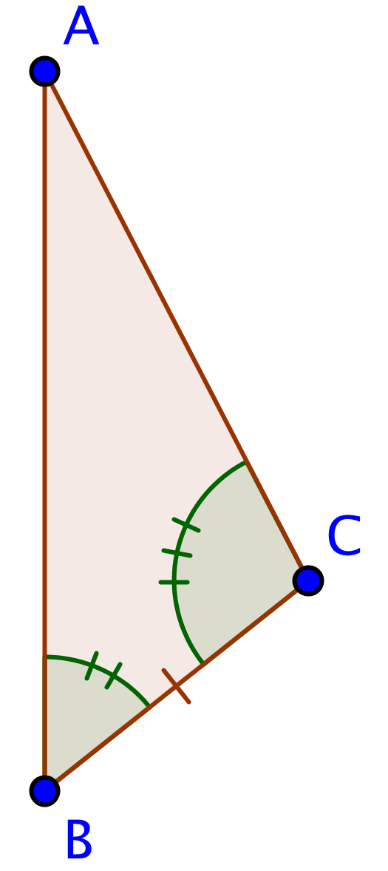 | 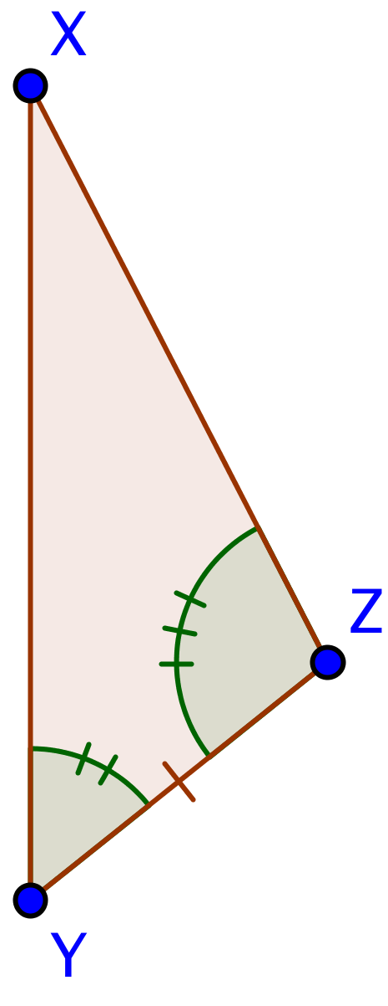
10 | 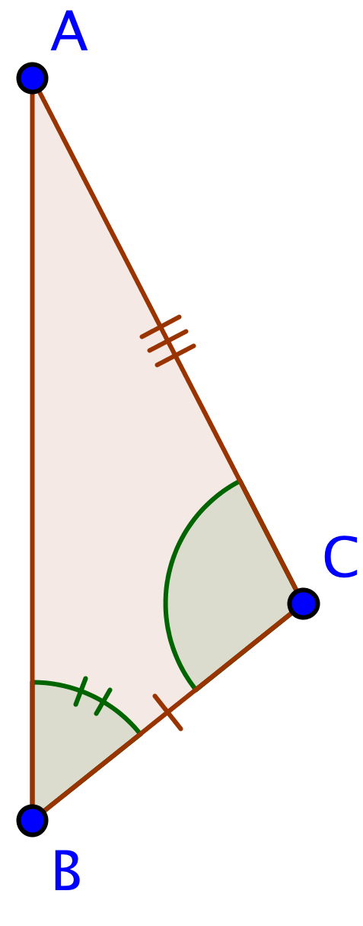 | 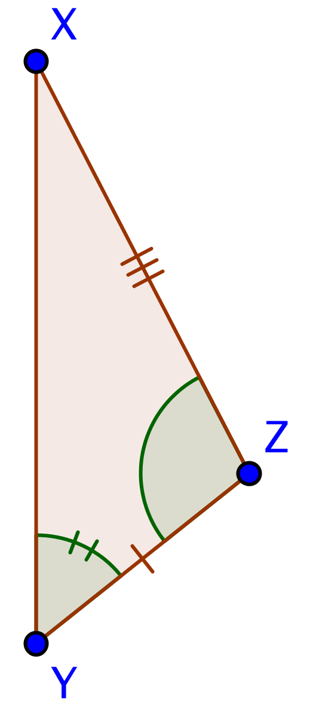
11 | 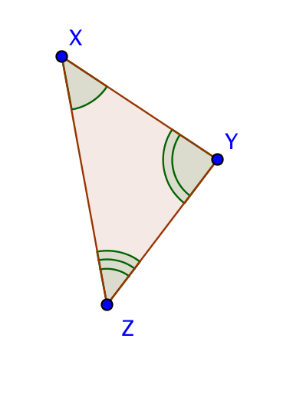 | 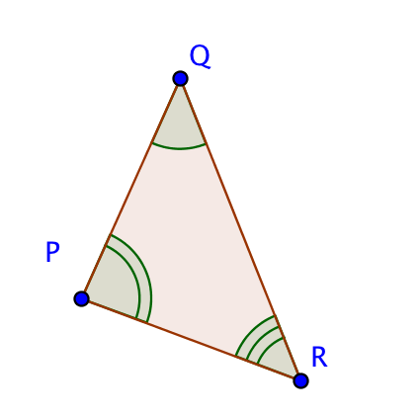
12 | 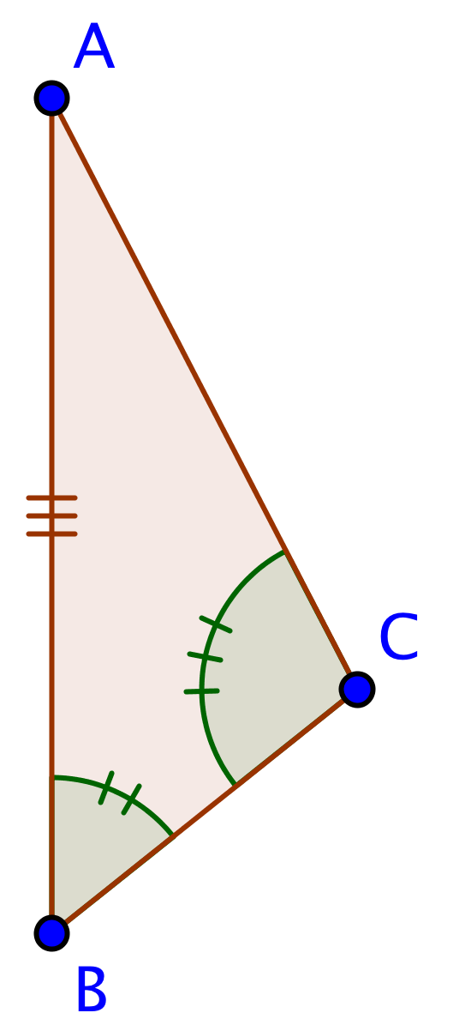 | 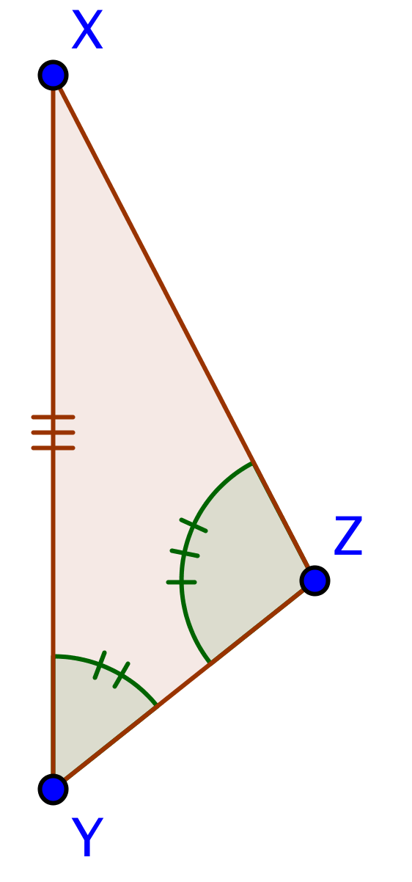

13 | 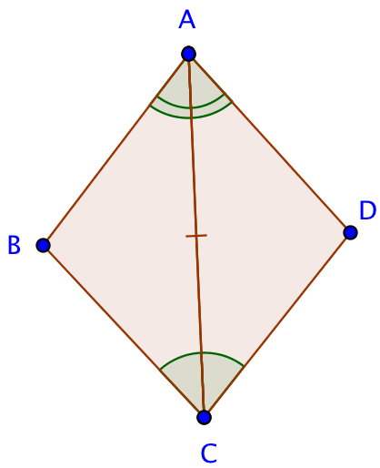
14 | 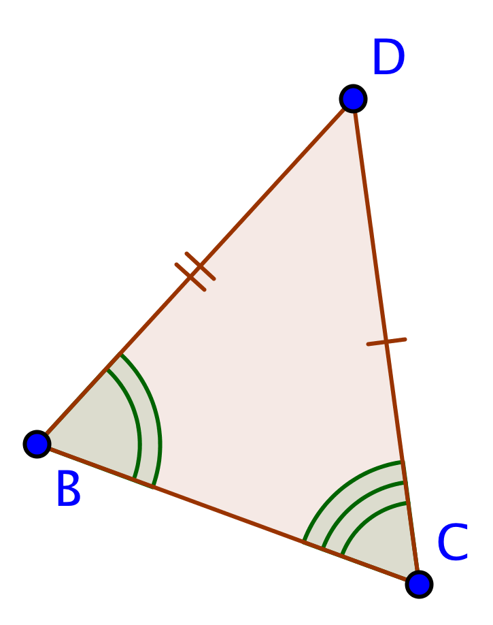 | 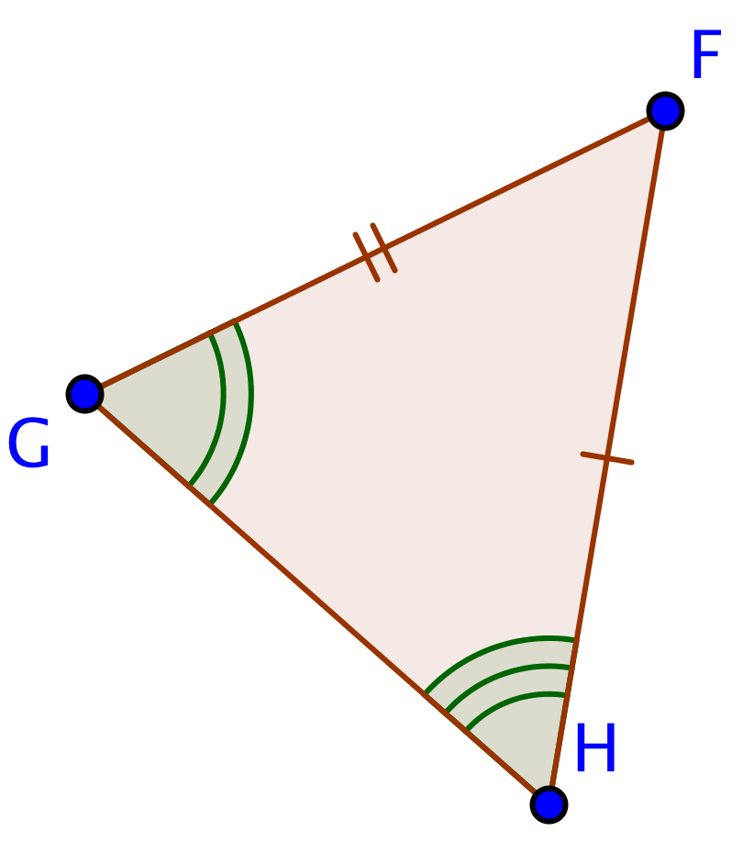
15 | 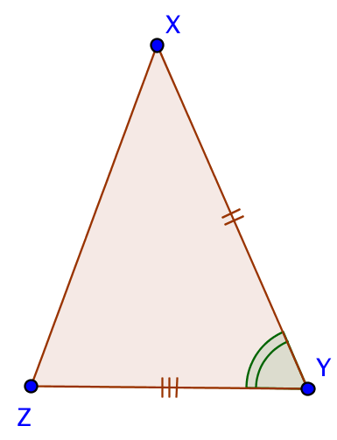 | 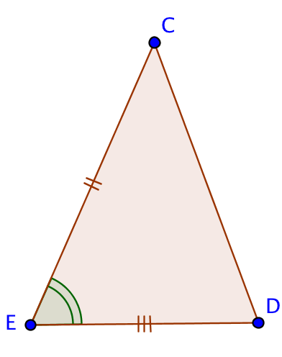
16 | 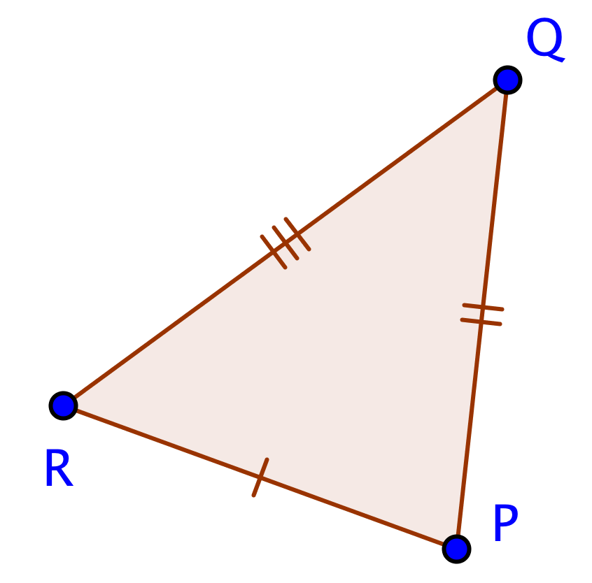 | 