Activity 2.2.3 ASA Congruence

In this activity you will discover and prove our second theorem about congruent triangles.
1. Included sides. For each pair of angles in ∆XYZ, name the included side.

Angles: $∠$XYZ and $∠$YZX Included Side: $___________$
Angles: $∠$XYZ and $∠$ZXY Included Side: $___________$
Angles: $∠$ZXY and $∠$YZX Included Side: $___________$

2. Experiment. Work with one other student. You will each draw two triangles using a ruler and protractor.

a. Agree upon the measure of two angles of the triangle and the included side.

Our two angles measure ______________ and ______________.
Our included side measures _______________.

b. Now draw your triangles. Cut one triangle out and place it on the other. What do you notice?

c. Formulate a conjecture: If two angles and the included side of one triangle are congruent to two angles and the included side of another triangle then ____________________________________________.
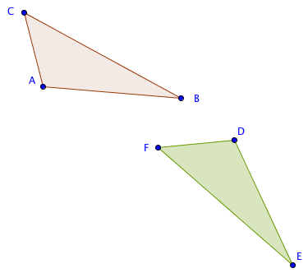
3. Proving the ASA Congruence Theorem. Study this proof and fill in the blanks.
Given ∆ABC and ∆DEF with
m$∠$BAC = m$∠$EDF,
$m∠$ABC = m$∠$DEF, and
AB = DE

Prove ∆ABC$≅$∆DEF.

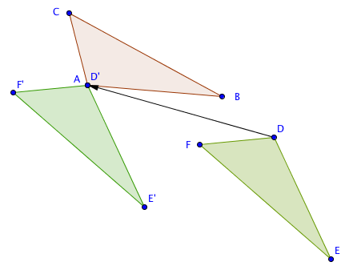
Step 1. If A and D do not coincide then translate ∆DEF by the vector from D to A.

Now D’ is the same point as _______.

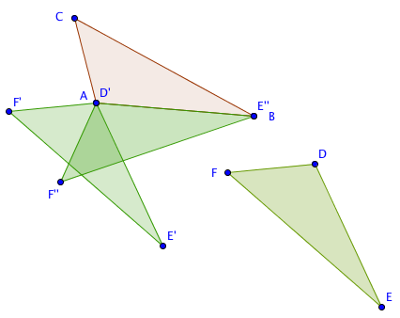
Step 2. If $\overline{AB}$ and $\overline{D'E'}$ do not coincide then rotate ∆$D’E’F’$ about point A through $∠$E’AB.

Step 3. $\overline{D’’E’’}$ will now coincide with $\overline{AB}$ since we were given that AB = _______.

Step 4. If F’’ is on the opposite side of $\overset{⃡}{AB}$ from C, reflect ∆D’’E’’F’’ over $\overset{⃡}{AB}$.
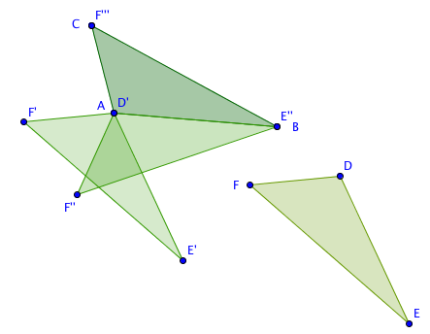
D’’ is the same as which point? _____

Step 5. $∠$E’’’D’’’F’’’ will now coincide with $∠$BAC since we were given m$∠$BAC = m$∠$______, and $∠$D’’’E’’’F’’’ will now coincide with $∠$ABC since we were given m$∠$ABC = m$∠$______.

6. Therefore ray $\vec{D’’’F’’’}$ coincides with ray $\vec{AC}$ and ray $\vec{E’’’F’’’}$ coincides with ray $\vec{BC}$. These two rays intersect at point C. Is it possible for them to intersect at another point? Explain. ________________________________________________________________
If we agree that two lines can only intersect at one point, we can conclude that point F’’’ coincides with point C.

Step 7. Since ∆ABC is the image of ∆DEF under an isometry, ∆ABC$≅$∆DEF.

4. Now state the theorem you have just proved. We will call this the ASA Congruence Theorem.

If ___________________________________________________________________________,

then ________________________________________________________________.

5. What properties of transformations were used in the proof?

6. How was this proof similar to the proof of the SAS Congruence Theorem? How was it different?

