Activity 2.2.2 Applying the SAS Congruence Theorem
In this activity you will use the SAS Congruence Theorem to make claims about triangles.
Examples are shown in each section
Section 1: Use the SAS Congruence Theorem to prove that the triangles shown are congruent
 | Triangle #1 | Triangle #2 | Proof
1. | 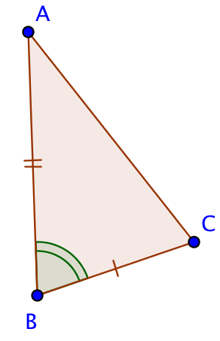 | 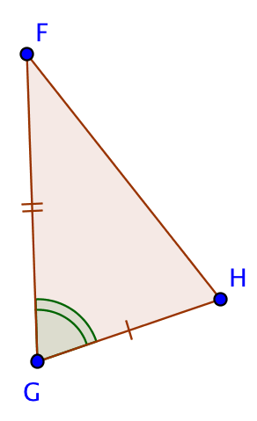 | $\overline{AB}≅\overline{FG}$ Given  $\overline{BC}≅\overline{GH}$ Given  $∡ABC≅∡FGH$ Given  $△ABC≅△FGH$ SAS
2. | 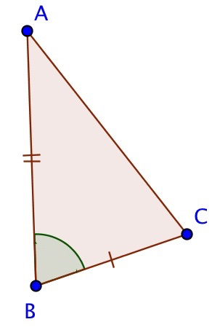 | 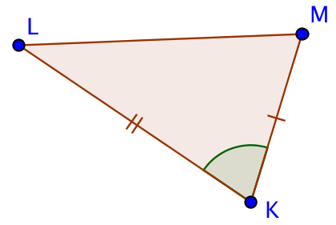
3. | 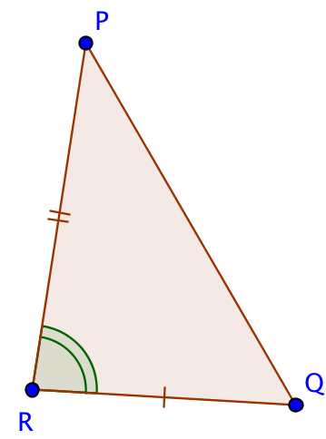 | 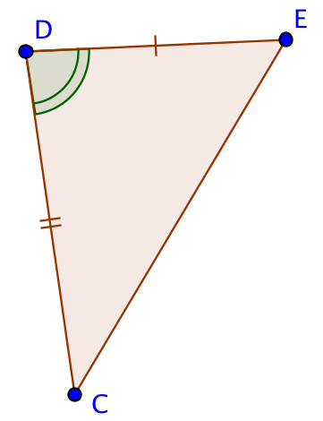
4. | 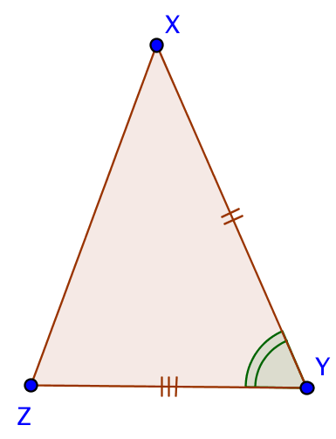 | 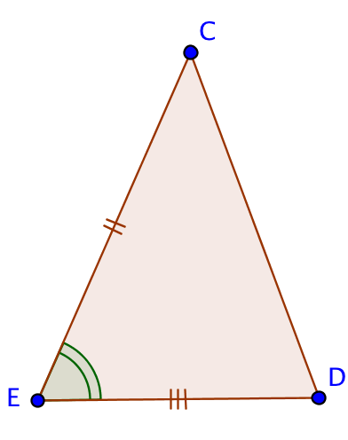

Section 2: Prove that the specified angles or segments are congruent
 | Triangle #1 | Triangle #2 | Proof
5. | 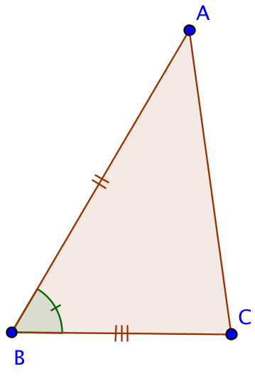 | 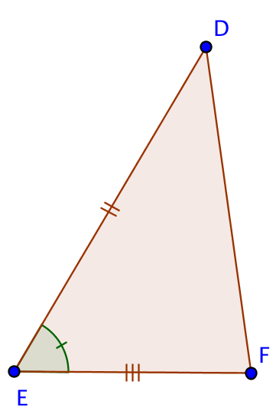 | Prove: $\overline{AC}≅\overline{DF}$  $\overline{AB}≅\overline{DE}$ Given  $\overline{BC}≅\overline{EF}$ Given  $∡ABC≅∡DEF$ Given  $△ABC≅△GEF$ SAS  $\overline{AC}≅\overline{DF}$ CPCTC
6. | 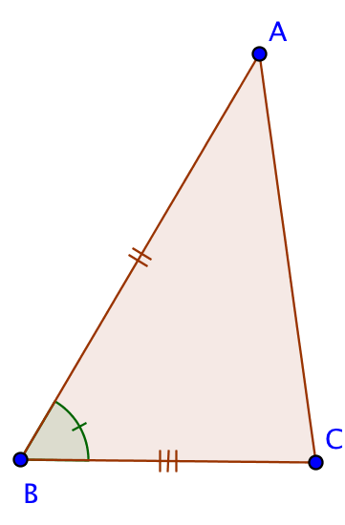 | 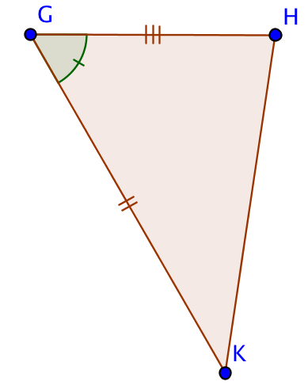 | Prove: $\overline{AC}≅\overline{KH}$
7. | 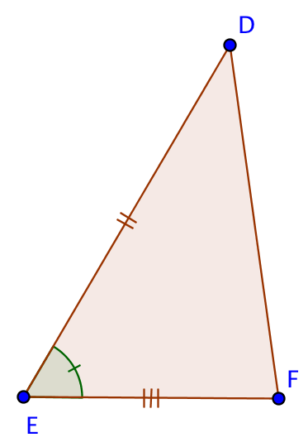 | 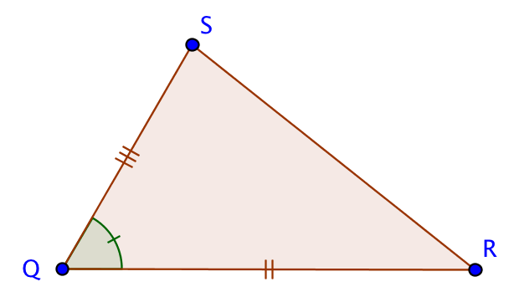 | Prove: $∡FDE≅∡SRQ$
8. | 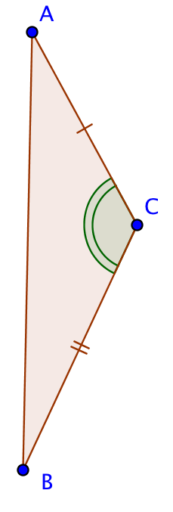 | 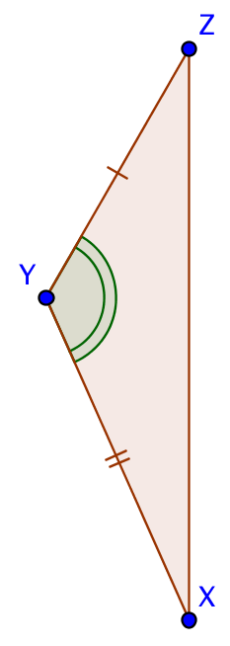 | Prove: $∡CAB≅∡YZX$
Section 3: Show how the triangles shown can be proved congruent using the SAS Congruence Theorem, or explain why the information given is not sufficient.
 | Triangle #1 | Triangle #2 | Proof
9. | 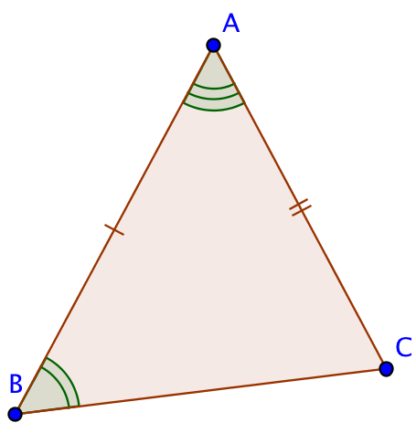 | 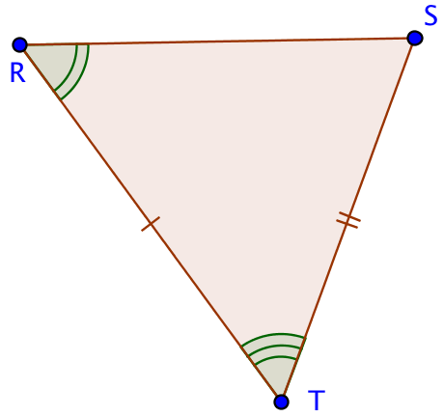
10 | 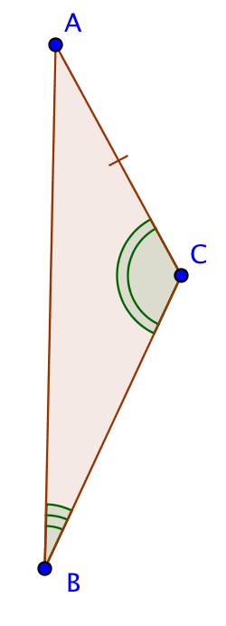 | 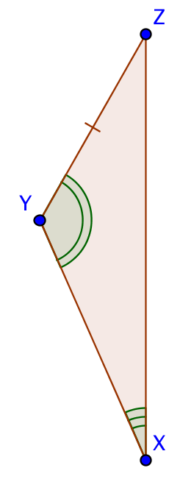
11 | 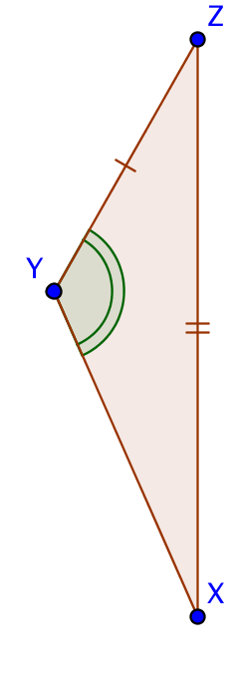 | 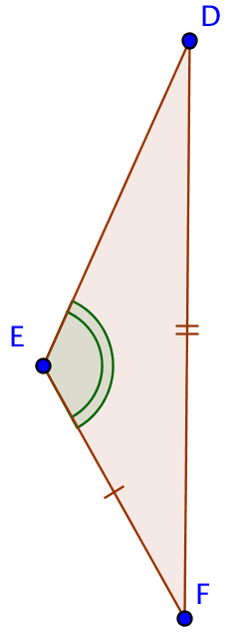
12 | 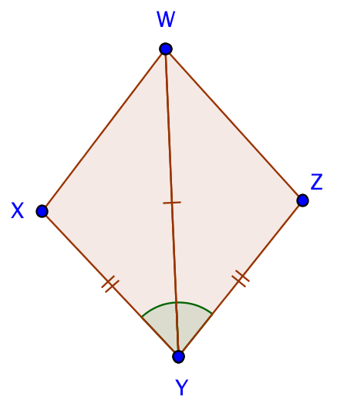

13 | 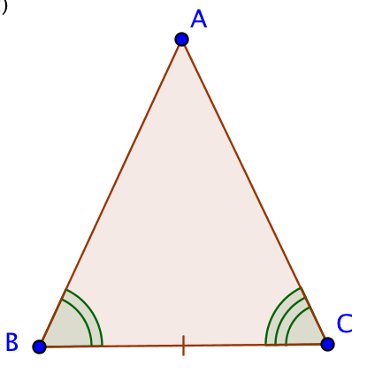 | 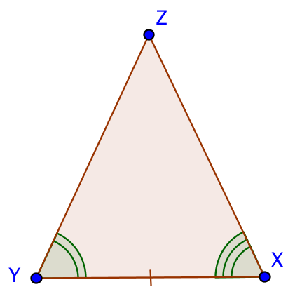
14 | 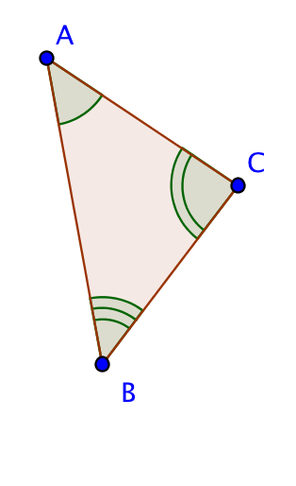 | 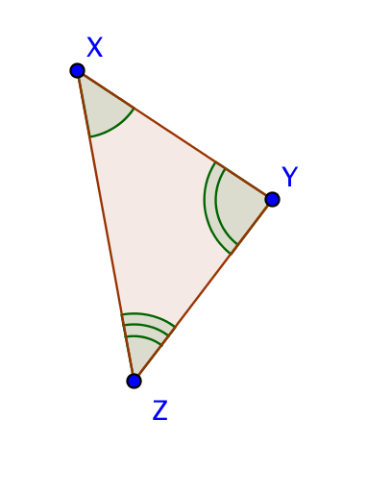
15 | 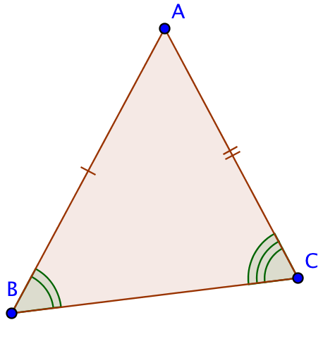 | 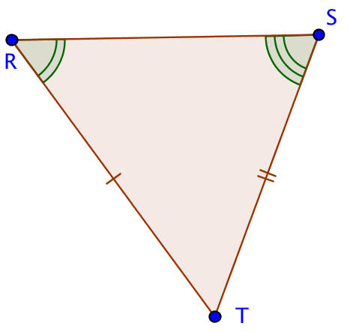
16 | 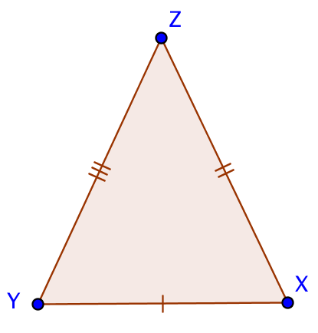 | 