**Activity 2.2.1 SAS Congruence**

In this activity you will discover and prove our first theorem about congruent triangles.



1. Included angles. For each pair of sides in ∆*XYZ*, name the included angle.

Sides: $\overline{XY}$ and $\overline{YZ}$ Included Angle: $∠ ___________$

Sides: $\overline{XY}$ and $\overline{ZX}$ Included Angle: $∠ ___________$

Sides: $\overline{ZX}$ and $\overline{YZ}$ Included Angle:

2. Experiment. Work with one other student. You will each draw one triangle using a ruler and protractor as described below:

a. Agree upon the measure of two sides of the triangle and the included angle.

Our two sides measure ______________ and ______________.

Our included angle measures _______________.

b. Now draw your triangles. Start by drawing the angle and then measure the sides. Cut one triangle out and place it on the other. What do you notice?

c. Formulate a conjecture: If two sides and the included angle of one triangle are congruent to two sides and the included angle of another triangle then ____________________________________________.

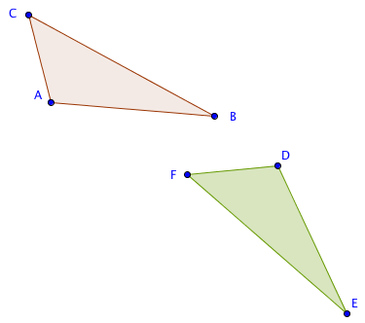3. Proving the SAS Congruence Theorem. Study this proof and fill in the blanks.

Given ∆*ABC* and ∆*DEF* with

*AB = DE*,  
*AC = DF*, and

m $∠$*BAC* = m $∠$*EDF*

Prove ∆*ABC $≅$*∆*DEF*.

*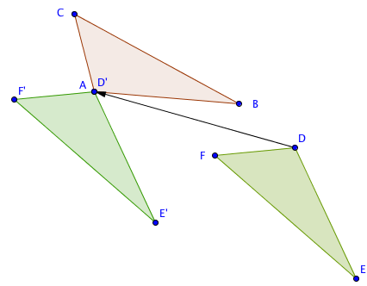Step 1*. If *A* and *D* do not coincide then translate ∆*DEF* by the vector from *D* to *A*.

Now *D*’ is the same point as _______.

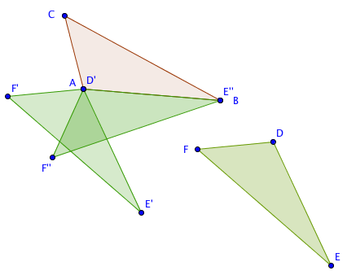

*Step 2*. If $\overline{AB}$ and $\overline{D’E’}$ do not coincide then rotate ∆*D’E’F’* about point *A* through $∠$*E’AB*

*Step 3. $\overline{D’’E’’}$* will now coincide with $\overline{AB}$ since we were given that *AB* = _______.

*Step 4.* If *F’’* is on the opposite side of $\overset{⃡}{AB}$ from *C,* reflect *∆D’’E’’F’’* over $\overset{⃡}{AB}$.

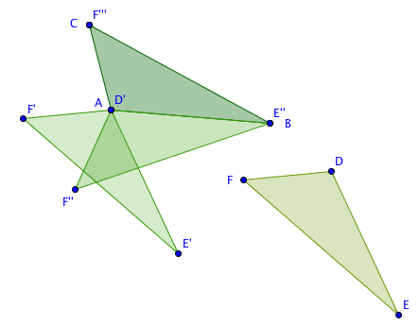

*D’’* is the same as which point? _____

*Step 5*. $∠$*E’’’D’’’F’’’* will now coincide with $∠$*BAC* since we were given m $∠$*BAC* = m $∠$*EDF*, and

$\overline{D’’’F’’’}$ will coincide with $\overline{AC}$ since we were given *AC* = *DF*.

*Step 6*. Therefore *F’’’* coincides with *C* and *E’’’* coincides with *B*.

How many lines can be drawn from point *B* to point *C*? ___________

Explain why $\overline{E’’’F’’’}$ must coincide with $\overline{BC}$:

________________________________________________________________________

*Step 7*. Since ∆*ABC* is the image of ∆*DEF* under an isometry, ∆*ABC*∆*DEF*.

4. Now state the theorem you have just proved. We will call this the SAS Congruence Theorem.

If ___________________________________________________________________________,

then ________________________________________________________________.

5. What properties of transformations were used in the proof?

6. Do you think this proof would work if the angle were not included between the two sides? Explain your thinking.