**Activity 2.1.6a Mapping Congruent Polygons**

In each exercise identify the transformation or transformations that will map one of two congruent polygons onto the other.

1. On a coordinate grid locate ∆*ABC* with *A* = (0,0), *B* = (5,0), and *C* = (4,2) and ∆*DEF* with   
   *D* = (7,1), *E* = (12,1), and *F* = (11,3). Map ∆*ABC* onto ∆*DEF*. Describe the transformation or transformations you used.

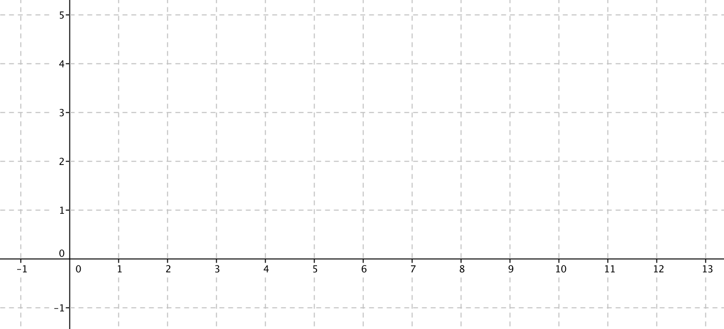

1. On a coordinate grid locate ∆*ABC* with *A* = (0,0), *B* = (5,0), and *C* = (4,2) and ∆*DEF* with   
   *D* = (3,7), *E* = (8,7), and *F* = (7,5). Map ∆*DEF* onto ∆*ABC*. Describe the transformation or transformations you used.

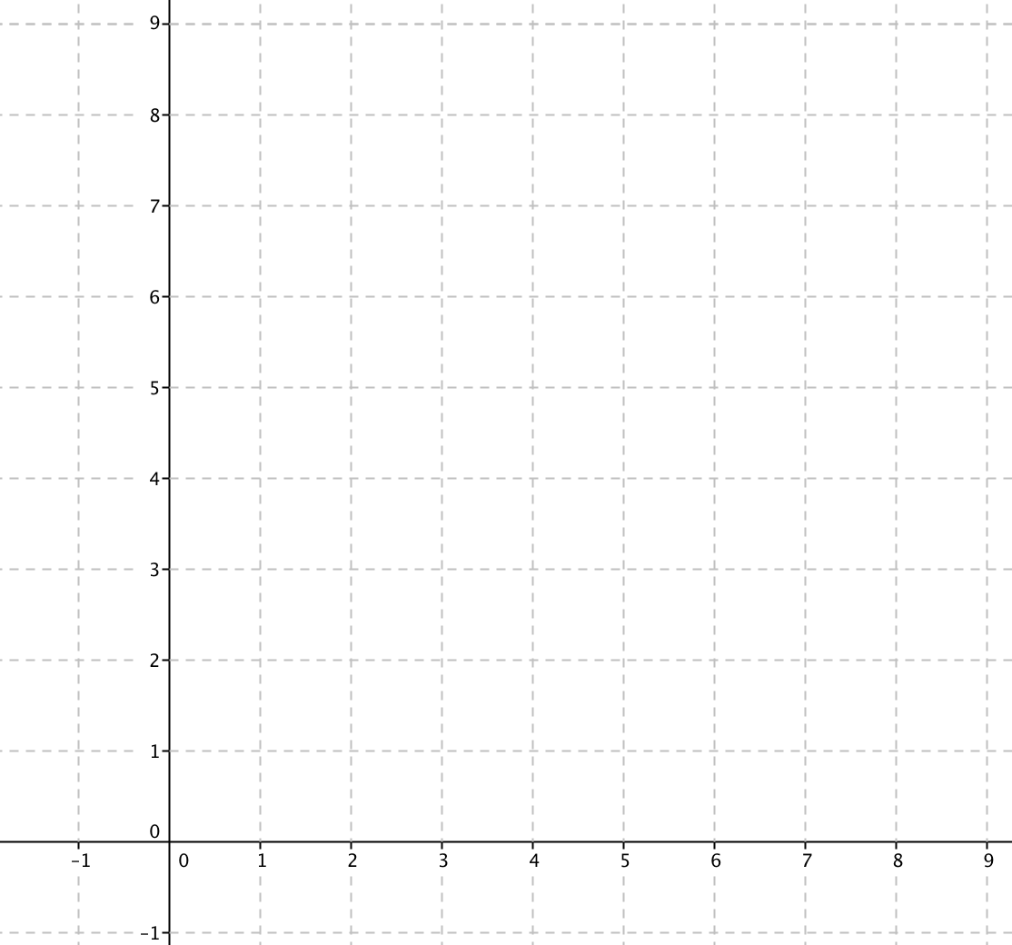

1. On a coordinate grid locate ∆*ABC* with *A* = (0,0), *B* = (5,0), and *C* = (4,2) and ∆*DEF* with   
   *D* = (1,3), *E* = (1,8), and *F* = (–1,7). Map ∆*ABC* onto ∆*DEF*. Describe the transformation or transformations you used.

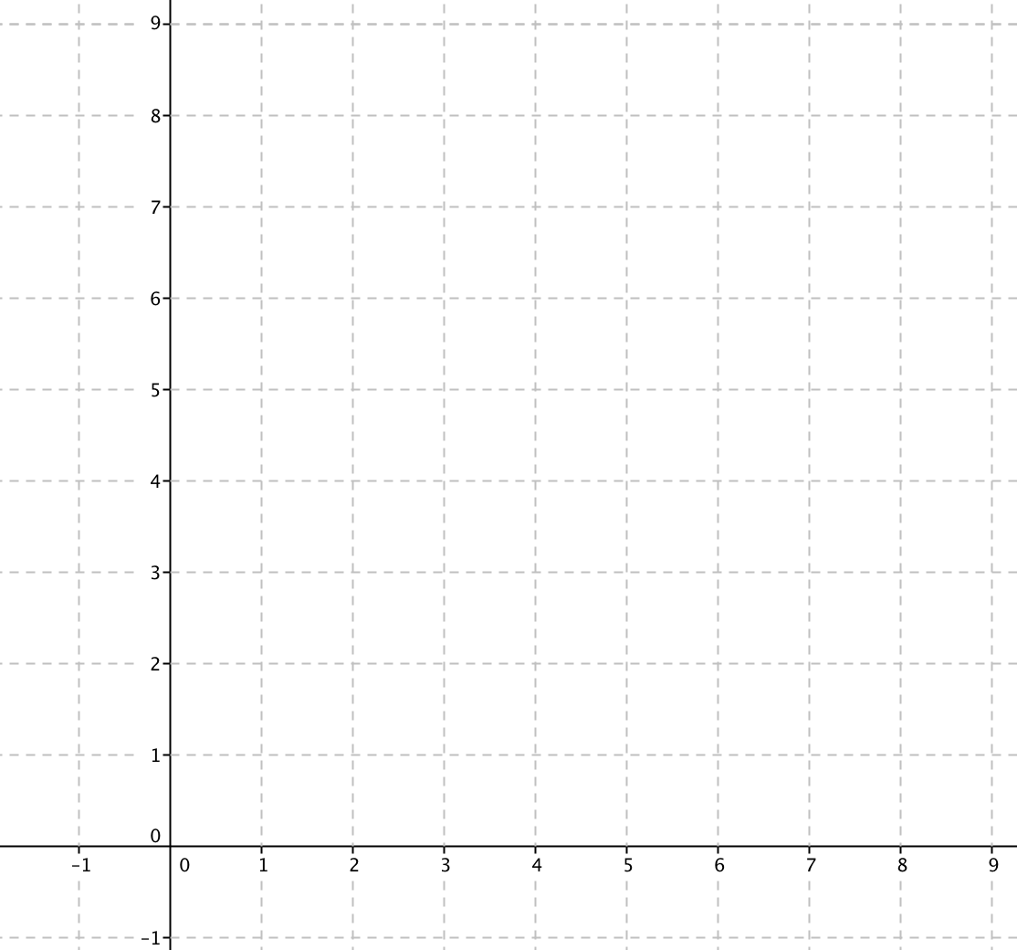

1. On a coordinate grid locate ∆*ABC* with *A* = (0,0), *B* = (5,0), and *C* = (4,2) and ∆*DEF* with   
   *D* = (0,1), *E* = (0,6), and *F* = (2,5). Map ∆*DEF* onto ∆*ABC*. Describe the transformation or transformations you used.



1. 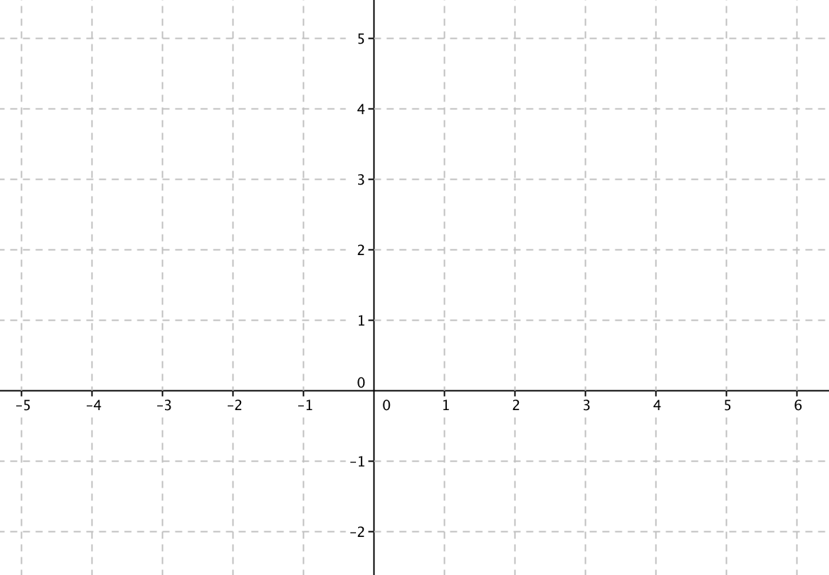On a coordinate grid locate pentagon *ABCDE* with *A* = (0,0), *B* = (4,0), *C* = (4,3),   
   *D* = (2,4) and *E* = (0,2) and pentagon *MNOPQ* with *M* = (0,2), *N* = (–4,2), *O* = (–4,5),   
   *P* = (–2,6) and *Q* = (0,4). Map pentagon *MNOPQ* onto pentagon *ABCDE*. Describe the transformation or transformations you used.
2. On a coordinate grid locate trapezoid *ABCD* with *A* = (0,0), *B* = (2,0), *C* = (5,3), and  
   *D* = (–1,3) and trapezoid *WTGZ* with *W* = (0,–3), *T* = (0,–1), *G* = (–3,2), and *Z* = (–3,–4). Map trapezoid *WTGZ* onto trapezoid *ABCD*.   
     
   a. Describe the transformation or transformations you used.

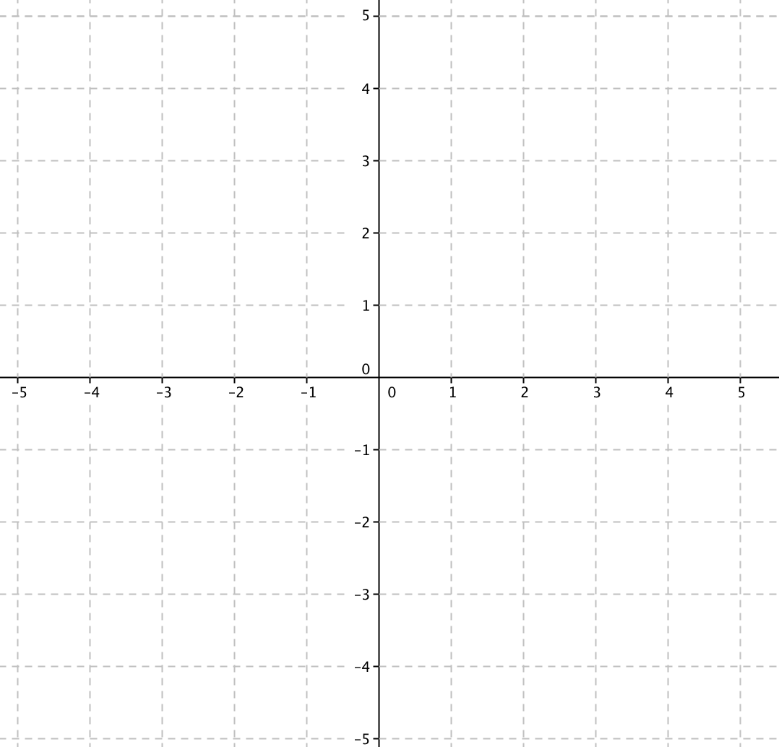b. Write a statement about congruence: Trapezoid $≅$*_______* Trapezoid *________.*