**Activity 2.1.4 Areas and Perimeters of Congruent Figures**

**Formulas you should remember:** Rectangle: Area = length x width   
Parallelogram: Area = base x altitude; Triangle: Area = ½ base x altitude

Circle: Area = π*r*2, Circumference = 2π*r*.

1. Parallelogram *A’B’C’D’* is the image of Parallelogram *ABCD* under a translation.

a. Write the transformation rule: (*x*, *y*) 🡪 (___, ___)

b. Explain why the two parallelograms are congruent.

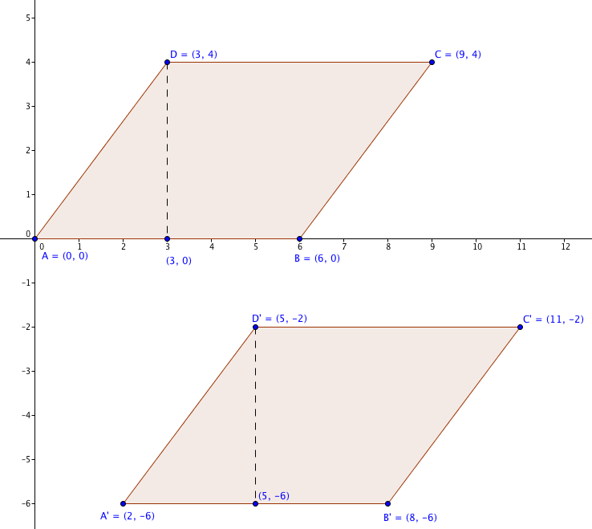

c. Find the area of parallelogram *ABCD*.

d. Find the area of parallelogram *A’B’C’D’*.

e. Find the perimeter of parallelogram *ABCD*.

f. Find the perimeter of parallelogram *A’B’C’D’*.

2. ∆*A’B’C’* is the image of ∆*ABC* under a reflection.

a. Write the transformation rule: (*x*, *y*) 🡪 (___, ___)

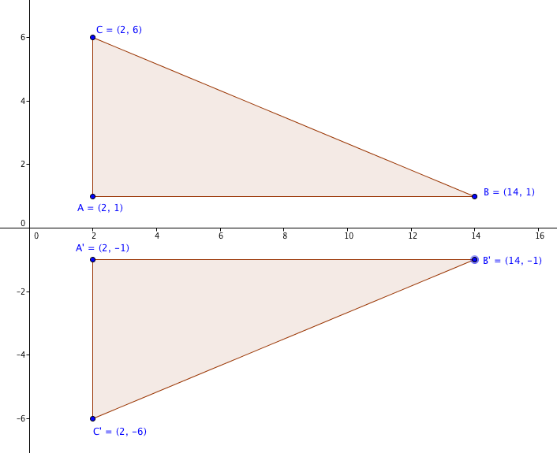b. Explain why the two triangles are congruent.

c. Find the area of ∆*ABC*.

d. Find the area of ∆*A’B’C’*.

e. Find the perimeter of ∆*ABC*.

f. Find the perimeter of ∆*A’B’C’*.

3. Rectangle *ABCD $≅$* Rectangle *MNOP*. *AB* = 4 units and *BC* = 6 units.

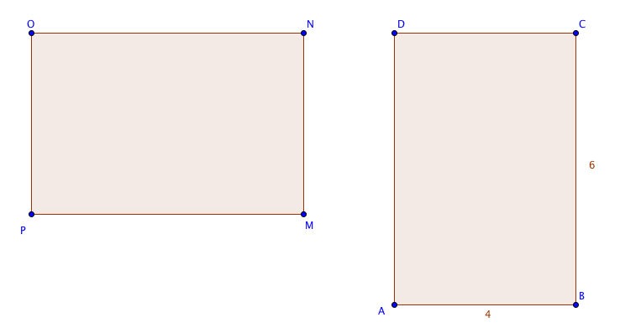

a. Find the area of each rectangle.

b. Find the perimeter of each rectangle.

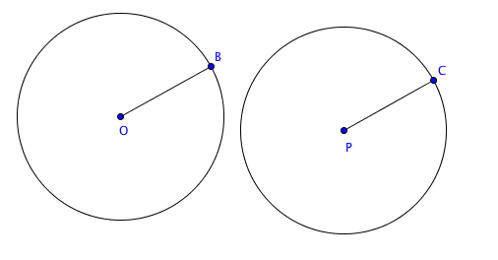

4. Given circle *O $≅$* circle *P*.   
The radius of the first circle, OB = 5 inches.

a. Find the area of each circle to the nearest 0.1 square inch. (Use π ≈ 3.14)

b. Find the circumference of each circle to the nearest 0.1 inch.

5. Based on your answers to question 1-4, if two figures are congruent, what can you say about their areas and perimeters?