Activity 1.5.5 - Glide Reflections

- Open a new GeoGebra file and set labeling to New Points Only. Hint: (Options/Labeling/New Points Only)

- Construct a vector using the Vector Tool and position its endpoint at the origin.

- Construct a line using the Line Tool and position one point on the y-axis. This line will later be used as a reflection line. Right now it doesn’t matter where the second point is for the line.

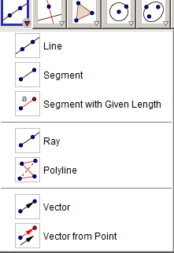
- In order to carry out the transformation in this activity we need to ensure that the line remains parallel to the vector. To do this, right-click on the line and choose object properties. This will open the Preferences tab.

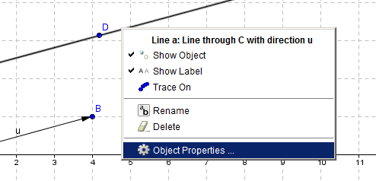

- Under the Basic tab, make sure that the Definition field, which defines the line, is represented as it is in the screen shot below, where the first value corresponds to the y-intercept and the second value (separated by the comma) corresponds to the vector.

* in the example below, this is point C and Vector u- Line[C, u]
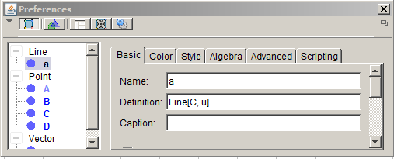

- Browse the internet to locate an image of an animal footprint.

Right-click on the image and save it. Note that you can also use use the standard paw print that your teacher has on file.



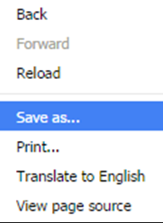
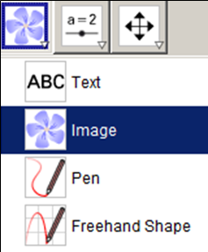
- Insert an image in GeoGebra by using the Insert Image Tool. Click in a space on the drawing pad close to the reflection line and just above it.
(you will be prompted choose an image from your files)

- You can adjust the position of the footprint by specifying three corner points where the image will be placed. To do this, plot three points close to the reflection. Then, right-click on the image, and choose Properties. In the picture below, D is chosen as corner 1, E as corner 2, and F as corner 3. Use the pull down menus for each vertex. Specify the three points that you plotted.

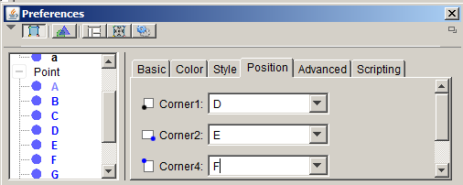

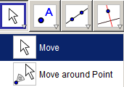
- Now you can distort/move the image by selecting and dragging the points using the Move Tool. Play around with the movement to ensure the footprint is located above the reflection line and walking in the direction of the line like this:

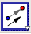
- Translate the foot print using the vector by selecting the Translate Object by
Vector Tool, and selecting the foot print and the vector. Notice that a

translated foot print appears after clicking the vector tool.

If you wish, you can alter the magnitude or direction of the translation by using the
move to adjust the vector.

- Reflect the translated footprint (image #1)
by using the Reflect about Line Tool, and selecting the translated
foot print (image #1) and the reflection line.

Notice that a reflected foot print (image #2) appears.

- Carry out steps 10 & 11 for image #2 by once again using
Translate Object by Vector Tool followed by the Reflect about Line Tool.

Notice that a translated foot print (image #3) and a reflected foot print (image #4) appears.

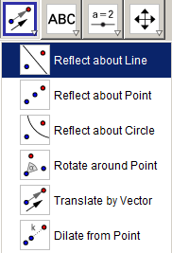
- Carry out steps 10 & 11 for image #4 by once again using
Translate Object by Vector Tool followed by the Reflect about Line Tool.

Notice that a translated foot print (image #5) and a reflected foot print (image #6) appears.

- At this point. in addition to the original foot print, you should have have six images of the original foot print. An example is shown below.

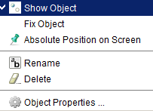
- In order for the composition of transformations (reflections and translations) to appear as successive footsteps you will need to hide certain images. In the example provided, this would include image #1, image #4 and image #5. Note: You can also choose to hide the reflection line and/or the vector.

To do this, Right-click on the image and click Show Object. This will “uncheck” the Show Object option, and thus “hide the image.

Exploration and Conclusions

Footprints represent a perfect illustration of glide reflections which are compositions of a reflection and a translation—in either order.

Carry out the steps below and observe relationships between consecutive images under a glide reflection in order to discover a general rule for a glide reflection along the x-axis:
- Using the Move Tool drag the vector so that it coincides with the x-axis.
- Alter the magnitude or direction of the translation by using the Move Tool to position the endpoint of the vector along different points on the x-axis.

Comprehension Question: How do the coordinates of the images produced by glide reflections relate?

Challenge Question:
Develop a General Rule to describe the image under a glide reflection along the x-axis:

Given a coordinate representation of the vector$\left[h,0\right]$ and (x, y) as a point on the pre-image, develop a general rule in terms of h, x, and y to describe the image of an object under a glide reflection along the x-axis is carried out.

(x, y) → (_____, _____)

