Activity 1.5.3a Composition –Two Rotations

Construction Steps
- Open a new GeoGebra file and set labeling to New Points Only.
Hint: (Options/Labeling/New Points Only)
- Hide the algebra window and the axes. | 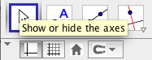
- Use the Polygon tool and click on the graphics window to create $∆ABC$  Hint: (Create Point A, then B, then C, then back to A) | 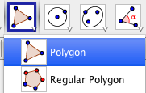
- Use the Point tool and click to the left of $∆ABC$ to create point D. | 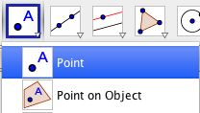
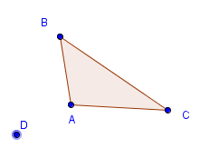
(An example of a possible scenario is shown below)

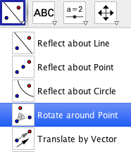
Exploration Steps and Comprehension Questions
- Using the Rotate around Point tool, rotate $∆ABC$ about point D by 120° counterclockwise to produce the image $∆A'B'C'$ .

- Choose two positive integers whose sum is 120.
Record your integer values: $n_{1}= ______{ n}_{ 2 }= ______$

- Again using the Rotate around Point tool, rotate $∆ABC$ counterclockwise around D by an angle measure equal to $n_{1}.$
- Again using the Rotate around Point tool, rotate the figure that resulted from step c counterclockwise around D by an angle measure equal to $n_{2}$.
- Comment on any relationship you observe between the two smaller rotations and the larger rotation.

- Now experiment by rotating objects by different angle measurements and then by measures of two smaller rotations that add to this angle, for example 240° with smaller rotations of 160°, and 80°, etc.

Do the relationships that you commented on in part e hold true here?

