Activity 1.5.2 Composition - Two Reflections II

Reflections Over Intersecting Lines - Construction Steps

- Open a new GeoGebra file and set labeling to New Points Only.
Hint: (Options/Labeling/New Points Only)
- Hide the algebra window, axes, and grid by deselecting the icons on the tool bar as shown to the right or by right clicking the mouse to access the same options. | 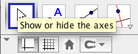
- Use the Polygon Tool and click on the graphics window to create $∆ABC$  Hint:(Create Point A, then B, then C, then back to A) | 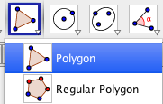
- Use the Line Tool (select two points) and click on the graphics window to the right of $∆ABC$ to create $\overset{⃡}{DE}$. | 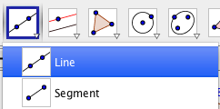
- Use the Point Tool and click to the right of $\overset{⃡}{DE}$ to create F. | 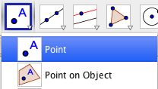
- Again, use the Line Tool (select two points) and click on point E and the graphics window to create $\overset{⃡}{EF}$.  $\overset{⃡}{DE}$ and $\overset{⃡}{EF}$ are the intersecting lines you will reflect $∆ABC$ over. | 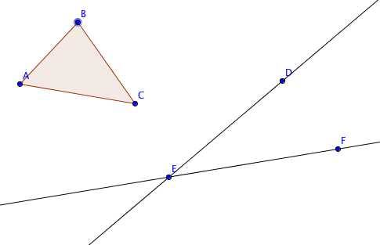
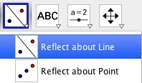
- Use the Reflect about Line Tool and click on $∆ABC$ and $\overset{⃡}{DE}$ to create $∆A'B'C'$.
- Use the Reflect about Line Tool and click on $∆A'B'C'$ and $\overset{⃡}{EF}$ to create $∆A''B''C''$.
Note: After step 7 or 8 the reflection might not be visible, so it may be necessary to zoom out. This can be done by right clicking and selecting the zoom feature, scrolling down with your mouse's scroll wheel, using your laptop's track pad, or swiping the screen of your tablet.
Exploration Steps and Comprehension Questions
- Using the Segment Tool, connect point E to a pair of corresponding vertices on the original figure ($∆ABC$) and the final image ($∆A''B''C''$). For example, connect E to A and connect E to A’’.

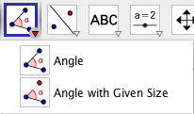
- Using the Angle Tool, measure and record two specific angles in the sketch. For the purpose of the investigation we will record these angles as $α and β$ (as they appear by name in the sketch).
Hint: Angles are created in counter clockwise orientation. Therefore, the order of selecting these objects is important for the Angle tool. Click on three points to create an angle between these points. The second point selected is the vertex of the angle.

- The first angle we will measure is formed by the intersecting reflection lines $\overset{⃡}{DE}$ and $\overset{⃡}{EF}$, which in the diagram below is $∠DEF (labled α: Click on F, E, and D in that order)$.
Record the angle measurement of the angle:
$α$ =______
- The second angle we will measure is formed by connecting the intersection point of the reflection lines to a pair of corresponding vertices from the pre-image and final image, which in the diagram below $∠CEC^{''}(labeled β)$.
Record the angle measurement of the angle:
$β$ =______
*An example of a possible scenario is shown to the right.

- What do you notice about the relationship between the measurements of the two angles $(α and β)?$
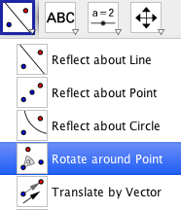
- Using the Rotate around Point Tool, rotate $∆ABC$ clockwise about point E (intersection point of $\overset{⃡}{DE}$ and $\overset{⃡}{EF}$) by a measure of degree equal to $β$.
To do this, select Rotate around Point as shown in the screenshot to the right.
Once you select the triangle and point of rotation, the screen below will appear, and you will be prompted to choose an angle and direction of rotation. Click on the alpha “$α$” symbol. This will allow us to set the degree equal to the measure of an angle stored as a variable in the sketch. This allows the angle of rotation to change dynamically as objects in the diagram are transformed.

Set the angle of rotation to equal the measure of angle $β$ by selecting it from the keypad screen that appears after you click on the alpha symbol “$α$”.
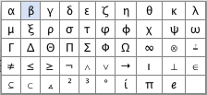
Specify a clockwise rotation as shown below.
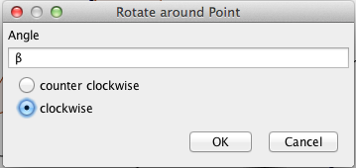

- Comment on any relationship you observe between the location of $∆ABC$ rotated $β°$ clockwise and other objects in the sketch.

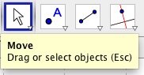
- Using the Move Tool, select and drag points D and/or F to dynamically alter the angle formed by the intersecting lines. Observe the modified angle measurements of $α and β$.
Do the relationships you previously observed still hold true when the angle measurements are altered?

- What is true about the angle measurement of $a ($the angle formed by the intersecting reflection lines $\overset{⃡}{DE}$ and $\overset{⃡}{EF}$) and the angle of rotation that maps $∆ABC$ directly onto $∆A''B''C''$?

Reflections over Parallel Lines – Construction Steps

- Open a new GeoGebra file with the grid display is on. Using the Line Tool, construct line $\overset{⃡}{AB}$ on the grid. Using the Move Tool select and drag points A and B so that they line up vertically and are positioned at a corner point (point where grid lines intersect).
*Refer to the diagram on the next page for a visual

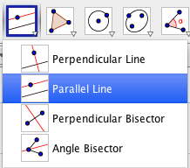
- Construct point C and position it at a corner point a few units to the right of the vertical line.

- Construct a line parallel to $\overset{⃡}{AB}$ by using the
Parallel Line Tool.

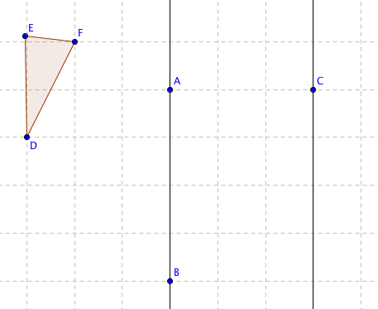
- Using the Polygon Tool, construct $∆DEF$
to the left of the $\overset{⃡}{AB}$, so that your sketch resembles the diagram to the right.

- Use the Reflect about Line Tool and click on $∆DEF$ and $\overset{⃡}{AB}$ to create $∆D'E'F'$

- Again, use the Reflect about Line Tool and click on $∆D'E'F'$ and the second line (line parallel $\overset{⃡}{AB}$) to create $∆D''E''F'$.

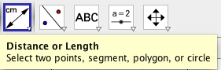
- Using the Distance or Length Tool, measure the distance between the vertical lines and the lengths of $DD^{''}, EE^{''}and FF^{''}.$

- Make a conjecture about the relationship between the distance between the parallel lines and the lengths of $DD^{''}, EE^{''}and FF^{''}.$

- Describe a single transformation that maps $∆DEF$ to $∆D''E''F''$.

- Using the Move Tool, select and drag points A and/or B to dynamically alter the slope of $\overset{⃡}{AB}$. Observe the modified distances, do the relationships you previously observed for a pair of vertical parallel lines hold true for any pair of parallel lines?

- How is the distance between the parallel lines related to the transformation that maps $∆DEF$ to $∆D''E''F''$?

