**Activity 1.2.6a Translating Lines**

1. Recall from Algebra 1: If two lines have the same _________, then they are parallel.
2. Describe, in your own words, what it means for two lines to be parallel.

3. Draw the line through the points *A*(1,4) and *B*(4,2). Then translate the line by the vector [3,1].

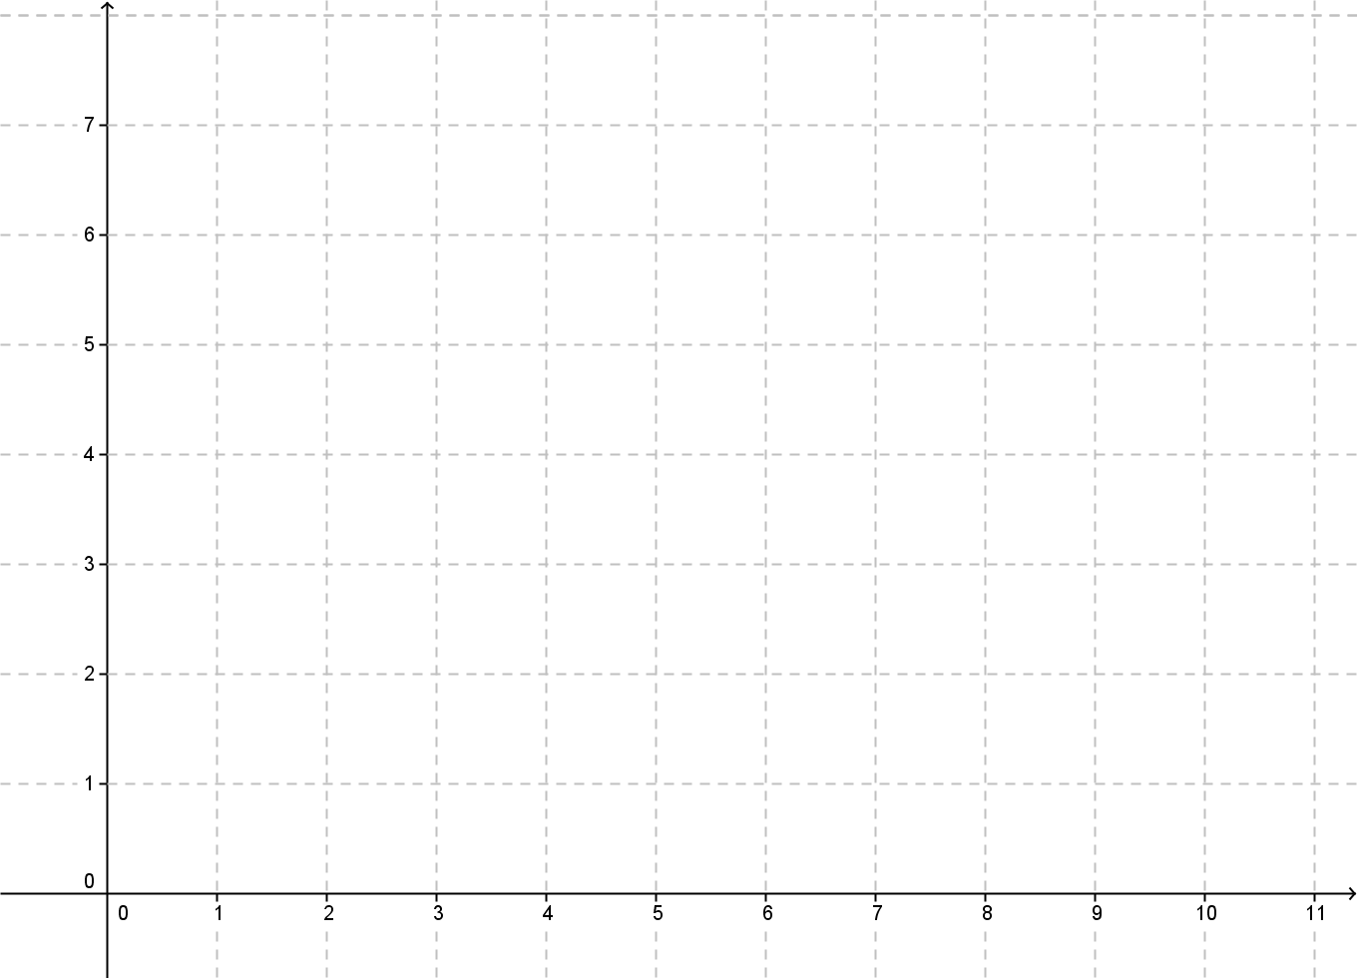

1. What are the coordinates of *A*’ and *B*’?
2. Find the slope of line $\overset{⃡}{AB}$ and the slope of its image, line $\overset{⃡}{A’B’.}$
3. What can you conclude about the two lines?
4. What happens if you translate the original line $\overset{⃡}{AB}$ by a different vector?
5. What would the vector have to be in order to make the original line and its image coincide?

9. On the grid below draw a line anywhere and create a vector that is parallel to your line. Translate the line by this vector. What do you notice?

