Activity 1.2.2 Describing Straight Objects

In this activity you will build upon what you learned in previous activity by relating the notion of the magnitude and direction of vectors to that of lines, rays, and segments. You will explore whether these objects have magnitude and direction and what this means in real-world contexts.
1. Open GeoGebra and select the Algebra & Graphics view from the Perspectives menu.

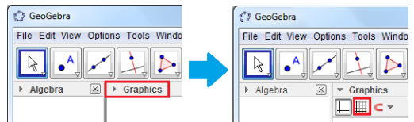
2. Display the grid by selecting the Move Tool and clicking the drop down arrow by Graphics as shown below.

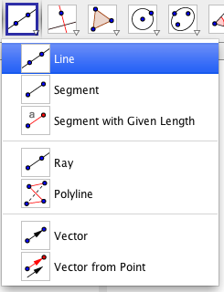
3. Select the Line Tool (as shown to the left) to place points on the coordinate. Select the appropriate tool to construct a segment, a line, a ray, and a vector. Make sure that the three objects do not overlap, so that you can focus on each of them. Use the Move Tool to select a point and translate it dynamically to alter the characteristics of the object such as slope, direction, x- and y- intercepts, etc.
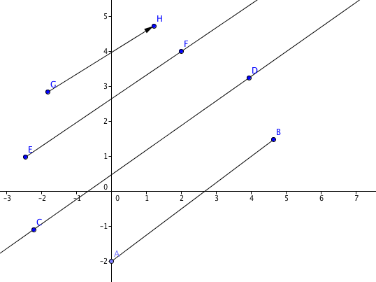

4. Based on your understanding of segment, line, ray, and vector as well as the space occupied by each object in the GeoGebra sketch, answer the following questions that relating each object to both magnitude and direction.
Organize your conjectures pertaining to each object in the table below:
Object | Does it have magnitude?  (Explain your reasoning) | Does it have direction?  (Explain your reasoning)
Segment
Line
Ray
Vector

