Activity 1.1.1 Pythagorean Theorem

- Farmer Pythagoras has three fields, but only two children. What is the easiest way for him to split the land in his fields equally between his kids?
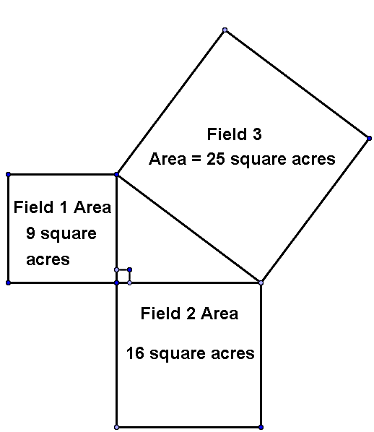
- What kind of problems can we solve with the Pythagorean Theorem?

- In the picture below identify the right angle, label the two legs, and label the hypotenuse

Pythagorean Theorem – In any right triangle, the sum of the squares of the lengths of the legs is equal to the square of the length of the hypotenuse
Symbols: (leg₁)² + (leg₂)² = (hypotenuse)² OR a² + b² = c² where a and b represent the lengths of the legs and c represents the length of the hypotenuse.

- Can you use the Pythagorean Theorem to solve the following problems? If yes, then calculate the value of the variable in simplest radical form. If not, then explain why not.
  - Find the value of x.
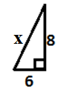

  - Find the value of c.
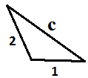
  - Find the value of x and y
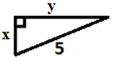

  - Find the value of a
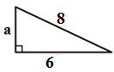

Perimeter – The perimeter of a closed plane figure is the distance around the figure.
- Find the perimeter of each triangle. Round your answer to the nearest tenth.

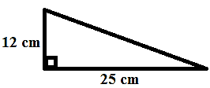

  - The dotted line is perpendicular to the base of this triangle.
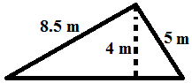

- A 35-foot ladder is leaning against the side of a building and is positioned such that the base of the ladder is 21 feet from the base of the building. (A) Sketch the scenario. (B) How far above the ground is the point where the ladder touches the building? Round your answer to the nearest hundredth.

- Two joggers started in the same place, but ran in different directions. One ran 8 miles south and the other ran 5 miles west. How far apart are they now? (Answer to nearest 0.001 mile)

- Pat is setting up volleyball in her backyard. The top of the volleyball net is 8 feet high. Two ropes connect the top of each post to stakes in the ground 7 feet from the base of the pole. Approximately how many feet of rope are being used? Round to the nearest hundredth.
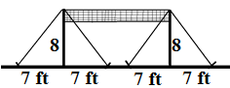

- On rainy days, Izzy goes from his house to the school by running 1.2 miles on West St, then makes a 90º turn and runs 0.5 miles on North Ave.
  - If Izzy runs 7.5 miles per hour, approximately how much time will it take her to run to school on rainy days?
  - On dry days, Izzy runs on the dashed path through the woods. How far is she traveling?
  - If Izzy runs 7.5 miles per hour, how much time will she save by cutting through the woods?
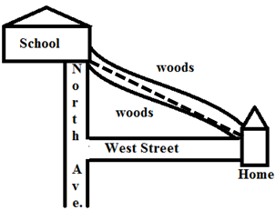
- Eric and Tim live on the same lake and have two methods of visiting each other. Eric can walk 3 miles turn and walk 1 more mile, or he can swim across the lake. He swims at 2 miles per hour and walks at 4 miles per hour. Which option is quicker and how many minutes quicker?

