Unit 8: Investigation 7 (2-3 Days)

Semi-regular and Stellated Polyhedra

Common Core State Standards (extended)

6-G4 Represent three-dimensional figures using nets made up of rectangles and triangles, and use the nets to find the surface area of these figures. Apply these techniques in the context of solving real-world and mathematical problems.

Overview

This investigation is an extension of Unit 6 Investigation 1 in which students were introduced to the classification of polyhedra. In activity 6.1.3 student proved that there are exactly five regular polyhedra, also known as Platonic Solids. In this Investigation they will show that there are exactly 13 Archimedean solids. These belong to a broader class known as semi-regular polyhedra. Students will explore the properties of these polyhedra and also extend their understanding of polyhedra to include a class of non-convex figures, the stellated polyhedra.

Assessment Activities

Evidence of Success: What Will Students Be Able to Do?

- Use a systematic exploration of possible semi-regular polyhedra to conclude that there are exactly 13 Archimedean solids
- Construct models of Archimedean solids and explore their properties
- Construct models of stellated polyhedra and explore their properties

Assessment Strategies: How Will They Show What They Know?

- Exit slip 8.7 asks students to determine which possible vertex configurations could belong to a semi-regular polyhedron.
- Journal entry asks students to describe the properties of a particular semi-regular polyhedron.

Launch Notes

Show students a model of one of the Archimedean solids and ask the class whether it can be classified as a regular polyhedron. Its faces are all regular polygons, but not of the same type, so it does not qualify as a regular polyhedron. However, it is classified as semi-regular.

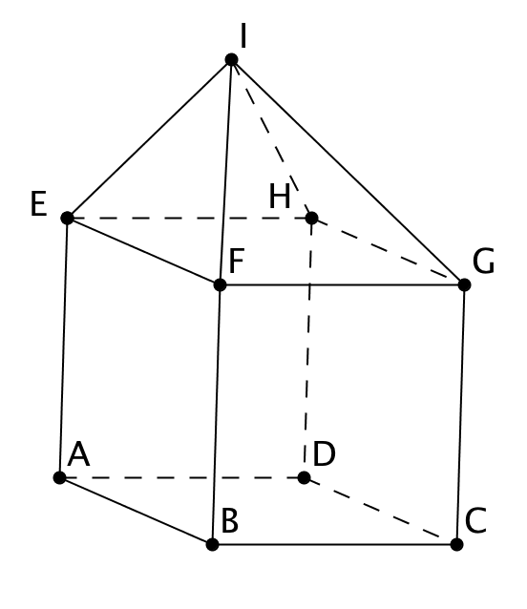

Emphasize that in a semi-regular polyhedron the configuration of polygons must be the same at each vertex. For example, if a square pyramid with equilateral triangular faces is placed so that its base coincides with a face of a cube, a polyhedron with 9 faces is formed as shown in the figure. Although all faces are regular polygons, the configurations at the vertices differ. Using the Schläfli symbol notation, the configuration at B is 4.4.4, at F it is 3.3.4.4, and at I it is 3.3.3.3.

You may then introduce these formal definitions of regular and semi-regular polyhedra:

Regular polyhedron: A polyhedron whose faces are all regular polygons of same type (i.e. having the same number of sides) For any two vertices there is an isometry mapping one onto the other that also maps the entire polyhedron onto itself.

Semi-regular polyhedron: A polyhedron whose faces are all two or more different types of regular polygons. For any two vertices there is an isometry mapping one onto the other that also maps the entire polyhedron onto itself.

Teaching Strategies

Following the launch, in which they are prompted to recall what they learned in Unit 6, students should be ready for the first Activity.

Activity 8.7.1 Exploring the Archimedean Solids leads students through a rigorous examination of what configurations of regular polygons are possible at each vertex. We begin with the property introduced in Unit 6, that the sum of the interior angles at each vertex must be less than 360° for any convex polyhedron. Using this property students conclude that no semi-regular polyhedron may be constructed with more than three different types of regular polygons. Further they discover restrictions on configurations of three or four polygons at a vertex. Students who completed Activity 8.3.1 Possible Semi-regular Tilings will notice that a similar approach is taken here.

Students then make systematic lists of possible configurations and eliminate those that will not work. In the process they learn that there are two infinite families of polyhedra (certain types of prisms and anti-prisms) that meet the criteria for semi-regular polyhedra but are not considered Archimedean solids.

Most of this activity up through question 19 should be completed in one class period. Students should conclude that exactly 13 vertex configurations solids produce possible Archimedean solids and will know the Schläfli symbol for each.

Group Activity
Any of these activities are suitable for group work. In particular, question 20 of Activity 8.7.1 asks students to make nets for the Archimedean solids and construct the solids. Each student in the class may be assigned a different solid to work on. Then in small groups they may compare their figures, discuss symmetries, and verify that Euler’s formula holds.

Question 20 assigned to small groups as indicated above may take an entire class period.

Differentiated Instruction (For Learners Needing More Help)
For question 20, assign struggling students polyhedra that have relatively small numbers of faces, e.g. truncated tetrahedron (8 faces), truncated cube (14 faces), truncated octahedron (14 faces) and cuboctahedron (14 faces).

Activity 8.7.2 More on the Archimedean Solids extends the investigation begun in Activity 8.7.1. The concept of duality is revisited. The names of the thirteen Archimedean solids are introduced and the rationale for many of them is made evident through exploring the process of truncation.

Differentiated Instruction (Enrichment)
We have seen the dual relationships between the cube and the octahedron and between the icosahedron and dodecahedron in an earlier lesson. The Archimedean solids have duals too. You may have learned that in the plane, the duals of the semi-regular tilings are not semi-regular tilings. In space the duals of the Archimedean solids are not semi-regular either. This is a topic for an advanced exploration. (This is question 8b in Activity 8.7.2)

Differentiated Instruction (Enrichment)
Some students may be interested to learn that there is one polyhedron that meets the vertex criterion for semi-regular polyhedra but does not have property that any pair of vertices determine an isometry mapping the polyhedron onto itself. This “oddball” polyhedron is the pseudo-rhombicuboctahedron. Students may research this topic and then asked to explain the difference between the rhombicuboctahedron and the pseudo-rhombicuboctahedron.

All the polyhedra studied so far have been convex. Activity 8.7.3 Stellated Polyhedra introduces students to a class of non-convex polyhedra. Students visualize and then construct a stellated dodecahedron and a stellated octahedron. They are then challenged to create the great dodecahedron and the stellated dodecahedron as well as one of the 59 stellations of the regular icosahedron.

Note: Questions 1b-1f of Activity 8.7.3 require students to use software to construct the net of the stellated dodecahedron. An alternative is to provide them with a template. Run off three copies of the Activity 8.7.3 Template for each student so that they have enough triangles to create the net.

Journal Prompt: Pick one of the Archimedean solids and describe it in as much detail as you can. Look for students to describe the number of faces, the types of regular polygons used, and the configuration at each face, preferably using Schläfli symbol notation.

Closure Notes

Have students share the solid figures they have created in this investigation and describe the properties of each figure.

Much has been learned about more complex polyhedra. When John Flinders Petrie and H.S.M. Coxeter were boys they found each other in beds next to each other in the school health center recovering from the chicken-pox. They started talking about mathematical shapes they were exploring. Later as adults they continued to collaborate on papers about geometry. More recently John H. Conway and collaborators explored polyhedra of many dimensions called “Polytopes”. Another resource is the work of Magnus Wenninger. There are many topics to explore for papers, models or other special projects to be found in their writings. This would be a good area to explore for a science or math fair.

Vocabulary

anti-prism
Archimedean solid.
convex vertex
non-convex vertex

regular polyhedron
semi-regular polyhedron
stellated polygon
stellated polyhedron

Materials Needed

Cardstock for Activity 8.7.1 and Activity 8.7.3
Dental floss and modeling clay for Activity 8.7.2
Activity_8_7_3_template.docx for Activity 8.7.3

Resources

Activity 8.7.1 Exploring the Archimedean Solids
Activity 8.7.2 More on the Archimedean Solids
Activity 8.7.3 Stellated Polyhedra
Exit Slip 8.7

Stella is a software program for Windows that explores nets of polyhedra and can assist in the making of many sophisticated models (http://www.software3d.com/). Magnus Wenninger has used this software to assist in recent models. This site has mobile apps for Android based devices.

Pedagoguery Software (http://www.peda.com/poly/ ) provides shareware software to explore nets, Schlegel diagrams and three dimensional animations of semi-regular and regular polyhedra and other polyhedra.

Jeffrey Weeks KaleidoTile encourages informal experiments with semi-regular and regular polyhedra and their symmetries. ( http://geometrygames.org/KaleidoTile/index.html).

The NCTM publication Polyhedron Models for the Classroom, by Magnus J. Wenninger (1966) is a classic reference for this unit.

H.S.M. Coxeter’s Introduction to Geometry (1961), Wiley Press, Chapter 10 is another classic resource that provides the teacher or advanced student with a discussion of the Platonic solids which includes Schläfli symbols, Schlegel diagrams and the dihedral angles between the faces. It also includes a proof of Euler’s Formula and a formal proof that there are just five convex regular polyhedra.

The Symmetries of Things, by John Conway, Heidi Burgiel and Chaim Goodman-Strauss (2008) A. K. Peters, includes a much more sophisticated view of polyhedra through the properties of symmetry for teachers and very advanced students.

