**Activity 8.7.3 Stellated Polyhedra**

At this point you have studied several types of polyhedra: prisms, antiprisms, pyramids, regular polyhedra and semi-regular polyhedra. All of these polyhedra are **convex**. Recall that this means that segment joining a pair of points in the interior of the figure, lies entirely within the interior of the figure. In this activity you will study a class of non-convex figures, the **stellated polyhedra.** (The word “stellate” comes from the Latin word for “star.”)

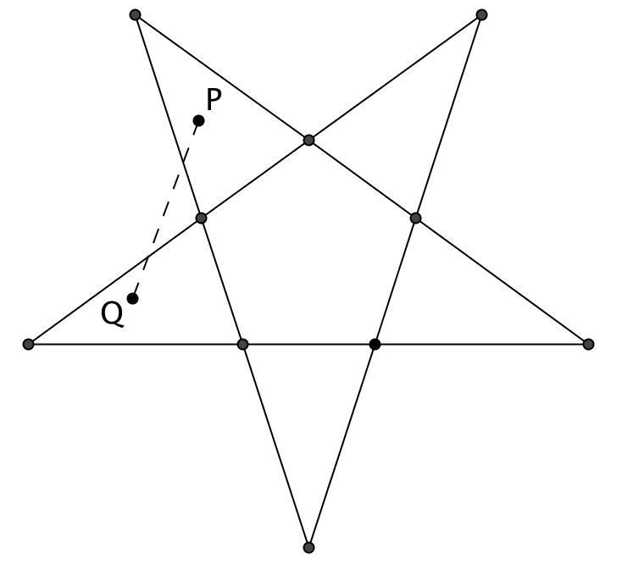First, let’s look at the two-dimensional analog of a stellated polyhedron, a **stellated polygon**. Start with a regular pentagon. Extend its sides until they meet. You now have a five-pointed star or pentagram. The figure is non convex, because if you draw a segment between points in two of the triangles that have been added to original pentagon, it may pass outside the pentagram. (For example, $\overline{PQ}$ in the figure at the right.)

1. Using the same method, make a stellated hexagon and a stellated heptagon.

A stellated polyhedron results from extending the faces of a regular polyhedron until they intersect. The planar intersections of two of these faces form edges. The points where multiple faces intersect are the new vertices.

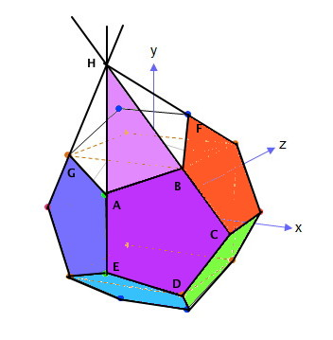

1. Here is a construction to get you going.
   1. Here is an illustration of a dodecahedron. Consider the face *ABCDE*. Extend the two edges adjacent to edge $\overline{AB}$ until rays $\overset{⃑}{EA}$ and $\overset{⃑}{CB}$ meet at point *H*. Triangle *ABH* is one face of a stellated dodecahedron. We can form 5 such faces from *ABCDE*. Since the dodecahedron has 12 faces, the stellated figure has 12 times 5 = 60 faces.
   2. Use Geometry software to construct a regular pentagon. 
   3. Extend two of the sides at opposite ends of one edge. 
   4. This new triangle is the intersection described in a above. Now we need to copy this 5 times. 
   5. The five shaded triangles form 5 faces of the stellated dodecahedron. Reflecting this about one edge and adding some tabs, we will have two pieces of a net for a stellated dodecahedron. We may not want all of the tabs later, but it is easy to cut extras off.
   6. Since a dodecahedron has twelve faces that will be replaced by these baseless pyramids we will need to make 6 copies of this to create a model. 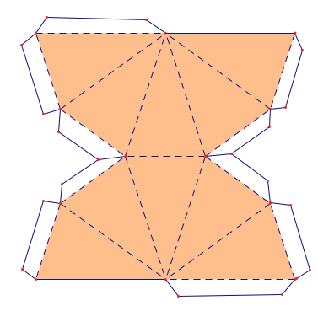
   7. 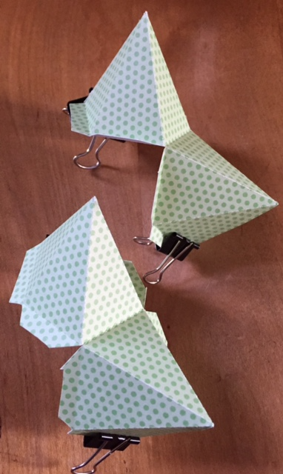On each piece, glue the long tabs to form the faces that look like lateral faces of a pyramid, Make a valley fold where the two pyramids connect, and where tabs meet at the bases. Make mountain folds along all of the long edges of the pyramids.
   8. Assemble these pieces so that three “pyramids” fit together at a non-convex vertex as shown. If you cut off some tabs you may be able to put glue on the outside of a tab and hold the connections with binder clips while the glue dries.

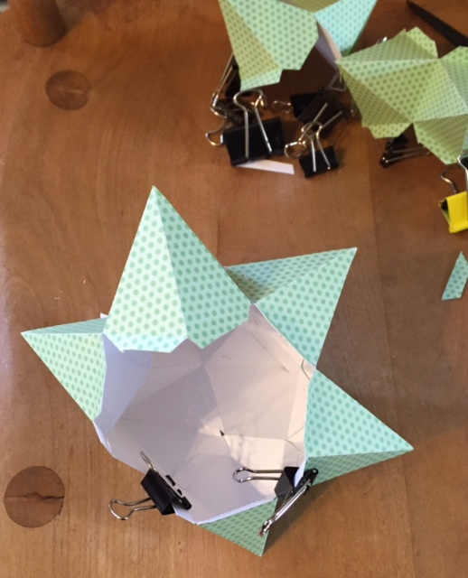

* 1. 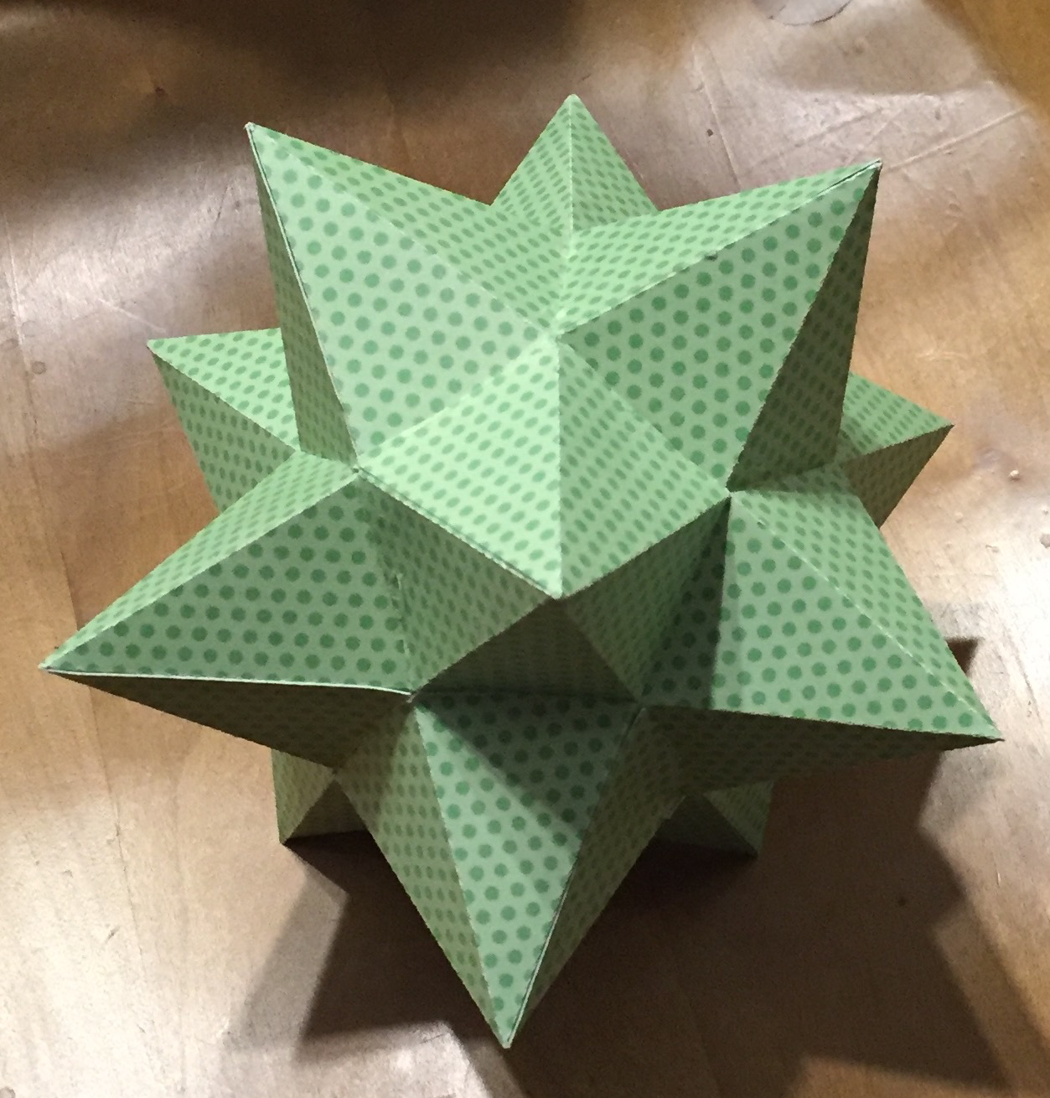Here is what the final shape should look like. To attach the last set of faces you may want to glue the tabs to the outside. Notice that the apexes of the “pyramids” give the solid a star-like quality.

1. 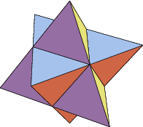The figure that you just constructed is called a *small stellated dodecahedron*. “Stella” is the Latin word for “star.” These figures are called "stellated” because star-like points have been added to all the faces. There are other regular polyhedrons that can be stellated in a similar fashion.
   1. First look at a regular octahedron. How could you extend the faces so that they intersect in other edges that intersect to form vertices of a stellated octahedron?
   2. Use geometry software to construct parts that could fit together to form this stellated octahedron. The name of this non-convex polygon is the *stella octangula*. It is the compound of two tetrahedral joined at the midpoints of their edges.
   3. Examine a cube. Do you think it could be stellated in the same way? Why or why not?
   4. Another polyhedron that might be considered for stellation is the tetrahedron. Does it make sense to stellate it? Some people confuse the stella octangula for the stellated tetrahedron. What happens when you extend the faces of a tetrahedron?
2. Now let’s analyze some features of the stellated dodecahedron and the stellated octahedron.
   1. Each figure has convex and non-convex vertices. Examine them and fill in the table below.

|  |  |  |
| --- | --- | --- |
|  | Stellated Dodecahedron | Stellated Octahedron |
| Number of convex vertices |  |  |
| Number of triangles at each convex vertex |  |  |
| Sum of interior angles at each convex vertex |  |  |
| Number of non-convex vertices |  |  |
| Number of triangles at each non-convex vertex |  |  |
| Sum of interior angles at each non-convex vertex |  |  |

* 1. Describe any patterns you observe in the table.
  2. Verify that both stellated polyhedra satisfy Euler’s formula.
  3. The three faces of a stellated octahedron that surround a triangular pyramid lie in the same plane. If these are counted as part of the same face, then how many faces does the stellated octahedron have?
  4. Similarly, the five faces of a stellated dodecahedron that surround a pentagonal pyramid lie in the same plane. If these are counted as part of the same face, then how many faces does the stellated octahedron have?

1. This section consists of some challenges for expert model builders.
   1. The dodecahedron is said to have four stellations. The dodecahedron itself is one of them, the *small stellated dodecahedron* is one of them and there are two more: the *great dodecahedron* and the *great stellated dodecahedron*. Pictures of them are shown below: 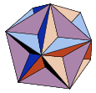 and 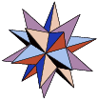

Study these illustrations from Wolfram MathWorld.:

[Weisstein, Eric W.](http://mathworld.wolfram.com/about/author.html) "Dodecahedron Stellations." From [*MathWorld*](http://mathworld.wolfram.com/)--A Wolfram Web Resource.<http://mathworld.wolfram.com/DodecahedronStellations.html> and see if you can figure out how to use geometry software to construct models of them.

* 1. The icosahedron has 59 stellations including itself! Below are illustrations of all of them.

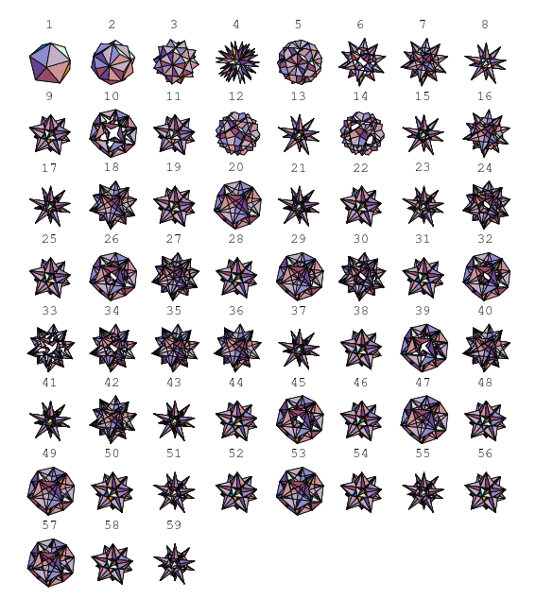

Select one of them (other than the icosahedron itself) and try to construct it.