Activity 8.7.2 More on the Archimedean Solids

We begin this activity by revisiting the Platonic solids and the concept of duality.

- It turns out all of the Platonic solids are related to each other in many powerful ways. If the faces of one polyhedron can be identified with the vertices of another they are called duals of each other. Thus the dodecahedron with its 12 regular pentagon faces is the dual of the icosahedron with its 12 vertices. The cube with its 6 faces is the dual of the octahedron with its 6 vertices. And the tetrahedron with its four faces and four vertices is its own dual. In Unit 6 you created a table similar to the first five columns of the table below. This table extends the patterns by showing the numbers of rotation axes and mirror planes for each of the Platonic solids. You notice that the cube and octahedron exhibit the same numbers of rotation axes and mirror planes. So do the icosahedron and dodecahedron.
Regular  Polyhedron | Faces | # Faces | # Edges | # Vertices | Schläfli Symbol | # Rotation axes |  |  |  | # Mirror planes
 |  |  |  |  |  | 2-fold | 3- fold | 4-fold | 5-fold
Tetrahedron | triangles | 4 | 6 | 4 | 3.3.3 | 3 | 4 | 0 | 0 | 6
Hexahedron  (Cube) | squares | 6 | 12 | 8 | 4.4.4 | 6 | 4 | 3 | 0 | 9
Octahedron | triangles | 8 | 12 | 6 | 3.3.3.3 | 6 | 4 | 3 | 0 | 9
Icosahedron | triangles | 20 | 30 | 12 | 3.3.3.3.3 | 15 | 10 | 0 | 6 | 15
Dodecahedron | pentagons | 12 | 30 | 20 | 5.5.5 | 15 | 10 | 0 | 6 | 15

Let’s verify some of these results, starting with the cube. Use models to answer these questions.
a. Imagine a line through the centers of two opposite faces of a cube. If the cube rotates around this line, what type of symmetry do you have? How many such lines are there?
b. Imagine a line through the midpoints of two opposite edges of a cube. If the cube rotates around this line, what type of symmetry do you have? How many such lines are there?
c. Imagine a line through two opposite vertices of a cube. If the cube rotates around this line, what type of symmetry do you have? How many such lines are there?
d. Describe the location of the 9 mirror planes for a cube.

e. Repeat questions a, b, c, and d for a regular octahedron.

f. Repeat questions a, b, c, and d for a regular tetrahedron.
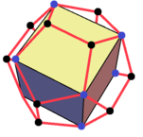
If you are interested, you may want to undertake a similar investigation of the dodecahedron and icosahedron.
- The dual relationships are well known, but perhaps more surprising are two more connections between the Platonic solids. If you carefully select vertices of a dodecahedron that are at the ends of diagonals of the pentagonal faces, these diagonals are the edges of a cube inscribed in a dodecahedron.
Image from "Cube in dodecahedron" by Tomruen - Own work. Licensed under CC BY-SA 4.0 via Commons https://commons.wikimedia.org/wiki/File:Cube_in_dodecahedron.png#/media/File:Cube_in_dodecahedron.png
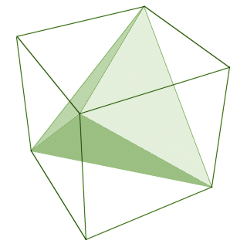
Similarly, if you select the diagonals of a cube carefully you can inscribe a tetrahedron inside a cube.

Explain using the table on the previous page, why the diagonals of one polyhedron can serve as edges of another in these two cases.

Image from http://www.technologyuk.net/mathematics/geometry/images/geometry_0175.gif
- The 13 Archimedean solids you found earlier in Activity 8.7.1 have names. The table shows the vertex configuration and names for each of them. Sketches of some are shown on the next page.
Configuration | Name of the solid
3.6.6 | Truncated tetrahedron
3.4.3.4 | Cuboctahedron
3.8.8 | Truncated cube
4.6.6 | Truncated octahedron
3.4.4.4 | Rhombicuboctahedron
4.6.8 | Truncated cuboctahedron
3.3.3.3.4 | Snub cube
3.5.3.5 | Icosidodecahedron
3.10.10 | Truncated dodecahedron
5.6.6 | Truncated icosahedron
3.4.5.4 | Rhombicosidodecahedron
4.6.10 | Truncated icosidodecahedron
3.3.3.3.5 | Snub dodecahedron

Image from pinterest.com
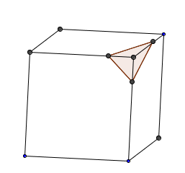
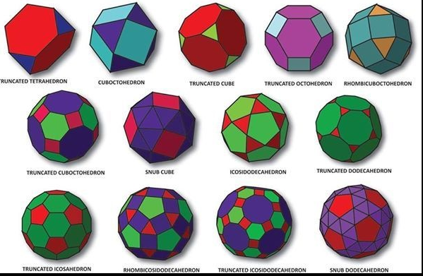
- The Archimedean solids seem to have unusual names that include some of the names of the Platonic solids. They seem to have some special vocabulary attached to them. They are truncated, snubed or rhomi versions. The following parts of this lesson explore what these terms mean. You will need to have some modeling clay and dental floss to do these explorations.

  - Form your clay into a cube. If you cut a vertex off equally distant from the vertex, the cut forms a triangle. Slowly trim each vertex until you have a solid with six regular octagons as faces. All of the edges of your solid should be the same length. Make a sketch of your resulting polyhedron or take a picture with your phone. This is called a truncated (“cut off”) cube. You should be able to see two octagons and one triangle around each vertex.

  - If you keep slicing triangles from each vertex you can eventually have the cuts meet so that all of the edges are the same, but they now are all triangles and squares. (The cuts will meet at the midpoints of the edges of the original cube.)
  - How many square faces are there?
  - How many triangular faces are there?
  - What is the vertex configuration of this solid?
  - What is the name attached to it in the chart on the previous page?
  - Where do you think it gets its name?

- You can do similar experiments starting with the tetrahedron and the dodecahedron (although the dodecahedron is hard to form with clay!) Record your observations here.
- If we decided to truncate the vertices of the cuboctahedron rather than enlarge the triangles, we would obtain 4.6.8 sometimes called the great rhombicuboctahedron for its rectangular cuts. What is another name for this polyhedron?

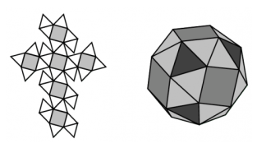
- To form the snub cube, we place a smaller square in the center of each face rotated slightly. (In this context, “snub” means “short” as in a “snub nose” or a “snub nosed pistol.”) Surround this smaller square by a belt of equilateral triangles. Let 6 of these replace a face of a cube and replace each original vertex of the cube with another triangle. When all edges of the polyhedron are the same length it will be a snub cube. Explain how a similar process is used to form a snub dodecahedron.
http://rightstartmath.com/snub-cube-pattern/

- The Archimedean solid with configuration 5.6.6 is found on a familiar object. What is it?

- The chart below shows a “family tree” of all the Platonic and Archimedean solids. 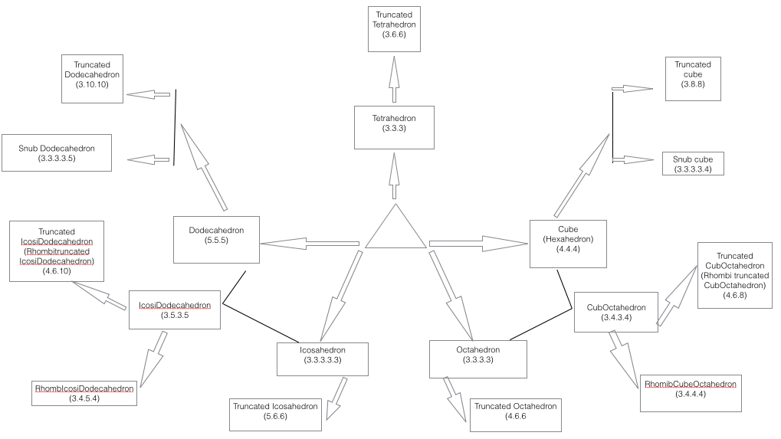
  - What patterns do you see in this diagram?

  - We have seen the dual relationships between the cube and the octahedron and between the icosahedron and dodecahedron in an earlier lesson. The Archimedean solids have duals too. You may have learned that in the plane, the duals of the semiregular tilings are not semiregular tilings. In space the duals of the Archimedean solids are not semi-regular either. This is a topic for an advanced exploration.

