8.6.5 Extensions for the Golden Ratio

- Properties of Phi. Recall that the golden rectangle has the following property:

$\frac{length}{width}$ =$\frac{length+width}{length}$
Because we are interested in a ratio, then without loss of generality we can assume the width is 1. This produces the sentence

$\frac{x}{1}=\frac{x+1}{x}$
which then produces the quadratic equation x² = x + 1 or x² - x – 1 = 0.

We call the two solutions ϕ (phi) and ϕ’ (phi prime).

ϕ = $\frac{1+\sqrt{5}}{2}$ ϕ’ = $\frac{1-\sqrt{5}}{2}$
You have seen some interesting properties of ϕ (phi). Some are relisted below and new ones are also included. Investigate with a calculator to understand what is being claimed. Then, use algebra to prove as many as you can.

- The reciprocal of phi is one less than phi.

$\frac{1}{ϕ}$ = ϕ – 1
- The opposite reciprocal of phi equals the second solution to the original quadratic equation.
$-\frac{1}{ϕ}$ = ϕ’

- The sum of consecutive powers of phi is the next power of phi.
1 + ϕ = ϕ²

ϕ + ϕ² = ϕ³

ϕ² + ϕ³ = ϕ⁴

- Powers of phi are related to Fibonacci numbers.
ϕ = 1 ϕ + 0
ϕ ² = 1 ϕ + 1
ϕ ³ = 2 ϕ + 1
ϕ ⁴ = 3 ϕ + 2
ϕ ⁵ = 5 ϕ + 3
…
- The product of the two solutions to the original quadratic equation is –1.
ϕ ϕ’ = –1
- Continued fraction. [Kinsey & Moore, p. 292].
Compute the following.
- 1 + $\frac{1}{1}$

- 1 + $\frac{1}{1+ \frac{1}{1}}$

- 1 + $\frac{1}{1 + \frac{1}{1+ \frac{1}{1}}}$

- Write the next two examples in the series and evaluate each of them.

- What number is the sequence of results approaching?

- Show that the continued fraction for this exercise satisfies the equation

x = 1 + $\frac{1}{x}$

- Construct a golden section. The following diagram is another way to construct a golden section (division of line segment) so that larger : smaller :: whole: larger.

- Follow the directions.
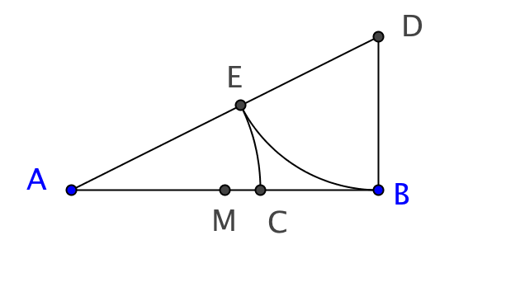
Let $\overline{AB}$ be the given segment with midpoint M. Construct $\overline{BD}$ perpendicular to $\overline{AB}$,
with BD = MB. Draw $\overline{AD}$

With center D, use radius DB to draw an arc intersecting $\overline{AD}$ at E.

With center A, use radius AE to draw an arc intersecting $\overline{AB}$ at C.

- Prove that the resulting ratio AC:CB is golden. (Huntley, p. 27).

- Fold a regular pentagon. Visit http://www.cutoutfoldup.com/105-fold-a-regular-pentagon.php to learn how to fold a regular pentagon from a square sheet of paper.

- Penrose Tiles. Sir Roger Penrose, a British mathematician, figured out how to tile a plane in a way that does not repeat like many other tilings do. He found two shapes, a kite and a dart, that could be used in different ways. They both derive from golden triangles. [See images below.]
- Show how the two shapes are related to the golden triangle.
- Make several copies of the two shapes. Use them to make the seven designs shown below.
- Explain what is special about the angles of these two shapes that makes them so well able to fit with one another.
- Make several of these kites and darts and use them to make some of your own designs with the two tiles.
- Read more about the Penrose tilings and prepare a report on it for others.

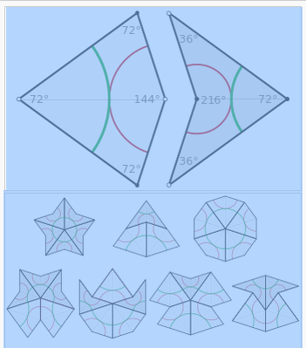
http://en.wikipedia.org/wiki/Penrose_tiling

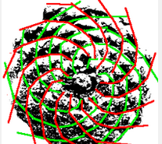
6. Fibonacci numbers and golden ratios in nature. Fibonacci numbers occur frequently in nature. Pinecones, pineapples, sunflowers, and many other plants have hidden spirals, called parastichies by botanists. In the example shown there are 13 counterclockwise and 8 clockwise spirals These are two adjacent Fibonacci numbers.

- Collect several pine cones or sunflowers (preferably from different species). Work with a friend and use yarn to find the different spirals. Did you find two consecutive Fibonacci numbers?
Phyllotaxis07 www.allometric.com

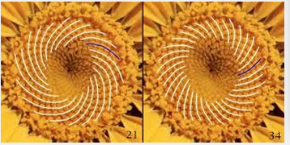
scotton.freeshell.org
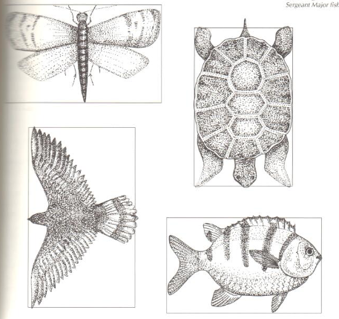

- Find natural objects (animals, plants) and find which ones include the golden ratio. Here are some samples of animals whose dimensions are close to those of a golden rectangle. (Newman & Boles, p. 57.)

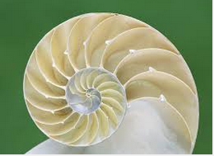
- A chambered nautilus is an example of an equiangular spiral from a golden rectangle. Learn more about this animal. Why does the equiangular spiral occur in nature? What are its biological and other properties?

1600 Robbycarroll.com

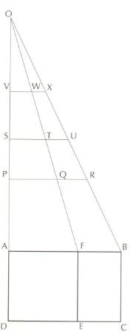
7. Golden Rule(r). [Newman & Boles Vol. 1, p. 60). Once you have a golden rectangle you can easily create other segments in the same ratio. Study this method and justify why it works.

a. Begin with golden rectangle ABCD and its associated square AFED.
b. Extend $\overline{DA}$ to O to create the length you prefer for the ruler.
c. Draw $\overline{OF}$ and $\overline{OB.}$
d. Show that any line segment parallel to $\overline{AB}$ is divided by $\overline{OF}$ into a golden section.

- Male bee and piano keys. The male bee has just one parent, its mother. The female bee has both a father and a mother. Here is a diagram of the previous generations of a male bee.
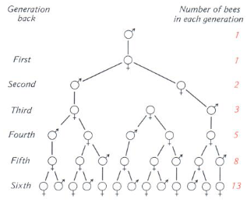
Jacobs. Mathematics as a Human Endeavor.

- Draw the seventh generation and show how it matches the next Fibonacci number.

- Study one cycle (octave) of keys on a piano. How does it correlate with the male bee’s hereditary pattern?

