Activity 8.6.4 Spirals from the Golden Ratio

Materials: Straight edge, compasses, dense square graph paper, polar graph paper, French curve (optional)

Golden rectangles and golden triangles are also related to spirals that appear in nature. One famous example is the shell of the chambered nautilus. While there are many types of spirals, the particular spiral in this animal is the equiangular spiral, also known as a “logarithmic spiral.”

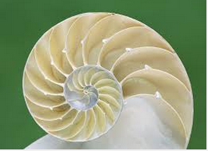

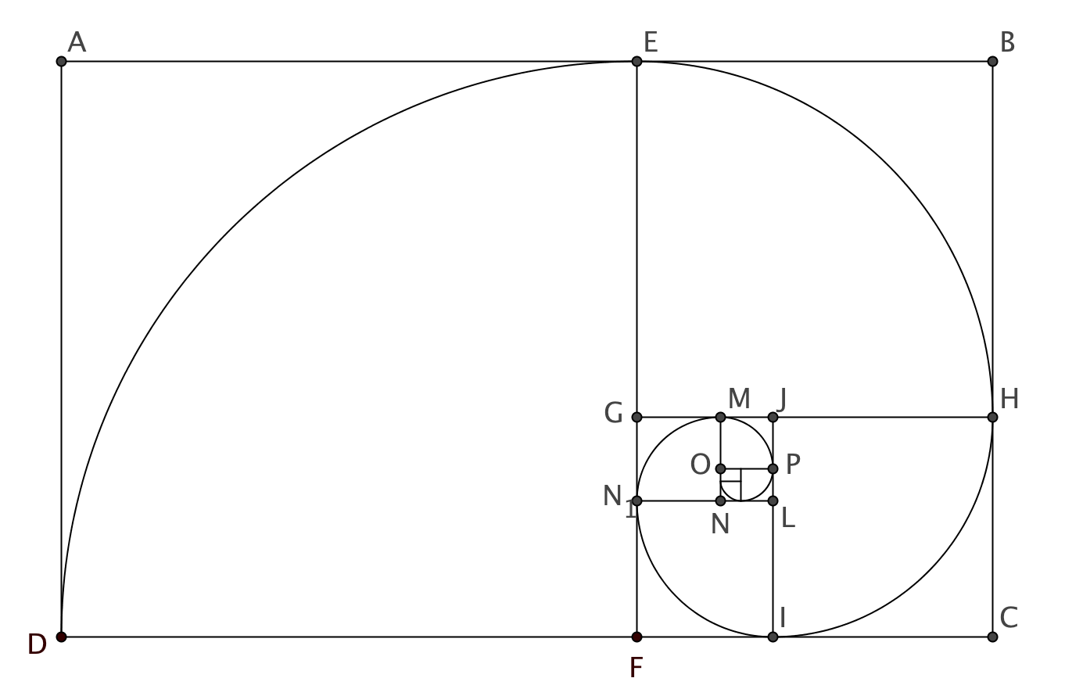
- You can construct an equiangular spiral from a golden rectangle. Refer to the diagram below and use the blank golden rectangle on the next page.

- Begin with golden rectangle ABCD.
- With your compass, copy the width AD from A on $\overline{AB}$ and locate E.
- With your compass, copy the width AD from D on $\overline{DC}$ to locate F.
- Draw $\overline{EF}$. You now have a square and another golden rectangle.
- In the same way copy $\overline{EB}$ onto $\overline{EF}$ and onto $\overline{BC }$to create another square and golden rectangle.
- Continue in the same way so far as your compass will allow.
- From F open your compass to FD and draw a quarter circle DE.
- From G open your compass to GE and draw a quarter circle EH.
- Continue in the same way to draw other portions of the spiral. [Hint: You may rotate your paper counterclockwise one quarter turn after each arc and repeatedly center your compass in the lower right corner of the square.]

- You can also construct an equiangular spiral from a golden triangle.

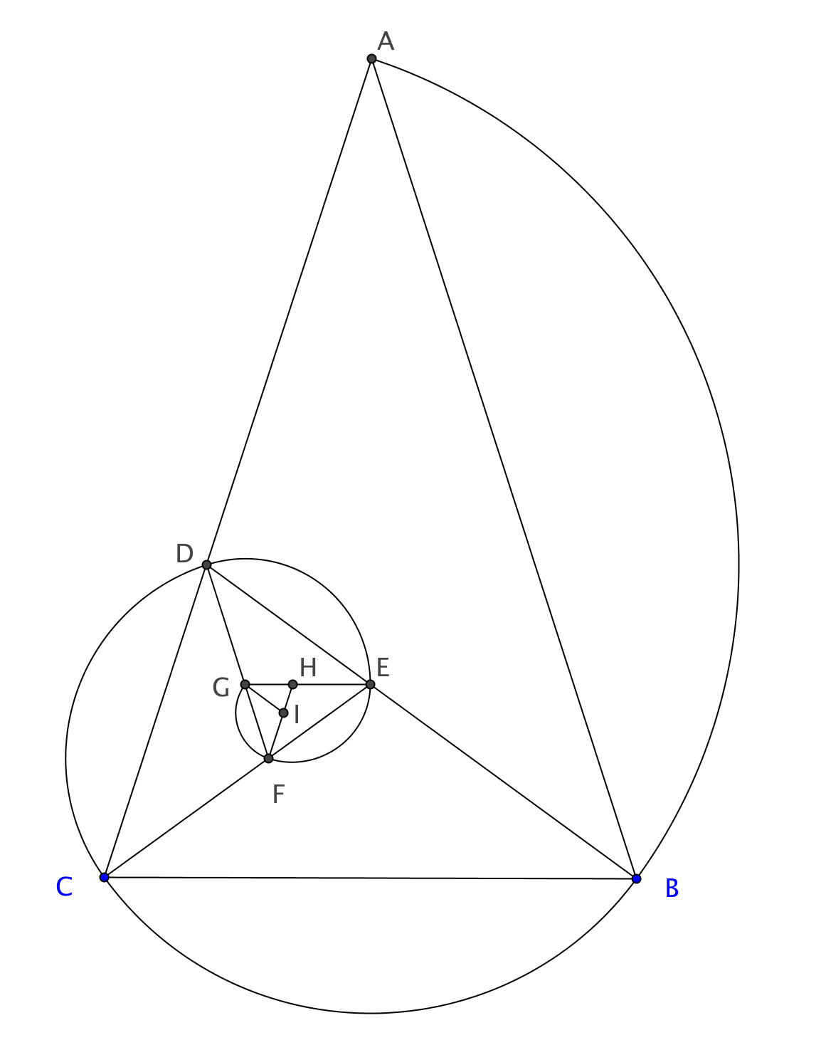

- Start with an isosceles 72°-72°-36° golden triangle. Use lettering as above.
- Bisect lower right 72° angle (angle B at outset). Extend bisector to opposite leg (point D at outset).
- Rotate your paper so the new 72°-72°-36° golden triangle (∆DCB at outset) has its short base at bottom.
- Repeat steps (b) and (c) as long as your compasses allow.
- Place metal tip of compass on D and draw arc AB.
- Place metal tip of compass at E and draw arc BC.
- Continue placing tip of compass at vertex of each successively smaller 36°-36°-108ˆ triangle and copying the leg length to make the next portion of the spiral.
- You can also use graph paper to create an approximate equiangular spiral from nested rectangles with sides from successive Fibonacci numbers. Study the image below.
- How were the Fibonacci numbers used?
- How was the compass used?
- Use dense graph paper to construct your own approximate spiral.
[image from Newman & Boles vol 1 p. 218]
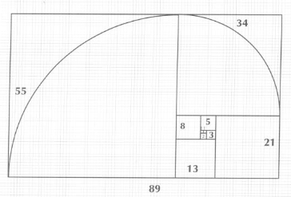
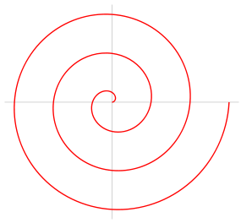
- To contrast an equiangular spiral with another type of spiral let’s look at an example of an Archimedean spiral, shown at the right. In what ways is the Archimedean spiral like the equiangular spiral? In what ways is it different?

https://en.wikipedia.org/wiki/Archimedean_spiral
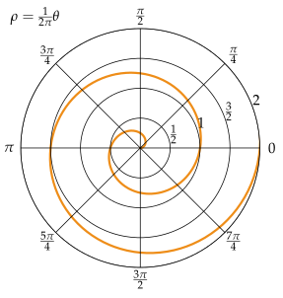
- This diagram is drawn on polar graph paper. A point on polar graph paper is located by its radius (distance from the center) and its angle (degrees from 0 ray). Confirm or refute each of the following statements. (Note: the angle measurements are given in radians).

https://en.wikipedia.org/wiki/Archimedean_spiral
- Each time the spiral turns 180 degrees, it intersects the next longer radius.
- As the spiral intersects each ray from the center, the distances between the spiral and itself are the same.
- The spiral lengthens at a constant rate for each unit turn it makes.

- Construct another Archimedean spiral that moves from the pole at a rate of one unit radius for each turn of 60°.
- Use polar graph paper.
- Locate the pole and label it A.
- Locate B at the intersection of the circle of radius 1 and the ray for 60°.
- Locate C at the intersection of the circle of radius 2 and the ray for 120°.
- Continue the process of locating points moving to the next larger circle and using the next ray (60° more) to get more points on the spiral.

- Is this spiral similar to the one shown in question 5? Explain.

- Do research on line or in a library to find out why the names “equiangular” and “Archimedean” are given to the two spirals.

