Activity 8.6.3 Fibonacci Numbers

Materials: Scientific Calculator

Surprisingly, the golden section (and rectangle and triangle) have relationships to many natural phenomena. One idealized version of a rabbit problem was posed by Leonardo de Pisa, who came to be known as Fibonacci (an abbreviation of Filius Bonacci, which translates as son of Bonacci). In 1202 he posed the following problem:

A pair of rabbits one month old is too young to reproduce. But after one month they produce a pair of rabbits (one male and one female). Suppose that each new pair of rabbits does the same (takes one month to mature, then reproduces one new pair). Suppose none of the rabbits die. How many pairs are there at the beginning of each month?
1. Study the following representation of this problem.

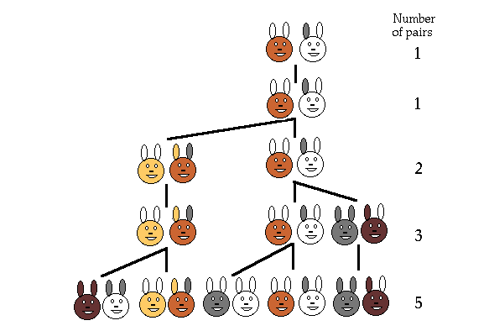
http://www.maths.surrey.ac.uk/hosted-sites/R.Knott/Fibonacci/fibnat.html

- Explain each row in the table. Where did each pair come from?
- Draw the next row of the table and explain where each pair comes from. Tell how many pairs there are now.
- Imagine yet another row. Find the number of pairs, if possible, without a drawing.
- Find a pattern in the number of pairs. Tell in words how the pattern works.
- Extend the pattern to the 15th term. [The number of pairs should be 610.]
- Find differences between successive terms. What do you notice? Why does this happen?

- There are many other patterns within the sequence you found which is called the Fibonacci Sequence. One comes from finding the ratio of successive terms.
- Continue the table with the first 15 terms of the sequence.
- Find each ratio in fraction and decimal forms.
- Explain what you notice happening to the decimal values.

- Recall that the golden ratio was $\frac{1+\sqrt{5}}{2}$. How does this value compare to what you are finding in the 3rd column?

Fibonacci Sequence | Ratio of  New Term to Previous Term | Decimal (to nearest 0.001)
1
1 | $$\frac{1}{1}$$
2 | $$\frac{2}{1}$$
3 | $$\frac{3}{2}$$
5 | $$\frac{5}{3}$$
8

- The Fibonacci sequence can be symbolized using subscripts.
Symbols Meaning of symbols
F ₁ = 1 Term one equals 1
F ₂ = 1 Term two equals 1
F _{n} = F _{n–1} + F _{n–2} The nth term equals the sum of the previous
(n–1) term and the second previous (n–2) term.
- Use the subscript notation to write an expression for the 5th term, F ₅.
- Evaluate the fifth term.

- The above symbolization of the Fibonacci sequence requires that you know previous terms in order to find later terms. Recall from Algebra 1 Unit 1 that such a formula is called recursive. Some people think about it as if you have to look back over your shoulder to see what just happened to figure out the next term.
It is also possible to find a given Fibonacci term directly from knowing where it is in the sequence. It may surprise you to learn that a formula to find the nth term directly uses the golden ratio! In fact, both solutions to the golden quadratic
x² – x – 1 = 0
are involved. The formula is named for the French mathematician Jacques Philippe Marie Binet (1786-1856) although others knew it earlier.

Here is Binet’s Formula for the nth Fibonacci number:
F_{n} = $\frac{1}{\sqrt{5}}$ $\left(\frac{1+\sqrt{5}}{2}\right)$^{n} – $\frac{1}{\sqrt{5}}$ $\left(\frac{1-\sqrt{5}}{2}\right)$^{n}

a. Use Binet’s formula and a scientific calculator to confirm that the 8th Fibonacci number is 21. (Your calculator may be off a little bit.)
b. Without the aid of a calculator, use algebra to find F₃.
c. Without the aid of a calculator, use algebra to find F₄.

- Explore more patterns in the Fibonacci sequence.
- In the table below, complete the first 9 rows and the first 2 columns.
- Find as many patterns as you can. Describe the patterns in words and, if possible, with symbols. [Hint: It helps for some patterns to think about factoring.]

Fibonacci Sequence | Cumulative Sums of Fibonacci terms | Squares of Fibonacci terms | Sum of Two Consecutive Squares | Sum of all preceding squares
1 | 1 | 1 | 1 | 1
1 | 2 | 1 | 1 + 1 = 2 | 1 + 1 = 2
2 | 4 | 4 | 1 + 4 = 5 | 2 + 4 = 6
3 | 7 | 9 | 4 + 9 = 13 | 6 + 9 = 15
5 | 12 | 25 | 9 + 25 = | 15 + 25 =
8
 |  | ---- | ---- | ----
 |  | ---- | ---- | ----
 |  | ---- | ---- | ----
 |  | ---- | ---- | ----
 |  | ---- | ---- | ----
 |  | ---- | ---- | ----

- Find a pattern in these three consecutive expressions. Continue to find at least four more consecutive cases. Explain in words or possibly symbols how the results relate to the Fibonacci sequence.
2³ + 1³ – 1³ =
3³ + 2³ – 1³ =
5³ + 3³ – 2³ =

