Activity 8.6.2 Golden Triangles

Materials: compasses, straight edge, protractor

In the previous activity you saw that a golden rectangle has the following property:

$\frac{length}{width}$ =$\frac{length+width}{length}$

What would it mean for a triangle to be ‘golden?’ How could we use this property to make a triangle? Because there are only two lengths, we need to think about an isosceles triangle.

1. Let the length : width ratio of the golden rectangle correspond to
the long side : short side ratio of an isosceles triangle.

a. Begin with a golden rectangle. [Reconstruct one as you did in Activity 8.6.1 or use the one below.]

b. Let the width (short side) of the rectangle be the base of an isosceles triangle. Use your compass and straight edge to copy the base $\overline{AB}$.

c. Let the length (long side) of the rectangle be the length of the two legs of the isosceles triangle. Use your compass and straight edge to copy the leg on each end of the base. Find the point where the two legs intersect. Call that point C. ∆ABC is a golden triangle.

d. Use your protractor to measure the angles of your golden triangle. Find the measures of the two congruent base angles and the measure of the vertex angle.

e. Write a proportion using the three angle measures,
base angle : base angle : vertex angle. Simplify the proportion.

f. True or false: All golden triangles are similar. Justify your answer.
2. It is also possible to construct an isosceles triangle in which the length of the golden rectangle corresponds to the base and its width corresponds to the two legs.
a. Use your construction tools to construct this second isosceles triangle.
b. Use your protractor to find the measures of the angles in this triangle.
c. Write a ratio using the three angle measures,
base angle : base angle : vertex angle. Simplify the ratio.
d. One name given to this obtuse isosceles triangle is the golden gnomon(pronounced “no mun”). Make at least three statements comparing the golden gnomon and the golden triangle.
3. The golden triangle can also be found in a regular pentagon.
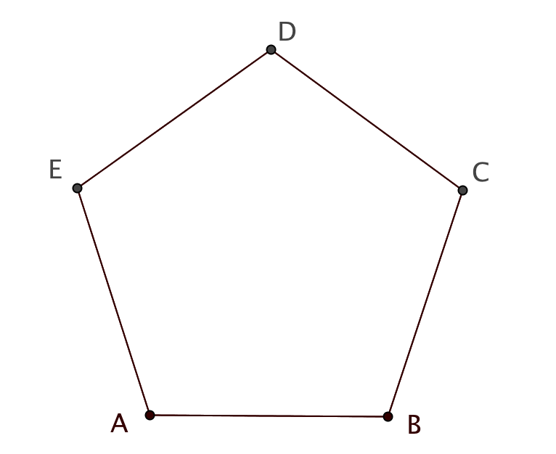

- What is the measure of each angle in the regular pentagon?
- Draw $\overline{AD}$ and $\overline{BD}$. Explain why each of the three resulting triangles is isosceles.
- Use reasoning (not measurement) to determine the measures of each angle in each triangle.
- Why is ∆ADB a golden triangle?
4. The pentagon has even more golden triangles.
- Draw an angle bisector for $∠$DAB. Label F the point where the bisector intersects $\overline{BD}$. Find the measures of the angles in ∆CDF and Triangle ADF.
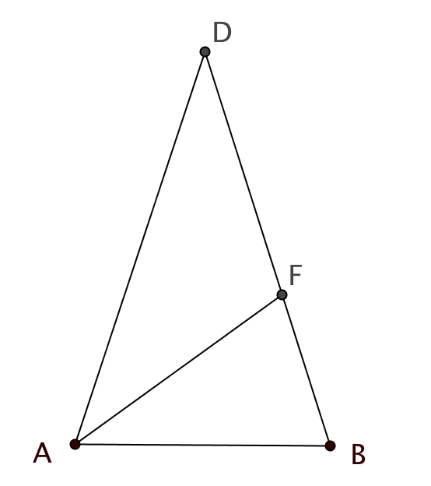

- Explain why ∆AFD and ∆BAF are isosceles.
- Explain why ∆FAB is similar to ∆ADB.
- Explain why the following proportion is true:$\frac{AD}{AB}=\frac{AB}{FB}$.
- Explain why the following proportion is true: $\frac{BD}{DF}=\frac{DF}{FB}$.
- Recall that the golden section results when a line segment is divided so that the following proportion is true.

$\frac{longer piece}{smaller piece}$ = $\frac{whole}{longer piece}$

Which line segment is divided into a golden section?

- What special names would you give to ∆FAB and ∆AFD? Explain.

5. a. How was the image below created?

b. Find as many golden triangles as you can. [Note: You will need to name more points.]

c. Find as many instances of a golden ratio as you can. Beware: there are many!

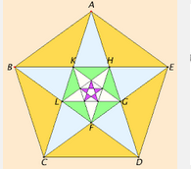

6. You have seen in questions 3 and 4, how golden triangles are found in pentagons. Now reverse the process and use a golden triangle to construct a regular pentagon with compass and straightedge alone. (Recall from Unit 3 that we are able construct regular polygons with 3, 4, and 6 sides using only Euclid’s tools. Now we may add the regular pentagon to the list.)

7. For further research. It has been proved impossible to construct a regular polygon with 7 sides or one with 9 sides using only compass and straightedge. Find out which regular polygons can be constructed with only these tools.

8. Euclid describes how to construct a regular polygon with 15 sides by inscribing and equilateral triangle and a regular pentagon in the same circle. (Elements Book IV Proposition 16). See if you can figure out how to do this on your own, or look up his method on line (http://aleph0.clarku.edu/~djoyce/java/elements/bookIV/propIV16.html) or in a library.

