**Activity 8.5.5 Using Matrices to Find Triangular Areas**

As you have seen in previous activities, matrices are a way of organizing data, in rows and columns, so that mathematical operations can be performed on them. In this assignment, you will use matrices to find areas of triangles. The process commonly used to find areas of non-right triangles is called Heron’s Formula. This particular use of matrices simplifies the process and allows for several extensions.

Consider, a right triangle, with vertices at the origin, (5,0) and (0,4). What would the area of this triangle be?

(0,4)

(5,0)

(0,0)

Now, let’s put the ordered pairs into a matrix. There are three ordered pairs, and it doesn’t matter the order that you put them in the matrix. However, we want to create a square, 3 x 3, matrix, so we will put 1’s in the last column. [There is a cool derivation of the formula for why this is so…so if you’re interested, go online and look for Cramer’s Rule Area of a Triangle]. Here is how I have set up my matrix:



Now, if we take one-half the value of the determinant of this matrix, we should get the same answer as we did above:

DET  = -20  2 =-10

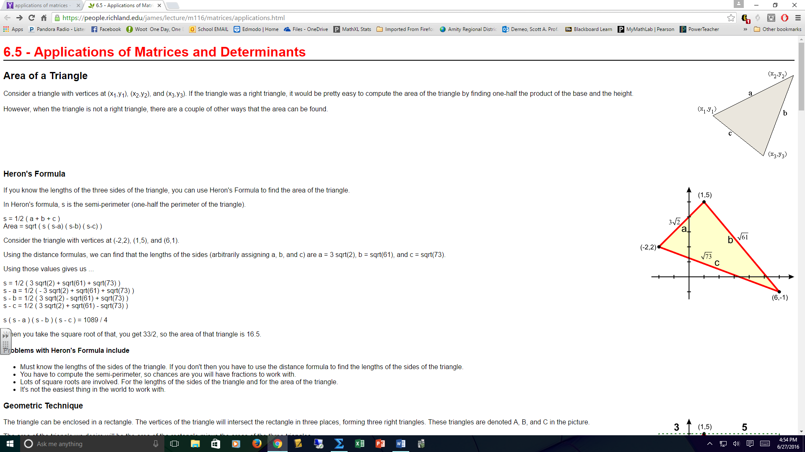Clearly, the area cannot be negative, so we take the absolute value of that number to get the area of our triangle. If we had ordered the pairs differently in the matrix, we may have gotten a positive number, but it’s unnecessary to worry about the order. Absolute value addresses the problem. So, in general, we say that if a triangle has the given setup, then it’s area can be calculated as:

AREA = 

**Exercises:**

On your own, calculate the areas of the given triangles. First, generate the matrix you will use to find the area, then use your calculator to find the area using the det function, accurate to the nearest tenth of a square unit. When you are done, check that you got the correct answer by going to <http://www.analyzemath.com> and use their area calculator.

1. A (-2, -2), B (5, -3), C (-6, 14) 2. D (-2, 0), E (-3, 5), F (-6, 11)

3. A (-3, -1), B (1, 12), C (-4, 4) 4. D (0,1), E (-3, -4), F (5, -5)

5. A (5, -3), B (-15, 8), C (-12, 17) 6. D (-1, 2), E (1, 9), F (-9, 17)

7. A (3, 4), B (9, -3), C (-6, 13) 8. D (0,4), E (0, -2), F (0, 1)

9. Explain why your answer found in #8 makes sense, given the ordered pairs.