Activity 8.3.3 Additional Explorations of Tilings

- More tilings with regular polygons. So far you have discovered that there are 3 types of regular tessellations (Activity 3.7.2) and 8 types of semi-regular tessellations (Activity 8.3.1).
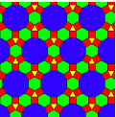
One of the requirements for a semi-regular tiling is that the arrangement of polygons at each vertex must be the same. If that restriction is removed there are additional tilings that are interesting. Many of these are called “demi-regular,” although there is no consensus on how that category is defined. An example is shown at the right. Notice that some vertices are 4.6.12 and others are 3.4.6.4. Use the chart you made in Investigation 8.3.1 to discover other demi-regular tilings.

- Escher-like tilings. Maurits Cornelis Escher (1989 – 1972), born in the Netherlands, is one of the world’s most famous graphic artists. He is famous for seemingly impossible drawings (e.g. staircases that make a loop but appear to ascend continuously) and what are called divisions of the plane using many mathematical transformations that he was inspired to learn after visiting the Alhambra, a 14th century Moorish castle in Granada, Spain.
The official website on Escher is http://www.mcescher.com.

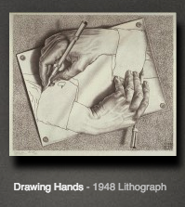
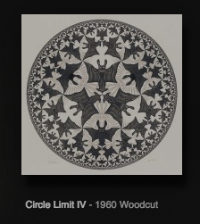

- Explore some of Escher’s work. Find two pieces that intrigue you. Write in words what it is about the piece and how it was constructed that is interesting. Include some mathematical ideas or terminology in your report.
- Use one of the online websites for creating your own Escher-like tilings of the plane.
- Explain the transformations that underlie the online tools. Where are translations being used? Where are reflections used and about what lines? Where are rotations used and with what angles and what centers?

- Penrose tilings. At the right is a famous mathematician, Sir Roger Penrose, at Texas A&M University, standing on a floored tiled in a “Penrose Tiling,” one of the ways Sir Roger found to tile using five-fold symmetry. At the left is a photo of the hallway of the Department of Mathematics and Statistics of the University of Michigan-Dearborn where Kim Sauve was the installer of a Penrose design.

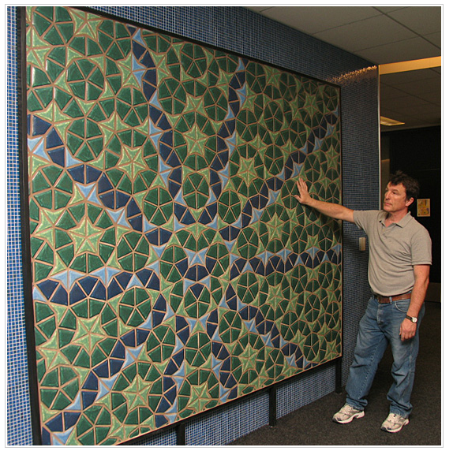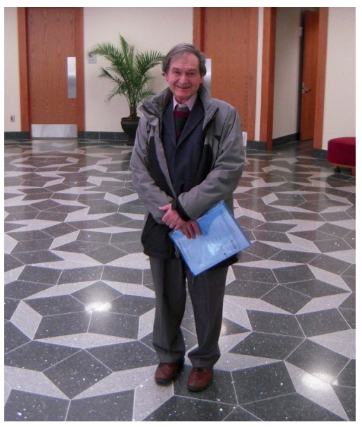

- In what ways are the designs the same? In what ways are they different?
- What is meant by ‘five-fold symmetry?’ How does it arise in these tilings?
- The left-hand tiling uses two shapes, a kite and a dart. Find each and use the tiling and its symmetries to figure out what the angles must be.
- Make your own darts and kites using the same angles that you found in (c). In what different ways can these pieces ‘fill a point?’ Sketch the different arrangements that you can make.
- Pose and investigate another problem related to the ones above. Solve and explain your reasoning or take the investigation as far as you can and report your work.

