Activity 8.3.2 Pentagonal Tilings

In Activities 3.7.3 and 3.7.4 you learned that every triangle and every quadrilateral can tile the plane. You also know, however, that regular pentagons cannot tile the plane. So the question arises: which non-regular pentagons, if any are able to tile the plane?

1. Here are two examples of non-regular pentagons that tile the plane.

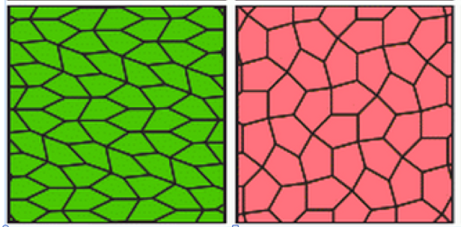

http://www.mathpuzzle.com/tilepent.html
Study these tilings and record any observations.

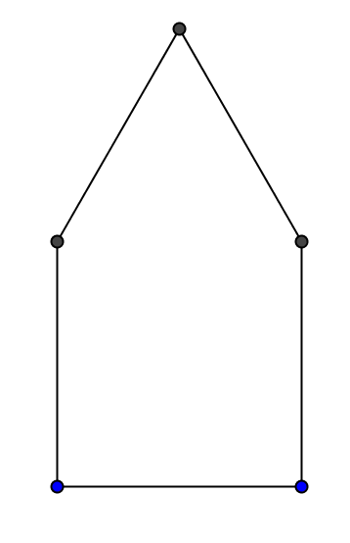
- Children often draw houses that are formed by a square and an equilateral triangle.

- Why is this pentagon not regular?

- Show how a “house” pentagon like this one (with no other shapes) can tile the plane.

- Modify the “house” pentagon and see if the resulting figure will still tile the plane:
a. What happens if you replace the square with a non-square rectangle? With a non-rectangular parallelogram?
b. What happens if you replace the equilateral triangle with a non-equilateral isosceles triangle? With a scalene triangle?
c. Try some other ways of modifying the “house” pentagon and see if you are still able to tile the plane.

- So far we have restricted our study of tessellations to edge-to-edge tilings. If we relax that restriction we can include tilings where some vertices lie in the interior of an edge of a tile. Which of the following are edge-to-edge tilings?
a. b. c. d.
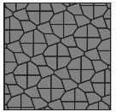
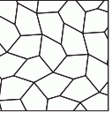
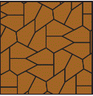
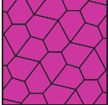

http://www.mathpuzzle.com/tilepent.html

e. The tiling you made with the “house” pentagon in question 2b.

- Several recipes have been discovered for creating pentagonal tilings. The most recent one was discovered in 2015! Visit these web sites to learn more. Chose one of the recipes to create your own tiling.
http://www.mathpuzzle.com/tilepent.html
https://en.wikipedia.org/wiki/Pentagonal_tiling#CITEREFBagina2011
https://sites.google.com/site/intriguingtessellations/home
- Another remarkable category of tilings are ones that use pentagons along with other shapes. Sir Roger Penrose, a British mathematician and scientist, has done considerable work in this area and has created surprising designs with unusual mathematical and aesthetic qualities. Below is one of his tilings.
- Describe each shape used in this tiling.

- The pentagons are regular. Use that and additional reasoning to figure out the angles of the other shapes in this tiling. Record your reasoning.
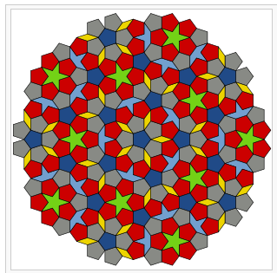
https://en.wikipedia.org/wiki/Penrose_tiling

