Activity 8.3.1 Possible Semi-regular Tilings

In a previous activity you found three possible tilings that can be made from just one regular polygon. Such tilings are called regular tilings.

You likely also noticed that some tilings, like those shown below, were made exclusively of two or more regular polygons. Moreover you may have noticed that in these tilings, every vertex had the same combination of shapes meeting in the same order. Such tilings are called semi-regular tilings.
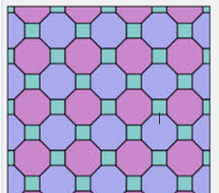
Here are two semi-regular tilings. Semi-regular tilings are the ones we will explore more in this activity. In particular, we want to figure out: What are the possible semi-regular tilings?

- Recall the reasoning you used to figure out for any regular n-gon, how many degrees there are in each angle. The first 8 rows are in the table you may have made for Activity 3.7.2.
Regular Polygon | Sides | Measure of Each interior angle
Triangle | 3
Square | 4
Pentagon | 5
Hexagon | 6
Heptagon | 7
Octagon | 8
Nonagon | 9
Decagon | 10
Dodecagon | 12
Pentakaidecagon | 15
Octakeidecagon | 18
Icosagon | 20
Tetrakaicosagon | 24

- What must be true about the polygons that meet together at any vertex?

- Suppose you were going to create a tiling with as many possible regular polygons as possible at each vertex. What is the largest number of regular polygons that could meet at a vertex? What are the shapes? How many are there?
- Can there be four different regular polygons at one vertex? Hint: the angles of each would need to be small. Explain your reasoning.
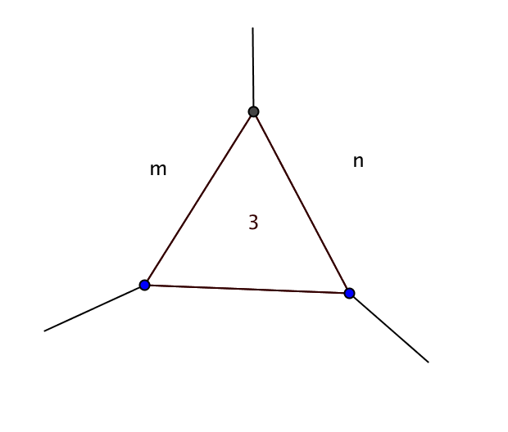
- If there are four or more regular polygons at one vertex, what must be true about them? Why?
- Suppose you begin to make a semi-regular tiling and you start with an equilateral triangle and two other shapes. We can symbolize this as 3.m.n. Suppose you put two other different shapes at the vertex at the top. What happens when you try to fill in the space at the bottom?

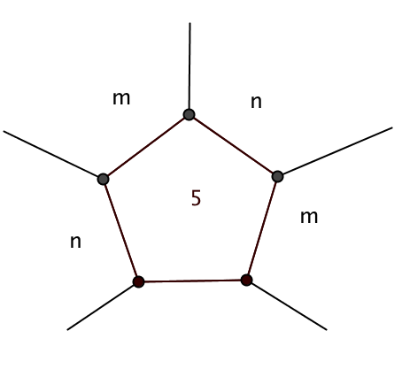
- Repeat the experiment from question 6 when you begin to make a semi-regular tiling with a regular pentagon. Symbolize it 5.m.n. Make a diagram. Explain your reasoning. Is it possible to have a regular pentagon and two different other regular polygons?

- Your results from considering a triangle or a pentagon with exactly two other different regular polygons can be generalized.
a. What general statement can you make for regular polygons with an odd number of sides?
b. Would this general statement hold for a regular polygon with an even number of sides? Why or why not?

- Now let’s see what sets of angles from our table will fit together to total exactly 360°. Use your numbers from the table in #1 and tiles from the Tiling Kit or software at http://illuminations.nctm.org/Activity.aspx?id=3533. The table below shows you there are 3 ways to put five shapes at each vertex, 5 ways to use four tiles, and 11 ways to use 3 tiles. Note that for some of the sums of 360, there are two different ways to arrange the same tiles. We included one at the bottom that totals 360 and is literally ‘off your chart.’ Find the different ways to use regular polygons to total 360° at a vertex. Try to work systematically.
6 | 3.3.3.3.3.3 | 60 + 60 + 60 + 60 + 60 + 60 = 360
5 | 3.3.3.3.6
5 | 3.3.3.4.4
5 | 3.3.4.3.4
4 | 4.4.4.4 | 90 + 90 + 90 + 90 =360
4 | 3.3.6.6
4 | 3.4.4.6
4 | 3.4.6.4
4 | 3.6.3.6
3 | 6.6.6 | 120 + 120 + 120 = 360
3 | 3.8.24
3 | 3.9.18
3 | 3.10.15
3 | 3.12.12
3 | 4.6.12
3 | 4.5.20
3 | 4.8.8 | 90 + 135 + 135 = 360
3 | 4.6.12
3 | 5.5.10
3 | 3.7.42 | 60 +128$\frac{4}{7}$ + 171 $\frac{3}{7}$= 360

- What strategies did you use or do you now see may have helped to do your search systematically?
- The table shows all the ways to get three, four, five, or six regular polygons to fit at one vertex to total 360°. But not all the sets correspond to possible tilings.
- Use your kit to investigate what is possible. Note that for some of the sums of 360, there are two different ways to arrange the same tiles and still get the design to repeat.
- You should have found exactly 8 semi-regular tilings, in addition to the 3 regular tilings you already knew. Write in symbols representations for the 8 tilings.
- Sketch diagrams of the eight semi-regular tilings. Use your kit to help you.
- Some students made these statements about the 8 semi-regular tilings. Do you agree or disagree? Explain your reasoning.
- Every semi-regular tiling includes equilateral triangles.
- There are no semi-regular tilings with three shapes.
- The same collection of shapes can make two different designs.

- Make your own true observations about the semi-regular tilings. Justify your statements.

