Activity 8.1.5 More Explorations with Frieze Patterns
Choose among these questions depending upon your interests. You may want to work with a partner or in a group and present your results to the class.
- Find more examples of border designs. Find your favorites for each of the seven types.
- Do a frieze scavenger hunt. Look at jewelry, pottery, buildings, furniture, porches, all around you. Find and photograph at least one example from each of the seven border types. Present your results in such a way that helps the viewer see the symmetries in each.
- For dancers. Create seven dances, one for each of the border designs. Find a place to video record where the camera is above you. Think about which designs can be demonstrated with only one dancer. Which ones can be demonstrated with exactly two dancers? What dance can you create with four or more dancers?
- The Cleveland Museum of Art has Degas’ Frieze of Dancers (1895). http://www.clevelandart.org/art/1946.83
Which one of the seven frieze designs do you think they are trying to imitate? Which pairs might make a start for a more mathematically precise frieze design? Create your own ‘picture’ of dancers in the various seven border designs.
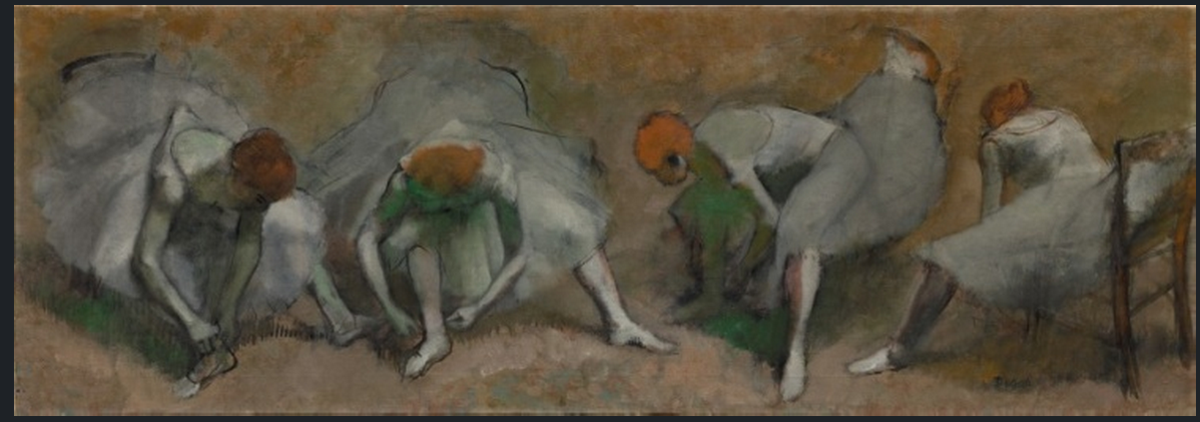
- For visual artists. choose one design element and create all seven border designs using your chosen element. Ask others to analyze your designs.
- For gamers. Create a border design game. One possible game might have feet or scalene triangle cards and given borders as goals. The borders might be already begun or not. Or the rules might work so that some moves make it impossible for another player to finish his border.
- For musicians. Create music based on the seven designs. Use music paper and let the B line of the treble clef be the horizontal line. Can you create a tune that is sequences of bars for each design?
- For archeologists and anthropologists. Lean which cultures used all seven designs in their artwork. What cultures used some subset of the seven? Which subsets are most common? What do which designs people use suggest about them?
- For actors. Read Doris Schattschneider’s article, “What Would Sherlock Do? Learn why there are exactly seven border designs. Create a skit with visual aids to re-enact Sherlock figuring out what the possibilities are. Make sure your skit helps audience members who are not familiar with the designs understand what the underlying movements are and how to use that to figure out the possibilities.
- For computer programmers or graphic designers. Make a program that takes a ‘starter’ element and creates, by the user’s choice, one or more of the border patterns based on that element. You may want to use dynamic geometry software (Geometer’s Sketchpad or Geogebra) or other electronic tools.
- For future teachers. Create a game for young children that engages them in using flips and half-turns to create frieze designs, perhaps with some asymmetrical 3D shape as a starting element (like the scalene triangle).

