Activity 8.1.4 Generating the Seven Patterns
You have seen seven border designs and have used and talked about the roles of half-turns, reflections, and slides (or translations) in creating these. Recall that when one transformation is followed by another, the result is called the composition of the two transformations. In this activity you will use compositions of transformations to analyze border designs.
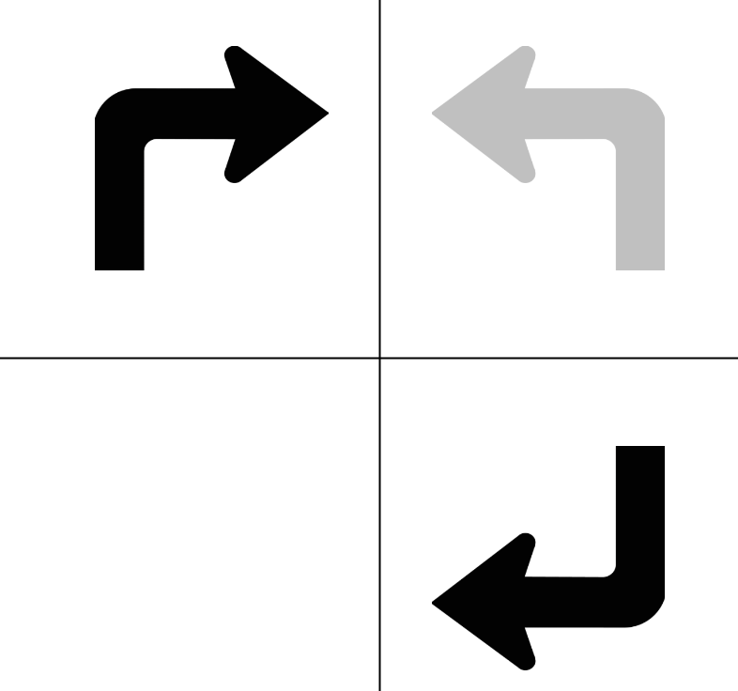
1. Take an asymmetrical shape (like the letter f, or a right turn arrow). Place it on a strip and then preform two transformations on it. For example, in the figure at the right, the arrow is first reflected over a vertical line. Then its image is reflected over a horizontal line. The result is a half turn (180°) rotation about the intersection of the two lines.

For each pair of transformations, describe the resulting transformation, i.e. one that maps the original object onto the final image. Draw a picture to support your conclusion.

- A glide reflection (along a horizontal mirror line) followed by another glide reflection along the same line.

- A reflection over a horizontal line followed by a glide reflection along the same line.

- A reflection over a vertical line followed by a glide reflection along a horizontal line.

- A reflection over a horizontal line followed by a 180° rotation about a point on the line.
- A translation by a horizontal vector followed by a reflection over a horizontal line.

- A translation by a horizontal vector followed by a reflection over a vertical line.

2. Imagine that in each of the examples from question 1, the original figure and its final image are translated continually in the horizontal direction to form a frieze pattern. In the given example we reflected over a vertical line and then over a horizontal line. If we now repeatedly translate both the original figure and the final image we get this.

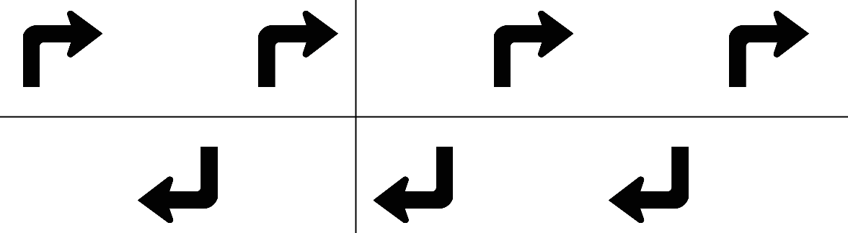
Use Conway’s terms or the IUC notation to identify the resulting border pattern.

3. Identify the border pattern that could result from repeated translation of each of the results in items (a) through (f) in question 1.

a.
b.
c.
d.
e.
f.

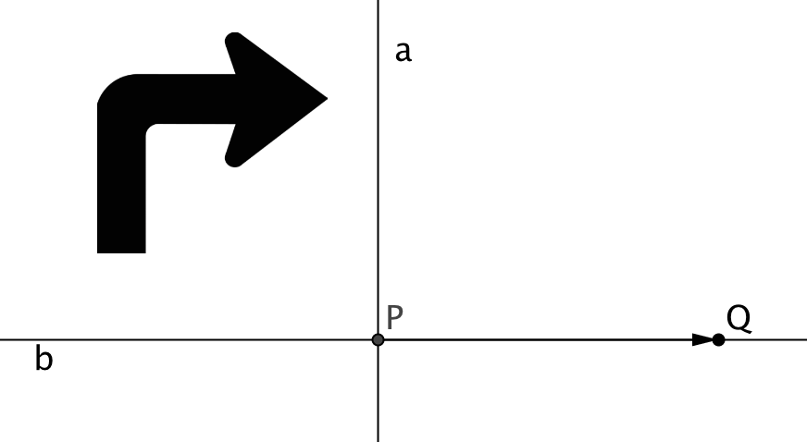
- Below is a sort of ‘multiplication table’ for transformations. Use an asymmetrical starting element (like the right turn arrow shown). Vertical line a and horizontal line b intersect at point P. Q is another point on line b. The transformation named in the first column is followed by the transformation in the top row. Fill in the table with a description of the resulting transformation.

 | Translate by the vector from P to Q | Reflect over horizontal line b | Reflect over vertical  line a | Half-turn about point P | Glide Reflection with vector from P to Q
Translate by the vector from P to Q

Reflect over horizontal line b

Reflect over vertical
line a

Half-turn about point P

Glide Reflection with vector from P to Q

- For each cell in the chart identify the frieze pattern resulting from applying the two transformations and then translating the original figure and its image repeatedly. Fill in the table with the results using either Conway’s terms or the IUC notation.

 | Translate (slide or hop) | Reflect horizontally | Reflect vertically | Half-turn | Glide Reflection
Translate (slide)
Reflect horizontally
Reflect vertically
Half-turn

Glide Reflection

- Two of the seven designs do not appear in the table. Explain what transformation would produce those designs.

- Explain why there are no border designs with IUC notations pmm1 or p1m2.
- Suppose a border design has both vertical mirror lines and 180° rotational symmetry.

- Show that if the center of rotation lies on the vertical mirror we also have horizontal reflection.

- Show that is the center of rotation does not lie on the vertical mirror, we also have glide reflection.

- Use the results in (a) and (b) to explain why there is no border design with IUC notation pm12.

